

Pentecost
June 8, 2025

SAINT PAUL LUTHERAN CHURCH
3383 EAST LAKE LANSING ROAD
EAST LANSING, MI 48823

PHONE (517) 351-8541

Pastor Carl E. Ballard
E-MAIL: pastor@stpaul-el.org
officemanager@stpaul-el.org

Visitors WELCOME! If this is your first time worshipping with us, please sign our guest registry just outside the sanctuary doors. We hope you are blessed through worship today. If you have any questions, please feel free to call the church at 351-8541.
Children are always welcome in worship! The choir room (off the sanctuary) can also be used as a cry room for younger children and includes a sound system so parents may continue to participate in the service. Clipboards with children's bulletins, activities and crayons are available for use during the service.
Sunday School is available during the worship service September-May except the last Sunday of the month.
Virtual Services We can provide a virtual live Zoom session during worship upon request.
This Bulletin is for your use during the service and to take home for the upcoming week. If you choose not to take it home, please place it in the recycle receptacle in the back.
Newsletters and Calendars of Upcoming Events are available in the lobby/narthex. We welcome anyone who has an interest in our small groups or activities! You can also look us up on the web at www.stpaul-el.org.
Contacting Us: Our Office Manager is Emily Polhamus. She can be reached by phone at 517-351-8541 or at her email address, officemanager@stpaul-el.org. Our Director of Music is Elene Kobulashvili. You may leave a message at 517-351-8541. Pastor Carl can be reached at 517-515-3129, and his email address is cballard123@msn.com.
Holy Communion is available at most services. All who believe in the real presence of Christ in the bread and the wine are invited to celebrate Communion with us. Those who wish may come forward for a blessing.
You’re invited to share in fellowship after worship. We would love this opportunity to introduce you to the St. Paul community.

P-Presiding Minister A-Assisting Minister C-Congregation
PRELUDE ELENE

INTRODUCTION
On Pentecost, we celebrate that we have been given an Advocate to accompany us. Poured out in wind and fire, water, wine, and bread, the Holy Spirit abides in and among us. We give thanks that God speaks to each of us, no matter our origins, language, or life path. Filled with the Spirit of truth, we go out from worship to proclaim the saving power of Christ’s love and the freedom of God’s grace with all the world.

GATHERING
P: The Holy Spirit calls us together as the people of God.

(Please rise as you are able.)

THANKSGIVING FOR BAPTISM
P: Alleluia! Christ is risen.
C: Christ is risen, indeed. Alleluia!
P: In the name of ☩ the One who was, who is, and who is to come.
C: Amen.
P: Baptized into Christ’s death and resurrection, and called to live the baptized life, let us give thanks for the gifts of baptism. Holy God, we give you thanks for the waters of baptism, waters that make a people your own, that restore to wholeness, and empower us to be witnesses in your name. Baptized into you, O Living One,
C: make us one as you are one.
P: We give you thanks for the waters of baptism, waters that strengthen believers and give new life to beloved servants of your church; waters that extend your boundless love and cross barriers of our own making. Baptized into you, O Living One,
C: make us one as you are one.
P: We give you thanks for the waters of baptism, waters that open the hearts of believers and give a voice in the night to those in captivity; waters that set your people on a new path, rejoicing in the Spirit’s power. Baptized into you, O Living One,
C: make us one as you are one.
P: Grant us grace, love, and life, O Living One, that our every day is shaped by these waters that give us our very lives in you. We ask this in the name of Jesus, the Crucified and Risen One.
C: Amen.

GATHERING SONG ELW 407
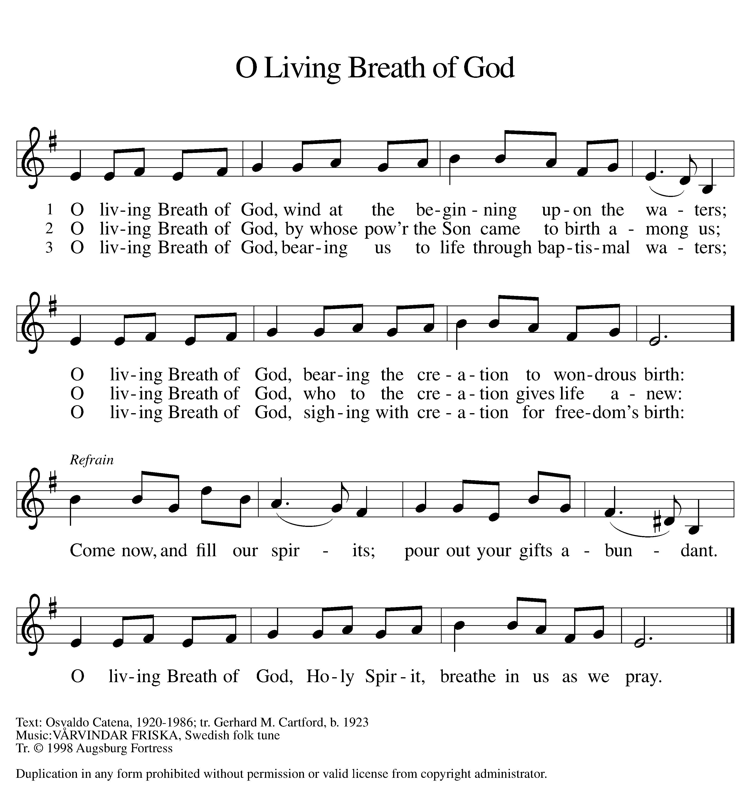
GREETING
P: The grace of our Lord Jesus Christ, the love of God, and the communion of the Holy Spirit be with you all.
C: And also with you.

KYRIE ELW Setting 8, Page 184-185
REFRAIN
Kyrie eleison, on our world and on our way.
Kyrie eleison, ev'ry day.
For peace in the world, for the health of the church,
for the unity of all;
for this holy house, for all who worship and praise,
let us pray to the Lord, let us pray to the Lord. Refrain

That we may live out your impassioned response
to the hungry and the poor;
that we may live out truth and justice and grace,
let us pray to the Lord, let us pray to the Lord. Refrain

For peace in our hearts, for peace in our homes,
for friends and family;
for life and for love, for our work and our play,
let us pray to the Lord, let us pray to the Lord. Refrain

For your Spirit to guide;
that you center our lives in the water and the Word;
that you nourish our souls with your body and blood,
let us pray to the Lord, let us pray to the Lord. Refrain

CANTICLE OF PRAISE ELW Setting 4, Page 149-150

This is the feast of victory for our God. Alleluia.

Worthy is Christ, the Lamb who was slain,
whose blood set us free to be people of God.
Power and riches and wisdom and strength,
and honor and blessing and glory are his.
This is the feast of victory for our God. Alleluia.

Sing with all the people of God
and join in the hymn of all creation:
Blessing and honor and glory and might
be to God and the Lamb forever. Amen.
This is the feast of victory for our God,
for the Lamb who was slain has begun his reign.
Alleluia. Alleluia.

PRAYER OF THE DAY

P: Let us pray. God our creator, the resurrection of your Son offers life to all the peoples of earth. By your Holy Spirit, kindle in us the fire of your love, empowering our lives for service and our tongues for praise, through Jesus Christ, our Savior and Lord, who lives and reigns with you and the Holy Spirit, one God, now and forever.

C: Amen.
(Please be seated.)
CHILDREN’S MESSAGE
(Children may return to their seats.)
WORD
P: God speaks to us in scripture, preaching, and song.

First Reading ACTS 2:1-21
Before Jesus ascended into heaven, he told his disciples they would be filled with the Holy Spirit. Now, amid signs of fire, wind, and a variety of languages, the people were amazed and astonished at Jesus’ promise coming true.
¹ When the day of Pentecost had come, [the apostles] were all together in one place. ² And suddenly from heaven there came a sound like the rush of a violent wind, and it filled the entire house where they were sitting. ³ Divided tongues, as of fire, appeared among them, and a tongue rested on each of them. ⁴ All of them were filled with the Holy Spirit and began to speak in other languages, as the Spirit gave them ability.
⁵ Now there were devout Jews from every people under heaven living in Jerusalem. ⁶ And at this sound the crowd gathered and was bewildered, because each one heard them speaking in the native language of each. ⁷ Amazed and astonished, they asked, “Are not all these who are speaking Galileans? ⁸ And how is it that we hear, each of us, in our own native language? ⁹ Parthians, Medes, Elamites, and residents of Mesopotamia, Judea and Cappadocia, Pontus and Asia, ¹⁰ Phrygia and Pamphylia, Egypt and the parts of Libya belonging to Cyrene, and visitors from Rome, both Jews and proselytes, ¹¹ Cretans and Arabs—in our own languages we hear them speaking about God’s deeds of power.” ¹² All were amazed and perplexed, saying to one another, “What does this mean?” ¹³ But others sneered and said, “They are filled with new wine.”
¹⁴ But Peter, standing with the eleven, raised his voice and addressed them, “Fellow Jews and all who live in Jerusalem, let this be known to you, and listen to what I say. ¹⁵ Indeed, these are not drunk, as you suppose, for it is only nine o’clock in the morning. ¹⁶ No, this is what was spoken through the prophet Joel: ¹⁷ ‘In the last days it will be, God declares, that I will pour out my Spirit upon all flesh, and your sons and your daughters shall prophesy, and your young men shall see visions, and your old men shall dream dreams. ¹⁸ Even upon my slaves, both men and women, in those days I will pour out my Spirit, and they shall prophesy. ¹⁹ And I will show portents in the heaven above and signs on the earth below, blood, and fire, and smoky mist. ²⁰ The sun shall be turned to darkness and the moon to blood, before the coming of the Lord’s great and glorious day. ²¹ Then everyone who calls on the name of the Lord shall be saved.’ ”
Reader: Word of God, word of life. C: Thanks be to God.

PSALM PSALM 104:24-34, 35b
Send forth your Spirit and renew the face of the earth. (Ps. 104:30)
²⁴How manifold are your works, O Lord! In wisdom you have made them all; the earth is full of your creatures.
²⁵Yonder is the sea, great and wide, with its swarms too many to number, living things both small and great.
²⁶There go the ships to and fro, and Leviathan, which you made for the sport of it.
²⁷All of them look to you to give them their food in due season.
²⁸You give it to them; they gather it; you open your hand, and they are filled with good things.
²⁹When you hide your face, they are terrified; when you take away their breath, they die and return to their dust.
³⁰You send forth your Spirit, and they are created; and so you renew the face of the earth.
³¹May the glory of the Lord endure forever; O Lord, rejoice in all your works.
³²You look at the earth and it trembles; you touch the mountains and they smoke.
³³I will sing to the Lord as long as I live; I will praise my God while I have my being.
³⁴May these words of mine please God. I will rejoice in the Lord.
^{35b}Bless the Lord, O my soul. Hallelujah!

SECOND READING ROMANS 8:14-17
Here Paul speaks about the mystery of baptism: through the Holy Spirit we are claimed, gathered, and welcomed into Christ’s body, the church. And we receive a new name in our adoption: child of God.
¹⁴ For all who are led by the Spirit of God are children of God. ¹⁵ For you did not receive a spirit of slavery to fall back into fear, but you received a spirit of adoption. When we cry, “Abba! Father!” ¹⁶ it is that very Spirit bearing witness with our spirit that we are children of God, ¹⁷ and if children, then heirs: heirs of God and joint heirs with Christ, if we in fact suffer with him so that we may also be glorified with him.
Reader: Word of God, word of life. C: Thanks be to God.

(Please rise as you are able.)

GOSPEL ACCLAMATION ELW Setting 8, Page 188
Alleluia. Lord, to whom shall we go?
You have the words of eternal life. Alleluia.
Alleluia, alleluia. Alleluia.
Alleluia, alleluia.

GOSPEL JOHN 14:8-17 [25-27]
P: The Holy Gospel according to John, the 14th chapter.
C: Glory to you, O Lord.
Though the disciples struggle with Jesus’ nature and identity, they receive the promise that they too will be identified with God and God’s mission. Though he must leave them now, Jesus promises the coming of the Advocate whom God will send to comfort and enlighten them.
⁸ Philip said to [Jesus,] “Lord, show us the Father, and we will be satisfied.” ⁹ Jesus said to him, “Have I been with you all this time, Philip, and you still do not know me? Whoever has seen me has seen the Father. How can you say, ‘Show us the Father’? ¹⁰ Do you not believe that I am in the Father and the Father is in me? The words that I say to you I do not speak on my own, but the Father who dwells in me does his works. ¹¹ Believe me that I am in the Father and the Father is in me, but if you do not, then believe because of the works themselves. ¹² Very truly, I tell you, the one who believes in me will also do the works that I do and, in fact, will do greater works than these, because I am going to the Father. ¹³ I will do whatever you ask in my name, so that the Father may be glorified in the Son. ¹⁴ If in my name you ask me for anything, I will do it.
¹⁵ “If you love me, you will keep my commandments. ¹⁶ And I will ask the Father, and he will give you another Advocate, to be with you forever. ¹⁷ This is the Spirit of truth, whom the world cannot receive because it neither sees him nor knows him. You know him because he abides with you, and he will be in you.
[²⁵ “I have said these things to you while I am still with you. ²⁶ But the Advocate, the Holy Spirit, whom the Father will send in my name, will teach you everything and remind you of all that I have said to you. ²⁷ Peace I leave with you; my peace I give to you. I do not give to you as the world gives. Do not let your hearts be troubled, and do not let them be afraid.”]
P: The Gospel of the Lord. C: Praise to you, O Christ.

(Please be seated.)

SERMON PASTOR CARL BALLARD

(Please rise as you are able.)

HYMN OF THE DAY ELW 482
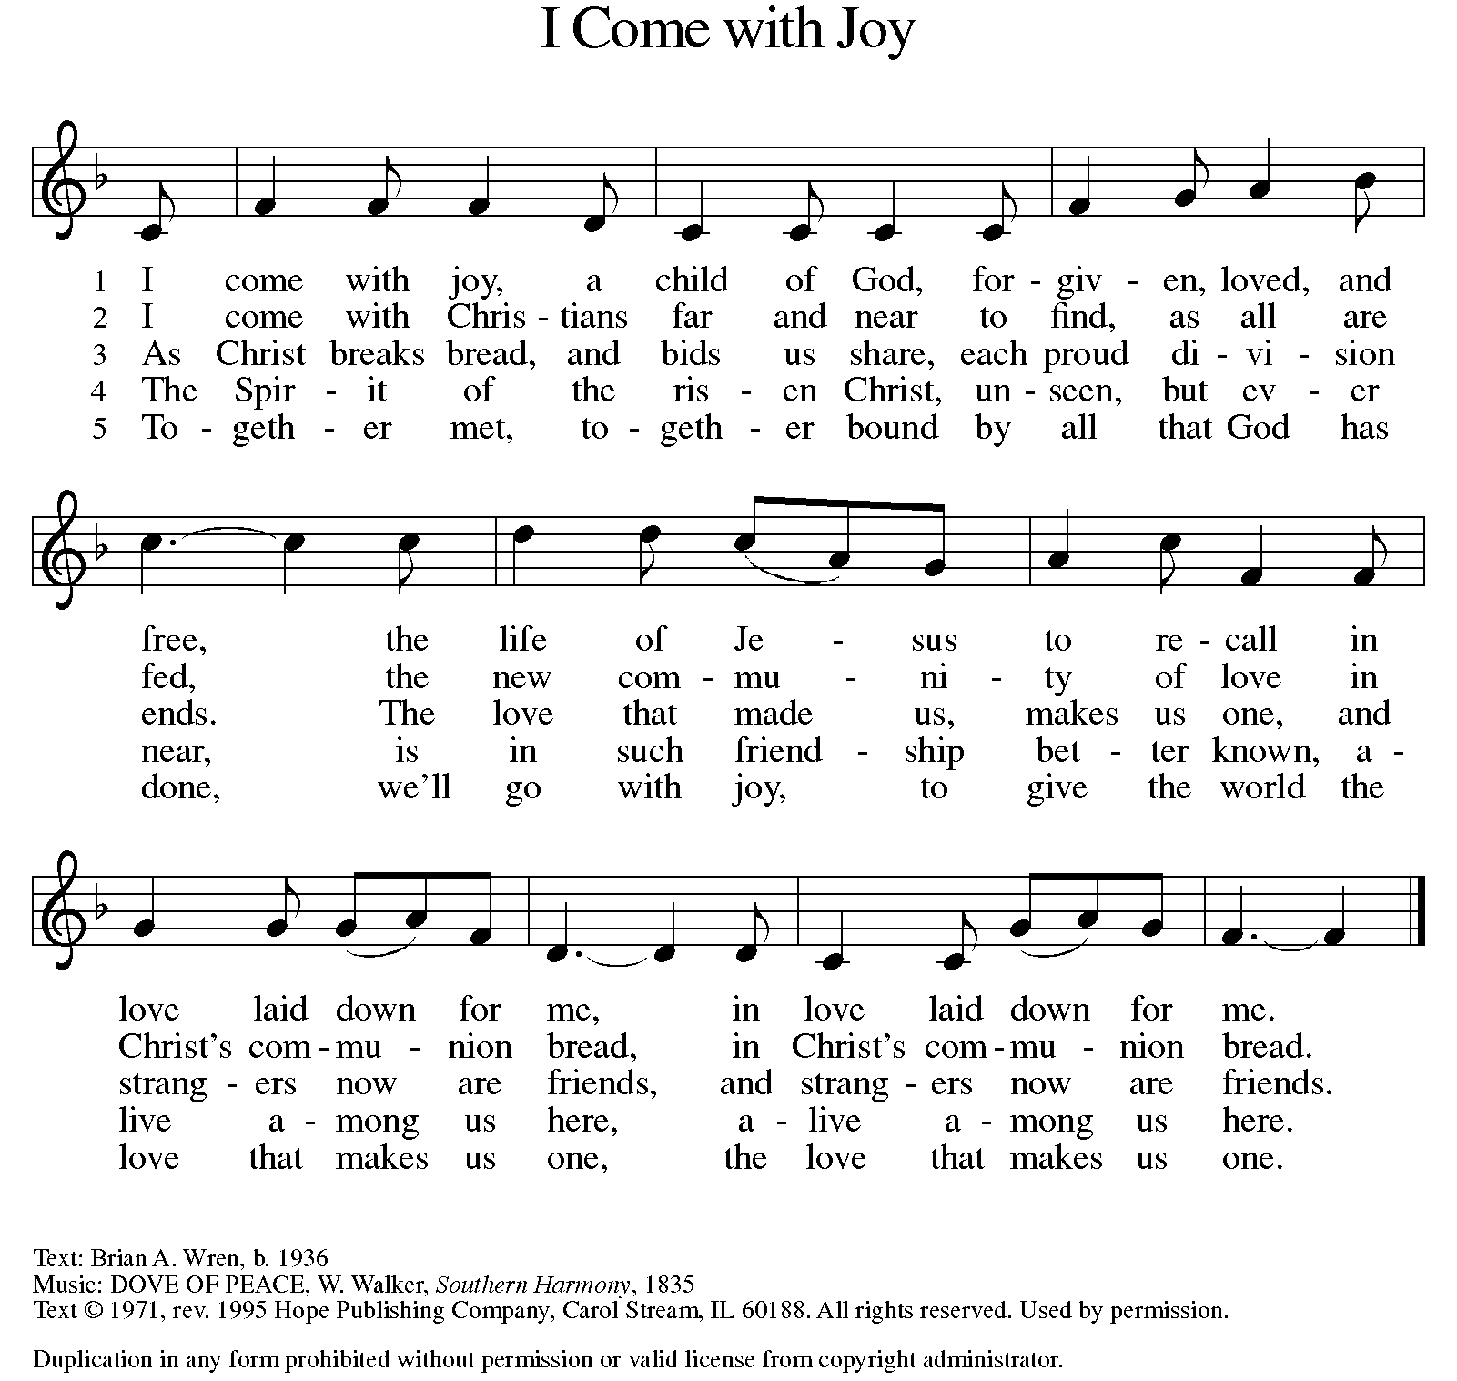

nicene CREED
We believe in one God,
the Father, the Almighty,
maker of heaven and earth,
of all that is, seen and unseen.
We believe in one Lord, Jesus Christ,
the only Son of God,
eternally begotten of the Father,
God from God, Light from Light,
true God from true God,
begotten, not made,
of one Being with the Father;
through him all things were made.
For us and for our salvation
he came down from heaven,
was incarnate of the Holy Spirit and the virgin Mary
and became truly human.
For our sake he was crucified under Pontius Pilate;
he suffered death and was buried.
On the third day he rose again
in accordance with the scriptures;
he ascended into heaven
and is seated at the right hand of the Father.
He will come again in glory to judge the living and the dead,
and his kingdom will have no end.

We believe in the Holy Spirit, the Lord, the giver of life.
who proceeds from the Father and the Son,
who with the Father and the Son is worshiped and glorified,
who has spoken through the prophets.
We believe in one holy catholic and apostolic church.
We acknowledge one baptism for the forgiveness of sins.
We look for the resurrection of the dead,
and the life of the world to come. Amen.

(Please be seated.)

THE PRAYERS
A: God of resurrection and new life, we come before you in prayer for the church, the world, and all who are in need.
(A brief silence.)
A: We pray for the church. Continue to inspire our sharing of the gospel and equip us to tear down the barriers we have erected. Make our welcome expansive, intentional, and open to loving challenge. Hear us, O God.
C: Your mercy is great.
A: We pray for creation. Allow fire to burn safely in habitats where it’s needed and quench flames when they threaten to run wild. Protect forests, prairies, and grasslands from destruction by natural forces or human misdeeds. Safeguard firefighters and rescuers in their dangerous work. Hear us, O God.
C: Your mercy is great.
A: We pray for courts and legislatures. Write your commandments on our hearts, and inspire all who govern to lead with love over retribution. Unite judges, lawyers, and systems of justice in a desire for reconciliation. Hear us, O God.
C: Your mercy is great.
A: We pray for this congregation. Raise up in us a deep desire to live out our baptismal promises and to support those of all ages in our shared journey of faith. Hear us, O God.
C: Your mercy is great.
A: We pray for those who serve in our armed forces. Guard them as they strive to bring justice and peace to an unsettled world. We pray especially for Beth & Ryan, Jonathan, Jacob, Noah, Irene, and Alex. Hear us, O God.
C: Your mercy is great.
A: We pray for the sick in body, mind, or spirit. Lift up all who have been bowed low by circumstances or internal strife. Bring to wholeness those who cry out to you in need. We pray especially Ahren, Allen, Beth, B.J., Carolyn, Dan, David, Don, Doretta, Family & friends of Glen, Gage, Gunny, Jim & Cheri, John, Johnny, Jon, Jordan, Lawton, Lera & family, Linda, Lizzy, Marge, Patty, Randy, Rick & Kathy, Sheri, Sheri, Stacy, Steve, Susan, Wanda, and all whom we name now aloud and in our hearts. Hear us, O God.
C: Your mercy is great.
A: We pray for the leaders of your church. Equip them with your word and wisdom. Especially be with Presiding Bishop Julie, our Synod Bishop Craig, and Pastor Carl. We ask that you be with their respective staffs as they live out their callings to serve. As we are called to be one, even as Jesus and the Father are one, be with the leaders and the congregation of Immanuel Lutheran Church in Grand Ledge and the churches in our community. Hear us, O God.
C: Your mercy is great.
A: We offer thanks for the faithful departed who now rest in you. Let their lives encourage our own daily living. Console us with the promise of eternal life. Hear us, O God.
C: Your mercy is great.
P: We commend these and all our prayers to you, O God, trusting that you are always with us; in the name of Jesus Christ, our risen Savior.
C: Amen.

GREETING OF PEACE
P: The peace of Christ be with you always.
C: And also with you.
(You are invited to share Christ’s peace with one another.)
(Please be seated.)
MEAL
OFFERING ELENE
(Please rise as you are able.)

OFFERTORY ELW 186
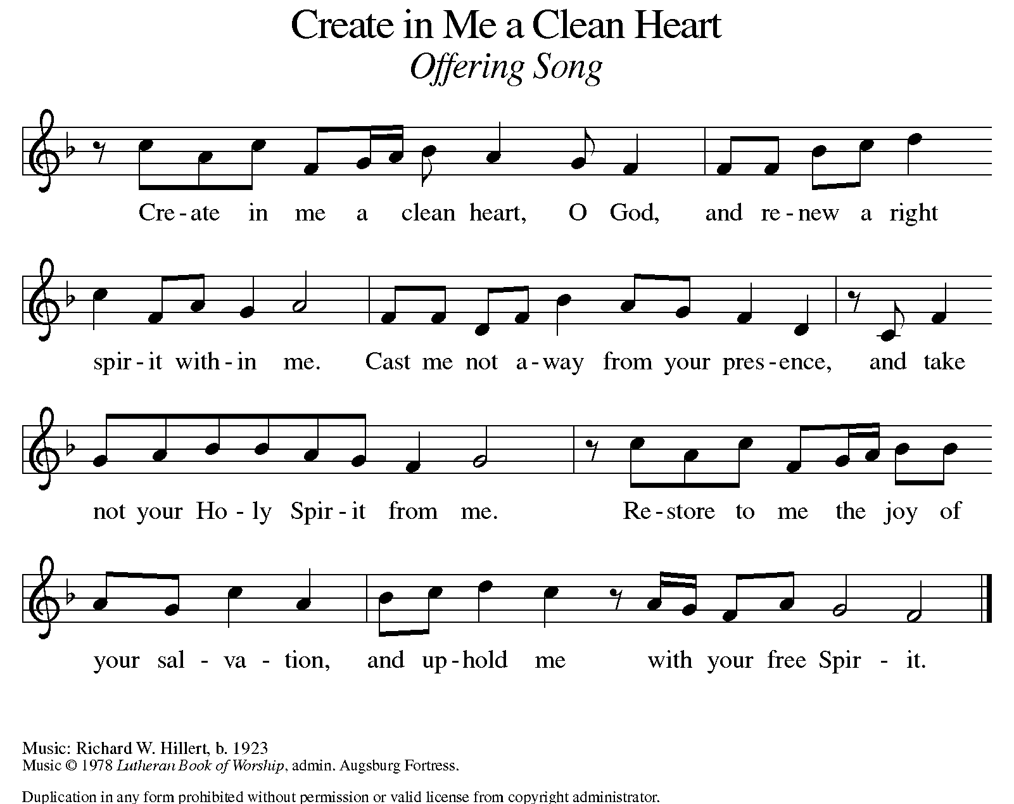
OFFERING PRAYER
A: Let us pray. Risen One, you have gathered us around your table of grace
along with these gifts we bring. Come among us again, breathe your life into us, and enliven us with this meal, that we may live as your risen body in the world.

C: Amen.

THE GREAT THANKSGIVING
P: The Lord be with you.
C: And also with you.
P: Lift up your hearts.
C: We lift them to the Lord.
P: Let us give thanks to the Lord our God.
C: It is right to give our thanks and praise.
PROPER PREFACE
P: It is indeed right, our duty and our joy, that we should at all times and in all places give thanks and praise to you, almighty and merciful God, through our Savior Jesus Christ. Fulfilling the promise of the resurrection, you pour out the fire of your Spirit, uniting in one body people of every nation and tongue. And so, with Mary Magdalene and Peter and all the witnesses of the resurrection, with earth and sea and all their creatures, and with angels and archangels, cherubim and seraphim, we praise your name and join their unending hymn:

HOLY, HOLY ELW Setting 8, Page 190
Holy, holy, holy Lord,
God of pow’r and might,
heaven and earth are full of your glory, full of your glory.
Hosanna, hosanna, hosanna in the highest.
Blessed is he who comes in the name of the Lord.
Hosanna, hosanna, hosanna in the highest.

EUCHARISTIC PRAYER
P: In the night in which he was betrayed, our Lord Jesus took bread, and gave thanks; broke it, and gave it to his disciples, saying:
Take and eat; this is my body, given for you.
Do this for the remembrance of me.
Again, after supper, he took the cup, gave thanks, and gave it for all to drink, saying:
This cup is the new covenant in my blood, shed for you and for all people for the forgiveness of sin. Do this for the remembrance of me.

LORD'S PRAYER
P: Lord, remember us in your kingdom, and teach us to pray:
C: Our Father in heaven, hallowed be your name, your kingdom come, your will be done, on earth as in heaven. Give us today our daily bread. Forgive us our sins as we forgive those who sin against us. Save us from the time of trial and deliver us from evil. For the kingdom, the power, and the glory are yours, now and forever. Amen.

(Please be seated.)

COMMUNION DISTRIBUTION
All who believe in the real presence of Christ in the bread and the wine (juice) are welcome to the table. Others may come forward for a blessing. If you prefer grape juice, please indicate this to the assisting minister.
When approaching the communion rail, come forward down the side aisle; kneel if you are able, starting at the front of the communion rail (spot closest to the font) on your side and filling in toward the altar. After receiving both the bread and the wine, you may return to your seat by the center aisle.

INVITATION TO COMMUNION
P: Come to the table of grace. Receive the gift of new life.

COMMUNION HYMN ELW 472
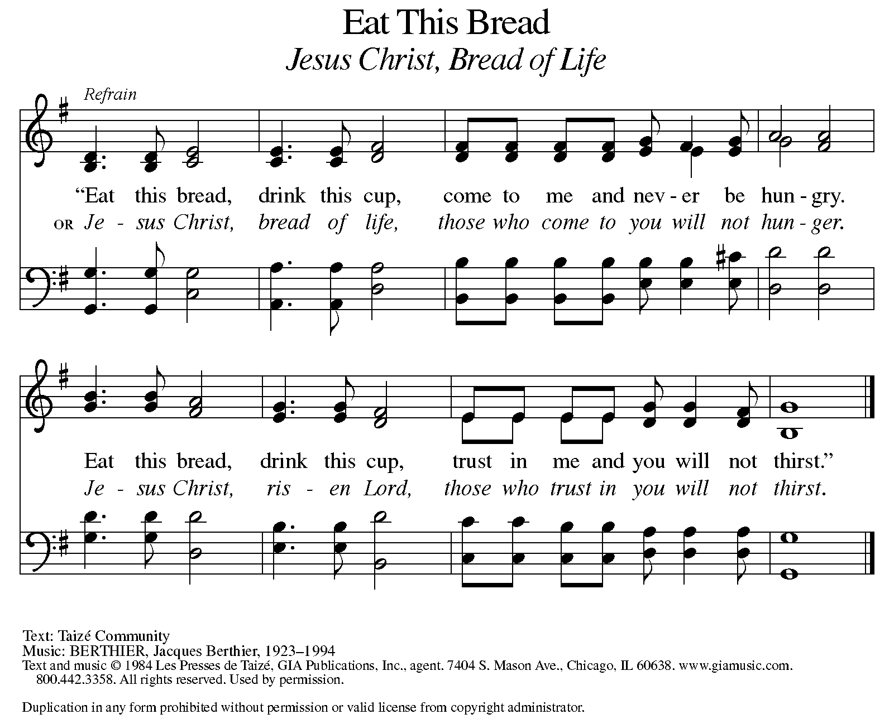
P: The body of Christ, given for you.
C: Amen.
A: The blood of Christ shed for you.
C: Amen.
(Please rise as you are able.)

P: May the body and blood of our Lord Jesus Christ strengthen and keep you in his grace.
C: Amen.

PRAYER AFTER COMMUNION
P: Let us pray. Living One, in this feast you have made yourself known to us. Send us now to tell of your wonders, sing of your glory, and proclaim your risen life to a wounded and weary world.
C: Amen.
SENDING

BLESSING
P: The triune God, who was, who is, and who is to come, Sovereign, ☩ Savior, and Spirit, light your way with resurrection dawn, now and always.
C: Amen.

SENDING HYMN ELW 379
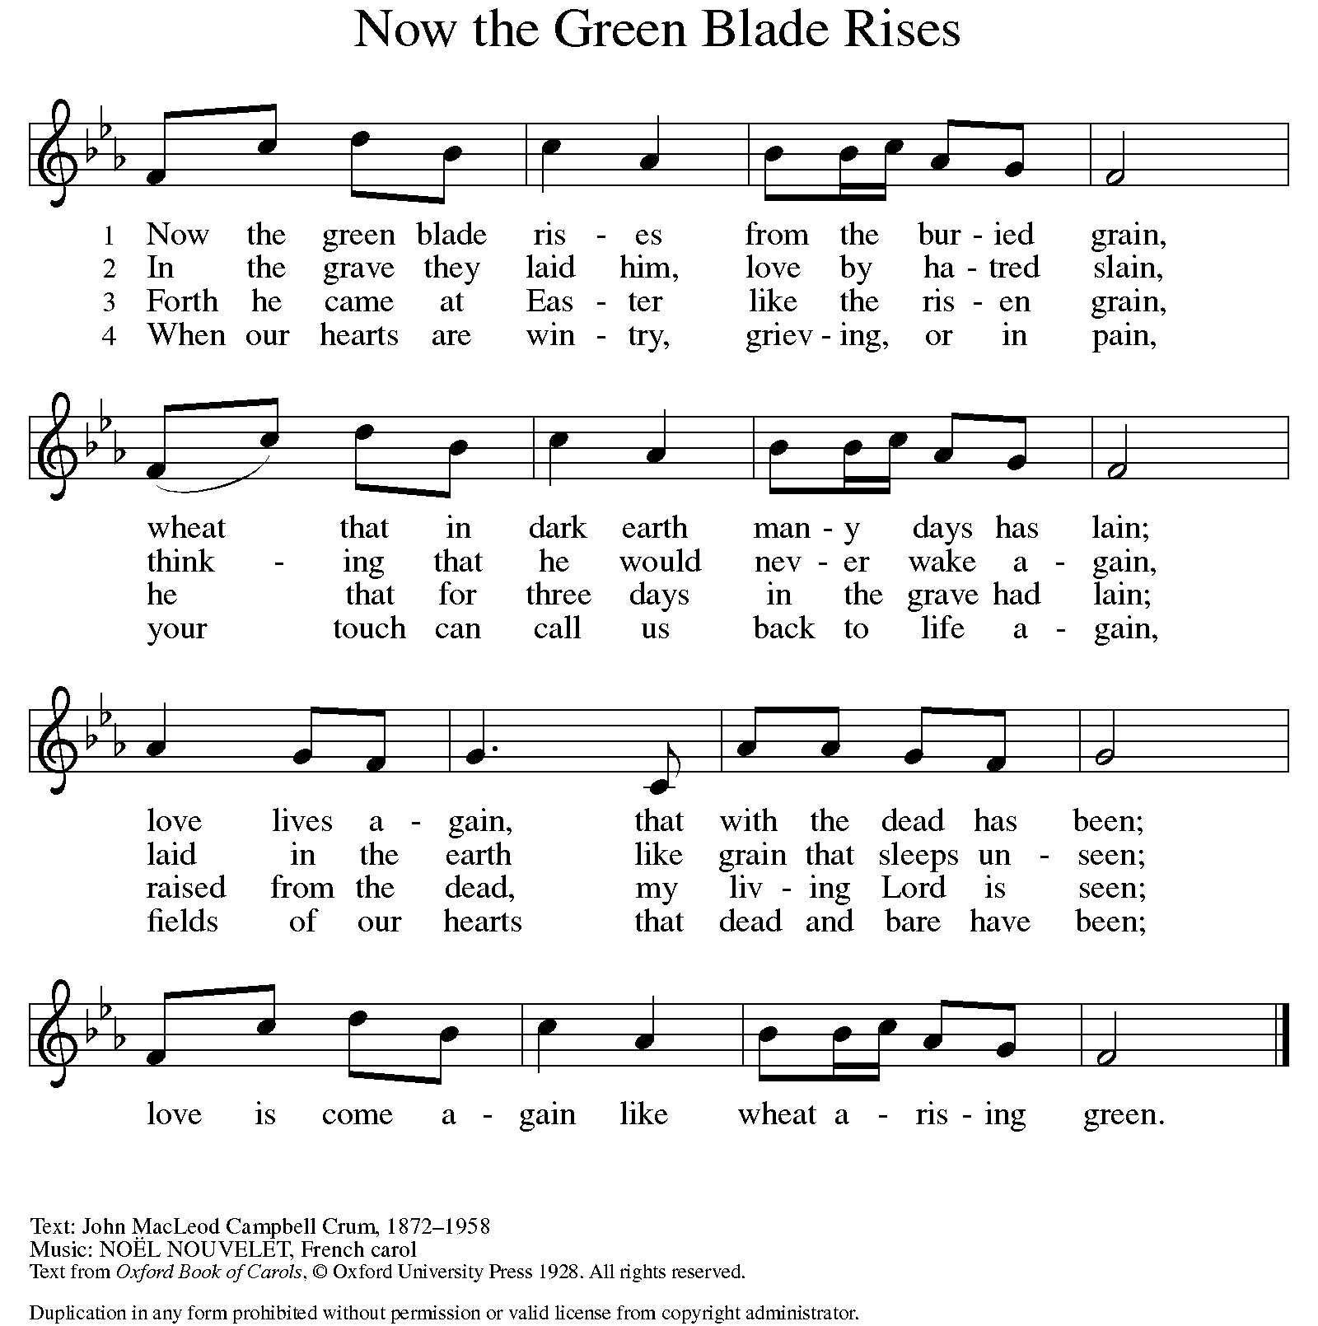

DISMISSAL
A: Alleluia! Christ is risen.
C: Christ is risen indeed. Alleluia!
A: Go in peace. In Christ you are made new. Alleluia! Alleluia!
C: Thanks be to God. Alleluia! Alleluia!

Announcements

- Sunday, June 15 – Father’s Day & celebrating the graduates.
- Saturday, June 21 – Taste of Honduras @ 1-3pm. University Lutheran
Church: 1020 S. Harrison Rd. East Lansing. RSVP: sign-up sheet in the foyer.

Recurring Events

- Every Sunday – Adult Bible Study @ 9am
- Monday, July 7 – Worship Committee Meeting @ 6:30pm
- Wednesday, June 11 – Women’s Bible Study @ 11am
- Thursday, June 19 – Council Meeting @ 7pm

Food Pantry Dates

Thursday, June 12, 1-3pm
Tuesday, June 17, 1:10-3pm
Wednesday, June 18, 5-6:30pm

Volunteers for June 8 Volunteers for June 15

Reader Sunday - Volunteer Reader Sunday – Volunteer
Assisting Minister - Volunteer Assisting Minister – Volunteer

June Birthday Celebrations

6/1 – Charlotte Co.
6/6 – Bob Se.
6/12 – Kathryn Ki.
6/15 – Logan Ro.
6/16 – Steve Op.
6/17 – Ardyth Cl.
6/20 – Charles Mc.

June Anniversary Celebrations

6/24 – Ryan & Jessica Sm.

Acknowledgments
- OneLicense.net, License #A-703165.
- CCLI, License #2281869.
- From SundaysandSeasons.com. Copyright 2022 Augsburg Fortress. All rights reserved. Reprinted by permission under Augsburg Fortress Liturgies Annual License #23806.
- New Revised Standard Version Bible, copyright 1989, Division of Christian Education of the National Council of the Churches of Christ in the United States of America. Used by permission. All rights reserved.

