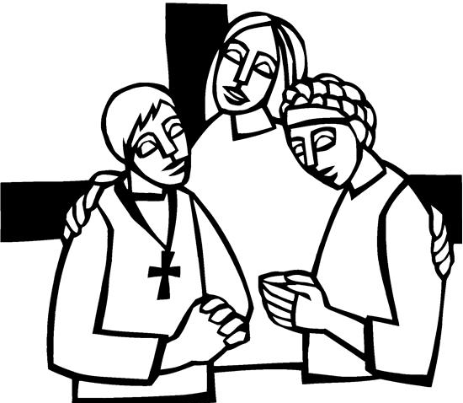

7th Sunday in Easter
June 1, 2025


SAINT PAUL LUTHERAN CHURCH
3383 EAST LAKE LANSING ROAD
EAST LANSING, MI 48823

PHONE (517) 351-8541

Pastor Carl E. Ballard
E-MAIL: pastor@stpaul-el.org
officemanager@stpaul-el.org
Visitors WELCOME! If this is your first time worshipping with us, please sign our guest registry just outside the sanctuary doors. We hope you are blessed through worship today. If you have any questions, please feel free to call the church at 351-8541.
Children are always welcome in worship! The choir room (off the sanctuary) can also be used as a cry room for younger children and includes a sound system so parents may continue to participate in the service. Clipboards with children's bulletins, activities and crayons are available for use during the service.
Sunday School is available during the worship service September-May except the last Sunday of the month.
Virtual Services We can provide a virtual live Zoom session during worship upon request.
This Bulletin is for your use during the service and to take home for the upcoming week. If you choose not to take it home, please place it in the recycle receptacle in the back.
Newsletters and Calendars of Upcoming Events are available in the lobby/narthex. We welcome anyone who has an interest in our small groups or activities! You can also look us up on the web at www.stpaul-el.org.
Contacting Us: Our Office Manager is Emily Polhamus. She can be reached by phone at 517-351-8541 or at her email address, officemanager@stpaul-el.org. Our Director of Music is Elene Kobulashvili. You may leave a message at 517-351-8541. Pastor Carl can be reached at 517-515-3129, and his email address is cballard123@msn.com.
Holy Communion is available at most services. All who believe in the real presence of Christ in the bread and the wine are invited to celebrate Communion with us. Those who wish can come forward for a blessing.
You’re invited to share in fellowship after worship. We would love this opportunity to introduce you to the St. Paul community.

P-Presiding Minister A-Assisting Minister C-Congregation

PRELUDE ELENE

INTRODUCTION

It is possible to hear in Jesus’ high priestly prayer, a prayer he offered shortly before his death, the petitions of the ascended Christ for his own throughout history—to our day—and beyond. Jesus prays for us. In holy baptism we become believers in God, have our robes washed in the flood of Christ’s forgiveness, and receive the gift of life forever with all the saints.

GATHERING

P: The Holy Spirit calls us together as the people of God.

(Please rise as you are able.)

THANKSGIVING FOR BAPTISM

P: Alleluia! Christ is risen.

C: Christ is risen, indeed. Alleluia!

P: In the name of ☩ the One who was, who is, and who is to come.

C: Amen.

P: Baptized into Christ’s death and resurrection, and called to live the baptized life, let us give thanks for the gifts of baptism.

(Silence is kept for reflection.)

P: Holy God, we give you thanks for the waters of baptism, waters that make a people your own, that restore to wholeness, and empower us to be witnesses in your name. Baptized into you, O Living One,

C: make us one as you are one.
P: We give you thanks for the waters of baptism, waters that strengthen believers and give new life to beloved servants of your church; waters that extend your boundless love and cross barriers of our own making. Baptized into you, O Living One,

C: make us one as you are one.

P: We give you thanks for the waters of baptism, waters that open the hearts of believers and give a voice in the night to those in captivity; waters that set your people on a new path, rejoicing in the Spirit’s power. Baptized into you, O Living One,

C: make us one as you are one.

P: Grant us grace, love, and life, O Living One, that our every day is shaped by these waters that give us our very lives in you. We ask this in the name of Jesus, the Crucified and Risen One.

C: Amen.

GATHERING SONG ELW 855
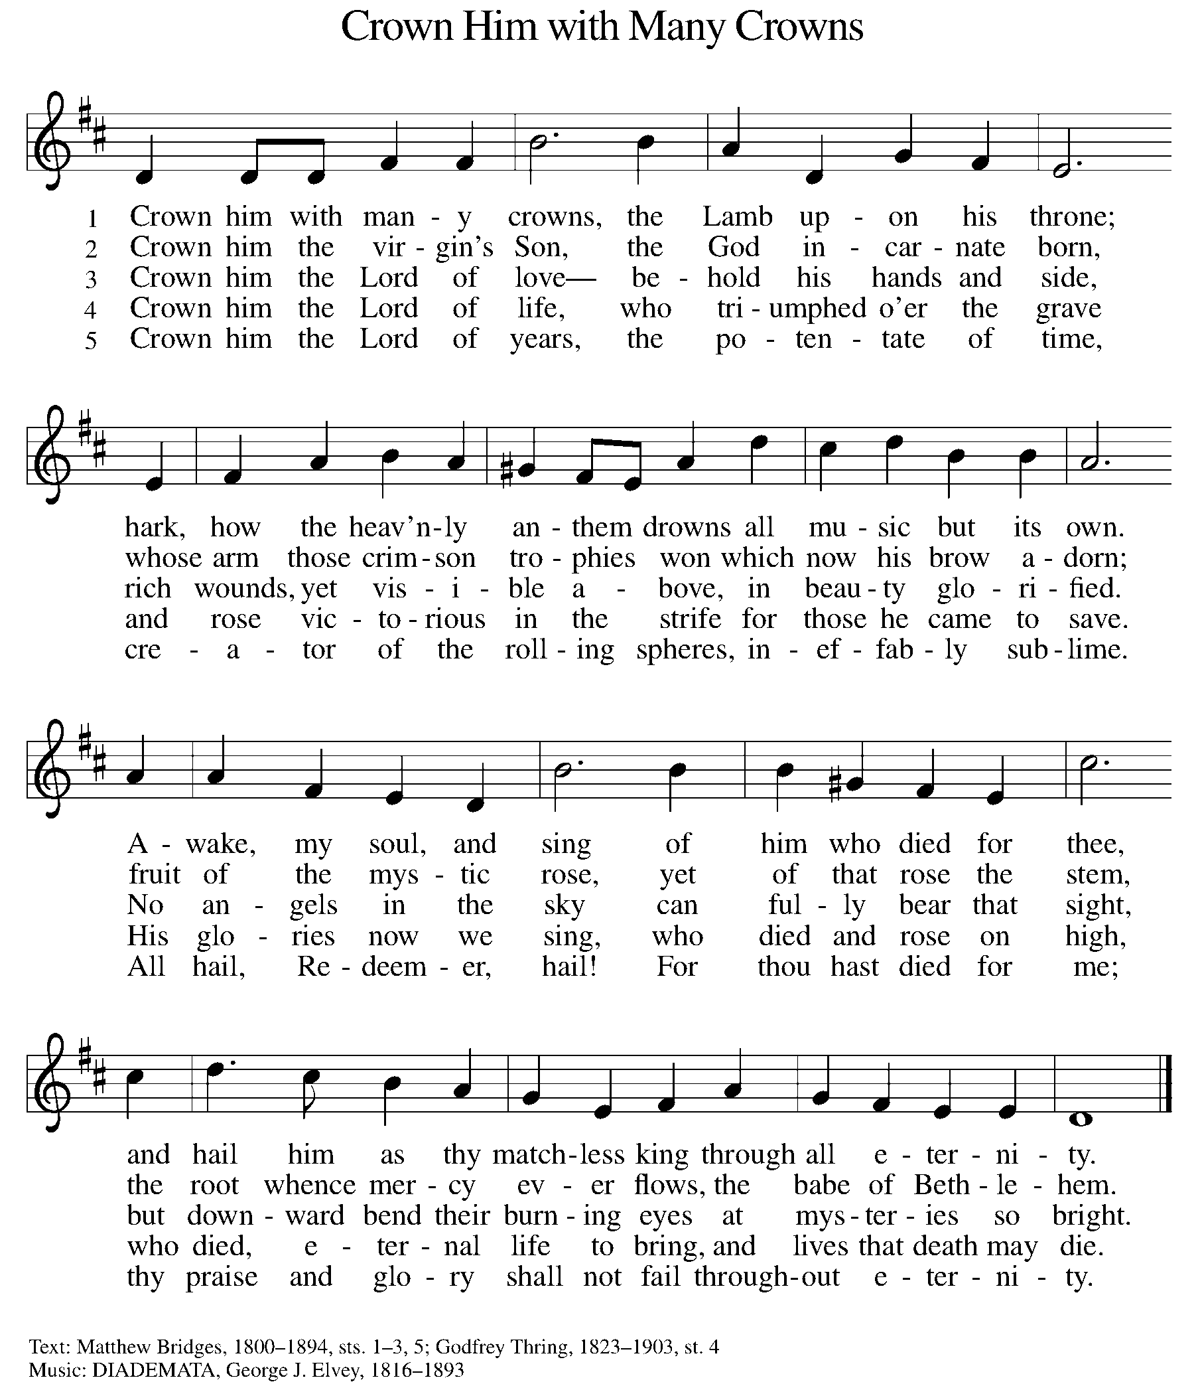

GREETING

P: The grace of our Lord Jesus Christ, the love of God, and the communion of the Holy Spirit be with you all.

C: And also with you.
KYRIE ELW Setting 10, Page 203

Have mercy on us, Lord,
and hear our solemn prayer.
We come to hear your living word;
it saves us from despair.

Have mercy on us, Christ,
and wash away our sin.
Pour out your grace and make us whole
that new life may begin.

Have mercy on us, Lord;
make sin and shame depart.
Renew us with your saving pow’r;
create in us new hearts!

CANTICLE OF PRAISE ELW Setting 4, Page 149-150

This is the feast of victory for our God. Alleluia.

Worthy is Christ, the Lamb who was slain,
whose blood set us free to be people of God.
Power and riches and wisdom and strength,
and honor and blessing and glory are his.
This is the feast of victory for our God. Alleluia.

Sing with all the people of God
and join in the hymn of all creation:
Blessing and honor and glory and might
be to God and the Lamb forever. Amen.
This is the feast of victory for our God,
for the Lamb who was slain has begun his reign.
Alleluia. Alleluia.

PRAYER OF THE DAY

P: Let us pray. O God, form the minds of your faithful people into your one will. Make us love what you command and desire what you promise, that, amid all the changes of this world, our hearts may be fixed where true joy is found, your Son, Jesus Christ our Lord, who lives and reigns with you and the Holy Spirit, one God, now and forever.

C: Amen.

(Please be seated.)

CHILDREN’S MESSAGE

(Children are invited to Sunday School.)

TRANSITION SONG ELW 509
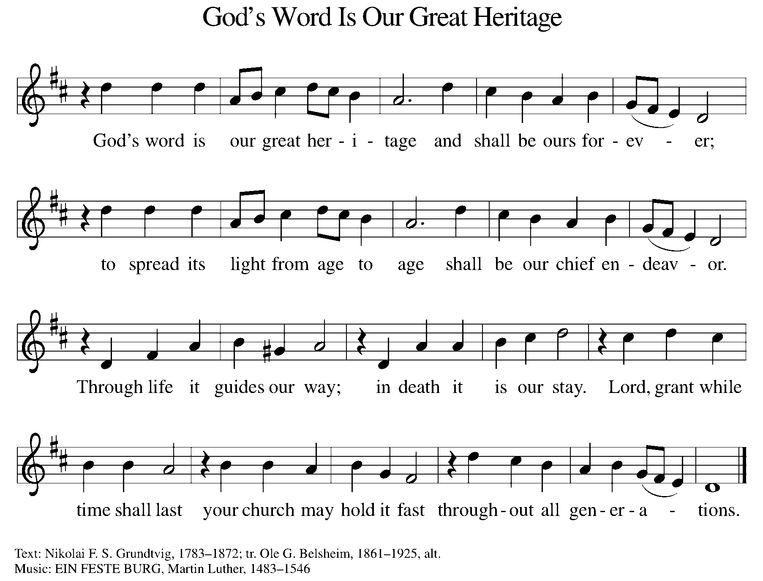

WORD

P: God speaks to us in scripture, preaching, and song.

FIRST READING ACTS 16:16-34

Those who had enslaved a girl and used her powers to tell fortunes threw Paul and Silas into jail for ordering the spirit to come out of her and consequently ruining their business. In prison, Paul and Silas bring the good news of the gospel to the jailer and his family.

¹⁶ One day as we were going to the place of prayer, we met a female slave who had a spirit of divination and brought her owners a great deal of money by fortune-telling. ¹⁷ While she followed Paul and us, she would cry out, “These men are slaves of the Most High God, who proclaim to you the way of salvation.” ¹⁸ She kept doing this for many days. But Paul, very much annoyed, turned and said to the spirit, “I order you in the name of Jesus Christ to come out of her.” And it came out that very hour.

¹⁹ But when her owners saw that their hope of making money was gone, they seized Paul and Silas and dragged them into the marketplace before the authorities. ²⁰ When they had brought them before the magistrates, they said, “These men, these Jews, are disturbing our city ²¹ and are advocating customs that are not lawful for us, being Romans, to adopt or observe.” ²² The crowd joined in attacking them, and the magistrates had them stripped of their clothing and ordered them to be beaten with rods. ²³ After they had given them a severe flogging, they threw them into prison and ordered the jailer to keep them securely. ²⁴ Following these instructions, he put them in the innermost cell and fastened their feet in the stocks.

²⁵ About midnight Paul and Silas were praying and singing hymns to God, and the prisoners were listening to them. ²⁶ Suddenly there was an earthquake so violent that the foundations of the prison were shaken, and immediately all the doors were opened and everyone’s chains were unfastened. ²⁷ When the jailer woke up and saw the prison doors wide open, he drew his sword and was about to kill himself, since he supposed that the prisoners had escaped. ²⁸ But Paul shouted in a loud voice, “Do not harm yourself, for we are all here.” ²⁹ The jailer called for lights, and rushing in, he fell down trembling before Paul and Silas. ³⁰ Then he brought them outside and said, “Sirs, what must I do to be saved?”

³¹ They answered, “Believe in the Lord Jesus, and you will be saved, you and your household.” ³² They spoke the word of the Lord to him and to all who were in his house. ³³ At the same hour of the night he took them and washed their wounds; then he and his entire family were baptized without delay. ³⁴ He brought them up into the house and set food before them, and he and his entire household rejoiced that he had become a believer in God.

Reader: Word of God, word of life. C: Thanks be to God.
PSALM PSALM 97

Rejoice in the Lord, you righteous. (Ps. 97:12)

¹The Lord reigns; let the earth rejoice; let the multitude of the isles be glad.
²Clouds and darkness surround the Lord, righteousness and justice are the foundations of God’s throne.
³Fire goes before the Lord, burning up enemies on every side.
⁴Lightings light up the world; the earth sees and trembles.
⁵The mountains melt like wax before the Lord of all the earth.
⁶The heavens declare your righteousness, O Lord, and all the peoples see your glory.
⁷Confounded be all who worship carved images and delight in false gods! Bow down before the Lord, all you gods.
⁸Zion hears and is glad, and the cities of Judah rejoice, because of your judgments, O Lord.
⁹For you are the Lord, most high over all the earth; you are exalted far above all gods.
¹⁰You who love the Lord, hate evil! God guards the lives of the saints and rescues them from the hand of the wicked.
¹¹Light dawns for the righteous, and joy for the honest of heart.
¹²Rejoice in the Lord, you righteous, and give thanks to God’s holy name.

SECOND READING REVELATION 22:12-14, 16-17, 20-21

The ascended Christ, hidden from our sight, promises to come again. We eagerly pray, “Come, Lord Jesus,” with all who respond to this invitation.

¹² “See, I am coming soon; my reward is with me, to repay according to everyone’s work. ¹³ I am the Alpha and the Omega, the First and the Last, the Beginning and the End.” ¹⁴ Blessed are those who wash their robes, so that they will have the right to the tree of life and may enter the city by the gates.

¹⁶ “It is I, Jesus, who sent my angel to you with this testimony for the churches. I am the root and the descendant of David, the bright morning star.” ¹⁷ The Spirit and the bride say, “Come.” And let everyone who hears say, “Come.” And let everyone who is thirsty come. Let anyone who wishes take the water of life as a gift.

²⁰ The one who testifies to these things says, “Surely I am coming soon.” Amen. Come, Lord Jesus! ²¹ The grace of the Lord Jesus be with all the saints. Amen.

Reader: Word of God, word of life. C: Thanks be to God.

(Please rise as you are able.)

GOSPEL ACCLAMATION ELW SETTING 10, PAGE 205

Alleluia! Lord and Savior: open now your saving word.
Let it burn like fire within us; speak until our hearts are stirred.
Alleluia! Lord, we sing for the good news that you bring.

GOSPEL JOHN 17:20-26

P: The Holy Gospel according to John, the 17th chapter.

C: Glory to you, O Lord.

Jesus prays that the life of his followers will be characterized by an intimate unity of identity with God. To be so identified with God means also to share in God’s mission: to proclaim the word that will bring others into this same unity.

[Jesus prayed:] ²⁰ “I ask not only on behalf of these but also on behalf of those who believe in me through their word, ²¹ that they may all be one. As you, Father, are in me and I am in you, may they also be in us, so that the world may believe that you have sent me. ²² The glory that you have given me I have given them, so that they may be one, as we are one, ²³ I in them and you in me, that they may become completely one, so that the world may know that you have sent me and have loved them even as you have loved me. ²⁴ Father, I desire that those also, whom you have given me, may be with me where I am, to see my glory, which you have given me because you loved me before the foundation of the world. ²⁵ “Righteous Father, the world does not know you, but I know you, and these know that you have sent me. ²⁶ I made your name known to them, and I will make it known, so that the love with which you have loved me may be in them and I in them.”

P: The Gospel of the Lord. C: Praise to you, O Christ.

(Please be seated.)

SERMON PASTOR CARL BALLARD
(Please rise as you are able.)

HYMN OF THE DAY ELW 655
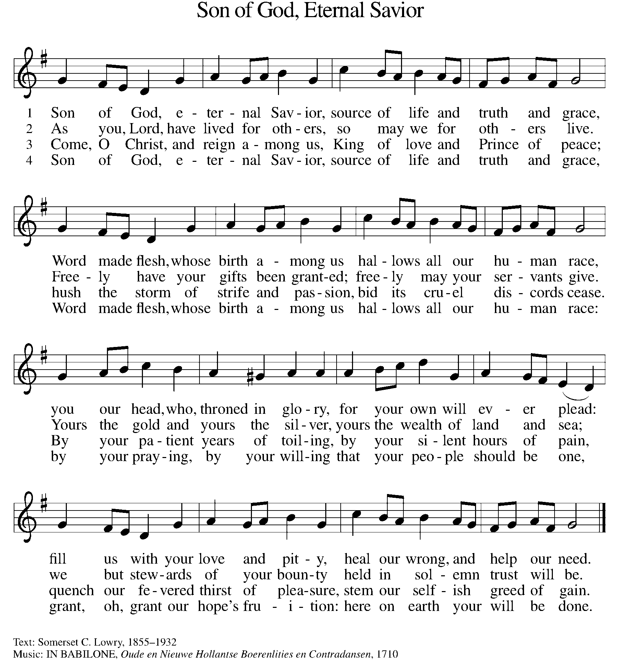

NICENE CREED

We believe in one God,
the Father, the Almighty,
maker of heaven and earth,
of all that is, seen and unseen.
We believe in one Lord, Jesus Christ,
the only Son of God,
eternally begotten of the Father,
God from God, Light from Light,
true God from true God,
begotten, not made,
of one Being with the Father;
through him all things were made.
For us and for our salvation
he came down from heaven,
was incarnate of the Holy Spirit and the virgin Mary
and became truly human.
For our sake he was crucified under Pontius Pilate;
he suffered death and was buried.
On the third day he rose again
in accordance with the scriptures;
he ascended into heaven
and is seated at the right hand of the Father.
He will come again in glory to judge the living and the dead,
and his kingdom will have no end.

We believe in the Holy Spirit, the Lord, the giver of life.
who proceeds from the Father and the Son,
who with the Father and the Son is worshiped and glorified,
who has spoken through the prophets.
We believe in one holy catholic and apostolic church.
We acknowledge one baptism for the forgiveness of sins.
We look for the resurrection of the dead,
and the life of the world to come. Amen.

(Please be seated.)

THE PRAYERS

A: God of resurrection and new life, we come before you in prayer for the church, the world, and all who are in need.
(A brief silence.)
A: Welcoming God, you invite all people to come and encounter your love. Give your church open hearts and minds to embrace all who seek your presence. Increase the capacity for cooperation between denominations and congregations. Hear us, O God.

C: Your mercy is great.
A: Creating God, your might is seen in storms and in silence. Where drought threatens, bring rain. Where waters flood, ease them back. Where fire, earthquake, hurricane, or tornado destroy, shelter your people and restore your land. Hear us, O God.

C: Your mercy is great.

A: Discerning God, fill the hearts of leaders with your passion for justice and mercy. Call the nations of this world to tables of peace and collaboration. Encourage governments to seek avenues of collective benefit and joy. Hear us, O God.

C: Your mercy is great.

A: Abiding God, all people are held in your care. Accompany survivors of abuse, trauma, and exploitation. Strengthen our resolve to listen and advocate on behalf of all who are unnoticed. Hear our prayers for those close to our heart. Hear us, O God.

C: Your mercy is great.

A: Rejoicing God, be with this congregation as summer begins in the northern hemisphere. Keep travelers safe. Keep the vulnerable cool. Invigorate summer ministry efforts in our community, and support the well-being of children and young people. Hear us, O God.

C: Your mercy is great.

A: Shielding God, guard and give courage to those who serve in our armed forces, especially Beth & Ryan, Jonathan, Jacob, Noah, Irene, and Alex. Hear us, O God.

C: Your mercy is great.

A: Healing God, grant wholeness to all in need of care: those mourning losses, enduring trauma, experiencing broken relationships, yearning for companionship, or facing illness, especially Ahren, Allen, Beth Ra., B.J., Carolyn, Dan, David, Don, Doretta, Friends & Family of Glen, Gage, Gunny, Jim & Cheri, John, Johnny, Jon, Jordan, Lawton, Lera & family, Linda, Lizzy, Marge, Patty, Randy, Rick & Kathy, Sheri, Sheri, Stacy, Steve, Susan, Wanda, and all whom we name now aloud and in our hearts. Hear us, O God.

C: Your mercy is great.

A: Guiding God, bless our church’s leaders with discernment and compassion. We pray especially for Presiding Bishop Julie, our Synod Bishop Craig, and Pastor Carl. We ask that you be with their respective staffs as they live out their callings to serve. As we are called to be one, even as Jesus and the Father are one, be with the leaders and the congregation of Settlement Lutheran Church in Gowen and all the churches in our community. Hear us, O God.

C: Your mercy is great.

A: Loving God, the beginning and the end, you are with us throughout our lives. In gratitude for the saints who have died. We look toward your coming again among us. Hear us, O God.

C: Your mercy is great.

P: We commend these and all our prayers to you, O God, trusting that you are always with us; in the name of Jesus Christ, our risen Savior.

C: Amen.

GREETING OF PEACE

P: The peace of Christ be with you always.

C: And also with you.

(You are invited to share Christ’s peace with one another.)

(Please be seated.)

MEAL

OFFERING ELENE
OFFERTORY ELW 186
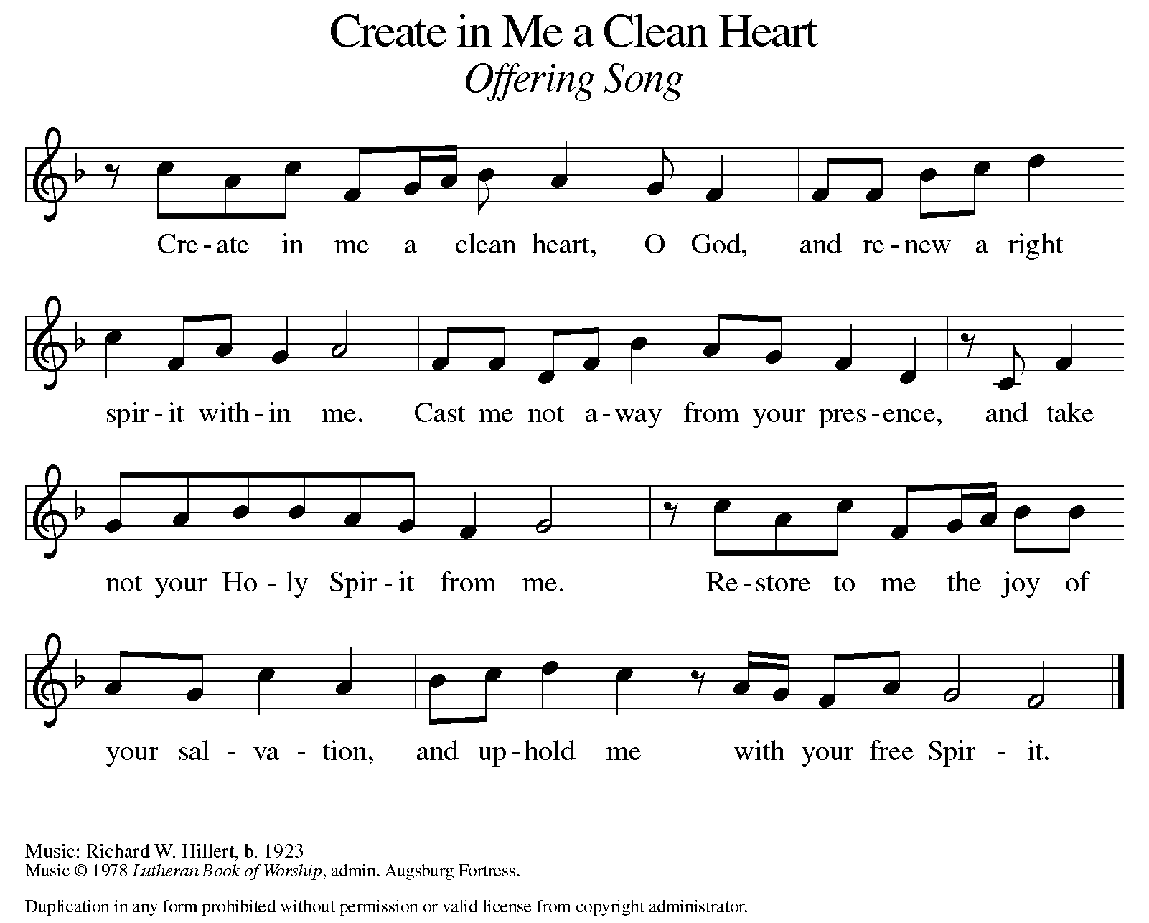

OFFERING PRAYER

A: Let us pray. Risen One, you have gathered us around your table of grace along with these gifts we bring. Come among us again, breathe your life into us, and enliven us with this meal, that we may live as your risen body in the world.

C: Amen.

THE GREAT THANKSGIVING

P: The Lord be with you.
C: And also with you.
P: Lift up your hearts.
C: We lift them to the Lord.
P: Let us give thanks to the Lord our God.
C: It is right to give our thanks and praise.

PROPER PREFACE

P: It is indeed right, our duty and our joy, that we should at all times and in all places give thanks and praise to you, almighty and merciful God, for the glorious resurrection of our Savior Jesus Christ, the true Paschal Lamb who gave himself to take away our sin; who in dying has destroyed death, and in rising has brought us to eternal life. And so, with Mary Magdalene and Peter and all the witnesses of the resurrection, with earth and sea and all their creatures, and with angels and archangels, cherubim and seraphim, we praise your name and join their unending hymn:

HOLY, HOLY ELW SETTING 10, Page 207

Holy, holy, holy Lord,
God of power and might,
heav’n and earth are full of your glory.
Hosanna in the highest.
Blessed is he who comes in the name of the Lord.
Hosanna in the highest,
hosanna in the highest.

EUCHARISTIC PRAYER

P: In the night in which he was betrayed, our Lord Jesus took bread, and gave thanks; broke it, and gave it to his disciples, saying:
Take and eat; this is my body, given for you. Do this for the remembrance of me.
Again, after supper, he took the cup, gave thanks, and gave it for all to drink, saying:
This cup is the new covenant in my blood, shed for you and for all people for the forgiveness of sin. Do this for the remembrance of me.

LORD'S PRAYER

P: Lord, remember us in your kingdom, and teach us to pray:

C: Our Father, who art in heaven, hallowed be thy name, thy kingdom come, thy will be done, on earth as it is in heaven. Give us this day our daily bread; and forgive us our trespasses, as we forgive those who trespass against us; and lead us not into temptation, but deliver us from evil. For thine is the kingdom, and the power, and the glory, forever and ever. Amen.

COMMUNION DISTRIBUTION

All who believe in the real presence of Christ in the bread and the wine (juice) are welcome to the table. Others may come forward for a blessing. If you prefer grape juice, please indicate this to the assisting minister.

When approaching the communion rail, come forward down the side aisle, kneel, if you are able, starting at the front of the communion rail (spot closest to the font) on your side and filling in toward the altar. After receiving both the bread and the wine, you may return to your seat by the center aisle.

INVITATION TO COMMUNION

P: Come to the table of grace. Receive the gift of new life.

COMMUNION HYMN ELW 472
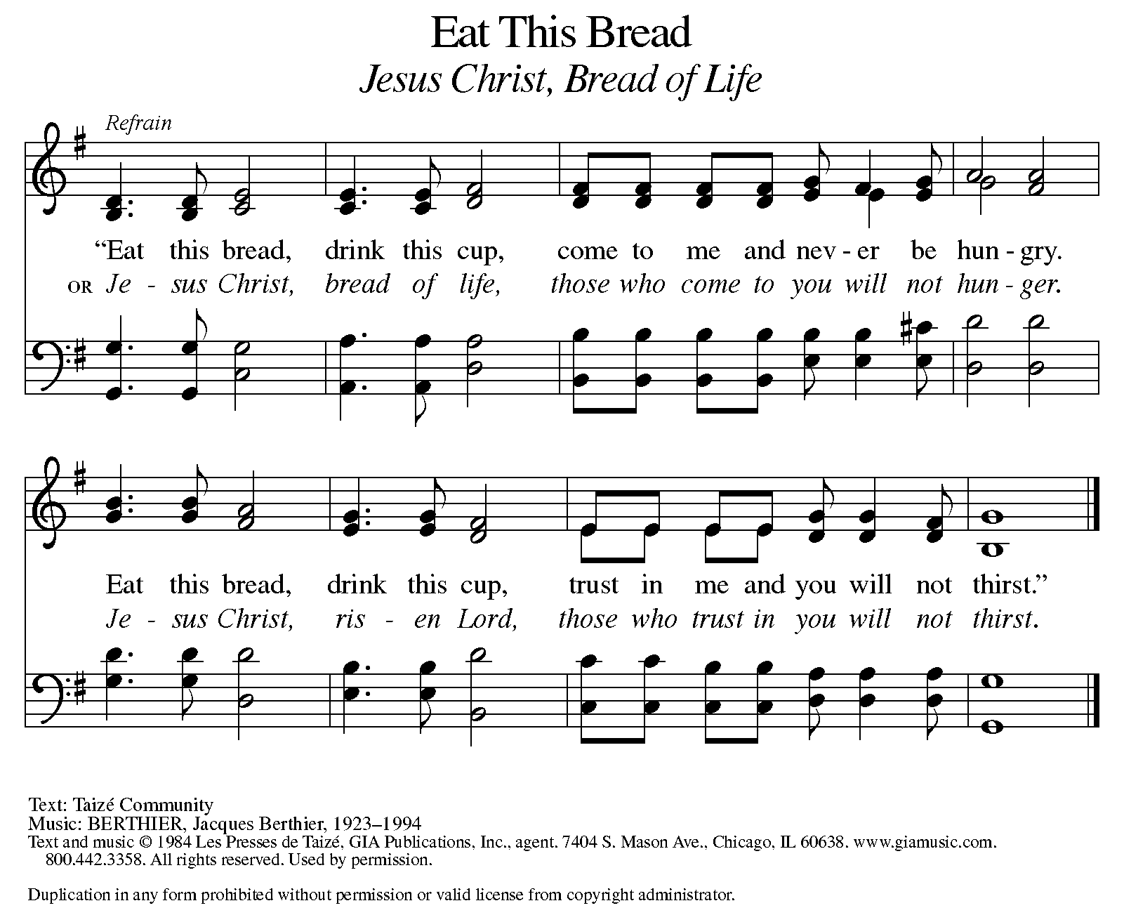

P: The body of Christ, given for you.

C: Amen.

A: The blood of Christ, shed for you.

C: Amen.
(Please rise as you are able.)

P: May the body and blood of our Lord Jesus Christ strengthen and keep you in his grace.

C: Amen.

PRAYER AFTER COMMUNION

P: Let us pray. Living One, in this feast you have made yourself known to us. Send us now to tell of your wonders, sing of your glory, and proclaim your risen life to a wounded and weary world.

C: Amen.

SENDING

BLESSING

P: The triune God, who was, who is, and who is to come, Sovereign, ☩ Savior, and Spirit, light your way with resurrection dawn, now and always.

C: Amen.

SENDING HYMN ELW 654
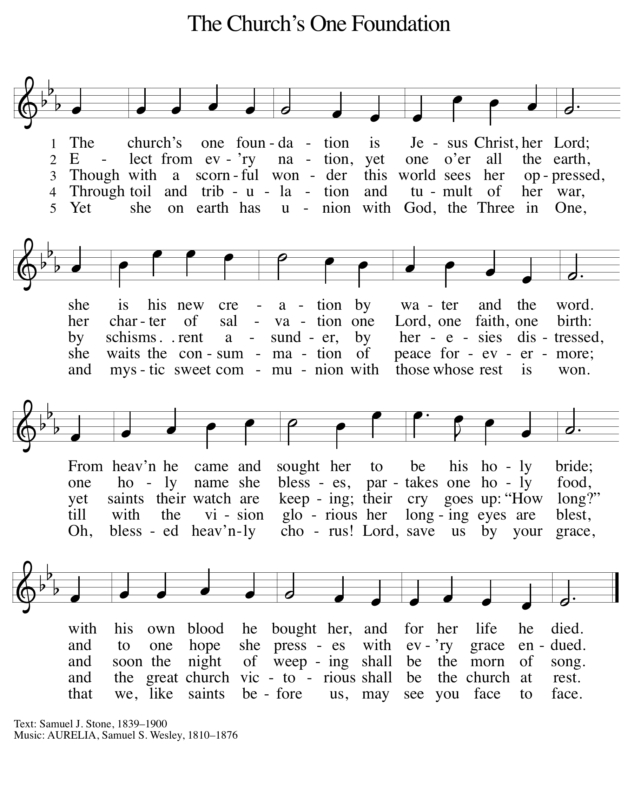

DISMISSAL

A: Alleluia! Christ is risen.
C: Christ is risen indeed. Alleluia!
A: Go in peace. In Christ you are made new. Alleluia! Alleluia!
C: Thanks be to God. Alleluia! Alleluia!

Announcements

We welcome Rev. Julie Schneider-Thomas as our newly elected Bishop. She begins her journey of term on September 1st, 2025.

- Sunday, June 8 – Remember to wear Red for Pentecost.
- Sunday, June 15 – Father’s Day & Celebrating Graduates.
- Saturday, June 21 – Taste of Honduras @ 1-3pm. University Lutheran
Church: 1020 S. Harrison Rd. East Lansing. RSVP: sign-up sheet in the foyer.

Recurring Events

- Every Sunday – Adult Bible Study @ 9am
- Monday, June 2 – Worship Committee Meeting @ 6:30pm
- Wednesday, June 11 – Women’s Bible Study @ 11am
- Thursday, June 19 – Council Meeting @ 7pm

Food Pantry Dates

Wednesday, June 4, 5-6:30pm
Thursday, June 12, 1-3pm
Tuesday, June 17, 1:10-3pm
Wednesday, June 18, 5-6:30pm

Volunteers for June 1 Volunteers for June 8

Reader Sunday – Volunteer Reader Sunday – Volunteer
Assisting Minister – Volunteer Assisting Minister – Volunteer

June Birthday Celebrations

6/1 – Charlotte Co.
6/6 – Bob Se.
6/12 – Kathryn Ki.
6/15 – Logan Ro.
6/16 – Steve Op.
6/17 – Ardyth Cl.
6/20 – Charles Mc.
June Anniversary Celebrations

6/24 – Ryan & Jessica Sm.

Acknowledgments
- OneLicense.net, License #A-703165. CCLI, License #2281869.
- From SundaysandSeasons.com. Copyright 2020 Augsburg Fortress. All rights reserved. Reprinted by permission under Augsburg Fortress Liturgies Annual License #23806.
- New Revised Standard Version Bible, copyright 1989, Division of Christian Education of the National Council of the Churches of Christ in the United States of America. Used by permission. All rights reserved.

