

6th Sunday in Easter
May 25, 2025

SAINT PAUL LUTHERAN CHURCH
3383 EAST LAKE LANSING ROAD
EAST LANSING, MI 48823

PHONE (517) 351-8541

Pastor Carl E. Ballard
E-MAIL: pastor@stpaul-el.org
officemanager@stpaul-el.org

Visitors WELCOME! If this is your first time worshipping with us, please sign our guest registry just outside the sanctuary doors. We hope you are blessed through worship today. If you have any questions, please feel free to call the church at 351-8541.
Children are always welcome in worship! The choir room (off the sanctuary) can also be used as a cry room for younger children and includes a sound system so parents may continue to participate in the service. Clipboards with children's bulletins, activities and crayons are available for use during the service.
Sunday School is available during the worship service September-May except the last Sunday of the month.
Virtual Services We can provide a virtual live Zoom session during worship upon request.
This Bulletin is for your use during the service and to take home for the upcoming week. If you choose not to take it home, please place it in the recycle receptacle in the back.
Newsletters and Calendars of Upcoming Events are available in the lobby/narthex. We welcome anyone who has an interest in our small groups or activities! You can also look us up on the web at www.stpaul-el.org.
Contacting Us: Our Office Manager is Emily Polhamus. She can be reached by phone at 517-351-8541 or at her email address, officemanager@stpaul-el.org. Our Director of Music is Elene Kobulashvili. You may leave a message at 517-351-8541. Pastor Carl can be reached at 517-515-3129, and his email address is cballard123@msn.com.
Holy Communion is available at most services. All who believe in the real presence of Christ in the bread and the wine are invited to celebrate Communion with us. Those who wish may come forward for a blessing.
You’re invited to share in fellowship after worship. We would love this opportunity to introduce you to the St. Paul community.

P-Presiding Minister A-Assisting Minister C-Congregation
PRELUDE ELENE

INTRODUCTION
Visions abound in the readings for the sixth Sunday of Easter. Paul has a vision about what to do. John has a vision of what will be. Jesus provides visions of peace that surpasses human understanding and power beyond human imagination.

GATHERING
P: The Holy Spirit calls us together as the people of God.

(Please rise as you are able.)

THANKSGIVING FOR BAPTISM
P: Alleluia! Christ is risen.
C: Christ is risen, indeed. Alleluia!
P: In the name of ☩ the One who was, who is, and who is to come.
C: Amen.
P: Baptized into Christ’s death and resurrection, and called to live the baptized life, let us give thanks for the gifts of baptism. Holy God, we give you thanks for the waters of baptism, waters that make a people your own, that restore to wholeness, and empower us to be witnesses in your name. Baptized into you, O Living One,
C: make us one as you are one.
P: We give you thanks for the waters of baptism, waters that strengthen believers and give new life to beloved servants of your church; waters that extend your boundless love and cross barriers of our own making. Baptized into you, O Living One,
C: make us one as you are one.
P: We give you thanks for the waters of baptism, waters that open the hearts of believers and give a voice in the night to those in captivity; waters that set your people on a new path, rejoicing in the Spirit’s power. Baptized into you, O Living One,
C: make us one as you are one.
P: Grant us grace, love, and life, O Living One, that our every day is shaped by these waters that give us our very lives in you. We ask this in the name of Jesus, the Crucified and Risen One.
C: Amen.

GATHERING SONG ELW 593
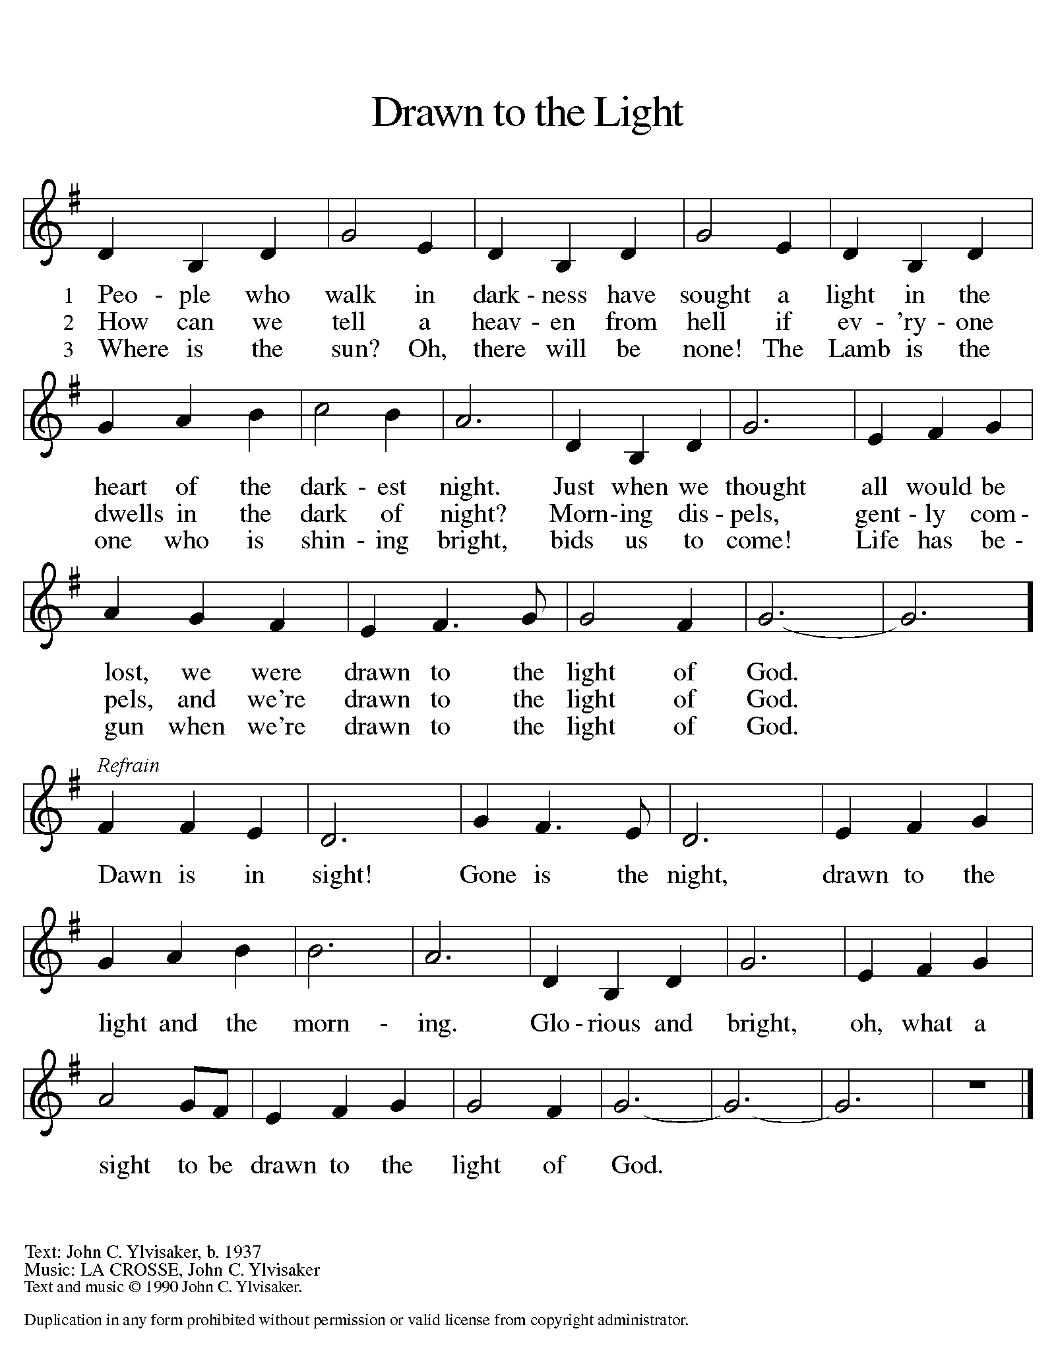

GREETING
P: The grace of our Lord Jesus Christ, the love of God, and the communion of the Holy Spirit be with you all.
C: And also with you.
KYRIE ELW Setting 8, Page 184-185
REFRAIN
Kyrie eleison, on our world and on our way.
Kyrie eleison, ev'ry day.

For peace in the world, for the health of the church,
for the unity of all;
for this holy house, for all who worship and praise,
let us pray to the Lord, let us pray to the Lord. Refrain

That we may live out your impassioned response
to the hungry and the poor;
that we may live out truth and justice and grace,
let us pray to the Lord, let us pray to the Lord. Refrain

For peace in our hearts, for peace in our homes,
for friends and family;
for life and for love, for our work and our play,
let us pray to the Lord, let us pray to the Lord. Refrain

For your Spirit to guide;
that you center our lives in the water and the Word;
that you nourish our souls with your body and blood,
let us pray to the Lord, let us pray to the Lord. Refrain

CANTICLE OF PRAISE ELW Setting 4, Page 149-150

This is the feast of victory for our God. Alleluia.

Worthy is Christ, the Lamb who was slain,
whose blood set us free to be people of God.
Power and riches and wisdom and strength,
and honor and blessing and glory are his.
This is the feast of victory for our God. Alleluia.
Sing with all the people of God
and join in the hymn of all creation:
Blessing and honor and glory and might
be to God and the Lamb forever. Amen.
This is the feast of victory for our God,
for the Lamb who was slain has begun his reign.
Alleluia. Alleluia.

PRAYER OF THE DAY

P: Let us pray. Bountiful God, you gather your people into your realm, and you promise us food from your tree of life. Nourish us with your word, that empowered by your Spirit we may love one another and the world you have made, through Jesus Christ, our Savior and Lord, who lives and reigns with you and the Holy Spirit, one God, now and forever.

C: Amen.
(Please be seated.)

CHILDREN’S MESSAGE/NOISY OFFERING

(Children may return to their seats.)

TRANSITION SONG ELW 595
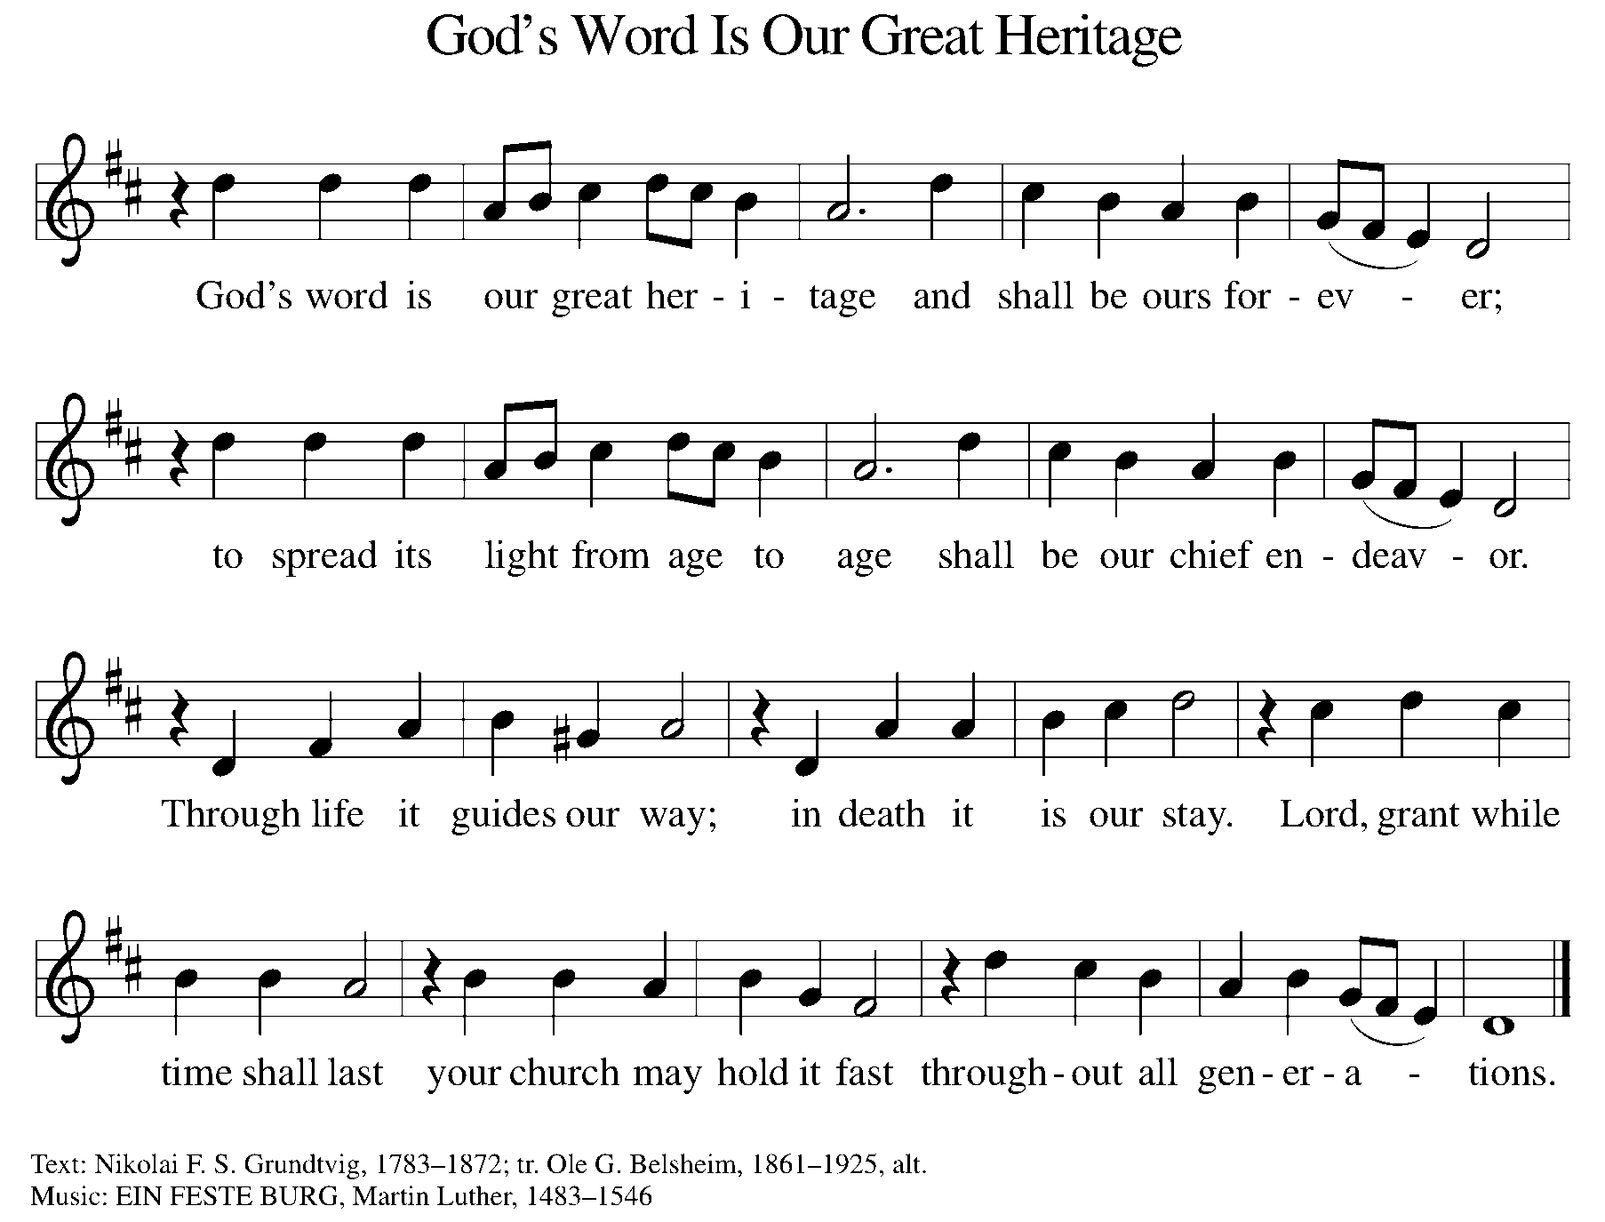
WORD
P: God speaks to us in scripture, preaching, and song.

First Reading ACTS 16:9-15
A vision compels Paul to move his ministry into Greece. There he meets Lydia, an important person in the business community, whose heart has been opened by God to receive the gospel. Her conversion and baptism provide the impetus for the founding of the church at Philippi.

⁹ During the night Paul had a vision: there stood a man of Macedonia pleading with him and saying, “Come over to Macedonia and help us.” ¹⁰ When he had seen the vision, we immediately tried to cross over to Macedonia, being convinced that God had called us to proclaim the good news to them. ¹¹ We therefore set sail from Troas and took a straight course to Samothrace, the following day to Neapolis, ¹² and from there to Philippi, which is a leading city of the district of Macedonia and a Roman colony. We remained in this city for some days.

¹³ On the Sabbath day we went outside the gate by the river, where we supposed there was a place of prayer, and we sat down and spoke to the women who had gathered there. ¹⁴ A certain woman named Lydia, a worshiper of God, was listening to us; she was from the city of Thyatira and a dealer in purple cloth. The Lord opened her heart to listen eagerly to what was said by Paul. ¹⁵ When she and her household were baptized, she urged us, saying, “If you have judged me to be faithful to the Lord, come and stay at my home.” And she prevailed upon us.
Reader: Word of God, word of life. C: Thanks be to God.

PSALM PSALM 67
Let the nations be glad and sing for joy. (Ps. 67:4)

¹May God be merciful to us and bless us; may the light of God’s face shine upon us.
²Let your way be known upon earth, your saving health among all nations.
³Let the peoples praise you, O God; let all the peoples praise you.
⁴Let the nations be glad and sing for joy, for you judge the peoples with equity and guide all the nations on earth.
⁵Let the peoples praise you, O God; let all the peoples praise you.
⁶The earth has brought forth its increase, God, our own God, has blessed us.
⁷May God give us blessing, and may all the ends of the earth stand in awe.
SECOND READING REVELATION 21:10, 22-22:5
John’s vision of a new Jerusalem coming out of heaven provides continuity with God’s past actions. Yet in this new city, God’s presence replaces the temple, and the glory of God and the Lamb supplants sun and moon.

¹⁰ And in the spirit [one of the angels] carried me away to a great, high mountain and showed me the holy city Jerusalem coming down out of heaven from God.
²² I saw no temple in the city, for its temple is the Lord God the Almighty and the Lamb. ²³ And the city has no need of sun or moon to shine on it, for the glory of God is its light, and its lamp is the Lamb. ²⁴ The nations will walk by its light, and the kings of the earth will bring their glory into it. ²⁵ Its gates will never be shut by day—and there will be no night there. ²⁶ People will bring into it the glory and the honor of the nations. ²⁷ But nothing unclean will enter it, nor anyone who practices abomination or falsehood, but only those who are written in the Lamb’s book of life.
^{22:1} Then the angel showed me the river of the water of life, bright as crystal, flowing from the throne of God and of the Lamb ² through the middle of the street of the city. On either side of the river is the tree of life with its twelve kinds of fruit, producing its fruit each month, and the leaves of the tree are for the healing of the nations. ³ Nothing accursed will be found there any more. But the throne of God and of the Lamb will be in it, and his servants will worship him; ⁴ they will see his face, and his name will be on their foreheads. ⁵ And there will be no more night; they need no light of lamp or sun, for the Lord God will be their light, and they will reign forever and ever.
Reader: Word of God, word of life. C: Thanks be to God.

(Please rise as you are able.)

GOSPEL ACCLAMATION ELW Setting 8, Page 188
Alleluia. Lord, to whom shall we go?
You have the words of eternal life. Alleluia.
Alleluia, alleluia. Alleluia.
Alleluia, alleluia.

GOSPEL JOHN 14:23-29
P: The Holy Gospel according to John, the 14th chapter.
C: Glory to you, O Lord.
As Jesus talks of returning to the Father, he promises to send the Advocate, the Holy Spirit, who will teach Jesus’ followers and remind them of all that Jesus taught. Even more, those in whom God makes a home will experience a peace that overcomes fear.

²³ Jesus answered [Judas (not Iscariot)], “Those who love me will keep my word, and my Father will love them, and we will come to them and make our home with them. ²⁴ Whoever does not love me does not keep my words, and the word that you hear is not mine but is from the Father who sent me.
²⁵ “I have said these things to you while I am still with you. ²⁶ But the Advocate, the Holy Spirit, whom the Father will send in my name, will teach you everything and remind you of all that I have said to you. ²⁷ Peace I leave with you; my peace I give to you. I do not give to you as the world gives. Do not let your hearts be troubled, and do not let them be afraid. ²⁸ You heard me say to you, ‘I am going away, and I am coming to you.’ If you loved me, you would rejoice that I am going to the Father, because the Father is greater than I. ²⁹ And now I have told you this before it occurs, so that when it does occur you may believe.”
P: The Gospel of the Lord. C: Praise to you, O Christ.
(Please be seated.)
SERMON PASTOR CARL BALLARD
(Please rise as you are able.)
HYMN OF THE DAY ELW 646
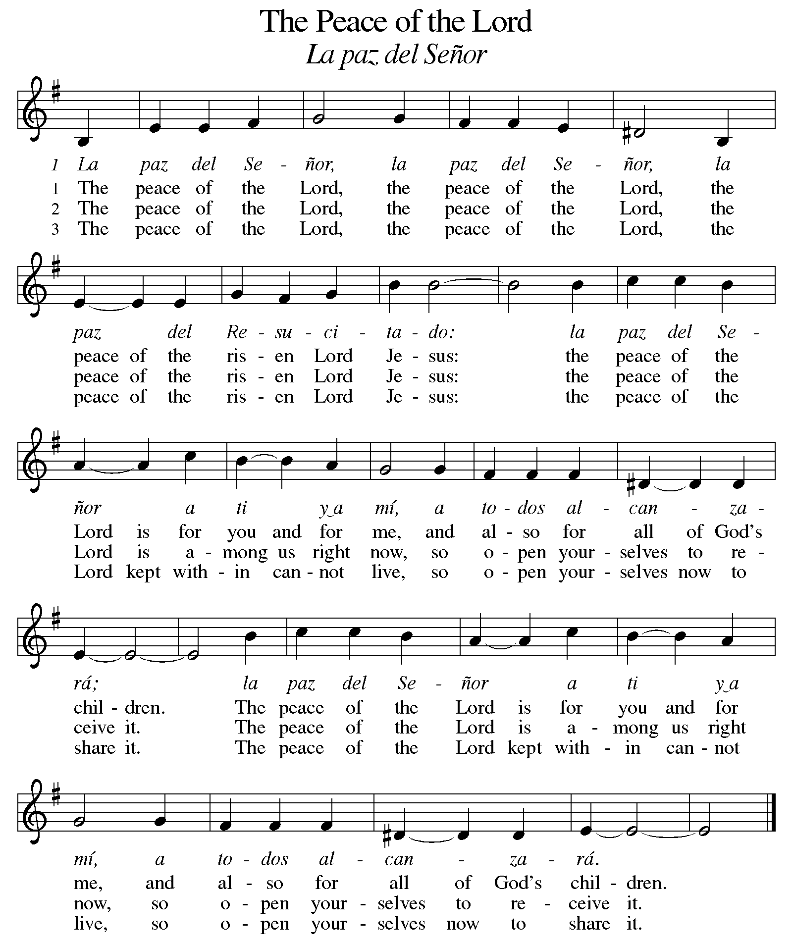
nicene CREED
We believe in one God,
the Father, the Almighty,
maker of heaven and earth,
of all that is, seen and unseen.
We believe in one Lord, Jesus Christ,
the only Son of God,
eternally begotten of the Father,
God from God, Light from Light,
true God from true God,
begotten, not made,
of one Being with the Father;
through him all things were made.
For us and for our salvation
he came down from heaven,
was incarnate of the Holy Spirit and the virgin Mary
and became truly human.
For our sake he was crucified under Pontius Pilate;
he suffered death and was buried.
On the third day he rose again
in accordance with the scriptures;
he ascended into heaven
and is seated at the right hand of the Father.
He will come again in glory to judge the living and the dead,
and his kingdom will have no end.

We believe in the Holy Spirit, the Lord, the giver of life.
who proceeds from the Father and the Son,
who with the Father and the Son is worshiped and glorified,
who has spoken through the prophets.
We believe in one holy catholic and apostolic church.
We acknowledge one baptism for the forgiveness of sins.
We look for the resurrection of the dead,
and the life of the world to come. Amen.

(Please be seated.)

THE PRAYERS
A: God of resurrection and new life, we come before you in prayer for the church, the world, and all who are in need.
(A brief silence.)
A: Unite your people with communities of faith throughout the world. Further cooperation between people of different faith traditions and bless our non-Christian neighbors that we learn and grow in deeper relationship. Hear us, O God.
C: Your mercy is great.
A: Bless the earth with fresh water, clean air, and rich soil. Nurture growing crops and encourage communities developing sustainable farming practices. Help us to live in balance and harmony with your good creation. Hear us, O God.
C: Your mercy is great.
A: Reconcile nations and communities suffering from violence and conflict. Protect refugees, asylum-seekers, and all who flee their homes seeking safety and security. Make all nations safe for both migrants and residents. Hear us, O God.
C: Your mercy is great.
A: This Memorial Day weekend, we remember all who have died in military service. Soothe loved ones who mourn, and strengthen support systems for veterans and their families. Bring peace among nations, that war and conflict around the world might cease. Hear us, O God.
C: Your mercy is great.
A: Guard those who serve in our armed forces as they strive to bring justice and peace to an unsettled world. We pray especially for Beth & Ryan, Jonathan, Jacob, Noah, Irene, and Alex. Hear us, O God.
C: Your mercy is great.
A: Sustain all who are in need, especially individuals and families struggling with trauma or addiction. Support caregivers, especially nurses, doctors, counselors, and social workers. Come alongside all who are ill or struggling, especially Ahren, Beth, B.J., Carolyn, Dan, David, Don, Doretta, Family & friends of Glen, Family & friends of Joseph, Family & friends of Nina, Gage, Gunny, Jim & Cheri, John, Johnny, Jon, Jordan, Lawton, Lera & family, Linda, Lizzy, Marge, Patty, Randy, Rick & Kathy, Sheri, Sheri, Stacy, Steve, Susan, Wanda, and all whom we name now aloud and in our hearts. Hear us, O God.
C: Your mercy is great.
A: Equip our church’s leaders with your word and wisdom. We pray especially for Presiding Bishop Elizabeth, our Synod Bishop Craig, and Pastor Carl. We ask that you be with their respective staffs as they live out their callings to serve. As we are called to be one, even as Jesus and the Father are one, be with the leaders and the congregation of Christ the King Lutheran in Gladwin and the churches in our community. Hear us, O God.
C: Your mercy is great.
A: We give you thanks for all your saints raised to new life in Christ. Gather us, with them, into the peace only you can give. Hear us, O God.
C: Your mercy is great.
P: We commend these and all our prayers to you, O God, trusting that you are always with us; in the name of Jesus Christ, our risen Savior.
C: Amen.

GREETING OF PEACE
P: The peace of Christ be with you always.
C: And also with you.
(You are invited to share Christ’s peace with one another.)
(Please be seated.)
MEAL
OFFERING ELENE
(Please rise as you are able.)
OFFERTORY ELW 186
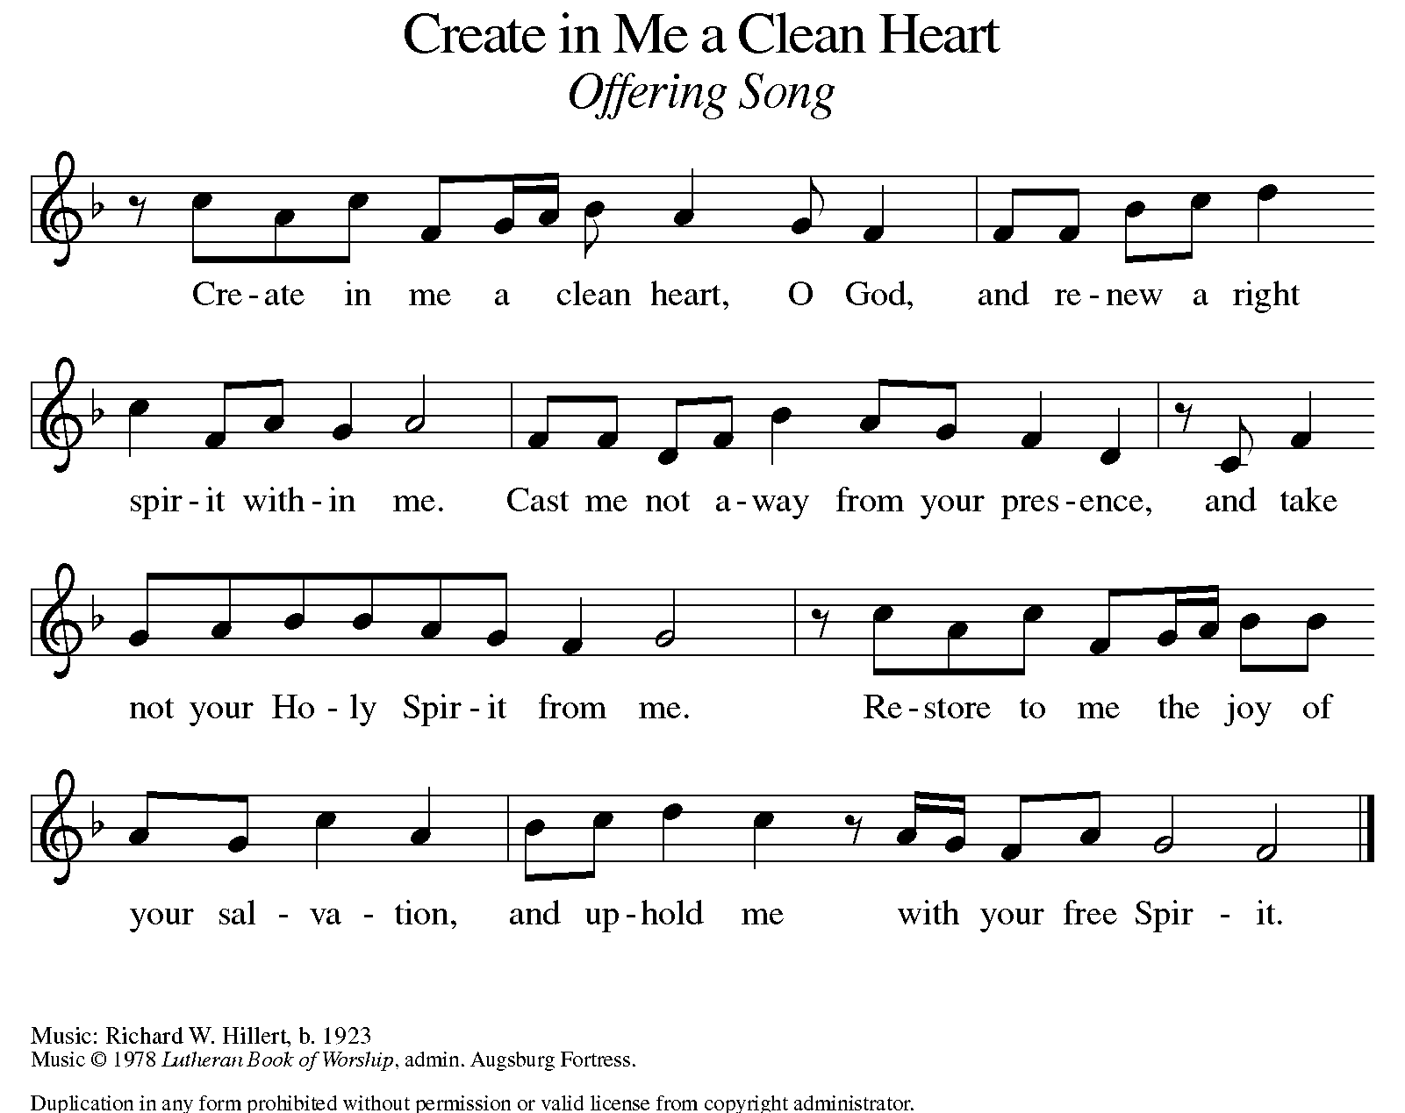

OFFERING PRAYER
A: Let us pray. Risen One, you have gathered us around your table of grace
along with these gifts we bring. Come among us again, breathe your life into us, and enliven us with this meal, that we may live as your risen body in the world.

C: Amen.

THE GREAT THANKSGIVING
P: The Lord be with you.
C: And also with you.
P: Lift up your hearts.
C: We lift them to the Lord.
P: Let us give thanks to the Lord our God.
C: It is right to give our thanks and praise.

PROPER PREFACE
P: It is indeed right, our duty and our joy, that we should at all times and in all places give thanks and praise to you, almighty and merciful God, for the glorious resurrection of our Savior Jesus Christ, the true Paschal Lamb who gave himself to take away our sin; who in dying has destroyed death, and in rising has brought us to eternal life. And so, with Mary Magdalene and Peter and all the witnesses of the resurrection, with earth and sea and all their creatures, and with angels and archangels, cherubim and seraphim, we praise your name and join their unending hymn:

HOLY, HOLY ELW Setting 8, Page 190
Holy, holy, holy Lord,
God of pow’r and might,
heaven and earth are full of your glory, full of your glory.
Hosanna, hosanna, hosanna in the highest.
Blessed is he who comes in the name of the Lord.
Hosanna, hosanna, hosanna in the highest.

EUCHARISTIC PRAYER
P: In the night in which he was betrayed, our Lord Jesus took bread, and gave thanks; broke it, and gave it to his disciples, saying:
Take and eat; this is my body, given for you.
Do this for the remembrance of me.
Again, after supper, he took the cup, gave thanks, and gave it for all to drink, saying:
This cup is the new covenant in my blood, shed for you and for all people for the forgiveness of sin. Do this for the remembrance of me.
LORD'S PRAYER
P: Lord, remember us in your kingdom, and teach us to pray:
C: Our Father in heaven, hallowed be your name, your kingdom come, your will be done, on earth as in heaven. Give us today our daily bread. Forgive us our sins as we forgive those who sin against us. Save us from the time of trial and deliver us from evil. For the kingdom, the power, and the glory are yours, now and forever. Amen.

(Please be seated.)

COMMUNION DISTRIBUTION
All who believe in the real presence of Christ in the bread and the wine (juice) are welcome to the table. Others may come forward for a blessing. If you prefer grape juice, please indicate this to the assisting minister.
When approaching the communion rail, come forward down the side aisle; kneel if you are able, starting at the front of the communion rail (spot closest to the font) on your side and filling in toward the altar. After receiving both the bread and the wine, you may return to your seat by the center aisle.

INVITATION TO COMMUNION
P: Come to the table of grace. Receive the gift of new life.

COMMUNION HYMN ELW 472
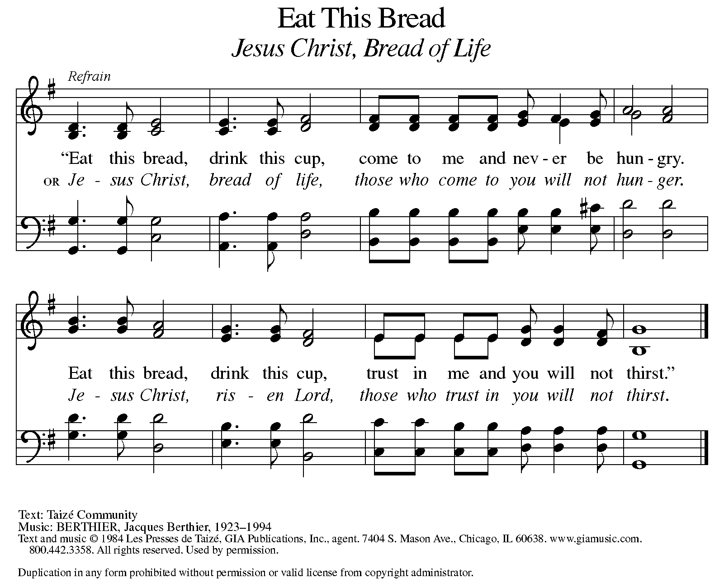
P: The body of Christ, given for you.
C: Amen.
A: The blood of Christ shed for you.
C: Amen.
(Please rise as you are able.)
P: May the body and blood of our Lord Jesus Christ strengthen and keep you in his grace.
C: Amen.

PRAYER AFTER COMMUNION
P: Let us pray. Living One, in this feast you have made yourself known to us. Send us now to tell of your wonders, sing of your glory, and proclaim your risen life to a wounded and weary world.
C: Amen.

SENDING

BLESSING
P: The triune God, who was, who is, and who is to come, Sovereign, ☩ Savior, and Spirit, light your way with resurrection dawn, now and always.
C: Amen.

SENDING HYMN ELW 866
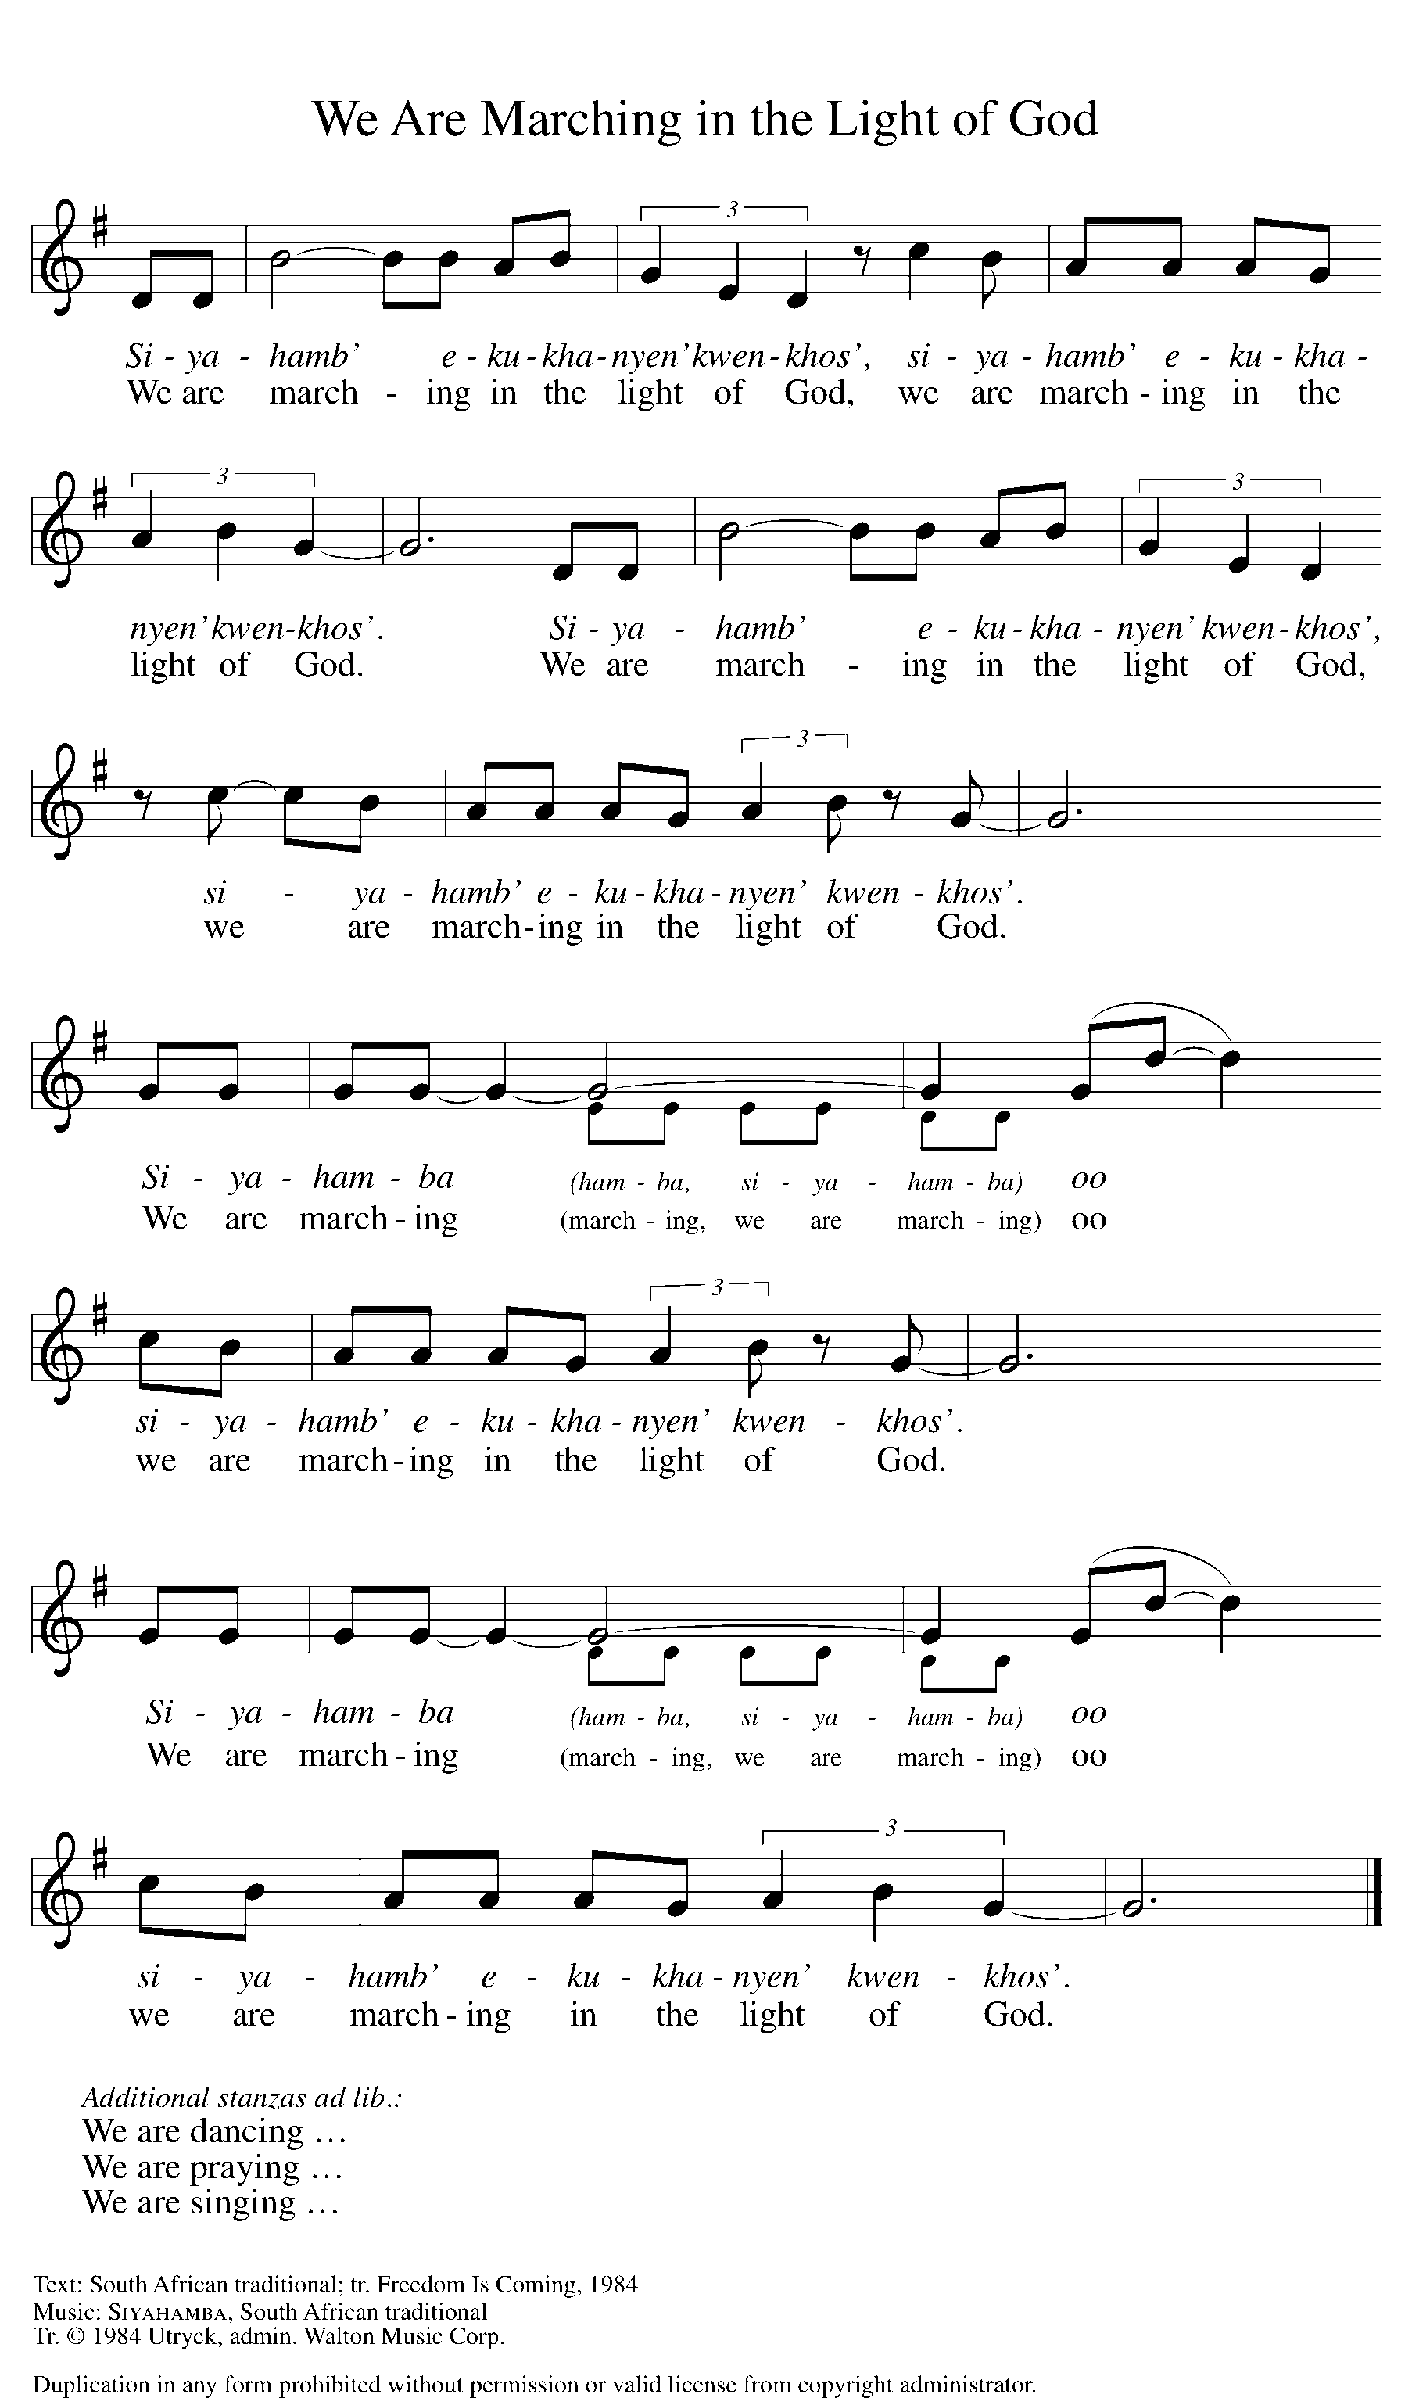

DISMISSAL
A: Alleluia! Christ is risen.
C: Christ is risen indeed. Alleluia!
A: Go in peace. In Christ you are made new. Alleluia! Alleluia!
C: Thanks be to God. Alleluia! Alleluia!

Announcements
We welcome Rev. Julie Schneider-Thomas as our newly elected Bishop. She begins her journey of term on September 1st, 2025.

- Sunday, June 1 – Fish Fry @ 11:15am following service. All donations go to St. Paul Food Pantry.
- Sunday, June 8 – Wear Red for Pentecost.
- Sunday, June 15 – Father’s Day & celebrating the graduates.
- Saturday, June 21 – Taste of Honduras @ 1-3pm. University Lutheran Church: 1020 S. Harrison Rd. East Lansing. RSVP: sign-up sheet in the foyer.

Recurring Events

- Every Sunday – Adult Bible Study @ 9am
- Monday, June 2 – Worship Committee Meeting @ 6:30pm
- Wednesday, June 11 – Women’s Bible Study @ 11am
- Thursday, June 19 – Council Meeting @ 7pm

Food Pantry Dates

Thursday, May 29, 1-3pm
Wednesday, June 4, 5-6:30pm
Thursday, June 12, 1-3pm
Tuesday, June 17, 1:10-3pm
Wednesday, June 18, 5-6:30pm
Volunteers for May 25 Volunteers for June 1

Reader Sunday - Volunteer Reader Sunday – Volunteer
Assisting Minister - Volunteer Assisting Minister – Volunteer

May & June Birthday Celebrations

5/2 – Jemal Ta.
5/2 – Melissa Ki.
5/9 – Pr. Carl
5/23 – Jim Cr.

6/1 – Charlotte Co.
6/6 – Bob Se.
6/12 – Kathryn Ki.
6/15 – Logan Ro.
6/16 – Steve Op.
6/17 – Ardyth Cl.
6/20 – Charles Mc.

May & June Anniversary Celebrations

5/11 – Emily & AJ Po.
5/26 – Jon & Tzulun Ke.

6/24 – Ryan & Jessica Sm.
Acknowledgments
- OneLicense.net, License #A-703165.
- CCLI, License #2281869.
- From SundaysandSeasons.com. Copyright 2022 Augsburg Fortress. All rights reserved. Reprinted by permission under Augsburg Fortress Liturgies Annual License #23806.
- New Revised Standard Version Bible, copyright 1989, Division of Christian Education of the National Council of the Churches of Christ in the United States of America. Used by permission. All rights reserved.

