

5th Sunday in Easter
May 18, 2025


SAINT PAUL LUTHERAN CHURCH
3383 EAST LAKE LANSING ROAD
EAST LANSING, MI 48823

PHONE (517) 351-8541

Pastor Carl E. Ballard
E-MAIL: pastor@stpaul-el.org
officemanager@stpaul-el.org
Visitors WELCOME! If this is your first time worshipping with us, please sign our guest registry just outside the sanctuary doors. We hope you are blessed through worship today. If you have any questions, please feel free to call the church at 351-8541.
Children are always welcome in worship! The choir room (off the sanctuary) can also be used as a cry room for younger children and includes a sound system so parents may continue to participate in the service. Clipboards with children's bulletins, activities and crayons are available for use during the service.
Sunday School is available during the worship service September-May except the last Sunday of the month.
Virtual Services We can provide a virtual live Zoom session during worship upon request.
This Bulletin is for your use during the service and to take home for the upcoming week. If you choose not to take it home, please place it in the recycle receptacle in the back.
Newsletters and Calendars of Upcoming Events are available in the lobby/narthex. We welcome anyone who has an interest in our small groups or activities! You can also look us up on the web at www.stpaul-el.org.
Contacting Us: Our Office Manager is Emily Polhamus. She can be reached by phone at 517-351-8541 or at her email address, officemanager@stpaul-el.org. Our Director of Music is Elene Kobulashvili. You may leave a message at 517-351-8541. Pastor Carl can be reached at 517-515-3129, and his email address is cballard123@msn.com.
Holy Communion is available at most services. All who believe in the real presence of Christ in the bread and the wine are invited to celebrate Communion with us. Those who wish can come forward for a blessing.
You’re invited to share in fellowship after worship. We would love this opportunity to introduce you to the St. Paul community.

P-Presiding Minister A-Assisting Minister C-Congregation

PRELUDE ELENE

INTRODUCTION

Easter initiates a new day. It anticipates a new heaven and a new earth. The risen Christ is making all things new. In the mystery of holy baptism God has made new people of us. Today Jesus invites us to see everyone in a new light—through the lens of love.

GATHERING

P: The Holy Spirit calls us together as the people of God.

(Please rise as you are able.)

THANKSGIVING FOR BAPTISM

P: Alleluia! Christ is risen.

C: Christ is risen, indeed. Alleluia!

P: In the name of ☩ the One who was, who is, and who is to come.

C: Amen.

P: Baptized into Christ’s death and resurrection, and called to live the baptized life, let us give thanks for the gifts of baptism.

(Silence is kept for reflection.)

P: Holy God, we give you thanks for the waters of baptism, waters that make a people your own, that restore to wholeness, and empower us to be witnesses in your name. Baptized into you, O Living One,

C: make us one as you are one.

P: We give you thanks for the waters of baptism, waters that strengthen believers and give new life to beloved servants of your church; waters that extend your boundless love and cross barriers of our own making. Baptized into you, O Living One,
C: make us one as you are one.

P: We give you thanks for the waters of baptism, waters that open the hearts of believers and give a voice in the night to those in captivity; waters that set your people on a new path, rejoicing in the Spirit’s power. Baptized into you, O Living One,

C: make us one as you are one.

P: Grant us grace, love, and life, O Living One, that our every day is shaped by these waters that give us our very lives in you. We ask this in the name of Jesus, the Crucified and Risen One.

C: Amen.

GATHERING SONG ELW 482
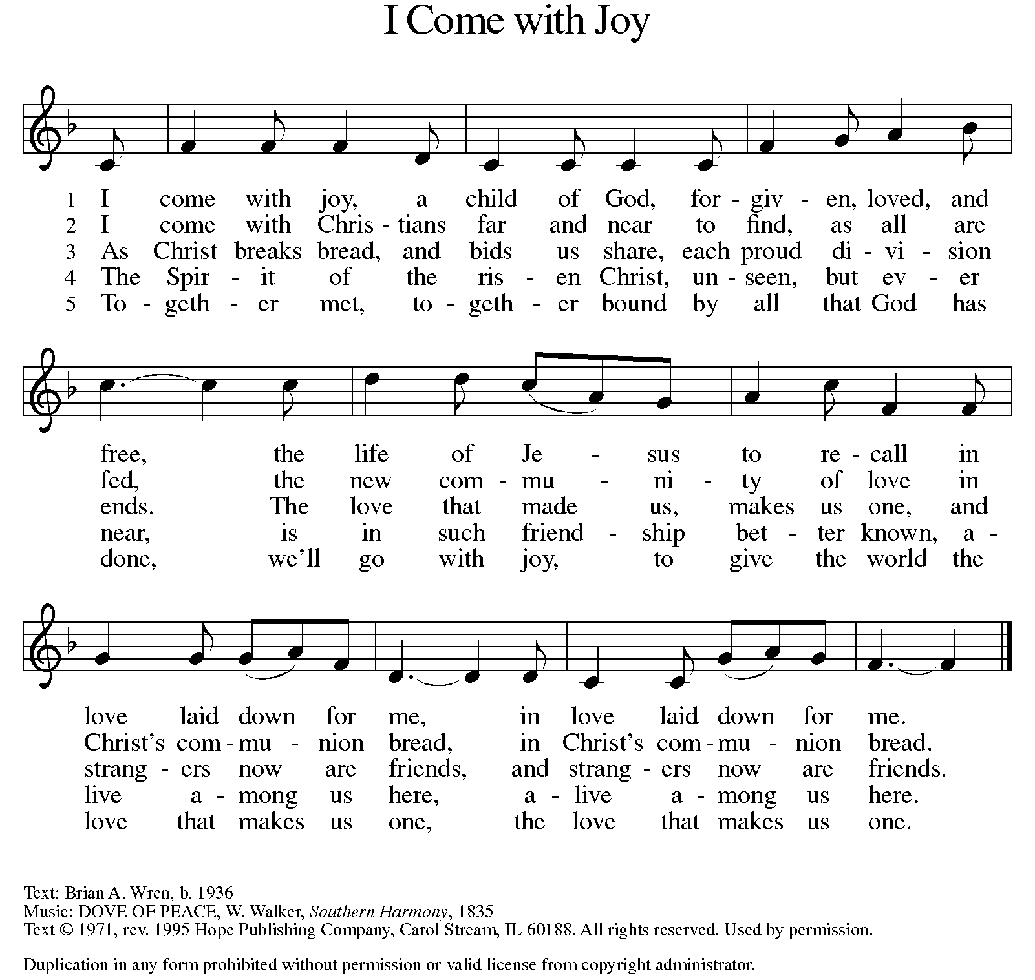
GREETING

P: The grace of our Lord Jesus Christ, the love of God, and the communion of the Holy Spirit be with you all.

C: And also with you.

KYRIE ELW Setting 10, Page 203

Have mercy on us, Lord,
and hear our solemn prayer.
We come to hear your living word;
it saves us from despair.

Have mercy on us, Christ,
and wash away our sin.
Pour out your grace and make us whole
that new life may begin.

Have mercy on us, Lord;
make sin and shame depart.
Renew us with your saving pow’r;
create in us new hearts!

CANTICLE OF PRAISE ELW Setting 4, Page 149-150

This is the feast of victory for our God. Alleluia.

Worthy is Christ, the Lamb who was slain,
whose blood set us free to be people of God.
Power and riches and wisdom and strength,
and honor and blessing and glory are his.
This is the feast of victory for our God. Alleluia.

Sing with all the people of God
and join in the hymn of all creation:
Blessing and honor and glory and might
be to God and the Lamb forever. Amen.
This is the feast of victory for our God,
for the Lamb who was slain has begun his reign.
Alleluia. Alleluia.

PRAYER OF THE DAY

P: Let us pray. O Lord God, you teach us that without love, our actions gain nothing. Pour into our hearts your most excellent gift of love, that, made alive by your Spirit, we may know goodness and peace, through your Son, Jesus Christ, our Savior and Lord, who lives and reigns with you and the Holy Spirit, one God, now and forever.

C: Amen.

(Please be seated.)

CHILDREN’S MESSAGE

(Children may return to their seats.)

TRANSITION SONG ELW 509
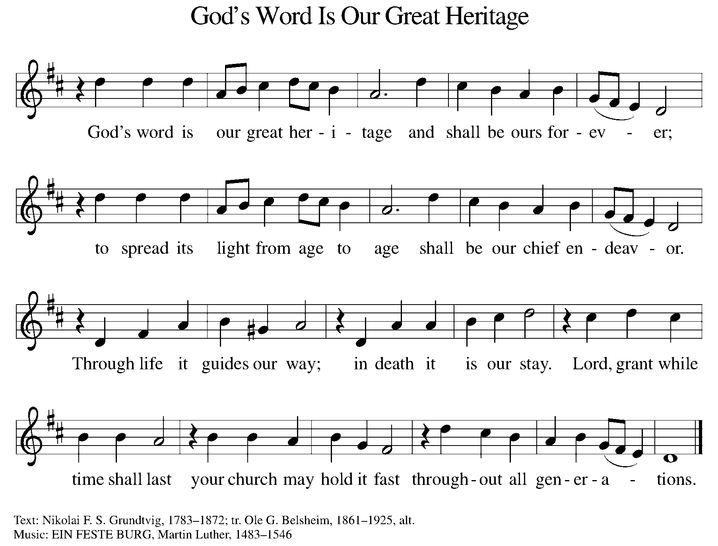

WORD

P: God speaks to us in scripture, preaching, and song.

FIRST READING ACTS 11:1-18

In defense of his earlier baptism of non-Jewish believers, Peter demonstrates to the members of the Jerusalem church that God’s intention to love Gentiles as well as Jews is revealed in Jesus’ testimony. In this way the mission to the Gentiles is officially authorized.

¹ Now the apostles and the brothers and sisters who were in Judea heard that the gentiles had also accepted the word of God. ² So when Peter went up to Jerusalem, the circumcised believers criticized him, ³ saying, “Why did you go to uncircumcised men and eat with them?” ⁴ Then Peter began to explain it to them, step by step, saying, ⁵ “I was in the city of Joppa praying, and in a trance I saw a vision. There was something like a large sheet coming down from heaven, being lowered by its four corners, and it came close to me. ⁶ As I looked at it closely I saw four-footed animals, beasts of prey, reptiles, and birds of the air. ⁷ I also heard a voice saying to me, ‘Get up, Peter; kill and eat.’ ⁸ But I replied, ‘By no means, Lord, for nothing profane or unclean has ever entered my mouth.’ ⁹ But a second time the voice answered from heaven, ‘What God has made clean, you must not call profane.’ ¹⁰ This happened three times; then everything was pulled up again to heaven.

¹¹ At that very moment three men, sent to me from Caesarea, arrived at the house where we were. ¹² The Spirit told me to go with them and not to make a distinction between them and us. These six brothers also accompanied me, and we entered the man’s house. ¹³ He told us how he had seen the angel standing in his house and saying, ‘Send to Joppa and bring Simon, who is called Peter; ¹⁴ he will give you a message by which you and your entire household will be saved.’ ¹⁵ And as I began to speak, the Holy Spirit fell upon them just as it had upon us at the beginning. ¹⁶ And I remembered the word of the Lord, how he had said, ‘John baptized with water, but you will be baptized with the Holy Spirit.’ ¹⁷ If then God gave them the same gift that he gave us when we believed in the Lord Jesus Christ, who was I that I could hinder God?” ¹⁸ When they heard this, they were silenced. And they praised God, saying, “Then God has given even to the gentiles the repentance that leads to life.”

Reader: Word of God, word of life. C: Thanks be to God.
PSALM PSALM 148

The splendor of the Lord is over earth and heaven. (Ps. 148:13)

¹ Hallelujah! Praise the Lord from the heavens; praise God in the heights.
² Praise the Lord, all you angels; sing praise, all you hosts of heaven.
³ Praise the Lord, sun and moon; sing praise, all you shining stars.
⁴ Praise the Lord, heaven of heavens, and you waters above the heavens.
⁵ Let them praise the name of the Lord, who commanded, and they were created,
⁶ who made them stand fast forever and ever, giving them a law that shall not pass away.
⁷ Praise the Lord from the earth, you sea monsters and all deeps;
⁸ fire and hail, snow and fog, tempestuous wind, doing God’s will;
⁹ mountains and all hills, fruit trees and all cedars;
¹⁰ wild beasts and all cattle, creeping things and flying birds;
¹¹ sovereigns of the earth and all peoples, princes and all rulers of the world;
¹² young men and maidens, old and young together.
¹³ Let them praise the name of the Lord, whose name only is exalted, whose splendor is over earth and heaven.
¹⁴ The Lord has raised up strength for the people and praise for all faithful servants, the children of Israel, a people who are near the Lord. Hallelujah!

SECOND READING REVELATION 21:1-6

John’s vision shows us that in the resurrection the new age has dawned; God dwells with us already. Yet we wait for the time when the tears that cloud our vision will be wiped away. Then we will see the new heaven, new earth, and new Jerusalem.

¹ I saw a new heaven and a new earth, for the first heaven and the first earth had passed away, and the sea was no more. ² And I saw the holy city, the new Jerusalem, coming down out of heaven from God, prepared as a bride adorned for her husband. ³ And I heard a loud voice from the throne saying, “See, the home of God is among mortals. He will dwell with them; they will be his peoples, and God himself will be with them and be their God;

⁴ he will wipe every tear from their eyes. Death will be no more; mourning and crying and pain will be no more, for the first things have passed away.” ⁵ And the one who was seated on the throne said, “See, I am making all things new.” Also he said, “Write this, for these words are trustworthy and true.” ⁶ Then he said to me, “It is done! I am the Alpha and the Omega, the Beginning and the End. To the thirsty I will give water as a gift from the spring of the water of life.”
Reader: Word of God, word of life. C: Thanks be to God.

(Please rise as you are able.)

GOSPEL ACCLAMATION ELW SETTING 10, PAGE 205

Alleluia! Lord and Savior: open now your saving word.
Let it burn like fire within us; speak until our hearts are stirred.
Alleluia! Lord, we sing for the good news that you bring.

GOSPEL JOHN 13:31-35

P: The Holy Gospel according to John, the 13th chapter.

C: Glory to you, O Lord.

After washing the disciples’ feet, predicting his betrayal, and then revealing his betrayer, Jesus speaks of his glorification on the cross. This deep complicated love of Jesus, even to death on the cross, will be the distinctive mark of Jesus’ community.

³¹ When he had gone out, Jesus said, “Now the Son of Man has been glorified, and God has been glorified in him. ³² If God has been glorified in him, God will also glorify him in himself and will glorify him at once. ³³ Little children, I am with you only a little longer. You will look for me, and as I said to the Jews so now I say to you, ‘Where I am going, you cannot come.’ ³⁴ I give you a new commandment, that you love one another. Just as I have loved you, you also should love one another. ³⁵ By this everyone will know that you are my disciples, if you have love for one another.”

P: The Gospel of the Lord. C: Praise to you, O Christ.

(Please be seated.)

SERMON PASTOR DAVID AUGENSTEIN
(Please rise as you are able.)

HYMN OF THE DAY ELW 631
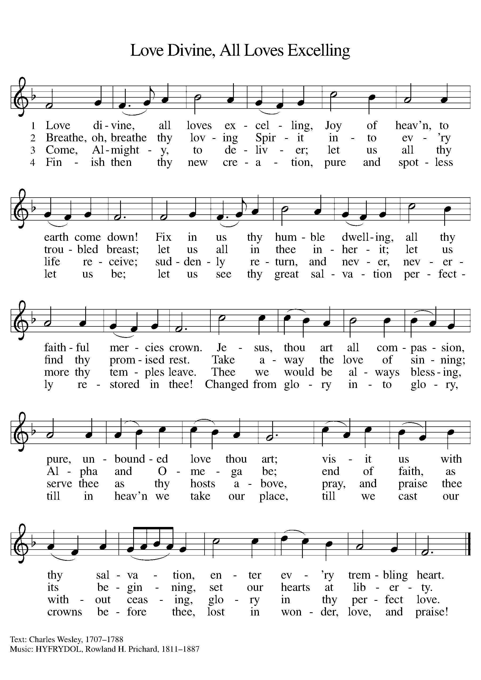

NICENE CREED

We believe in one God,
the Father, the Almighty,
maker of heaven and earth,
of all that is, seen and unseen.
We believe in one Lord, Jesus Christ,
the only Son of God,
eternally begotten of the Father,
God from God, Light from Light,
true God from true God,
begotten, not made,
of one Being with the Father;
through him all things were made.
For us and for our salvation
he came down from heaven,
was incarnate of the Holy Spirit and the virgin Mary
and became truly human.
For our sake he was crucified under Pontius Pilate;
he suffered death and was buried.
On the third day he rose again
in accordance with the scriptures;
he ascended into heaven
and is seated at the right hand of the Father.
He will come again in glory to judge the living and the dead,
and his kingdom will have no end.

We believe in the Holy Spirit, the Lord, the giver of life.
who proceeds from the Father and the Son,
who with the Father and the Son is worshiped and glorified,
who has spoken through the prophets.
We believe in one holy catholic and apostolic church.
We acknowledge one baptism for the forgiveness of sins.
We look for the resurrection of the dead,
and the life of the world to come. Amen.

(Please be seated.)

THE PRAYERS

A: God of resurrection and new life, we come before you in prayer for the church, the world, and all who are in need.
(A brief silence.)
A: Fill the church with the spirit of your redeeming love. Make us steadfast in our proclamation of your grace for all people without exceptions, especially those often overlooked in our communities. Hear us, O God.

C: Your mercy is great.

A: Awaken joy in the beauty and abundance of your creation. Show us the wonder of your presence from the smallest flower to the tallest tree. Recommit us to preservation of wild places. Hear us, O God.

C: Your mercy is great.

A: Instruct all world leaders to protect the most vulnerable among us. Guide those in power toward equitable and just economic policies, so that all might have sufficient resources to live safely and with dignity. Hear us, O God.

C: Your mercy is great.

A: Abide with all who are victims of racism, especially people who are doubly marginalized because of gender, sexuality, or ability. Destroy all forms of systemic oppression, and renew our commitment to healing the wounds of our collective body in this community and beyond. Hear us, O God.

C: Your mercy is great.

A: Protect and give courage to those who serve in our armed forces, especially Beth & Ryan, Jonathan, Jacob, Noah, Irene, and Alex. Hear us, O God.

C: Your mercy is great.

A: Pour out your love on all in need of care: those mourning losses, enduring trauma, experiencing broken relationships, yearning for companionship, or facing illness, especially Ahren, Beth Ra., B.J., Carolyn, Dan, David, Don, Doretta, Family & friends of Joseph Ra., Family & friends of Nina, Gage, Gunny, Jim & Cheri, John, Johnny, Jon, Jordan, Lawton, Lera & family, Linda, Lizzy, Marge, Patty, Randy, Rick & Kathy, Sheri, Sheri, Stacy, Steve, Susan, and Wanda, and all that we name now aloud and in our hearts. Wipe away every tear. Hear us, O God.

C: Your mercy is great.

A: Give our church’s leaders receptive minds and dedicated responses to your leading. We pray especially for Presiding Bishop Elizabeth, our Synod Bishop Craig, Pastor Carl, and Pastor David. We ask that you be with their respective staffs as they live out their callings to serve. As we are called to be one, even as Jesus and the Father are one, be with the leaders and the congregation of Peace Lutheran Church in Gaylord and all the churches in our community. Hear us, O God.

C: Your mercy is great.

A: We give thanks for all the saints whose lives bear witness to your redeeming love. Guide us by their example, until we join them in your eternal home. Hear us, O God.

C: Your mercy is great.

P: We commend these and all our prayers to you, O God, trusting that you are always with us; in the name of Jesus Christ, our risen Savior.

C: Amen.

GREETING OF PEACE

P: The peace of Christ be with you always.

C: And also with you.

(You are invited to share Christ’s peace with one another.)

(Please be seated.)

MEAL

OFFERING ELENE

OFFERTORY ELW 186
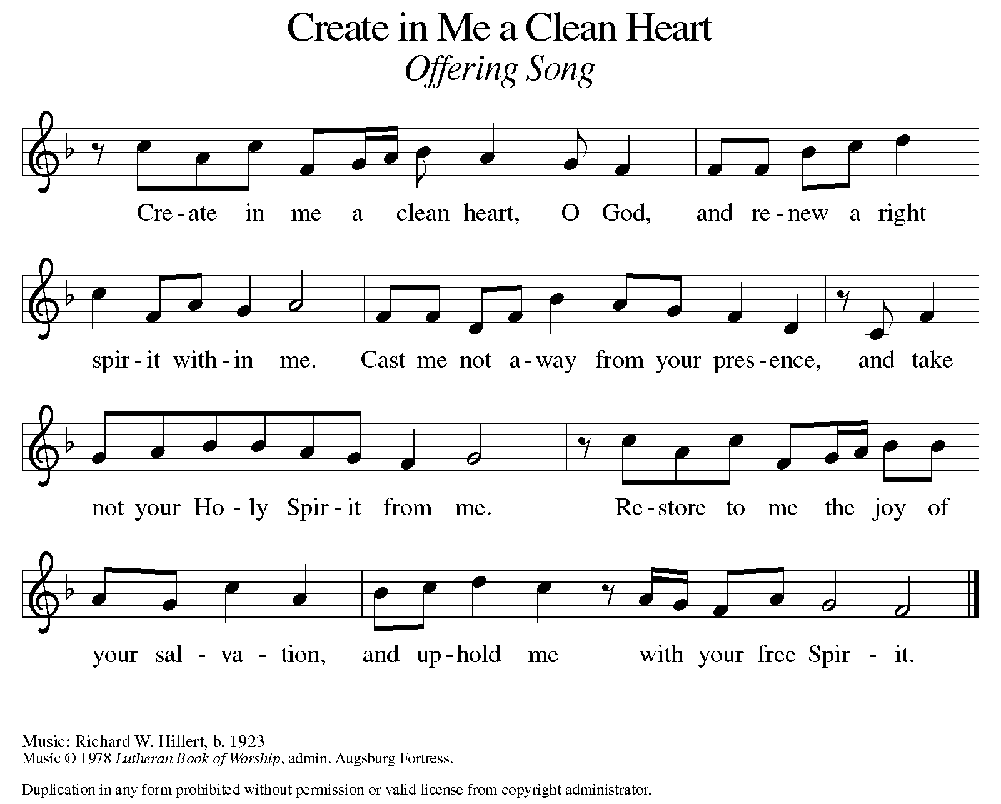

OFFERING PRAYER

A: Let us pray. Risen One, you have gathered us around your table of grace along with these gifts we bring. Come among us again, breathe your life into us, and enliven us with this meal, that we may live as your risen body in the world.

C: Amen.

THE GREAT THANKSGIVING

P: The Lord be with you.
C: And also with you.
P: Lift up your hearts.
C: We lift them to the Lord.
P: Let us give thanks to the Lord our God.
C: It is right to give our thanks and praise.

PROPER PREFACE

P: It is indeed right, our duty and our joy, that we should at all times and in all places give thanks and praise to you, almighty and merciful God, for the glorious resurrection of our Savior Jesus Christ, the true Paschal Lamb who gave himself to take away our sin; who in dying has destroyed death, and in rising has brought us to eternal life. And so, with Mary Magdalene and Peter and all the witnesses of the resurrection, with earth and sea and all their creatures, and with angels and archangels, cherubim and seraphim, we praise your name and join their unending hymn:

HOLY, HOLY ELW SETTING 10, Page 207

Holy, holy, holy Lord,
God of power and might,
heav’n and earth are full of your glory.
Hosanna in the highest.
Blessed is he who comes in the name of the Lord.
Hosanna in the highest,
hosanna in the highest.

EUCHARISTIC PRAYER

P: In the night in which he was betrayed, our Lord Jesus took bread, and gave thanks; broke it, and gave it to his disciples, saying:
Take and eat; this is my body, given for you. Do this for the remembrance of me.
Again, after supper, he took the cup, gave thanks, and gave it for all to drink, saying:
This cup is the new covenant in my blood, shed for you and for all people for the forgiveness of sin. Do this for the remembrance of me.

LORD'S PRAYER

P: Lord, remember us in your kingdom, and teach us to pray:

C: Our Father, who art in heaven, hallowed be thy name, thy kingdom come, thy will be done, on earth as it is in heaven. Give us this day our daily bread; and forgive us our trespasses, as we forgive those who trespass against us; and lead us not into temptation, but deliver us from evil. For thine is the kingdom, and the power, and the glory, forever and ever. Amen.

COMMUNION DISTRIBUTION

All who believe in the real presence of Christ in the bread and the wine (juice) are welcome to the table. Others may come forward for a blessing. If you prefer grape juice, please indicate this to the assisting minister.

When approaching the communion rail, come forward down the side aisle, kneel, if you are able, starting at the front of the communion rail (spot closest to the font) on your side and filling in toward the altar. After receiving both the bread and the wine, you may return to your seat by the center aisle.

INVITATION TO COMMUNION

P: Come to the table of grace. Receive the gift of new life.

COMMUNION HYMN ELW 472
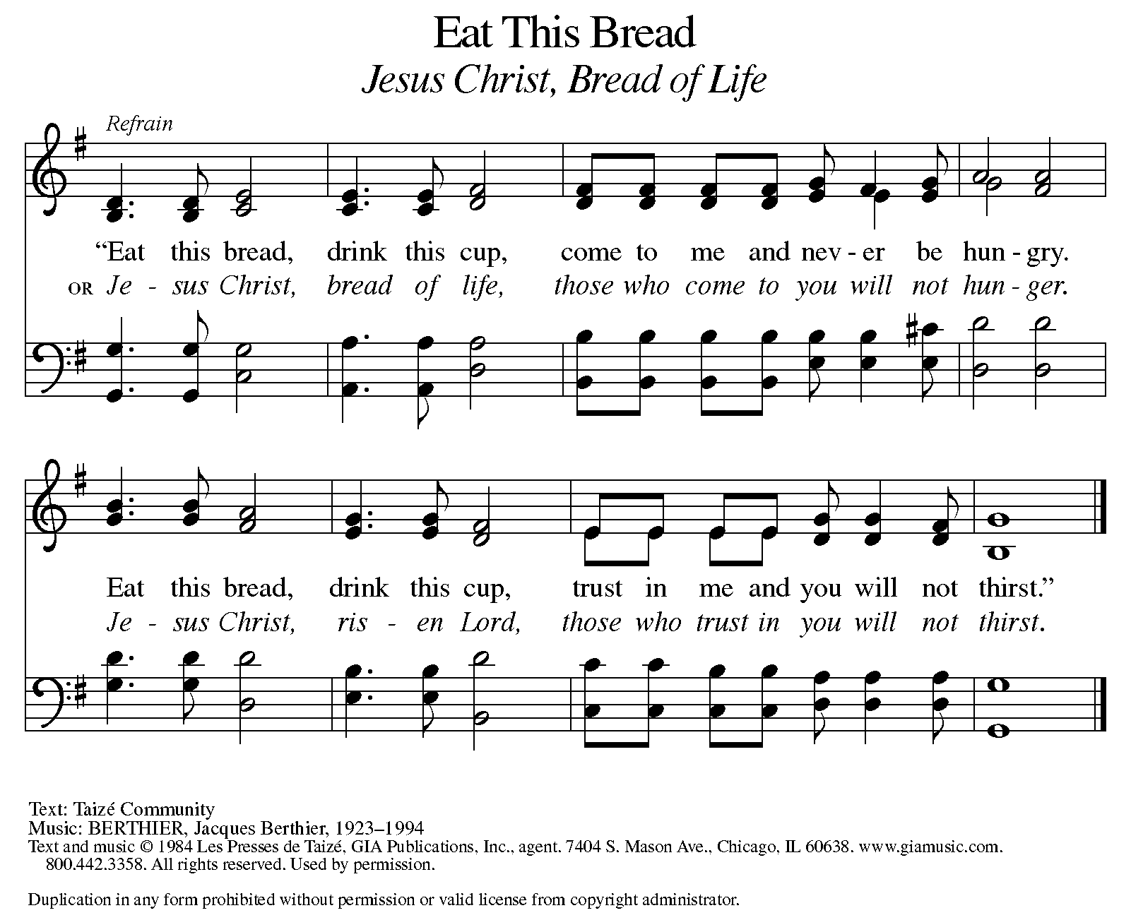

P: The body of Christ, given for you.

C: Amen.

A: The blood of Christ, shed for you.

C: Amen.
(Please rise as you are able.)

P: May the body and blood of our Lord Jesus Christ strengthen and keep you in his grace.

C: Amen.

PRAYER AFTER COMMUNION

P: Let us pray. Living One, in this feast you have made yourself known to us. Send us now to tell of your wonders, sing of your glory, and proclaim your risen life to a wounded and weary world.

C: Amen.

SENDING

BLESSING

P: The triune God, who was, who is, and who is to come, Sovereign, ☩ Savior, and Spirit, light your way with resurrection dawn, now and always.

C: Amen.

SENDING HYMN ELW 379
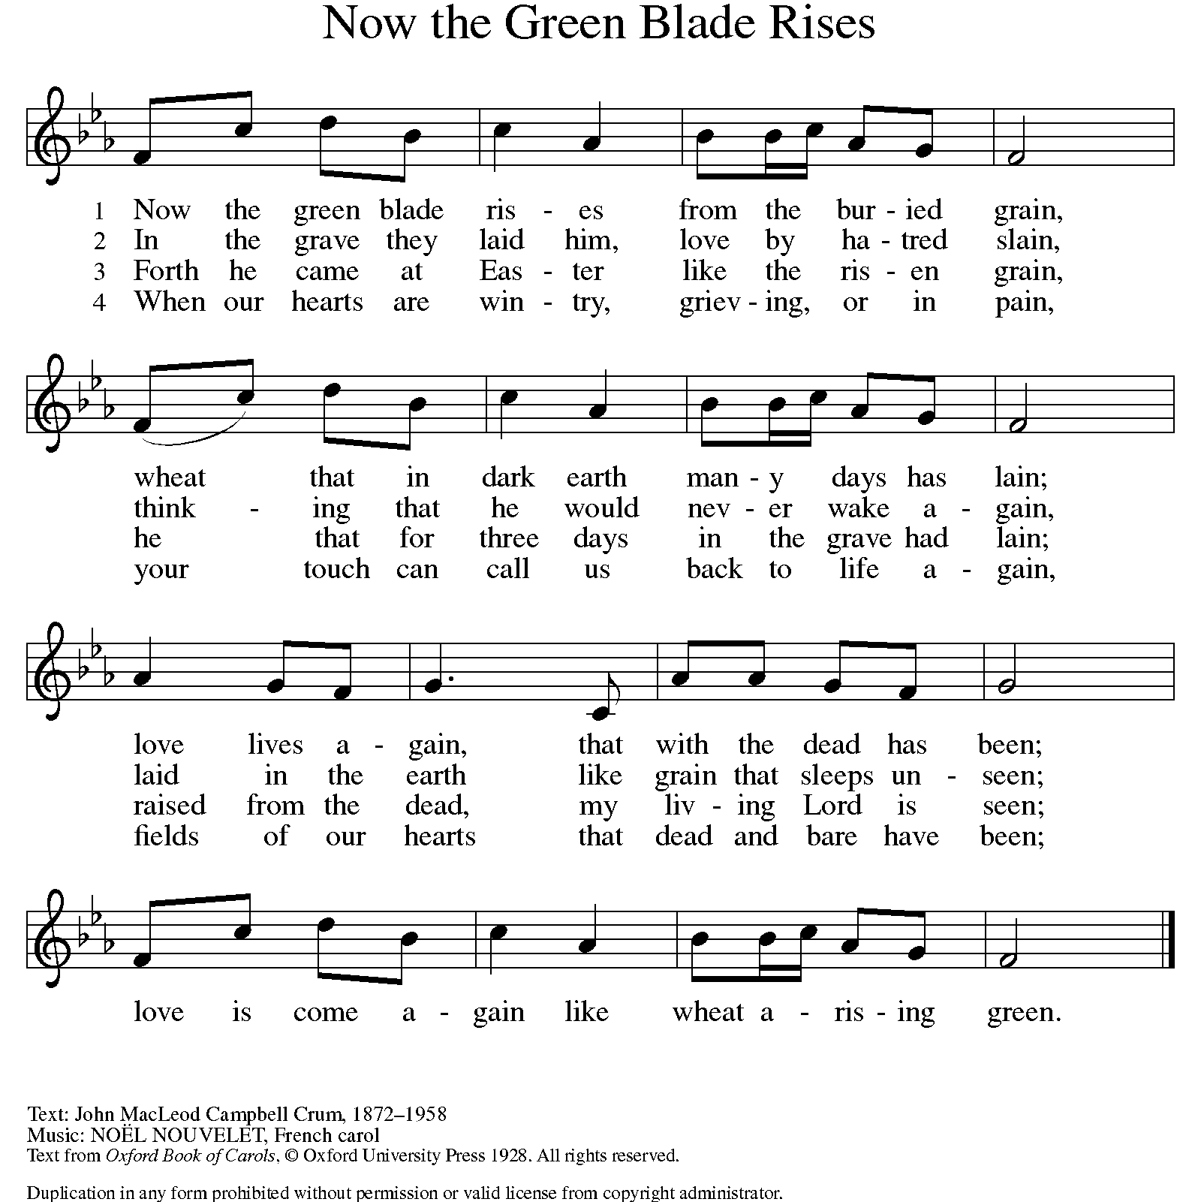

DISMISSAL

A: Alleluia! Christ is risen.
C: Christ is risen indeed. Alleluia!
A: Go in peace. In Christ you are made new. Alleluia! Alleluia!
C: Thanks be to God. Alleluia! Alleluia!

Announcements
- Sunday – Tuesday, May 18 – 20 – 2025 North/West Lower MI Synod Assembly will be held in person @ Comfort Inn & Suites in Mt. Pleasant.
- Sunday, June 1 – Fish Fry @ 11:15am following service. All donations go to St. Paul Food Pantry.
- Sunday, June 8 – Remember to wear Red for Pentecost.

Recurring Events
- Every Sunday – Adult Bible Study @ 9am
- Monday, June 2 – Worship Committee Meeting @ 6:30pm
- Wednesday, June 11 – Women’s Bible Study @ 11am
- Thursday, June 19 – Council Meeting @ 7pm

Food Pantry Dates
Wednesday, May 21, 5-6:30pm
Thursday, May 29, 1-3pm
Wednesday, June 4, 5-6:30pm
Thursday, June 12, 1-3pm
Tuesday, June 17, 1:10-3pm
Wednesday, June 18, 5-6:30pm

Volunteers for May 18 Volunteers for May 25
Reader Sunday – Volunteer Reader Sunday – Volunteer
Assisting Minister – Volunteer Assisting Minister – Volunteer

May Birthday Celebrations
5/2 – Jemal Ta.
5/2 – Melissa Ki.
5/9 – Pr. Carl
5/23 – Jim Cr.

May Anniversary Celebrations
5/11 – Emily & AJ Po.
5/26 – Jon & Tzulun K.

Acknowledgments
- OneLicense.net, License #A-703165. CCLI, License #2281869.
- From SundaysandSeasons.com. Copyright 2020 Augsburg Fortress. All rights reserved. Reprinted by permission under Augsburg Fortress Liturgies Annual License #23806.
- New Revised Standard Version Bible, copyright 1989, Division of Christian Education of the National Council of the Churches of Christ in the United States of America. Used by permission. All rights reserved.

