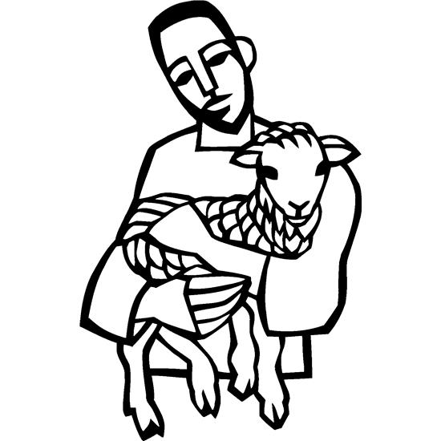

4th Sunday in Easter
May 11, 2025

SAINT PAUL LUTHERAN CHURCH
3383 EAST LAKE LANSING ROAD
EAST LANSING, MI 48823

PHONE (517) 351-8541

Pastor Carl E. Ballard
E-MAIL: pastor@stpaul-el.org
officemanager@stpaul-el.org

Visitors WELCOME! If this is your first time worshipping with us, please sign our guest registry just outside the sanctuary doors. We hope you are blessed through worship today. If you have any questions, please feel free to call the church at 351-8541.
Children are always welcome in worship! The choir room (off the sanctuary) can also be used as a cry room for younger children and includes a sound system so parents may continue to participate in the service. Clipboards with children's bulletins, activities and crayons are available for use during the service.
Sunday School is available during the worship service September-May except the last Sunday of the month.
Virtual Services We can provide a virtual live Zoom session during worship upon request.
This Bulletin is for your use during the service and to take home for the upcoming week. If you choose not to take it home, please place it in the recycle receptacle in the back.
Newsletters and Calendars of Upcoming Events are available in the lobby/narthex. We welcome anyone who has an interest in our small groups or activities! You can also look us up on the web at www.stpaul-el.org.
Contacting Us: Our Office Manager is Emily Polhamus. She can be reached by phone at 517-351-8541 or at her email address, officemanager@stpaul-el.org. Our Director of Music is Elene Kobulashvili. You may leave a message at 517-351-8541. Pastor Carl can be reached at 517-515-3129, and his email address is cballard123@msn.com.
Holy Communion is available at most services. All who believe in the real presence of Christ in the bread and the wine are invited to celebrate Communion with us. Those who wish may come forward for a blessing.
You’re invited to share in fellowship after worship. We would love this opportunity to introduce you to the St. Paul community.

P-Presiding Minister A-Assisting Minister C-Congregation
PRELUDE ELENE

INTRODUCTION
The gift of new life, of eternal life, is the gift of the risen Christ. It is the promise of Jesus. It was true for Dorcas in Joppa. It was true for those “who have come out of the great ordeal” in the Revelation vision. It is true for us and for all the baptized: Surely goodness and mercy shall follow me all the days of my life, and I will dwell in the house of the Lord forever.

GATHERING
P: The Holy Spirit calls us together as the people of God.

(Please rise as you are able.)

THANKSGIVING FOR BAPTISM
P: Alleluia! Christ is risen.
C: Christ is risen, indeed. Alleluia!
P: In the name of ☩ the One who was, who is, and who is to come.
C: Amen.
P: Baptized into Christ’s death and resurrection, and called to live the baptized life, let us give thanks for the gifts of baptism. Holy God, we give you thanks for the waters of baptism, waters that make a people your own, that restore to wholeness, and empower us to be witnesses in your name. Baptized into you, O Living One,
C: make us one as you are one.
P: We give you thanks for the waters of baptism, waters that strengthen believers and give new life to beloved servants of your church; waters that extend your boundless love and cross barriers of our own making. Baptized into you, O Living One,
C: make us one as you are one.
P: We give you thanks for the waters of baptism, waters that open the hearts of believers and give a voice in the night to those in captivity; waters that set your people on a new path, rejoicing in the Spirit’s power. Baptized into you, O Living One,
C: make us one as you are one.
P: Grant us grace, love, and life, O Living One, that our every day is shaped by these waters that give us our very lives in you. We ask this in the name of Jesus, the Crucified and Risen One.
C: Amen.

GATHERING SONG ELW 860
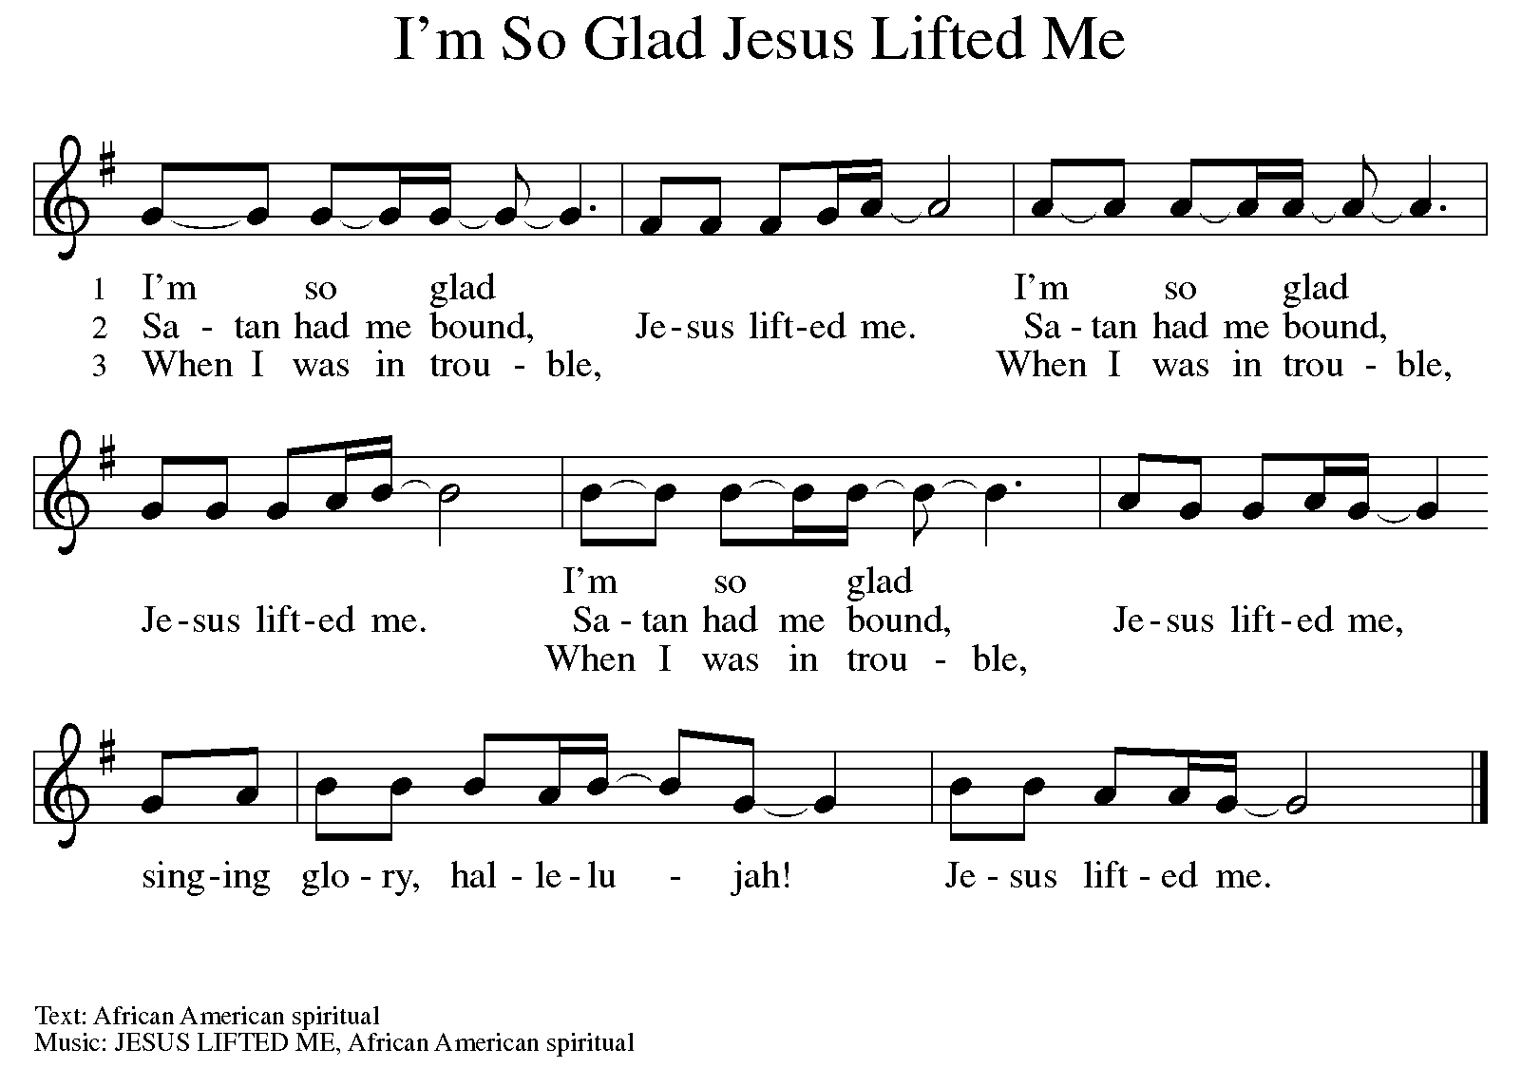
GREETING
P: The grace of our Lord Jesus Christ, the love of God, and the communion of the Holy Spirit be with you all.
C: And also with you.

KYRIE ELW Setting 8, Page 184-185
REFRAIN
Kyrie eleison, on our world and on our way.
Kyrie eleison, ev'ry day.
For peace in the world, for the health of the church,
for the unity of all;
for this holy house, for all who worship and praise,
let us pray to the Lord, let us pray to the Lord. Refrain

That we may live out your impassioned response
to the hungry and the poor;
that we may live out truth and justice and grace,
let us pray to the Lord, let us pray to the Lord. Refrain

For peace in our hearts, for peace in our homes,
for friends and family;
for life and for love, for our work and our play,
let us pray to the Lord, let us pray to the Lord. Refrain

For your Spirit to guide;
that you center our lives in the water and the Word;
that you nourish our souls with your body and blood,
let us pray to the Lord, let us pray to the Lord. Refrain

CANTICLE OF PRAISE ELW Setting 4, Page 149-150

This is the feast of victory for our God. Alleluia.
Worthy is Christ, the Lamb who was slain,
whose blood set us free to be people of God.
Power and riches and wisdom and strength,
and honor and blessing and glory are his.
This is the feast of victory for our God. Alleluia.

Sing with all the people of God
and join in the hymn of all creation:
Blessing and honor and glory and might
be to God and the Lamb forever. Amen.
This is the feast of victory for our God,
for the Lamb who was slain has begun his reign.
Alleluia. Alleluia.

PRAYER OF THE DAY

P: Let us pray. O God of peace, you brought again from the dead our Lord Jesus Christ, the great shepherd of the sheep. By the blood of your eternal covenant, make us complete in everything good that we may do your will, and work among us all that is well-pleasing in your sight, through Jesus Christ, our Savior and Lord, who lives and reigns with you and the Holy Spirit, one God, now and forever.

C: Amen.
(Please be seated.)

CHILDREN’S MESSAGE

(Children are invited to Sunday school.)

TRANSITION SONG ELW 509
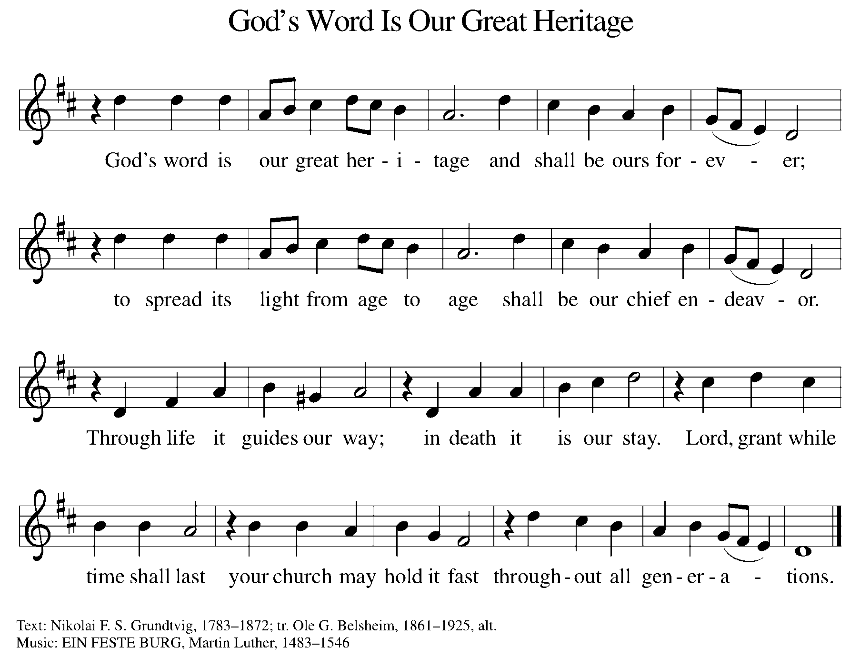
WORD
P: God speaks to us in scripture, preaching, and song.

First Reading ACTS 9:36-43
Dorcas was a faithful and devoted woman of charity in the community of Joppa. Her kindness and her work with clothing were well-known, especially to the widows in town. When she fell ill and died, Peter raised her back to life through the power of prayer.
³⁶ Now in Joppa there was a disciple whose name was Tabitha, which in Greek is Dorcas. She was devoted to good works and acts of charity. ³⁷ At that time she became ill and died. When they had washed her, they laid her in a room upstairs. ³⁸ Since Lydda was near Joppa, the disciples, who heard that Peter was there, sent two men to him with the request, “Please come to us without delay.” ³⁹ So Peter got up and went with them, and when he arrived, they took him to the room upstairs. All the widows stood beside him, weeping and showing tunics and other clothing that Dorcas had made while she was with them. ⁴⁰ Peter put all of them outside, and then he knelt down and prayed. He turned to the body and said, “Tabitha, get up.” Then she opened her eyes, and seeing Peter, she sat up. ⁴¹ He gave her his hand and helped her up. Then calling the saints and widows, he showed her to be alive. ⁴² This became known throughout Joppa, and many believed in the Lord. ⁴³ Meanwhile, he stayed in Joppa for some time with a certain Simon, a tanner.
Reader: Word of God, word of life. C: Thanks be to God.

PSALM PSALM 23
The Lord is my shepherd; I shall not be in want. (Ps. 23:1)

¹ The Lord is my shepherd; I shall not be in want.
² The Lord makes me lie down in green pastures and leads me beside still waters.
³ You restore my soul, O Lord, and guide me along right pathways for your name’s sake.
⁴ Though I walk through the valley of the shadow of death, I shall fear no evil; for you are with me; your rod and your staff, they comfort me.
⁵ You prepare a table before me in the presence of my enemies; you anoint my head with oil, and my cup is running over.
⁶ Surely goodness and mercy shall follow me all the days of my life, and I will dwell in the house of the Lord forever.

SECOND READING REVELATION 7:9-17
Christ is the shepherd who leads his faithful to springs of the water of life. Christ is also the lamb who vanquishes sin and suffering.

⁹ After this I looked, and there was a great multitude that no one could count, from every nation, from all tribes and peoples and languages, standing before the throne and before the Lamb, robed in white, with palm branches in their hands. ¹⁰ They cried out in a loud voice, saying, “Salvation belongs to our God who is seated on the throne and to the Lamb!”
¹¹ And all the angels stood around the throne and around the elders and the four living creatures, and they fell on their faces before the throne and worshiped God, ¹² singing, “Amen! Blessing and glory and wisdom and thanksgiving and honor and power and might be to our God forever and ever! Amen.”
¹³ Then one of the elders addressed me, saying, “Who are these, robed in white, and where have they come from?” ¹⁴ I said to him, “Sir, you are the one who knows.” Then he said to me, “These are they who have come out of the great ordeal; they have washed their robes and made them white in the blood of the Lamb. ¹⁵ For this reason they are before the throne of God and worship him day and night within his temple, and the one who is seated on the throne will shelter them. ¹⁶ They will hunger no more and thirst no more; the sun will not strike them, nor any scorching heat, ¹⁷ for the Lamb at the center of the throne will be their shepherd, and he will guide them to springs of the water of life, and God will wipe away every tear from their eyes.”
Reader: Word of God, word of life. C: Thanks be to God.

(Please rise as you are able.)

GOSPEL ACCLAMATION ELW Setting 8, Page 188
Alleluia. Lord, to whom shall we go?
You have the words of eternal life. Alleluia.
Alleluia, alleluia. Alleluia.
Alleluia, alleluia.

GOSPEL JOHN 10:22-30
P: The Holy Gospel according to John, the 10th chapter.
C: Glory to you, O Lord.
Jesus responds to questions about his identity with the remarkable claim that he and the Father are one. Those who understand this are his sheep; they hear his voice, follow, and will never be snatched from his hand.

²² At that time the Festival of the Dedication took place in Jerusalem. It was winter, ²³ and Jesus was walking in the temple, in the portico of Solomon. ²⁴ So the Jews gathered around him and said to him, “How long will you keep us in suspense? If you are the Messiah, tell us plainly.” ²⁵ Jesus answered, “I have told you, and you do not believe. The works that I do in my Father’s name testify to me, ²⁶ but you do not believe because you do not belong to my sheep. ²⁷ My sheep hear my voice. I know them, and they follow me. ²⁸ I give them eternal life, and they will never perish. No one will snatch them out of my hand. ²⁹ My Father, in regard to what he has given me, is greater than all, and no one can snatch them out of the Father’s hand. ³⁰ The Father and I are one.”
P: The Gospel of the Lord. C: Praise to you, O Christ.

(Please be seated.)

SERMON PASTOR CARL BALLARD
(Please rise as you are able.)
HYMN OF THE DAY ELW 780
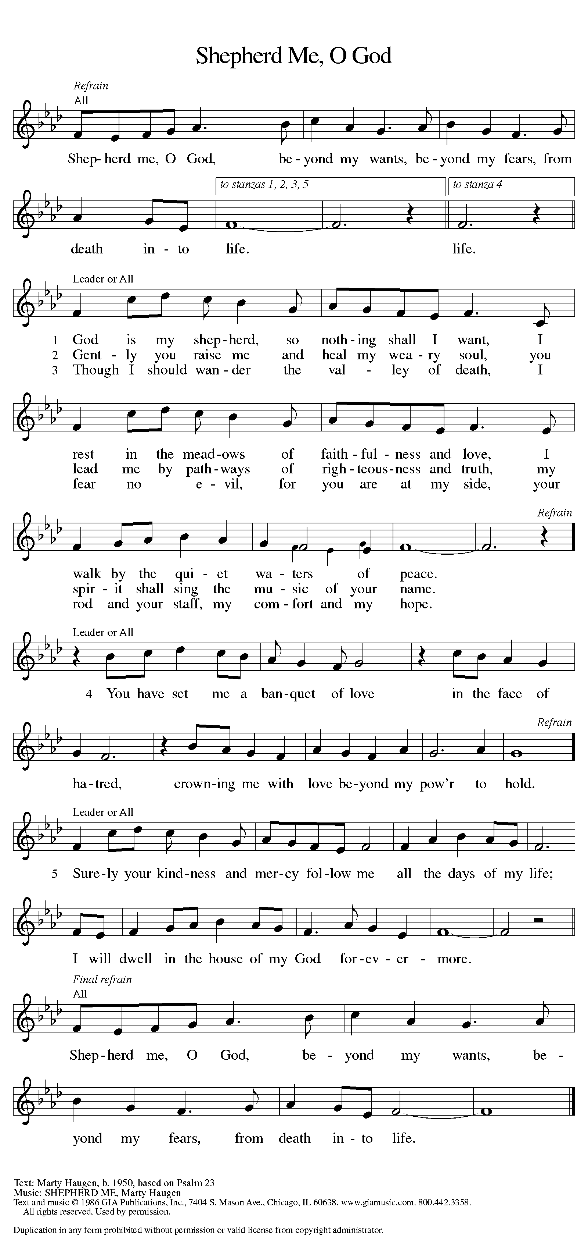
nicene CREED

We believe in one God,
the Father, the Almighty,
maker of heaven and earth,
of all that is, seen and unseen.

We believe in one Lord, Jesus Christ,
the only Son of God,
eternally begotten of the Father,
God from God, Light from Light,
true God from true God,
begotten, not made,
of one Being with the Father;
through him all things were made.
For us and for our salvation
he came down from heaven,
was incarnate of the Holy Spirit and the virgin Mary
and became truly human.
For our sake he was crucified under Pontius Pilate;
he suffered death and was buried.
On the third day he rose again
in accordance with the scriptures;
he ascended into heaven
and is seated at the right hand of the Father.
He will come again in glory to judge the living and the dead,
and his kingdom will have no end.

We believe in the Holy Spirit, the Lord, the giver of life.
who proceeds from the Father and the Son,
who with the Father and the Son is worshiped and glorified,
who has spoken through the prophets.
We believe in one holy catholic and apostolic church.
We acknowledge one baptism for the forgiveness of sins.
We look for the resurrection of the dead,
and the life of the world to come. Amen.

(Please be seated.)

THE PRAYERS
A: God of resurrection and new life, we come before you in prayer for the church, the world, and all who are in need.
(A brief silence.)
A: You guide your people to the waters of life. Make your church a nourishing place for all who are thirsty for hope and healing. Renew us in the waters of baptism, and send us forth as signs of your love. Hear us, O God.
C: Your mercy is great.
A: You tend to the earth, sustaining life in all places. Revive fragile ecosystems and restore species in danger of extinction. Teach us new ways of living in balance and harmony with our non-human neighbors. Hear us, O God.
C: Your mercy is great.
A: You lead all peoples along right pathways. Grant wisdom and compassion to judges, lawyers, mediators, and legal advocates. Dismantle systems of mass incarceration, empower processes of restorative justice, and encourage all who strive for healing in our communities. Hear us, O God.
C: Your mercy is great.
A: This Mother’s Day, bless mothers, grandmothers, and all who offer mothering care. Come close to those whose relationships with their families are difficult, and console all who grieve the loss of mother figures or the loss of children. Hear us, O God.
C: Your mercy is great.
A: You defend justice and peace. Guard those who serve in our armed forces as they strive to bring justice and peace to an unsettled world. We pray especially for Beth & Ryan, Jonathan, Jacob, Noah, Irene, and Alex. Hear us, O God.
C: Your mercy is great.
A: You wipe the tears from every eye. Tend to all who struggle with anxiety or depression, loneliness or despair. Enfold all who are in any need in your shepherding care, especially Ahren, Beth Ra., B.J., Carolyn, Dan, David, Don, Doretta, Family & friends of Joseph Ra., Family & friends of Nina, Gage, Gunny, Jim & Cheri, John, Johnny, Jon, Jordan, Lawton, Lera & family, Linda, Lizzy, Marge, Patty, Randy, Rick & Kathy, Sheri, Sheri, Stacy, Steve, Susan, and Wanda, and all whom we name now aloud and in our hearts. Hear us, O God.
C: Your mercy is great.
A: You have called our church’s leaders to carry on your work here on earth, and you speak to us through them. Equip them with your word and wisdom as they respond to your call. We pray especially for Presiding Bishop Elizabeth, our Synod Bishop Craig, and Pastor Carl. We ask that you be with their respective staffs as they live out their callings to serve. As we are called to be one, even as Jesus and the Father are one, be with the leaders and the congregation of Edgewood Lutheran Church in Fruitport and the churches in our community. Hear us, O God.
C: Your mercy is great.
A: You are the source of everlasting life. In deep gratitude for all your saints, we rejoice in the joy and hope of the resurrection made known to us in Jesus, your beloved child. Hear us, O God.
C: Your mercy is great.
P: We commend these and all our prayers to you, O God, trusting that you are always with us; in the name of Jesus Christ, our risen Savior.
C: Amen.

GREETING OF PEACE
P: The peace of Christ be with you always.
C: And also with you.
(You are invited to share Christ’s peace with one another.)
(Please be seated.)
MEAL
OFFERING ELENE
(Please rise as you are able.)
OFFERTORY ELW 186
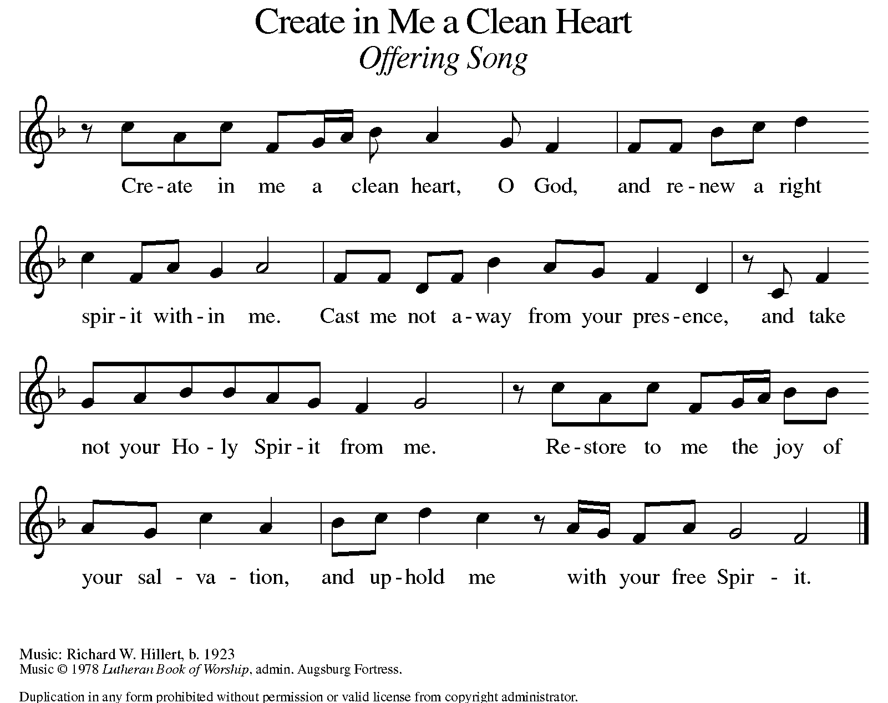
OFFERING PRAYER
A: Let us pray. Risen One, you have gathered us around your table of grace
along with these gifts we bring. Come among us again, breathe your life into us, and enliven us with this meal, that we may live as your risen body in the world.

C: Amen.

THE GREAT THANKSGIVING
P: The Lord be with you.
C: And also with you.
P: Lift up your hearts.
C: We lift them to the Lord.
P: Let us give thanks to the Lord our God.
C: It is right to give our thanks and praise.

PROPER PREFACE
P: It is indeed right, our duty and our joy, that we should at all times and in all places give thanks and praise to you, almighty and merciful God, for the glorious resurrection of our Savior Jesus Christ, the true Paschal Lamb who gave himself to take away our sin; who in dying has destroyed death, and in rising has brought us to eternal life. And so, with Mary Magdalene and Peter and all the witnesses of the resurrection, with earth and sea and all their creatures, and with angels and archangels, cherubim and seraphim, we praise your name and join their unending hymn:

HOLY, HOLY ELW Setting 8, Page 190
Holy, holy, holy Lord,
God of pow’r and might,
heaven and earth are full of your glory, full of your glory.
Hosanna, hosanna, hosanna in the highest.
Blessed is he who comes in the name of the Lord.
Hosanna, hosanna, hosanna in the highest.

EUCHARISTIC PRAYER
P: In the night in which he was betrayed, our Lord Jesus took bread, and gave thanks; broke it, and gave it to his disciples, saying:
Take and eat; this is my body, given for you.
Do this for the remembrance of me.
Again, after supper, he took the cup, gave thanks, and gave it for all to drink, saying:
This cup is the new covenant in my blood, shed for you and for all people for the forgiveness of sin. Do this for the remembrance of me.

LORD'S PRAYER
P: Lord, remember us in your kingdom, and teach us to pray:
C: Our Father in heaven, hallowed be your name, your kingdom come, your will be done, on earth as in heaven. Give us today our daily bread. Forgive us our sins as we forgive those who sin against us. Save us from the time of trial and deliver us from evil. For the kingdom, the power, and the glory are yours, now and forever. Amen.

(Please be seated.)

COMMUNION DISTRIBUTION
All who believe in the real presence of Christ in the bread and the wine (juice) are welcome to the table. Others may come forward for a blessing. If you prefer grape juice, please indicate this to the assisting minister.
When approaching the communion rail, come forward down the side aisle; kneel if you are able, starting at the front of the communion rail (spot closest to the font) on your side and filling in toward the altar. After receiving both the bread and the wine, you may return to your seat by the center aisle.

INVITATION TO COMMUNION
P: Come to the table of grace. Receive the gift of new life.

COMMUNION HYMN ELW 472
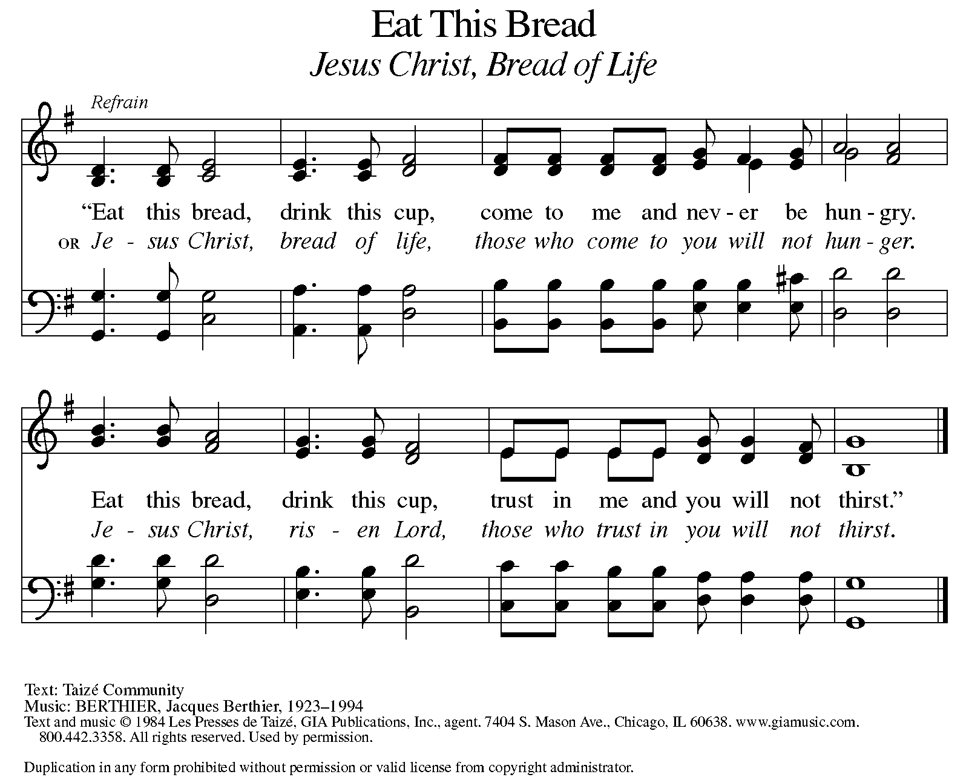
P: The body of Christ, given for you.
C: Amen.
A: The blood of Christ shed for you.
C: Amen.
(Please rise as you are able.)

P: May the body and blood of our Lord Jesus Christ strengthen and keep you in his grace.
C: Amen.

PRAYER AFTER COMMUNION
P: Let us pray. Living One, in this feast you have made yourself known to us. Send us now to tell of your wonders, sing of your glory, and proclaim your risen life to a wounded and weary world.
C: Amen.

SENDING

BLESSING
P: The triune God, who was, who is, and who is to come, Sovereign, ☩ Savior, and Spirit, light your way with resurrection dawn, now and always.
C: Amen.

SENDING HYMN LEAD ME, GUIDE ME ELW 768

REFRAIN
Lead me, guide me, along the way;
for if you lead me, I cannot stray.
Lord, let me walk each day with thee.
Lead me, O Lord, lead me.

1 I am weak and I need thy strength and pow’r
to help me over my weakest hour.
Help me through the darkness thy face to see.
Lead me, O Lord, lead me.

REFRAIN

2 Help me tread in the paths of righteousness,
be my aid when Satan and sin oppress.
I am putting all my trust in thee.
Lead me, O Lord, lead me.

REFRAIN

3 I am lost if you take your hand from me,
I am blind without thy light to see.
Lord, just always let me thy servant be.
Lead me, O Lord, lead me.

REFRAIN

DISMISSAL
A: Alleluia! Christ is risen.
C: Christ is risen indeed. Alleluia!
A: Go in peace. In Christ you are made new. Alleluia! Alleluia!
C: Thanks be to God. Alleluia! Alleluia!

Announcements

- Sunday, May 11 – Happy Mother’s Day!
- Wednesday, May 14 – Gather Pg. 24 Session 4 for Women’s Bible Study.
- Saturday, May 17 & Sunday, May 18 – East Lansing Art Festival Downtown.
- Sunday, May 18 – Tuesday, May 20 – Synod Assembly, Mt. Pleasant Election of the Bishop.
- Monday, May 26 – Memorial Day!
- Sunday, June 1 – Fish Fry @ 11:15am following service. All donations go to St. Paul Food Pantry.

Recurring Events

- Every Sunday – Adult Bible Study @ 9am
- Monday, June 2 – Worship Committee Meeting @ 6:30pm
- Wednesday, May 14 – Women’s Bible Study @ 11am
- Thursday, May 15 – Council Meeting @ 7pm

Food Pantry Dates

Thursday, May 15, 1-3pm
Wednesday, May 21, 5-6:30pm
Thursday, May 29, 1-3pm
Wednesday, June 4, 5-6:30pm
Thursday, June 12, 1-3pm

Volunteers for May 11 Volunteers for May 18

Reader Sunday - Volunteer Reader Sunday – Volunteer
Assisting Minister - Volunteer Assisting Minister – Volunteer

May Birthday Celebrations

5/2 – Jemal Ta.
5/2 – Melissa Ki.
5/9 – Pr. Carl
5/23 – Jim Cr.

May Anniversary Celebrations

5/11 – Emily & AJ Po.
5/26 – Jon & Tzulun Ke.

Acknowledgments
- OneLicense.net, License #A-703165.
- CCLI, License #2281869.
- From SundaysandSeasons.com. Copyright 2022 Augsburg Fortress. All rights reserved. Reprinted by permission under Augsburg Fortress Liturgies Annual License #23806.
- New Revised Standard Version Bible, copyright 1989, Division of Christian Education of the National Council of the Churches of Christ in the United States of America. Used by permission. All rights reserved.

