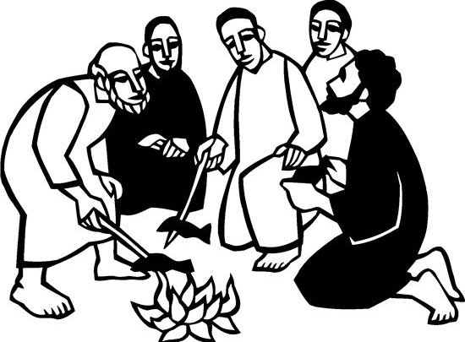

3rd Sunday in Easter
May 4, 2025


SAINT PAUL LUTHERAN CHURCH
3383 EAST LAKE LANSING ROAD
EAST LANSING, MI 48823

PHONE (517) 351-8541

Pastor Carl E. Ballard
E-MAIL: pastor@stpaul-el.org
officemanager@stpaul-el.org
Visitors WELCOME! If this is your first time worshipping with us, please sign our guest registry just outside the sanctuary doors. We hope you are blessed through worship today. If you have any questions, please feel free to call the church at 351-8541.
Children are always welcome in worship! The choir room (off the sanctuary) can also be used as a cry room for younger children and includes a sound system so parents may continue to participate in the service. Clipboards with children's bulletins, activities and crayons are available for use during the service.
Sunday School is available during the worship service September-May except the last Sunday of the month.
Virtual Services We can provide a virtual live Zoom session during worship upon request.
This Bulletin is for your use during the service and to take home for the upcoming week. If you choose not to take it home, please place it in the recycle receptacle in the back.
Newsletters and Calendars of Upcoming Events are available in the lobby/narthex. We welcome anyone who has an interest in our small groups or activities! You can also look us up on the web at www.stpaul-el.org.
Contacting Us: Our Office Manager is Emily Polhamus. She can be reached by phone at 517-351-8541 or at her email address, officemanager@stpaul-el.org. Our Director of Music is Elene Kobulashvili. You may leave a message at 517-351-8541. Pastor Carl can be reached at 517-515-3129, and his email address is cballard123@msn.com.
Holy Communion is available at most services. All who believe in the real presence of Christ in the bread and the wine are invited to celebrate Communion with us. Those who wish can come forward for a blessing.
You’re invited to share in fellowship after worship. We would love this opportunity to introduce you to the St. Paul community.

P-Presiding Minister A-Assisting Minister C-Congregation

PRELUDE ELENE

INTRODUCTION

The disciples make a big splash and eat breakfast with the risen Jesus. Wading in the water (remembering baptism) and eating with Jesus (celebrating holy communion) is our weekly encounter with the risen Christ. Jesus asks us again and again: Do you love me? And Jesus invites us, again and again, to follow him, bringing the Easter life to others.

GATHERING

P: The Holy Spirit calls us together as the people of God.

(Please rise as you are able.)

THANKSGIVING FOR BAPTISM

P: Alleluia! Christ is risen.

C: Christ is risen, indeed. Alleluia!

P: In the name of ☩ the One who was, who is, and who is to come.

C: Amen.

P: Baptized into Christ’s death and resurrection, and called to live the baptized life, let us give thanks for the gifts of baptism.

(Silence is kept for reflection)

P: Holy God, we give you thanks for the waters of baptism, waters that make a people your own, that restore to wholeness, and empower us to be witnesses in your name. Baptized into you, O Living One,

C: make us one as you are one.

P: We give you thanks for the waters of baptism, waters that strengthen believers and give new life to beloved servants of your church; waters that extend your boundless love and cross barriers of our own making. Baptized into you, O Living One,

C: make us one as you are one.

P: We give you thanks for the waters of baptism, waters that open the hearts of believers and give a voice in the night to those in captivity; waters that set your people on a new path, rejoicing in the Spirit’s power. Baptized into you, O Living One,

C: make us one as you are one.

P: Grant us grace, love, and life, O Living One, that our every day is shaped by these waters that give us our very lives in you. We ask this in the name of Jesus, the Crucified and Risen One.

C: Amen.

GATHERING SONG ELW 588
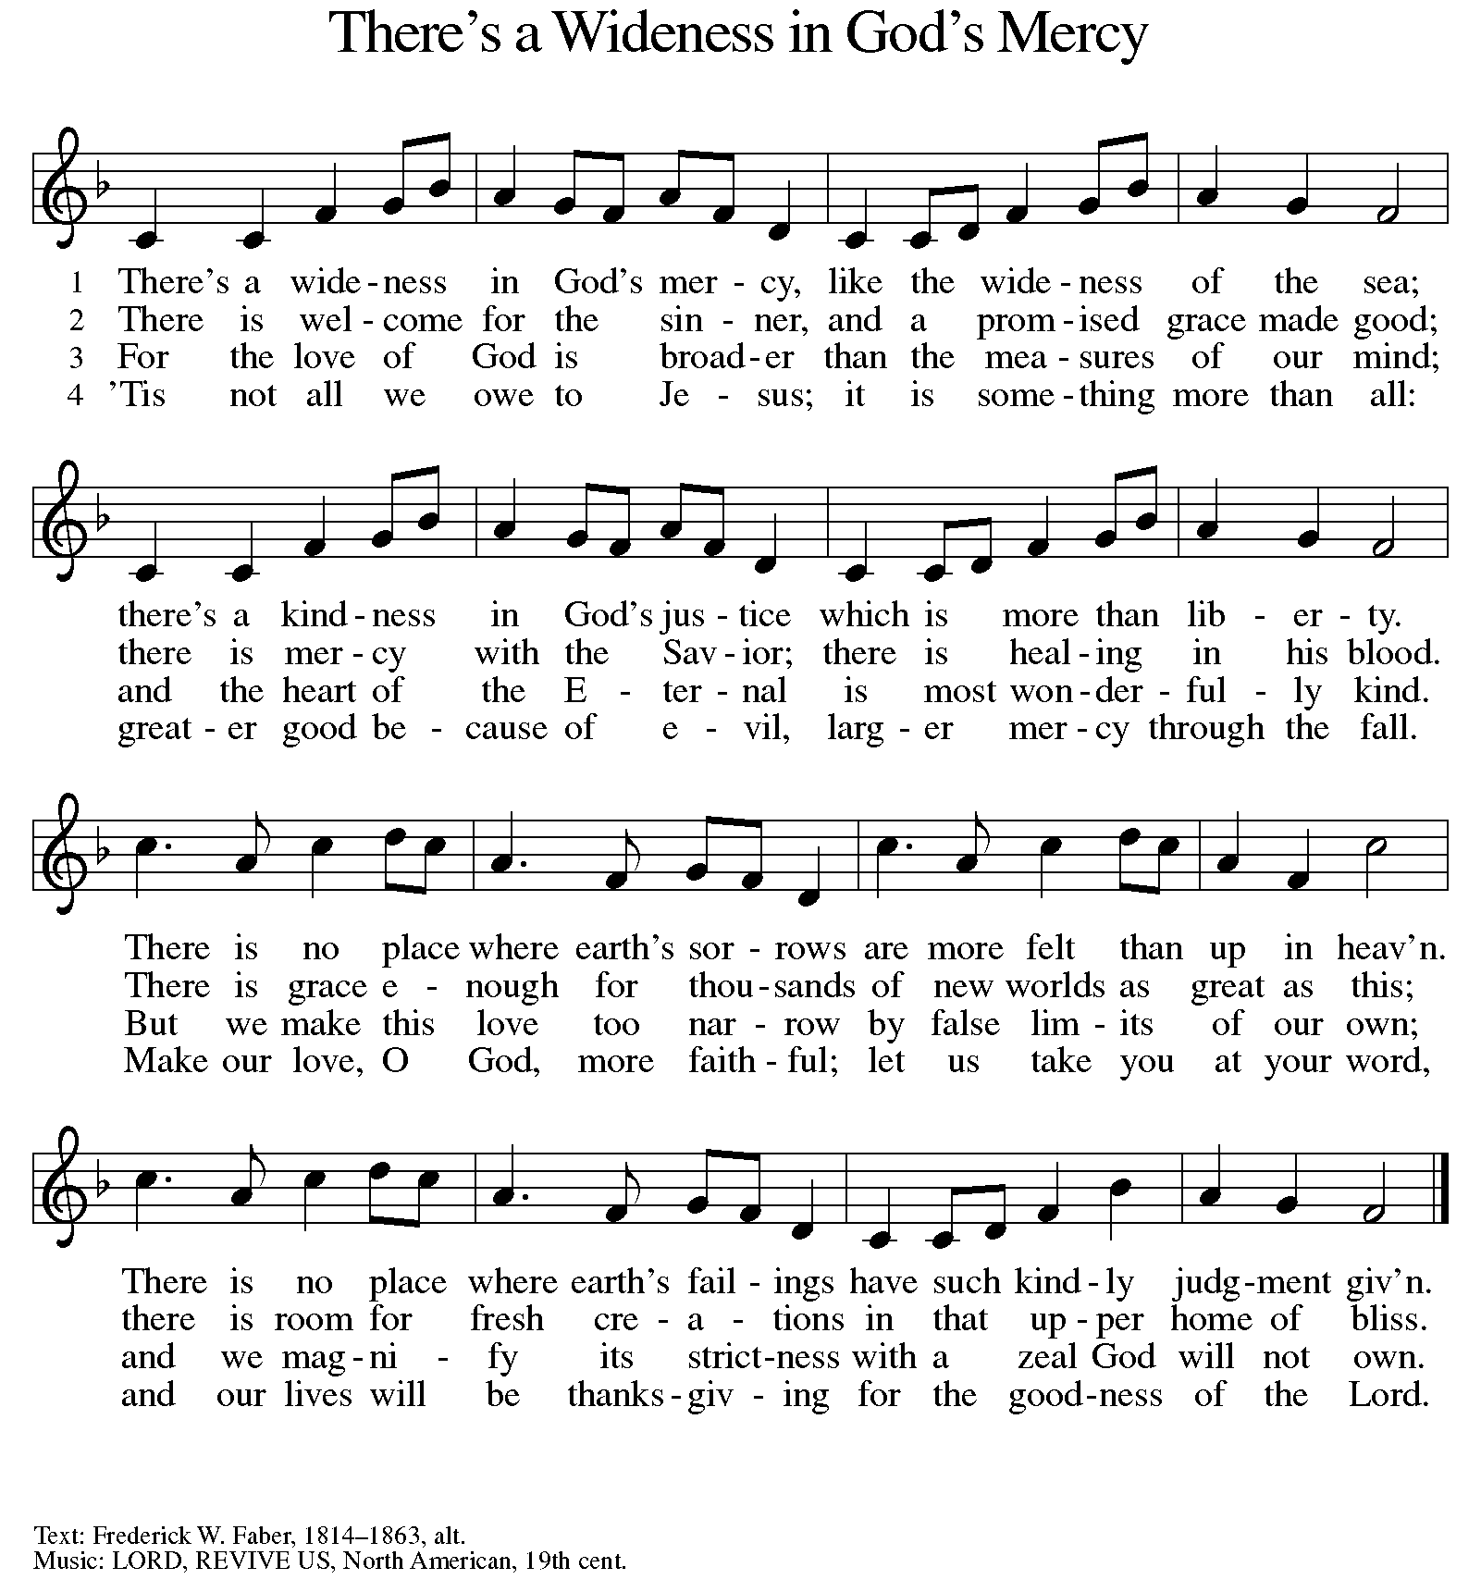

GREETING

P: The grace of our Lord Jesus Christ, the love of God, and the communion of the Holy Spirit be with you all.

C: And also with you.

KYRIE ELW Setting 10, Page 203

Have mercy on us, Lord,
and hear our solemn prayer.
We come to hear your living word;
it saves us from despair.

Have mercy on us, Christ,
and wash away our sin.
Pour out your grace and make us whole
that new life may begin.

Have mercy on us, Lord;
make sin and shame depart.
Renew us with your saving pow’r;
create in us new hearts!

CANTICLE OF PRAISE ELW Setting 4, Page 149-150

This is the feast of victory for our God.
Alleluia.

Worthy is Christ, the Lamb who was slain,
whose blood set us free to be people of God.
Power and riches and wisdom and strength,
and honor and blessing and glory are his.
This is the feast of victory for our God.
Alleluia.

Sing with all the people of God
and join in the hymn of all creation:
Blessing and honor and glory
and might be to God and the Lamb forever.
Amen.

This is the feast of victory for our God,
for the Lamb who was slain has begun his reign.
Alleluia. Alleluia.

PRAYER OF THE DAY

P: Let us pray. Eternal and all-merciful God, with all the angels and all the saints we laud your majesty and might. By the resurrection of your Son, show yourself to us and inspire us to follow Jesus Christ, our Savior and Lord, who lives and reigns with you and the Holy Spirit, one God, now and forever.

C: Amen.

(Please be seated.)

CHILDREN’S MESSAGE

(Children are invited to Sunday School.)

TRANSITION SONG ELW 509
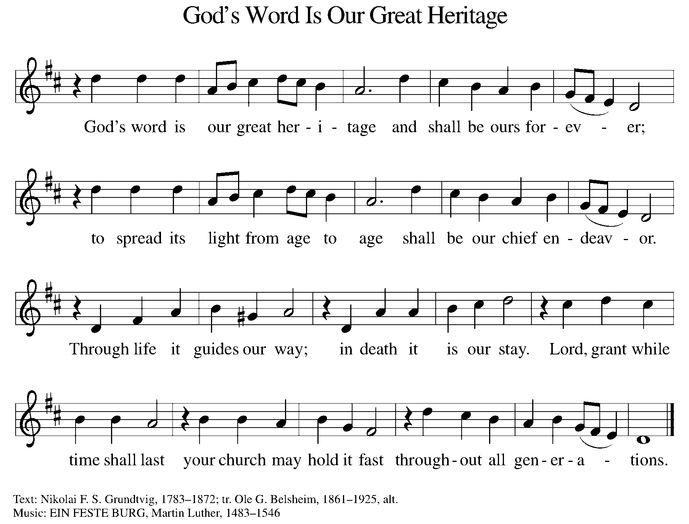

WORD

P: God speaks to us in scripture, preaching, and song.

FIRST READING ACTS 9:1-6 [7-20]

Saul (later called Paul) was an ardent persecutor of all who followed the Way of Christ. This reading recounts the story of his transformation beginning with an encounter with Jesus Christ on the way to Damascus.

¹ Saul, still breathing threats and murder against the disciples of the Lord, went to the high priest ² and asked him for letters to the synagogues at Damascus, so that if he found any who belonged to the Way, men or women, he might bring them bound to Jerusalem. ³ Now as he was going along and approaching Damascus, suddenly a light from heaven flashed around him. ⁴ He fell to the ground and heard a voice saying to him, “Saul, Saul, why do you persecute me?” ⁵ He asked, “Who are you, Lord?” The reply came, “I am Jesus, whom you are persecuting. ⁶ But get up and enter the city, and you will be told what you are to do.”

^{[7} The men who were traveling with him stood speechless because they heard the voice but saw no one. ⁸ Saul got up from the ground, and though his eyes were open, he could see nothing; so they led him by the hand and brought him into Damascus. ⁹ For three days he was without sight and neither ate nor drank. ¹⁰ Now there was a disciple in Damascus named Ananias. The Lord said to him in a vision, “Ananias.” He answered, “Here I am, Lord.”

¹¹ The Lord said to him, “Get up and go to the street called Straight, and at the house of Judas look for a man of Tarsus named Saul. At this moment he is praying, ¹² and he has seen in a vision a man named Ananias come in and lay his hands on him so that he might regain his sight.” ¹³ But Ananias answered, “Lord, I have heard from many about this man, how much evil he has done to your saints in Jerusalem, ¹⁴ and here he has authority from the chief priests to bind all who invoke your name.” ¹⁵ But the Lord said to him, “Go, for he is an instrument whom I have chosen to bring my name before gentiles and kings and before the people of Israel; ¹⁶ I myself will show him how much he must suffer for the sake of my name.”

¹⁷ So Ananias went and entered the house. He laid his hands on Saul and said, “Brother Saul, the Lord Jesus, who appeared to you on your way here, has sent me so that you may regain your sight and be filled with the Holy Spirit.” ¹⁸ And immediately something like scales fell from his eyes, and his sight was restored. Then he got up and was baptized, ¹⁹ and after taking some food, he regained his strength. For several days he was with the disciples in Damascus, ²⁰ and immediately he began to proclaim Jesus in the synagogues, saying, “He is the Son of God.”]

Reader: Word of God, word of life. C: Thanks be to God.
PSALM PSALM 30

You have turned my wailing into dancing. (Ps. 30:11)

¹ I will exalt you, O Lord, because you have lifted me up and have not let my enemies triumph over me.
² O Lord my God, I cried out to you, and you restored me to health.
³ You brought me up, O Lord, from the dead; you restored my life as I was going down to the grave.
⁴ Sing praise to the Lord, all you faithful; give thanks in holy remembrance.
⁵ God’s wrath is short; God’s favor lasts a lifetime. Weeping spends the night, but joy comes in the morning.
⁶ While I felt secure, I said, “I shall never be disturbed.
⁷ You, Lord, with your favor, made me as strong as the mountains.” Then you hid your face, and I was filled with fear.
⁸ I cried to you, O Lord; I pleaded with my Lord, saying,
⁹ “What profit is there in my blood, if I go down to the pit? Will the dust praise you or declare your faithfulness?
¹⁰ Hear, O Lord, and have mercy upon me; O Lord, be my helper.”
¹¹ You have turned my wailing into dancing; you have put off my sackcloth and clothed me with joy.
¹² Therefore my heart sings to you without ceasing; O Lord my God, I will give you thanks forever.

SECOND READING REVELATION 5:11-14

The vision of John recorded in Revelation offers a glimpse of cosmic worship around the throne. At its center is “the Lamb who was slain.”

¹¹ Then I looked, and I heard the voice of many angels surrounding the throne and the living creatures and the elders; they numbered myriads of myriads and thousands of thousands, ¹² singing with full voice, “Worthy is the Lamb that was slaughtered to receive power and wealth and wisdom and might and honor and glory and blessing!” ¹³ Then I heard every creature in heaven and on earth and under the earth and in the sea and all that is in them, singing, “To the one seated on the throne and to the Lamb be blessing and honor and glory and might forever and ever!” ¹⁴ And the four living creatures said, “Amen!” And the elders fell down and worshiped.

Reader: Word of God, word of life. C: Thanks be to God.

(Please rise as you are able.)

GOSPEL ACCLAMATION ELW SETTING 10, PAGE 205

Alleluia! Lord and Savior: open now your saving word.
Let it burn like fire within us; speak until our hearts are stirred.
Alleluia! Lord, we sing for the good news that you bring.

GOSPEL JOHN 21:1-19

P: The Holy Gospel according to John, the 21st chapter.

C: Glory to you, O Lord.

The risen Christ appears again to his disciples by the sea where they were first called. After echoes of the fishing and feeding miracles, he gives a final reminder of the cost of a disciple’s love and obedience.

¹ After [he appeared to his followers in Jerusalem,] Jesus showed himself again to the disciples by the Sea of Tiberias, and he showed himself in this way. ² Gathered there together were Simon Peter, Thomas called the Twin, Nathanael of Cana in Galilee, the sons of Zebedee, and two others of his disciples. ³ Simon Peter said to them, “I am going fishing.” They said to him, “We will go with you.” They went out and got into the boat, but that night they caught nothing.

⁴ Just after daybreak, Jesus stood on the beach, but the disciples did not know that it was Jesus. ⁵ Jesus said to them, “Children, you have no fish, have you?” They answered him, “No.” ⁶ He said to them, “Cast the net to the right side of the boat, and you will find some.” So they cast it, and now they were not able to haul it in because there were so many fish. ⁷ That disciple whom Jesus loved said to Peter, “It is the Lord!” When Simon Peter heard that it was the Lord, he put on his outer garment, for he had taken it off, and jumped into the sea. ⁸ But the other disciples came in the boat, dragging the net full of fish, for they were not far from the land, only about a hundred yards off.

⁹ When they had gone ashore, they saw a charcoal fire there, with fish on it, and bread. ¹⁰ Jesus said to them, “Bring some of the fish that you have just caught.” ¹¹ So Simon Peter went aboard and hauled the net ashore, full of large fish, a hundred fifty-three of them, and though there were so many, the net was not torn. ¹² Jesus said to them, “Come and have breakfast.” Now none of the disciples dared to ask him, “Who are you?” because they knew it was the Lord. ¹³ Jesus came and took the bread and gave it to them and did the same with the fish. ¹⁴ This was now the third time that Jesus appeared to the disciples after he was raised from the dead.

¹⁵ When they had finished breakfast, Jesus said to Simon Peter, “Simon son of John, do you love me more than these?” He said to him, “Yes, Lord; you know that I love you.” Jesus said to him, “Feed my lambs.” ¹⁶ A second time he said to him, “Simon son of John, do you love me?” He said to him, “Yes, Lord; you know that I love you.” Jesus said to him, “Tend my sheep.” ¹⁷ He said to him the third time, “Simon son of John, do you love me?” Peter felt hurt because he said to him the third time, “Do you love me?” And he said to him, “Lord, you know everything; you know that I love you.” Jesus said to him, “Feed my sheep. ¹⁸ Very truly, I tell you, when you were younger, you used to fasten your own belt and to go wherever you wished. But when you grow old, you will stretch out your hands, and someone else will fasten a belt around you and take you where you do not wish to go.” ¹⁹ (He said this to indicate the kind of death by which he would glorify God.) After this he said to him, “Follow me.”

P: The Gospel of the Lord. C: Praise to you, O Christ.

(Please be seated.)

SERMON Jon K.

(Please rise as you are able.)

HYMN OF THE DAY ELW 666
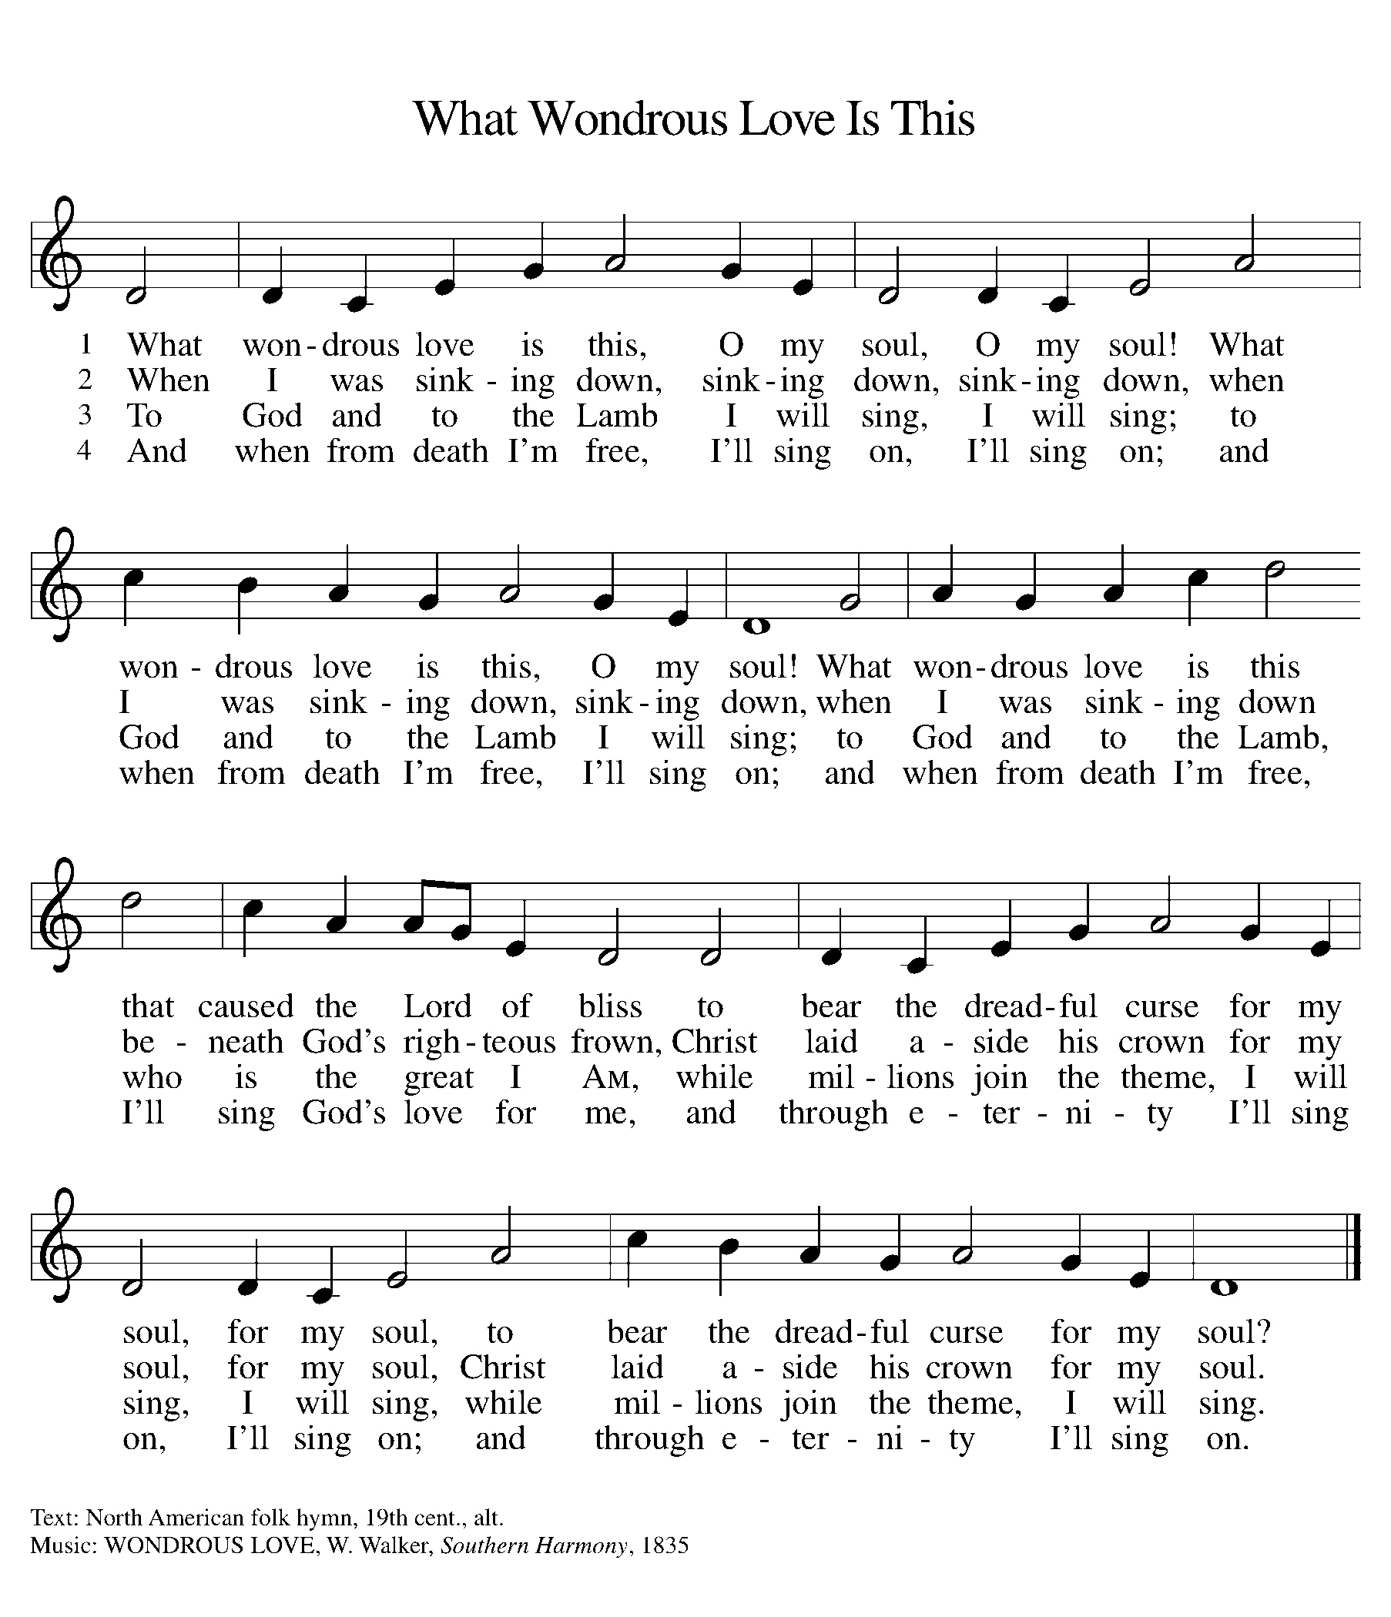

NICENE CREED

We believe in one God,
the Father, the Almighty,
maker of heaven and earth,
of all that is, seen and unseen.
We believe in one Lord, Jesus Christ,
the only Son of God,
eternally begotten of the Father,
God from God, Light from Light,
true God from true God,
begotten, not made,
of one Being with the Father;
through him all things were made.
For us and for our salvation
he came down from heaven,
was incarnate of the Holy Spirit and the virgin Mary
and became truly human.
For our sake he was crucified under Pontius Pilate;
he suffered death and was buried.
On the third day he rose again
in accordance with the scriptures;
he ascended into heaven
and is seated at the right hand of the Father.
He will come again in glory to judge the living and the dead,
and his kingdom will have no end.

We believe in the Holy Spirit, the Lord, the giver of life.
who proceeds from the Father and the Son,
who with the Father and the Son is worshiped and glorified,
who has spoken through the prophets.
We believe in one holy catholic and apostolic church.
We acknowledge one baptism for the forgiveness of sins.
We look for the resurrection of the dead,
and the life of the world to come. Amen.

(Please be seated.)

THE PRAYERS

A: God of resurrection and new life, we come before you in prayer for the church, the world, and all who are in need.
(A brief silence.)
A: Your love sustains the church and its ministries. By that love, equip youth directors, Sunday school teachers, and all who guide formation in the church to nurture vibrant, living faith among your people. Hear us, O God.
C: Your mercy is great.

A: Your abundance is made known throughout creation. Preserve oceans and rivers, lakes and estuaries so that all creatures living in them might flourish. Make us wise stewards of our local watersheds. Hear us, O God.

C: Your mercy is great.

A: Your wisdom guides all who strive for justice and peace. Strengthen the work of grassroots organizers, especially among communities on the frontlines of justice work. Amplify the voices of those most in need, that their leadership guides the way forward. Hear us, O God.

C: Your mercy is great.

A: Your compassion surrounds all who are in need. We pray for all people experiencing poverty and food insecurity, and for all struggling with debt and economic uncertainty. Reassure all who experience hopelessness or need your tender care. Hear us, O God.

C: Your mercy is great.

A: You invite all people to your table of grace. Make this a community of radical hospitality where all feel loved and celebrated. Show us how to better welcome visitors and bless the ministries of hospitality in this place. Hear us, O God.

C: Your mercy is great.

A: Your strength gives courage, Lord. We pray that you will provide that sustenance and care for those who service in our armed forces, especially
Beth & Ryan, Jonathan, Jacob, Noah, Irene, and Alex. Hear us, O God.

C: Your mercy is great.

A: You heal both body and soul. Show us how to care for those who are bowed down with illness or sorrow and those who are undergoing transition in relationships, occupation, living situation, or health condition, especially Ahren, Beth Ra., B.J., Carolyn, Dan, David, Don, Doretta, Family & friends of Joseph Ra., Family & friends of Nina, Gage, Jim & Cheri, John, Johnny, Jon, Jordan, Lawton, Lera & family, Linda, Lizzy, Marge, Randy, Rick & Kathy, Sheri, Sheri, Stacy, Steve, Susan, and Wanda, and all that we name now aloud and in our hearts. Hear us, O God.

C: Your mercy is great.

A: You have guided the church’s leaders throughout history. Continue to make your way known to them, especially to Presiding Bishop Elizabeth, our Synod Bishop Craig, and Pastor Carl. We ask that you be with their respective staffs as they live out their callings to serve. As we are called to be one, even as Jesus and the Father are one, be with the leaders and the congregation of Zion Lutheran Church in Freeland and all the churches in our community. Hear us, O God.

C: Your mercy is great.

A: We praise you for the witness of your saints of all times and places. May their lives of faith guide us in our own journeys with you, today and every day. Hear us, O God.

C: Your mercy is great.

P: We commend these and all our prayers to you, O God, trusting that you are always with us; in the name of Jesus Christ, our risen Savior.

C: Amen.

GREETING OF PEACE

P: The peace of Christ be with you always.

C: And also with you.

(You are invited to share Christ’s peace with one another.)

(Please be seated.)

MEAL

OFFERING ELENE

OFFERTORY ELW 186
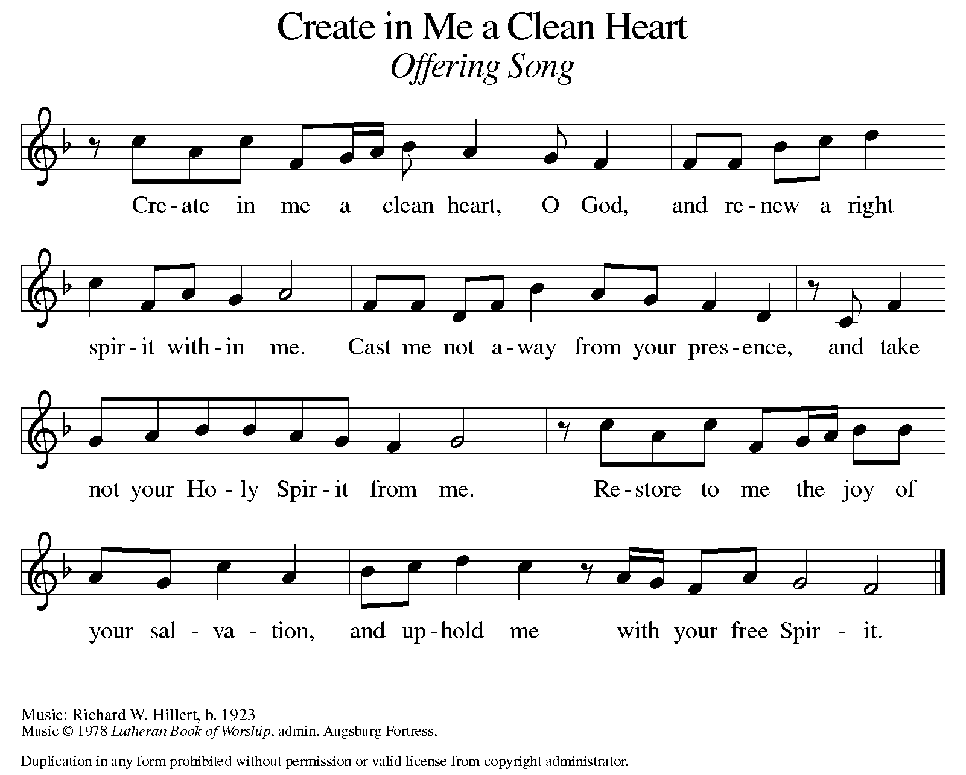

OFFERING PRAYER

A: Let us pray. Risen One, you have gathered us around your table of grace along with these gifts we bring. Come among us again, breathe your life into us, and enliven us with this meal, that we may live as your risen body in the world.

C: Amen.

THE GREAT THANKSGIVING

P: The Lord be with you.
C: And also with you.
P: Lift up your hearts.
C: We lift them to the Lord.
P: Let us give thanks to the Lord our God.
C: It is right to give our thanks and praise.

PROPER PREFACE

P: It is indeed right, our duty and our joy, that we should at all times and in all places give thanks and praise to you, almighty and merciful God, for the glorious resurrection of our Savior Jesus Christ, the true Paschal Lamb who gave himself to take away our sin; who in dying has destroyed death, and in rising has brought us to eternal life. And so, with Mary Magdalene and Peter and all the witnesses of the resurrection, with earth and sea and all their creatures, and with angels and archangels, cherubim and seraphim, we praise your name and join their unending hymn:

HOLY, HOLY ELW SETTING 10, Page 207

Holy, holy, holy Lord,
God of power and might,
heav’n and earth are full of your glory.
Hosanna in the highest.
Blessed is he who comes in the name of the Lord.
Hosanna in the highest,
hosanna in the highest.

EUCHARISTIC PRAYER

P: In the night in which he was betrayed, our Lord Jesus took bread, and gave thanks; broke it, and gave it to his disciples, saying:
Take and eat; this is my body, given for you. Do this for the remembrance of me.
Again, after supper, he took the cup, gave thanks, and gave it for all to drink, saying:
This cup is the new covenant in my blood, shed for you and for all people for the forgiveness of sin. Do this for the remembrance of me.

LORD'S PRAYER

P: Lord, remember us in your kingdom, and teach us to pray:

C: Our Father, who art in heaven, hallowed by thy name, thy kingdom come, thy will be done, on earth as it is in heaven. Give us this day our daily bread; and forgive us our trespasses, as we forgive those who trespass against us; and lead us not into temptation, but deliver us from evil. For thine is the kingdom, and the power, and the glory, forever and ever. Amen.

COMMUNION DISTRIBUTION

All who believe in the real presence of Christ in the bread and the wine (juice) are welcome to the table. Others may come forward for a blessing. If you prefer grape juice, please indicate this to the assisting minister.

When approaching the communion rail, come forward down the side aisle, kneel, if you are able, starting at the front of the communion rail (spot closest to the font) on your side and filling in toward the altar. After receiving both the bread and the wine, you may return to your seat by the center aisle.

INVITATION TO COMMUNION

P: Come to the table of grace. Receive the gift of new life.

COMMUNION HYMN ELW 472
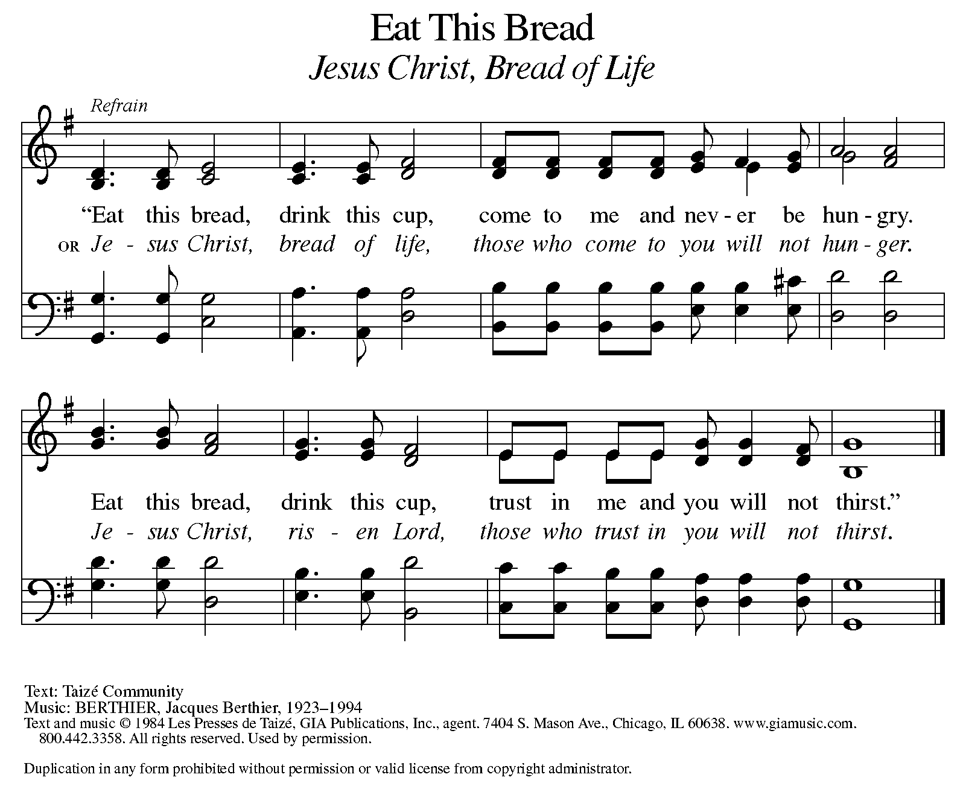

P: The body of Christ, given for you.

C: Amen.

A: The blood of Christ, shed for you.

C: Amen.
(Please rise as you are able.)

P: May the body and blood of our Lord Jesus Christ strengthen and keep you in his grace.

C: Amen.

PRAYER AFTER COMMUNION

P: Let us pray. Living One, in this feast you have made yourself known to us. Send us now to tell of your wonders, sing of your glory, and proclaim your risen life to a wounded and weary world.

C: Amen.

SENDING

BLESSING

P: The triune God, who was, who is, and who is to come, Sovereign, ☩ Savior, and Spirit, light your way with resurrection dawn, now and always.

C: Amen.

SENDING HYMN ELW 835
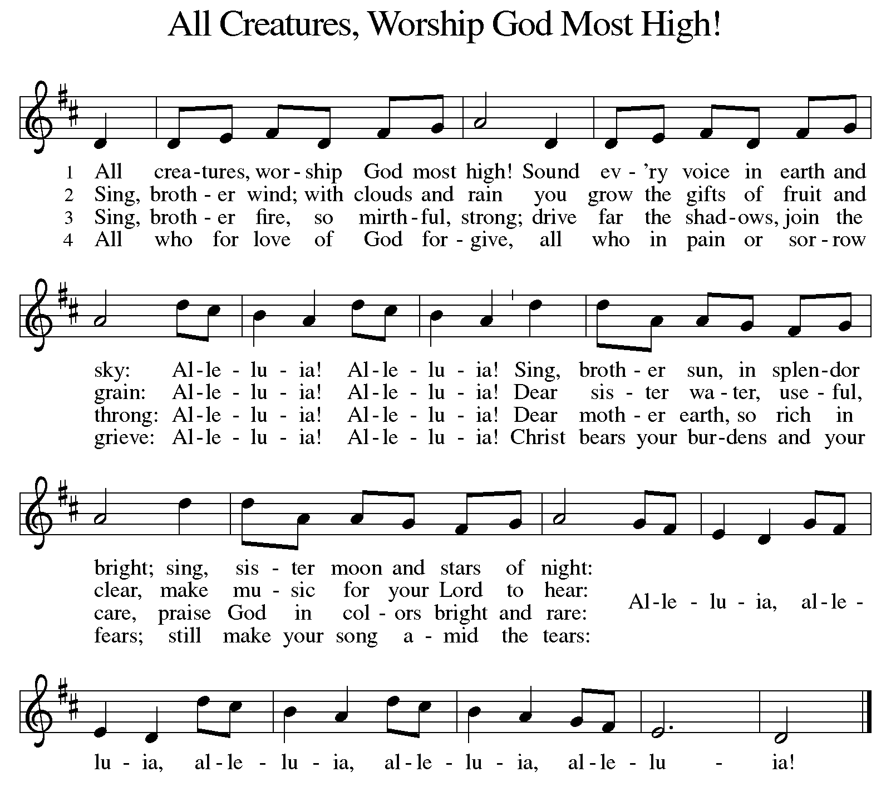

DISMISSAL

A: Alleluia! Christ is risen.

C: Christ is risen indeed. Alleluia!

A: Go in peace. In Christ you are made new. Alleluia! Alleluia!

C: Thanks be to God. Alleluia! Alleluia!

Announcements
- Sunday, May 11 – Happy Mother’s Day!
- Sunday – Tuesday, May 18 – 20 – 2025 North/West Lower MI Synod Assembly will be held in person @ Comfort Inn & Suites in Mt. Pleasant.
- Monday, May 26 – Memorial Day
- Sunday, June 1 – Fish Fry @ 11:15am following service. All donations go to St. Paul Food Pantry.

Recurring Events
- Every Sunday – Adult Bible Study @ 9am
- Monday, May 5 – Worship Committee Meeting @ 6:30pm
- Wednesday, May 14 – Women’s Bible Study @ 11am
- Thursday, May 15 – Council Meeting @ 7pm

Food Pantry Dates
Wednesday, May 7, 5-6:30pm
Thursday, May 15, 1-3pm
Wednesday, May 21, 5-6:30pm
Thursday, May 29, 1-3pm

Volunteers for May 4 Volunteers for May 11
Reader Sunday – Volunteer Reader Sunday – Volunteer
Assisting Minister – Jon K. Assisting Minister – Volunteer

May Birthday Celebrations
5/2 – Jemal Ta.
5/2 – Melissa Ki.
5/9 – Pr. Carl
5/23 – Jim Cr.

May Anniversary Celebrations
5/11 – Emily & AJ Po.
5/26 – Jon & Tzulun K.

Acknowledgments
- OneLicense.net, License #A-703165. CCLI, License #2281869.
- From SundaysandSeasons.com. Copyright 2020 Augsburg Fortress. All rights reserved. Reprinted by permission under Augsburg Fortress Liturgies Annual License #23806.
- New Revised Standard Version Bible, copyright 1989, Division of Christian Education of the National Council of the Churches of Christ in the United States of America. Used by permission. All rights reserved.

