

Palm/Passion Sunday
April 13, 2025

SAINT PAUL LUTHERAN CHURCH
3383 EAST LAKE LANSING ROAD
EAST LANSING, MI 48823

PHONE (517) 351-8541

Pastor Carl E. Ballard
E-MAIL: pastor@stpaul-el.org
officemanager@stpaul-el.org

Visitors WELCOME! If this is your first time worshipping with us, please sign our guest registry just outside the sanctuary doors. We hope you are blessed through worship today. If you have any questions, please feel free to call the church at 351-8541.
Children are always welcome in worship! The choir room (off the sanctuary) can also be used as a cry room for younger children and includes a sound system so parents may continue to participate in the service. Clipboards with children’s bulletins, activities and crayons are available for use during the service. Please see an usher if you are unable to locate them.
Sunday School is available during the worship service September-May except the last Sunday of the month.
This Bulletin is for your use during the service and to take home for the upcoming week. If you choose not to take it home, please place it in the recycle receptacle in the back.
Newsletters and Calendars of Upcoming Events are available in the lobby/narthex. We welcome anyone who has an interest in our small groups or activities! You can also look us up on the web at www.stpaul-el.org.
Contacting Us: Our office manager is Emily Polhamus. She can be reached by phone at 517-351-8541 or at her email address, officemanager@stpaul-el.org. Our Director of Music is Elene Kobulashvili. You may leave a message at 517-351-8541. Pastor Carl can be reached at 517-515-3129, and his email address is cballard123@msn.com.
Holy Communion is available at most services. All who believe in the real presence of Christ in the bread and the wine are invited to celebrate Communion with us. Those who wish may come forward for a blessing.
You are invited to share in fellowship after worship. We would love this opportunity to introduce you to the St. Paul community.

P-Presiding Minister A-Assisting Minister C-Congregation

PRELUDE ELENE

INTRODUCTION

Today we follow Christ from triumphal entry to the cross, each waypoint of the journey marked by Jesus’ compassion for those who would betray, mock, accuse, or do violence to him. Though persecuted and beaten, Jesus the Son of God is not disgraced; instead, he asks forgiveness for those who put him to death. We have walked the Lenten pathway these forty days, each of us invited through baptism to “let the same mind be in you that was in Christ Jesus.” We enter this holy week accompanying Jesus to the cross with both grief and thanksgiving in our hearts, trusting in God’s redeeming love.

GATHERING

P: The Holy Spirit calls us together as the people of God.

ACCLAMATION ELW 256

P: Blessed is the one who comes in the name of the Lord.

C: Hosanna in the highest.

PROCESSIONAL GOSPEL LUKE 19:28-40

P: The holy gospel according to Luke.

C: Glory to you, O Lord.

²⁸After he had said this, [Jesus] went on ahead, going up to Jerusalem. ²⁹When he had come near Bethphage and Bethany, at the place called the Mount of Olives, he sent two of the disciples, ³⁰saying, “Go into the village ahead of you, and as you enter it you will find tied there a colt that has never been ridden. Untie it and bring it here. ³¹If anyone asks you, ‘Why are you untying it?’ just say this, ‘The Lord needs it.’”

³²So those who were sent departed and found it as he had told them. ³³As they were untying the colt, its owners asked them, “Why are you untying the cold?” ³⁴They said, “The Lord needs it.” ³⁵Then they brought it to Jesus, and after throwing their cloaks on the colt, they set Jesus on it. ³⁶As he rode along, people kept spreading their cloaks on the road. ³⁷Now as he was approaching the path down from the Mount of Olives, the whole multitude of the disciples began to praise God joyfully with a loud voice for all the deeds of power that they had seen, ³⁸saying, “Blessed is the King who comes in the name of the Lord! Peace in heaven, and glory in the highest heaven!” ³⁹Some of the pharisees in the crowd said to him, “Teacher, order your disciples to stop.” ⁴⁰He answered, “I tell you, if these were silent, the stones would shout out.”

P: The gospel of the Lord. C: Praise to you, O Christ.

BLESSING OF PALMS ELW 256

P: The Lord be with you.

C: And also with you.

P: Let us pray.
(A brief silence is kept.)
P: We praise you, O God, for redeeming the world through our Savior Jesus Christ. Today he entered the holy city in triumph and was proclaimed messiah and king by those who spread garments and branches along his way. Bless these branches and those who carry them. Grant us grace to follow our Lord in the way of the cross, so that, joined to his death and resurrection, we enter into life with you; through the same Jesus Christ, who lives and reigns with you and the Holy Spirit, one God, now and forever.
C: Amen.

PROCESSION ELW 256

A: Let us go forth in peace.

C: in the name of Christ. Amen.

PROCESSION HYMN ELW 344
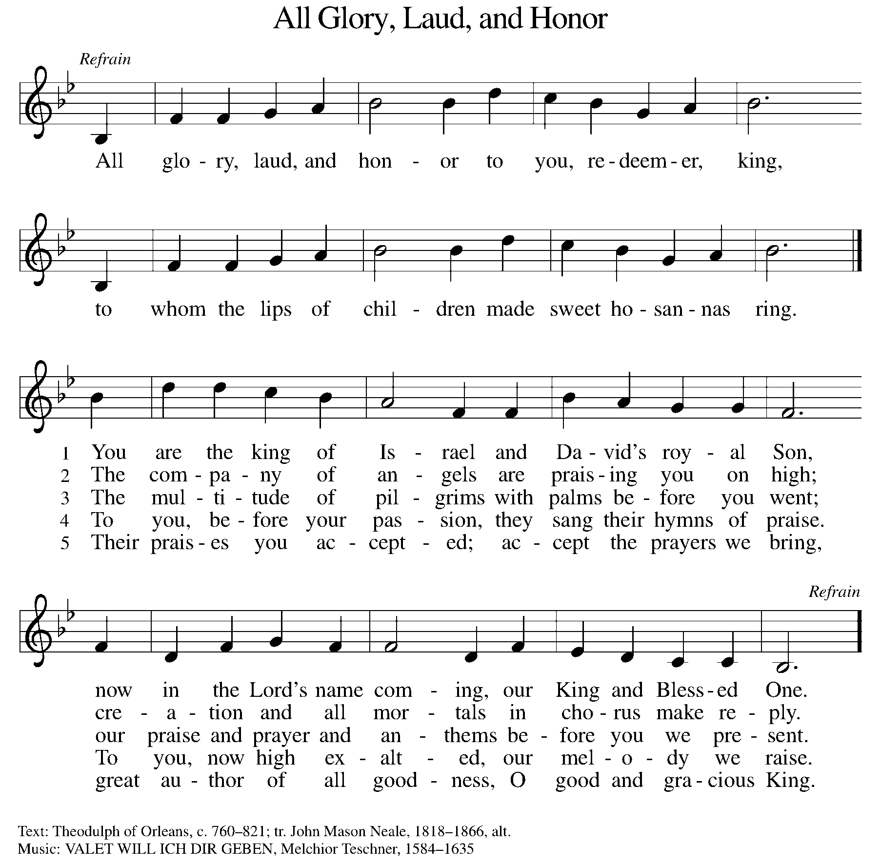

PRAYER OF THE DAY

P: Let us pray. As we now enter into the contemplation of the passion of our Lord Jesus Christ and meditate on the salvation of the world through his sufferings, death, burial, and resurrection, let us pray.

(Silence is kept.)

P: Everlasting God, in your endless love for the human race you sent our Lord Jesus Christ to take on our nature and to suffer death on the cross. In your mercy enable us to share in his obedience to your will and in the glorious victory of his resurrection, who lives and reigns with you and the Holy Spirit, one God, now and forever.

C: Amen.

(Please be seated.)

CHILDREN’S MESSAGE

(Children are invited to Sunday School.)

TRANSITION SONG ELW 595
(VERSE 1 & REFRAIN ONLY)
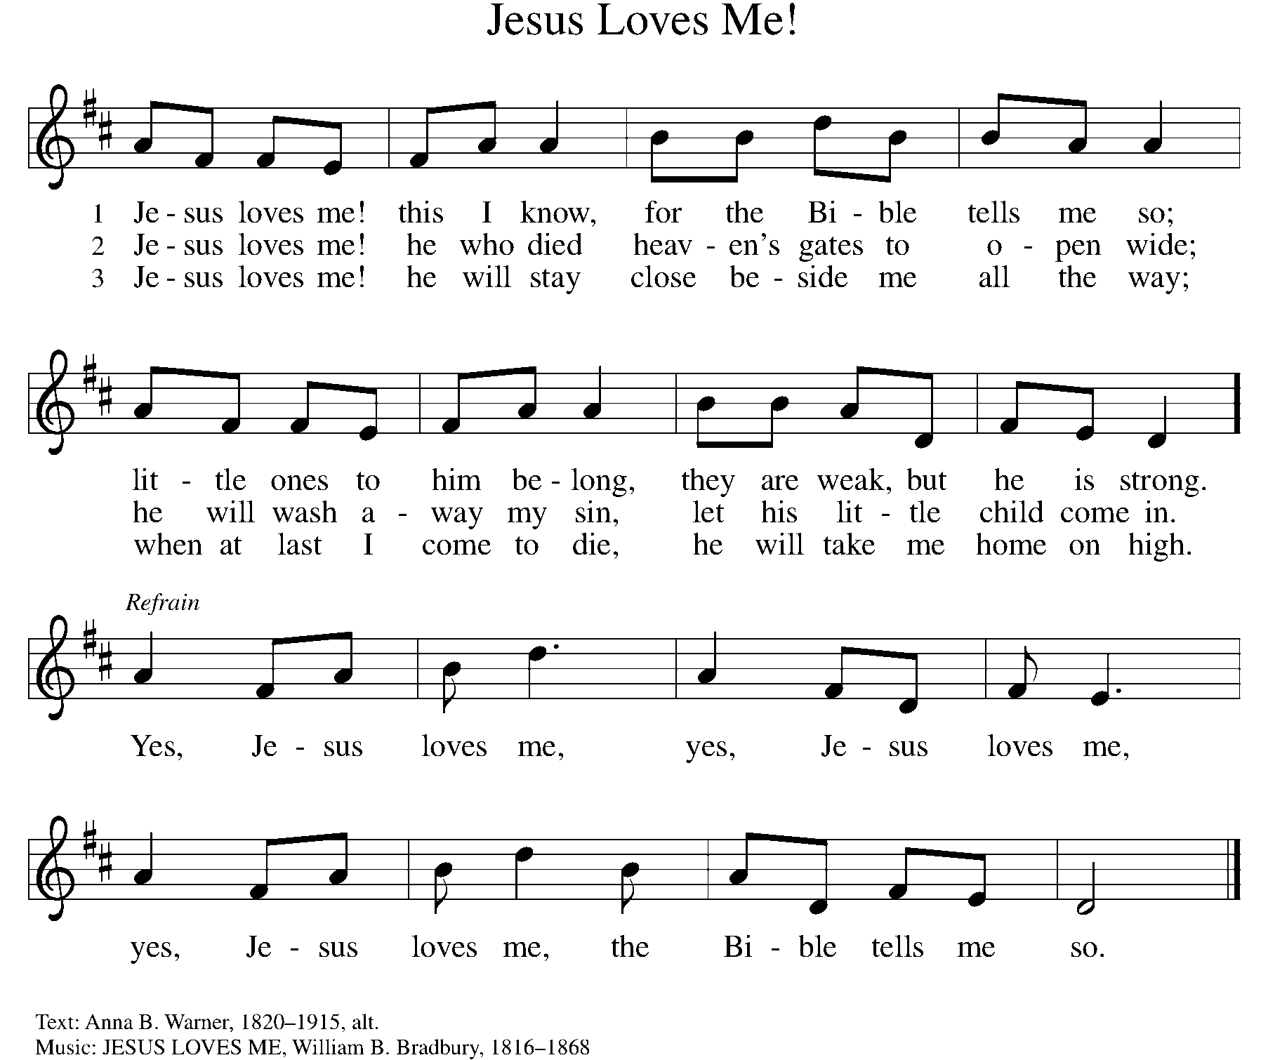

WORD

God speaks to us in scripture, preaching, and song.

First Reading ISAIAH 50:4-9A
This text, the third of the four Servant Songs in Isaiah, speaks of the servant’s obedience amid persecution. Though the servant has been variously understood as the prophet himself or a remnant of faithful Israel, Christians have often recognized the figure of Christ in these poems.

⁴ The Lord God has given me a trained tongue, that I may know how to sustain the weary with a word. Morning by morning he wakens, wakens my ear to listen as those who are taught. ⁵ The Lord God has opened my ear, and I was not rebellious; I did not turn backward. ⁶ I gave my back to those who struck me and my cheeks to those who pulled out the beard; I did not hide my face from insult and spitting. ⁷ The Lord God helps me; therefore I have not been disgraced; therefore I have set my face like flint, and I know that I shall not be put to shame; ⁸ he who vindicates me is near. Who will contend with me? Let us stand in court together. Who are my adversaries? Let them confront me. ^{9a} It is the Lord God who helps me; who will declare me guilty?

Word of God, word of life. C: Thanks be to God.

PSALM PSALM 31:9-16
Into your hands, O Lord, I commend my spirit. (Ps. 31:5)

⁹ Have mercy on me, O Lord, for I am in trouble; my eye is consumed with sorrow, and also my throat and my belly.
¹⁰ For my life is wasted with grief, and my years with sighing; my strength fails me because of affliction, and my bones are consumed.
¹¹ I am the scorn of all my enemies, a disgrace to my neighbors, a dismay to my acquaintances; when they see me in the street they avoid me.
¹² Like the dead I am forgotten, out of mind; I am as useless as a broken pot.
¹³ For I have heard the whispering of the crowd; fear is all around; they put their heads together against me; they plot to take my life.
¹⁴ But as for me, I have trusted in you, O Lord. I have said, “You are my God.
¹⁵ My times are in your hand; rescue me from the hand of my enemies, and from those who persecute me.
¹⁶ Let your face shine upon your servant; save me in your steadfast love.”

SECOND READING PHILIPPIANS 2:5-11
Paul quotes from an early Christian hymn that describes Jesus’ humble obedience in his incarnation as a human being, even to death, and his exaltation and glory as Lord of all.

⁵ Let the same mind be in you that was in Christ Jesus, ⁶ who, though he existed in the form of God, did not regard equality with God as something to be grasped, ⁷ but emptied himself, taking the form of a slave, assuming human likeness. And being found in appearance as a human, ⁸ he humbled himself and became obedient to the point of death—even death on a cross.

⁹ Therefore God exalted him even more highly and gave him the name that is above every other name, ¹⁰ so that at the name given to Jesus every knee should bend, in heaven and on earth and under the earth, ¹¹ and every tongue should confess that Jesus Christ is Lord, to the glory of God the Father.

Word of God, word of life. C: Thanks be to God.

(Please rise as you are able.)

GOSPEL ACCLAMATION ELW Setting 7, Page 179
Turn back to the Lord, your God,
Who is gracious and merciful,
Slow to anger and abounding in love and faithfulness.
GOSPEL LUKE 22:14-23:56

P: The Holy Gospel according to Luke, the 22nd and 23rd chapters.
C: Glory to you, O Lord.
Through the teachings and events of the passion story we see and hear the great contradictions that characterize the coming of God’s reign. The leader serves the followers, proud Peter is revealed in his cowardice, and Jesus—the innocent bringer of life—is arrested, beaten, executed, and buried.
NARRATOR: When the hour came, [Jesus] took his place at the table, and the apostles with him.

JESUS: “I have eagerly desired to eat this Passover with you before I suffer; for I tell you, I will not eat it until it is fulfilled in the kingdom of God.”

NARRATOR: Then he took a cup, and after giving thanks he said,

JESUS: “Take this and divide it among yourselves; for I tell you that from now on I will not drink of the fruit of the vine until the kingdom of God comes.”

NARRATOR: Then he took a loaf of bread, and when he had given thanks, he broke it and gave it to them, saying,

JESUS: “This is my body, which is given for you. Do this in remembrance of me.”

NARRATOR: And he did the same with the cup after supper, saying,

JESUS: “This cup that is poured out for you is the new covenant in my blood. But see, the one who betrays me is with me, and his hand is on the table. For the Son of Man is going as it has been determined, but woe to that one by whom he is betrayed!”

NARRATOR: Then they began to ask one another which one of them it could be who would do this. A dispute also arose among them as to which one of them was to be regarded as the greatest.

JESUS: “The kings of the Gentiles lord it over them; and those in authority over them are called benefactors. But not so with you; rather the greatest among you must become like the youngest, and the leader like one who serves. For who is greater, the one who is at the table or the one who serves? Is it not the one at the table? But I am among you as one who serves. You are those who have stood by me in my trials; and I confer on you, just as my Father has conferred on me, a kingdom, so that you may eat and drink at my table in my kingdom, and you will sit on thrones judging the twelve tribes of Israel.

“Simon, Simon, listen! Satan has demanded to sift all of you like wheat, ³² but I have prayed for you that your own faith may not fail; and you, when once you have turned back, strengthen your brothers.”

PETER: “Lord, I am ready to go with you to prison and to death!”

JESUS: “I tell you, Peter, the cock will not crow this day, until you have denied three times that you know me.”

“When I sent you out without a purse, bag, or sandals, did you lack anything?”

(APOSTLES) ALL: “No, not a thing.”

JESUS: “But now, the one who has a purse must take it, and likewise a bag. And the one who has no sword must sell his cloak and buy one. For I tell you, this scripture must be fulfilled in me, ‘And he was counted among the lawless’; and indeed what is written about me is being fulfilled.”

(APOSTLES) ALL: “Lord, look, here are two swords.”

JESUS: “It is enough.”

NARRATOR: He came out and went, as was his custom, to the Mount of Olives; and the disciples followed him. When he reached the place, he said to them,

JESUS: “Pray that you may not come into the time of trial.”

NARRATOR: Then he withdrew from them about a stone’s throw, knelt down, and prayed,

JESUS: “Father, if you are willing, remove this cup from me; yet, not my will but yours be done.”

NARRATOR: [Then an angel from heaven appeared to him and gave him strength. In his anguish he prayed more earnestly, and his sweat became like great drops of blood falling down on the ground.] When he got up from prayer, he came to the disciples and found them sleeping because of grief, and he said to them,

JESUS: “Why are you sleeping? Get up and pray that you may not come into the time of trial.”

NARRATOR: While he was still speaking, suddenly a crowd came, and the one called Judas, one of the twelve, was leading them. He approached Jesus to kiss him; but Jesus said to him,

JESUS: “Judas, is it with a kiss that you are betraying the Son of Man?”

NARRATOR: When those who were around him saw what was coming, they asked,

(APOSTLES) ALL: “Lord, should we strike with the sword?”

NARRATOR: Then one of them struck the slave of the high priest and cut off his right ear. But Jesus said,

JESUS: “No more of this!”

NARRATOR: And he touched his ear and healed him. Then Jesus said to the chief priests, the officers of the temple police, and the elders who had come for him,

JESUS: “Have you come out with swords and clubs as if I were a bandit? When I was with you day after day in the temple, you did not lay hands on me. But this is your hour, and the power of darkness!”

NARRATOR: Then they seized him and led him away, bringing him into the high priest’s house. But Peter was following at a distance. When they had kindled a fire in the middle of the courtyard and sat down together, Peter sat among them. Then a servant-girl, seeing him in the firelight, stared at him and said,

SERVANT GIRL: “This man also was with him.”

NARRATOR: But he denied it, saying,

PETER: “Woman, I do not know him.”

NARRATOR: A little later someone else, on seeing him, said,

SPECTATOR 1: “You also are one of them.”

NARRATOR: But Peter said,

PETER: “Man, I am not!”

NARRATOR: Then about an hour later still another kept insisting,

SPECTATOR 2: “Surely this man also was with him; for he is a Galilean.”

NARRATOR: But Peter said,

PETER: “Man, I do not know what you are talking about!”

NARRATOR: At that moment, while he was still speaking, the cock crowed. The Lord turned and looked at Peter. Then Peter remembered the word of the Lord, how he had said to him,

JESUS: “Before the cock crows today, you will deny me three times.”

NARRATOR: And he went out and wept bitterly. Now the men who were holding Jesus began to mock him and beat him; they also blindfolded him and kept asking him,

SPECTATOR 1 & 2 & SERVANT GIRL: “Prophesy! Who is it that struck you?”

NARRATOR: They kept heaping many other insults on him. When day came, the assembly of the elders of the people, both chief priests and scribes, gathered together, and they brought him to their council. They said,

(COUNCIL) PEOPLE ON THE LEFT HAND SIDE: “If you are the Messiah, tell us.” He replied,

JESUS: “If I tell you, you will not believe; and if I question you, you will not answer. But from now on the Son of Man will be seated at the right hand of the power of God.”

NARRATOR: All of them asked,

ALL: “Are you, then, the Son of God?” He said to them,

JESUS: “You say that I am.”

NARRATOR: Then they said,

(COUNCIL) PEOPLE ON THE LEFT HAND SIDE: “What further testimony do we need? We have heard it ourselves from his own lips!”

NARRATOR: Then the assembly rose as a body and brought Jesus before Pilate. They began to accuse him, saying,

(RELIGIOUS LEADERS) PEOPLE ON RIGHT HAND SIDE: “We found this man perverting our nation, forbidding us to pay taxes to the emperor, and saying that he himself is the Messiah, a king.”

NARRATOR: Then Pilate asked him

PILATE: “Are you the king of the Jews?”

NARRATOR: He answered,

JESUS: “You say so.”

NARRATOR: Then Pilate said to the chief priests and the crowds,

PILATE: “I find no basis for an accusation against this man.”

NARRATOR: But they were insistent and said,

(RELIGIOUS LEADERS) PEOPLE ON RIGHT HAND SIDE: “He stirs up the people by teaching throughout all Judea, from Galilee where he began even to this place.”

NARRATOR: When Pilate heard this, he asked whether the man was a Galilean. And when he learned that he was under Herod’s jurisdiction, he sent him off to Herod, who was himself in Jerusalem at that time. When Herod saw Jesus, he was very glad, for he had been wanting to see him for a long time, because he had heard about him and was hoping to see him perform some sign. He questioned him at some length, but Jesus gave him no answer. The chief priests and the scribes stood by, vehemently accusing him. Even Herod with his soldiers treated him with contempt and mocked him; then he put an elegant robe on him, and sent him back to Pilate. That same day Herod and Pilate became friends with each other; before this they had been enemies. Pilate then called together the chief priests, the leaders, and the people, and said to them,

PILATE: “You brought me this man as one who was perverting the people; and here I have examined him in your presence and have not found this man guilty of any of your charges against him. Neither has Herod, for he sent him back to us. Indeed, he has done nothing to deserve death. I will therefore have him flogged and release him.”

NARRATOR: ¹⁸ Then they all shouted out together,

ALL: “Away with this fellow! Release Barabbas for us!”

NARRATOR: (This was a man who had been put in prison for an insurrection that had taken place in the city, and for murder.) Pilate, wanting to release Jesus, addressed them again; but they kept shouting,

ALL: “Crucify, crucify him!”

NARRATOR: A third time he said to them,

PILATE: “Why, what evil has he done? I have found in him no ground for the sentence of death; I will therefore have him flogged and then release him.”

NARRATOR: But they kept urgently demanding with loud shouts that he should be crucified; and their voices prevailed. So Pilate gave his verdict that their demand should be granted. He released the man they asked for, the one who had been put in prison for insurrection and murder, and he handed Jesus over as they wished. As they led him away, they seized a man, Simon of Cyrene, who was coming from the country, and they laid the cross on him, and made him carry it behind Jesus. A great number of the people followed him, and among them were women who were beating their breasts and wailing for him. But Jesus turned to them and said,

JESUS: “Daughters of Jerusalem, do not weep for me, but weep for yourselves and for your children. For the days are surely coming when they will say, ‘Blessed are the barren, and the wombs that never bore, and the breasts that never nursed.’ ³⁰ Then they will begin to say to the mountains, ‘Fall on us’; and to the hills, ‘Cover us.’ ³¹ For if they do this when the wood is green, what will happen when it is dry?”

NARRATOR: Two others also, who were criminals, were led away to be put to death with him. ³³ When they came to the place that is called The Skull, they crucified Jesus there with the criminals, one on his right and one on his left. [Then Jesus said,

JESUS: “Father, forgive them; for they do not know what they are doing.”]

NARRATOR: And they cast lots to divide his clothing. And the people stood by, watching; but the leaders scoffed at him, saying,

(RELIGIOUS LEADERS) PEOPLE ON RIGHT HAND SIDE: “He saved others; let him save himself if he is the Messiah of God, his chosen one!”

NARRATOR: The soldiers also mocked him, coming up and offering him sour wine, and saying,

(SOLDIERS) PEOPLE ON LEFT HAND SIDE: “If you are the King of the Jews, save yourself!”

NARRATOR: There was also an inscription over him, “This is the King of the Jews.” One of the criminals who were hanged there kept deriding him and saying,

CRIMINAL 1: “Are you not the Messiah? Save yourself and us!”

NARRATOR: But the other rebuked him, saying,

CRIMINAL 2: “Do you not fear God, since you are under the same sentence of condemnation? And we indeed have been condemned justly, for we are getting what we deserve for our deeds, but this man has done nothing wrong. Jesus, remember me when you come into your kingdom.” He replied,

JESUS: “Truly I tell you, today you will be with me in Paradise.”

NARRATOR: It was now about noon, and darkness came over the whole land until three in the afternoon, while the sun’s light failed; and the curtain of the temple was torn in two. Then Jesus, crying with a loud voice, said,

JESUS: Father, into your hands I commend my spirit.”

NARRATOR: Having said this, he breathed his last. When the centurion saw what had taken place, he praised God and said,

CENTURION: “Certainly this man was innocent.”

NARRATOR: And when all the crowds who had gathered there for this spectacle saw what had taken place, they returned home, beating their breasts. But all his acquaintances, including the women who had followed him from Galilee, stood at a distance, watching these things. Now there was a good and righteous man named Joseph, who, though a member of the council, had not agreed to their plan and action. He came from the Jewish town of Arimathea, and he was waiting expectantly for the kingdom of God. This man went to Pilate and asked for the body of Jesus. Then he took it down, wrapped it in a linen cloth, and laid it in a rock-hewn tomb where no one had ever been laid. It was the day of Preparation, and the sabbath was beginning. The women who had come with him from Galilee followed, and they saw the tomb and how his body was laid. Then they returned, and prepared spices and ointments. On the sabbath they rested according to the commandment.

P: The Gospel of the Lord. C: Praise to you, O Christ.
(Please be seated.)

SERMON PASTOR CARL BALLARD

(Please rise as you are able.)
HYMN OF THE DAY ELW 264
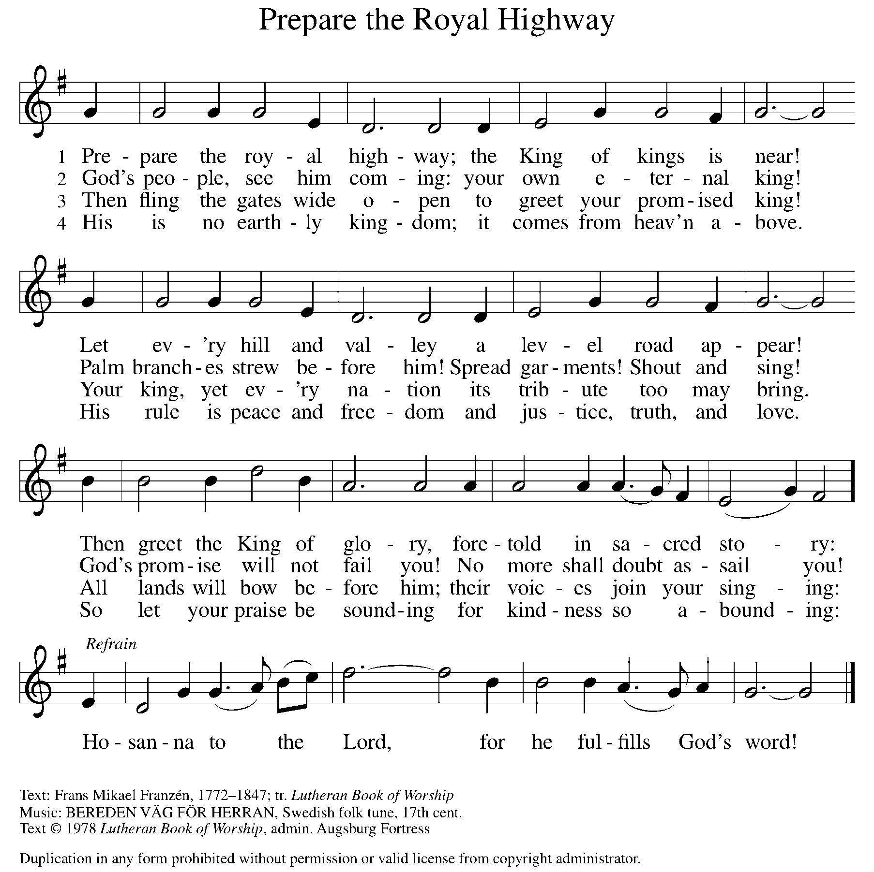

apostles’ CREED

I believe in God, the Father almighty,
creator of heaven and earth.
I believe in Jesus Christ, God’s only Son, our Lord,
who was conceived by the Holy Spirit,
born of the virgin Mary,
suffered under Pontius Pilate,
was crucified, died, and was buried;
he descended to the dead.
On the third day he rose again;
he ascended into heaven,
he is seated at the right hand of the Father,
and he will come to judge the living and the dead.
I believe in the Holy Spirit,
the holy catholic church,
the communion of saints,
the forgiveness of sins,
the resurrection of the body,
and the life everlasting. Amen.

(Please be seated.)

THE PRAYERS

A: Led by the Spirit, let us turn to God in prayer for the church, the world, and all those in need.
(A brief silence)
A: Guide your church this Holy Week as we follow in the servant way of Jesus. Protect those who face hostility or oppression for their faith. Humble those who would use faith to dominate others and reinforce their own power. God, in your mercy,

C: receive our prayer.
A: Make your creation a living witness to Christ’s passion and resurrection: in waving palms, shouting stones, fragrant vineyards, murmuring wheat, and revealing fire. Make us attentive to your holy presence in the world, that we may care for the earth you love. God, in your mercy,

C: receive our prayer.
A: Let your face shine upon the leaders of nations and let the same mind be in them as was in Christ Jesus, so that those with the most power may humble themselves to serve the most vulnerable. God, in your mercy,

C: receive our prayer.

A: Sustain the weary with a word. Grant perseverance to political prisoners and to any who are exploited, unjustly accused, or wrongly convicted. Abide with all who are in jails, detention centers, or prisons. Console all who experience times of trial or suffering. God, in your mercy,
C: receive our prayer.
A: Give strength to those who will lead worship during Holy Week: pastors and deacons, altar guilds and sacristans, musicians and assisting ministers, ushers, and office staff. Instill in them awe and joy, that their service may reflect the love of Jesus. God, in your mercy,
C: receive our prayer.

A: Empower and give courage to those who are entrusted for our safe-keeping. Especially be with those who serve in our armed forces; protect and care for Beth & Ryan, Jonathan, Jacob, Noah, Irene, and Alex. God, in your mercy,

C: receive our prayer.
A: Enable those who are overlooked, vulnerable, lonely, ill, suffering or undergoing life transitions of any kind to recognize your constant presence and care for them, especially, Ahren, Beth Ra., B.J., Carolyn, Dan, David, Doretta, Family & friends of Joseph Ra., friends & family of Nina, Gage, Jim & Cheri, John, Johnny, Jon, Jordan, Lawton, Lera & family, Linda, Lizzy, Marge, Randy, Rick & Kathy, Sheri, Sheri, Stacy, Steve, and Wanda, and all whom we name now aloud and in our hearts. God, in your mercy,

C: receive our prayer.

A: Make your way clear to those you have called to be leaders in ministry and shepherds of your people, especially to our Presiding Bishop Elizabeth, our Synod Bishop Craig, and Pastor Carl and their respective staffs as they live out their callings to serve. As we are called to be one, even as Jesus and the Father are one, be with the leaders and the congregation Our Savior’s Lutheran Church in Edmore and all the churches in our community. God, in your mercy,

C: receive our prayer.

A: We give thanks to you for our beloved dead, trusting that as the cross of Jesus led to the empty tomb, so you welcome those who have died into the paradise of your presence. God, in your mercy,

C: receive our prayer.

P: Receive the prayers of your people and draw all things together in your love, in the name of Jesus, who leads us from death to life.

C: Amen.

GREETING OF PEACE

(You are invited to share Christ’s peace with one another.)

P: The peace of Christ be with you always.

C: And also with you.
(Please be seated.)
MEAL
OFFERING ELENE
(Please rise if you are able.)
OFFERTORY ELW 325
(VERSE 1 ONLY)
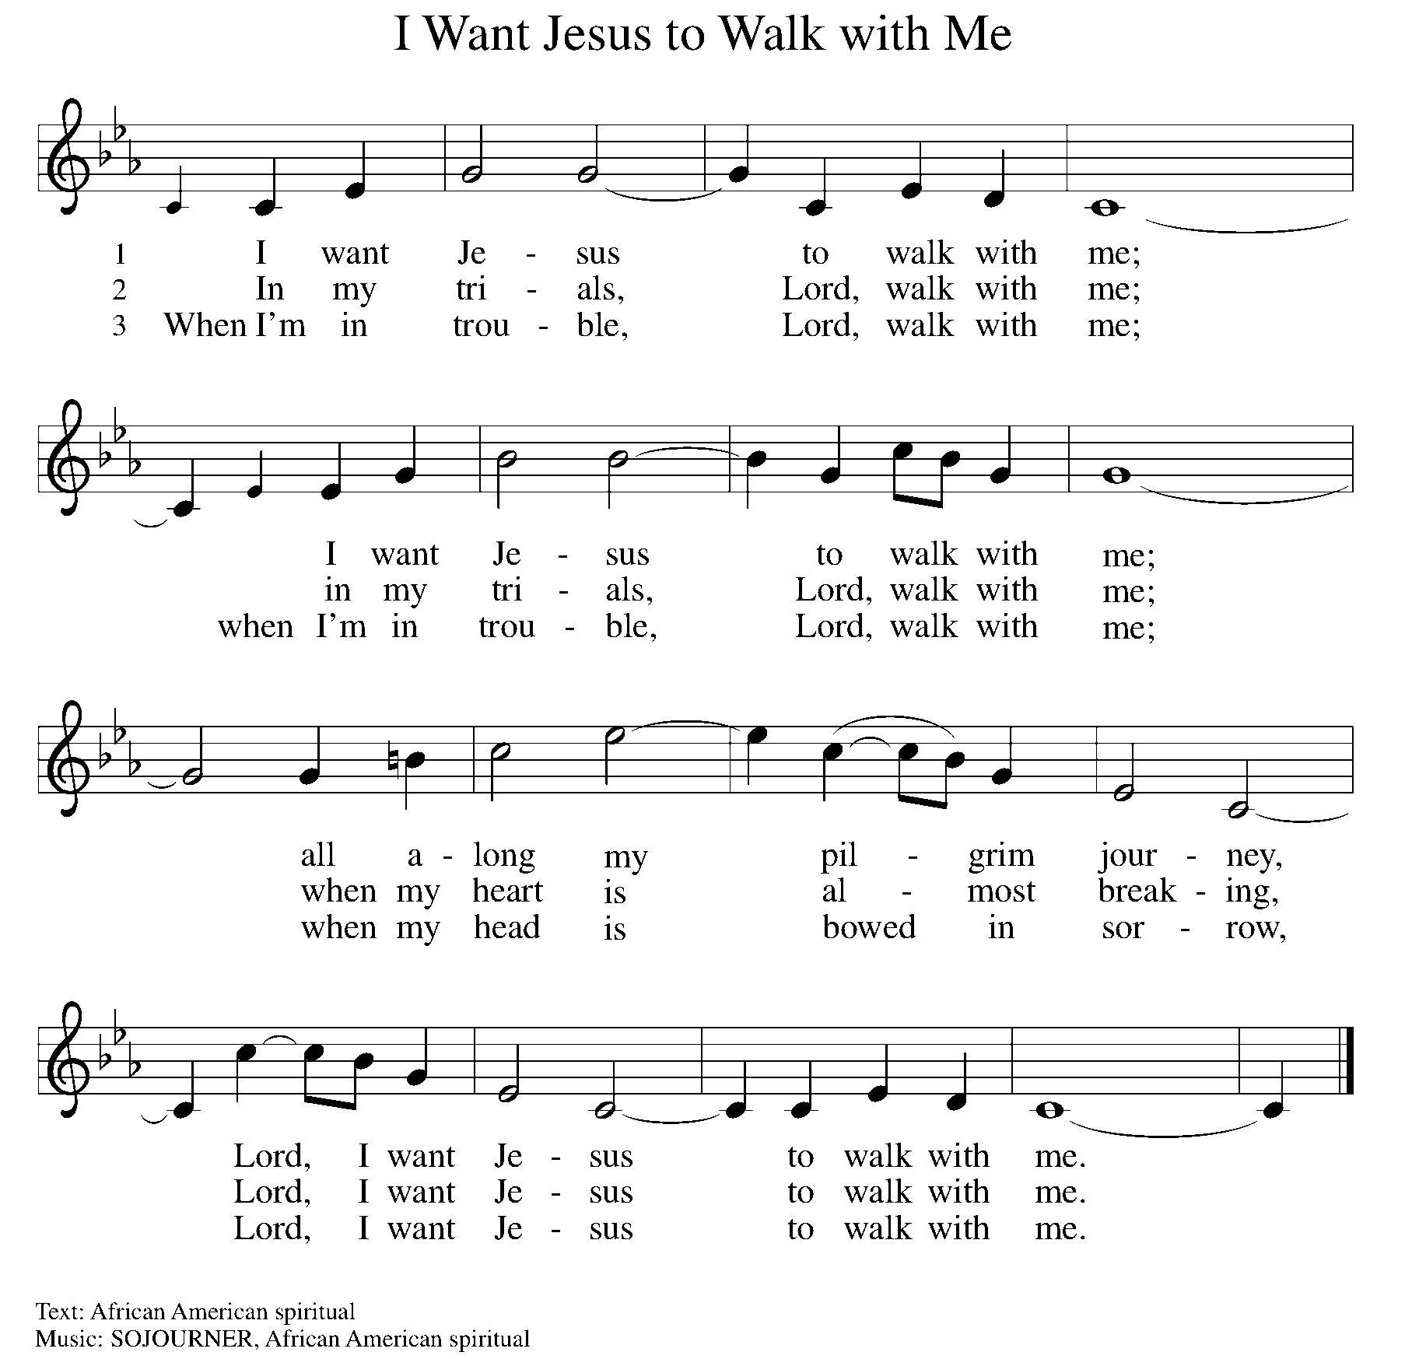
OFFERING PRAYER
A: Let us pray. Gracious Provider, you set your immense treasures among us, opening your heart to the world. As we prepare to feast on your bountiful love, deepen our commitment to sharing those treasures with others, through our Savior, Jesus Christ.

C: Amen.
THE GREAT THANKSGIVING

P: The Lord be with you.
C: And also with you.
P: Lift up your hearts.
C: We lift them to the Lord.
P: Let us give thanks to the Lord our God.
C: It is right to give our thanks and praise.

PROPER PREFACE

P: It is indeed right, our duty and our joy, that we should at all times and in all places give thanks and praise to you, almighty and merciful God, through our Savior Jesus Christ, whose suffering and death gave salvation to all. You gather your people around the tree of the cross, transforming death into life. And so, with all the choirs of angels, with the church on earth and the hosts of heaven, we praise your name and join their unending hymn:

HOLY, HOLY ELW Setting 7, Page 181
Holy, holy, holy Lord God,
God of might and power; holy is the Lord.
Holy, holy, holy, holy Lord God,
God of might and power; holy is the Lord.
Hosanna in the highest, hosanna here on earth.
Blest is he who comes in the name of the Lord.
Hosanna in the highest, hosanna here on earth.
Blest is he who comes in the name of the Lord.

EUCHARISTIC PRAYER

P: In the night in which he was betrayed, our Lord Jesus took bread, and gave thanks; broke it, and gave it to his disciples, saying:
Take and eat; this is my body, given for you. Do this for the
remembrance of me.
Again, after supper, he took the cup, gave thanks, and gave it for all to drink, saying:
This cup is the new covenant in my blood, shed for you and for all people for the forgiveness of sin. Do this for the remembrance of me.

LORD'S PRAYER

P: Lord, remember us in your kingdom, and teach us to pray:

C: Our Father in heaven, hallowed be your name, your kingdom come, your will be done, on earth as in heaven. Give us today our daily bread. Forgive us our sins as we forgive those who sin against us. Save us from the time of trial and deliver us from evil. For the kingdom, the power, and the glory are yours, now and forever. Amen.

(Please be seated.)

COMMUNION DISTRIBUTION

All who believe in the real presence of Christ in the bread and the wine (juice) are welcome to the table. Others may come forward for a blessing. If you prefer grape juice, please indicate this to the assisting minister.

When approaching the communion rail, come forward down the side aisle, kneel if you are able, starting at the front of the communion rail (spot closest to the font) on your side and filling in toward the altar. After receiving both the bread and the wine, you may return to your seat by the center aisle.

INVITATION TO COMMUNION

P: All who are hungry, come! The feast of grace is spread.

COMMUNION HYMN ELW 779
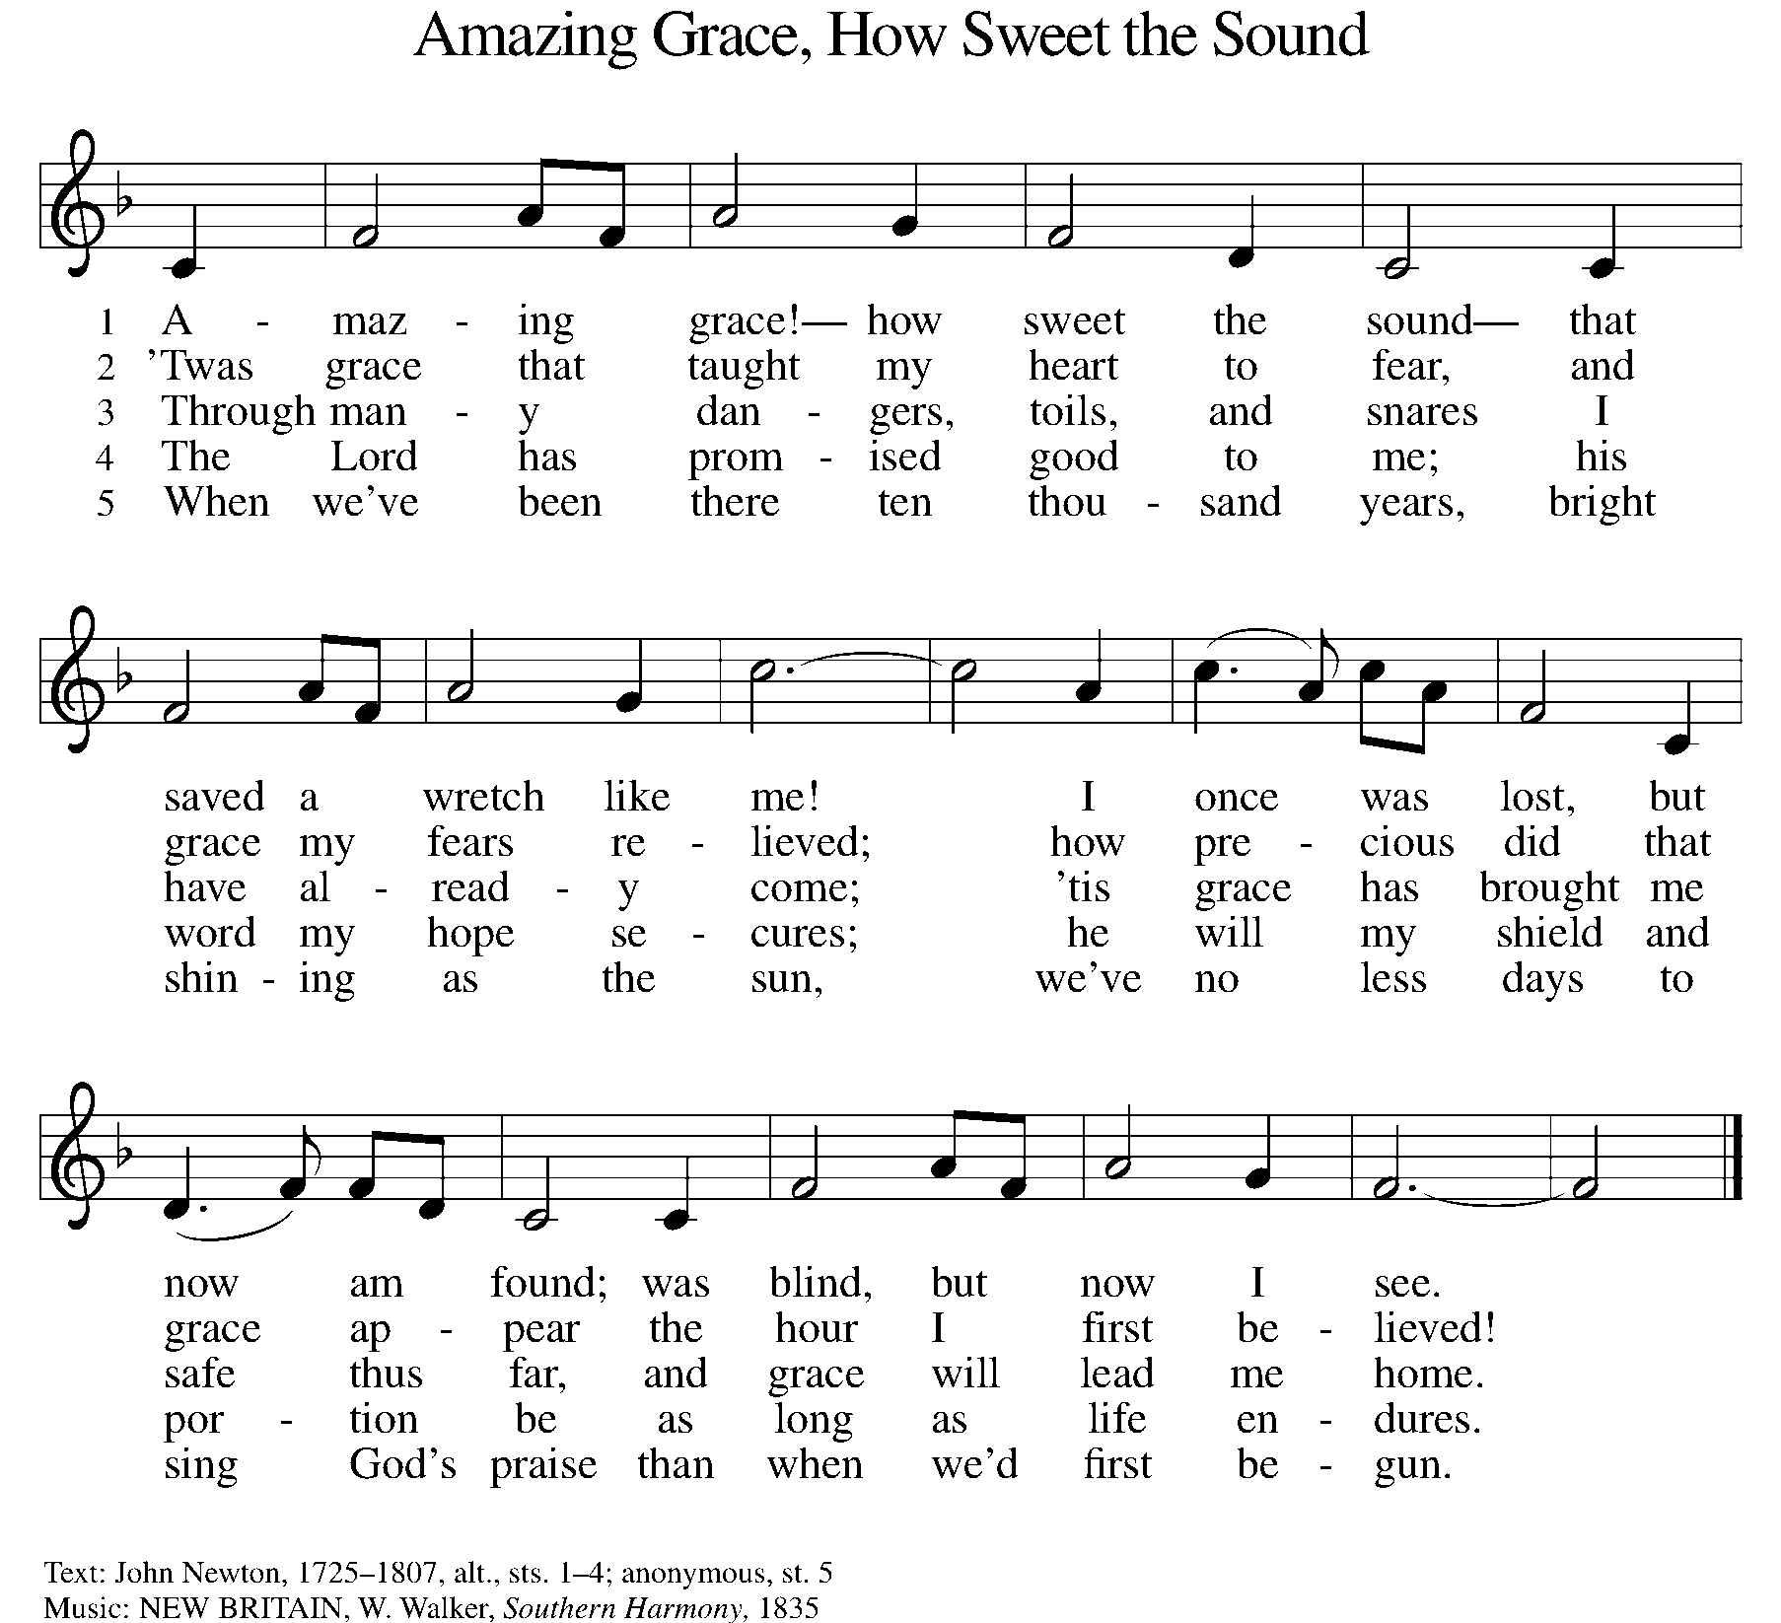

P: The body of Christ, given for you.

C: Amen.

A: The blood of Christ, shed for you.

C: Amen.
(Please rise as you are able.)
P: May the body and blood of our Lord Jesus Christ strengthen and keep you in his grace.

C: Amen.

PRAYER AFTER COMMUNION

P: Let us pray. Generous Host, you have shared your feast with us and made us new. Send us now to set tables of love and grace in our communities, that your liberating love might nourish the world into freedom, in the name of the crucified one, Jesus Christ our Lord.

C: Amen.

SENDING

BLESSING

P: God our tender parent, God the crucified one, God the reconciling Spirit, ☩ bless you now and forever.

C: Amen.

SENDING HYMN ELW 342
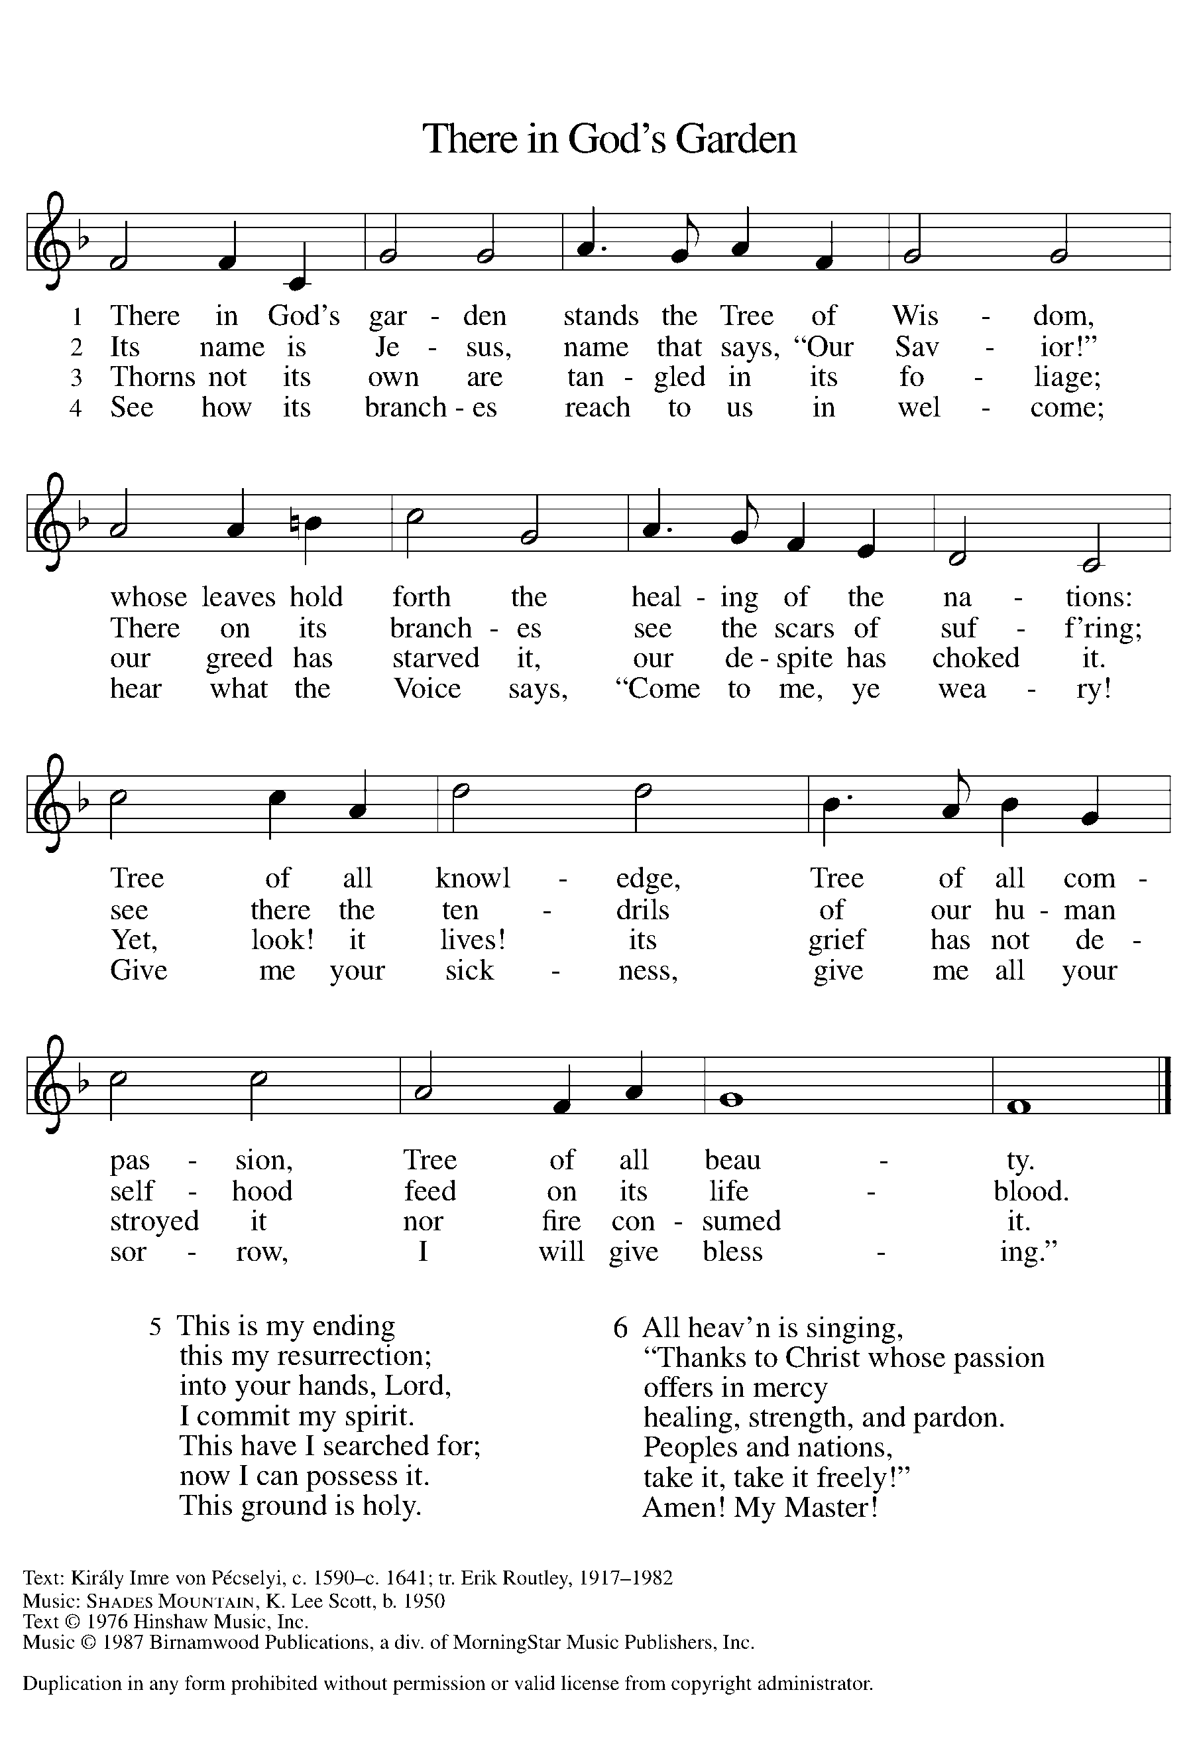

DISMISSAL

A: Go in peace. Care for others as God cares for you!

C: Thanks be to God.

Announcements
Bring items for the Food Pantry & Homeless!

- Friday, April 18 – Good Friday Service @ 6pm
- Sunday, April 20 – Easter
- Sunday, April 20 – Easter Breakfast Potluck @ 9am
- Sunday, April 20 – Children’s Easter Egg Hunt @ 9:15am

Recurring Events
- Every Sunday – Adult Bible Study @ 9am
- Monday, May 5 – Worship Committee Meeting @ 6:30pm
- Wednesday, May 14 – Women’s Bible Study @ 11am
- Thursday, April 24 – Council Meeting @ 7pm

Food Pantry Dates

Wednesday, April 16, 5-6:30pm
Thursday, April 24, 1-3pm
Wednesday, May 7, 5-6:30pm
Thursday, May 15, 1-3pm
Wednesday, May 21, 5-6:30pm
Thursday, May 29, 1-3pm

Volunteers for April 13 Volunteers for April 20

Reader – Volunteer Reader – Volunteer
Assisting Minister - Volunteer Assisting Minister – Volunteer
April Birthday Celebrations

4/2 – Noah Ki.
4/4 – Doretta Th.
4/4 – RJ Mc.
4/11 – Kathy Gr.
4/14 – Carol Ha.
4/26 – Vicki Ki.
4/27 – Kristen Op.
4/27 – Pat Cr.
4/29 – Mary Mc.

Acknowledgments
- OneLicense.net, License #A-703165.
- CCLI, License #2281869.
- From SundaysandSeasons.com. Copyright 2020 Augsburg Fortress. All rights reserved. Reprinted by permission under Augsburg Fortress Liturgies Annual License #23806.
- New Revised Standard Version Bible, copyright 1989, Division of Christian Education of the National Council of the Churches of Christ in the United States of America. Used by permission. All rights reserved.

