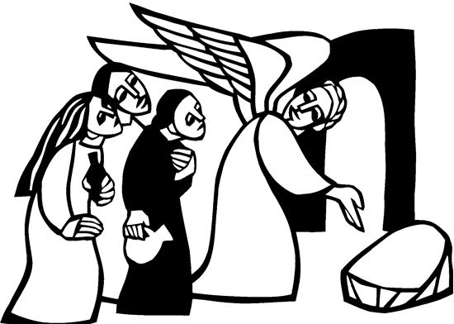

Easter Sunday
April 20th, 2025


SAINT PAUL LUTHERAN CHURCH
3383 EAST LAKE LANSING ROAD
EAST LANSING, MI 48823

PHONE (517) 351-8541

Pastor Carl E. Ballard
E-MAIL: pastor@stpaul-el.org
officemanager@stpaul-el.org
Visitors WELCOME! If this is your first time worshipping with us, please sign our guest registry just outside the sanctuary doors. We hope you are blessed through worship today. If you have any questions, please feel free to call the church at 351-8541.
Children are always welcome in worship! The choir room (off the sanctuary) can also be used as a cry room for younger children and includes a sound system so parents may continue to participate in the service. Clipboards with children's bulletins, activities and crayons are available for use during the service.
Sunday School is available during the worship service September-May except the last Sunday of the month.
Virtual Services We can provide a virtual live Zoom session during worship upon request.
This Bulletin is for your use during the service and to take home for the upcoming week. If you choose not to take it home, please place it in the recycle receptacle in the back.
Newsletters and Calendars of Upcoming Events are available in the lobby/narthex. We welcome anyone who has an interest in our small groups or activities! You can also look us up on the web at www.stpaul-el.org.
Contacting Us: Our Office Manager is Emily Polhamus. She can be reached by phone at 517-351-8541 or at her email address, officemanager@stpaul-el.org. Our Director of Music is Elene Kobulashvili. You may leave a message at 517-351-8541. Pastor Carl can be reached at 517-515-3129, and his email address is cballard123@msn.com.
Holy Communion is available at most services. All who believe in the real presence of Christ in the bread and the wine are invited to celebrate Communion with us. Those who wish may come forward for a blessing.
You’re invited to share in fellowship after worship. We would love this opportunity to introduce you to the St. Paul community.

A BIG THANK YOU TO OUR MUSICIANS: Vasilii Marshev, Marj Kelsey, and Liza Tavadze. Thank you for using God’s gifts to share your joyous music with us today.

P-Presiding Minister A-Assisting Minister C-Congregation

PRELUDE ELENE

(We gather in the entryway for the processional)

INTRODUCTION

The Easter season is a week of weeks, seven Sundays when we play in the mystery of Christ’s presence, mostly through the glorious Gospel of John. Today we gather with the disciples on the first Easter, and Jesus breathes the Spirit on us. With Thomas we ask for a sign, and Jesus offers us his wounded self in the broken bread. From frightened individuals we are transformed into a community of open doors, peace, forgiveness, and material sharing such that no one among us is in need.

P: The Sunday School students will assist in unburying the banner because Christ is now risen and because of our faith in Christ, we, too, will be raised up as He is risen.

P: With Christ risen, the Alleluia has also come from death to life the same way we have life because of the risen Christ.

THANKSGIVING FOR BAPTISM

P: Alleluia! Christ is risen.

C: Christ is risen, indeed. Alleluia!

P: In the name of ☩ the One who was, who is, and who is to come.

C: Amen.

P: Baptized into Christ’s death and resurrection, and called to live the baptized life, let us give thanks for the gifts of baptism. Holy God, we give you thanks for the waters of baptism, waters that make a people your own, that restore to wholeness, and empower us to be witnesses in your name. Baptized into you, O Living One,

C: make us one as you are one.

P: We give you thanks for the waters of baptism, waters that strengthen believers and give new life to beloved servants of your church; waters that extend your boundless love and cross barriers of our own making. Baptized into you, O Living One,

C: make us one as you are one.

P: We give you thanks for the waters of baptism, waters that open the hearts of believers and give a voice in the night to those in captivity;
waters that set your people on a new path, rejoicing in the Spirit’s power. Baptized into you, O Living One,

C: make us one as you are one.

P: Grant us grace, love, and life, O Living One, that our every day is shaped by these waters that give us our very lives in you. We ask this in the name of Jesus, the Crucified and Risen One.

C: Amen.

(PROCESSIONAL)

GATHERING SONG ELW 365
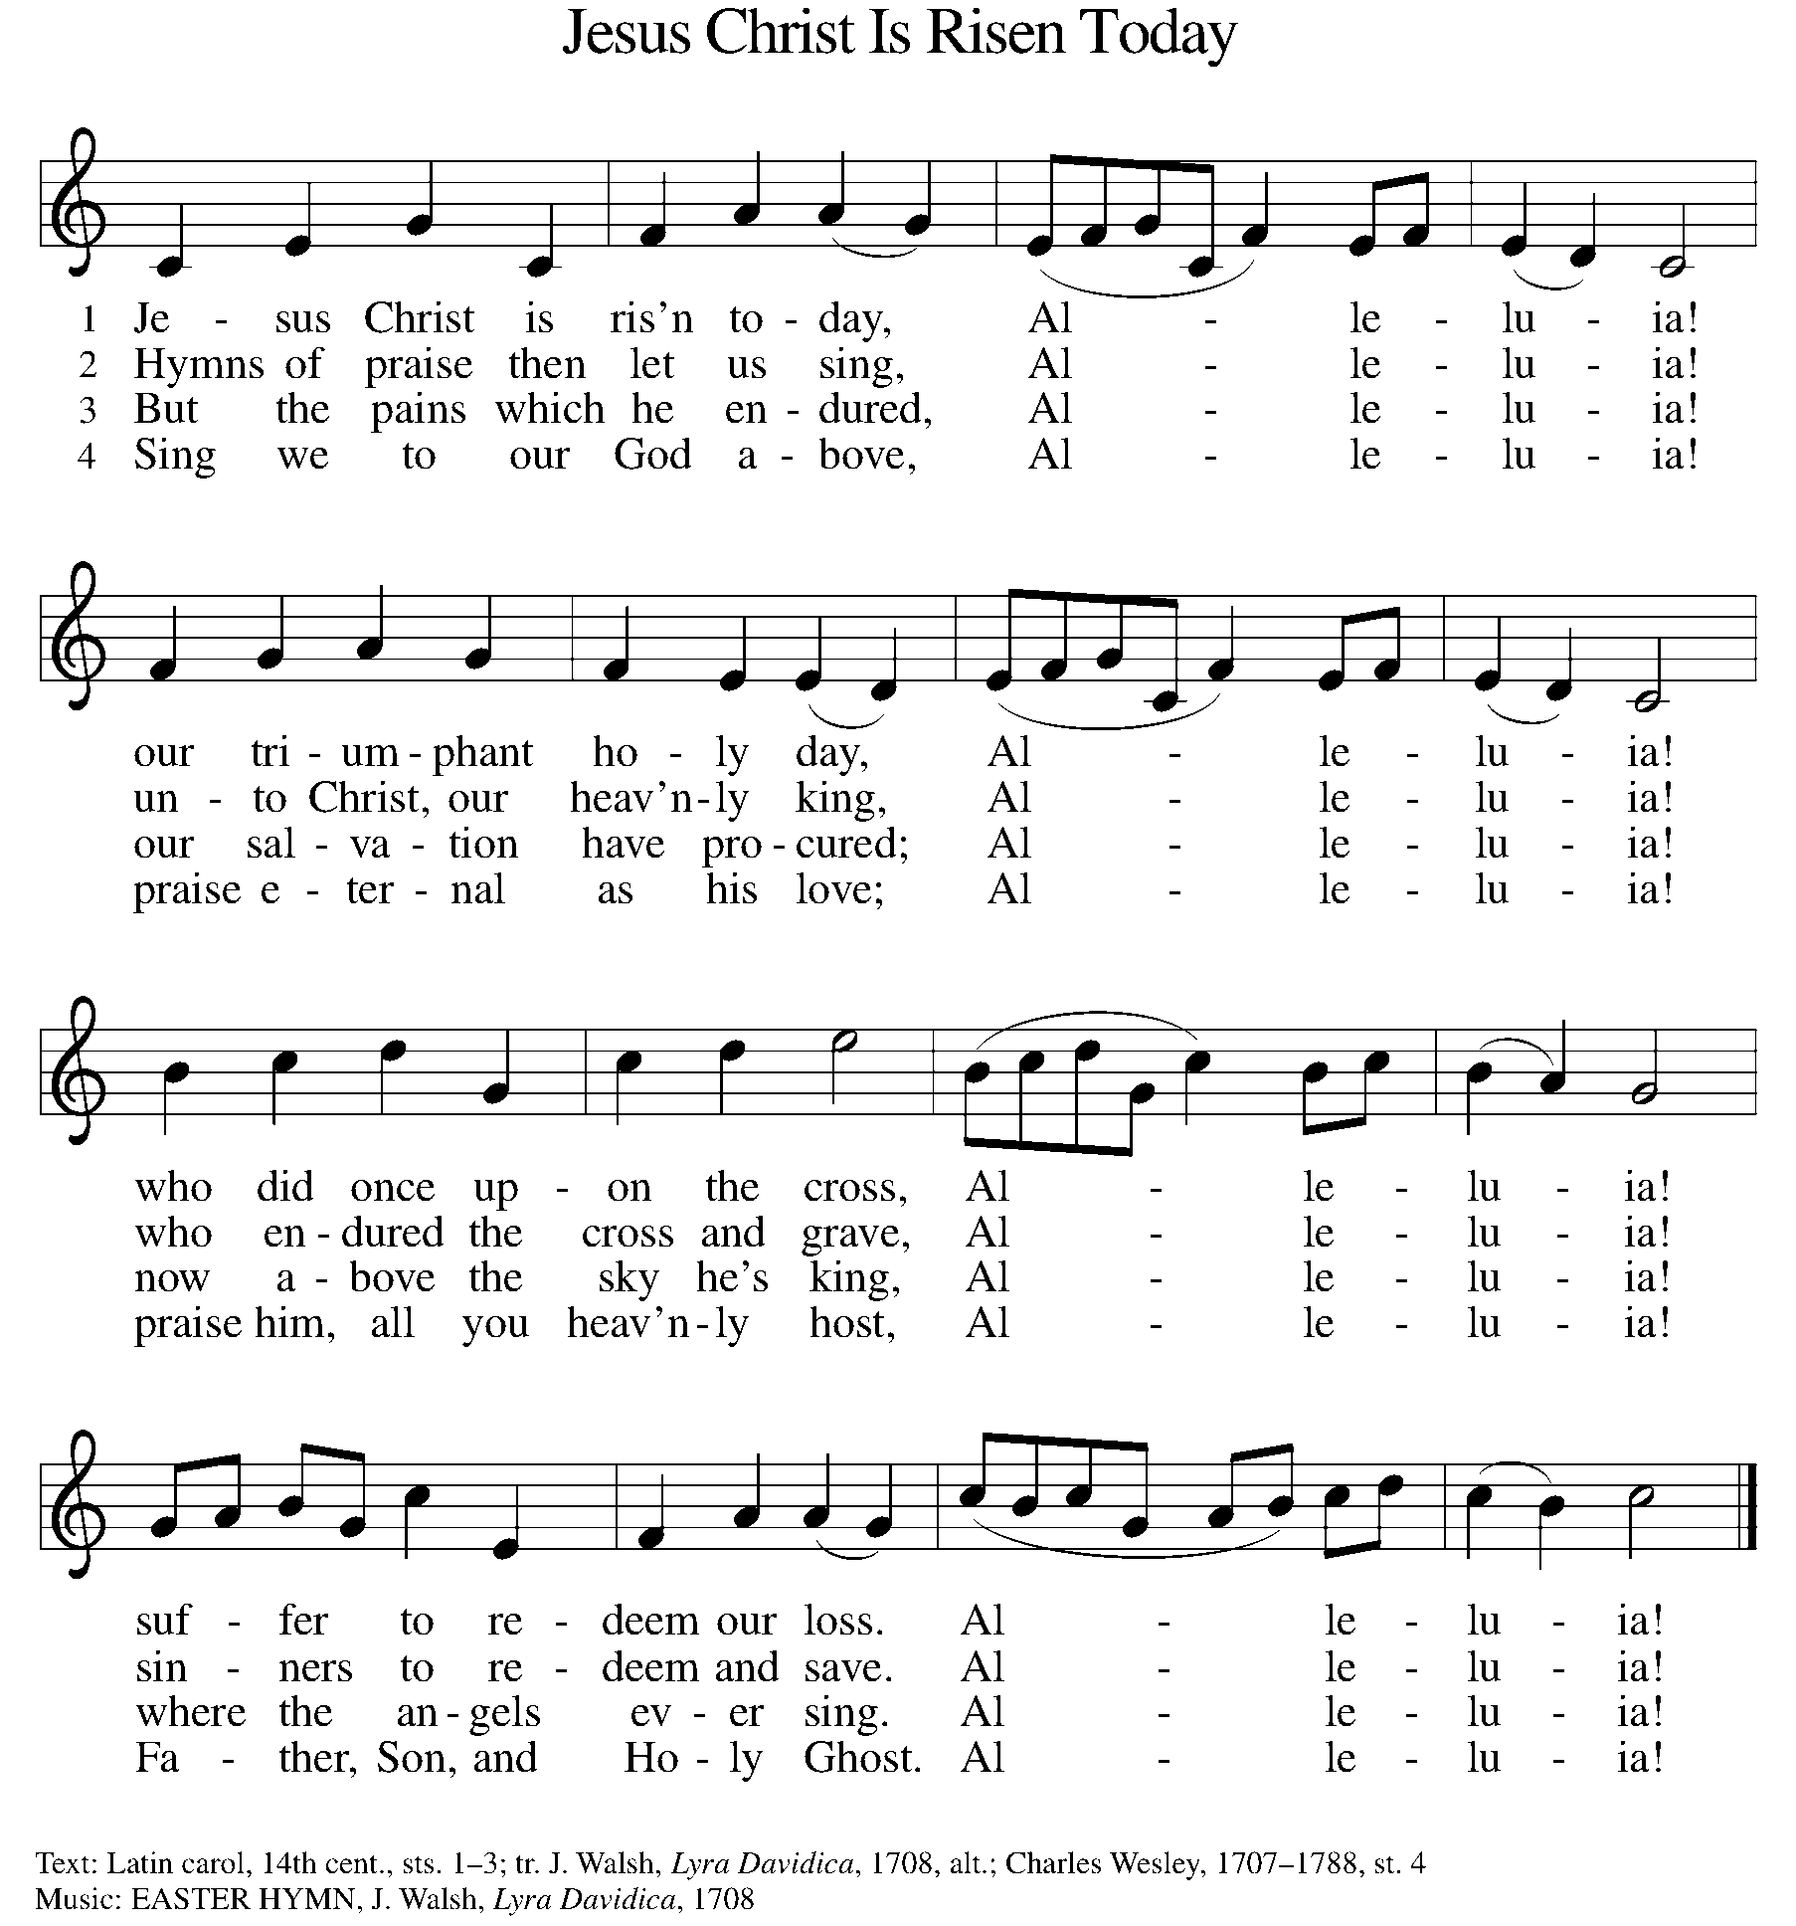

GREETING

P: The grace of our Lord Jesus Christ, the love of God, and the communion of the Holy Spirit be with you all.

C: And also with you.

KYRIE ELW Setting 10, Page 203

Have mercy on us, Lord,
and hear our solemn prayer.
We come to hear your living word;
it saves us from despair.

Have mercy on us, Christ,
and wash away our sin.
Pour out your grace and make us whole
that new life may begin.

Have mercy on us, Lord;
make sin and shame depart.
Renew us with your saving pow’r;
create in us new hearts!

CANTICLE OF PRAISE ELW Setting 4, Page 149-150

This is the feast of victory for our God.
Alleluia.

Worthy is Christ, the Lamb who was slain,
whose blood set us free to be people of God.
Power and riches and wisdom and strength,
and honor and blessing and glory are his.
This is the feast of victory for our God.
Alleluia.

Sing with all the people of God
and join in the hymn of all creation:
Blessing and honor and glory
and might be to God and the Lamb forever.
Amen.

This is the feast of victory for our God,
for the Lamb who was slain has begun his reign.
Alleluia. Alleluia.

PRAYER OF THE DAY

P: Let us pray. O God, you gave your only Son to suffer death on the cross for our redemption, and by his glorious resurrection you delivered us from the power of death. Make us die every day to sin, that we may live with him forever in the joy of the resurrection, through your Son, Jesus Christ our Lord, who lives and reigns with you and the Holy Spirit, one God, now and forever.

C: Amen.

(Please be seated.)

CHILDREN’S MESSAGE/NOISY OFFERING

(Children may return to their seats.)

TRANSITION SONG ELW 595
(VERSE 1 & REFRAIN ONLY)
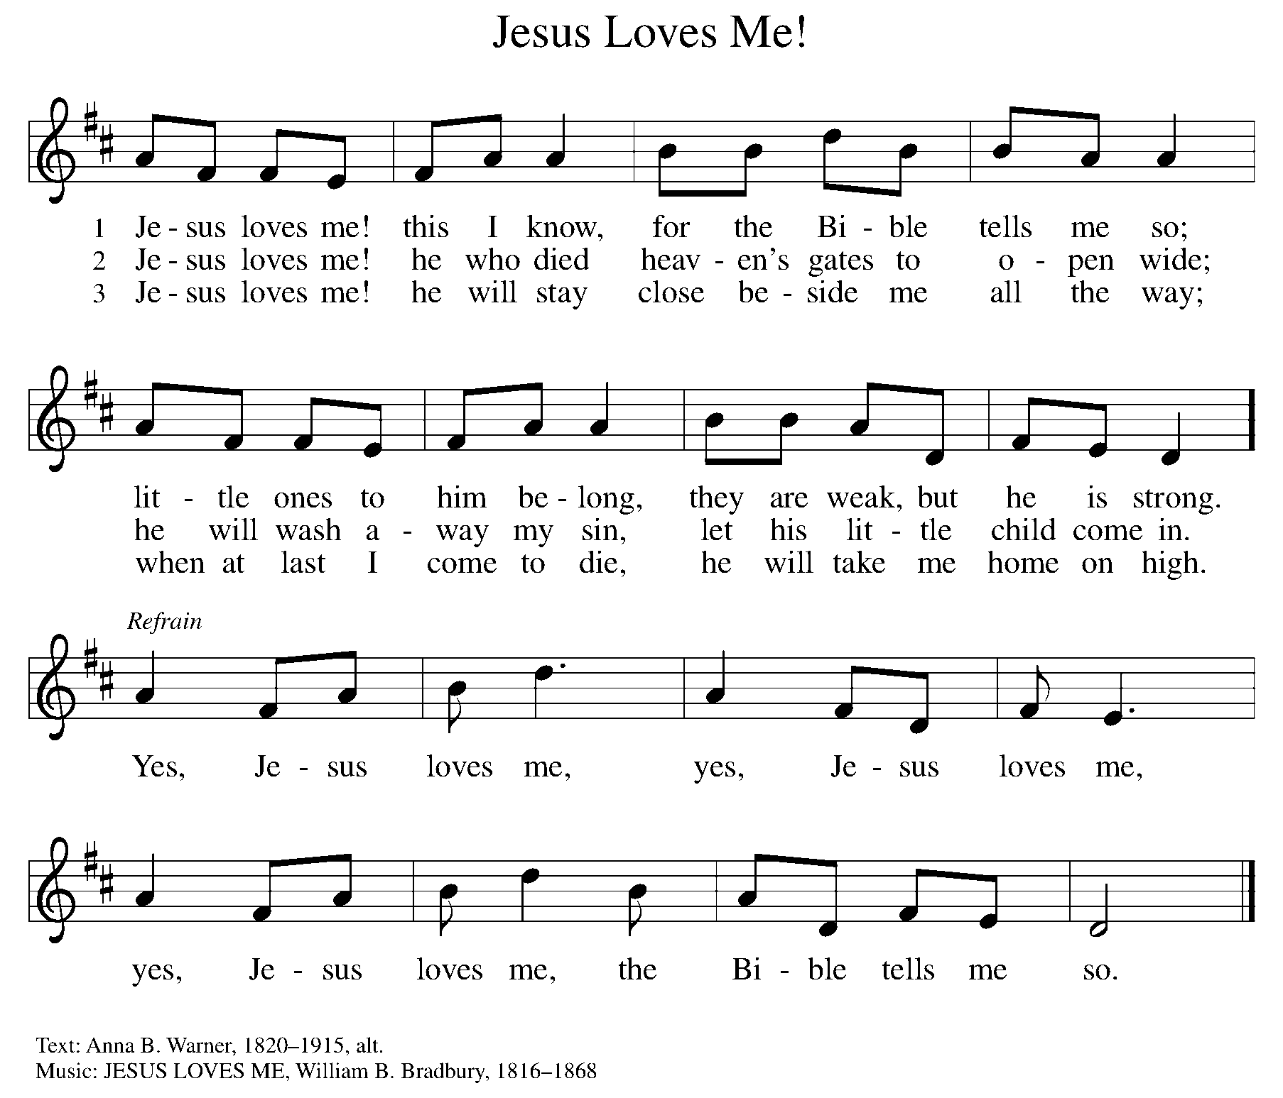

WORD

P: God speaks to us in scripture, preaching, and song.

FIRST READING ACTS 10:34-43

Peter’s sermon, delivered at the home of Cornelius, a Roman army officer, is a summary of the essential message of Christianity: Everyone who believes in Jesus, whose life, death, and resurrection fulfilled the words of the prophets, receives forgiveness of sins through his name.

³⁴ Peter began to speak to [the people]: “I truly understand that God shows no partiality, ³⁵ but in every people anyone who fears him and practices righteousness is acceptable to him. ³⁶ You know the message he sent to the people of Israel, preaching peace by Jesus Christ—he is Lord of all. ³⁷ That message spread throughout Judea, beginning in Galilee after the baptism that John announced: ³⁸ how God anointed Jesus of Nazareth with the Holy Spirit and with power; how he went about doing good and healing all who were oppressed by the devil, for God was with him.

³⁹ We are witnesses to all that he did both in Judea and in Jerusalem. They put him to death by hanging him on a tree, ⁴⁰ but God raised him on the third day and allowed him to appear, ⁴¹ not to all the people but to us who were chosen by God as witnesses and who ate and drank with him after he rose from the dead. ⁴² He commanded us to preach to the people and to testify that he is the one ordained by God as judge of the living and the dead. ⁴³ All the prophets testify about him that everyone who believes in him receives forgiveness of sins through his name.”

Reader: Word of God, word of life. C: Thanks be to God.
PSALM PSALM 118:1-2, 14-24

This is the day that the Lord has made; let us rejoice and be glad in it. (Ps. 118:24)

¹ Give thanks to the Lord, for the Lord is good; God’s mercy endures forever.
² Let Israel now declare, “God’s mercy endures forever.”

¹⁴ The Lord is my strength and my song, and has become my salvation.
¹⁵ Shouts of rejoicing and salvation echo in the tents of the righteous: “The right hand of the Lord acts valiantly!
¹⁶ The right hand of the Lord is exalted! The right hand of the Lord acts valiantly!”
¹⁷ I shall not die, but live, and declare the works of the Lord.
¹⁸ The Lord indeed punished me sorely, but did not hand me over to death.
¹⁹ Open for me the gates of righteousness; I will enter them and give thanks to the Lord.
²⁰ “This is the gate of the Lord; here the righteous may enter.”
²¹ I give thanks to you, for you have answered me and you have become my salvation.
²² The stone that the builders rejected has become the chief cornerstone.
²³ By the Lord has this been done; it is marvelous in our eyes.
²⁴ This is the day that the Lord has made; let us rejoice and be glad in it.

SECOND READING 1 CORINTHIANS 15:19-26

Paul describes the consequences of the resurrection, including the promise of new life in Christ to a world that has been in bondage to death. He celebrates the destruction of evil and the establishment of God’s victorious rule over all.

¹⁹ If for this life only we have hoped in Christ, we are of all people most to be pitied. ²⁰ But in fact Christ has been raised from the dead, the first fruits of those who have died. ²¹ For since death came through a human, the resurrection of the dead has also come through a human, ²² for as all die in Adam, so all will be made alive in Christ.

²³ But each in its own order: Christ the first fruits, then at his coming those who belong to Christ. ²⁴ Then comes the end, when he hands over the kingdom to God the Father, after he has destroyed every ruler and every authority and power. ²⁵ For he must reign until he has put all his enemies under his feet. ²⁶ The last enemy to be destroyed is death.

Reader: Word of God, word of life. C: Thanks be to God.

(Please rise as you are able.)

GOSPEL ACCLAMATION ELW SETTING 10, PAGE 205

Alleluia! Lord and Savior: open now your saving word.
Let it burn like fire within us; speak until our hearts are stirred.
Alleluia! Lord, we sing for the good news that you bring.

GOSPEL LUKE 24:1-12

P: The Holy Gospel according to Luke, the 24th chapter.

C: Glory to you, O Lord.

Evidently expecting to find Jesus’ corpse, some of the women among his followers go to the tomb with embalming spices. After a perplexing encounter with the empty tomb and angelic visitors, the women become the first to proclaim the amazing news of resurrection.

¹ On the first day of the week, at early dawn, [the women] went to the tomb, taking the spices that they had prepared. ² They found the stone rolled away from the tomb, ³ but when they went in they did not find the body. ⁴ While they were perplexed about this, suddenly two men in dazzling clothes stood beside them.

⁵ The women were terrified and bowed their faces to the ground, but the men said to them, “Why do you look for the living among the dead? He is not here but has risen. ⁶ Remember how he told you, while he was still in Galilee, ⁷ that the Son of Man must be handed over to the hands of sinners and be crucified and on the third day rise again.” ⁸ Then they remembered his words, ⁹ and returning from the tomb they told all this to the eleven and to all the rest.¹⁰ Now it was Mary Magdalene, Joanna, Mary the mother of James, and the other women with them who told this to the apostles. ¹¹ But these words seemed to them an idle tale, and they did not believe them. ¹² But Peter got up and ran to the tomb; stooping and looking in, he saw the linen cloths by themselves; then he went home, amazed at what had happened.

P: The Gospel of the Lord. C: Praise to you, O Christ.

(Please be seated.)
SERMON PASTOR CARL BALLARD

(Please rise as you are able.)

HYMN OF THE DAY ELW 369
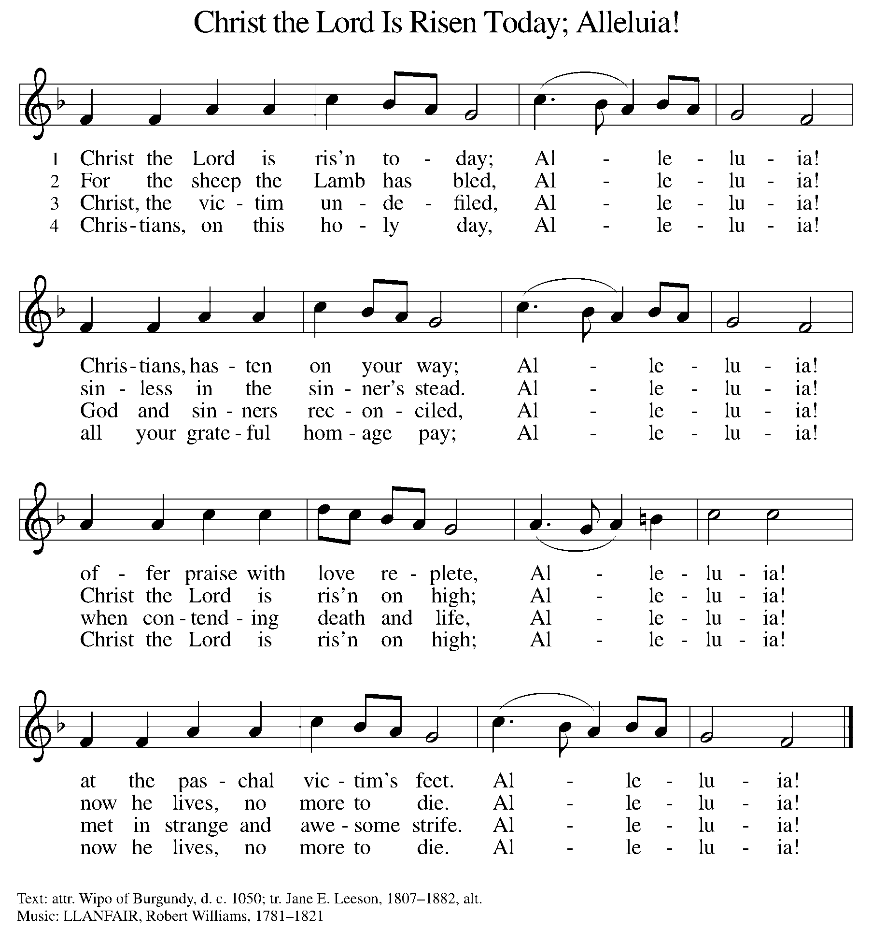

NICENE CREED

We believe in one God,
the Father, the Almighty,
maker of heaven and earth,
of all that is, seen and unseen.

We believe in one Lord, Jesus Christ,
the only Son of God,
eternally begotten of the Father,
God from God, Light from Light,
true God from true God,
begotten, not made,
of one Being with the Father;
through him all things were made.
For us and for our salvation
he came down from heaven,
was incarnate of the Holy Spirit and the virgin Mary
and became truly human.
For our sake he was crucified under Pontius Pilate;
he suffered death and was buried.
On the third day he rose again
in accordance with the scriptures;
he ascended into heaven
and is seated at the right hand of the Father.
He will come again in glory to judge the living and the dead,
and his kingdom will have no end.

We believe in the Holy Spirit, the Lord, the giver of life,
who proceeds from the Father and the Son,
who with the Father and the Son is worshiped and glorified,
who has spoken through the prophets.
We believe in one holy catholic and apostolic church.
We acknowledge one baptism for the forgiveness of sins.
We look for the resurrection of the dead,
and the life of the world to come. Amen.

(Please be seated.)
THE PRAYERS

A: God of resurrection and new life, we come before you in prayer for the church, the world, and all who are in need.

(A brief silence.)
A: Kindle new life in your church. Encourage all who seek creative ways to share the good news of Christ’s resurrection. Bless mission developers and new ministries, that their work plant seeds that flourish. God of grace,

C: hear our prayer.

A: Nourish new life in all of creation. Shower forests and grasslands, deserts, and mountains with life-giving rains. Grant us delight in your glory that shows forth in all that grows this season. God of grace,

C: hear our prayer.

A: Empower new life among the nations. As you raised Jesus from the dead, bring new hope for peace and reconciliation in places of war and strife. Raise up leaders who are steadfast in their commitment to justice and transformation. God of grace,

C: hear our prayer.

A: Awaken new life in this place. Open our hearts to ways you are calling us to be at work in the world and our community. Give us courage to boldly share your love for all people beyond our walls. God of grace,

C: hear our prayer.

A: Surround those who serve in our armed forces with your protection and bolster them with courage; especially, we pray for Beth & Ryan, Jonathan, Jacob, Noah, Irene, and Alex. God of grace,

C: hear our prayer.

A: Bring new hope among all who are in need, especially neighbors without homes or food, and those whose housing or food supply is at risk. Bring healing to all who are fearful, ill, or grieving. Especially, we lift to you Ahren, Beth Ra., B.J., Carolyn, Dan, David, Doretta, Family & friends of Joseph Ra., Friends & family of Nina, Gage, Jim & Cheri, John, Johnny, Jon, Jordan, Lawton, Lera & family, Linda, Lizzy, Marge, Randy, Rick & Kathy, Sheri, Sheri, Stacy, Steve, and Wanda, and all whom we name now aloud and in our hearts. God of grace,

C: hear our prayer.

A: Mold the minds and hearts of our church’s leaders to be receptive to your direction. We pray especially for Presiding Bishop Elizabeth, our Synod Bishop Craig, and Pastor Carl. We ask that you be with their respective staffs as they live out their callings to serve. As we are called to be one, even as Jesus and the Father are one, be with the leaders and the congregation of Calvary Lutheran Church in Elk Rapids and all the churches in our community. God of grace,

C: hear our prayer.

A: Trusting in the promises of the resurrection, we remember with thanksgiving our beloved dead. Sustain us with a living hope until we are reunited with them and all the saints at the heavenly banquet. God of grace,

C: hear our prayer.

P: We commend these and all our prayers to you, O God, trusting that you are always with us; in the name of Jesus Christ, our risen Savior.

C: Amen.

GREETING OF PEACE

P: The peace of Christ be with you always.

C: And also with you.

(You are invited to share Christ’s peace with one another.)

(Please be seated.)

MEAL

OFFERING ELENE

OFFERTORY ELW 186
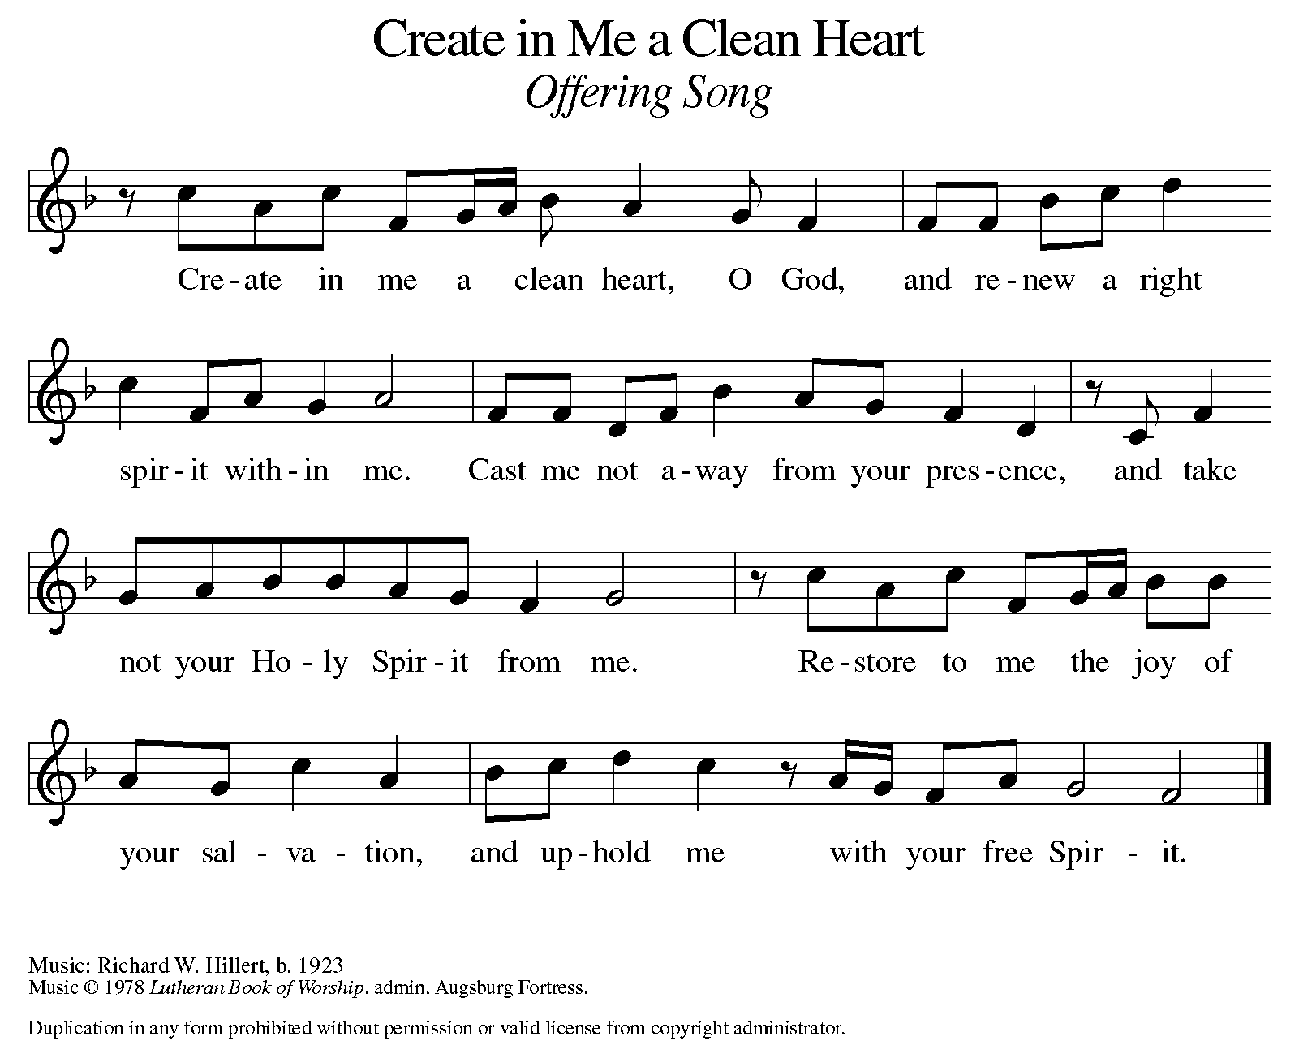

OFFERING PRAYER

A: Let us pray. Risen One, you have gathered us around your table of grace along with these gifts we bring. Come among us again, breathe your life into us, and enliven us with this meal, that we may live as your risen body in the world.

C: Amen.

THE GREAT THANKSGIVING

P: The Lord be with you.
C: And also with you.
P: Lift up your hearts.
C: We lift them to the Lord.
P: Let us give thanks to the Lord our God.
C: It is right to give our thanks and praise.

PROPER PREFACE

P: It is indeed right, our duty and our joy, that we should at all times and in all places give thanks and praise to you, almighty and merciful God, for the glorious resurrection of our Savior Jesus Christ, the true Paschal Lamb who gave himself to take away our sin; who in dying has destroyed death, and in rising has brought us to eternal life. And so, with Mary Magdalene and Peter and all the witnesses of the resurrection, with earth and sea and all their creatures, and with angels and archangels, cherubim and seraphim, we praise your name and join their unending hymn:

HOLY, HOLY ELW SETTING 10, Page 207

Holy, holy, holy Lord,
God of power and might,
heav’n and earth are full of your glory.
Hosanna in the highest.
Blessed is he who comes in the name of the Lord.
Hosanna in the highest,
hosanna in the highest.

THANKSGIVING AT THE TABLE

P: You are indeed holy, almighty and merciful God. You are most holy, and great is the majesty of your glory. You so loved the world that you gave your only Son, so that everyone who believes in him may not perish
but have eternal life. We give you thanks for his coming into the world
to fulfill for us your holy will and to accomplish all things for our salvation.

In the night in which he was betrayed, our Lord Jesus took bread, and gave thanks; broke it, and gave it to his disciples, saying:
Take and eat; this is my body, given for you.
Do this for the remembrance of me.

Again, after supper, he took the cup, gave thanks,
and gave it for all to drink, saying:
This cup is the new covenant in my blood,
shed for you and for all people for the forgiveness of sin.
Do this for the remembrance of me.

For as often as we eat of this bread and drink from this cup, we proclaim the Lord’s death until he comes.

LORD'S PRAYER

P: Lord, remember us in your kingdom, and teach us to pray:

C: Our Father, who art in heaven, hallowed be thy name, thy kingdom come, thy will be done, on earth as it is in heaven. Give us this day our daily bread; and forgive us our trespasses, as we forgive those who trespass against us; and lead us not into temptation, but deliver us from evil. For thine is the kingdom, and the power, and the glory, forever and ever. Amen.

COMMUNION DISTRIBUTION

All who believe in the real presence of Christ in the bread and the wine (juice) are welcome to the table. Others may come forward for a blessing. If you prefer grape juice, please indicate this to the assisting minister.

When approaching the communion rail, come forward down the side aisle, kneel if you are able, starting at the front of the communion rail (spot closest to the font) on your side and filling in toward the altar. After receiving both the bread and the wine, you may return to your seat by the center aisle.

INVITATION TO COMMUNION

P: Come to the table of grace. Receive the gift of new life.

We welcome the Moran family, with Clare and Rosie, as they take their first communion today.

COMMUNION HYMN ELW 779
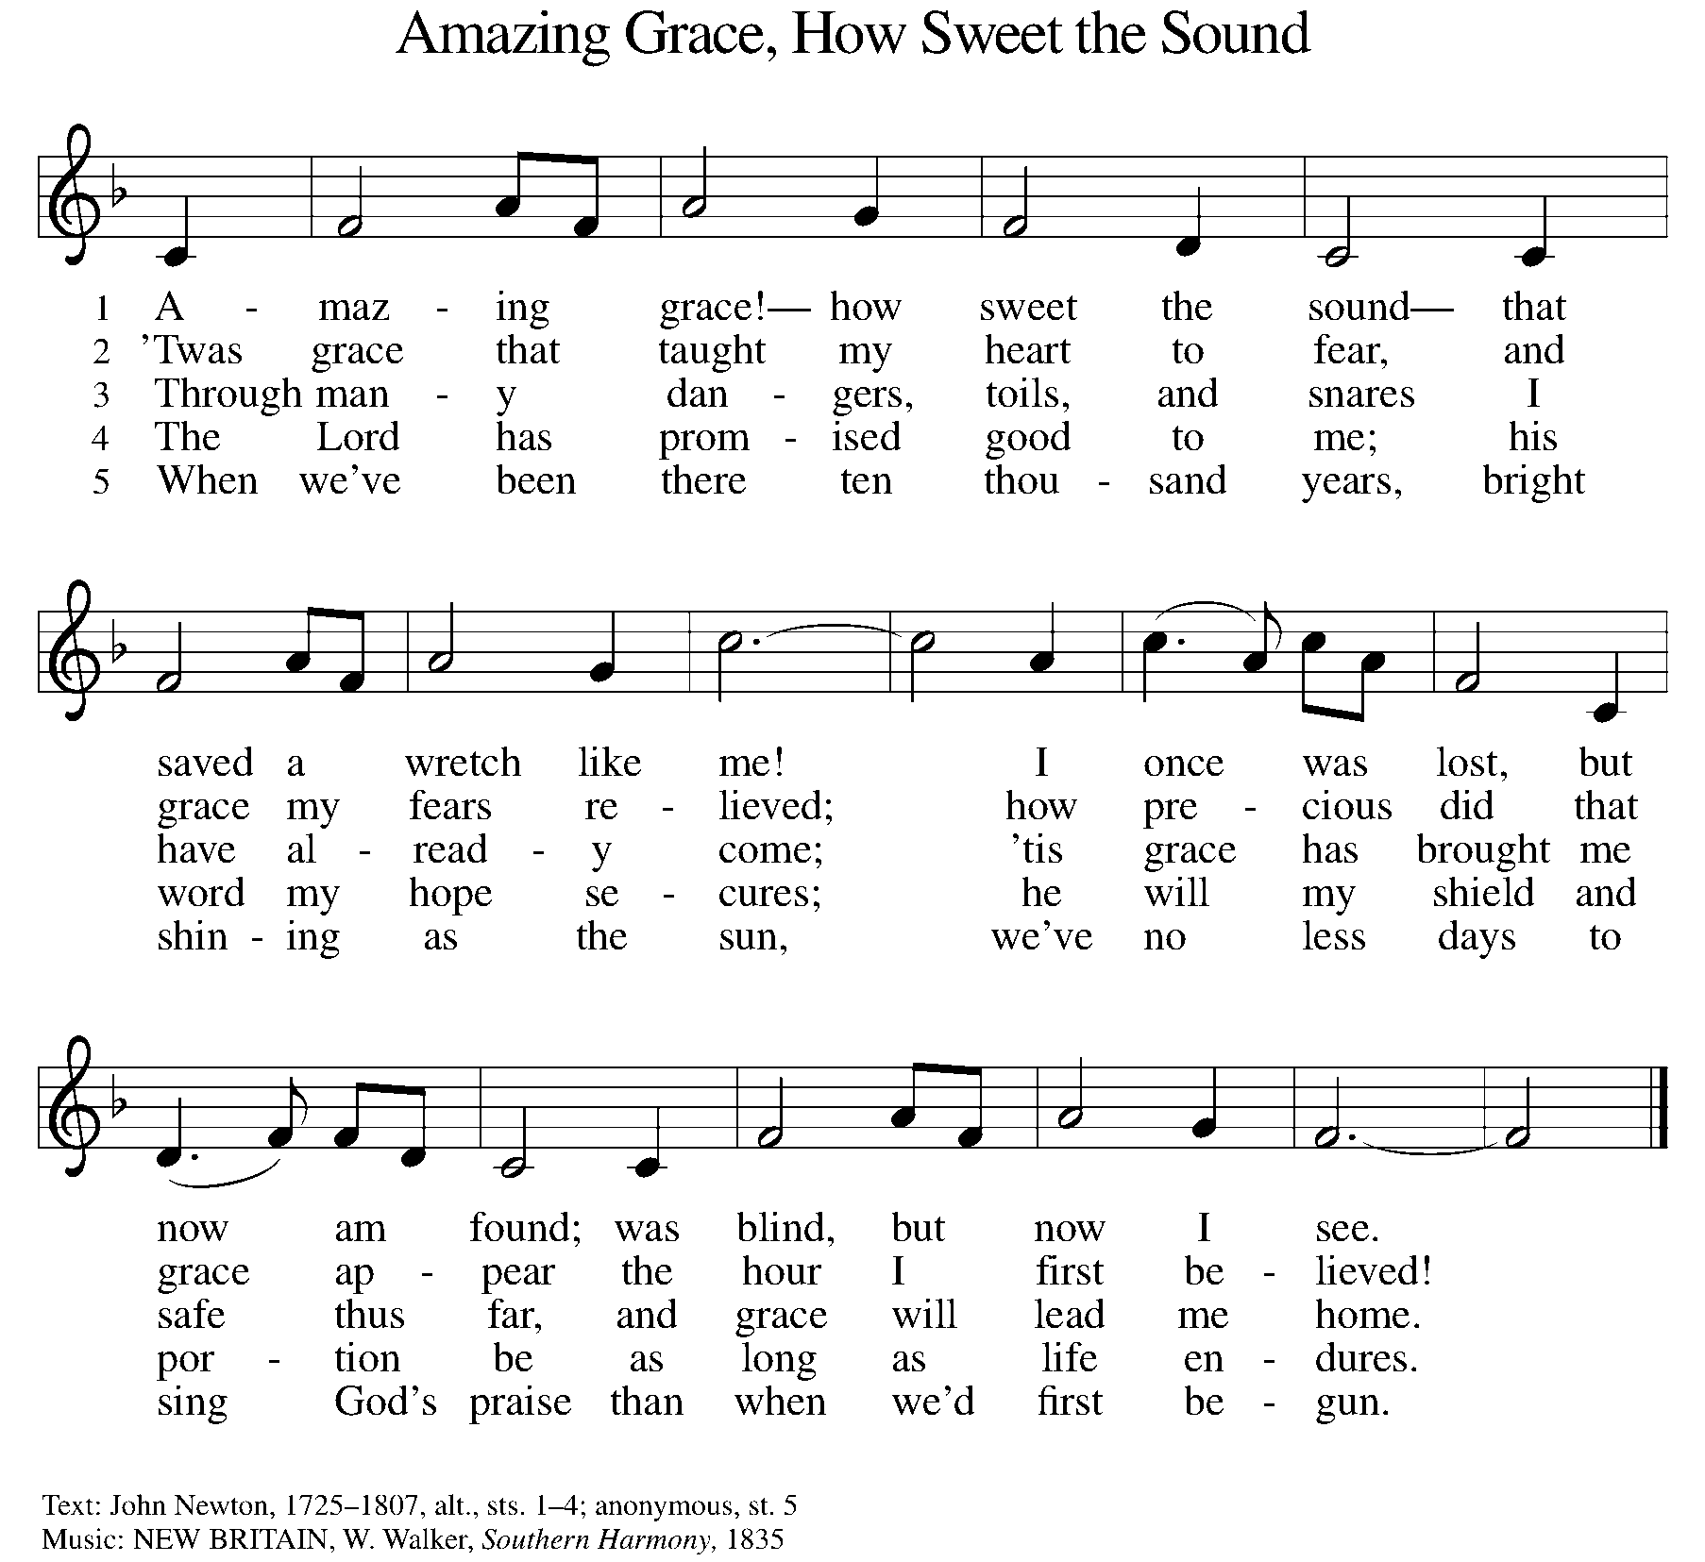

P: The body of Christ, given for you.

C: Amen.

A: The blood of Christ, shed for you.

C: Amen.
(Please rise as you are able.)

P: May the body and blood of our Lord Jesus Christ strengthen and keep you in his grace.

C: Amen.
PRAYER AFTER COMMUNION

P: Let us pray. Living One, in this feast you have made yourself known to us. Send us now to tell of your wonders, sing of your glory, and proclaim your risen life to a wounded and weary world.

C: Amen.

SENDING

BLESSING

P: The triune God, who was, who is, and who is to come, Sovereign, ☩ Savior, and Spirit, light your way with resurrection dawn, now and always.

C: Amen.

SENDING HYMN ELW 376
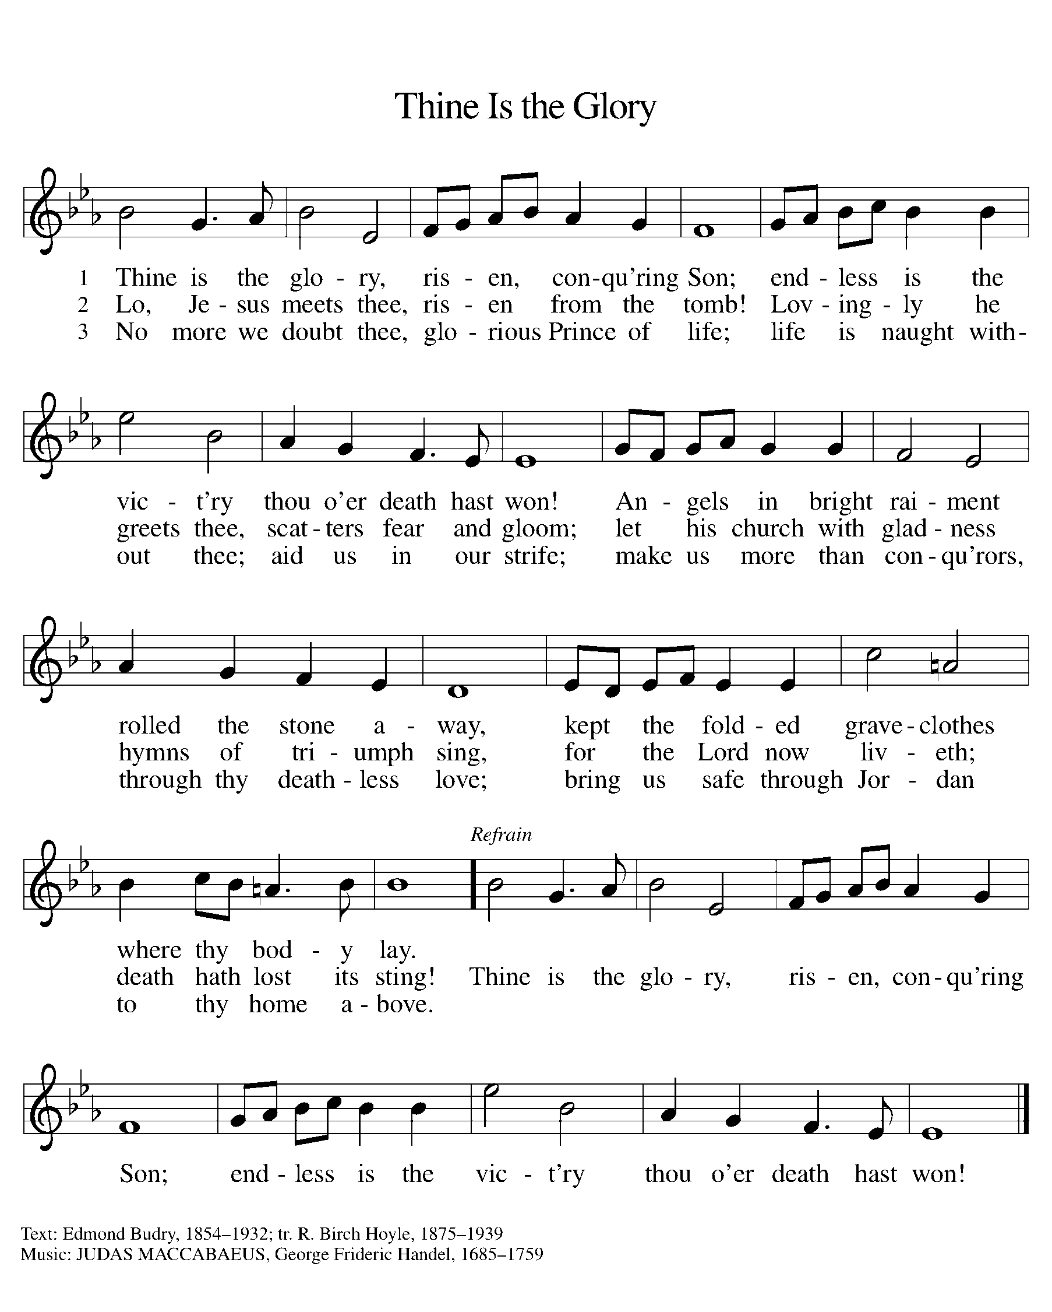

DISMISSAL

A: Alleluia! Christ is risen.

C: Christ is risen indeed. Alleluia!

A: Go in peace. In Christ you are made new. Alleluia! Alleluia!

C: Thanks be to God. Alleluia! Alleluia!

Announcements

Sunday, May 11 – Happy Mother’s Day!
Monday, May 26 – Memorial Day

Recurring Events

- Every Sunday – Adult Bible Study @ 9am
- Monday, May 5 – Worship Committee Meeting @ 6:30pm
- Wednesday, May 14 – Women’s Bible Study @ 11am
- Thursday, April 24 – Council Meeting @ 7pm

Food Pantry Dates

Thursday, April 24, 1-3pm
Wednesday, May 7, 5-6:30pm
Thursday, May 15, 1-3pm
Wednesday, May 21, 5-6:30pm
Thursday, May 29, 1-3pm

Volunteers for April 20 Volunteers for April 27

Reader Sunday – Volunteer Reader Sunday – Volunteer
Assisting Minister – Volunteer Assisting Minister – Volunteer

April Birthday Celebrations

4/2 – Noah Ki.
4/4 – Doretta Th.
4/4 – RJ Mc.
4/11 – Kathy Gr.
4/14 – Carol Ha.
4/26 – Vicki Ki.
4/27 – Kristen Op.
4/27 – Pat Cr.
4/29 – Mary Mc.

Acknowledgments
- OneLicense.net, License #A-703165. CCLI, License #2281869.
- From SundaysandSeasons.com. Copyright 2020 Augsburg Fortress. All rights reserved. Reprinted by permission under Augsburg Fortress Liturgies Annual License #23806.
- New Revised Standard Version Bible, copyright 1989, Division of Christian Education of the National Council of the Churches of Christ in the United States of America. Used by permission. All rights reserved.

