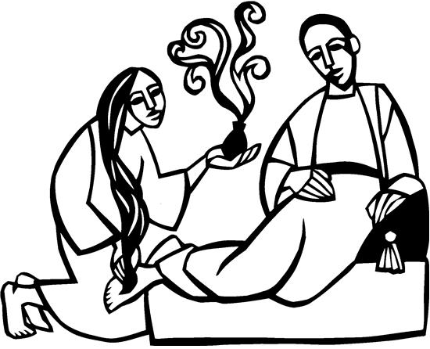

5th Sunday in Lent
April 6, 2025

SAINT PAUL LUTHERAN CHURCH
3383 EAST LAKE LANSING ROAD
EAST LANSING, MI 48823

PHONE (517) 351-8541

Pastor Carl E. Ballard
E-MAIL: pastor@stpaul-el.org
officemanager@stpaul-el.org
Visitors WELCOME! If this is your first time worshipping with us, please sign our guest registry just outside the sanctuary doors. We hope you are blessed through worship today. If you have any questions, please feel free to call the church at 351-8541.
Children are always welcome in worship! The choir room (off the sanctuary) can also be used as a cry room for younger children and includes a sound system so parents may continue to participate in the service. Clipboards with children’s bulletins, activities and crayons are available for use during the service. Please see an usher if you are unable to locate them.
Sunday School is available during the worship service September-May except the last Sunday of the month.
This Bulletin is for your use during the service and to take home for the upcoming week. If you choose not to take it home, please place it in the recycle receptacle in the back.
Newsletters and Calendars of Upcoming Events are available in the lobby/narthex. We welcome anyone who has an interest in our small groups or activities! You can also look us up on the web at www.stpaul-el.org.
Contacting Us: Our office manager is Emily Polhamus. She can be reached by phone at 517-351-8541 or at her email address, officemanager@stpaul-el.org. Our Director of Music is Elene Kobulashvili. You may leave a message at 517-351-8541. Pastor Carl can be reached at 517-515-3129, and his email address is cballard123@msn.com.
Holy Communion is available at most services. All who believe in the real presence of Christ in the bread and the wine are invited to celebrate Communion with us. Those who wish may come forward for a blessing.
You are invited to share in fellowship after worship. We would love this opportunity to introduce you to the St. Paul community.

P-Presiding Minister A-Assisting Minister C-Congregation

PRELUDE ELENE

INTRODUCTION

Our God makes all things new. In the first reading God promises it. In the gospel Mary anticipates it, anointing Jesus’ feet with costly perfume in preparation for the day of his burial. In the second reading Paul recalls his transformation from the persecutor Saul into an apostle. In baptism, God’s new person (you!) rises daily from the deadly mire of trespasses and sins.

GATHERING

P: The Holy Spirit calls us together as the people of God.

(Please rise as you are able.)

CONFESSION & FORGIVENESS

All may make the sign of the cross, the sign that is marked at baptism, as the presiding minister begins.

P: Blessed be the holy Trinity, ☩ one God, who forgives all our sin, whose mercy endures forever.

C: Amen.

P: Let us return to God, confessing our sin in the assurance of God’s abiding love.

(Silence is kept for reflection.)

P: Compassionate One,
C: you are slow to anger and abounding in steadfast love, but our lives do not always reflect you and your love for the world. We do not show others the tender compassion you have shown to us. We do not welcome others with the radical hospitality you grant to all people. We oppress others, even though you have set us free again and again. We squander the abundant gifts of the earth. Transform our lives and guide us again in the way of the cross. Amen.

P: Beloved in Christ, God’s arms are always stretched open wide to welcome the wandering ones home. In ☩ Christ your sins are forgiven. You have a place in God’s house forever.

C: Amen.

GATHERING SONG ELW 838
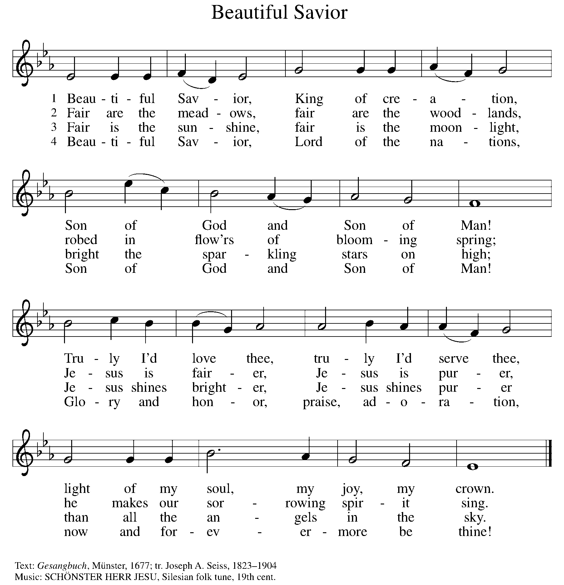

GREETING

P: The grace of our Lord Jesus Christ, the love of God, and the communion of the Holy Spirit be with you all.

C: And also with you.

KYRIE ELW Setting 2, Page 120
In peace, let us pray to the Lord.
Lord, have mercy.
For the peace from above and for our salvation,
let us pray to the Lord.
Lord, have mercy.
For the peace of the whole world, for the well-being of the church of God, and for the unity of all, let us pray to the Lord.
Lord, have mercy.
For this holy house and for all who offer here their worship and praise, let us pray to the Lord.
Lord, have mercy.
Help, save, comfort, and defend us, gracious Lord.
Amen.

CANTICLE OF PRAISE ELW Setting 4, Page 148-149
Glory to God in the highest, and peace to God’s people on earth.
Lord God, heavenly King, almighty God and Father,
we worship you, we give you thanks, we praise you for your glory. Lord Jesus Christ, only Son of the Father, Lord God, Lamb of God, you take away the sin of the world: have mercy on us;
you are seated at the right hand of the Father: receive our prayer. For you alone are the Holy One, you alone are the Lord,
you alone are the Most High, Jesus Christ, with the Holy Spirit,
in the glory of God the Father. Amen.

PRAYER OF THE DAY

P: Let us pray. Creator God, you prepare a new way in the wilderness, and your grace waters our desert. Open our hearts to be transformed by the new thing you are doing, that our lives may proclaim the extravagance of your love given to all through your Son, Jesus Christ, our Savior and Lord, who lives and reigns with you and the Holy Spirit, one God, now and forever.

C: Amen.

(Please be seated.)

CHILDREN’S MESSAGE

(Children are invited to Sunday School.)

TRANSITION SONG ELW 595
(VERSE 1 & REFRAIN ONLY)
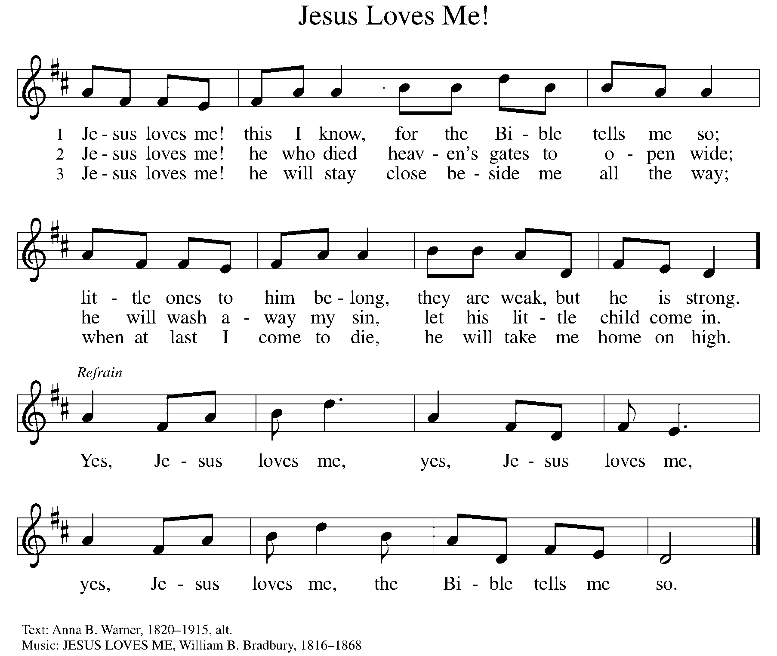

WORD

God speaks to us in scripture, preaching, and song.

First Reading ISAIAH 43:16-21
The prophet declares that long ago God performed mighty deeds and delivered Israel from Egyptian bondage through the waters of the sea. Now, God is about to do a new thing, bringing the exiles out of Babylon and through the wilderness in a new Exodus.

¹⁶ Thus says the Lord, who makes a way in the sea, a path in the mighty waters, ¹⁷ who brings out chariot and horse, army and warrior; they lie down; they cannot rise; they are extinguished, quenched like a wick: ¹⁸ Do not remember the former things or consider the things of old. ¹⁹ I am about to do a new thing; now it springs forth; do you not perceive it? I will make a way in the wilderness and rivers in the desert. ²⁰ The wild animals will honor me, the jackals and the ostriches, for I give water in the wilderness, rivers in the desert, to give drink to my chosen people, ²¹ the people whom I formed for myself so that they might declare my praise.

Word of God, word of life. C: Thanks be to God.

PSALM PSALM 126
Those who sowed with tears will reap with songs of joy. (Ps. 126:5)

¹ When the Lord restored the fortunes of Zion, then were we like those who dream.
² Then was our mouth filled with laughter, and our tongue with shouts of joy. Then they said among the nations, “The Lord has done great things for them.”
³ The Lord has done great things for us, and we are glad indeed.
⁴ Restore our fortunes, O Lord, like the watercourses of the Negeb.
⁵ Those who sowed with tears will reap with songs of joy.
⁶ Those who go out weeping, carrying the seed, will come again with joy, shouldering their sheaves.

SECOND READING PHILIPPIANS 3:4b-14
Writing to Christians in Philippi, Paul admits that his heritage and reputation could give him more reason than most people to place confidence in his spiritual pedigree. But the overwhelming grace of God in Jesus calls Paul to a new set of values.

[Paul writes:] ^{4b} If anyone else has reason to be confident in the flesh, I have more: ⁵ circumcised on the eighth day, a member of the people of Israel, of the tribe of Benjamin, a Hebrew born of Hebrews; as to the law, a Pharisee; ⁶ as to zeal, a persecutor of the church; as to righteousness under the law, blameless. ⁷ Yet whatever gains I had, these I have come to regard as loss because of Christ. ⁸ More than that, I regard everything as loss because of the surpassing value of knowing Christ Jesus my Lord. For his sake I have suffered the loss of all things, and I regard them as rubbish, in order that I may gain Christ ⁹ and be found in him, not having a righteousness of my own that comes from the law but one that comes through faith in Christ, the righteousness from God based on faith. ¹⁰ I want to know Christ and the power of his resurrection and the sharing of his sufferings by becoming like him in his death, ¹¹ if somehow I may attain the resurrection from the dead.

¹² Not that I have already obtained this or have already reached the goal, but I press on to lay hold of that for which Christ has laid hold of me. ¹³ Brothers and sisters, I do not consider that I have laid hold of it, but one thing I have laid hold of: forgetting what lies behind and straining forward to what lies ahead, ¹⁴ I press on toward the goal, toward the prize of the heavenly call of God in Christ Jesus.

Word of God, word of life. C: Thanks be to God.

(Please rise as you are able.)
GOSPEL ACCLAMATION ELW Setting 2, Page 125
Let your steadfast love come to us, O Lord.
Save us as you promised; we will trust your word.
Save us as you promised; we will trust your word.

GOSPEL JOHN 12:1-8

P: The Holy Gospel according to John, the 12th chapter.
C: Glory to you, O Lord.
Judas willfully misinterprets as waste Mary’s extravagant act of anointing Jesus’ feet with costly perfume. Jesus recognizes that her lavish gift is both an expression of love and an anticipation of his burial.
¹ Six days before the Passover Jesus came to Bethany, the home of Lazarus, whom he had raised from the dead. ² There they gave a dinner for him. Martha served, and Lazarus was one of those reclining with him. ³ Mary took a pound of costly perfume made of pure nard, anointed Jesus’s feet, and wiped them with her hair. The house was filled with the fragrance of the perfume. ⁴ But Judas Iscariot, one of his disciples (the one who was about to betray him), said, ⁵ “Why was this perfume not sold for three hundred denarii and the money given to the poor?” ⁶ ⁽He said this not because he cared about the poor but because he was a thief; he kept the common purse and used to steal what was put into it.) ⁷ Jesus said, “Leave her alone. She bought it so that she might keep it for the day of my burial. ⁸ You always have the poor with you, but you do not always have me.”

P: The Gospel of the Lord. C: Praise to you, O Christ.

(Please be seated.)

SERMON PASTOR CARL BALLARD

(Please rise as you are able.)
HYMN OF THE DAY ELW 583
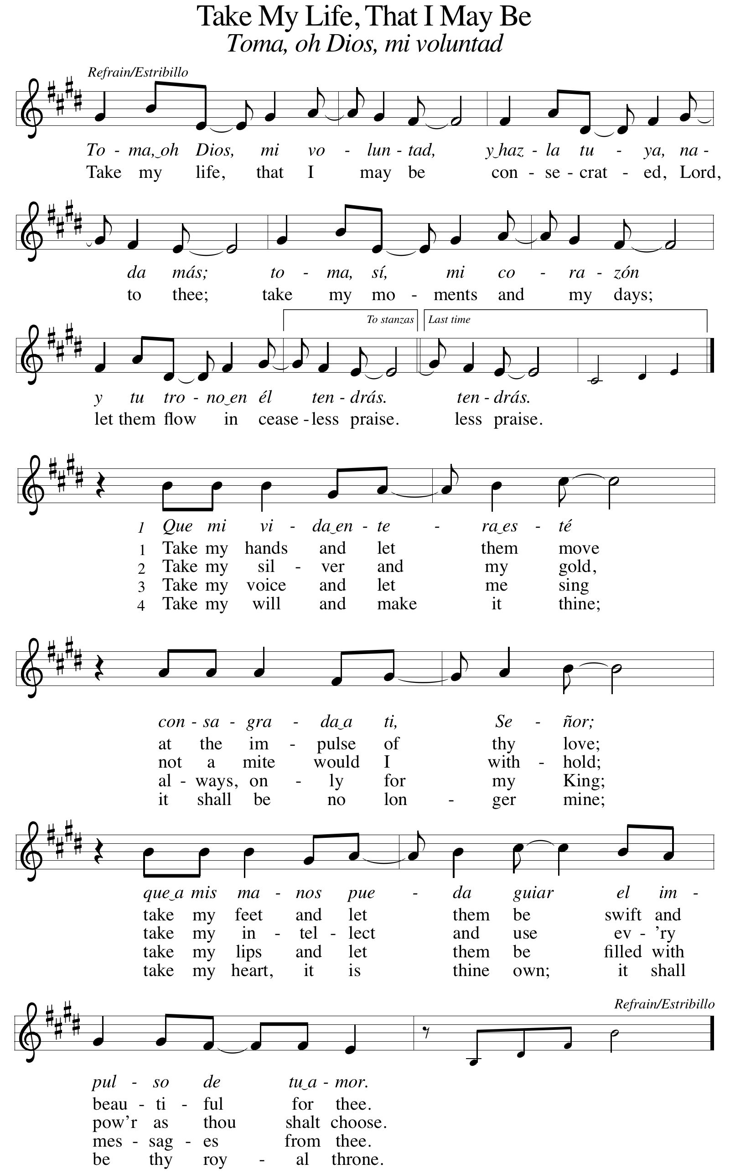
apostles’ CREED

I believe in God, the Father almighty,
creator of heaven and earth.
I believe in Jesus Christ, God’s only Son, our Lord,
who was conceived by the Holy Spirit,
born of the virgin Mary,
suffered under Pontius Pilate,
was crucified, died, and was buried;
he descended to the dead.
On the third day he rose again;
he ascended into heaven,
he is seated at the right hand of the Father,
and he will come to judge the living and the dead.
I believe in the Holy Spirit,
the holy catholic church,
the communion of saints,
the forgiveness of sins,
the resurrection of the body,
and the life everlasting. Amen.

(Please be seated.)

THE PRAYERS

A: Led by the Spirit, let us turn to God in prayer for the church, the world, and all those in need.
(A brief silence)
A: The church declares your praise, O God. Guide us in the example of Isaiah’s imagination, Paul’s transformed identity, and Mary’s faith and devotion; that our lives, too, may be poured out in love as we trust in your promises. God, in your mercy,

C: receive our prayer.
A: The earth declares your praise, O God. Make a way for the planet’s future in the sea and the wilderness, the mountains and plains, the tundra and wetlands. Repair habitats and sustainable ecosystems on, above, and beneath the ground. God, in your mercy,

C: receive our prayer.
A: The nations declare your praise, O God. Where religious differences divide, bring together those who worship you in the name of Jesus Christ and those who call to you with different names. Guide interreligious dialogue, that faith may unite rather than divide communities. God, in your mercy,

C: receive our prayer.

A: The gifts of the Spirit declare your praise, O God. We thank you for artists who proclaim the gospel. Inspire music, poetry, and images that proclaim the new thing you are doing. God, in your mercy,
C: receive our prayer.

A: The nations declare your praise, O God. Protect and care for those who defend our country, especially Beth & Ryan, Jonathan, Jacob, Noah, Irene, and Alex. God, in your mercy,

C: receive our prayer.

A: The people declare your praise, O God. Restore those whose hope has been dampened through a health diagnosis, job or home loss, divorce, or death. Bring healing to those in need, especially Ahren, Beth Ra., Carolyn, Dan, David, Doretta, family & friends of Nina, Gage, Jim & Cheri, John, Johnny, Jon, Jordan, Joseph Ra., Lawton, Lera & family, Linda, Lizzy, Marge, Randy, Rick & Kathy, Sheri, Sheri, Steve, and Wanda, and all whom we name now aloud and in our hearts. May all who weep now sing songs of joy again. God, in your mercy,

C: receive our prayer.

A: The communities of faith declare your praise, O God. Give direction to their faithful leaders, especially Presiding Bishop Elizabeth, our Synod Bishop Craig, and Pastor Carl and their respective staffs as they live out their callings to serve. As we are called to be one, even as Jesus and the Father are one, be with the leaders and the congregation Grace Lutheran Church in East Tawas and all the churches in our community. God, in your mercy,

C: receive our prayer.

A: The communion of saints declares your praise, O God. Giving thanks for those who have died, we trust in the one who has made them his own: Christ Jesus, our crucified and risen Savior. God, in your mercy,

C: receive our prayer.

P: Receive the prayers of your people and draw all things together in your love, in the name of Jesus, who leads us from death to life.

C: Amen.

GREETING OF PEACE

(You are invited to share Christ’s peace with one another.)

P: The peace of Christ be with you always.

C: And also with you.
(Please be seated.)
MEAL
OFFERING ELENE
(Please rise if you are able.)
OFFERTORY ELW 325
(VERSE 1 ONLY)
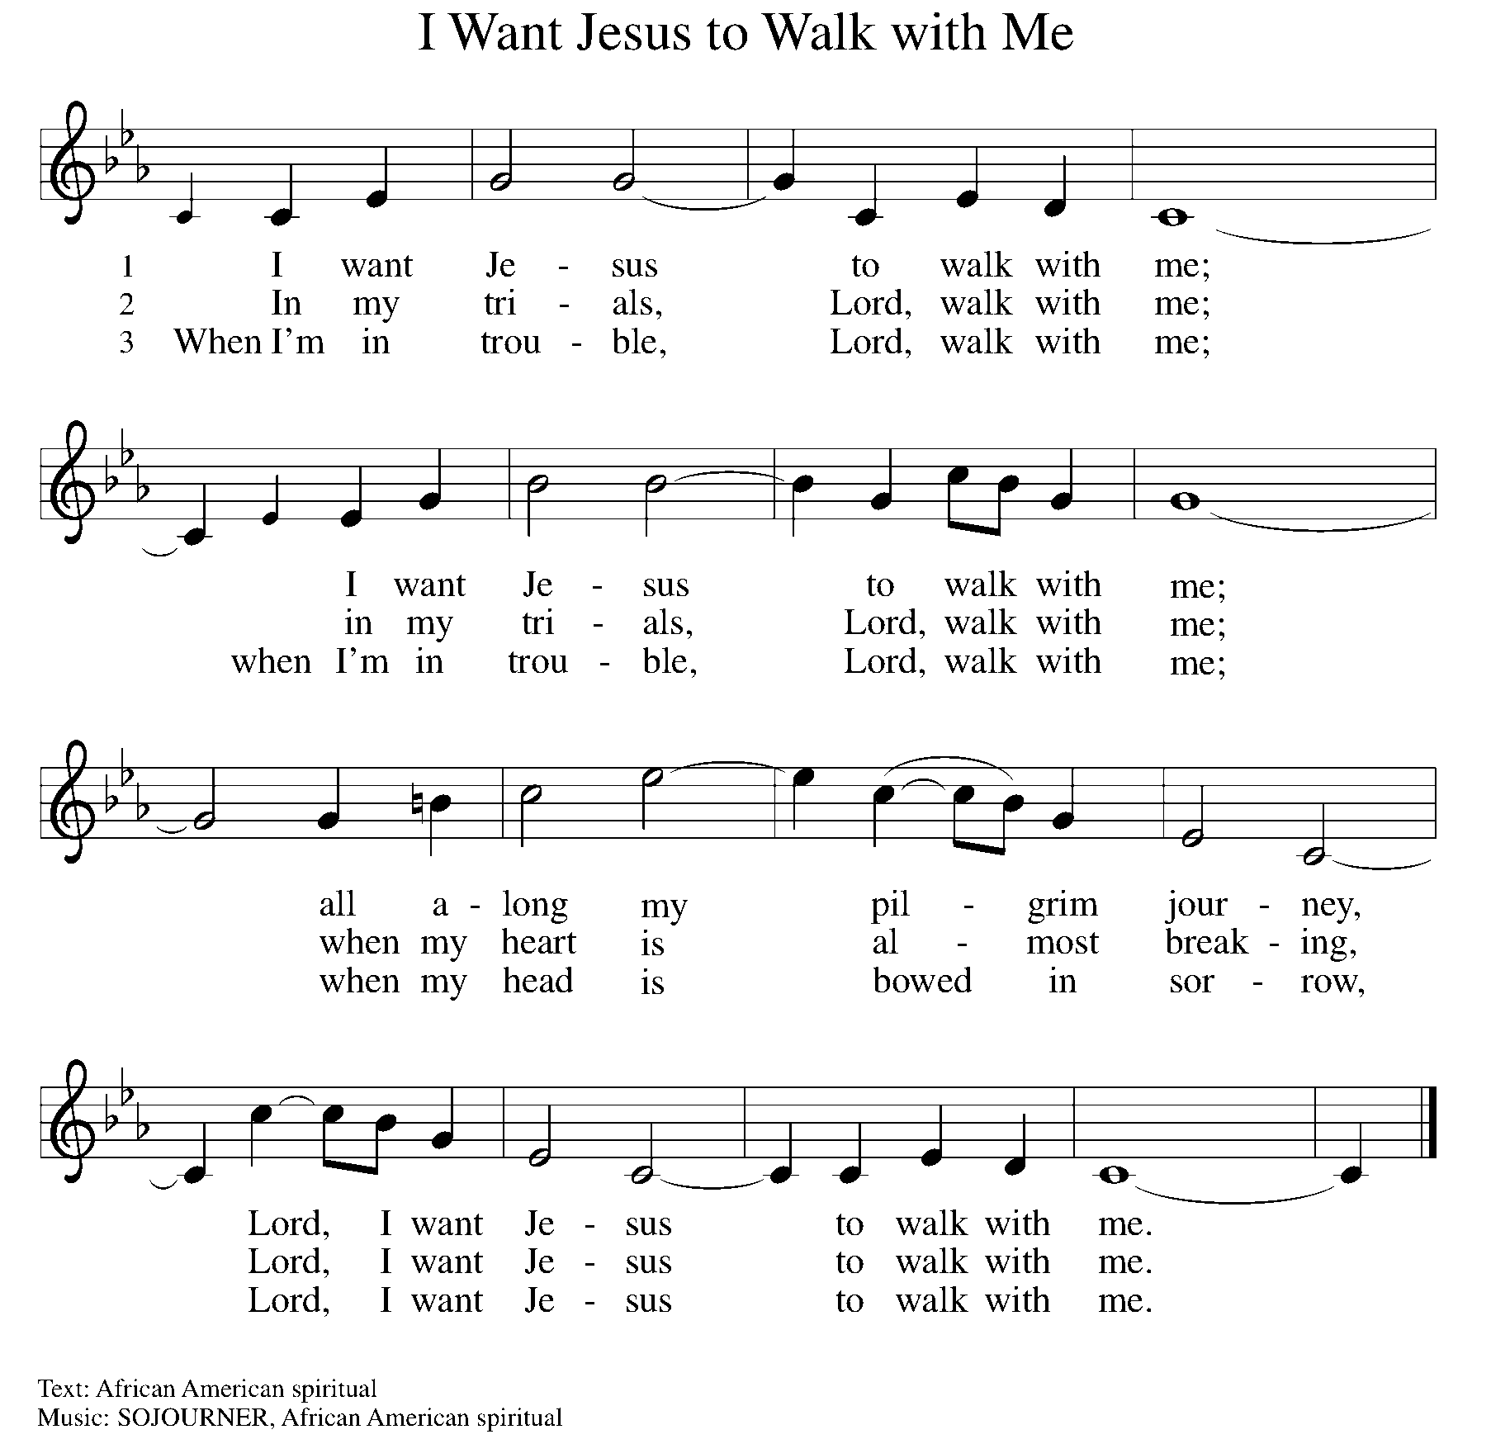

OFFERING PRAYER
A: Let us pray. Gracious Provider, you set your immense treasures among us, opening your heart to the world. As we prepare to feast on your bountiful love, deepen our commitment to sharing those treasures with others, through our Savior, Jesus Christ.

C: Amen.
THE GREAT THANKSGIVING

P: The Lord be with you.
C: And also with you.
P: Lift up your hearts.
C: We lift them to the Lord.
P: Let us give thanks to the Lord our God.
C: It is right to give our thanks and praise.

PROPER PREFACE

P: It is indeed right, our duty and our joy, that we should at all times and in all places give thanks and praise to you, almighty and merciful God, through our Savior Jesus Christ; who on this day overcame death and the grave, and by his glorious resurrection opened to us the way of everlasting life. And so, with all the choirs of angels, with the church on earth and the hosts of heaven, we praise your name and join their unending hymn:

HOLY, HOLY ELW Setting 2, Page 130
Holy, holy, holy Lord, God of power and might,
heaven and earth are full of your glory.
Hosanna in the highest.
Blessed is he who comes in the name of the Lord.
Hosanna in the highest. Hosanna in the highest.

EUCHARISTIC PRAYER

P: In the night in which he was betrayed, our Lord Jesus took bread, and gave thanks; broke it, and gave it to his disciples, saying:
Take and eat; this is my body, given for you. Do this for the
remembrance of me.
Again, after supper, he took the cup, gave thanks, and gave it for all to drink, saying:
This cup is the new covenant in my blood, shed for you and for all people for the forgiveness of sin. Do this for the remembrance of me.

LORD'S PRAYER

P: Lord, remember us in your kingdom, and teach us to pray:

C: Our Father, who art in heaven, hallowed be thy name, thy kingdom come, thy will be done on earth as it is in heaven. Give us this day our daily bread; and forgive us our trespasses as we forgive those who trespass against us; and lead us not into temptation, but deliver us from evil. For thine is the kingdom, and the power, and the glory, forever and ever. Amen.
(Please be seated.)

COMMUNION DISTRIBUTION

All who believe in the real presence of Christ in the bread and the wine (juice) are welcome to the table. Others may come forward for a blessing. If you prefer grape juice, please indicate this to the assisting minister.

When approaching the communion rail, come forward down the side aisle, kneel, if you are able, starting at the front of the communion rail (spot closest to the font) on your side and filling in toward the back. After receiving both the bread and the wine, you may return to your seat by the center aisle.

INVITATION TO COMMUNION

P: All who are hungry, come! The feast of grace is spread.

COMMUNION HYMN ELW 779
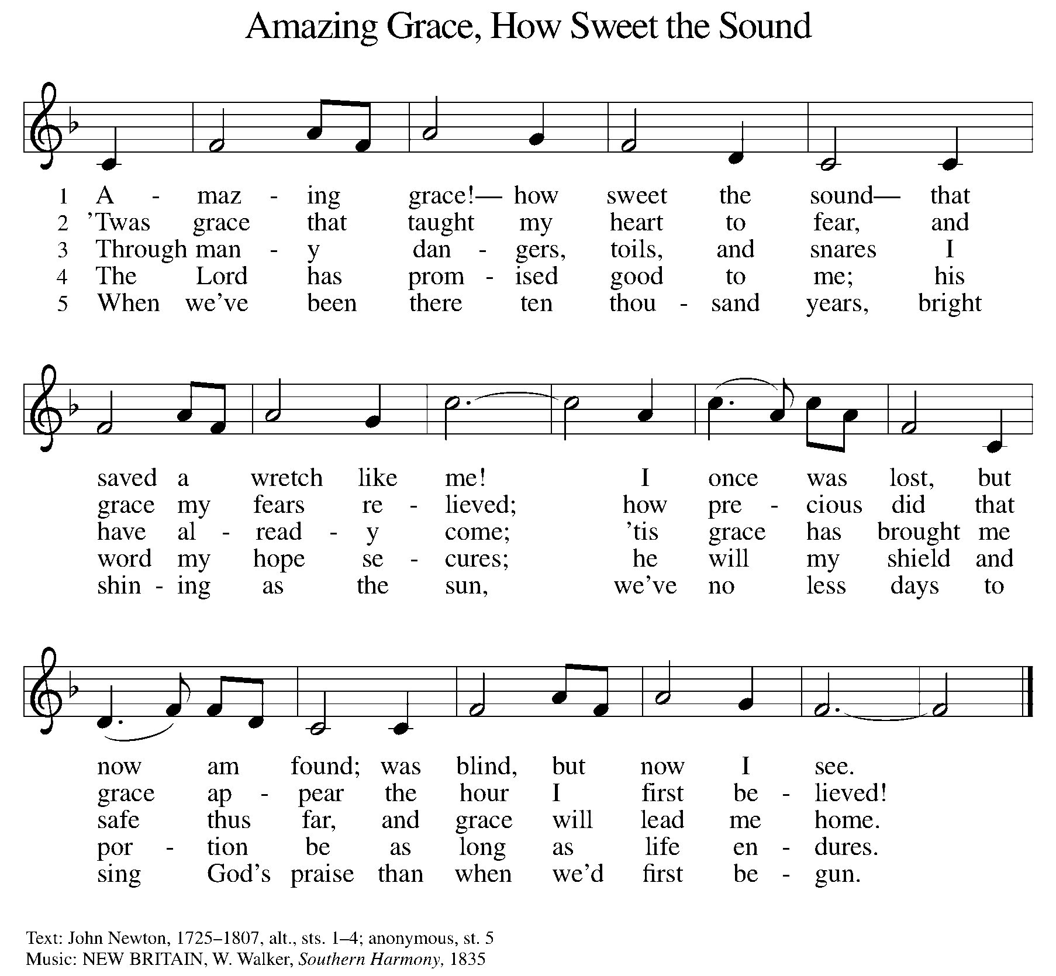

P: The body of Christ, given for you.

C: Amen.

A: The blood of Christ, shed for you.

C: Amen.
(Please rise as you are able.)

P: May the body and blood of our Lord Jesus Christ strengthen and keep you in his grace.

C: Amen.
PRAYER AFTER COMMUNION

P: Let us pray. Generous Host, you have shared your feast with us and made us new. Send us now to set tables of love and grace in our communities, that your liberating love might nourish the world into freedom, in the name of the crucified one, Jesus Christ our Lord.

C: Amen.

SENDING

BLESSING

P: God our tender parent, God the crucified one, God the reconciling Spirit, ☩ bless you now and forever.

C: Amen.

SENDING HYMN ACS 1000
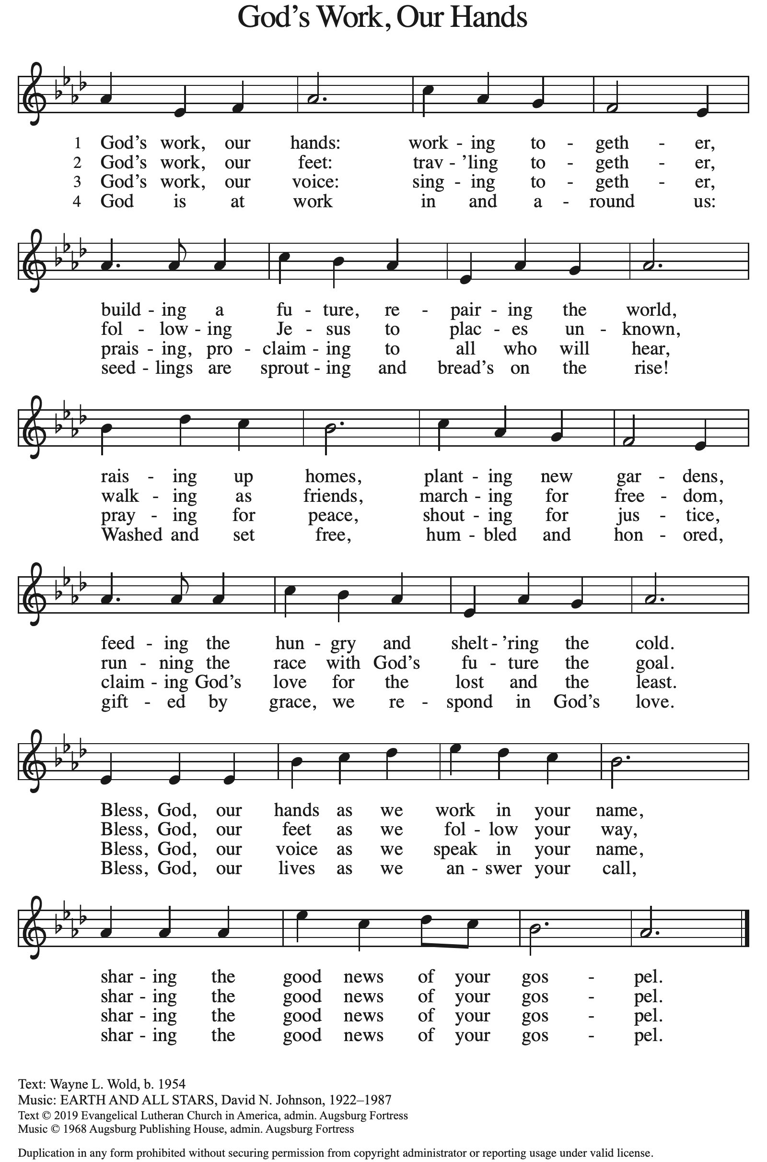

DISMISSAL

A: Go in peace. Care for others as God cares for you.

C: Thanks be to God.

Announcements

Bring items for the Food Pantry & Homeless!

Readers needed for Palm Sunday – See Pr. Carl

- Sunday, April 13 – Palm Sunday
- Friday, April 18 – Good Friday Service @ 6pm
- Sunday, April 20 – Easter
- Sunday, April 20 – Easter Breakfast Potluck @ 9am
- Sunday, April 20 – Children’s Easter Egg Hunt @ 9:15am

Recurring Events

- Every Sunday – Adult Bible Study @ 9am
- Monday, April 7 – Worship Committee Meeting @ 6:30pm
- Wednesday, May 14– Women’s Bible Study @ 11am
- Thursday, April 17 – Council Meeting @ 7pm

Food Pantry Dates

Thursday, April 10, 1-3pm
Wednesday, April 16, 5-6:30pm
Thursday, April 24, 1-3pm
Wednesday, May 7, 5-6:30pm
Thursday, May 15, 1-3pm
Wednesday, May 21, 5-6:30pm
Volunteers for April 6 Volunteers for April 13

Reader - Volunteer Reader – Volunteer
Assisting Minister - Kathy Assisting Minister – Volunteer

April Birthday Celebrations

4/2 – Noah Ki.
4/4 – Doretta Th.
4/4 – RJ Mc.
4/11 – Kathy Gr.
4/14 – Carol Ha.
4/26 – Vicki Ki.
4/27 – Kristen Op.
4/27 – Pat Cr.
4/29 – Mary Mc.

Acknowledgments
- OneLicense.net, License #A-703165.
- CCLI, License #2281869.
- From SundaysandSeasons.com. Copyright 2020 Augsburg Fortress. All rights reserved. Reprinted by permission under Augsburg Fortress Liturgies Annual License #23806.
- New Revised Standard Version Bible, copyright 1989, Division of Christian Education of the National Council of the Churches of Christ in the United States of America. Used by permission. All rights reserved.

