

2nd Sunday in Easter
April 27, 2025

SAINT PAUL LUTHERAN CHURCH
3383 EAST LAKE LANSING ROAD
EAST LANSING, MI 48823

PHONE (517) 351-8541

Pastor Carl E. Ballard
E-MAIL: pastor@stpaul-el.org
officemanager@stpaul-el.org

Visitors WELCOME! If this is your first time worshipping with us, please sign our guest registry just outside the sanctuary doors. We hope you are blessed through worship today. If you have any questions, please feel free to call the church at 351-8541.
Children are always welcome in worship! The choir room (off the sanctuary) can also be used as a cry room for younger children and includes a sound system so parents may continue to participate in the service. Clipboards with children's bulletins, activities and crayons are available for use during the service.
Sunday School is available during the worship service September-May except the last Sunday of the month.
Virtual Services We can provide a virtual live Zoom session during worship upon request.
This Bulletin is for your use during the service and to take home for the upcoming week. If you choose not to take it home, please place it in the recycle receptacle in the back.
Newsletters and Calendars of Upcoming Events are available in the lobby/narthex. We welcome anyone who has an interest in our small groups or activities! You can also look us up on the web at www.stpaul-el.org.
Contacting Us: Our Office Manager is Emily Polhamus. She can be reached by phone at 517-351-8541 or at her email address, officemanager@stpaul-el.org. Our Director of Music is Elene Kobulashvili. You may leave a message at 517-351-8541. Pastor Carl can be reached at 517-515-3129, and his email address is cballard123@msn.com.
Holy Communion is available at most services. All who believe in the real presence of Christ in the bread and the wine are invited to celebrate Communion with us. Those who wish may come forward for a blessing.
You’re invited to share in fellowship after worship. We would love this opportunity to introduce you to the St. Paul community.

P-Presiding Minister A-Assisting Minister C-Congregation
PRELUDE ELENE

INTRODUCTION

In spite of all we have heard and all we have seen, it is often hard to believe. Because it is hard to believe, we will invest ourselves in the Easter mystery for fifty days (a week of weeks). Because it is hard to believe, John the evangelist will provide sign after sign celebrating Jesus’ victory over death. Because it is hard to believe, the risen Jesus will return to us again and again in the mystery of holy communion, inviting us to touch and taste his presence, and offering us his peace.

GATHERING

P: The Holy Spirit calls us together as the people of God.

(Please rise as you are able.)

THANKSGIVING FOR BAPTISM

P: Alleluia! Christ is risen.
C: Christ is risen, indeed. Alleluia!
P: In the name of ☩ the One who was, who is, and who is to come.
C: Amen.
P: Baptized into Christ’s death and resurrection, and called to live the baptized life, let us give thanks for the gifts of baptism. Holy God, we give you thanks for the waters of baptism, waters that make a people your own, that restore to wholeness, and empower us to be witnesses in your name. Baptized into you, O Living One,
C: make us one as you are one.
P: We give you thanks for the waters of baptism, waters that strengthen believers and give new life to beloved servants of your church; waters that extend your boundless love and cross barriers of our own making. Baptized into you, O Living One,
C: make us one as you are one.
P: We give you thanks for the waters of baptism, waters that open the hearts of believers and give a voice in the night to those in captivity; waters that set your people on a new path, rejoicing in the Spirit’s power. Baptized into you, O Living One,
C: make us one as you are one.
P: Grant us grace, love, and life, O Living One, that our every day is shaped by these waters that give us our very lives in you. We ask this in the name of Jesus, the Crucified and Risen One.
C: Amen.

GATHERING SONG ELW 379
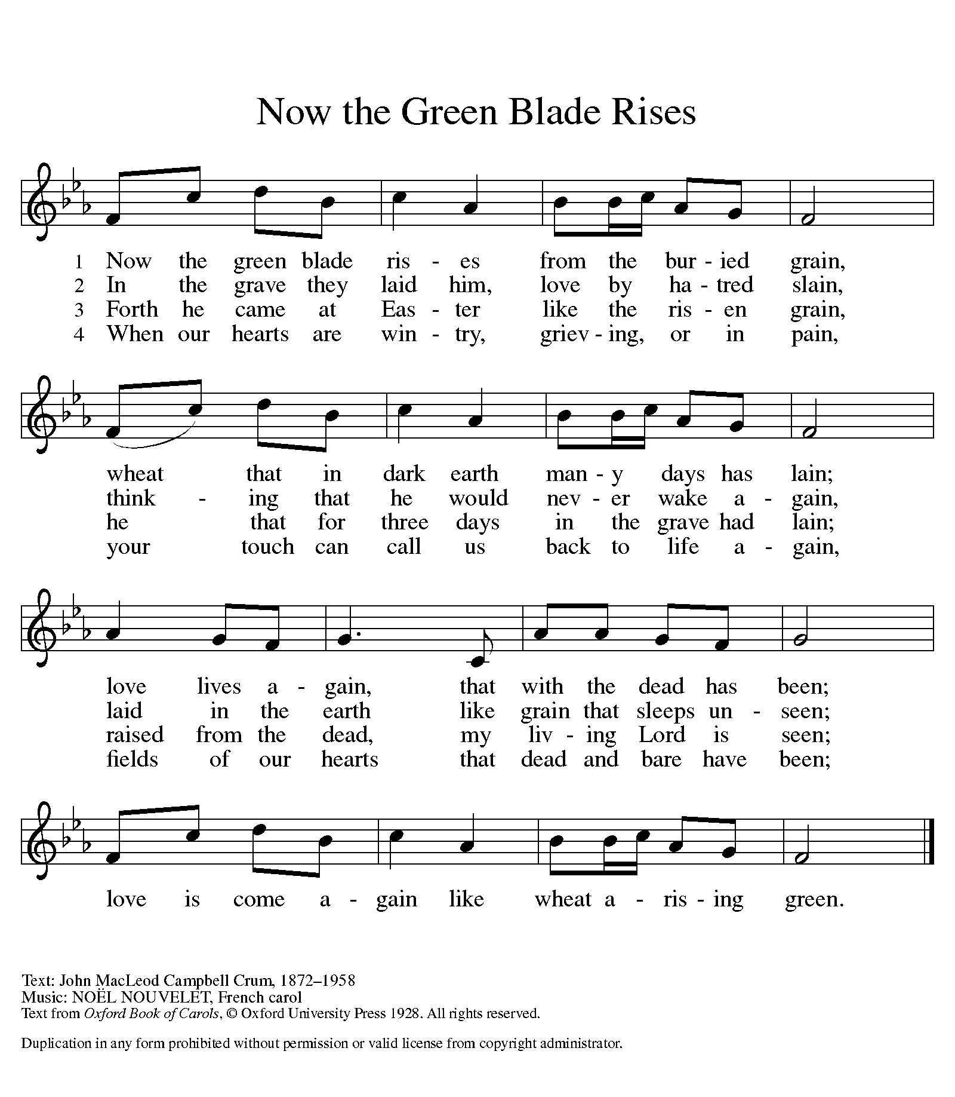

GREETING

P: The grace of our Lord Jesus Christ, the love of God, and the communion of the Holy Spirit be with you all.
C: And also with you.

KYRIE ELW Setting 8, Page 184-185
REFRAIN
Kyrie eleison, on our world and on our way.
Kyrie eleison, ev'ry day.
For peace in the world, for the health of the church,
for the unity of all;
for this holy house, for all who worship and praise,
let us pray to the Lord, let us pray to the Lord. Refrain

That we may live out your impassioned response
to the hungry and the poor;
that we may live out truth and justice and grace,
let us pray to the Lord, let us pray to the Lord. Refrain

For peace in our hearts, for peace in our homes,
for friends and family;
for life and for love, for our work and our play,
let us pray to the Lord, let us pray to the Lord. Refrain

For your Spirit to guide;
that you center our lives in the water and the Word;
that you nourish our souls with your body and blood,
let us pray to the Lord, let us pray to the Lord. Refrain

CANTICLE OF PRAISE ELW Setting 4, Page 149-150

This is the feast of victory for our God. Alleluia.

Worthy is Christ, the Lamb who was slain,
whose blood set us free to be people of God.
Power and riches and wisdom and strength,
and honor and blessing and glory are his.

This is the feast of victory for our God. Alleluia.

Sing with all the people of God and join in the hymn of all creation:
Blessing and honor and glory and might be to God
and the Lamb forever. Amen.

This is the feast of victory for our God, for the Lamb who was slain has begun his reign.
Alleluia. Alleluia.

PRAYER OF THE DAY

P: Let us pray. O God of life, you reach out to us amid our fears with the wounded hands of your risen Son. By your Spirit’s breath revive our faith in your mercy, and strengthen us to be the body of your Son, Jesus Christ, our Savior and Lord, who lives and reigns with you and the Holy Spirit, one God, now and forever.

C: Amen.
(Please be seated.)

CHILDREN’S MESSAGE/NOISY OFFERING

(Children are invited to Sunday school.)

TRANSITION SONG (ONLY VERSE 1 & REFRAIN) ELW 595
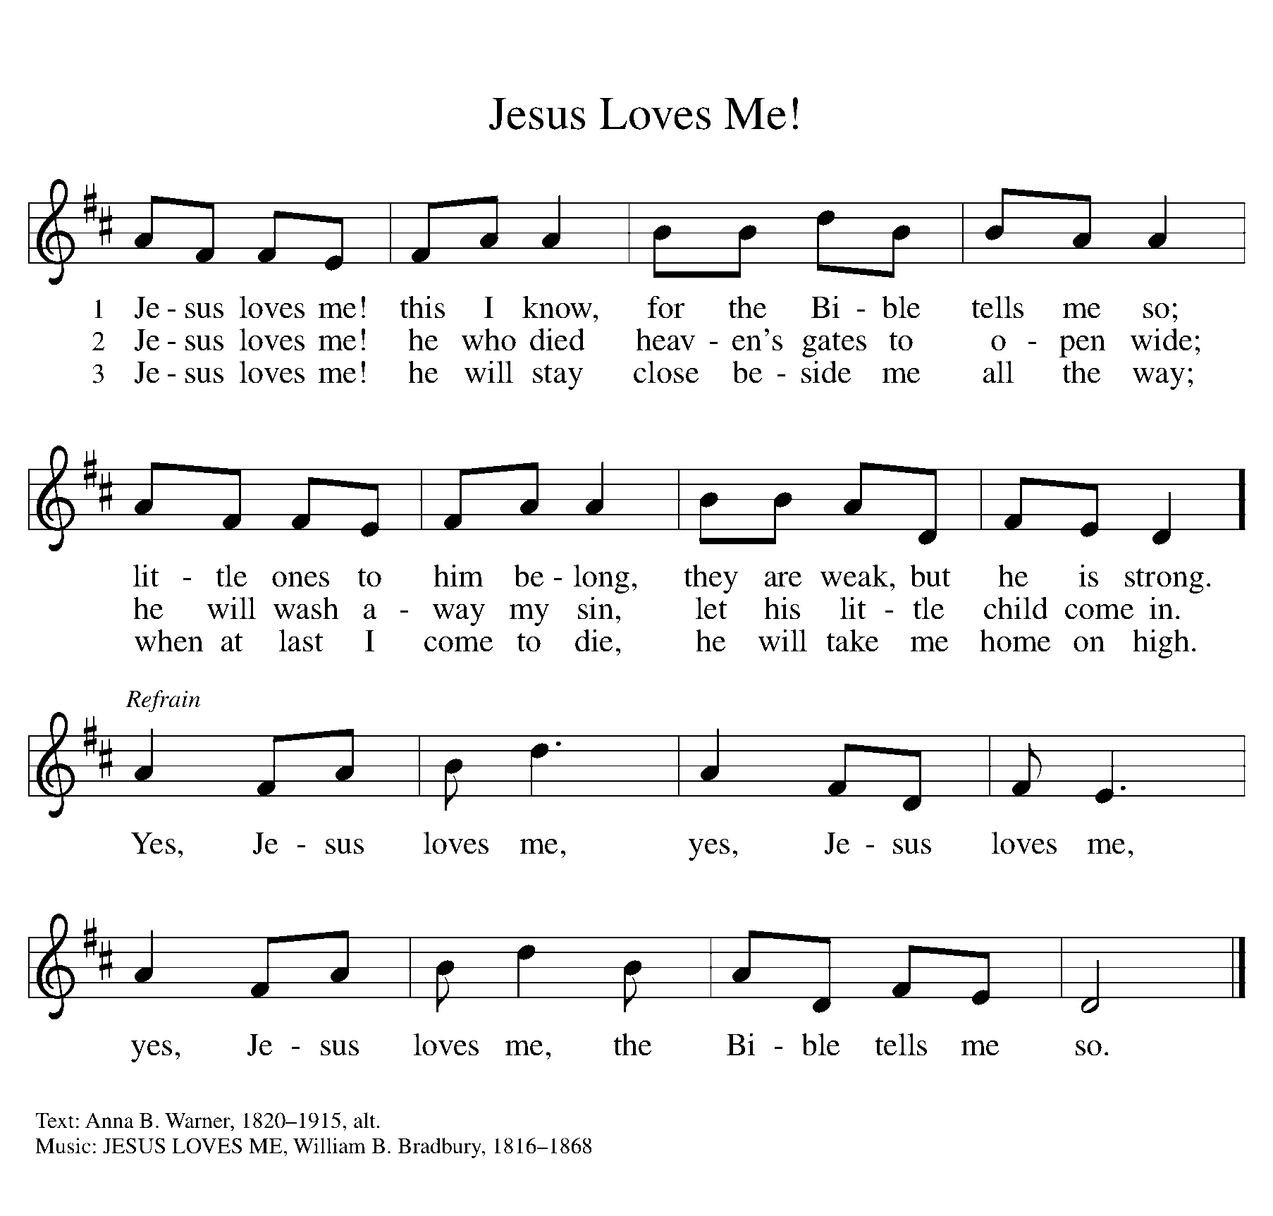
WORD

P: God speaks to us in scripture, preaching, and song.

First Reading ACTS 5:27-32
Peter has been arrested for proclaiming the good news of Jesus’ death and resurrection. His response to the charges of the high priest summarizes the early church’s proclamation of forgiveness of sin through repentance.

²⁷ When they had brought [the apostles], they had them stand before the council. The high priest questioned them, ²⁸ saying, “We gave you strict orders not to teach in this name, yet here you have filled Jerusalem with your teaching, and you are determined to bring this man’s blood on us.” ²⁹ But Peter and the apostles answered, “We must obey God rather than any human authority. ³⁰ The God of our ancestors raised up Jesus, whom you had killed by hanging him on a tree. ³¹ God exalted him at his right hand as Leader and Savior that he might give repentance to Israel and forgiveness of sins. ³² And we are witnesses to these things, and so is the Holy Spirit whom God has given to those who obey him.”

Reader: Word of God, word of life. C: Thanks be to God.

PSALM PSALM 118:14-29
You are my God, and I will exalt you. (Ps. 118:28)

¹⁴ The Lord is my strength and my song, and has become my salvation.
¹⁵ Shouts of rejoicing and salvation echo in the tents of the righteous: “The right hand of the Lord acts valiantly!
¹⁶ The right hand of the Lord is exalted! The right hand of the Lord acts valiantly!”
¹⁷ I shall not die, but live, and declare the works of the Lord.
¹⁸ The Lord indeed punished me sorely, but did not hand me over to death.
¹⁹ Open for me the gates of righteousness; I will enter them and give thanks to the Lord.
²⁰ “This is the gate of the Lord; here the righteous may enter.”
²¹ I give thanks to you, for you have answered me and you have become my salvation.
²² The stone that the builders rejected has become the chief cornerstone.
²³ By the Lord has this been done; it is marvelous in our eyes.
²⁴ This is the day that the Lord has made; let us rejoice and be glad in it.
²⁵ Hosanna! O Lord, save us! We pray to you, Lord, prosper our days!
²⁶ Blessed is the one who comes in the name of the Lord; we bless you from the house of the Lord.
²⁷ The Lord is God and has given us light. Form a procession with branches up to the corners of the altar.
²⁸ You are my God, and I will thank you; you are my God, and I will exalt you.
²⁹ Give thanks to the Lord, for the Lord is good; God’s mercy endures forever.

SECOND READING REVELATION 1:4-8
The book of Revelation recounts a mystical vision of the risen Christ experienced by a Christian prophet named John. Here he describes Christ as a timeless redeemer, the beginning, present, and end of all time.
⁴ John to the seven churches that are in Asia: Grace to you and peace from him who is and who was and who is to come and from the seven spirits who are before his throne, ⁵ and from Jesus Christ, the faithful witness, the firstborn of the dead, and the ruler of the kings of the earth. To him who loves us and freed us from our sins by his blood ⁶ and made us a kingdom, priests serving his God and Father, to him be glory and dominion forever and ever. Amen. ⁷ Look! He is coming with the clouds; every eye will see him, even those who pierced him, and all the tribes of the earth will wail on account of him. So it is to be. Amen. ⁸ “I am the Alpha and the Omega,” says the Lord God, who is and who was and who is to come, the Almighty.

Reader: Word of God, word of life. C: Thanks be to God.

(Please rise as you are able.)

GOSPEL ACCLAMATION ELW Setting 8, Page 188

Alleluia. Lord, to whom shall we go?
You have the words of eternal life. Alleluia.
Alleluia, alleluia. Alleluia.
Alleluia, alleluia.

GOSPEL JOHN 20:19-31
P: The Holy Gospel according to John, the 20th chapter.
C: Glory to you, O Lord.
The unprecedented events of the day of resurrection continue as the risen Jesus appears to his fearful disciples. A week later, after Thomas worships Jesus, Jesus pronounces that the blessings of the resurrection are also for those who “have not seen and yet believe.”
¹⁹ When it was evening on that day, the first day of the week, and the doors were locked where the disciples were, for fear of the Jews, Jesus came and stood among them and said, “Peace be with you.” ²⁰ After he said this, he showed them his hands and his side. Then the disciples rejoiced when they saw the Lord. ²¹ Jesus said to them again, “Peace be with you. As the Father has sent me, so I send you.” ²² When he had said this, he breathed on them and said to them, “Receive the Holy Spirit. ²³ If you forgive the sins of any, they are forgiven them; if you retain the sins of any, they are retained.”
²⁴ But Thomas (who was called the Twin), one of the twelve, was not with them when Jesus came. ²⁵ So the other disciples told him, “We have seen the Lord.” But he said to them, “Unless I see the mark of the nails in his hands and put my finger in the mark of the nails and my hand in his side, I will not believe.”
²⁶ A week later his disciples were again in the house, and Thomas was with them. Although the doors were shut, Jesus came and stood among them and said, “Peace be with you.” ²⁷ Then he said to Thomas, “Put your finger here and see my hands. Reach out your hand and put it in my side. Do not doubt but believe.” ²⁸ Thomas answered him, “My Lord and my God!” ²⁹ Jesus said to him, “Have you believed because you have seen me? Blessed are those who have not seen and yet have come to believe.”
³⁰ Now Jesus did many other signs in the presence of his disciples that are not written in this book. ³¹ But these are written so that you may continue to believe that Jesus is the Messiah, the Son of God, and that through believing you may have life in his name.

P: The Gospel of the Lord. C: Praise to you, O Christ.

(Please be seated.)

SERMON Pastor Carl Ballard

(Please rise as you are able.)

HYMN OF THE DAY ELW 635
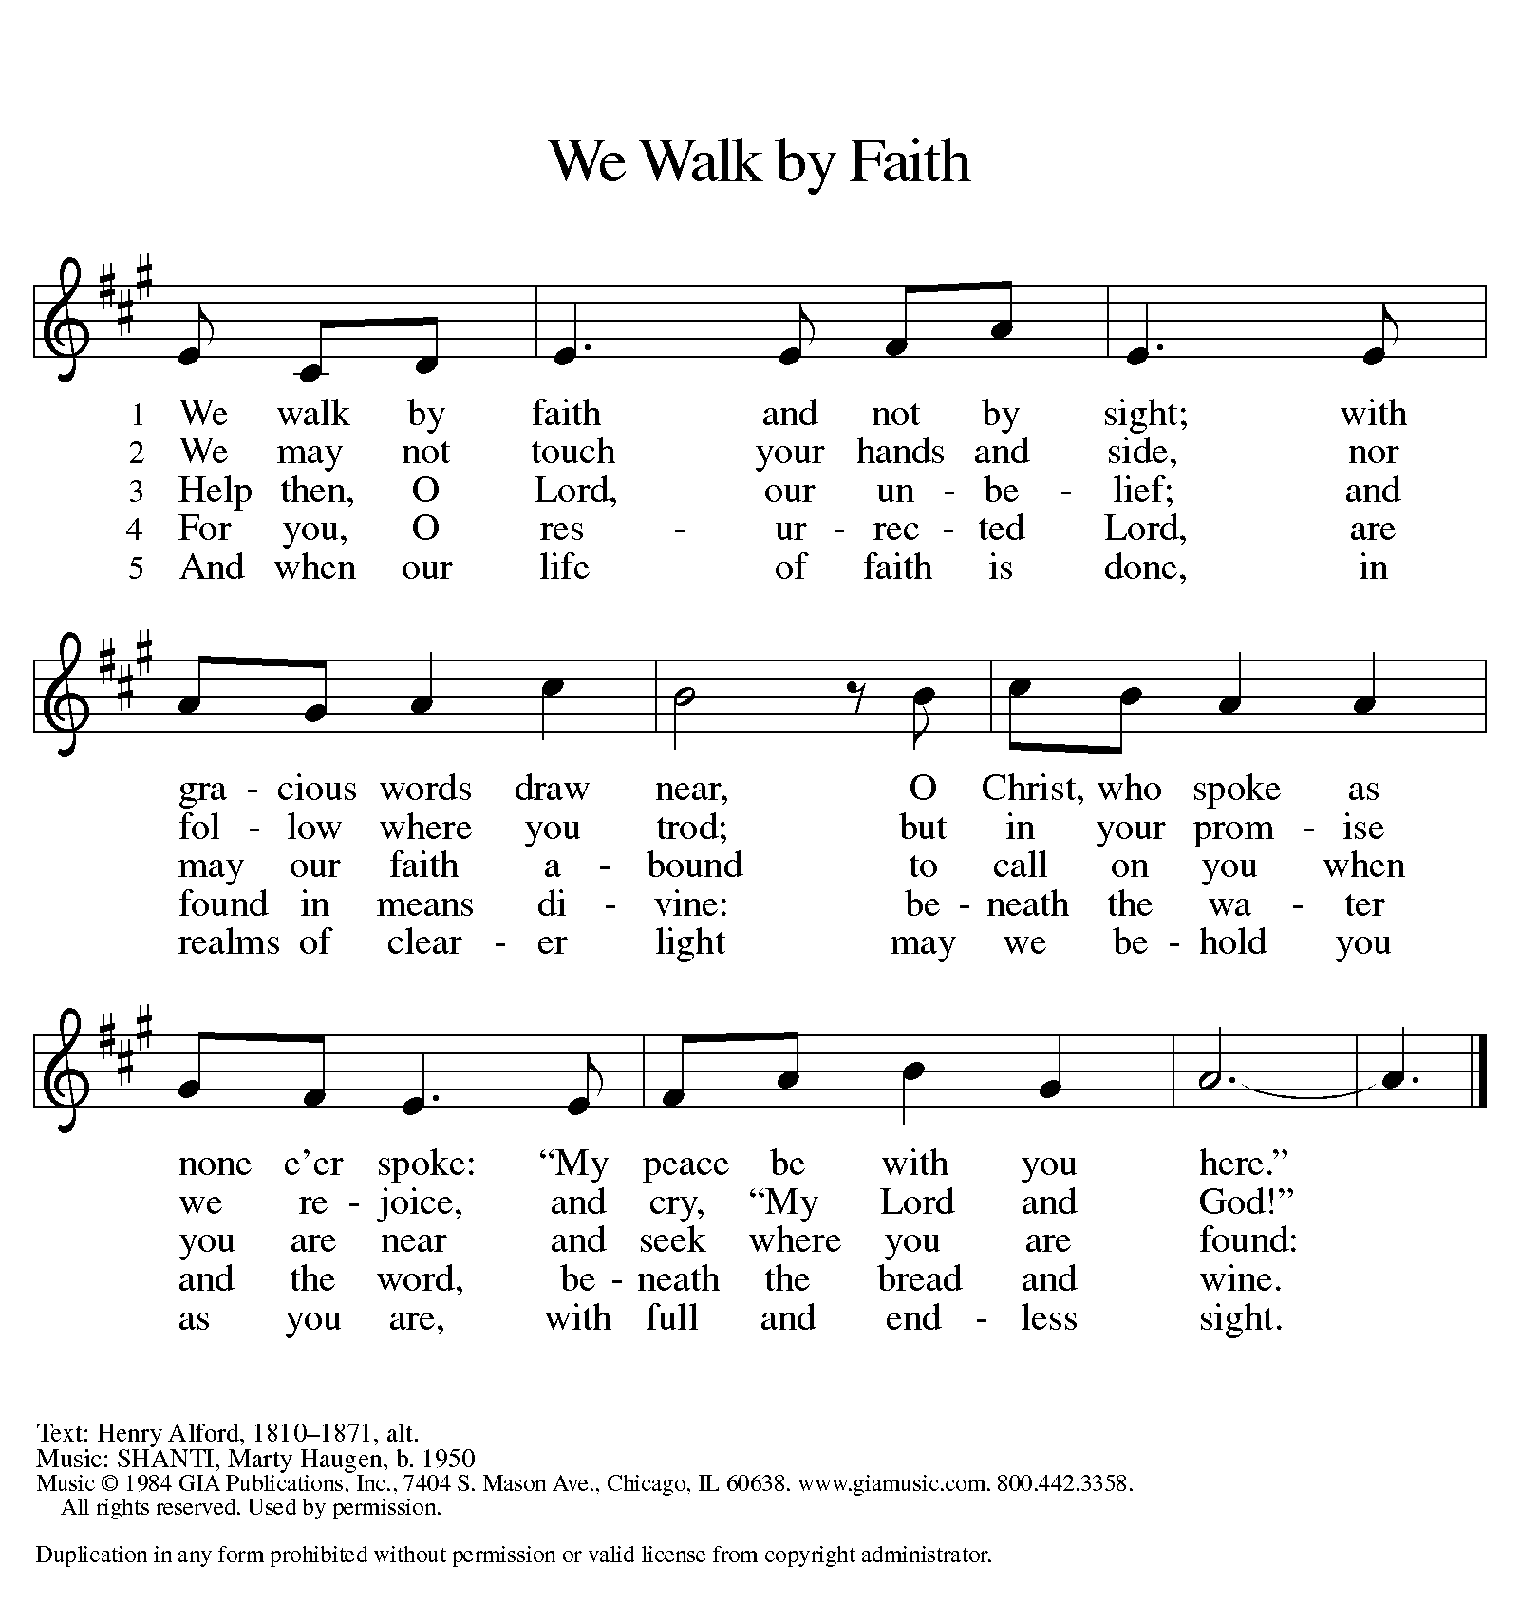

nicene CREED

We believe in one God,
the Father, the Almighty,
maker of heaven and earth,
of all that is, seen and unseen.

We believe in one Lord, Jesus Christ,
the only Son of God,
eternally begotten of the Father,
God from God, Light from Light,
true God from true God,
begotten, not made,
of one Being with the Father;
through him all things were made.
For us and for our salvation
he came down from heaven.
was incarnate of the Holy Spirit and the virgin Mary
and became truly human.
For our sake he was crucified under Pontius Pilate;
he suffered death and was buried.
On the third day he rose again
in accordance with the scriptures;
he ascended into heaven
and is seated at the right hand of the Father.
He will come again in glory to judge the living and the dead,
and his kingdom will have no end.

We believe in the Holy Spirit, the Lord, the giver of life.
who proceeds from the Father and the Son,
who with the Father and the Son is worshiped and glorified,
who has spoken through the prophets.
We believe in one holy catholic and apostolic church.
We acknowledge one baptism for the forgiveness of sins.
We look for the resurrection of the dead,
and the life of the world to come. Amen.

(Please be seated.)

THE PRAYERS

A: God of resurrection and new life, we come before you in prayer for the church, the world, and all who are in need.
(A brief silence.)
A: Inspire the church with the breath of your Holy Spirit, that we sing the good news of the resurrection. Inspire deacons and pastors, lay leaders and bishops to boldly proclaim your love for all people. Hear us, O God.
C: Your mercy is great.
A: Preserve the earth as a safe home for all creatures. Restore habitats contaminated by pollution or overuse, strengthen efforts to shape more sustainable communities, and make us mindful of the impacts of our daily lives on the well-being of creation. Hear us, O God.
C: Your mercy is great.
A: Kindle in the nations a spirit of cooperation and mutual care. Raise up creative and courageous leaders committed to shaping just solutions to complex challenges in our local and global communities Hear us, O God.
C: Your mercy is great.
A: Transform our fear into curiosity and love, especially across differences in race, religion, sexuality, gender identity, and economic situation. Unravel stereotypes that lead to discrimination, and destroy oppressive systems that marginalize vulnerable communities. Hear us, O God.
C: Your mercy is great.
A: Send angels of protection to provide care and compassion to those who serve in our armed forces. We pray especially for Beth & Ryan, Jonathan, Jacob, Noah, Irene, and Alex. Hear us, O God.
C: Your mercy is great.
A: Embrace all who carry wounds, that they might know your compassion. Draw near to those with chronic pain or anxiety, and all for whom death is near. Comfort communities and individuals suffering in any way, especially Ahren, Beth Ra., B.J., Carolyn, Dan, David, Doretta, Family & friends of Joseph Ra., Family & friends of Nina, Gage, Jim & Cheri, John, Johnny, Jon, Jordan, Lawton, Lera & family, Linda, Lizzy, Marge, Randy, Rick & Kathy, Sheri, Sheri, Stacy, Steve, and Wanda, and all whom we name now aloud and in our hearts. Hear us, O God.
C: Your mercy is great.
A: Inspire those whom you have called to lead your church here on earth, guiding it toward the congregation of saints in heaven. We pray especially for Presiding Bishop Elizabeth, our Synod Bishop Craig, and Pastor Carl. We ask that you be with their respective staffs as they live out their callings to serve. As we are called to be one, even as Jesus and the Father are one, be with the leaders and the congregation of Trinity Lutheran Church in Frankfort and the churches in our community. Hear us, O God.
C: Your mercy is great.
A: We remember the faithful departed from all times and places. Confident that you are the Alpha and Omega, we pray for your wisdom and guidance until our earthly pilgrimage is complete. Hear us, O God.
C: Your mercy is great.
A: We commend these and all our prayers to you, O God, trusting that you are always with us; in the name of Jesus Christ, our risen Savior.
C: Amen.

GREETING OF PEACE

P: The peace of Christ be with you always.
C: And also with you.
(You are invited to share Christ’s peace with one another.)

(Please be seated.)

MEAL
OFFERING ELENE
(Please rise if you are able.)
OFFERTORY ELW 186
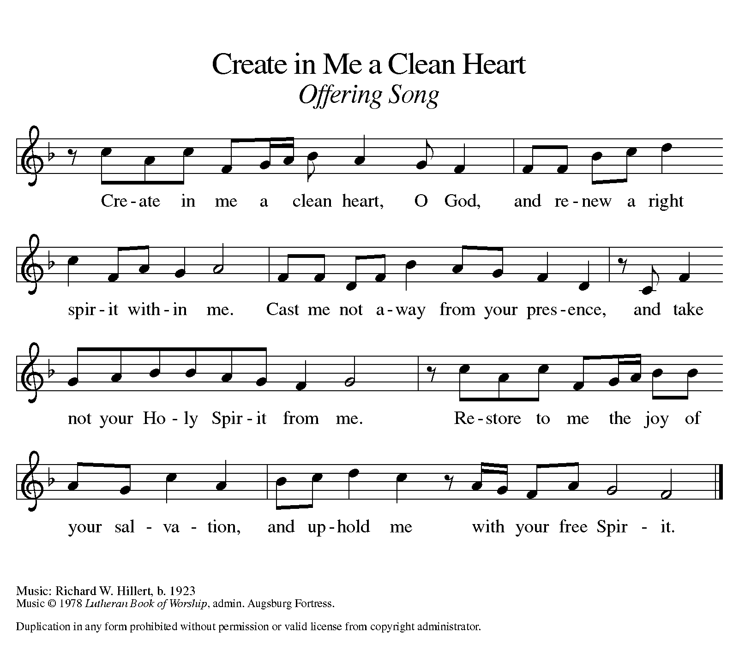
OFFERING PRAYER

A: Let us pray. Risen One, you have gathered us around your table of grace
along with these gifts we bring. Come among us again, breathe your life into us, and enliven us with this meal, that we may live as your risen body in the world.

C: Amen.

THE GREAT THANKSGIVING

P: The Lord be with you.
C: And also with you.
P: Lift up your hearts.
C: We lift them to the Lord.
P: Let us give thanks to the Lord our God.
C: It is right to give our thanks and praise.

PROPER PREFACE

P: It is indeed right, our duty and our joy, that we should at all times and in all places give thanks and praise to you, almighty and merciful God, for the glorious resurrection of our Savior Jesus Christ, the true Paschal Lamb who gave himself to take away our sin; who in dying has destroyed death, and in rising has brought us to eternal life. And so, with Mary Magdalene and Peter and all the witnesses of the resurrection, with earth and sea and all their creatures, and with angels and archangels, cherubim and seraphim, we praise your name and join their unending hymn:

HOLY, HOLY ELW Setting 8, Page 190
Holy, holy, holy Lord,
God of pow’r and might,
heaven and earth are full of your glory, full of your glory.
Hosanna, hosanna, hosanna in the highest.
Blessed is he who comes in the name of the Lord.
Hosanna, hosanna, hosanna in the highest.

EUCHARISTIC PRAYER

P: In the night in which he was betrayed, our Lord Jesus took bread, and gave thanks; broke it, and gave it to his disciples, saying:
Take and eat; this is my body, given for you.
Do this for the remembrance of me.
Again, after supper, he took the cup, gave thanks, and gave it for all to drink, saying:
This cup is the new covenant in my blood, shed for you and for all people for the forgiveness of sin. Do this for the remembrance of me.

LORD'S PRAYER

P: Lord, remember us in your kingdom, and teach us to pray:
C: Our Father in heaven, hallowed be your name, your kingdom come, your will be done, on earth as in heaven. Give us today our daily bread. Forgive us our sins as we forgive those who sin against us. Save us from the time of trial and deliver us from evil. For the kingdom, the power, and the glory are yours, now and forever. Amen.

(Please be seated.)

COMMUNION DISTRIBUTION

All who believe in the real presence of Christ in the bread and the wine (juice) are welcome to the table. Others may come forward for a blessing. If you prefer grape juice, please indicate this to the assisting minister.
When approaching the communion rail, come forward down the side aisle; kneel if you are able, starting at the front of the communion rail (spot closest to the font) on your side and filling in toward the altar. After receiving both the bread and the wine, you may return to your seat by the center aisle.

INVITATION TO COMMUNION

P: Come to the table of grace. Receive the gift of new life.

COMMUNION HYMN ELW 779
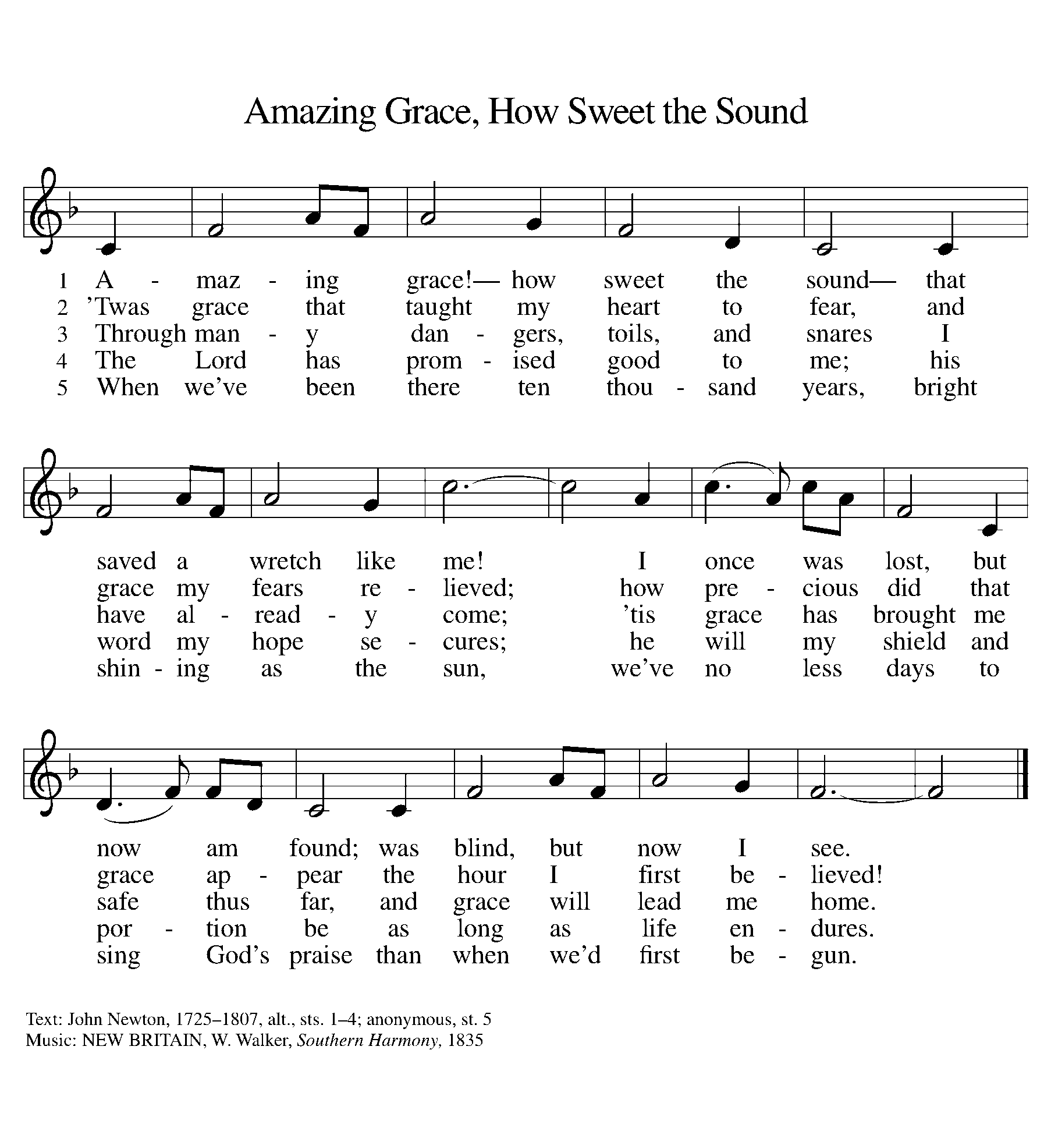

P: The body of Christ, given for you.
C: Amen.
A: The blood of Christ shed for you.
C: Amen.
(Please rise as you are able.)
P: May the body and blood of our Lord Jesus Christ strengthen and keep you in his grace.
C: Amen.

PRAYER AFTER COMMUNION

P: Let us pray. Living One, in this feast you have made yourself known to us. Send us now to tell of your wonders, sing of your glory, and proclaim your risen life to a wounded and weary world.
C: Amen.

SENDING

BLESSING

P: The triune God, who was, who is, and who is to come, Sovereign, ☩ Savior, and Spirit, light your way with resurrection dawn, now and always.
C: Amen.

SENDING HYMN ELW 646
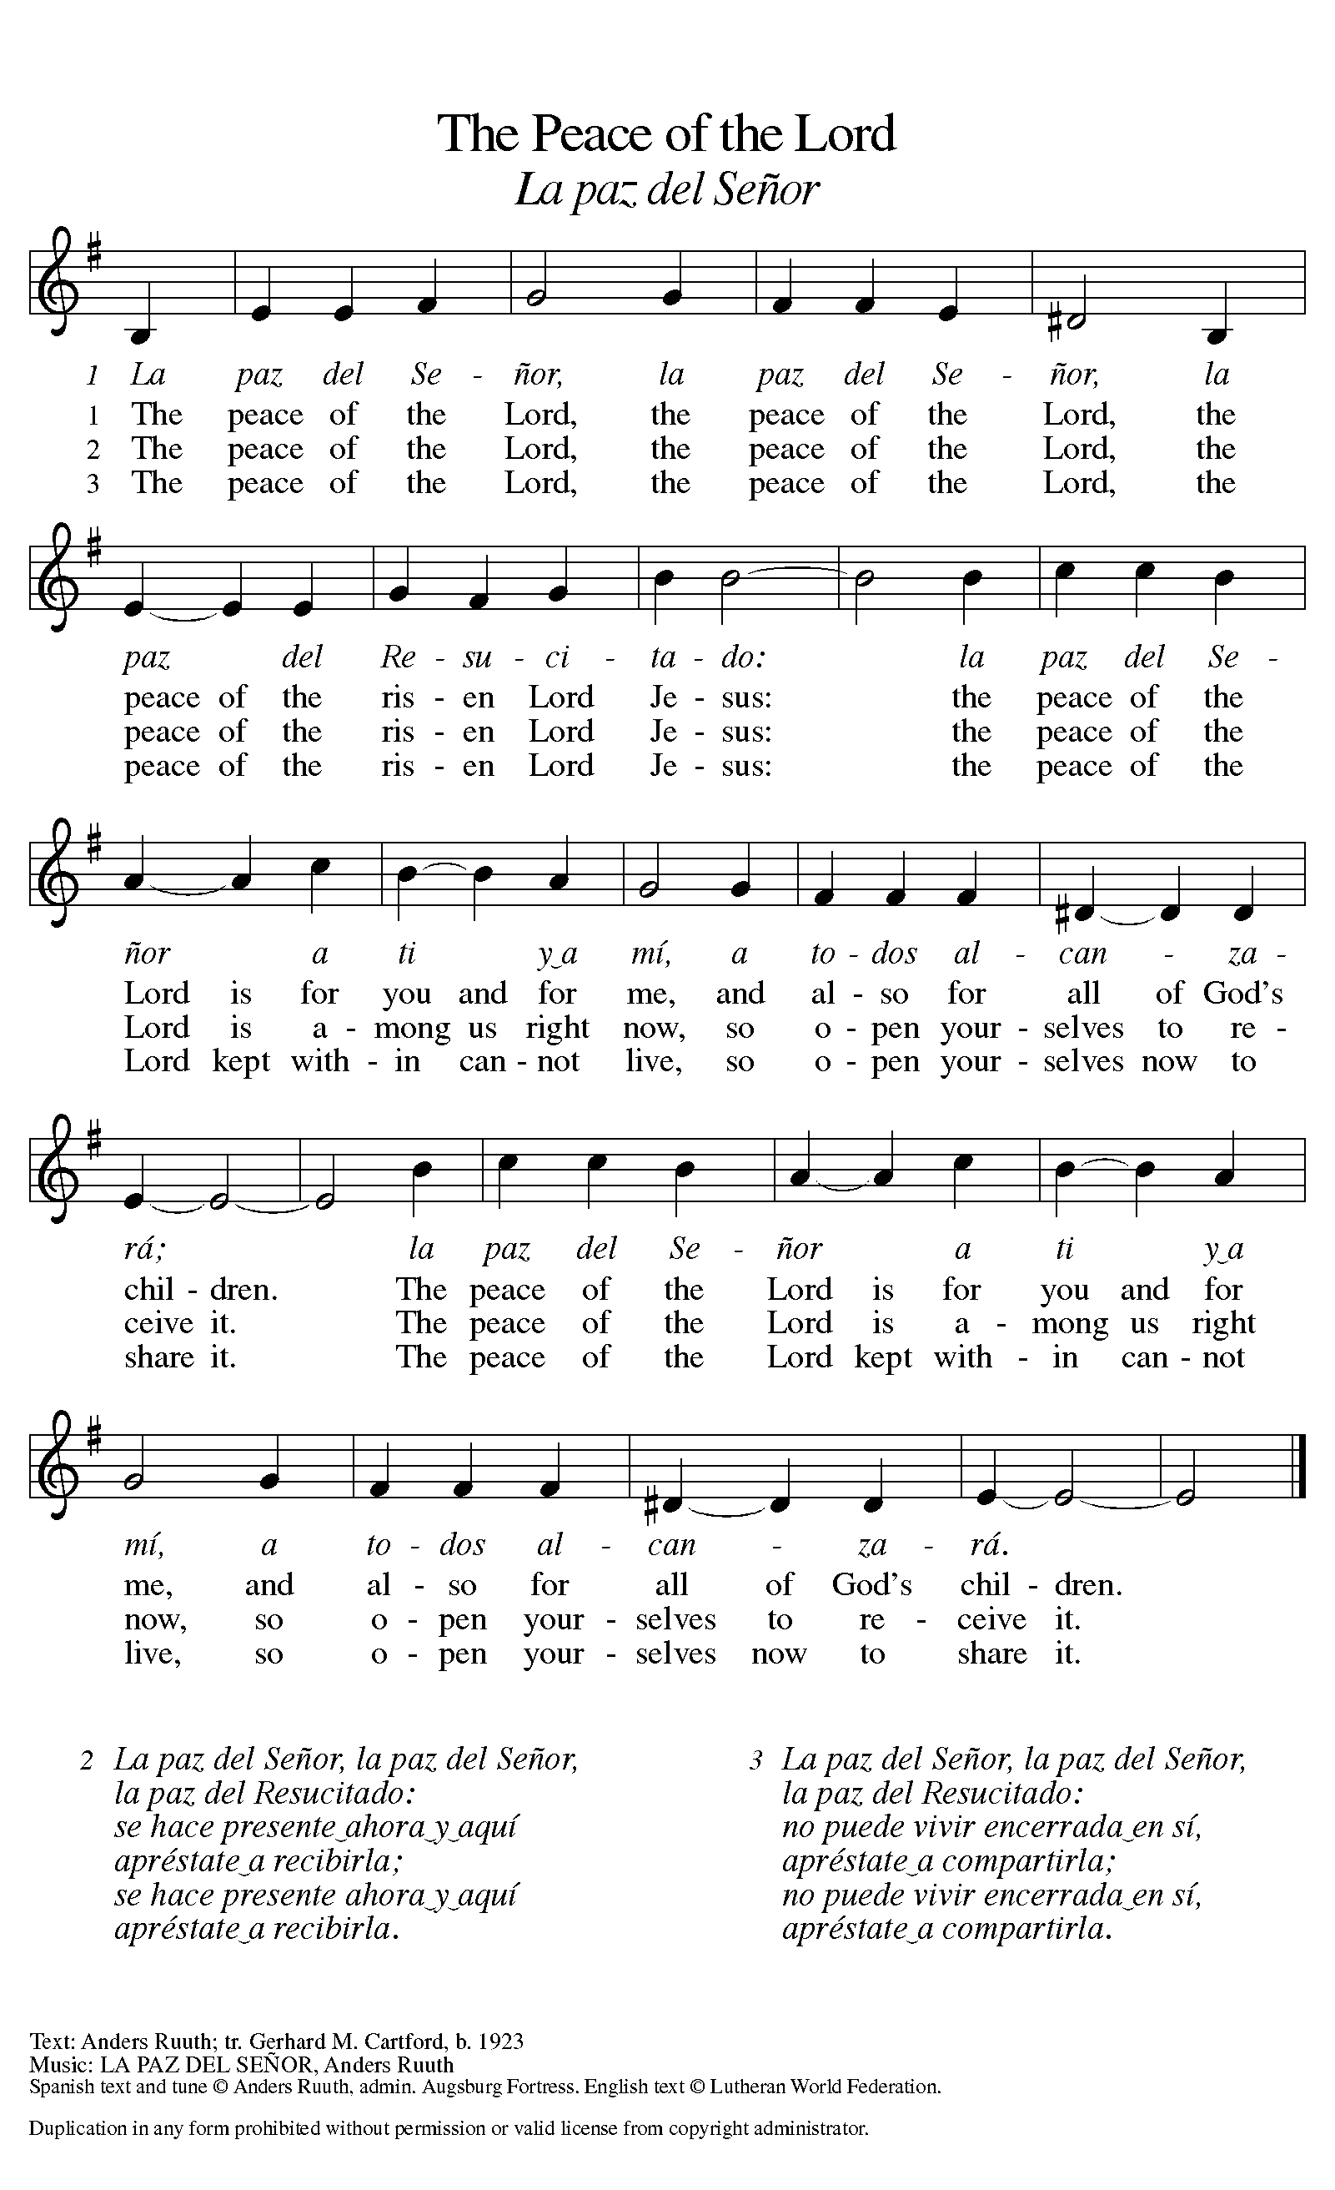

DISMISSAL

P: Alleluia! Christ is risen.
C: Christ is risen indeed. Alleluia!
P: Go in peace. In Christ you are made new. Alleluia! Alleluia!
C: Thanks be to God. Alleluia! Alleluia!

Announcements

- Sunday, May 11 – Happy Mother’s Day!
- Saturday, May 17 & Sunday, May 18 – East Lansing Art Festival Downtown.
- Monday, May 26 – Memorial Day!
- Sunday, June 1 – Fish Fry @ 11:15am following service. All donations go to St. Paul Food Pantry.

Recurring Events

- Every Sunday – Adult Bible Study @ 9am
- Monday, May 5 – Worship Committee Meeting @ 6:30pm
- Wednesday, May 14 – Women’s Bible Study @ 11am
- Thursday, May 15 – Council Meeting @ 7pm

Food Pantry Dates

Wednesday, May 7, 5-6:30pm
Thursday, May 15, 1-3pm
Wednesday, May 21, 5-6:30pm
Thursday, May 29, 1-3pm

Volunteers for April 27 Volunteers for May 4

Reader Sunday - Volunteer Reader Sunday – Volunteer
Assisting Minister - Volunteer Assisting Minister – Volunteer

April & May Birthday Celebrations

4/2 – Noah Ki.
4/4 – Doretta Th.
4/4 – RJ Mc.
4/11 – Kathy Gr.
4/14 – Carol Ha.
4/26 – Vicki Ki.
4/27 – Kristen Op.
4/27 – Pat Cr.
4/29 – Mary Mc.

5/2 – Jemal Tavadze
5/2 – Melissa Ki.
5/9 – Pr. Carl
5/23 – Jim Cr.

May Anniversary Celebrations

5/11 – Emily & AJ Po.
5/26 – Jon & Tzulun Ke.

Acknowledgments
- OneLicense.net, License #A-703165.
- CCLI, License #2281869.
- From SundaysandSeasons.com. Copyright 2022 Augsburg Fortress. All rights reserved. Reprinted by permission under Augsburg Fortress Liturgies Annual License #23806.
- New Revised Standard Version Bible, copyright 1989, Division of Christian Education of the National Council of the Churches of Christ in the United States of America. Used by permission. All rights reserved.

