

4th Sunday in Lent
March 30, 2025

SAINT PAUL LUTHERAN CHURCH
3383 EAST LAKE LANSING ROAD
EAST LANSING, MI 48823

PHONE (517) 351-8541

Pastor Carl E. Ballard
E-MAIL: pastor@stpaul-el.org
officemanager@stpaul-el.org

Visitors WELCOME! If this is your first time worshipping with us, please sign our guest registry just outside the sanctuary doors. We hope you are blessed through worship today. If you have any questions, please feel free to call the church at 351-8541.
Children are always welcome in worship! The choir room (off the sanctuary) can also be used as a cry room for younger children and includes a sound system so parents may continue to participate in the service. Clipboards with children’s bulletins, activities and crayons are available for use during the service. Please see an usher if you are unable to locate them.
Sunday School is available during the worship service September-May except the last Sunday of the month.
This Bulletin is for your use during the service and to take home for the upcoming week. If you choose not to take it home, please place it in the recycle receptacle in the back.
Newsletters and Calendars of Upcoming Events are available in the lobby/narthex. We welcome anyone who has an interest in our small groups or activities! You can also look us up on the web at www.stpaul-el.org.
Contacting Us: Our office manager is Emily Polhamus. She can be reached by phone at 517-351-8541 or at her email address, officemanager@stpaul-el.org. Our Director of Music is Elene Kobulashvili. You may leave a message at 517-351-8541. Pastor Carl can be reached at 517-515-3129, and his email address is cballard123@msn.com.
Holy Communion is available at most services. All who believe in the real presence of Christ in the bread and the wine are invited to celebrate Communion with us. Those who wish may come forward for a blessing.
You are invited to share in fellowship after worship. We would love this opportunity to introduce you to the St. Paul community.

P-Presiding Minister A-Assisting Minister C-Congregation

PRELUDE ELENE

INTRODUCTION

The psalm sets the tone this day: “Happy are they whose transgressions are forgiven, and whose sin is put away!” Happy are those who have “become the righteousness of God” in the merits of Christ Jesus. Happy are those for whom the forgiveness of God has “rolled away . . . the disgrace” of former times. Happy is the father at the return of his prodigal son. Happy are we that our sins are forgiven for Jesus’ sake. Rejoice!

GATHERING

P: The Holy Spirit calls us together as the people of God.

(Please rise as you are able.)

CONFESSION & FORGIVENESS

All may make the sign of the cross, the sign that is marked at baptism, as the presiding minister begins.

P: Blessed be the holy Trinity, ☩ one God, who forgives all our sin, whose mercy endures forever.

C: Amen.

P: Let us return to God, confessing our sin in the assurance of God’s abiding love.

(Silence is kept for reflection.)

P: Compassionate One,
C: you are slow to anger and abounding in steadfast love, but our lives do not always reflect you and your love for the world. We do not show others the tender compassion you have shown to us. We do not welcome others with the radical hospitality you grant to all people. We oppress others, even though you have set us free again and again. We squander the abundant gifts of the earth. Transform our lives and guide us again in the way of the cross. Amen.

P: Beloved in Christ, God’s arms are always stretched open wide to welcome the wandering ones home. In ☩ Christ your sins are forgiven. You have a place in God’s house forever.

C: Amen.

GATHERING SONG ELW 407
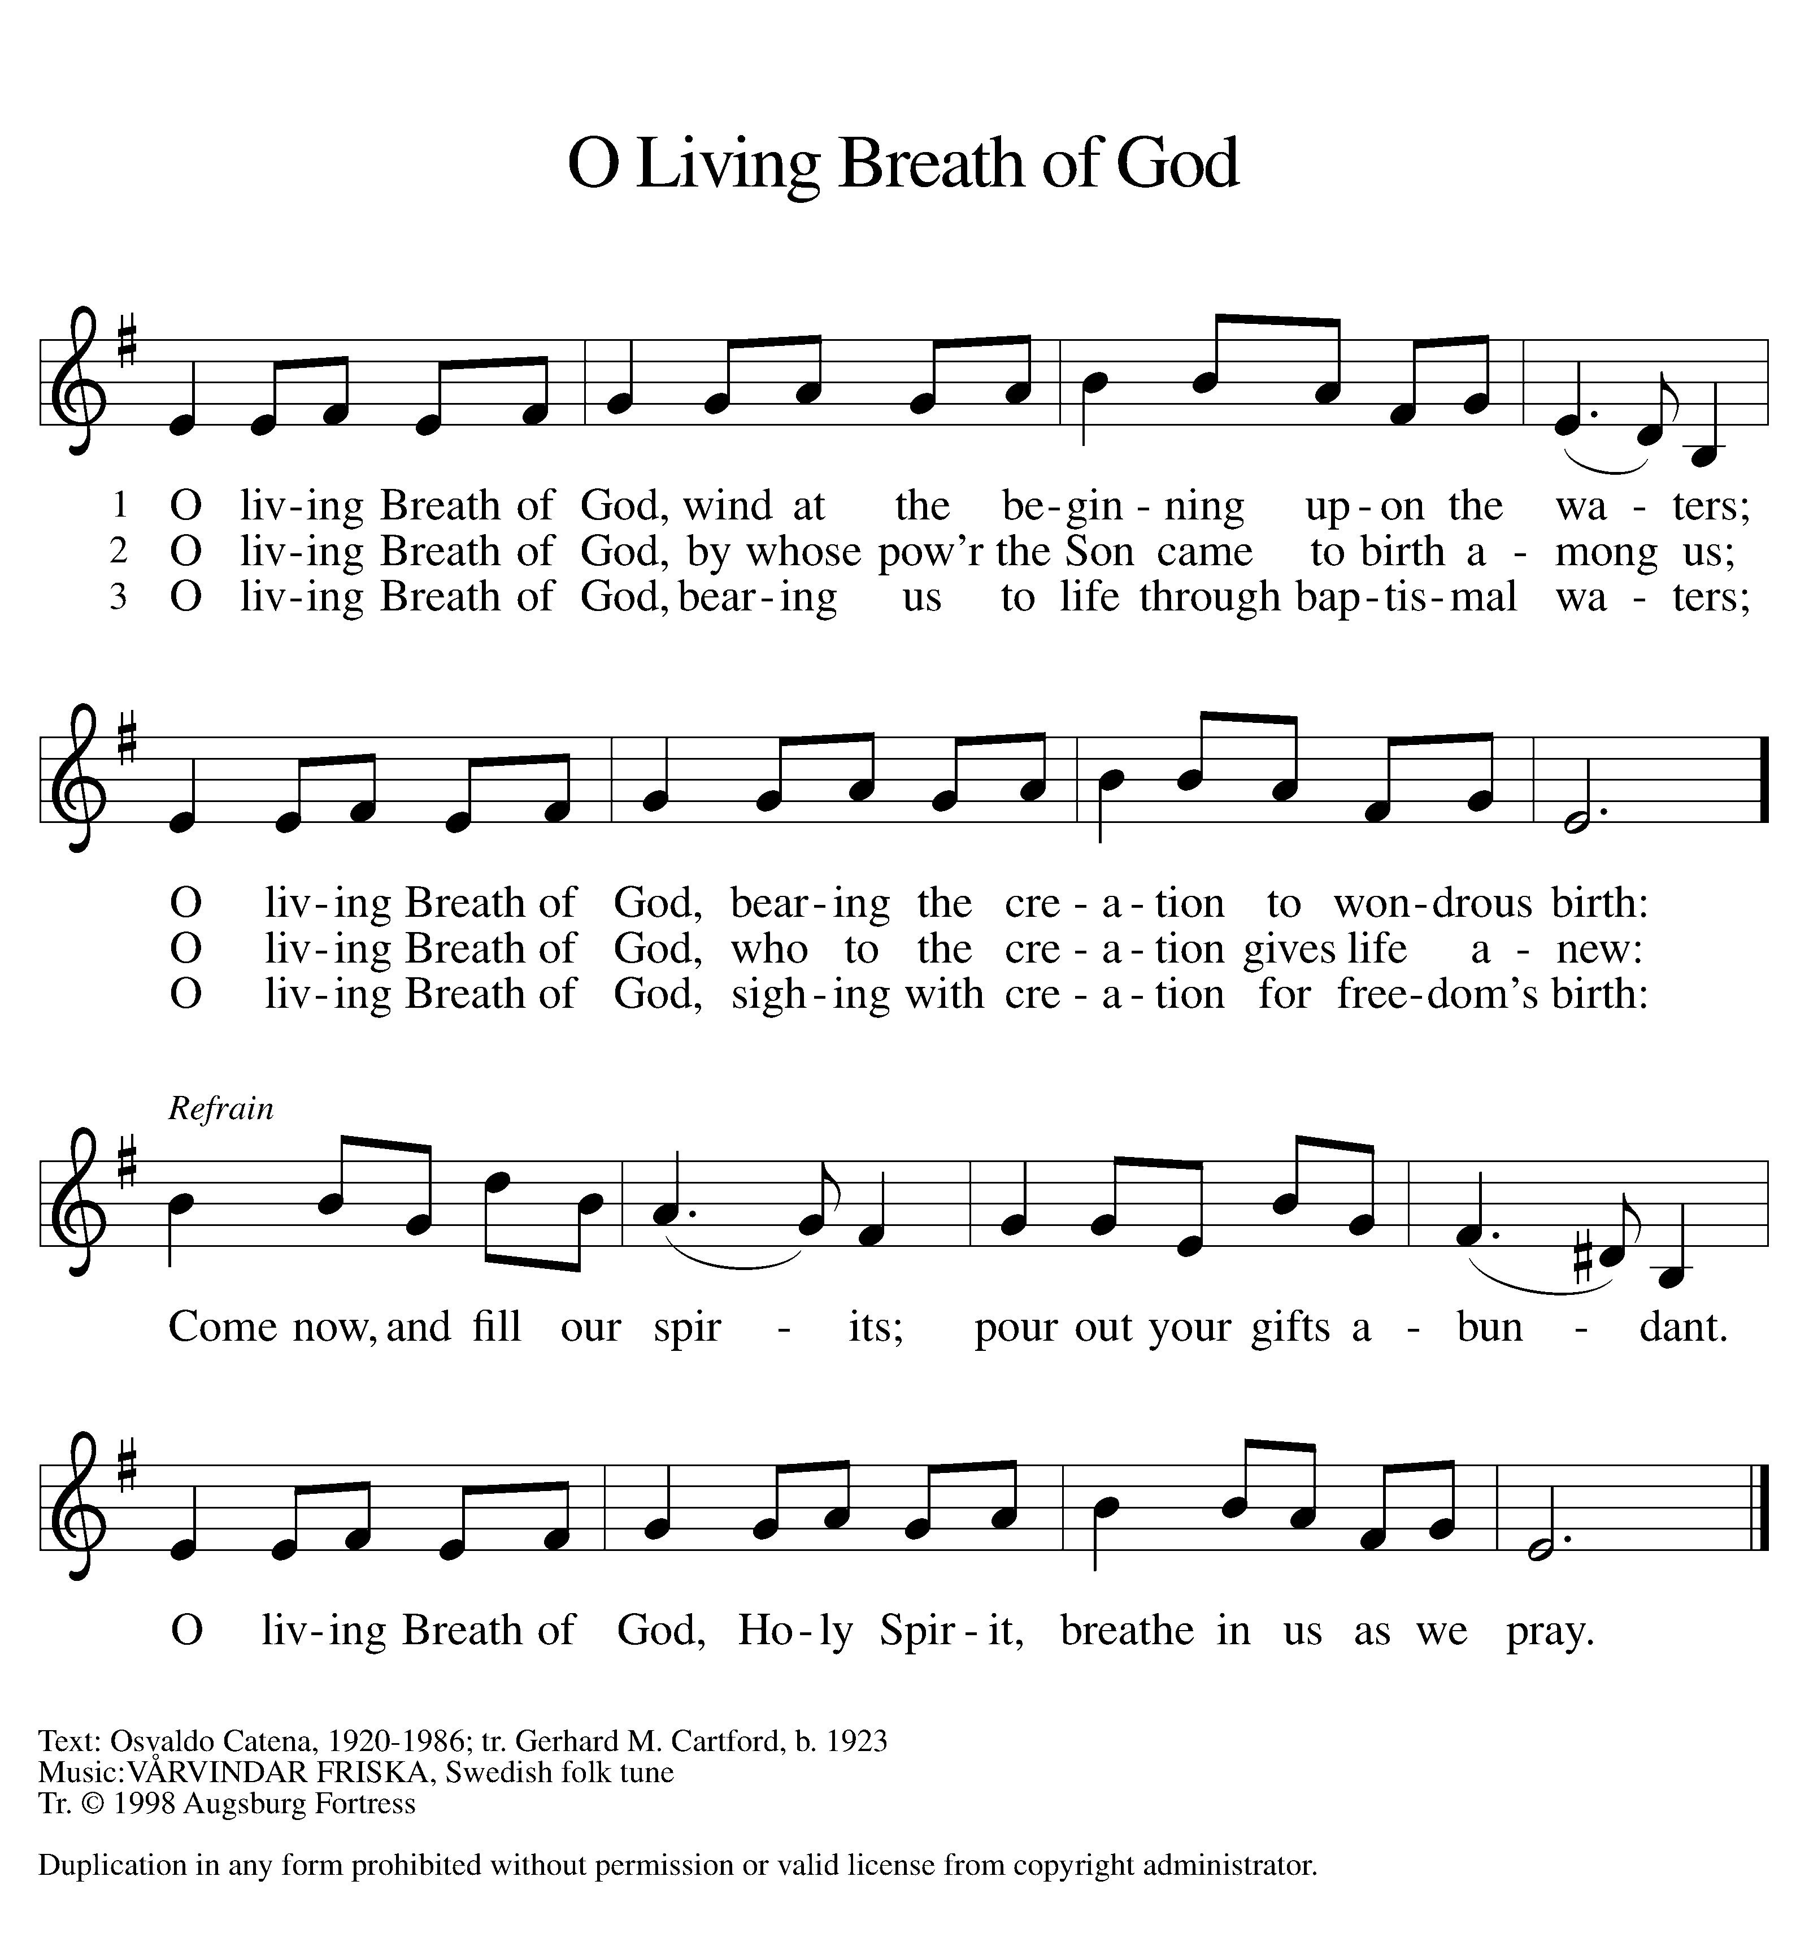
GREETING

P: The grace of our Lord Jesus Christ, the love of God, and the communion of the Holy Spirit be with you all.

C: And also with you.

KYRIE ELW Setting 7, Page 175

Lord, have mercy on us; O Lord, have mercy.
Lord, have mercy on us; O Lord, have mercy.
Christ, have mercy on us; O Christ, have mercy.
Christ, have mercy on us; O Christ, have mercy.
Lord, have mercy on us; O Lord, have mercy.
Lord, have mercy on us; O Lord, have mercy.

CANTICLE OF PRAISE ELW Setting 4, Page 148-149

Glory to God in the highest, and peace to God’s people on earth.
Lord God, heavenly King, almighty God and Father,
we worship you, we give you thanks, we praise you for your glory. Lord Jesus Christ, only Son of the Father, Lord God, Lamb of God, you take away the sin of the world: have mercy on us;
you are seated at the right hand of the Father: receive our prayer. For you alone are the Holy One, you alone are the Lord,
you alone are the Most High, Jesus Christ, with the Holy Spirit,
in the glory of God the Father. Amen.

PRAYER OF THE DAY

P: Let us pray. God of compassion, you welcome the wayward, and you embrace us all with your mercy. By our baptism clothe us with garments of your grace, and feed us at the table of your love, through Jesus Christ, our Savior and Lord, who lives and reigns with you and the Holy Spirit, one God, now and forever.

C: Amen.

(Please be seated.)

CHILDREN’S MESSAGE/NOISY OFFERING

(Children are invited to Sunday School.)

TRANSITION SONG ELW 595
(VERSE 1 & REFRAIN ONLY)
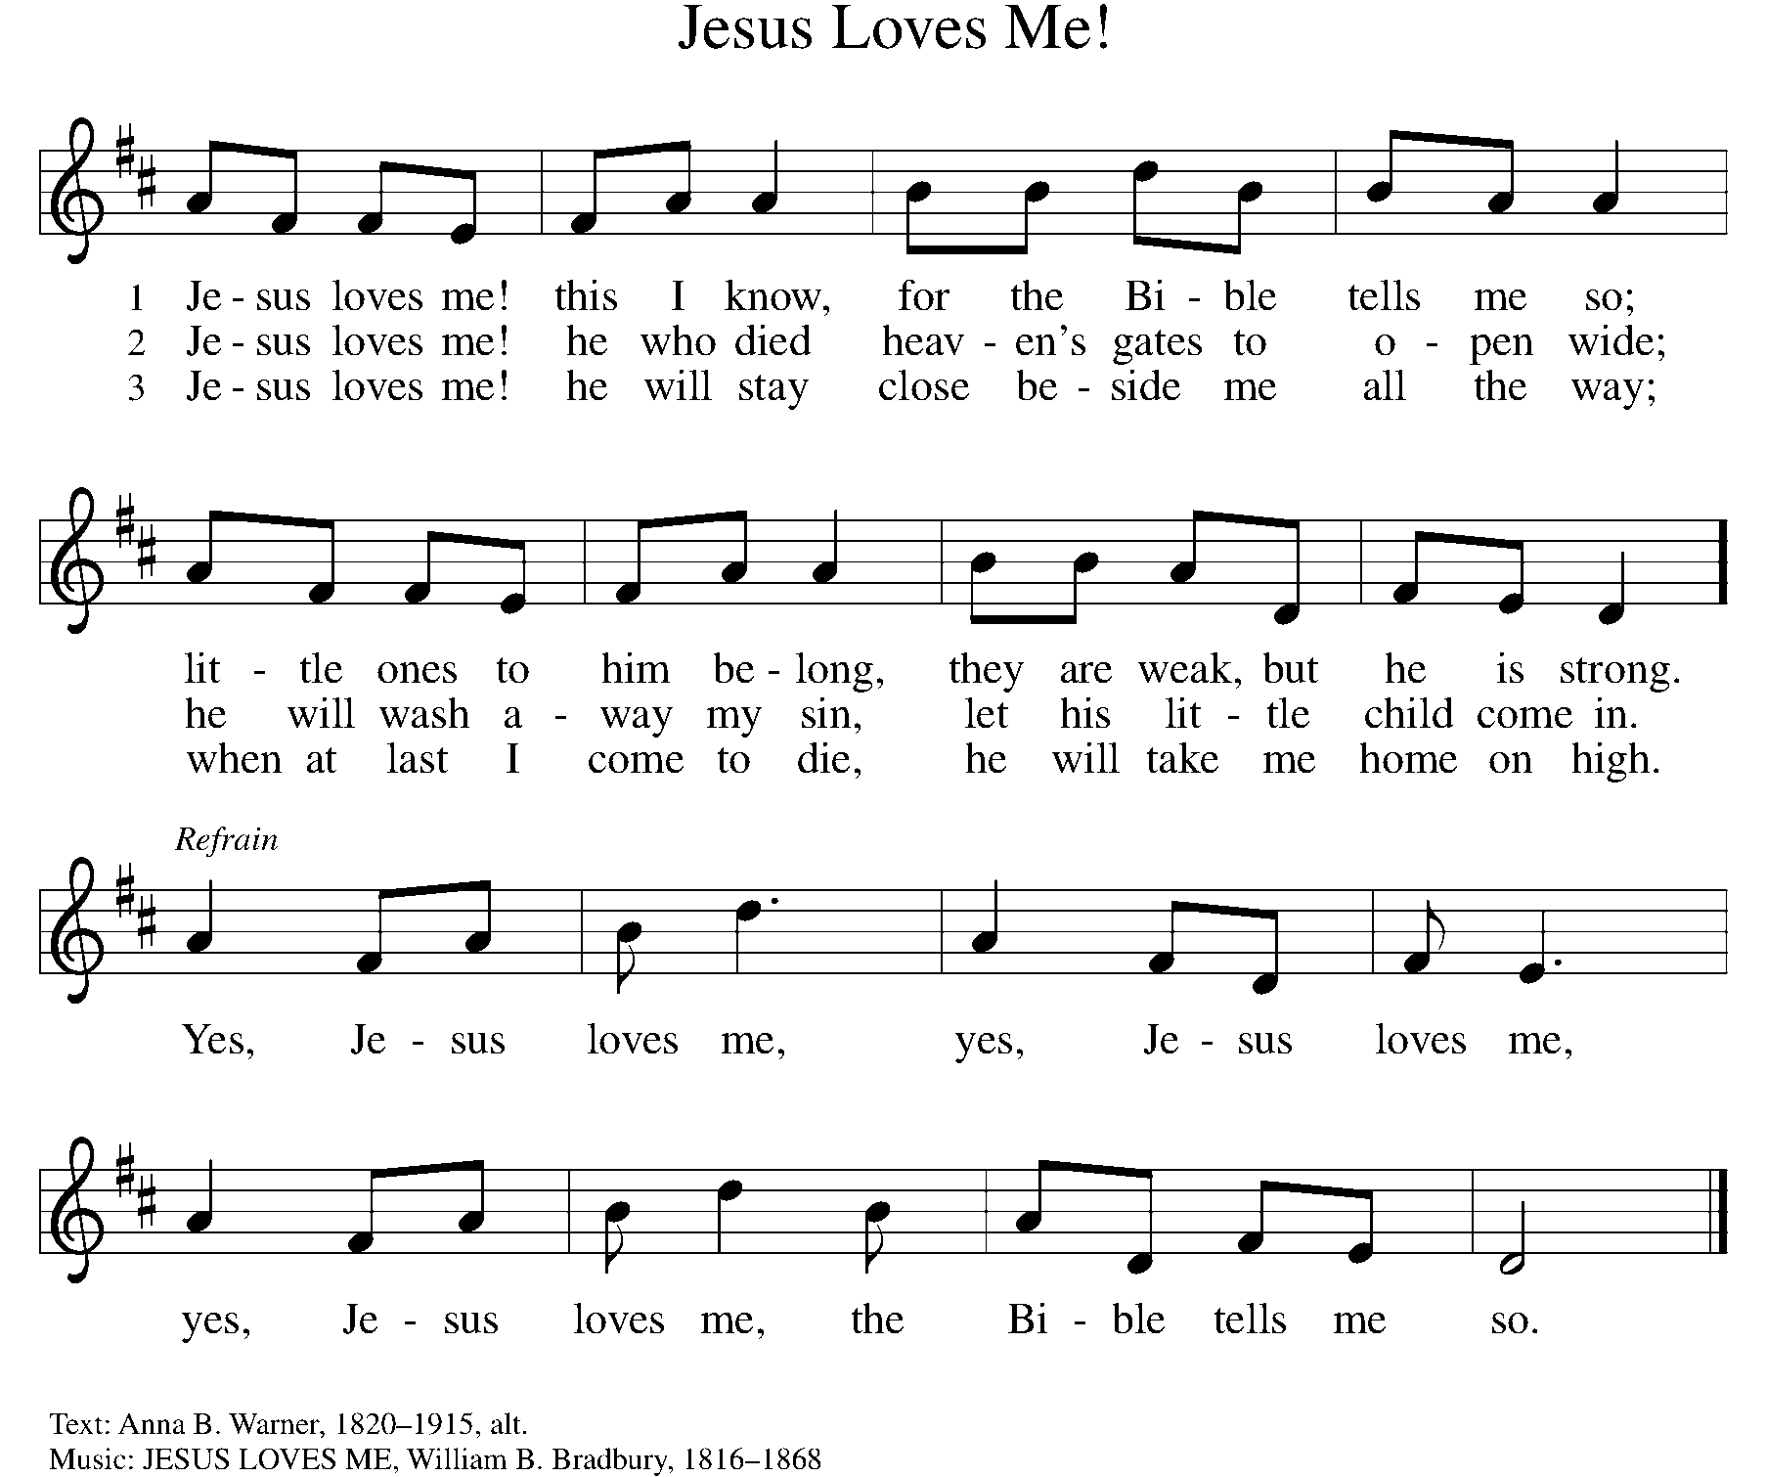
THE WORD

God speaks to us in scripture, preaching, and song.

First Reading joshua 5:9-12
By celebrating the Passover and eating the produce of the promised land instead of the miraculous manna that had sustained them in the desert, the Israelites symbolically bring their forty years of wilderness wandering to an end at Gilgal.

⁹ The Lord said to Joshua, “Today I have rolled away from you the disgrace of Egypt.” And so that place is called Gilgal to this day. ¹⁰ While the Israelites were camped in Gilgal, they kept the Passover in the evening on the fourteenth day of the month in the plains of Jericho. ¹¹ On the day after the Passover, on that very day, they ate the produce of the land, unleavened cakes and roasted grain. ¹² The manna ceased on the day they ate the produce of the land, and the Israelites no longer had manna; they ate the crops of the land of Canaan that year.

Word of God, word of life. C: Thanks be to God.

PSALM PSALM 32
Be glad, you righteous, and rejoice in the Lord. (Ps. 32:11)

¹ Happy are they whose transgressions are forgiven, and whose sin is put away!

² Happy are they to whom the Lord imputes no guilt, and in whose spirit there is no guile!

³ While I held my tongue, my bones withered away, because of my groaning all day long.

⁴ For your hand was heavy upon me day and night; my moisture was dried up as in the heat of summer.

⁵ Then I acknowledged my sin to you, and did not conceal my guilt. I said, “I will confess my transgressions to the Lord.” Then you forgave me the guilt of my sin.

⁶ Therefore all the faithful will make their prayers to you in time of trouble; when the great waters overflow, they shall not reach them.

⁷ You are my hiding-place; you preserve me from trouble; you surround me with shouts of deliverance.

⁸ “I will instruct you and teach you in the way that you should go; I will guide you with my eye.

⁹ Do not be like horse or mule, which have no understanding; who must be fitted with bit and bridle, or else they will not stay near you.”

¹⁰ Great are the tribulations of the wicked; but mercy embraces those who trust in the Lord.

¹¹ Be glad, you righteous, and rejoice in the Lord; shout for joy, all who are true of heart.

SECOND READING 2 CORINTHIANS 5:16-21
One way to describe the gospel is the promise that in Christ everything is transformed into newness. All mistakes, all deliberate sins, all old history is reconciled with Christ’s resurrection. This is Paul’s strong message to the congregation in the city of Corinth.

¹⁶ From now on, therefore, we regard no one from a human point of view; even though we once knew Christ from a human point of view, we no longer know him in that way. ¹⁷ So if anyone is in Christ, there is a new creation: everything old has passed away; look, new things have come into being! ¹⁸ All this is from God, who reconciled us to himself through Christ and has given us the ministry of reconciliation; ¹⁹ that is, in Christ God was reconciling the world to himself, not counting their trespasses against them, and entrusting the message of reconciliation to us. ²⁰ So we are ambassadors for Christ, since God is making his appeal through us; we entreat you on behalf of Christ: be reconciled to God. ²¹ For our sake God made the one who knew no sin to be sin, so that in him we might become the righteousness of God.

Word of God, word of life. C: Thanks be to God.

(Please rise as you are able.)
GOSPEL ACCLAMATION ELW Setting 7, Page 179
Turn back to the Lord, your God,
Who is gracious and merciful,
Slow to anger and abounding in love and faithfulness.
GOSPEL LUKE 15:1-3, 11b-32

P: The Holy Gospel according to Luke, the 15th chapter.
C: Glory to you, O Lord.

Jesus tells a parable about a son who ponders his father’s love only after he has spurned it. The grace he receives is beyond his hopes. That same grace is a crisis for an older brother who believes it is his obedience that has earned his place in the father’s home.

¹ Now all the tax collectors and sinners were coming near to listen to [Jesus.] ² And the Pharisees and the scribes were grumbling and saying, “This fellow welcomes sinners and eats with them.”

³ So he told them this parable: ^{11b} “There was a man who had two sons. ¹² The younger of them said to his father, ‘Father, give me the share of the wealth that will belong to me.’ So he divided his assets between them. ¹³ A few days later the younger son gathered all he had and traveled to a distant region, and there he squandered his wealth in dissolute living. ¹⁴ When he had spent everything, a severe famine took place throughout that region, and he began to be in need. ¹⁵ So he went and hired himself out to one of the citizens of that region, who sent him to his fields to feed the pigs. ¹⁶ He would gladly have filled his stomach with the pods that the pigs were eating, and no one gave him anything. ¹⁷ But when he came to his senses he said, ‘How many of my father’s hired hands have bread enough and to spare, but here I am dying of hunger! ¹⁸ I will get up and go to my father, and I will say to him, “Father, I have sinned against heaven and before you; ¹⁹ I am no longer worthy to be called your son; treat me like one of your hired hands.” ’

²⁰ So he set off and went to his father. But while he was still far off, his father saw him and was filled with compassion; he ran and put his arms around him and kissed him. ²¹ Then the son said to him, ‘Father, I have sinned against heaven and before you; I am no longer worthy to be called your son.’ ²² But the father said to his slaves, ‘Quickly, bring out a robe—the best one—and put it on him; put a ring on his finger and sandals on his feet. ²³ And get the fatted calf and kill it, and let us eat and celebrate, ²⁴ for this son of mine was dead and is alive again; he was lost and is found!’ And they began to celebrate.

²⁵ “Now his elder son was in the field, and as he came and approached the house, he heard music and dancing. ²⁶ He called one of the slaves and asked what was going on. ²⁷ He replied, ‘Your brother has come, and your father has killed the fatted calf because he has got him back safe and sound.’ ²⁸ Then he became angry and refused to go in. His father came out and began to plead with him. ²⁹ But he answered his father, ‘Listen! For all these years I have been working like a slave for you, and I have never disobeyed your command, yet you have never given me even a young goat so that I might celebrate with my friends. ³⁰ But when this son of yours came back, who has devoured your assets with prostitutes, you killed the fatted calf for him!’ ³¹ Then the father said to him, ‘Son, you are always with me, and all that is mine is yours. ³² But we had to celebrate and rejoice, because this brother of yours was dead and has come to life; he was lost and has been found.’ ”

P: The Gospel of the Lord. C: Praise to you, O Christ.
(Please be seated.)

SERMON PASTOR CARL BALLARD

(Please rise as you are able.)

HYMN OF THE DAY ELW 460
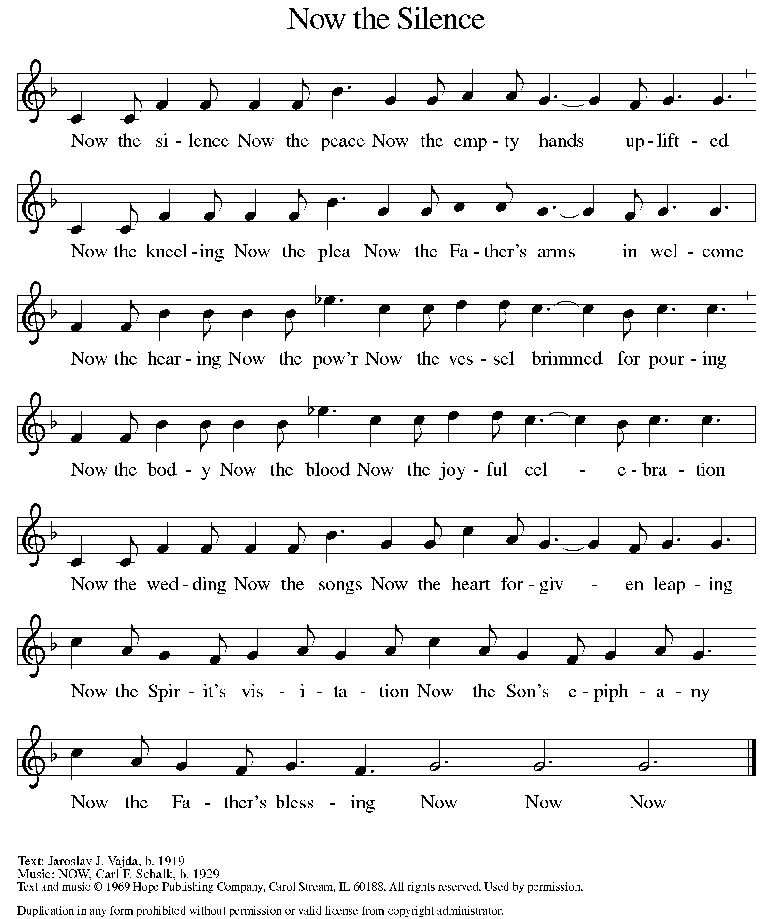

apostles’ CREED

I believe in God, the Father almighty,
creator of heaven and earth.
I believe in Jesus Christ, God’s only Son, our Lord,
who was conceived by the Holy Spirit,
born of the virgin Mary,
suffered under Pontius Pilate,
was crucified, died, and was buried;
he descended to the dead.
On the third day he rose again;
he ascended into heaven,
he is seated at the right hand of the Father,
and he will come to judge the living and the dead.
I believe in the Holy Spirit,
the holy catholic church,
the communion of saints,
the forgiveness of sins,
the resurrection of the body,
and the life everlasting. Amen.

(Please be seated.)

THE PRAYERS

A: Led by the Spirit, let us turn to God in prayer for the church, the world, and all those in need.
(A brief silence)
A: God of faithful promise, make your church a new creation in Christ. As you reconcile us to yourself, guide us also in your way of reconciliation, that through confession and forgiveness, repentance and reparations, your church may bear witness to your love. God, in your mercy,

C: receive our prayer.
A: God of new beginnings, restore balance to the earth. Send rain to places of drought and sunshine to places of flooding, that the produce of the land may again support life. God, in your mercy,

C: receive our prayer.
A: God of prodigal grace, unite the nations as fellow members of the human family. Give leaders the courage to put aside pride and ego, to cease squandering lives and time, and to work for the well-being of all. God, in your mercy,

C: receive our prayer.

A: God of boundless love, receive with open arms any in need of compassion. Embrace all who are far from home or estranged from loved ones, and all who live with regret. Embolden your people to offer and to seek forgiveness. God, in your mercy,
C: receive our prayer.
A: God of radical inclusion, widen human circles to welcome all who are excluded. Bless the work of disability ministries, ministries by and with neurodivergent people, and multicultural and ethnic-specific ministries; that the welcome of Jesus be extended to all. God, in your mercy,
C: receive our prayer.

A: God of both justice and safe-keeping, empower and protect those who stand up for what is right. Especially be with those who serve in our armed forces; protect and care for Beth & Ryan, Jonathan, Jacob, Noah, Irene, and Alex. God, in your mercy,

C: receive our prayer.
A: God of companionship, help all of us to recognize your constant nearness to us. We pray that those who are overlooked, vulnerable, lonely, ill, suffering or undergoing life transitions of any kind may experience an extra measure of your grace and love; especially, Ahren, Beth Ra., B.J., Carolyn, Dan, David, Doretta, family & friends of Mary, friends & family of Nina, Jim & Cheri, John, Johnny, Jon, Jordan, Joseph Ra., Kay, Lawton, Lera & family, Linda, Lizzy, Marge, Randy, Rick & Kathy, Sheri, Sheri, Steve, and Wanda, and all whom we name now aloud and in our hearts. God, in your mercy,

C: receive our prayer.

A: God of empowerment, enable those you have called to be leaders in ministry and shepherds of your people, especially our Presiding Bishop Elizabeth, our Synod Bishop Craig, and Pastor Carl and their respective staffs as they live out their callings to serve. As we are called to be one, even as Jesus and the Father are one, be with the leaders and the congregation University Lutheran Church in East Lansing and all the churches in our community. God, in your mercy,

C: receive our prayer.

A: God of resurrection life, welcome home all who have died. We thank you for their lives and entrust them into your keeping, where true reconciliation and eternal peace are found. God, in your mercy,

C: receive our prayer.

P: Receive the prayers of your people and draw all things together in your love, in the name of Jesus, who leads us from death to life.

C: Amen.

GREETING OF PEACE

(You are invited to share Christ’s peace with one another.)

P: The peace of Christ be with you always.

C: And also with you.
(Please be seated.)
THE MEAL
OFFERING ELENE
(Please rise if you are able.)
OFFERTORY ELW 325
(VERSE 1 ONLY)
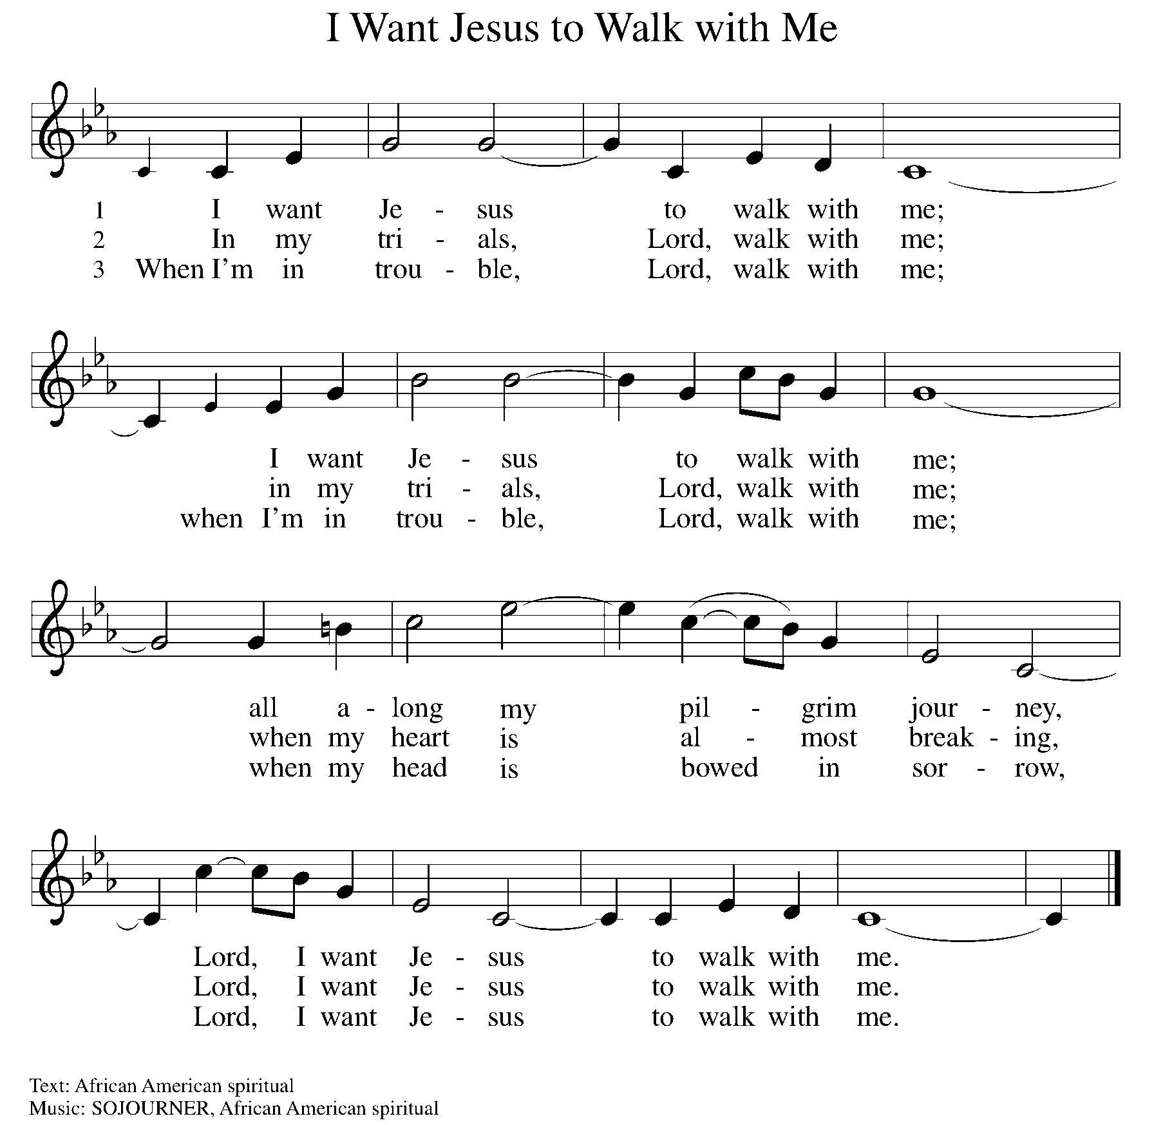

OFFERING PRAYER

A: Let us pray. Gracious Provider, you set your immense treasures among us, opening your heart to the world. As we prepare to feast on your bountiful love, deepen our commitment to sharing those treasures with others, through our Savior, Jesus Christ.

C: Amen.

THE GREAT THANKSGIVING

P: The Lord be with you.
C: And also with you.
P: Lift up your hearts.
C: We lift them to the Lord.
P: Let us give thanks to the Lord our God.
C: It is right to give our thanks and praise.

PROPER PREFACE

P: It is indeed right, our duty and our joy, that we should at all times and in all places give thanks and praise to you, almighty and merciful God, through our Savior Jesus Christ. You call your people to cleanse their hearts and prepare with joy for the paschal feast, that, renewed in the gift of baptism, we may come to the fullness of your grace. And so, with all the choirs of angels, with the church on earth and the hosts of heaven, we praise your name and join their unending hymn:

HOLY, HOLY ELW Setting 7, Page 181

Holy, holy, holy Lord God,
God of might and power; holy is the Lord.
Holy, holy, holy, holy Lord God,
God of might and power; holy is the Lord.
Hosanna in the highest, hosanna here on earth.
Blest is he who comes in the name of the Lord.
Hosanna in the highest, hosanna here on earth.
Blest is he who comes in the name of the Lord.

EUCHARISTIC PRAYER

P: In the night in which he was betrayed, our Lord Jesus took bread, and gave thanks; broke it, and gave it to his disciples, saying:
Take and eat; this is my body, given for you. Do this for the
remembrance of me.
Again, after supper, he took the cup, gave thanks, and gave it for all to drink, saying:
This cup is the new covenant in my blood, shed for you and for all people for the forgiveness of sin. Do this for the remembrance of me.

LORD'S PRAYER

P: Lord, remember us in your kingdom, and teach us to pray:

C: Our Father in heaven, hallowed be your name, your kingdom come, your will be done, on earth as in heaven. Give us today our daily bread. Forgive us our sins as we forgive those who sin against us. Save us from the time of trial and deliver us from evil. For the kingdom, the power, and the glory are yours, now and forever. Amen.

(Please be seated.)

COMMUNION DISTRIBUTION

All who believe in the real presence of Christ in the bread and the wine (juice) are welcome to the table. Others may come forward for a blessing. If you prefer grape juice, please indicate this to the assisting minister.

When approaching the communion rail, come forward down the side aisle, kneel, if you are able, starting at the front of the communion rail (spot closest to the font) on your side and filling in toward the back. After receiving both the bread and the wine, you may return to your seat by the center aisle.

INVITATION TO COMMUNION

P: All who are hungry, come! The feast of grace is spread.

COMMUNION HYMN ELW 779
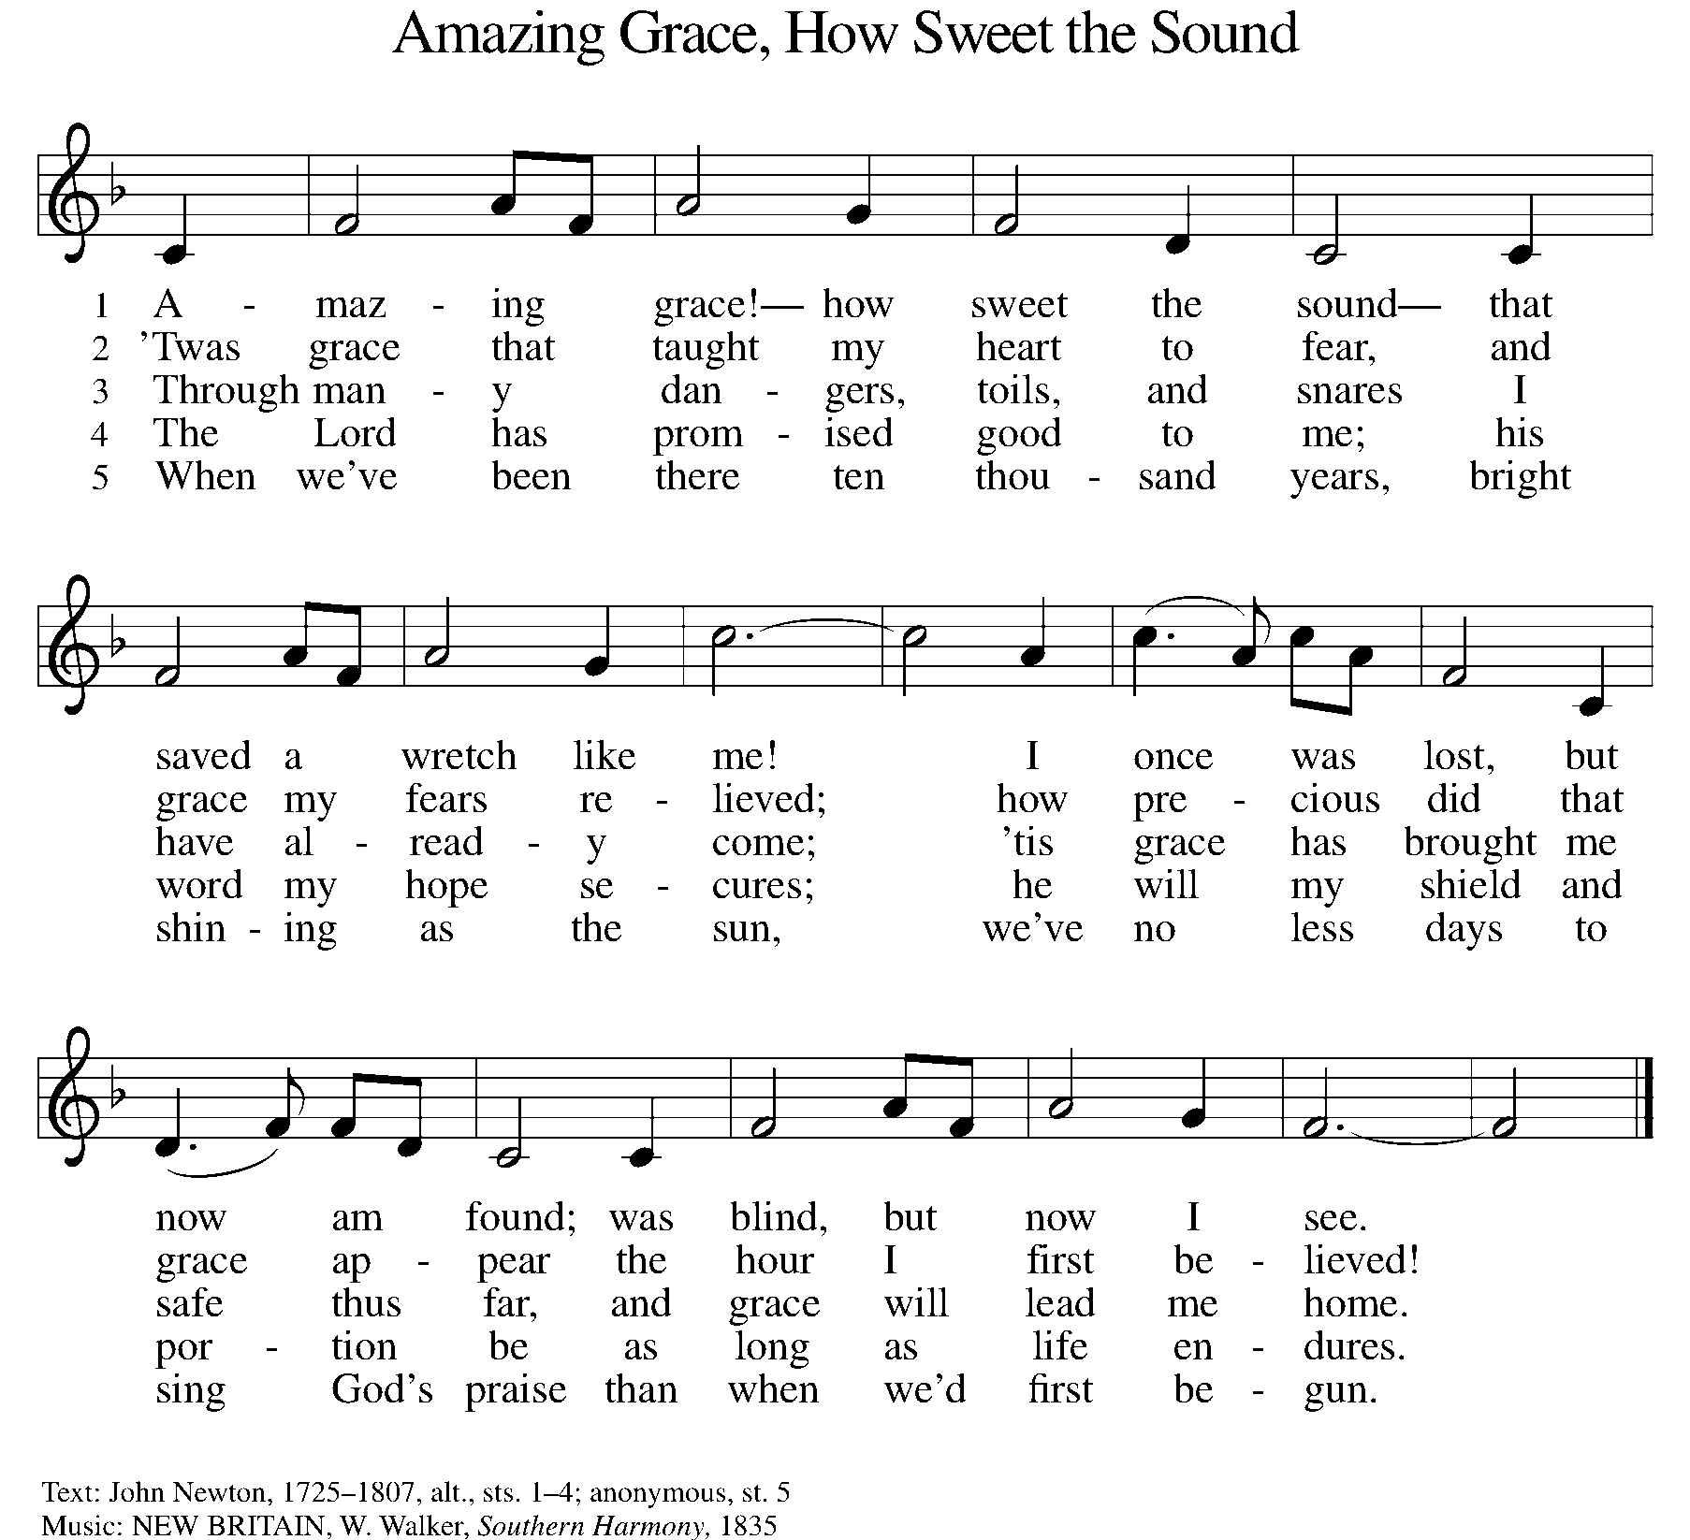

P: The body of Christ, given for you.

C: Amen.

A: The blood of Christ, shed for you.

C: Amen.
(Please rise as you are able.)
P: May the body and blood of our Lord Jesus Christ strengthen and keep you in his grace.

C: Amen.

PRAYER AFTER COMMUNION

P: Let us pray. Generous Host, you have shared your feast with us and made us new. Send us now to set tables of love and grace in our communities, that your liberating love might nourish the world into freedom, in the name of the crucified one, Jesus Christ our Lord.

C: Amen.

SENDING

BLESSING

P: God our tender parent, God the crucified one, God the reconciling Spirit, ☩ bless you now and forever.

C: Amen.

SENDING HYMN ELW 763
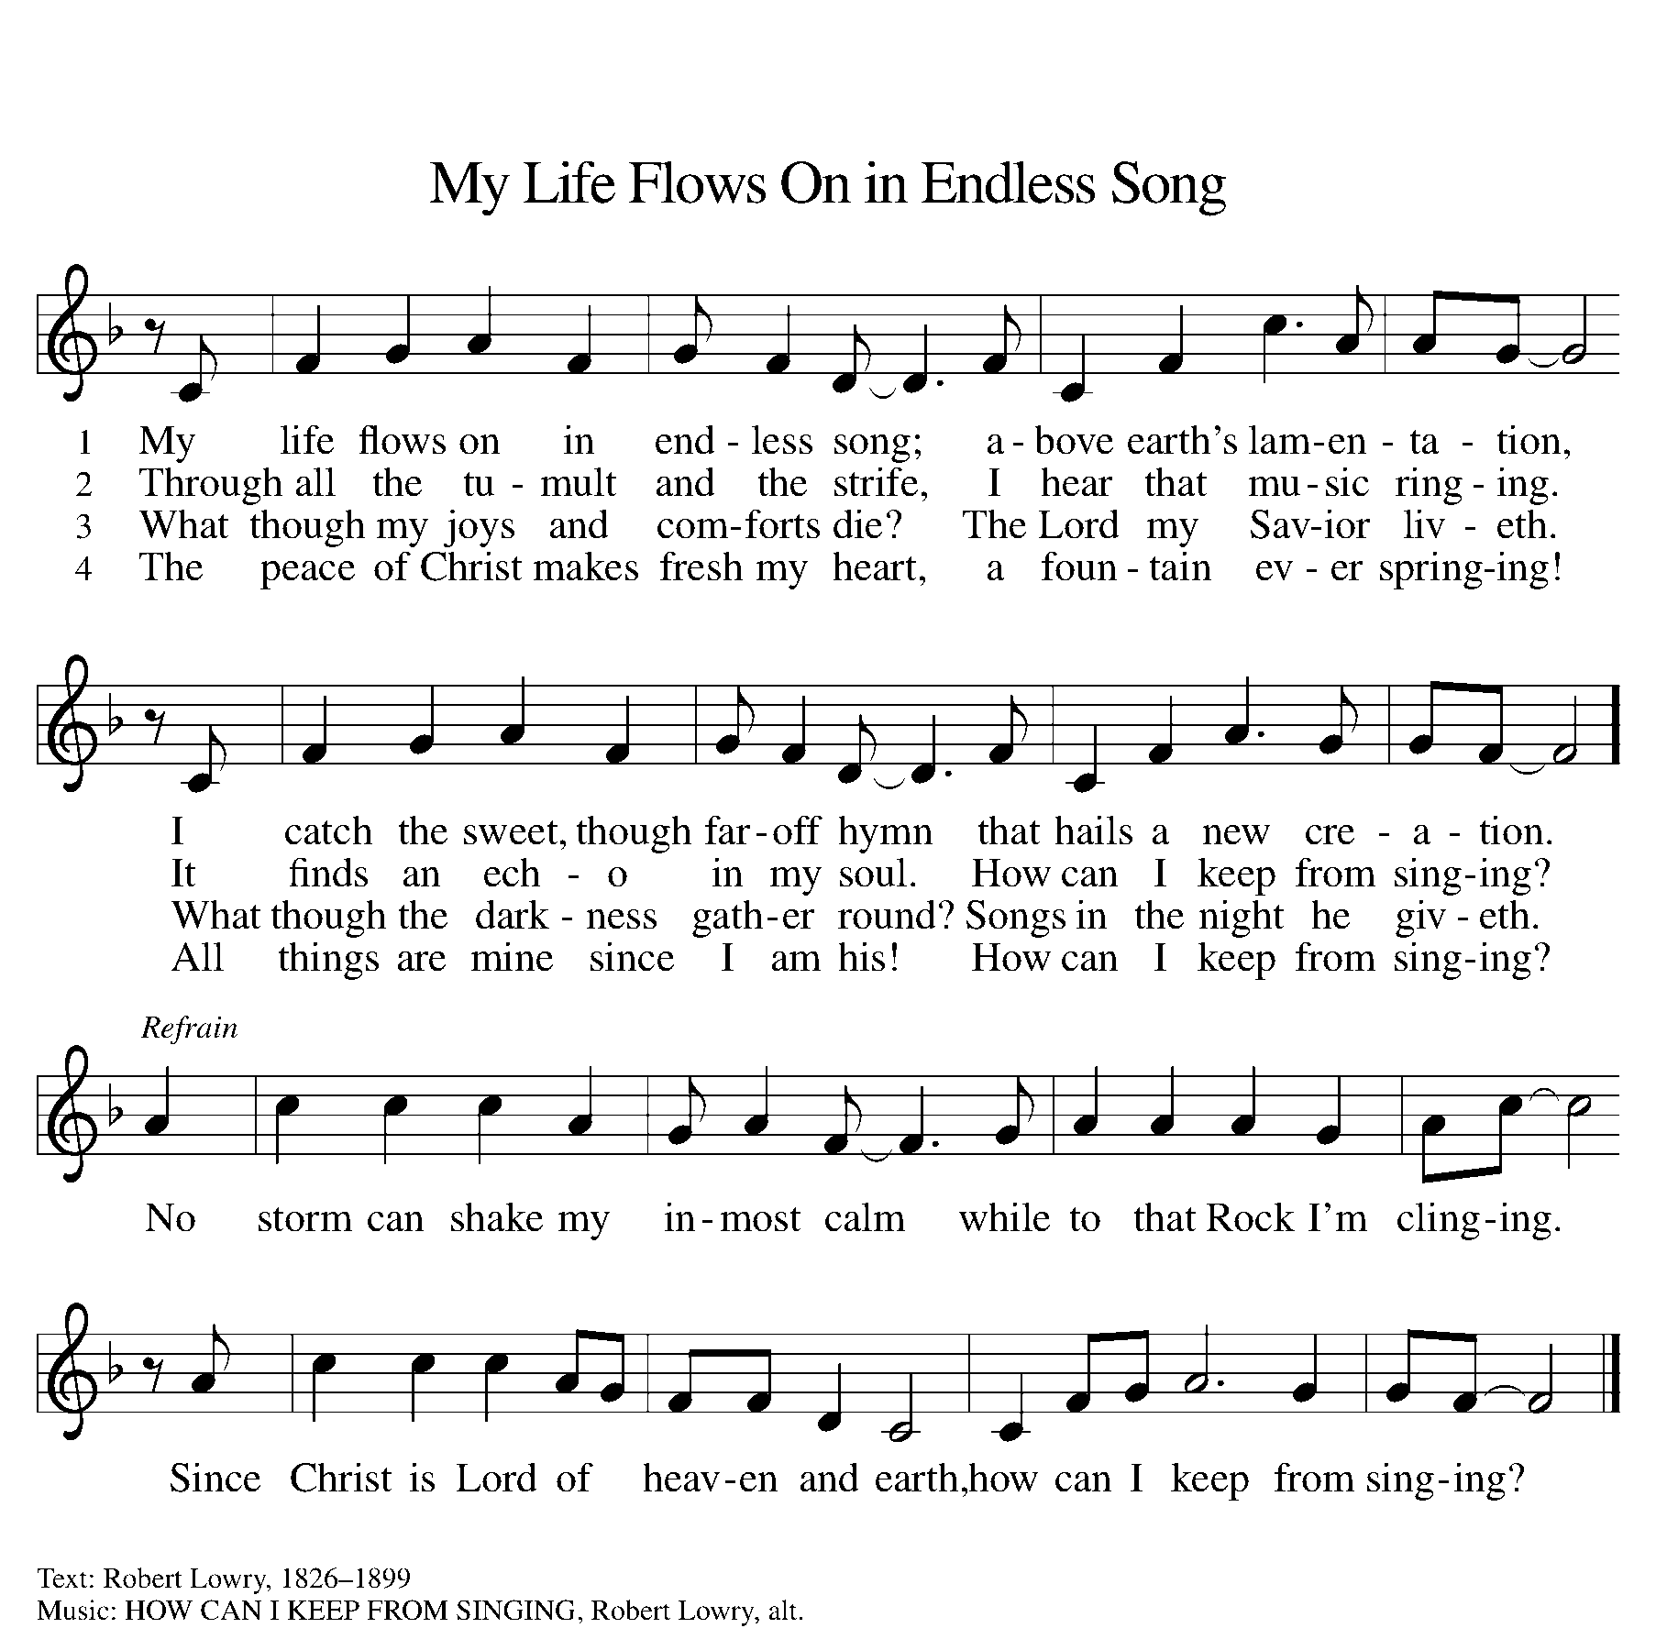

DISMISSAL

A: Go in peace. Care for others as God cares for you!

C: Thanks be to God.

Announcements

Bring items for the Food Pantry & Homeless!

- Sunday, April 13 – Palm Sunday
- Friday, April 18 – Good Friday Service @ 6pm
- Sunday, April 20 – Easter
- Sunday, April 20 – Children’s Easter Egg Hunt @ 9:15am
- Sunday, April 20 – Easter Breakfast Potluck @ 9am

Recurring Events

- Every Sunday – Adult Bible Study @ 9am
- Monday, April 7 – Worship Committee Meeting @ 6:30pm
- Wednesday, May 14 – Women’s Bible Study @ 11am
- Thursday, April 17 – Council Meeting @ 7pm

Food Pantry Dates

Wednesday, April 2, 5-6:30pm
Thursday, April 10, 1-3pm
Wednesday, April 16, 5-6:30pm
Thursday, April 24, 1-3pm

Volunteers for March 30 Volunteers for April 6

Reader - Volunteer Reader – Volunteer
Assisting Minister - Kathy Assisting Minister – Kathy

March & April Birthday Celebrations

3/17 – Beth Ann Ro.
3/30 – Kathy Kl.
4/2 – Noah Ki.
4/4 – Doretta Th.
4/4 – RJ Mc.
4/11 – Kathy Gr.
4/14 – Carol Ha.
4/26 – Vicki Ki.
4/27 – Kristen Op.
4/27 – Pat Cr.
4/29 – Mary Mc.

Anniversary Celebrations

3/27 – James & Lynne Fo.

Acknowledgments
- OneLicense.net, License #A-703165.
- CCLI, License #2281869.
- From SundaysandSeasons.com. Copyright 2020 Augsburg Fortress. All rights reserved. Reprinted by permission under Augsburg Fortress Liturgies Annual License #23806.
- New Revised Standard Version Bible, copyright 1989, Division of Christian Education of the National Council of the Churches of Christ in the United States of America. Used by permission. All rights reserved.

