

3rd Sunday in Lent
March 23, 2025

SAINT PAUL LUTHERAN CHURCH
3383 EAST LAKE LANSING ROAD
EAST LANSING, MI 48823

PHONE (517) 351-8541

Pastor Carl E. Ballard
E-MAIL: pastor@stpaul-el.org
officemanager@stpaul-el.org

Visitors WELCOME! If this is your first time worshipping with us, please sign our guest registry just outside the sanctuary doors. We hope you are blessed through worship today. If you have any questions, please feel free to call the church at 351-8541.
Children are always welcome in worship! The choir room (off the sanctuary) can also be used as a cry room for younger children and includes a sound system so parents may continue to participate in the service. Clipboards with children’s bulletins, activities and crayons are available for use during the service. Please see an usher if you are unable to locate them.
Sunday School is available during the worship service September-May except the last Sunday of the month.
This Bulletin is for your use during the service and to take home for the upcoming week. If you choose not to take it home, please place it in the recycle receptacle in the back.
Newsletters and Calendars of Upcoming Events are available in the lobby/narthex. We welcome anyone who has an interest in our small groups or activities! You can also look us up on the web at www.stpaul-el.org.
Contacting Us: Our office manager is Emily Polhamus. She can be reached by phone at 517-351-8541 or at her email address, officemanager@stpaul-el.org. Our Director of Music is Elene Kobulashvili. You may leave a message at 517-351-8541. Pastor Carl can be reached at 517-515-3129, and his email address is cballard123@msn.com.
Holy Communion is available at most services. All who believe in the real presence of Christ in the bread and the wine are invited to celebrate Communion with us. Those who wish can come forward for a blessing.
You are invited to share in fellowship after worship. We would love this opportunity to introduce you to the St. Paul community.

P-Presiding Minister A-Assisting Minister C-Congregation

PRELUDE ELENE

INTRODUCTION

The warnings are plentiful and blunt on the third Sunday in Lent. Cut it out or get cut down! The warnings are accompanied by God’s invitation to attentiveness: “Incline your ear, and come to me; listen, so that you may live.” The landowner’s ultimatum is forestalled by the gardener’s readiness to till the ground one more year. That is good news for all of us. Thanks be to God!

GATHERING

P: The Holy Spirit calls us together as the people of God.

(Please rise as you are able.)

CONFESSION & FORGIVENESS

All may make the sign of the cross, the sign that is marked at baptism, as the presiding minister begins.

P: Blessed be the holy Trinity, ☩ one God, who forgives all our sin, whose mercy endures forever.

C: Amen.

P: Let us return to God, confessing our sin in the assurance of God’s abiding love.

(Silence is kept for reflection.)

P: Compassionate One,
C: you are slow to anger and abounding in steadfast love, but our lives do not always reflect you and your love for the world. We do not show others the tender compassion you have shown to us. We do not welcome others with the radical hospitality you grant to all people. We oppress others, even though you have set us free again and again. We squander the abundant gifts of the earth. Transform our lives and guide us again in the way of the cross. Amen.

P: Beloved in Christ, God’s arms are always stretched open wide to welcome the wandering ones home. In ☩ Christ your sins are forgiven. You have a place in God’s house forever.

C: Amen.

GATHERING SONG ELW 336
LAMB OF GOD

- Your only Son, no sin to hide.
but you have sent him from your side
to walk upon this guilty sod
and to become the Lamb of God.

REFRAIN
O Lamb of God, sweet Lamb of God,
I love the holy Lamb of God.
Oh, wash me in your precious blood,
my Jesus Christ, the Lamb of God.

- Your gift of love we crucified.
We laughed and scorned him as he died.
The humble king we named a fraud
and sacrificed the Lamb of God.

REFRAIN
- I was so lost, I should have died.
but you have brought me to your side
to be led by your staff and rod
and to be called a lamb of God.

REFRAIN
GREETING

P: The grace of our Lord Jesus Christ, the love of God, and the communion of the Holy Spirit be with you all.

C: And also with you.

KYRIE ELW Setting 7, Page 175

Lord, have mercy on us; O Lord, have mercy.
Lord, have mercy on us; O Lord, have mercy.
Christ, have mercy on us; O Christ, have mercy.
Christ, have mercy on us; O Christ, have mercy.
Lord, have mercy on us; O Lord, have mercy.
Lord, have mercy on us; O Lord, have mercy.

CANTICLE OF PRAISE ELW Setting 4, Page 148-149

Glory to God in the highest, and peace to God’s people on earth.
Lord God, heavenly King, almighty God and Father,
we worship you, we give you thanks, we praise you for your glory. Lord Jesus Christ, only Son of the Father, Lord God, Lamb of God, you take away the sin of the world: have mercy on us;
you are seated at the right hand of the Father: receive our prayer. For you alone are the Holy One, you alone are the Lord,
you alone are the Most High, Jesus Christ, with the Holy Spirit,
in the glory of God the Father. Amen.

PRAYER OF THE DAY

P: Let us pray. Eternal God, your kingdom has broken into our troubled world through the life, death, and resurrection of your Son. Help us to hear your word and obey it, and bring your saving love to fruition in our lives, through Jesus Christ, our Savior and Lord, who lives and reigns with you and the Holy Spirit, one God, now and forever.

C: Amen.

(Please be seated.)

CHILDREN’S MESSAGE

(Children may return to their seats.)

TRANSITION SONG ELW 595
(VERSE 1 & REFRAIN ONLY)
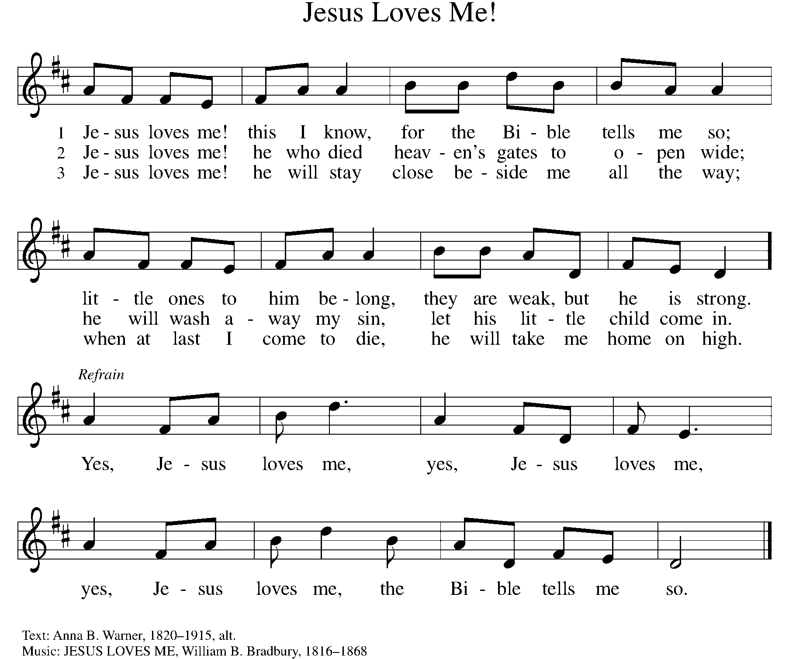
THE WORD

God speaks to us in scripture, preaching, and song.

First Reading isaiah 55:1-9
To those who have experienced long years in exile, the return to their homeland is a celebration of abundant life. God calls them into an everlasting covenant of love. Those who return to God will enjoy new life and forgiveness, because God’s ways are not our ways.

¹ Hear, everyone who thirsts; come to the waters; and you who have no money,
come, buy and eat! Come, buy wine and milk without money and without price.
² Why do you spend your money for that which is not bread and your earnings for that which does not satisfy? Listen carefully to me, and eat what is good, and delight yourselves in rich food. ³ Incline your ear, and come to me; listen, so that you may live. I will make with you an everlasting covenant, my steadfast, sure love for David. ⁴ See, I made him a witness to the peoples, a leader and commander for the peoples. ⁵ Now you shall call nations that you do not know, and nations that do not know you shall run to you, because of the Lord your God, the Holy One of Israel, for he has glorified you.

⁶ Seek the Lord while he may be found; call upon him while he is near; ⁷ let the wicked forsake their way and the unrighteous their thoughts; let them return to the Lord, that he may have mercy on them, and to our God, for he will abundantly pardon. ⁸ For my thoughts are not your thoughts, nor are your ways my ways, says the Lord. ⁹ For as the heavens are higher than the earth, so are my ways higher than your ways and my thoughts than your thoughts.

Word of God, word of life. C: Thanks be to God.

PSALM PSALM 63:1-8
O God, eagerly I seek you; my soul thirsts for you. (Ps. 63:1)

¹ O God, you are my God; eagerly I seek you; my soul thirsts for you, my flesh faints for you, as in a dry and weary land where there is no water.
² Therefore I have gazed upon you in your holy place, that I might behold your power and your glory.
³ For your steadfast love is better than life itself; my lips shall give you praise.
⁴ So will I bless you as long as I live and lift up my hands in your name.
⁵ My spirit is content, as with the richest of foods, and my mouth praises you with joyful lips,
⁶ when I remember you up-on my bed, and meditate on you in the night watches.
⁷ For you have been my helper, and under the shadow of your wings I will rejoice.
⁸ My whole being clings to you; your right hand holds me fast.

SECOND READING 1 CORINTHIANS 10:1-13
Paul uses images from Hebrew Scriptures and prophecy to speak the truth of Jesus Christ: He is our rock, our water, our food, and our drink. Christ is the living sign of God’s faithfulness.

¹ I do not want you to be ignorant, brothers and sisters, that our ancestors were all under the cloud, and all passed through the sea, ² and all were baptized into Moses in the cloud and in the sea, ³ and all ate the same spiritual food, ⁴ and all drank the same spiritual drink. For they drank from the spiritual rock that followed them, and the rock was Christ. ⁵ Nevertheless, God was not pleased with most of them, and they were struck down in the wilderness.

⁶ Now these things occurred as examples for us, so that we might not desire evil as they did. ⁷ Do not become idolaters as some of them did, as it is written, “The people sat down to eat and drink, and they rose up to play.” ⁸ We must not engage in sexual immorality, as some of them did, and twenty-three thousand fell in a single day. ⁹ We must not put Christ to the test, as some of them did, and were destroyed by serpents. ¹⁰ And do not complain, as some of them did, and were destroyed by the destroyer. ¹¹ These things happened to them to serve as an example, and they were written down to instruct us, on whom the ends of the ages have come. ¹² So if you think you are standing, watch out that you do not fall. ¹³ No testing has overtaken you that is not common to everyone. God is faithful, and he will not let you be tested beyond your strength, but with the testing he will also provide the way out so that you may be able to endure it.

Word of God, word of life. C: Thanks be to God.

(Please rise as you are able.)

GOSPEL ACCLAMATION ELW Setting 7, Page 179
Turn back to the Lord, your God,
Who is gracious and merciful,
Slow to anger and abounding in love and faithfulness.
GOSPEL LUKE 13:1-9

P: The Holy Gospel according to Luke, the 13th chapter.
C: Glory to you, O Lord.

Asked about current tragic events, Jesus turns a lesson about whether suffering is deserved into a hard call to obedience. He then tells a parable that holds out hope that the timeline for ultimate judgment will be tempered by patience.

¹ At that very time there were some present who told Jesus about the Galileans whose blood Pilate had mingled with their sacrifices. ² [Jesus] asked them, “Do you think that because these Galileans suffered in this way they were worse sinners than all other Galileans? ³ No, I tell you, but unless you repent you will all perish as they did. ⁴ Or those eighteen who were killed when the tower of Siloam fell on them—do you think that they were worse offenders than all the other people living in Jerusalem? ⁵ No, I tell you, but unless you repent you will all perish just as they did.”

⁶ Then he told this parable: “A man had a fig tree planted in his vineyard, and he came looking for fruit on it and found none. ⁷ So he said to the man working the vineyard, ‘See here! For three years I have come looking for fruit on this fig tree, and still I find none. Cut it down! Why should it be wasting the soil?’ ⁸ He replied, ‘Sir, let it alone for one more year, until I dig around it and put manure on it. ⁹ If it bears fruit next year, well and good, but if not, you can cut it down.’ ”

P: The Gospel of the Lord. C: Praise to you, O Christ.
(Please be seated.)

SERMON PASTOR CARL BALLARD

(Please rise as you are able.)
HYMN OF THE DAY ELW 342
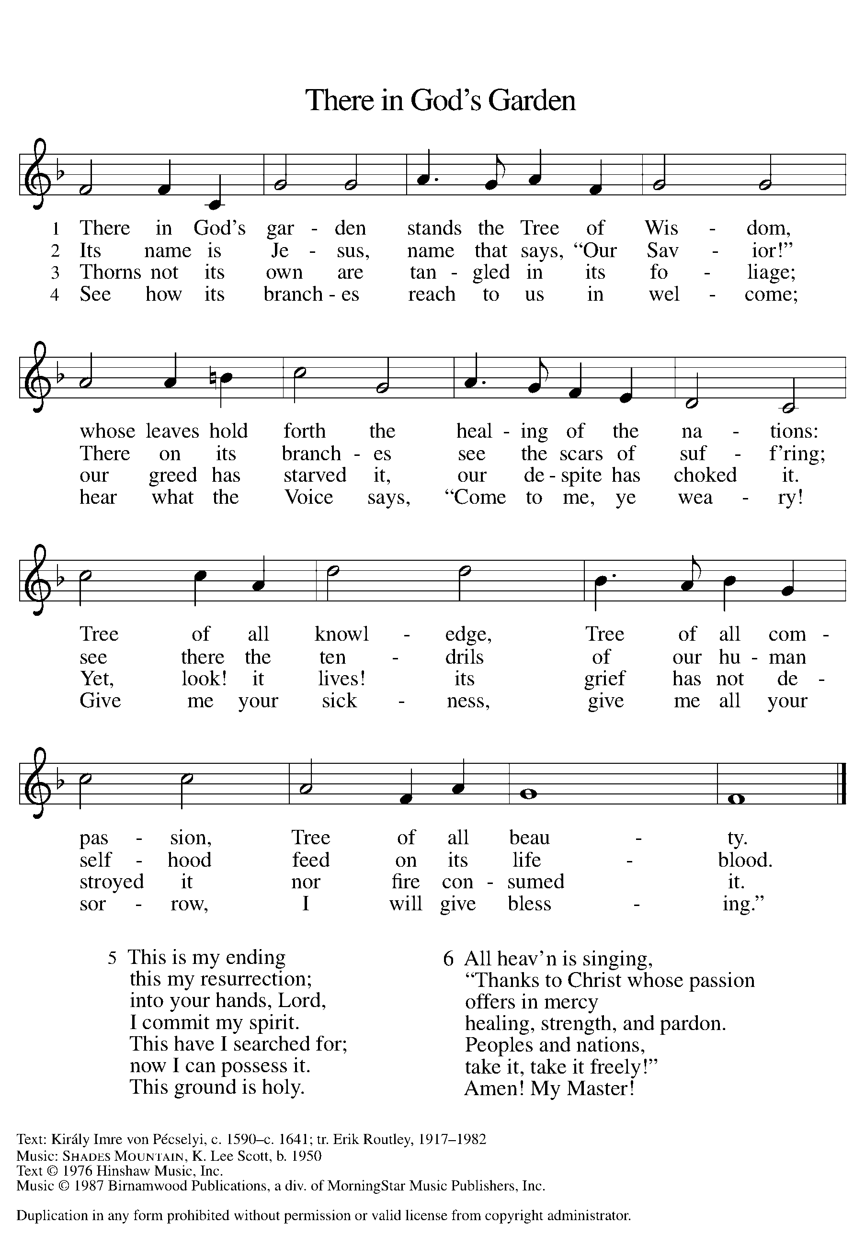

apostles’ CREED

I believe in God, the Father almighty,
creator of heaven and earth.
I believe in Jesus Christ, God’s only Son, our Lord,
who was conceived by the Holy Spirit,
born of the virgin Mary,
suffered under Pontius Pilate,
was crucified, died, and was buried;
he descended to the dead.
On the third day he rose again;
he ascended into heaven,
he is seated at the right hand of the Father,
and he will come to judge the living and the dead.
I believe in the Holy Spirit,
the holy catholic church,
the communion of saints,
the forgiveness of sins,
the resurrection of the body,
and the life everlasting. Amen.

(Please be seated.)

THE PRAYERS

A: Led by the Spirit, let us turn to God in prayer for the church, the world, and all those in need.
(A brief silence)
A: We pray for the church, called to be a witness to all peoples. Grant humility and wisdom to bishops, pastors, deacons, elders, councils, and congregations, that they may call upon you in making decisions. God, in your mercy,

C: receive our prayer.
A: We pray for the earth, called to provide abundantly. Teach your people the goodness of your generosity, that in sharing what we have been given, all life may flourish on the planet that is our shared home. God, in your mercy,

C: receive our prayer.
A: We pray for the nations, called to protect their inhabitants and collaborate in the work of justice and peace. Forge bonds of compassion and mutual care across human borders and boundaries, that all the world may have enough to live. God, in your mercy,

C: receive our prayer.

A: We pray for those in need, called to receive your compassion. Comfort those whose lives have been disrupted through natural disasters and human conflict. Aid communities in coming together to mourn, heal, and rebuild. God, in your mercy,
C: receive our prayer.
A: We pray for this assembly, called to welcome its neighbors to the table of your grace. Bless food pantries, community gardens and kitchens, clean water projects, and all ministries that address human hunger and thirst. God, in your mercy,
C: receive our prayer.

A: We pray for those, both military and civilian, called to defend justice in this time of political unrest. Especially, be with those who serve in our armed forces; protect and care for Beth & Ryan, Jonathan, Jacob, Noah, Irene, and Alex. God, in your mercy,

C: receive our prayer.
A: We pray for those called to befriend and bring your message to ones who are overlooked, vulnerable, lonely, ill or suffering in any way and to those who are undergoing transition in relationships, occupation, living situation, or health condition. Especially watch over Ahren, Beth Ra., B.J., Carolyn, Dan, David, Doretta, family & friends of Mary, friends & family of Nina, Jim & Cheri, John, Johnny, Jon, Jordan, Joseph Ra., Kay, Lawton, Lera & family, Linda, Lizzy, Marge, Randy, Rick & Kathy, Sheri, Sheri, Steve, and Wanda, and all whom we name now aloud and in our hearts. Provide an extra measure of your grace and love. God, in your mercy,

C: receive our prayer.

A: We pray for those called to be leaders in ministry, especially our Presiding Bishop Elizabeth, our Synod Bishop Craig, and Pastor Carl and their respective staffs as they live out their callings to serve. As we are called to be one, even as Jesus and the Father are one, be with the leaders and the congregation St. Paul Lutheran Church in East Lansing and all the churches in our community. God, in your mercy,

C: receive our prayer.

A: We give thanks for the faithful lives of those who proclaimed your gospel in times of challenge and strife, and for all those whose lives of love and service have ended. May their witness inspire our own. God, in your mercy,

C: receive our prayer.

P: Receive the prayers of your people and draw all things together in your love, in the name of Jesus, who leads us from death to life.

C: Amen.

GREETING OF PEACE

(You are invited to share Christ’s peace with one another.)

P: The peace of Christ be with you always.

C: And also with you.
(Please be seated.)
THE MEAL
OFFERING ELENE
(Please rise if you are able.)
OFFERTORY ELW 325
(VERSE 1 ONLY)
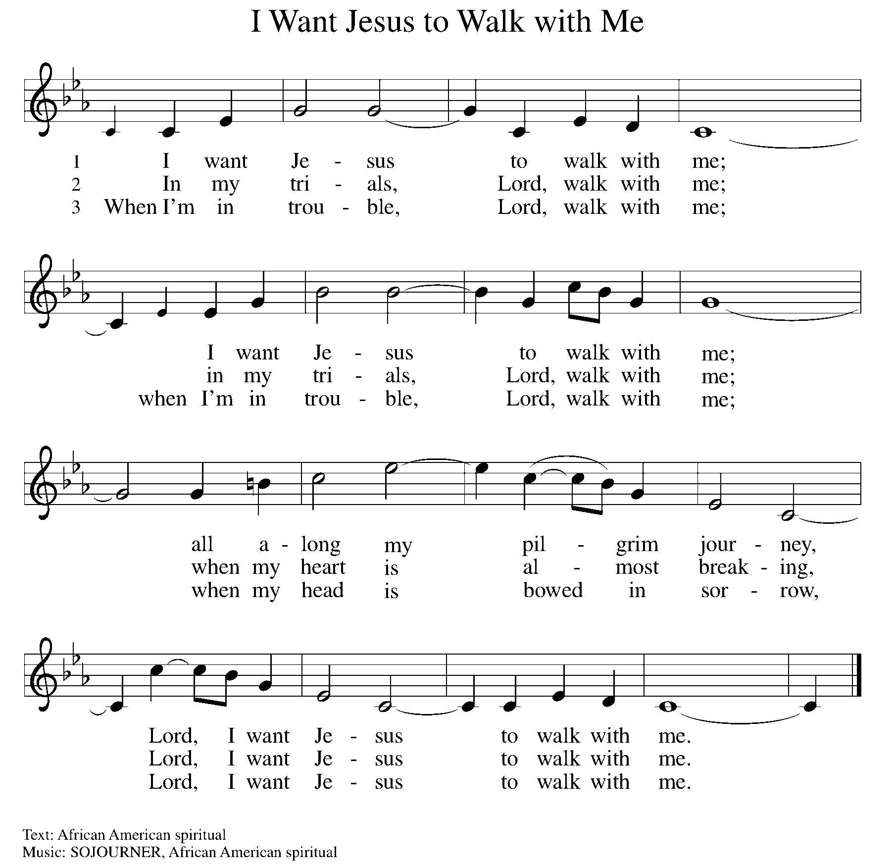

OFFERING PRAYER

A: Let us pray. Gracious Provider, you set your immense treasures among us, opening your heart to the world. As we prepare to feast on your bountiful love, deepen our commitment to sharing those treasures with others, through our Savior, Jesus Christ.

C: Amen.

THE GREAT THANKSGIVING

P: The Lord be with you.
C: And also with you.
P: Lift up your hearts.
C: We lift them to the Lord.
P: Let us give thanks to the Lord our God.
C: It is right to give our thanks and praise.

PROPER PREFACE

P: It is indeed right, our duty and our joy, that we should at all times and in all places give thanks and praise to you, almighty and merciful God, through our Savior Jesus Christ. You call your people to cleanse their hearts and prepare with joy for the paschal feast, that, renewed in the gift of baptism, we may come to the fullness of your grace. And so, with all the choirs of angels, with the church on earth and the hosts of heaven, we praise your name and join their unending hymn:

HOLY, HOLY ELW Setting 7, Page 181

Holy, holy, holy Lord God,
God of might and power; holy is the Lord.
Holy, holy, holy, holy Lord God,
God of might and power; holy is the Lord.
Hosanna in the highest, hosanna here on earth.
Blest is he who comes in the name of the Lord.
Hosanna in the highest, hosanna here on earth.
Blest is he who comes in the name of the Lord.

EUCHARISTIC PRAYER

P: In the night in which he was betrayed, our Lord Jesus took bread, and gave thanks; broke it, and gave it to his disciples, saying:
Take and eat; this is my body, given for you. Do this for the
remembrance of me.
Again, after supper, he took the cup, gave thanks, and gave it for all to drink, saying:
This cup is the new covenant in my blood, shed for you and for all people for the forgiveness of sin. Do this for the remembrance of me.

LORD'S PRAYER

P: Lord, remember us in your kingdom, and teach us to pray:

C: Our Father in heaven, hallowed be your name, your kingdom come, your will be done, on earth as in heaven. Give us today our daily bread. Forgive us our sins as we forgive those who sin against us. Save us from the time of trial and deliver us from evil. For the kingdom, the power, and the glory are yours, now and forever. Amen.
(Please be seated.)

COMMUNION DISTRIBUTION

All who believe in the real presence of Christ in the bread and the wine (juice) are welcome to the table. Others may come forward for a blessing. If you prefer grape juice, please indicate this to the assisting minister.

When approaching the communion rail, come forward down the side aisle, kneel, if you are able, starting at the front of the communion rail (spot closest to the font) on your side and filling in toward the back. After receiving both the bread and the wine, you may return to your seat by the center aisle.

INVITATION TO COMMUNION

P: All who are hungry, come! The feast of grace is spread.

COMMUNION HYMN ELW 779
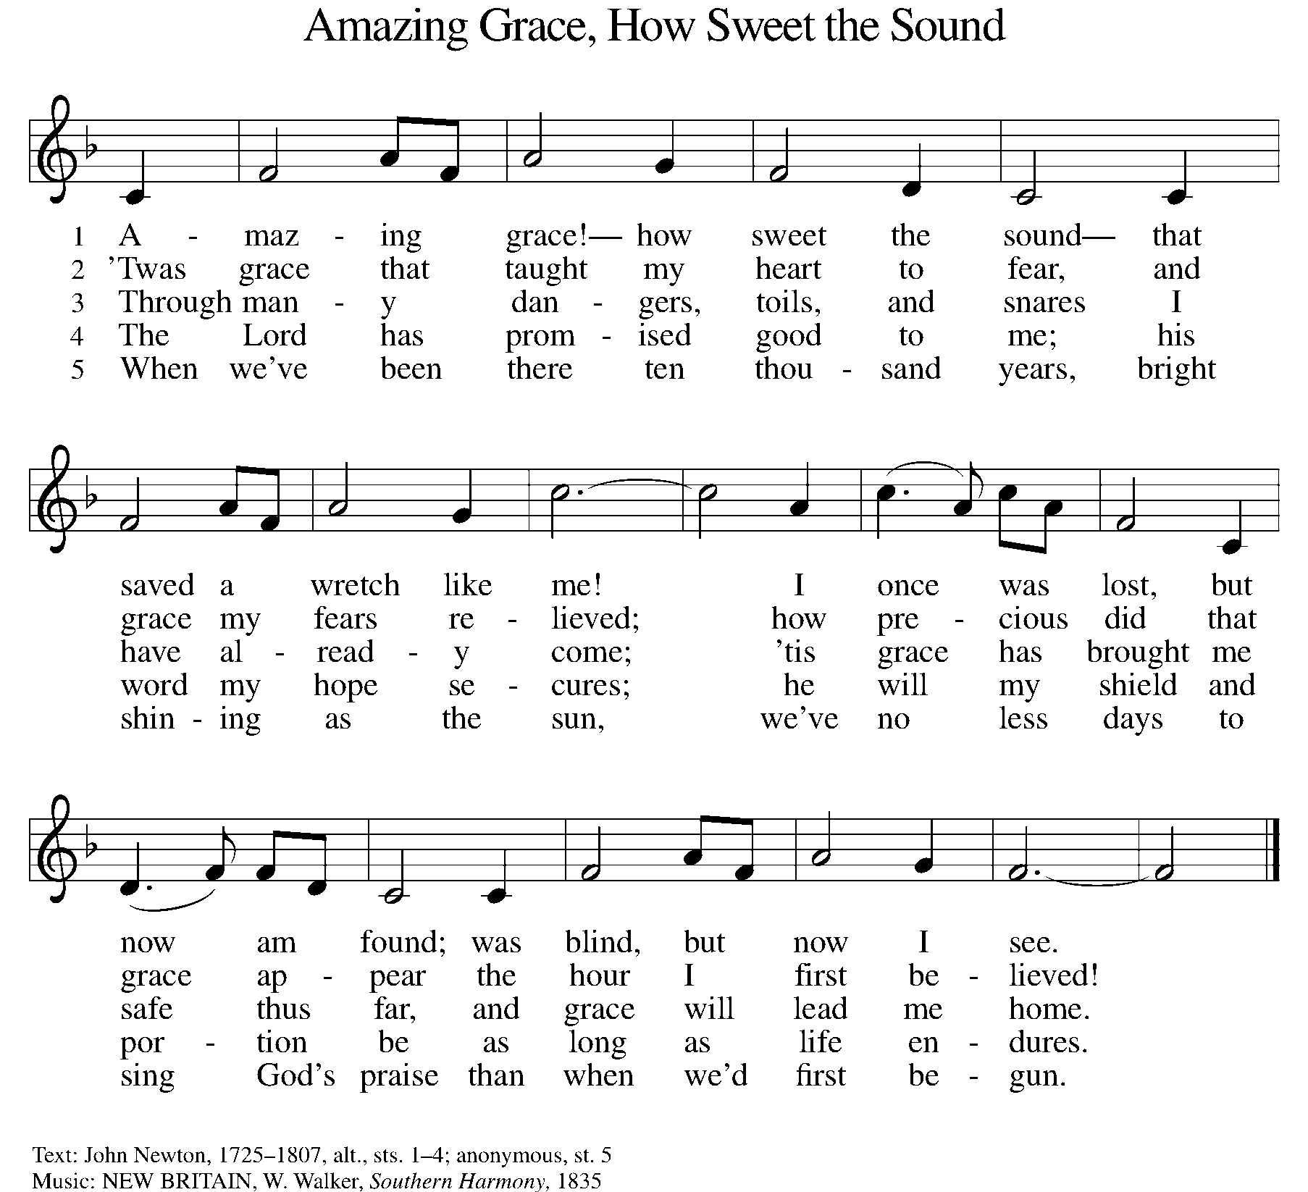

P: The body of Christ, given for you.

C: Amen.

A: The blood of Christ, shed for you.

C: Amen.
(Please rise as you are able.)
P: May the body and blood of our Lord Jesus Christ strengthen and keep you in his grace.

C: Amen.
PRAYER AFTER COMMUNION

P: Let us pray. Generous Host, you have shared your feast with us and made us new. Send us now to set tables of love and grace in our communities, that your liberating love might nourish the world into freedom, in the name of the crucified one, Jesus Christ our Lord.

C: Amen.

SENDING

BLESSING

P: God our tender parent, God the crucified one, God the reconciling Spirit, ☩ bless you now and forever.

C: Amen.

SENDING HYMN ELW 726
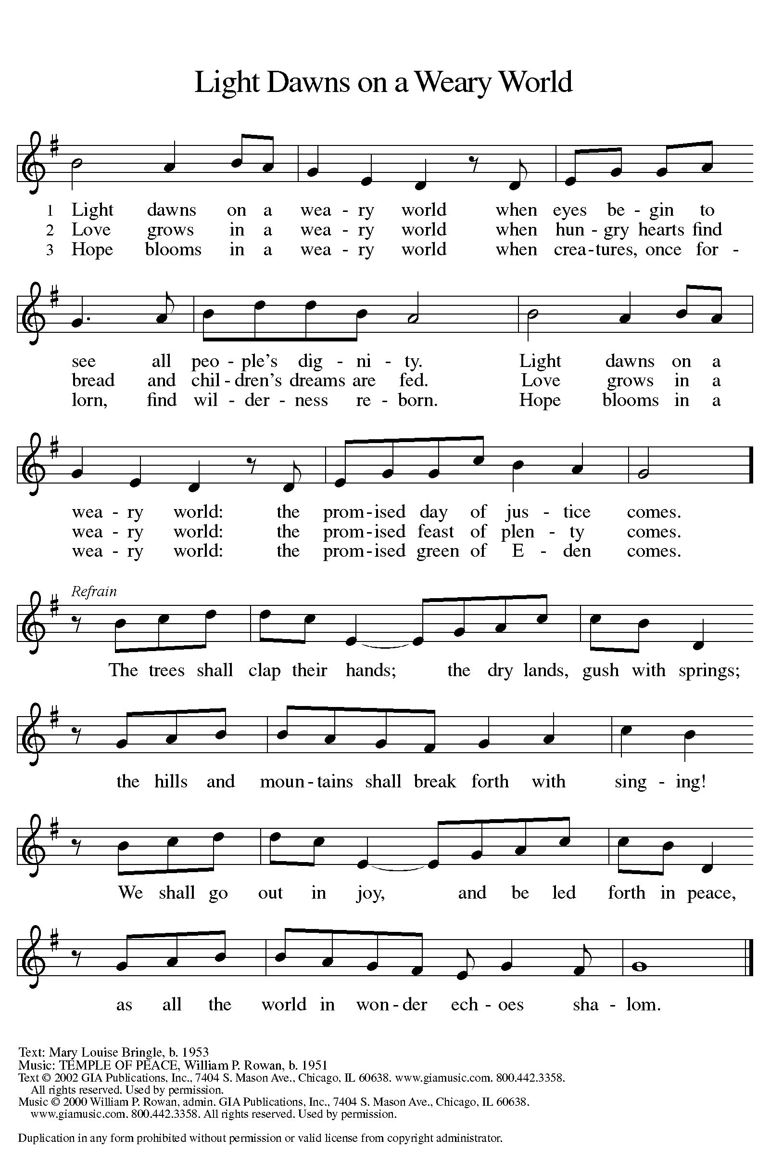

DISMISSAL

A: Go in peace. Care for others as God cares for you!

C: Thanks be to God.

Announcements

Bring items for the Food Pantry & Homeless!

Sign up for soup & bread for Mid-Week Lenten Supper!

- Wednesday, March 26 – Soup supper & devotions @ 6pm
- Sunday, March 30 – Concert by Elene & Ivane Ko. (following service)
- Tuesday, April 1 – April Fools’ Day!
- Sunday, April 13 – Palm Sunday
- Friday, April 18 – Good Friday Service @ 6pm
- Sunday, April 20 – Easter
- Sunday, April 20 – Children’s Easter Egg Hunt @ 9:15am

Recurring Events

- Every Sunday – Adult Bible Study @ 9am
- Monday, April 7 – Worship Committee Meeting @ 6:30pm
- Wednesday, May 14 – Women’s Bible Study @ 11am
- Thursday, April 17 – Council Meeting @ 7pm

Food Pantry Dates

Thursday, March 27, 1-3pm
Wednesday, April 2, 5-6:30pm
Thursday, April 10, 1-3pm
Wednesday, April 16, 5-6:30pm
Thursday, April 24, 1-3pm

Volunteers for March 23 Volunteers for March 30

Reader - Pat Reader – Volunteer
Assisting Minister - Kathy Assisting Minister – Kathy

March & April Birthday Celebrations

3/17 – Beth Ann Ro.
3/30 – Kathy Kl.

4/2 – Noah Ki.
4/4 – Doretta Th.
4/4 – RJ Mc.
4/11 – Kathy Gr.
4/14 – Carol Ha.
4/26 – Vicki Ki.
4/27 – Kristen Op.
4/27 – Pat Cr.
4/29 – Mary Mc.

Anniversary Celebrations

3/27 – James & Lynne Fo.

Acknowledgments
- OneLicense.net, License #A-703165.
- CCLI, License #2281869.
- From SundaysandSeasons.com. Copyright 2020 Augsburg Fortress. All rights reserved. Reprinted by permission under Augsburg Fortress Liturgies Annual License #23806.
- New Revised Standard Version Bible, copyright 1989, Division of Christian Education of the National Council of the Churches of Christ in the United States of America. Used by permission. All rights reserved.

