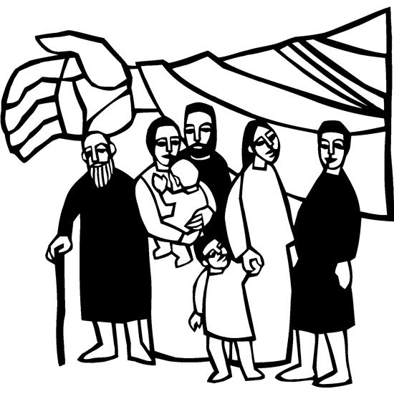

2nd Sunday in Lent
March 16, 2025

SAINT PAUL LUTHERAN CHURCH
3383 EAST LAKE LANSING ROAD
EAST LANSING, MI 48823

PHONE (517) 351-8541

Pastor Carl E. Ballard
E-MAIL: pastor@stpaul-el.org
officemanager@stpaul-el.org
Visitors WELCOME! If this is your first time worshipping with us, please sign our guest registry just outside the sanctuary doors. We hope you are blessed through worship today. If you have any questions, please feel free to call the church at 351-8541.
Children are always welcome in worship! The choir room (off the sanctuary) can also be used as a cry room for younger children and includes a sound system so parents may continue to participate in the service. Clipboards with children’s bulletins, activities and crayons are available for use during the service. Please see an usher if you are unable to locate them.
Sunday School is available during the worship service September-May except the last Sunday of the month.
This Bulletin is for your use during the service and to take home for the upcoming week. If you choose not to take it home, please place it in the recycle receptacle in the back.
Newsletters and Calendars of Upcoming Events are available in the lobby/narthex. We welcome anyone who has an interest in our small groups or activities! You can also look us up on the web at www.stpaul-el.org.
Contacting Us: Our office manager is Emily Polhamus. She can be reached by phone at 517-351-8541 or at her email address, officemanager@stpaul-el.org. Our Director of Music is Elene Kobulashvili. You may leave a message at 517-351-8541. Pastor Carl can be reached at 517-515-3129, and his email address is cballard123@msn.com.
Holy Communion is available at most services. All who believe in the real presence of Christ in the bread and the wine are invited to celebrate Communion with us. Those who wish can come forward for a blessing.
You are invited to share in fellowship after worship. We would love this opportunity to introduce you to the St. Paul community.

P-Presiding Minister A-Assisting Minister C-Congregation

PRELUDE ELENE

INTRODUCTION

Though we sometimes doubt and often resist God’s desire to protect and save us, our God persists. In holy baptism, God’s people have been called and gathered into a God-initiated relationship that will endure. Lent provides the church with a time and a tradition in which to seek God’s face again. Lent provides another occasion to behold the God of our salvation in the face of the Blessed One who “comes in the name of the Lord.”

GATHERING

P: The Holy Spirit calls us together as the people of God.

(Please rise as you are able.)

CONFESSION & FORGIVENESS

All may make the sign of the cross, the sign that is marked at baptism, as the presiding minister begins.

P: Blessed be the holy Trinity, ☩ one God, who forgives all our sin, whose mercy endures forever.

C: Amen.

P: Let us return to God, confessing our sin in the assurance of God’s abiding love.

(Silence is kept for reflection.)
P: Compassionate One,
C: you are slow to anger and abounding in steadfast love, but our lives do not always reflect you and your love for the world. We do not show others the tender compassion you have shown to us. We do not welcome others with the radical hospitality you grant to all people. We oppress others, even though you have set us free again and again. We squander the abundant gifts of the earth. Transform our lives and guide us again in the way of the cross. Amen.

P: Beloved in Christ, God’s arms are always stretched open wide to welcome the wandering ones home. In ☩ Christ your sins are forgiven. You have a place in God’s house forever.

C: Amen.

GATHERING SONG ELW 623
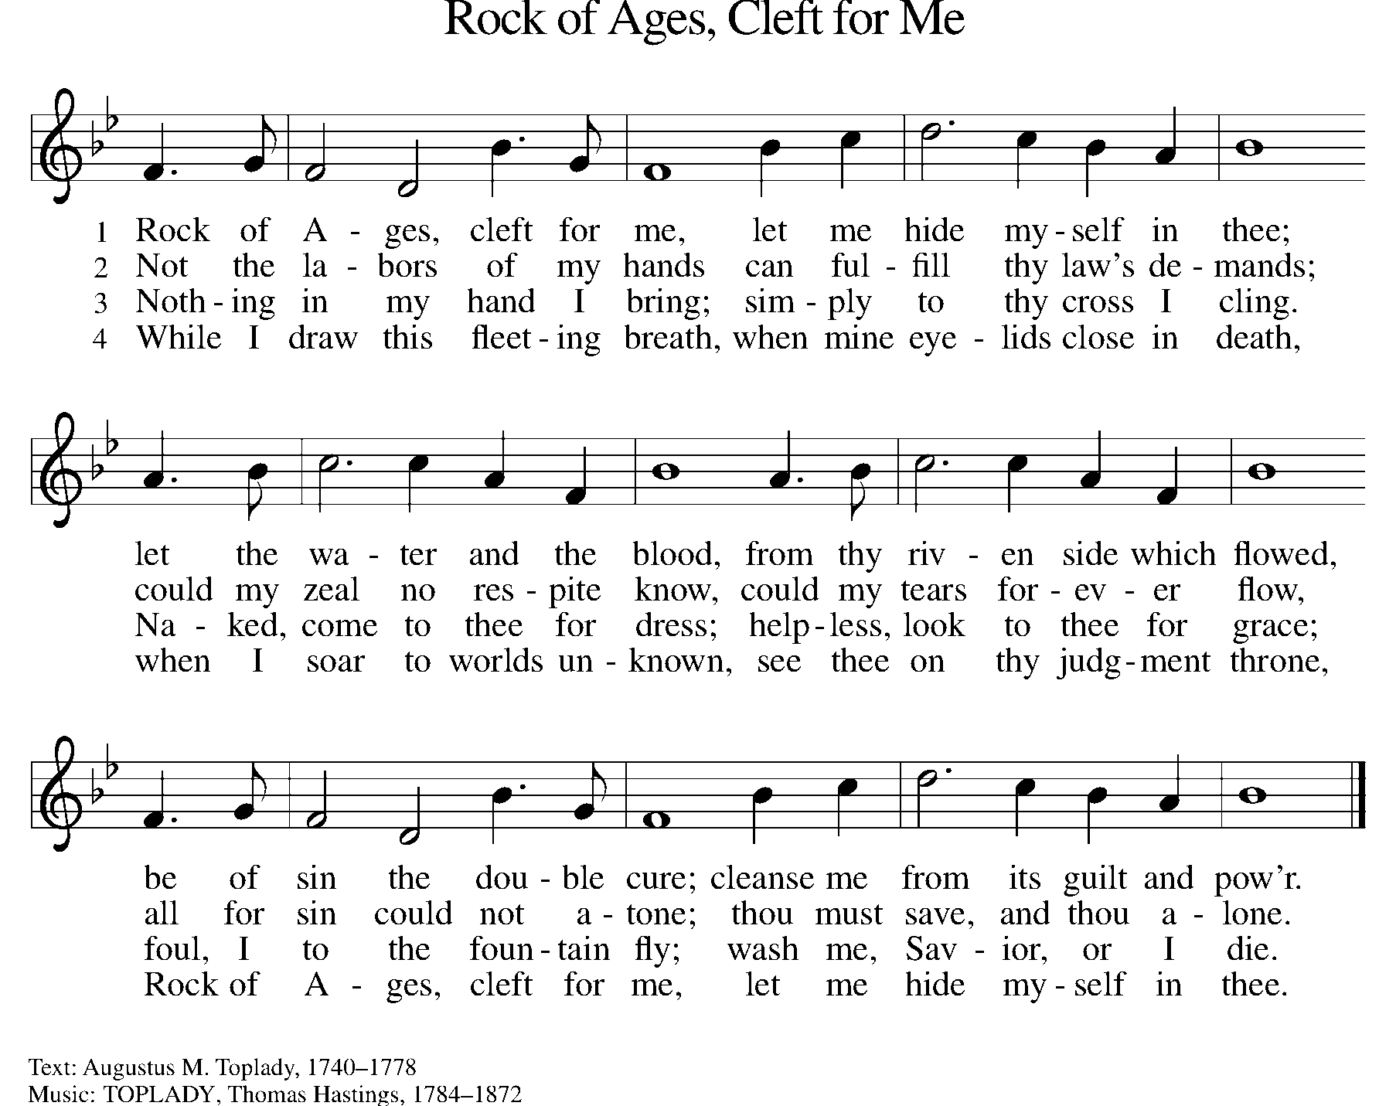

GREETING

P: The grace of our Lord Jesus Christ, the love of God, and the communion of the Holy Spirit be with you all.

C: And also with you.

KYRIE ELW Setting 2, Page 120
In peace, let us pray to the Lord.
Lord, have mercy.
For the peace from above and for our salvation,
let us pray to the Lord.
Lord, have mercy.
For the peace of the whole world, for the well-being of the church of God, and for the unity of all, let us pray to the Lord.
Lord, have mercy.
For this holy house and for all who offer here their worship and praise, let us pray to the Lord.
Lord, have mercy.
Help, save, comfort, and defend us, gracious Lord.
Amen.

CANTICLE OF PRAISE ELW Setting 4, Page 148-149
Glory to God in the highest, and peace to God’s people on earth.
Lord God, heavenly King, almighty God and Father,
we worship you, we give you thanks, we praise you for your glory. Lord Jesus Christ, only Son of the Father, Lord God, Lamb of God, you take away the sin of the world: have mercy on us;
you are seated at the right hand of the Father: receive our prayer. For you alone are the Holy One, you alone are the Lord,
you alone are the Most High, Jesus Christ, with the Holy Spirit,
in the glory of God the Father. Amen.

PRAYER OF THE DAY

P: Let us pray. God of the covenant, in the mystery of the cross you promise everlasting life to the world. Gather all peoples into your arms, and shelter us with your mercy, that we may rejoice in the life we share in your Son, Jesus Christ, our Savior and Lord, who lives and reigns with you and the Holy Spirit, one God, now and forever.

C: Amen.

(Please be seated.)

CHILDREN’S MESSAGE

(Children are invited to Sunday School.)
TRANSITION SONG ELW 595
(VERSE 1 & REFRAIN ONLY)
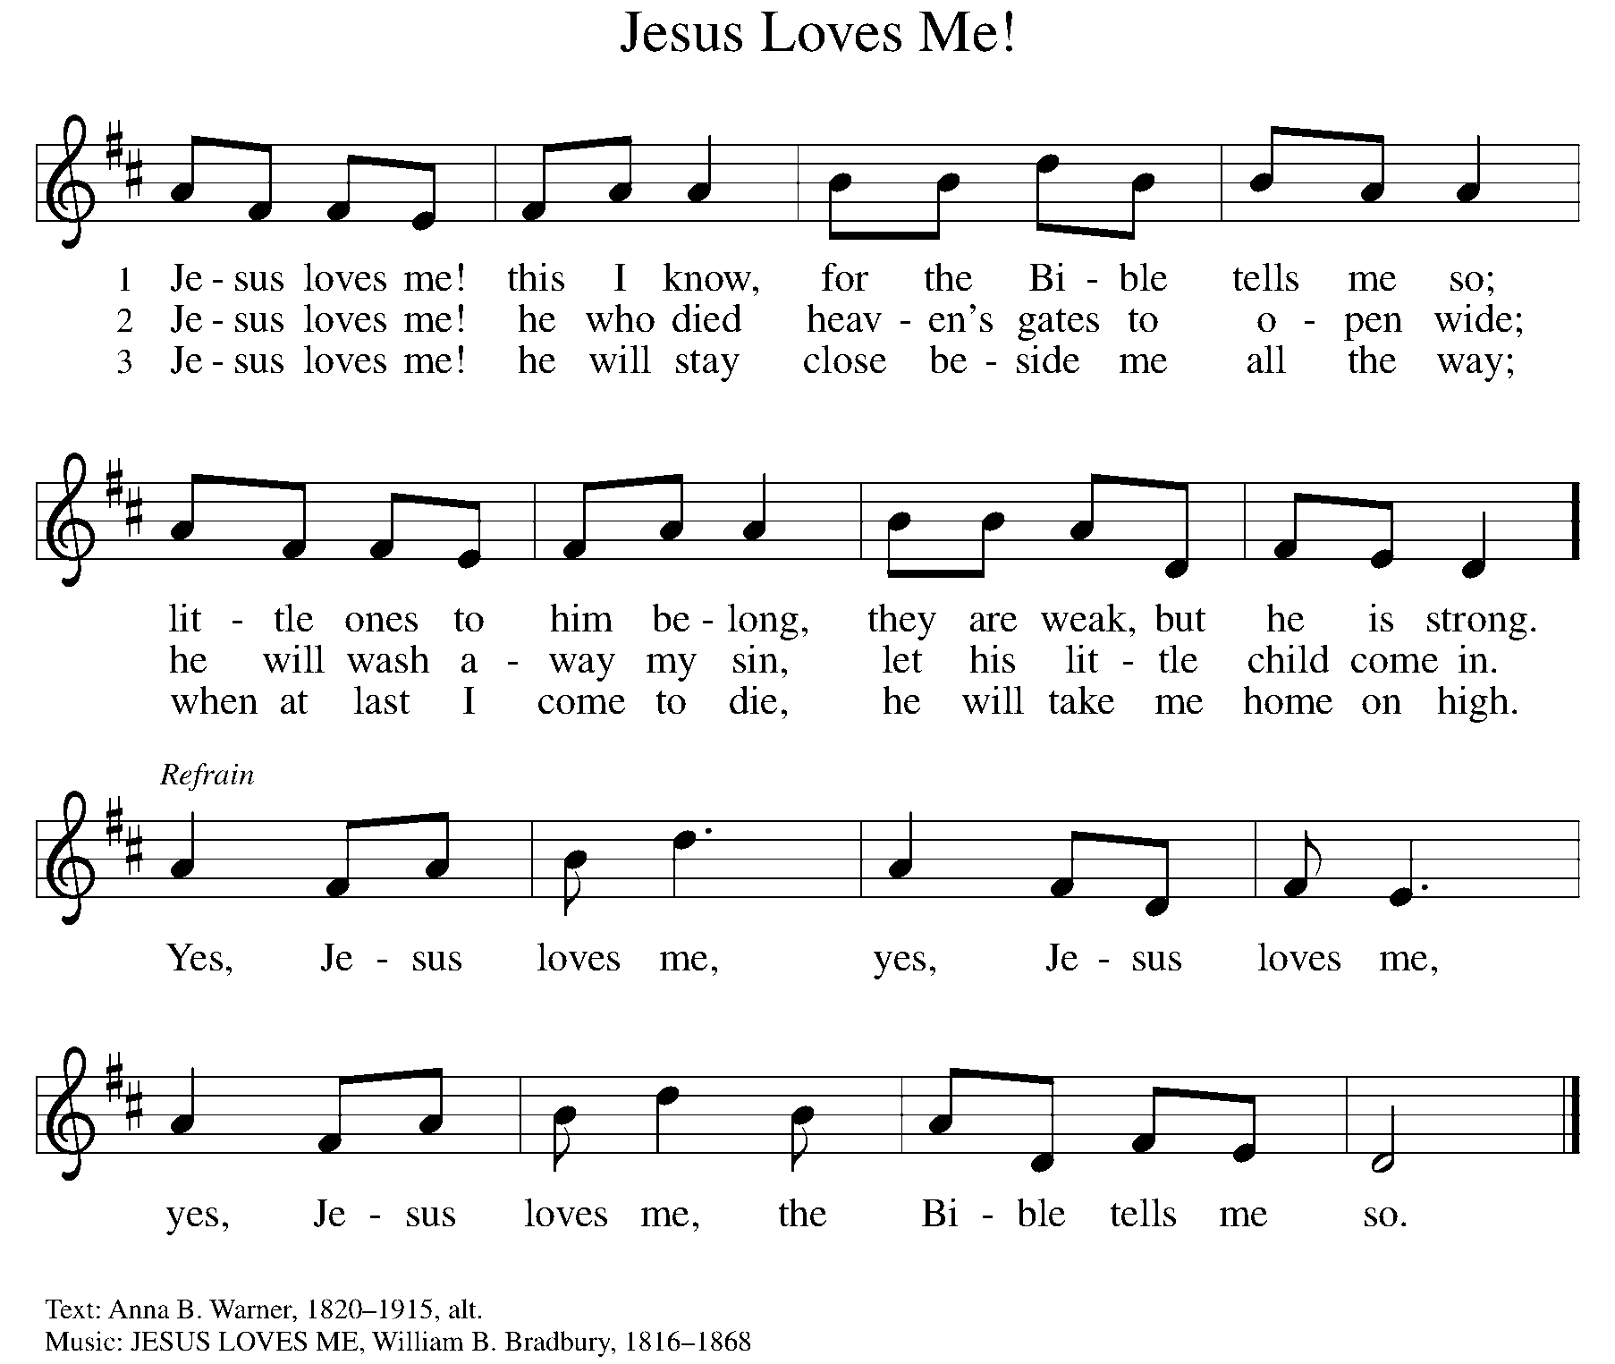
THE WORD

God speaks to us in scripture, preaching, and song.

First Reading GENESIS 15:1-12, 17-18
God promises a childless and doubting Abram that he will have a child, that his descendants will be as numerous as the stars, and that the land of Canaan will be their inheritance. Abram’s trust in God is sealed with a covenant-making ceremony, a sign of God’s promise.

¹ After these things the word of the Lord came to Abram in a vision, “Do not be afraid, Abram, I am your shield; your reward shall be very great.” ² But Abram said, “O Lord God, what will you give me, for I continue childless, and the heir of my house is Eliezer of Damascus?” ³ And Abram said, “You have given me no offspring, so a slave born in my house is to be my heir.” ⁴ But the word of the Lord came to him, “This man shall not be your heir; no one but your very own issue shall be your heir.” ⁵ He brought him outside and said, “Look toward heaven and count the stars, if you are able to count them.” Then he said to him, “So shall your descendants be.” ⁶ And he believed the Lord, and the Lord reckoned it to him as righteousness.

⁷ Then he said to him, “I am the Lord who brought you from Ur of the Chaldeans, to give you this land to possess.” ⁸ But he said, “O Lord God, how am I to know that I shall possess it?” ⁹ He said to him, “Bring me a heifer three years old, a female goat three years old, a ram three years old, a turtledove, and a young pigeon.” ¹⁰ He brought him all these and cut them in two, laying each half over against the other, but he did not cut the birds in two. ¹¹ And when birds of prey came down on the carcasses, Abram drove them away. ¹² As the sun was going down, a deep sleep fell upon Abram, and a deep and terrifying darkness descended upon him.

¹⁷ When the sun had gone down and it was dark, a smoking fire pot and a flaming torch passed between these pieces. ¹⁸ On that day the Lord made a covenant with Abram, saying, “To your descendants I give this land, from the river of Egypt to the great river, the River Euphrates.”

Word of God, word of life. C: Thanks be to God.

PSALM PSALM 27
In the day of trouble, God will give me shelter. (Ps. 27:5)

¹ The Lord is my light and my salvation; whom then shall I fear? The Lord is the stronghold of my life; of whom shall I be afraid?
² When evildoers close in against me to devour my flesh, they, my foes and my enemies, will stumble and fall.
³ Though an army encamp against me, my heart will not fear. Though war rise up against me, my trust will not be shaken.
⁴ One thing I ask of the Lord; one thing I seek; that I may dwell in the house of the Lord all the days of my life; to gaze upon the beauty of the Lord and to seek God in the temple.
⁵ For in the day of trouble God will give me shelter, hide me in the hidden places of the sanctuary, and raise me high upon a rock.
⁶ Even now my head is lifted up above my enemies who surround me. Therefore I will offer sacrifice in the sanctuary, sacrifices of rejoicing; I will sing and make music to the Lord.
⁷ Hear my voice, O Lord, when I call; have mercy on me and answer me.
⁸ My heart speaks your message— “Seek my face.” Your face, O Lord, I will seek.
⁹ Hide not your face from me, turn not away from your servant in anger. Cast me not away—you have been my helper; forsake me not, O God of my salvation.
¹⁰ Though my father and my mother forsake me, the Lord will take me in.
¹¹ Teach me your way, O Lord; lead me on a level path, because of my oppressors.
¹² Subject me not to the will of my foes, for they rise up against me, false witnesses breathing violence.
¹³ This I believe—that I will see the goodness of the Lord in the land of the living!
¹⁴ Wait for the Lord and be strong. Take heart and wait for the Lord!

SECOND READING PHILIPPIANS 3:17-4:1

Although Paul’s devotion to Christ has caused him to be persecuted, he does not regret the course he has taken. Writing from prison, he expresses confidence in a glorious future and encourages other Christians to follow in his footsteps.

¹⁷ Brothers and sisters, join in imitating me, and observe those who live according to the example you have in us. ¹⁸ For many live as enemies of the cross of Christ; I have often told you of them, and now I tell you even with tears. ¹⁹ Their end is destruction, their god is the belly, and their glory is in their shame; their minds are set on earthly things. ²⁰ But our citizenship is in heaven, and it is from there that we are expecting a Savior, the Lord Jesus Christ. ²¹ He will transform the body of our humiliation that it may be conformed to the body of his glory, by the power that also enables him to make all things subject to himself.

^{4:1} Therefore, my brothers and sisters, whom I love and long for, my joy and crown, stand firm in the Lord in this way, my beloved.

Word of God, word of life. C: Thanks be to God.

(Please rise as you are able.)
GOSPEL ACCLAMATION ELW Setting 2, Page 125
Let your steadfast love come to us, O Lord.
Save us as you promised; we will trust your word.
Save us as you promised; we will trust your word.
GOSPEL LUKE 13:31-35

P: The Holy Gospel according to Luke, the 13th chapter.
C: Glory to you, O Lord.

Neither Herod’s plotting nor Jerusalem’s resistance to maternal love will deter Jesus from his sacrificial mission.

³¹ At that very hour some Pharisees came and said to [Jesus], “Get away from here, for Herod wants to kill you.” ³² He said to them, “Go and tell that fox for me, ‘Listen, I am casting out demons and performing cures today and tomorrow, and on the third day I finish my work. ³³ Yet today, tomorrow, and the next day I must be on my way, because it is impossible for a prophet to be killed outside of Jerusalem.’ ³⁴ Jerusalem, Jerusalem, the city that kills the prophets and stones those who are sent to it! How often have I desired to gather your children together as a hen gathers her brood under her wings, and you were not willing! ³⁵ See, your house is left to you. And I tell you, you will not see me until the time comes when you say, ‘Blessed is the one who comes in the name of the Lord.’ ”

P: The Gospel of the Lord. C: Praise to you, O Christ.
(Please be seated.)

SERMON PASTOR CARL BALLARD

(Please rise as you are able.)
HYMN OF THE DAY ELW 613
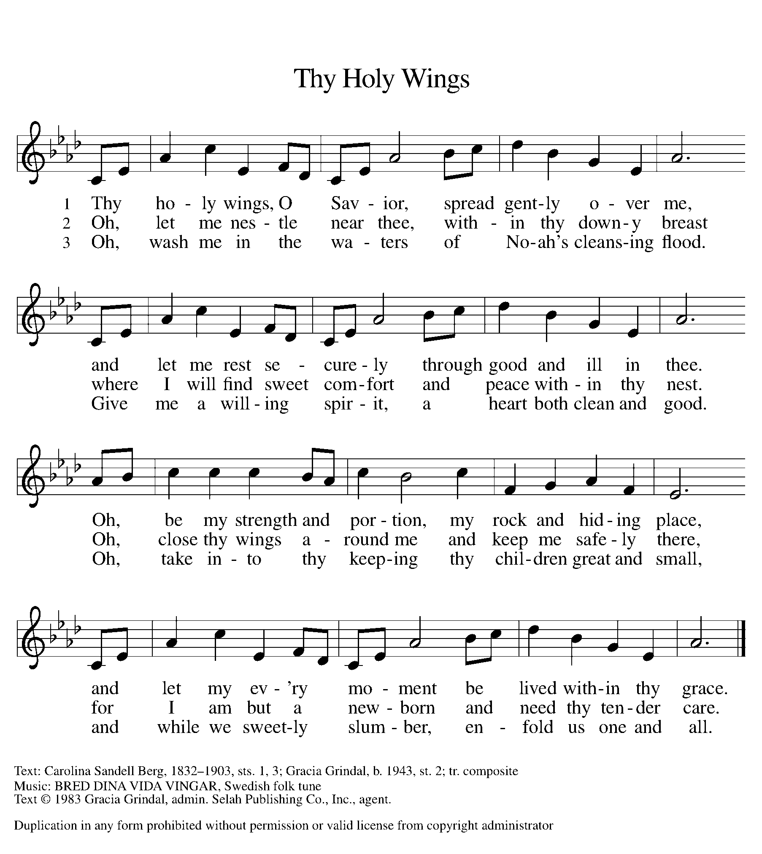

apostles’ CREED

I believe in God, the Father almighty,
creator of heaven and earth.
I believe in Jesus Christ, God’s only Son, our Lord,
who was conceived by the Holy Spirit,
born of the virgin Mary,
suffered under Pontius Pilate,
was crucified, died, and was buried;
he descended to the dead.
On the third day he rose again;
he ascended into heaven,
he is seated at the right hand of the Father,
and he will come to judge the living and the dead.
I believe in the Holy Spirit,
the holy catholic church,
the communion of saints,
the forgiveness of sins,
the resurrection of the body,
and the life everlasting. Amen.

(Please be seated.)

THE PRAYERS

A: Led by the Spirit, let us turn to God in prayer for the church, the world, and all those in need.
(A brief silence)
A: Holy God, you long to gather your church under your wings. Bless the churches of Jerusalem, and all persecuted churches, that your people may take heart and stand firm as they witness and minister in your name. God, in your mercy,

C: receive our prayer.
A: Holy God, you give shelter to living things as numerous as the stars. Strengthen the voice of prophets who call humanity to faithful care for the planet, that they would not be silenced but heeded as your messengers. God, in your mercy,

C: receive our prayer.
A: Holy God, you raised up leaders like Abram, Sarai, and Paul to show your people what it means to rely on your promises. Guide today’s leaders to work for justice and safeguard the world for future generations. God, in your mercy,

C: receive our prayer.

A: Holy God, you offer us citizenship in heaven. Unite communities of faith who are divided over earthly things, that following the way of your Son, they may set aside grudges and serve their neighbors with generosity and love. God, in your mercy,
C: receive our prayer.

A: Holy God, you guard those who defend what is right. Protect and care for those who serve in our armed forces during this time of political unrest, especially Beth & Ryan, Jonathan, Jacob, Noah, Irene, and Alex. God, in your mercy,

C: receive our prayer.

A: Holy God, you are the stronghold of our life. Care tenderly for those who are ill in body or mind, and for people living in fear or need, especially Ahren, Beth Ra., Carolyn, Dan, David, Doretta, family & friends of Mary, Jim & Cheri, John, Johnny, Jon, Jordan, Joseph Ra., Kay, Lawton, Lera & family, Linda, Lizzy, Marge, Randy, Rick & Kathy, Sheri, Sheri, Steve, and Wanda, and all whom we name now aloud and in our hearts. May all know they are not alone. God, in your mercy,

C: receive our prayer.

A: Holy God, you have called faithful followers to lead your church. Give direction to Presiding Bishop Elizabeth, our Synod Bishop Craig, and Pastor Carl and their respective staffs as they live out their callings to serve. As we are called to be one, even as Jesus and the Father are one, be with the leaders and the congregation Evangelical Lutheran Church in East Jordan and all the churches in our community. God, in your mercy,

C: receive our prayer.

A: Holy God, you are our light and our salvation. We give thanks for the saints who have gone before us. Help us to trust in you as they did and to live according to their example. God, in your mercy,

C: receive our prayer.

P: Receive the prayers of your people and draw all things together in your love, in the name of Jesus, who leads us from death to life.

C: Amen.

GREETING OF PEACE

(You are invited to share Christ’s peace with one another.)

P: The peace of Christ be with you always.

C: And also with you.
(Please be seated.)
THE MEAL
OFFERING ELENE
(Please rise if you are able.)
OFFERTORY ELW 325
(VERSE 1 ONLY)
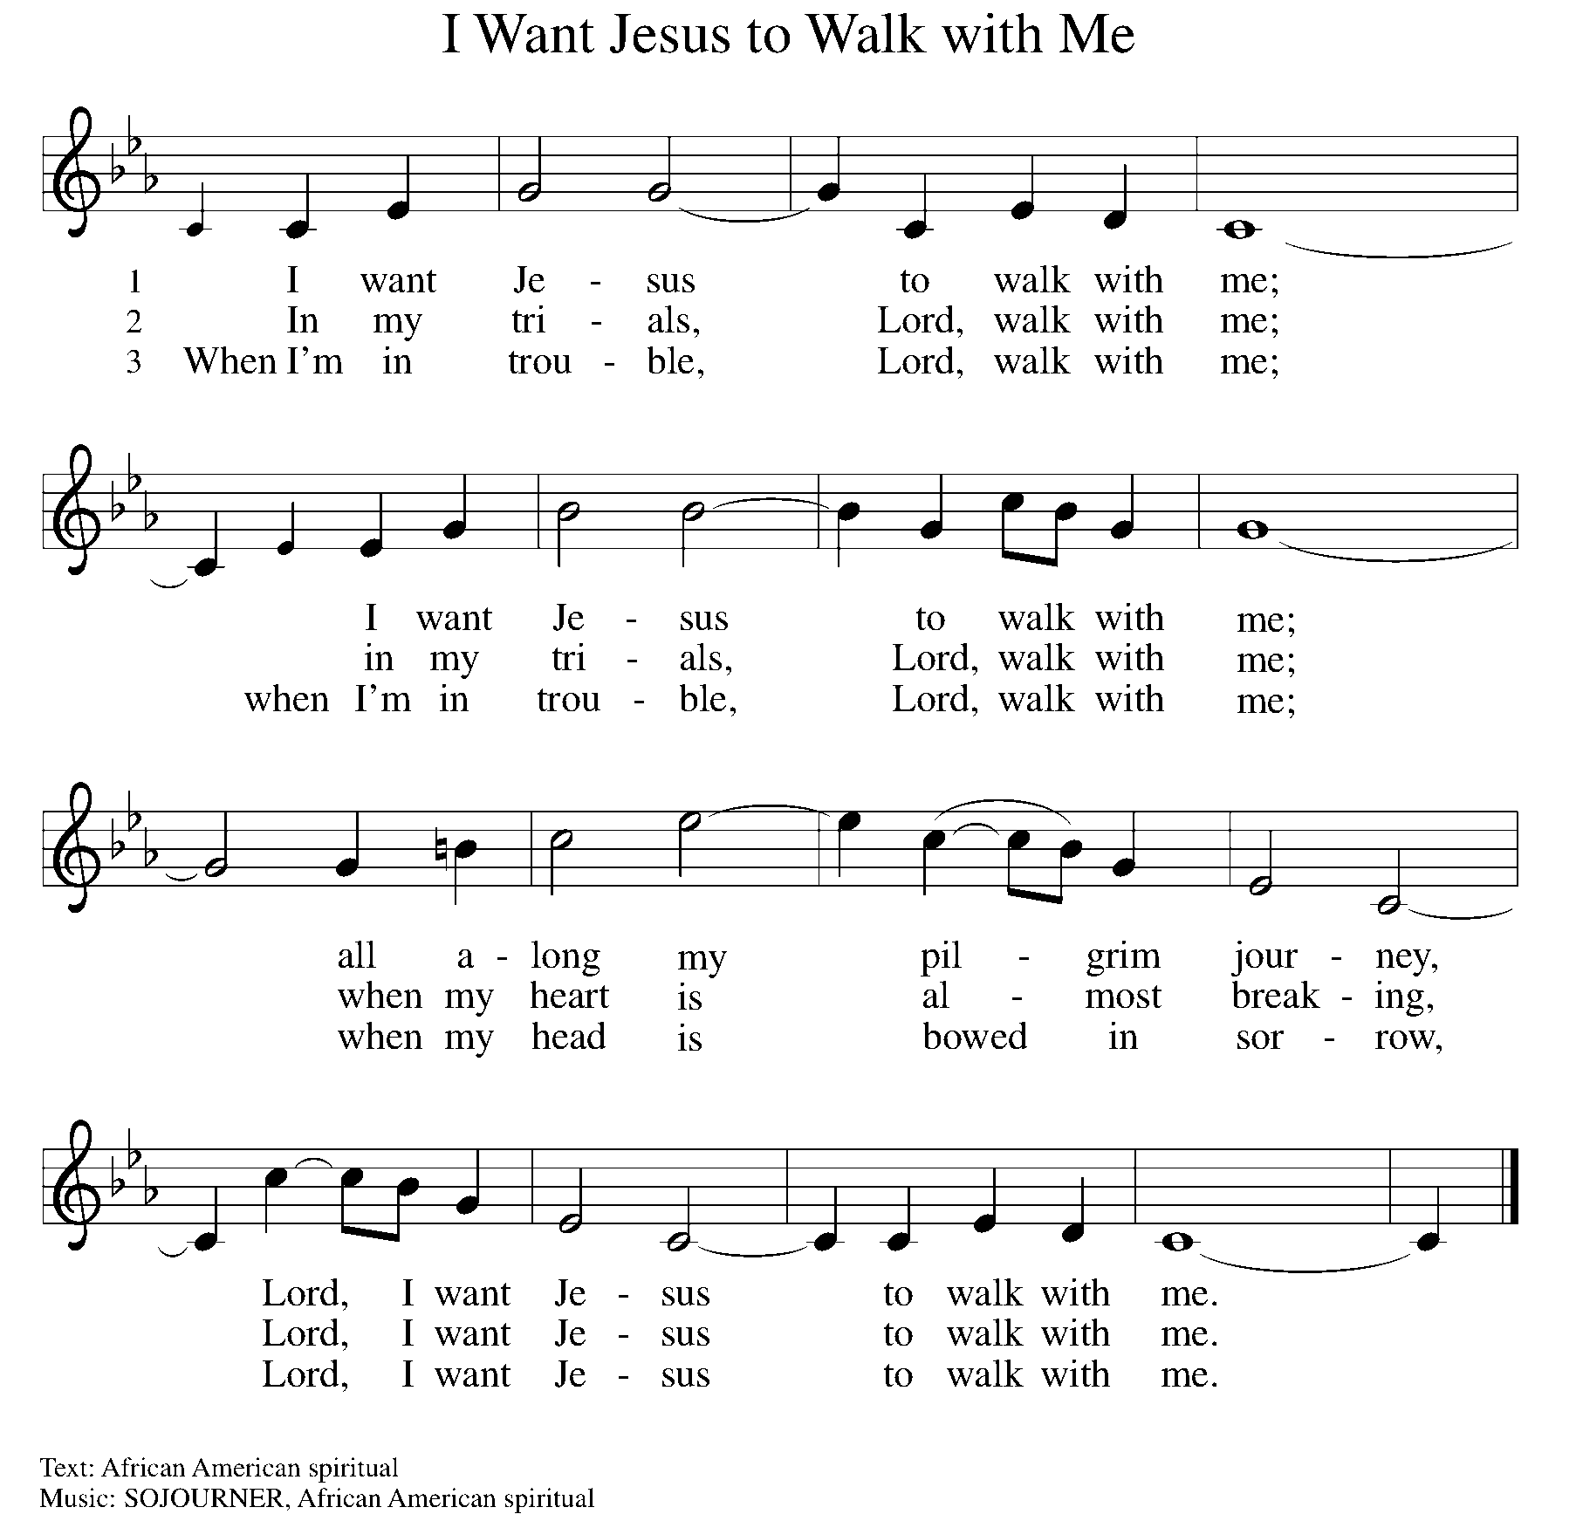

OFFERING PRAYER
A: Let us pray. Gracious Provider, you set your immense treasures among us, opening your heart to the world. As we prepare to feast on your bountiful love, deepen our commitment to sharing those treasures with others, through our Savior, Jesus Christ.

C: Amen.
THE GREAT THANKSGIVING

P: The Lord be with you.
C: And also with you.
P: Lift up your hearts.
C: We lift them to the Lord.
P: Let us give thanks to the Lord our God.
C: It is right to give our thanks and praise.

PROPER PREFACE

P: It is indeed right, our duty and our joy, that we should at all times and in all places give thanks and praise to you, almighty and merciful God, through our Savior Jesus Christ; who on this day overcame death and the grave, and by his glorious resurrection opened to us the way of everlasting life. And so, with all the choirs of angels, with the church on earth and the hosts of heaven, we praise your name and join their unending hymn:

HOLY, HOLY ELW Setting 2, Page 130
Holy, holy, holy Lord, God of power and might,
heaven and earth are full of your glory.
Hosanna in the highest.
Blessed is he who comes in the name of the Lord.
Hosanna in the highest. Hosanna in the highest.

EUCHARISTIC PRAYER

P: In the night in which he was betrayed, our Lord Jesus took bread, and gave thanks; broke it, and gave it to his disciples, saying:
Take and eat; this is my body, given for you. Do this for the
remembrance of me.
Again, after supper, he took the cup, gave thanks, and gave it for all to drink, saying:
This cup is the new covenant in my blood, shed for you and for all people for the forgiveness of sin. Do this for the remembrance of me.

LORD'S PRAYER

P: Lord, remember us in your kingdom, and teach us to pray:

C: Our Father, who art in heaven, hallowed be thy name, thy kingdom come, thy will be done on earth as it is in heaven. Give us this day our daily bread; and forgive us our trespasses as we forgive those who trespass against us; and lead us not into temptation, but deliver us from evil. For thine is the kingdom, and the power, and the glory, forever and ever. Amen.
(Please be seated.)
COMMUNION DISTRIBUTION

All who believe in the real presence of Christ in the bread and the wine (juice) are welcome to the table. Others may come forward for a blessing. If you prefer grape juice, please indicate this to the assisting minister.

When approaching the communion rail, come forward down the side aisle, kneel, if you are able, starting at the front of the communion rail (spot closest to the font) on your side and filling in toward the back. After receiving both the bread and the wine, you may return to your seat by the center aisle.

INVITATION TO COMMUNION

P: All who are hungry, come! The feast of grace is spread.

COMMUNION HYMN ELW 779
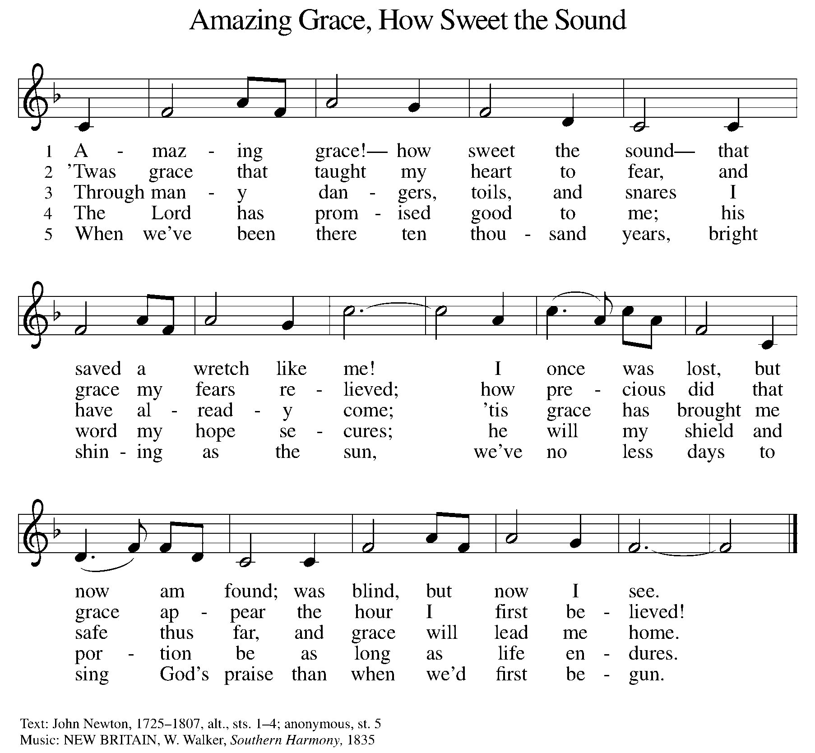

P: The body of Christ, given for you.

C: Amen.

A: The blood of Christ, shed for you.

C: Amen.
(Please rise as you are able.)

P: May the body and blood of our Lord Jesus Christ strengthen and keep you in his grace.

C: Amen.
PRAYER AFTER COMMUNION

P: Let us pray. Generous Host, you have shared your feast with us and made us new. Send us now to set tables of love and grace in our communities, that your liberating love might nourish the world into freedom, in the name of the crucified one, Jesus Christ our Lord.

C: Amen.

SENDING

BLESSING

P: God our tender parent, God the crucified one, God the reconciling Spirit, ☩ bless you now and forever.

C: Amen.

SENDING HYMN ELW 705
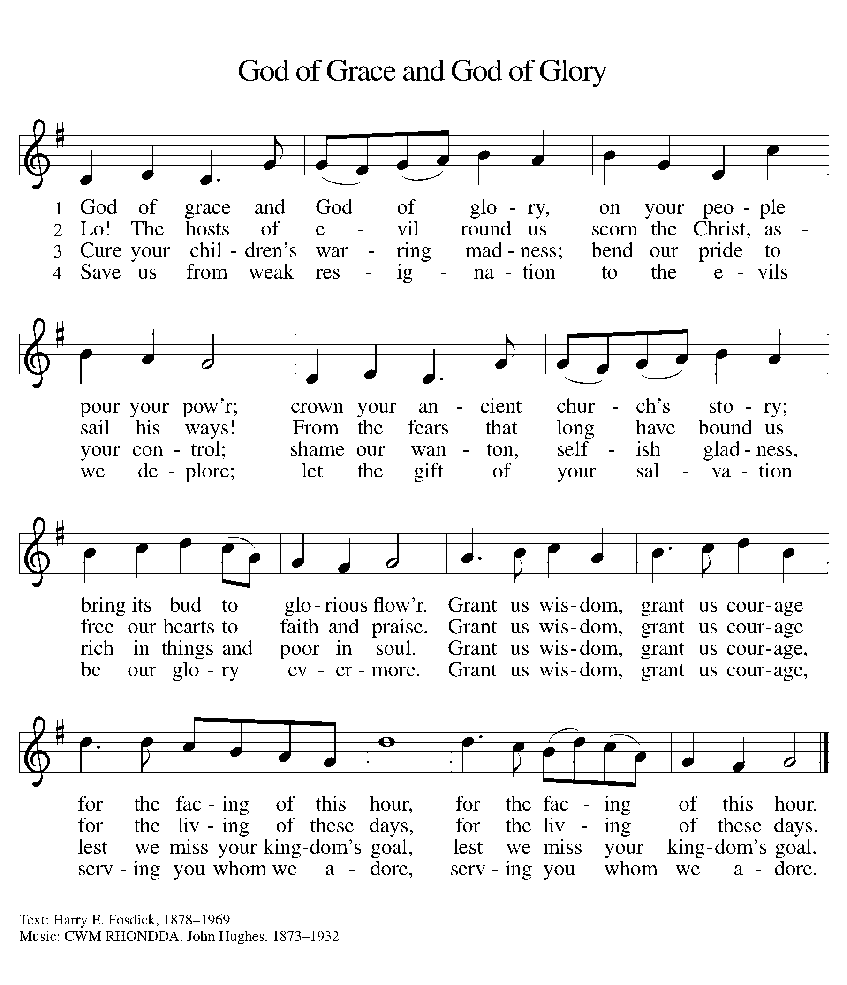

DISMISSAL

A: Go in peace. Care for others as God cares for you.

C: Thanks be to God.

Announcements

During Lent, we can heed God’s call to bear the fruits of mercy and justice by bringing an item for our food pantry and an item for the homeless ministry at Advent House each Sunday. Pick up a list of the most needed items to take with you.
- Monday, March 17 – St. Patrick’s Day! 
- Wednesday, March 19 & 26 – Mid-Week Devotional Time @ 6pm
- Sunday, March 30 – Concert by Elene & Ivane Ko. (following service)

Recurring Events

- Every Sunday – Adult Bible Study @ 9am
- Monday, April 7 – Worship Committee Meeting @ 6:30pm
- Wednesday, April 9 – Women’s Bible Study @ 11am
- Thursday, March 20 – Council Meeting @ 7pm

Food Pantry Dates

Wednesday, March 19, 5-6:30pm
Thursday, March 27, 1-3pm
Wednesday, April 2, 5-6:30pm
Thursday, April 10, 1-3pm
Wednesday, April 16, 5-6:30pm
Thursday, April 24, 1-3pm

Volunteers for March 16 Volunteers for March 23

Reader - Teresa Reader – Volunteer
Assisting Minister - Volunteer Assisting Minister – Volunteer

March Birthday Celebrations
3/17 – Beth Ann Ro.
3/30 – Kathy Kl.

Anniversary Celebrations

3/27 – James & Lynne Fo.

Acknowledgments
- OneLicense.net, License #A-703165.
- CCLI, License #2281869.
- From SundaysandSeasons.com. Copyright 2020 Augsburg Fortress. All rights reserved. Reprinted by permission under Augsburg Fortress Liturgies Annual License #23806.
- New Revised Standard Version Bible, copyright 1989, Division of Christian Education of the National Council of the Churches of Christ in the United States of America. Used by permission. All rights reserved.

