
7th Sunday After Epiphany
February 23, 2025


SAINT PAUL LUTHERAN CHURCH
3383 EAST LAKE LANSING ROAD
EAST LANSING, MI 48823

PHONE (517) 351-8541

Pastor Carl E. Ballard

E-MAIL: pastor@stpaul-el.org
officemanager@stpaul-el.org

Visitors WELCOME! If this is your first time worshipping with us, please sign our guest registry just outside the sanctuary doors. We hope you are blessed through worship today. If you have any questions, please feel free to call the church at 351-8541.
Children are always welcome in worship! The choir room (off the sanctuary) can also be used as a cry room for younger children and includes a sound system so parents may continue to participate in the service. Clipboards with children's bulletins, activities and crayons are available for use during the service.
Sunday School is available during the worship service September-May except the last Sunday of the month.
This Bulletin is for your use during the service and to take home for the upcoming week. If you choose not to take it home, please place it in the recycle receptacle in the back.
Newsletters and Calendars of Upcoming Events are available in the lobby/narthex. We welcome anyone who has an interest in our small groups or activities! You can also look us up on the web at www.stpaul-el.org.
Contacting Us: Our Office Manager is Emily Polhamus. She can be reached by phone at 517-351-8541 or at her email address, officemanager@stpaul-el.org. Our Director of Music is Elene Kobulashvili. You may leave a message at 517-351-8541. Pastor Carl can be reached at 517-515-3129, and his email address is cballard123@msn.com.
Holy Communion is available at most services. All who believe in the real presence of Christ in the bread and the wine are invited to celebrate Communion with us. Those who wish can come forward for a blessing.
You’re invited to share in fellowship after worship. We would love this opportunity to introduce you to the St. Paul community.

P-Presiding Minister A-Assisting Minister C-Congregation

PRELUDE ELENE

INTRODUCTION

Mercy. Mercy. Mercy. Joseph lives it in Egypt. Jesus preaches it in the gospel. The Spirit guides us into merciful lives with the power of forgiveness to reconcile what is fractured and divided. Such merciful living is the baptismal blessing of having put on Christ. It is the gift of the life-giving Spirit. It is a reflection of God’s glory revealed in Christ.

GATHERING

P: The Holy Spirit calls us together as the people of God.

(Please rise as you are able.)

CONFESSION & FORGIVENESS

All may make the sign of the cross, the sign that is marked at baptism, as the presiding minister begins.

P: Blessed be the holy Trinity, ☩ one God, our creator, our protector, our wellspring of life.

C: Amen.

P: Trusting that God receives our words and the meditations of our hearts, let us confess our sin.

(Silence for reflection.)

P: Merciful God,

C: you speak blessing and compassion into the world. Forgive us for the ways we act with judgment, cruelty, or indifference. We ignore the needs of our neighbors; we resist your call to oppose injustice; we give in to scarcity and fear; we assume the worst about one another. Cleanse us from our faults and release us from their grasp. Show us your loving kindness. Restore our hearts and repair your world, that we may live in Christ’s ways. Amen.

P: God proclaims these words of assurance: “Do not fear, for I have redeemed you. I have called you by name. You are mine.” In ☩ Christ, you are forgiven. In the Spirit, you are made free. Refreshed by the waters of mercy, live anew as beloved children of God.

C: Amen.

GATHERING SONG ELW 835
(Only Verses 1-4)
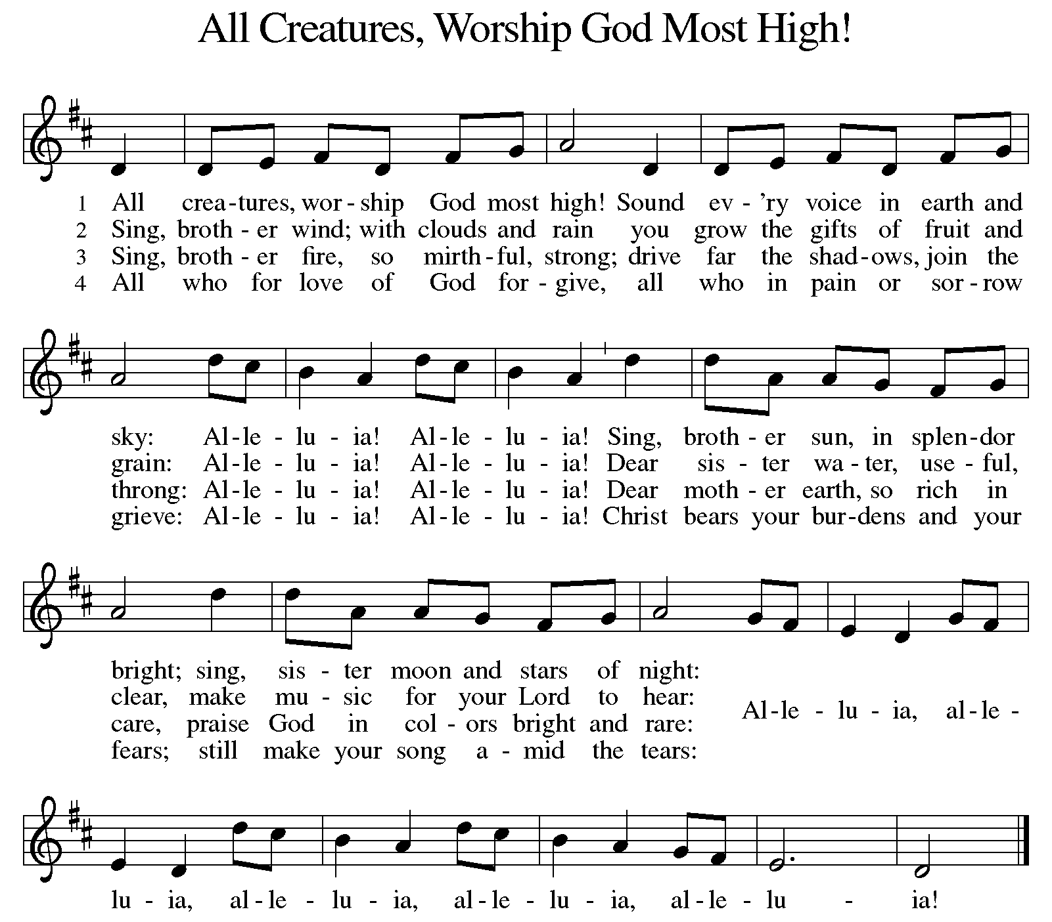

GREETING

P: The grace of our Lord Jesus Christ, the love of God, and the communion of the Holy Spirit be with you all.

C: And also with you.
KYRIE ELW Setting 7, Page 175

Lord, have mercy on us; O Lord, have mercy.
Lord, have mercy on us; O Lord, have mercy.
Christ, have mercy on us; O Christ, have mercy.
Christ, have mercy on us; O Christ, have mercy.
Lord, have mercy on us; O Lord, have mercy.
Lord, have mercy on us; O Lord, have mercy.
CANTICLE OF PRAISE ELW Setting 4, Page 148-149

Glory to God in the highest, and peace to God’s people on earth.

Lord God, heavenly King, almighty God and Father,
we worship you, we give you thanks, we praise you for your glory.
Lord Jesus Christ, only Son of the Father, Lord God, Lamb of God,
you take away the sin of the world: have mercy on us;
you are seated at the right hand of the Father: receive our prayer.
For you alone are the Holy One, you alone are the Lord,
you alone are the Most High, Jesus Christ, with the Holy Spirit,
in the glory of God the Father. Amen.

PRAYER OF THE DAY

P: Let us pray. O Lord Jesus, make us instruments of your peace, that where there is hatred, we may sow love, where there is injury, pardon, and where there is despair, hope. Grant, O divine master, that we may seek to console, to understand, and to love in your name, for you live and reign with the Father and the Holy Spirit, one God, now and forever.

C: Amen.

(Please be seated.)

CHILDREN’S MESSAGE/NOISY OFFERING

(Children may return to their seats.)

TRANSITION SONG ELW 801
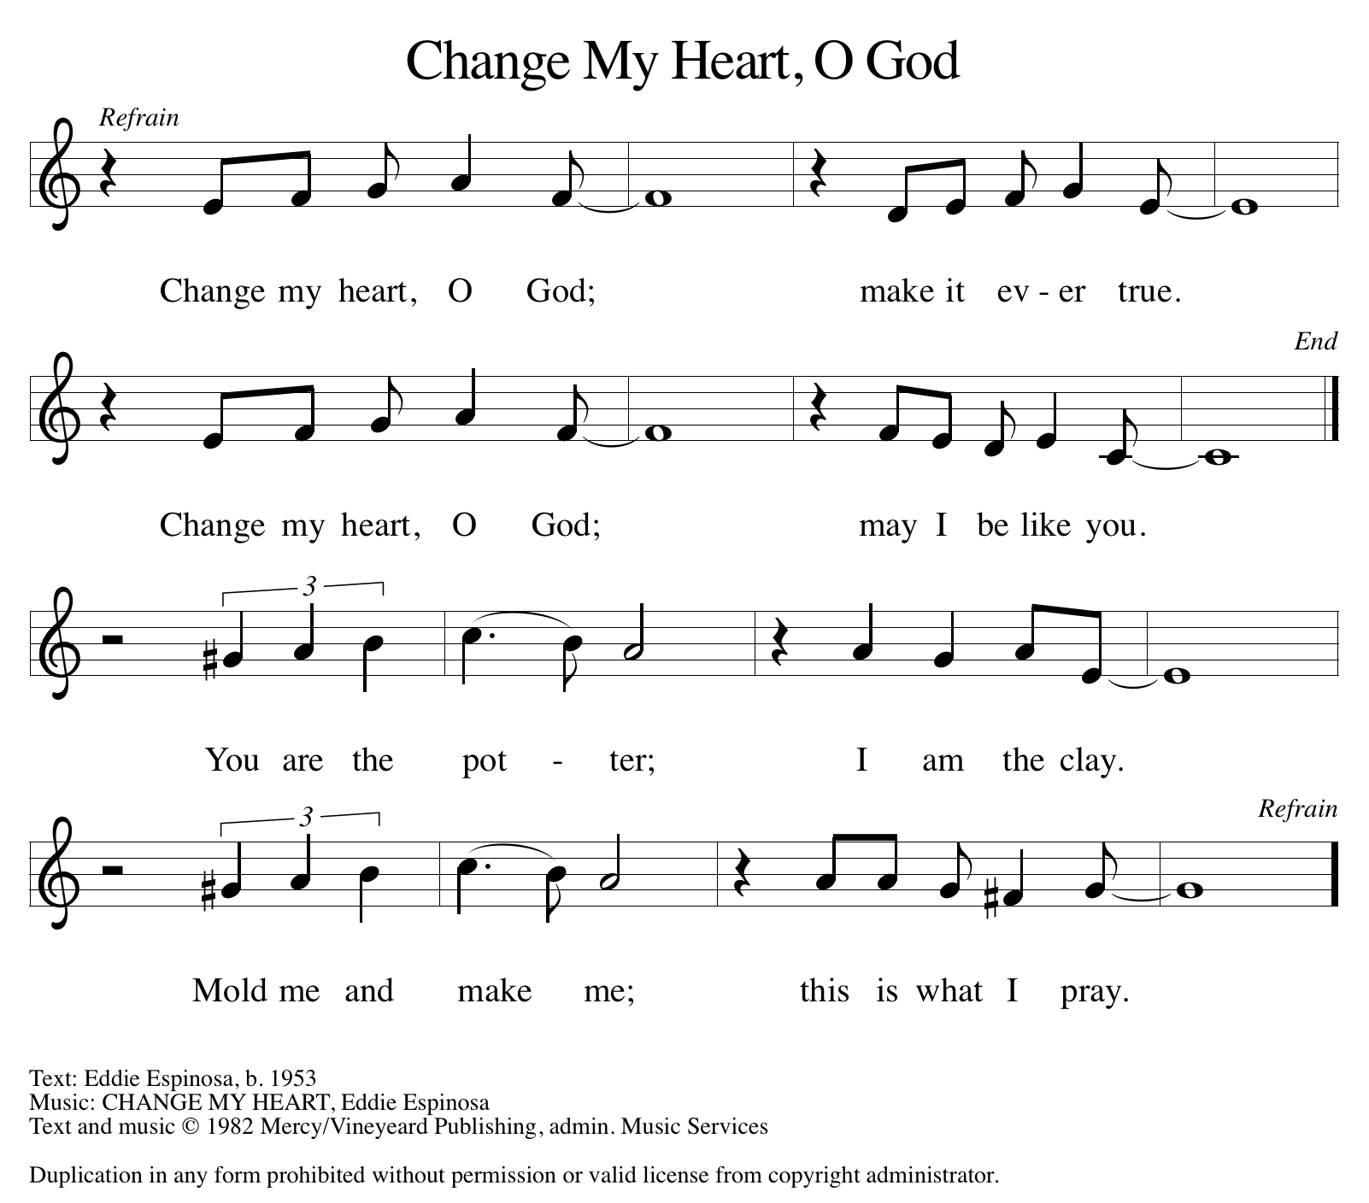

THE WORD

P: God speaks to us in scripture, preaching, and song.

FIRST READING GENESIS 45:3-11, 15

Many years after being sold into slavery by his jealous brothers, Joseph reveals himself to them. Now the second-in-command in Egypt, Joseph reassures his brothers that God has used their evil intentions for good to preserve life during a devastating famine, and Joseph forgives them.

³ Joseph said to his brothers, “I am Joseph. Is my father still alive?” But his brothers could not answer him, so dismayed were they at his presence. ⁴ Then Joseph said to his brothers, “Come closer to me.” And they came closer. He said, “I am your brother, Joseph, whom you sold into Egypt. ⁵ And now do not be distressed or angry with yourselves because you sold me here, for God sent me before you to preserve life. ⁶ For the famine has been in the land these two years, and there are five more years in which there will be neither plowing nor harvest. ⁷ God sent me before you to preserve for you a remnant on earth and to keep alive for you many survivors. ⁸ So it was not you who sent me here but God; he has made me a father to Pharaoh and lord of all his house and ruler over all the land of Egypt. ⁹ Hurry and go up to my father and say to him, ‘Thus says your son Joseph, God has made me lord of all Egypt; come down to me; do not delay. ¹⁰ You shall settle in the land of Goshen, and you shall be near me, you and your children and your children’s children, as well as your flocks, your herds, and all that you have. ¹¹ I will provide for you there, since there are five more years of famine to come, so that you and your household and all that you have will not come to poverty.’ ”

¹⁵ And he kissed all his brothers and wept upon them, and after that his brothers talked with him.

Reader: Word of God, word of life. C: Thanks be to God.

PSALM PSALM 37:1-11, 39-40

The lowly shall possess the land; they will delight in abundance of peace. (Ps. 37:11)

¹ Do not be provoked by evildoers; do not be jealous of those who do wrong.
² For they shall soon wither like the grass, and like the green grass fade away.
³ Put your trust in the Lord and do good; dwell in the land and find safe pasture.
⁴ Take delight in the Lord, who shall give you your heart’s desire.
⁵ Commit your way to the Lord; put your trust in the Lord, and see what God will do.
⁶ The Lord will make your vindication as clear as the light and the justice of your case like the noonday sun.
⁷ Be still before the Lord and wait patiently. Do not be provoked by the one who prospers, the one who succeeds in evil schemes.
⁸ Refrain from anger, leave rage alone; do not be provoked; it leads only to evil.
⁹ For evildoers shall be cut off, but those who hope in the Lord shall possess the land.
¹⁰ In a little while the wicked shall be no more; even if you search out their place, they will not be there.
¹¹ But the lowly shall possess the land; they will delight in abundance of peace.

³⁹ But the deliverance of the righteous comes from you, O Lord; you are their stronghold in time of trouble.
⁴⁰ You, O Lord, will help them and rescue them; you will rescue them from the wicked and deliver them, because in you they seek refuge.

SECOND READING 1 CORINTHIANS 15:35-38, 42-50

In the Apostles’ Creed, we speak of the “resurrection of the body, and the life everlasting.” Using the metaphor of a planted seed and the story of Adam, Paul preaches passionately about the mystery of following Christ’s perfect life into eternity.

³⁵ But someone will ask, “How are the dead raised? With what kind of body do they come?” ³⁶ Fool! What you sow does not come to life unless it dies. ³⁷ And as for what you sow, you do not sow the body that is to be but a bare seed, perhaps of wheat or of some other grain. ³⁸ But God gives it a body as he has chosen and to each kind of seed its own body.

⁴² So it is with the resurrection of the dead. What is sown is perishable; what is raised is imperishable. ⁴³ It is sown in dishonor; it is raised in glory. It is sown in weakness; it is raised in power. ⁴⁴ It is sown a physical body; it is raised a spiritual body. If there is a physical body, there is also a spiritual body. ⁴⁵ Thus it is written, “The first man, Adam, became a living being”; the last Adam became a life-giving spirit. ⁴⁶ But it is not the spiritual that is first but the physical and then the spiritual. ⁴⁷ The first man was from the earth, made of dust; the second man is from heaven. ⁴⁸ As one of dust, so are those who are of the dust, and as one of heaven, so are those who are of heaven. ⁴⁹ Just as we have borne the image of the one of dust, we will also bear the image of the one of heaven. ⁵⁰ What I am saying, brothers and sisters, is this: flesh and blood cannot inherit the kingdom of God, nor does the perishable inherit the imperishable.

Reader: Word of God, word of life. C: Thanks be to God.

(Please rise as you are able.)
GOSPEL ACCLAMATION ELW Setting 7, Page 179

Alleluia, alleluia, alleluia!
Alleluia, alleluia, alleluia!
Alleluia, alleluia, alleluia! Alleluia!

GOSPEL LUKE 6:27-38

P: The Holy Gospel according to Luke, the 6th chapter.
C: Glory to you, O Lord.

Jesus continues to address a crowd of his disciples. He invites his followers to shower radical love, blessing, forgiveness, generosity, and trust even on enemies and outsiders. Living in harmony with God’s intent brings the reward of overflowing blessing.

[Jesus said:] ²⁷ “But I say to you who are listening: Love your enemies; do good to those who hate you; ²⁸ bless those who curse you; pray for those who mistreat you. ²⁹ If anyone strikes you on the cheek, offer the other also, and from anyone who takes away your coat do not withhold even your shirt. ³⁰ Give to everyone who asks of you, and if anyone takes away what is yours, do not ask for it back again. ³¹ Do to others as you would have them do to you.

³² “If you love those who love you, what credit is that to you? For even sinners love those who love them. ³³ If you do good to those who do good to you, what credit is that to you? For even sinners do the same. ³⁴ If you lend to those from whom you expect to receive payment, what credit is that to you? Even sinners lend to sinners, to receive as much again. ³⁵ Instead, love your enemies, do good, and lend, expecting nothing in return. Your reward will be great, and you will be children of the Most High, for he himself is kind to the ungrateful and the wicked. ³⁶ Be merciful, just as your Father is merciful.

³⁷ “Do not judge, and you will not be judged; do not condemn, and you will not be condemned. Forgive, and you will be forgiven; ³⁸ give, and it will be given to you. A good measure, pressed down, shaken together, running over, will be put into your lap, for the measure you give will be the measure you get back.”

P: The Gospel of the Lord. C: Praise to you, O Christ.

(Please be seated.)

SERMON PASTOR MIRIAM BUNGE

(Please rise as you are able.)

HYMN OF THE DAY ELW 615
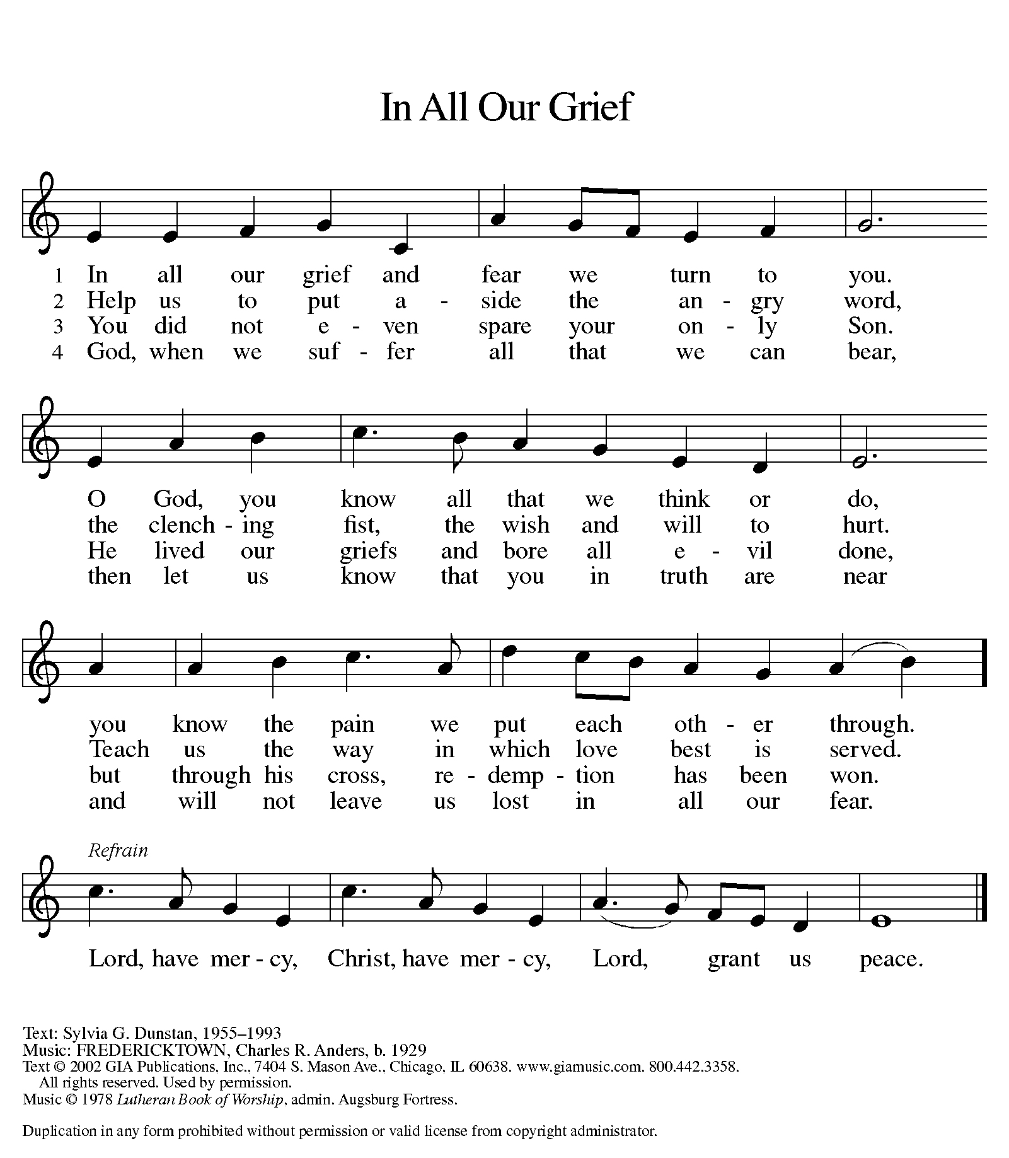

APOSTLES’ CREED

I believe in God, the Father almighty,
creator of heaven and earth.

I believe in Jesus Christ, God’s only Son, our Lord,
who was conceived by the Holy Spirit,
born of the Virgin Mary,
suffered under Pontius Pilate,
was crucified, died, and was buried;
he descended to the dead.
On the third day he rose again;
he ascended into heaven,
he is seated at the right hand of the Father,
and he will come to judge the living and the dead.

I believe in the Holy Spirit,
the holy catholic church,
the communion of saints,
the forgiveness of sins,
the resurrection of the body,
and the life everlasting. Amen.

(Please be seated.)
THE PRAYERS

A: With the Spirit of Christ shining upon us, let us boldly pray for the church, the world, and all of creation.

(A brief silence.)

A: Surprising God, you call us to love our enemies and to show kindness in the face of cruelty. Let our actions be a shining witness of your overwhelming grace for all. God of grace,

C: hear our prayer.

A: As animals hibernate and fields lay dormant, let them be a reminder that life and faith are not static but always changing and growing. May we, with all creation, trust that the ending of one thing promises life in a new way. God of grace,

C: hear our prayer.

A: We pray for leaders and policymakers who work to reduce violence in our nations, cities, and towns. Give your wisdom and discernment amid heated arguments and differing viewpoints. God of grace,

C: hear our prayer.

A: We pray for the victims of abuse and violence. Provide safe shelter and new beginnings to those experiencing domestic violence and dangerous situations. Enfold with love all who seek your healing care. God of grace,

C: hear our prayer.

A: Empower our faith communities to be signs of your gracious love. Bless the local ministries of parish nursing and caregiving, that they will be a voice for those in need in our communities. God of grace,

C: hear our prayer.

A: Open the hearts of all leaders, especially those who serve in the armed forces, that they respond to their commission with wisdom and patience. Ensure that all who serve are kept safe in body, mind, and spirit, especially Beth & Ryan, Jonathan, Jacob, Noah, Irene, and Alex. We pray for an end to all war and armed conflict. God of grace,

C: hear our prayer.

A: Fill with your compassionate presence all who are suffering from addiction, mental illness, injury, or illness of any kind especially Ahren, Barb, Beth Ra., Carolyn, Dan, David, Doretta, Friends & family of Mary, Jim & Cheri, John, Johnny, Jon, Jordan, Joseph Ra., Kay, Lawton, Lera & family, Linda, Lizzy, Marge, Rick & Kathy, Randy, Sheri, Sheri, Steve, and Wanda, and all whom we name now aloud and in our hearts. Draw helpers to their side so that they find relief from their burdens. God of grace,

C: hear our prayer.
A: Guide the leaders of your church—Presiding Bishop Elizabeth, our Synod Bishop Craig, and Pastor Carl. We ask that you be with their respective staffs as they live out their callings to serve. As we are called to be one, even as Jesus and the Father are one, be with the leaders and the congregation of Zion Lutheran Church in Comstock Park and all the churches in our community. God of grace,

C: hear our prayer.

A: We give thanks for the enduring witness of those who have died before us. May their lives in you provide a witness of your everlasting grace. God of grace,

C: hear our prayer.

P: We entrust our prayers to you, O God, in the sure and certain hope that your promise is revealed among the people.

C: Amen.

GREETING OF PEACE

(You are invited to share Christ’s peace with one another.)

P: The peace of Christ be with you always.

C: And also with you.

(Please be seated.)

THE MEAL

OFFERING ELENE
(Please rise as you are able.)

OFFERTORY (VERSE 1 ONLY) ELW 677
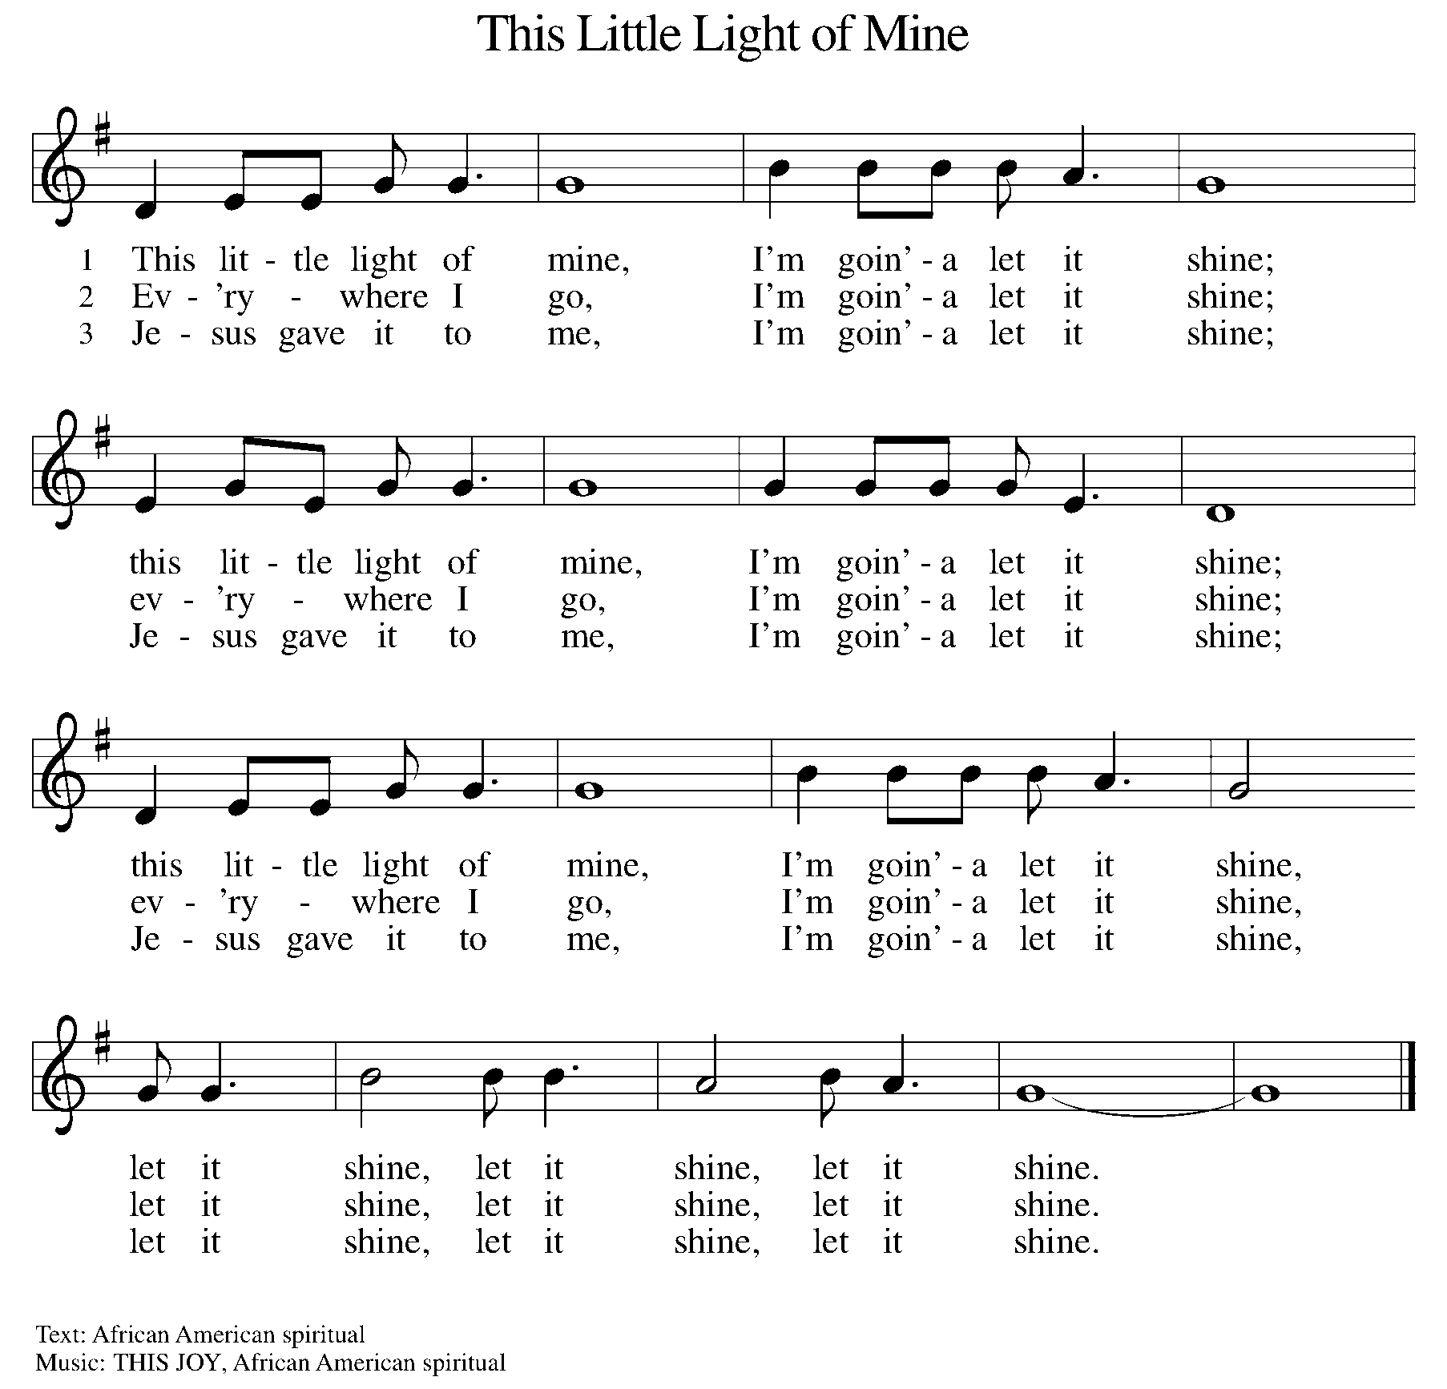

OFFERING PRAYER

A: Let us pray. God of grace, your love reaches to the heavens, and your abundance to the depths of the seas. Bless what we offer to your service: our gifts, our abilities, and our hearts. Let us overflow with gratitude and generosity, now and always.

C: Amen.

THE GREAT THANKSGIVING

P: The Lord be with you.
C: And also with you.
P: Lift up your hearts.
C: We lift them to the Lord.
P: Let us give thanks to the Lord our God.
C: It is right to give our thanks and praise.

PROPER PREFACE

P: It is indeed right, our duty and our joy, that we should at all times and in all places give thanks and praise to you, almighty and merciful God, through our Savior Jesus Christ; who on this day overcame death and the grave, and by his glorious resurrection opened to us the way of everlasting life. And so, with all the choirs of angels, with the church on earth and the hosts of heaven, we praise your name and join their unending hymn:

HOLY, HOLY ELW Setting 7, Page 181

Holy, holy, holy Lord God,
God of might and power; holy is the Lord.
Holy, holy, holy, holy Lord God,
God of might and power; holy is the Lord.
Hosanna in the highest, hosanna here on earth.
Blest is he who comes in the name of the Lord.
Hosanna in the highest, hosanna here on earth.
Blest is he who comes in the name of the Lord.

EUCHARISTIC PRAYER

P: In the night in which he was betrayed, our Lord Jesus took bread, and gave thanks; broke it, and gave it to his disciples, saying:
Take and eat; this is my body, given for you. Do this for the remembrance of me.
Again, after supper, he took the cup, gave thanks, and gave it for all to drink, saying:
This cup is the new covenant in my blood, shed for you and for all people for the forgiveness of sin. Do this for the remembrance of me.

LORD'S PRAYER

P: Lord, remember us in your kingdom, and teach us to pray:

C: Our Father in heaven, hallowed be your name, your kingdom come, your will be done, on earth as in heaven. Give us today our daily bread. Forgive us our sins as we forgive those who sin against us. Save us from the time of trial and deliver us from evil. For the kingdom, the power, and the glory are yours, now and forever. Amen.

(Please be seated.)

COMMUNION DISTRIBUTION

All who believe in the real presence of Christ in the bread and the wine (juice) are welcome to the table. Others may come forward for a blessing. If you prefer grape juice, please indicate this to the assisting minister.

When approaching the communion rail, come forward down the side aisle, kneel, if you are able, starting at the front of the communion rail (spot closest to the font) on your side and filling in toward the back. After receiving both the bread and the wine, you may return to your seat by the center aisle.

INVITATION TO COMMUNION

P: The joy of the Lord is our strength. Come, eat this meal of gladness.

COMMUNION HYMN ELW 496
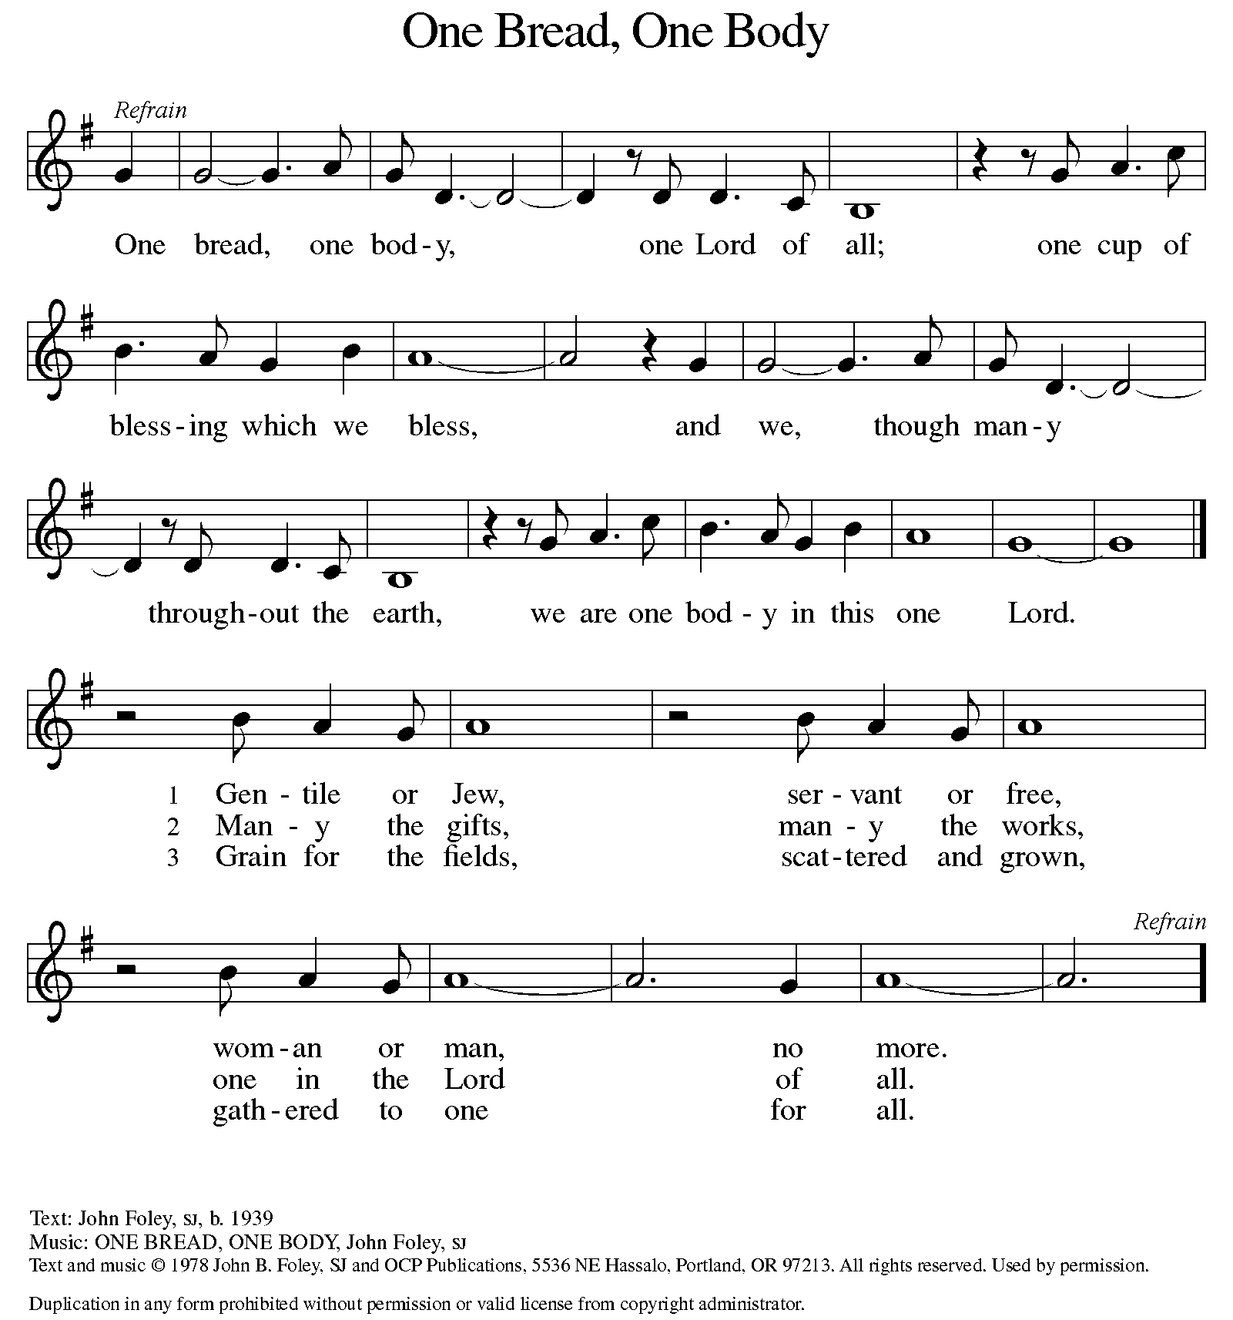

P: The body of Christ, given for you.

C: Amen.

A: The blood of Christ, shed for you.

C: Amen.
(Please rise as you are able.)

P: May the body and blood of our Lord Jesus Christ strengthen and keep you in his grace.

C: Amen.
PRAYER AFTER COMMUNION

P: Let us pray. Nourishing God, at this table you have refreshed us with holy gifts of food and drink. Strengthen us for service, and send us out to embody your good news of liberation and healing for the sake of the world. In the name of Christ we pray,

C: Amen.

SENDING

BLESSING

P: The Spirit of the triune God ☩ bless you with joy, anoint you with compassion, and send you in love.

C: Amen.

SENDING HYMN ELW 605
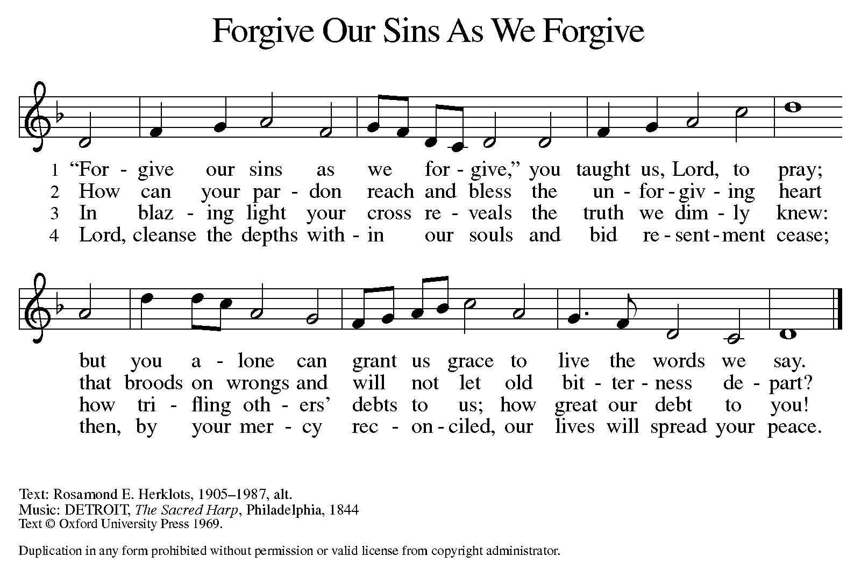

DISMISSAL

A: Go in peace. Live in hope.

C: Thanks be to God.

Announcements

- Wednesday, March 5 – Ash Wednesday Service @ 6pm
- Sunday, March 9 – Daylight Savings Time: Spring Forward!
- Monday, March 17 - 

Recurring Events

- Every Sunday – Adult Bible Study @ 9am
- Monday, March 3 – Worship Committee Meeting @ 6:30pm
- Wednesday, March 12 – Women’s Bible Study @ 11am
- Thursday, March 20 – Council Meeting @ 7pm

Food Pantry Dates

- Thursday, February 27, 1-3pm
- Thursday, March 6, 5-6:30pm
- Thursday, March 13, 1-3pm
- Wednesday, March 19, 5-6:30pm
- Thursday, March 27, 1-3pm

Volunteers for February 23 Volunteers for March 2

Reader Sunday – Stacy Reader Sunday – Volunteer
Assisting Minister - Kathy Assisting Minister – Kathy

February & March Birthday Celebrations

2/3 – Liza Ta.
2/8 – Sara Ha.
2/18 – Lynne Fo.
2/19 – Elene Ko.
2/22 – Barb Pa.

3/17 – Beth Ro.
3/30 – Kathy Kl.

February & March Anniversary Celebrations

2/9 – Elizabeth (Beth) & Ryan Mc.
2/22 – Stan & Judy St.

3/27 – James & Lynne Fo.

Acknowledgments
- OneLicense.net, License #A-703165. CCLI, License #2281869.
- From SundaysandSeasons.com. Copyright 2020 Augsburg Fortress. All rights reserved. Reprinted by permission under Augsburg Fortress Liturgies Annual License #23806.
- New Revised Standard Version Bible, copyright 1989, Division of Christian Education of the National Council of the Churches of Christ in the United States of America. Used by permission. All rights reserved.

