

6th Sunday After Epiphany
February 16, 2025

SAINT PAUL LUTHERAN CHURCH
3383 EAST LAKE LANSING ROAD
EAST LANSING, MI 48823

PHONE (517) 351-8541

Pastor Carl E. Ballard
E-MAIL: pastor@stpaul-el.org
officemanager@stpaul-el.org

Visitors WELCOME! If this is your first time worshipping with us, please sign our guest registry just outside the sanctuary doors. We hope you are blessed through worship today. If you have any questions, please feel free to call the church at 351-8541.
Children are always welcome in worship! The choir room (off the sanctuary) can also be used as a cry room for younger children and includes a sound system so parents may continue to participate in the service. Clipboards with children’s bulletins, activities and crayons are available for use during the service. Please see an usher if you are unable to locate them.
Sunday School is available during the worship service September-May except the last Sunday of the month.
This Bulletin is for your use during the service and to take home for the upcoming week. If you choose not to take it home, please place it in the recycle receptacle in the back.
Newsletters and Calendars of Upcoming Events are available in the lobby/narthex. We welcome anyone who has an interest in our small groups or activities! You can also look us up on the web at www.stpaul-el.org.
Contacting Us: Our office manager is Emily Polhamus. She can be reached by phone at 517-351-8541 or at her email address, officemanager@stpaul-el.org. Our Director of Music is Elene Kobulashvili. You may leave a message at 517-351-8541. Pastor Carl can be reached at 517-515-3129, and his email address is cballard123@msn.com.
Holy Communion is available at most services. All who believe in the real presence of Christ in the bread and the wine are invited to celebrate Communion with us. Those who wish can come forward for a blessing.
You are invited to share in fellowship after worship. We would love this opportunity to introduce you to the St. Paul community.

P-Presiding Minister A-Assisting Minister C-Congregation

PRELUDE ELENE

INTRODUCTION

Blessings and curses abound on the sixth Sunday after Epiphany. We would do well to listen closely to whom the “blessed ares” and the “woe tos” are directed and to find our place in the crowd among those who desire to touch Jesus. The risen Christ stands among us in the mystery of the holy supper with an invitation to live in him, and offers power to heal us all.

GATHERING

P: The Holy Spirit calls us together as the people of God.

(Please rise as you are able.)

CONFESSION & FORGIVENESS

All may make the sign of the cross, the sign that is marked at baptism, as the presiding minister begins.

P: Blessed be the holy Trinity, ☩ one God, our creator, our protector, our wellspring of life.

C: Amen.

P: Trusting that God receives our words and the meditations of our hearts, let us confess our sin.

(Silence is kept for reflection.)
P: Merciful God,
C: you speak blessing and compassion into the world. Forgive us for the ways we act with judgment, cruelty, or indifference. We ignore the needs of our neighbors; we resist your call to oppose injustice; we give in to scarcity and fear; we assume the worst about one another. Cleanse us from our faults and release us from their grasp. Show us your loving kindness. Restore our hearts and repair your world, that we may live in Christ’s ways. Amen.

P: God proclaims these words of assurance: “Do not fear, for I have redeemed you. I have called you by name. You are mine.” In ☩ Christ, you are forgiven. In the Spirit, you are made free. Refreshed by the waters of mercy, live anew as beloved children of God.

C: Amen.

GATHERING SONG ELW 717
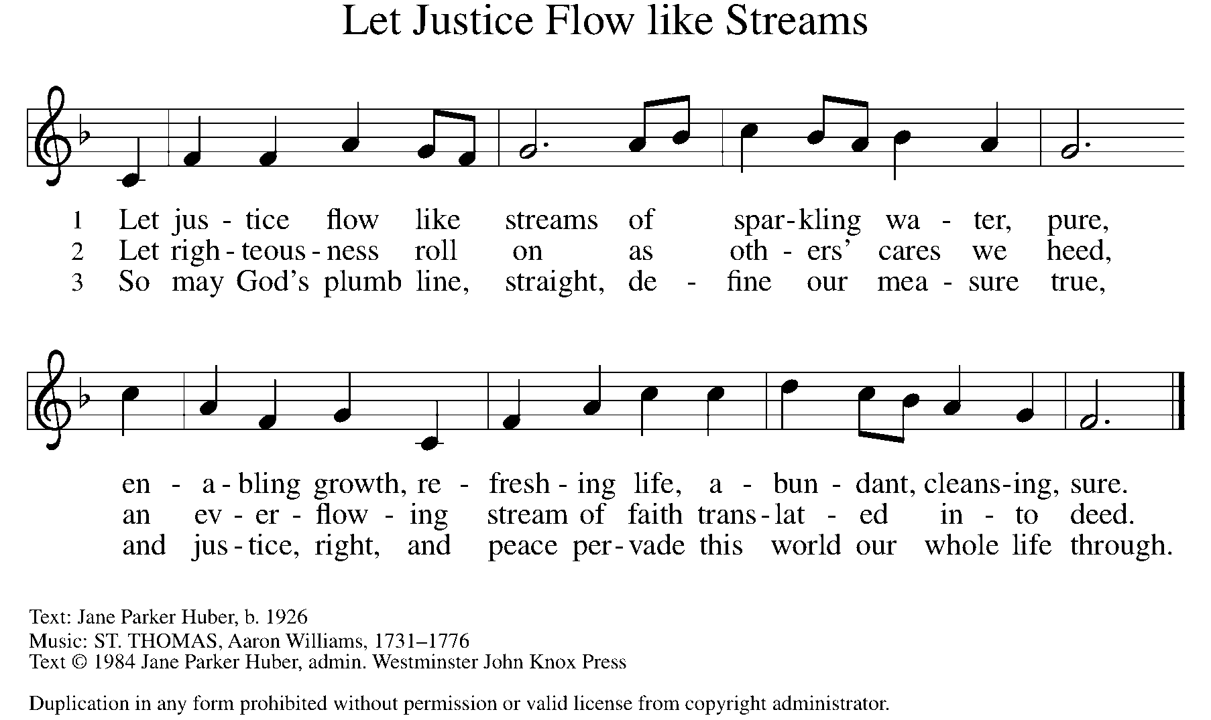

GREETING

P: The grace of our Lord Jesus Christ, the love of God, and the communion of the Holy Spirit be with you all.

C: And also with you.

KYRIE ELW Setting 2, Page 120
In peace, let us pray to the Lord.
Lord, have mercy.
For the peace from above and for our salvation,
let us pray to the Lord.
Lord, have mercy.
For the peace of the whole world, for the well-being of the church of God, and for the unity of all, let us pray to the Lord.
Lord, have mercy.
For this holy house and for all who offer here their worship and praise, let us pray to the Lord.
Lord, have mercy.
Help, save, comfort, and defend us, gracious Lord.
Amen.

CANTICLE OF PRAISE ELW Setting 4, Page 148-149
Glory to God in the highest, and peace to God’s people on earth.
Lord God, heavenly King, almighty God and Father,
we worship you, we give you thanks, we praise you for your glory. Lord Jesus Christ, only Son of the Father, Lord God, Lamb of God, you take away the sin of the world: have mercy on us;
you are seated at the right hand of the Father: receive our prayer. For you alone are the Holy One, you alone are the Lord,
you alone are the Most High, Jesus Christ, with the Holy Spirit,
in the glory of God the Father. Amen.

PRAYER OF THE DAY

P: Let us pray. Living God, in Christ you make all things new. Transform the poverty of our nature by the riches of your grace, and in the renewal of our lives make known your glory, through Jesus Christ, our Savior and Lord.

C: Amen.

(Please be seated.)

CHILDREN’S MESSAGE

(Children are invited to Sunday School.)

TRANSITION SONG ELW 801
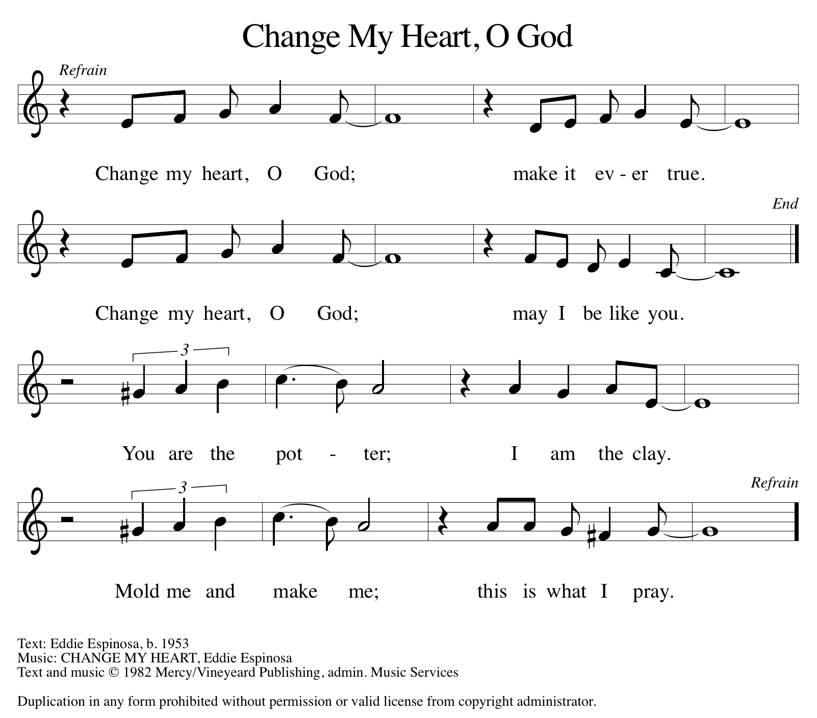
THE WORD

God speaks to us in scripture, preaching, and song.

First Reading jeremiah 17:5-10
These verses compose a poem that is part of a larger collection of wisdom sayings that contrast two ways of life. Life with God brings blessing; the power and vitality of God is active in our life. Life without God brings a curse, the power of death.

⁵ Thus says the Lord: Cursed are those who trust in mere mortals and make mere flesh their strength, whose hearts turn away from the Lord. ⁶ They shall be like a shrub in the desert and shall not see when relief comes. They shall live in the parched places of the wilderness, in an uninhabited salt land. ⁷ Blessed are those who trust in the Lord, whose trust is the Lord. ⁸ They shall be like a tree planted by water, sending out its roots by the stream. It shall not fear when heat comes, and its leaves shall stay green; in the year of drought it is not anxious, and it does not cease to bear fruit. ⁹ The heart is devious above all else; it is perverse— who can understand it? ¹⁰ I the Lord test the mind and search the heart, to give to all according to their ways, according to the fruit of their doings.

Word of God, word of life. C: Thanks be to God.

PSALM PSALM 1
They are like trees planted by streams of water. (Ps. 1:3)
¹ Happy are they who have not walked in the counsel of the wicked, nor lingered in the way of sinners, nor sat in the seats of the scornful!
² Their delight is in the law of the Lord, and they meditate on God’s teaching day and night.
³ They are like trees planted by streams of water, bearing fruit in due season, with leaves that do not wither; everything they do shall prosper.
⁴ It is not so with the wicked; they are like chaff which the wind blows away.
⁵ Therefore the wicked shall not stand upright when judgment comes, nor the sinner in the council of the righteous.
⁶ For the Lord knows the way of the righteous, but the way of the wicked shall be destroyed.

SECOND READING 1 CORINTHIANS 15:12-20

For Paul, the resurrection of Christ is the basis for Christian hope. Because Christ has been raised, those who are in Christ know that they too will be raised to a new life beyond death.

¹² Now if Christ is proclaimed as raised from the dead, how can some of you say there is no resurrection of the dead? ¹³ If there is no resurrection of the dead, then Christ has not been raised, ¹⁴ and if Christ has not been raised, then our proclamation is in vain and your faith is in vain. ¹⁵ We are even found to be misrepresenting God, because we testified of God that he raised Christ—whom he did not raise if it is true that the dead are not raised. ¹⁶ For if the dead are not raised, then Christ has not been raised. ¹⁷ If Christ has not been raised, your faith is futile, and you are still in your sins. ¹⁸ Then those also who have died in Christ have perished. ¹⁹ If for this life only we have hoped in Christ, we are of all people most to be pitied. ²⁰ But in fact Christ has been raised from the dead, the first fruits of those who have died.

Word of God, word of life. C: Thanks be to God.

(Please rise as you are able.)
GOSPEL ACCLAMATION ELW Setting 2, Page 124
Alleluia, alleluia, alleluia, alleluia.
Lord, to whom shall we go?
You have the words of eternal life.
Alleluia, alleluia, alleluia, alleluia.

GOSPEL LUKE 6:17-26

P: The Holy Gospel according to Luke, the 6th chapter.
C: Glory to you, O Lord.
After choosing his twelve apostles, Jesus teaches a crowd of followers about the nature and demands of discipleship. He begins his great sermon with surprising statements about who is truly blessed in the eyes of God.
¹⁷ [Jesus] came down with [the twelve] and stood on a level place with a great crowd of his disciples and a great multitude of people from all Judea, Jerusalem, and the coast of Tyre and Sidon.¹⁸ They had come to hear him and to be healed of their diseases, and those who were troubled with unclean spirits were cured. ¹⁹ And everyone in the crowd was trying to touch him, for power came out from him and healed all of them.
²⁰ Then he looked up at his disciples and said: “Blessed are you who are poor, for yours is the kingdom of God. ^{21 “}Blessed are you who are hungry now, for you will be filled. “Blessed are you who weep now, for you will laugh. ²² “Blessed are you when people hate you and when they exclude you, revile you, and defame you on account of the Son of Man. ²³ Rejoice on that day and leap for joy, for surely your reward is great in heaven, for that is how their ancestors treated the prophets.
²⁴ “But woe to you who are rich, for you have received your consolation. ²⁵ “Woe to you who are full now, for you will be hungry. “Woe to you who are laughing now, for you will mourn and weep. ²⁶ “Woe to you when all speak well of you, for that is how their ancestors treated the false prophets.”
P: The Gospel of the Lord. C: Praise to you, O Christ.
(Please be seated.)

SERMON PASTOR DAVID AUGUSTEIN

(Please rise as you are able.)

HYMN OF THE DAY ELW 726
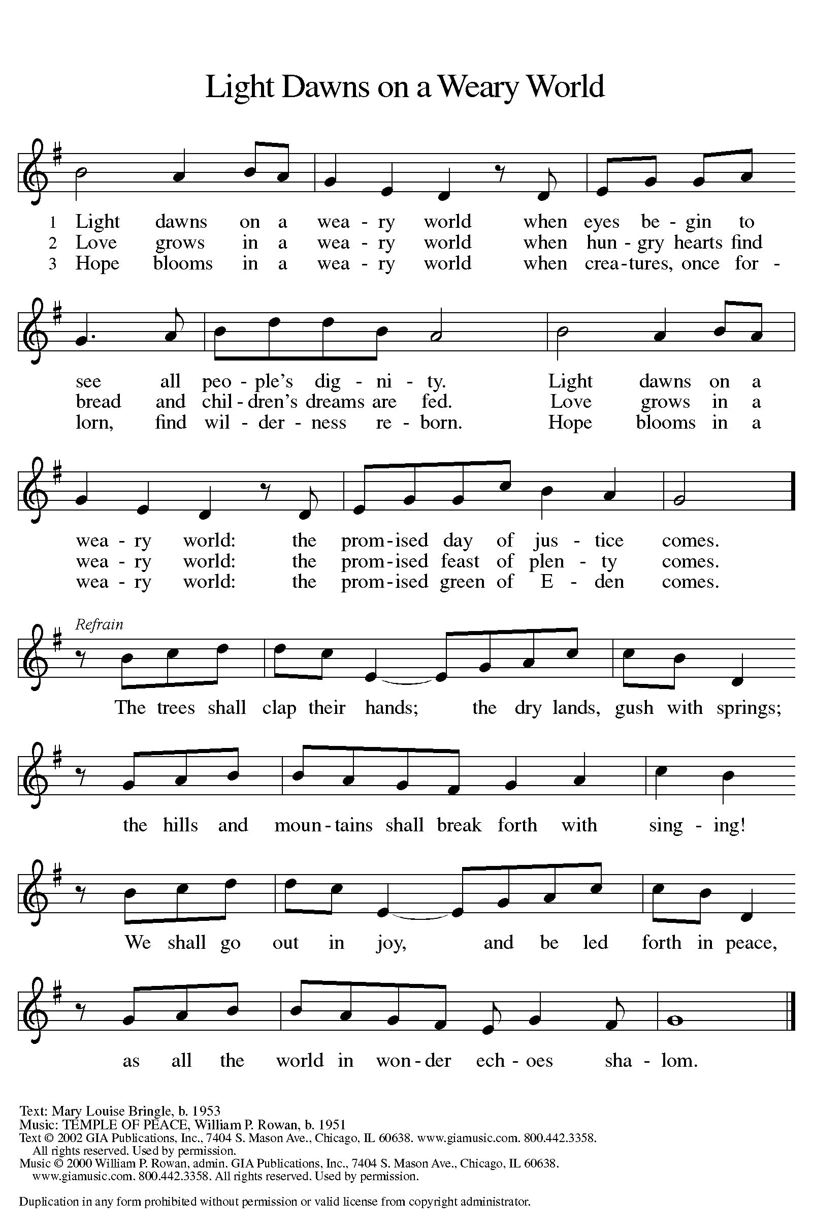

apostles’ CREED

I believe in God, the Father almighty,
creator of heaven and earth.
I believe in Jesus Christ, God’s only Son, our Lord,
who was conceived by the Holy Spirit,
born of the virgin Mary,
suffered under Pontius Pilate,
was crucified, died, and was buried;
he descended to the dead.
On the third day he rose again;
he ascended into heaven,
he is seated at the right hand of the Father,
and he will come to judge the living and the dead.
I believe in the Holy Spirit,
the holy catholic church,
the communion of saints,
the forgiveness of sins,
the resurrection of the body,
and the life everlasting. Amen.

(Please be seated.)

THE PRAYERS

A: With the Spirit of Christ shining upon us, let us boldly pray for the church, the world, and all of creation.
(A brief silence)
A: Blessed is your church transformed by your Spirit. Give us courage to proclaim to all people the promises made true in the death and resurrection of Christ. God of grace,

C: hear our prayer.
A: Blessed is creation. As earth experiences destruction from harmful practices and climate change, give us courage to help bring about its restoration. Encourage those who work in forestry to be a voice for the hidden places of creation and provide skills for its conservation. God of grace,

C: hear our prayer.
A: Blessed are the nations. We pray for presidents, prime ministers, and leaders of nations. Grant that their courage will not run dry in the face of challenge, but that they will delight in the fountain of your righteousness. God of grace,

C: hear our prayer.

A: Blessed is this congregation. Like a tree planted by streams of water, we are nourished by faith in you. Provide courage in times that feel dry, trusting that you sustain us in many ways. God of grace,
C: hear our prayer.

A: Blessed are those who defend justice in this time of political unrest. Protect and care for those who serve in our armed forces, especially Beth & Ryan, Jonathan, Jacob, Noah, Irene, and Alex. God of grace,

C: hear our prayer.

A: Blessed are those in need. Give to all facing illness wise and caring doctors, nurses, and therapists. Draw close to those who feel far from you or who are suffering in any way, especially Ahren, Barb, Beth Ra., Carolyn, Dan, David, Doretta, family & friends of Mary, family & friends of Randy, Jim & Cheri, John, Johnny, Jon, Jordan, Joseph Ra., Kay, Lawton, Lera & family, Linda, Lizzy, Marge, Randy, Rick & Kathy, Sheri, Sheri, Steve, and Wanda, and all whom we name now aloud and in our hearts. Provide an extra measure of your grace and love. God of grace,

C: hear our prayer.

A: Blessed is your church to have faithful leaders whom you have called to serve. Give direction to Presiding Bishop Elizabeth, our Synod Bishop Craig, and Pastor Carl and their respective staffs as they live out their callings to serve. As we are called to be one, even as Jesus and the Father are one, be with the leaders and the congregation St. Thomas Ev. Lutheran Church in Cheboygan and all the churches in our community. God of grace,

C: hear our prayer.

A: Blessed are those saints who now rest in your peace. Through lives of both sorrow and joy, challenge and triumph, they provide witness of faith in all times. May their lives be a witness to the living. God of grace,

C: hear our prayer.

P: We entrust our prayers to you, O God, in the sure and certain hope that your promise is revealed among the people.

C: Amen.

GREETING OF PEACE

(You are invited to share Christ’s peace with one another.)

P: The peace of Christ be with you always.

C: And also with you.
(Please be seated.)
THE MEAL
OFFERING ELENE
(Please rise if you are able.)
OFFERTORY ELW 677
(Only Verse 1)
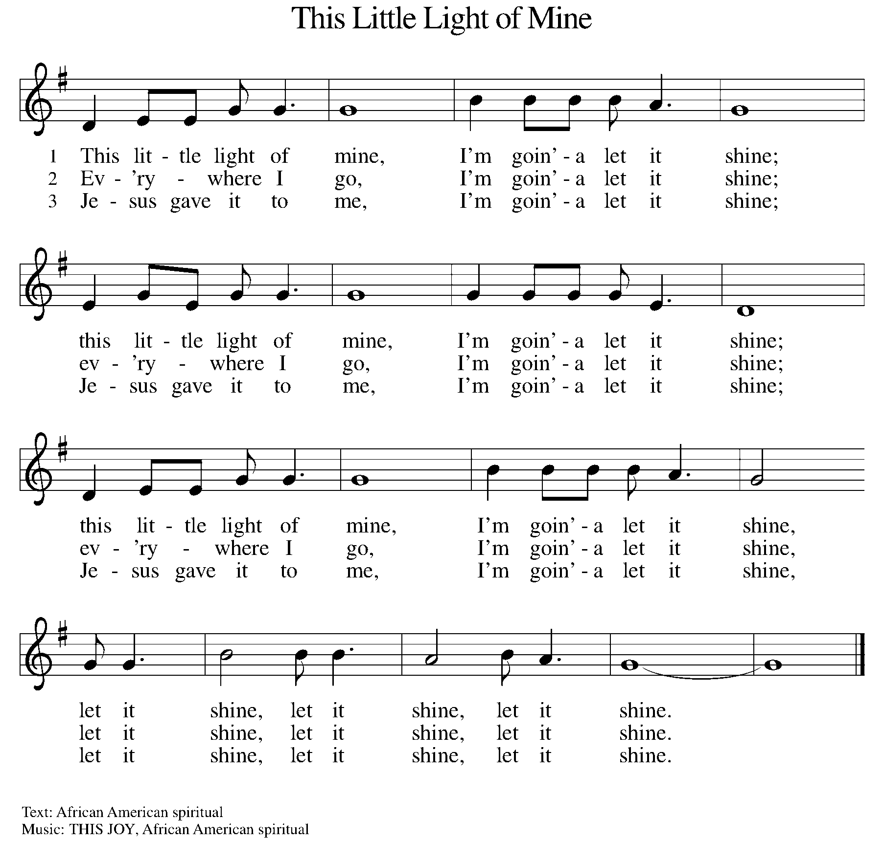

OFFERING PRAYER
A: Let us pray. God of grace, your love reaches to the heavens, and your abundance to the depths of the seas. Bless what we offer to your service: our gifts, our abilities, and our hearts. Let us overflow with gratitude and generosity, now and always.

C: Amen.

THE GREAT THANKSGIVING

P: The Lord be with you.
C: And also with you.
P: Lift up your hearts.
C: We lift them to the Lord.
P: Let us give thanks to the Lord our God.
C: It is right to give our thanks and praise.

PROPER PREFACE

P: It is indeed right, our duty and our joy, that we should at all times and in all places give thanks and praise to you, almighty and merciful God, through our Savior Jesus Christ; who on this day overcame death and the grave, and by his glorious resurrection opened to us the way of everlasting life. And so, with all the choirs of angels, with the church on earth and the hosts of heaven, we praise your name and join their unending hymn:

HOLY, HOLY ELW Setting 2, Page 130
Holy, holy, holy Lord, God of power and might,
heaven and earth are full of your glory.
Hosanna in the highest.
Blessed is he who comes in the name of the Lord.
Hosanna in the highest. Hosanna in the highest.

EUCHARISTIC PRAYER

P: In the night in which he was betrayed, our Lord Jesus took bread, and gave thanks; broke it, and gave it to his disciples, saying:
Take and eat; this is my body, given for you. Do this for the
remembrance of me.
Again, after supper, he took the cup, gave thanks, and gave it for all to drink, saying:
This cup is the new covenant in my blood, shed for you and for all people for the forgiveness of sin. Do this for the remembrance of me.

LORD'S PRAYER

P: Lord, remember us in your kingdom, and teach us to pray:

C: Our Father, who art in heaven, hallowed be thy name, thy kingdom come, thy will be done on earth as it is in heaven. Give us this day our daily bread; and forgive us our trespasses as we forgive those who trespass against us; and lead us not into temptation, but deliver us from evil. For thine is the kingdom, and the power, and the glory, forever and ever. Amen.
(Please be seated.)
COMMUNION DISTRIBUTION

All who believe in the real presence of Christ in the bread and the wine (juice) are welcome to the table. Others may come forward for a blessing. If you prefer grape juice, please indicate this to the assisting minister.

When approaching the communion rail, come forward down the side aisle, kneel, if you are able, starting at the front of the communion rail (spot closest to the font) on your side and filling in toward the back. After receiving both the bread and the wine, you may return to your seat by the center aisle.

INVITATION TO COMMUNION

P: The joy of the Lord is our strength. Come, eat this meal of gladness.

COMMUNION HYMN ELW 496
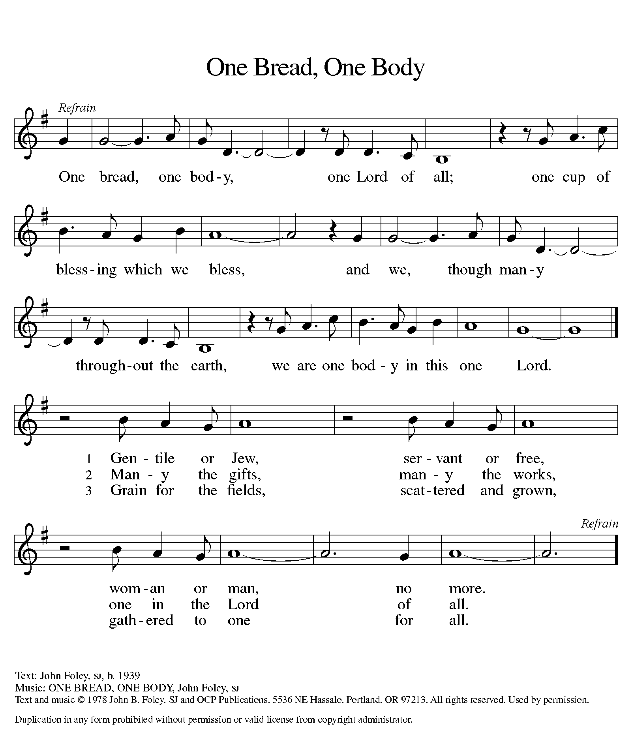

P: The body of Christ, given for you.

C: Amen.

A: The blood of Christ, shed for you.

C: Amen.
(Please rise as you are able.)

P: May the body and blood of our Lord Jesus Christ strengthen and keep you in his grace.

C: Amen.
PRAYER AFTER COMMUNION

P: Let us pray. Nourishing God, at this table you have refreshed us with holy gifts of food and drink. Strengthen us for service, and send us out to embody your good news of liberation and healing for the sake of the world. In the name of Christ we pray,

C: Amen.

SENDING

BLESSING

P: The Spirit of the triune God ☩ bless you with joy, anoint you with compassion, and send you in love.

C: Amen.

SENDING HYMN ELW 710
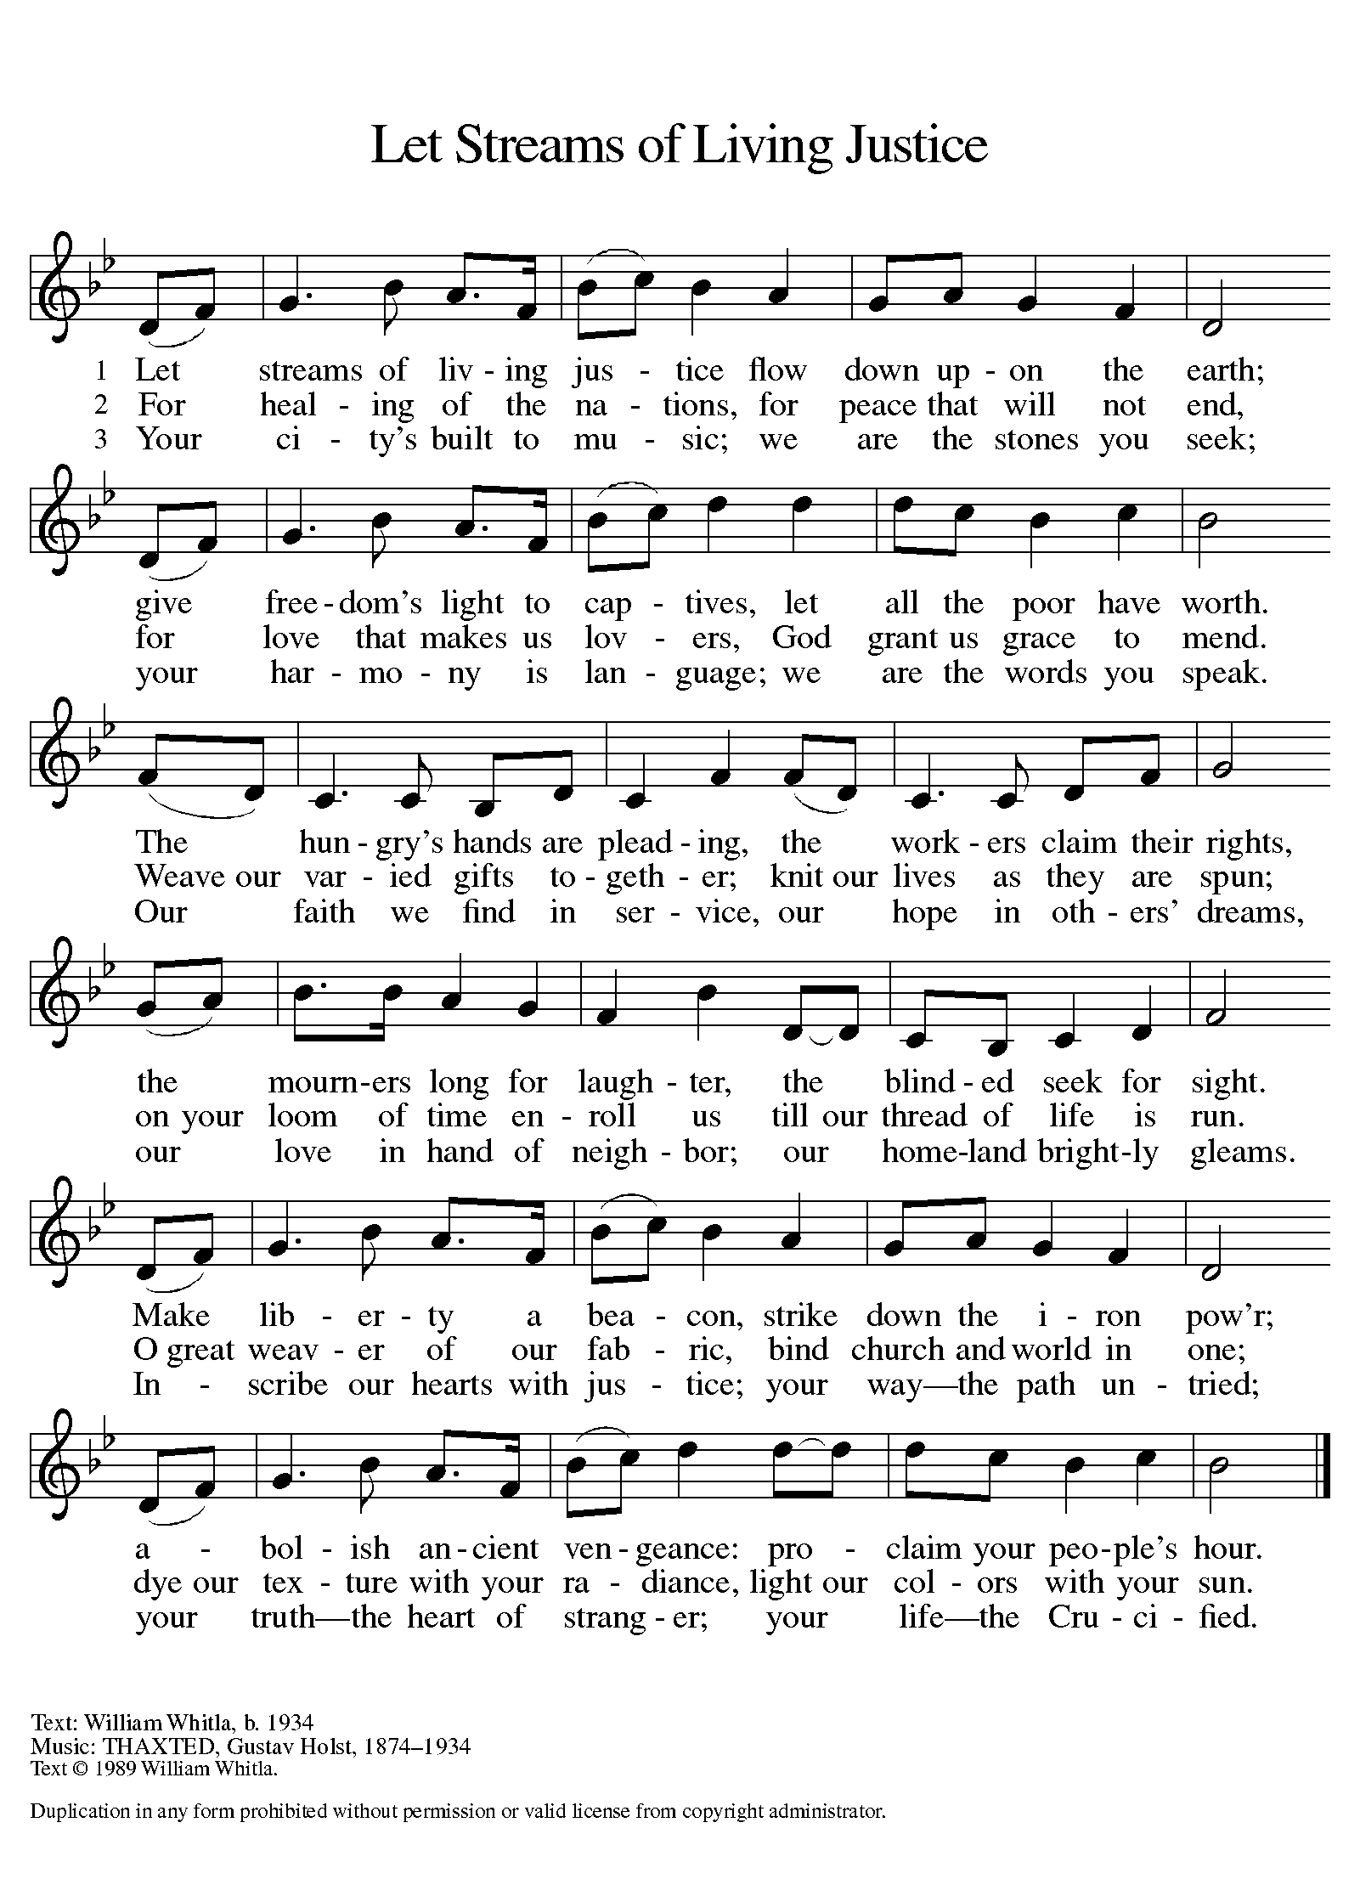

DISMISSAL

A: Go in peace. Live in hope.

C: Thanks be to God.
Announcements

- Monday, February 17 – Presidents’ Day
- Wednesday, March 5 – Ash Wednesday Service @ 6pm
- Sunday, March 30 – Concert by Elene & Ivane Ko. (following service)

Recurring Events

- Every Sunday – Adult Bible Study @ 9am
- Monday, March 3 – Worship Committee Meeting @ 6:30pm
- Wednesday, March 12 – Women’s Bible Study @ 11am
- Thursday, February 20 – Council Meeting @ 7pm

Food Pantry Dates

Wednesday, February 19, 5-6:30pm
Thursday, February 27, 1-3pm
Thursday, March 6, 5-6:30pm
Thursday, March 13, 1-3pm
Wednesday, March 19, 5-6:30pm
Thursday, March 27, 1-3pm

Volunteers for February 16 Volunteers for February 23

Reader - Volunteer Reader – Stacy
Assisting Minister - Kathy Assisting Minister – Volunteer

February Birthday Celebrations

2/3 – Liza Ta.
2/8 – Sara Ha.
2/18 – Lynne Fo.
2/19 – Elene Ko.
2/22 – Barb Pa.
Anniversary Celebrations

2/9 – Elizabeth (Beth) & Ryan Mc.
2/22 – Stan & Judy St.

Acknowledgments
- OneLicense.net, License #A-703165.
- CCLI, License #2281869.
- From SundaysandSeasons.com. Copyright 2020 Augsburg Fortress. All rights reserved. Reprinted by permission under Augsburg Fortress Liturgies Annual License #23806.
- New Revised Standard Version Bible, copyright 1989, Division of Christian Education of the National Council of the Churches of Christ in the United States of America. Used by permission. All rights reserved.

