

Baptism of Our Lord
January 12, 2025


SAINT PAUL LUTHERAN CHURCH
3383 EAST LAKE LANSING ROAD
EAST LANSING, MI 48823

PHONE (517) 351-8541

Pastor Carl E. Ballard

E-MAIL: pastor@stpaul-el.org
officemanager@stpaul-el.org

Visitors WELCOME! If this is your first time worshipping with us, please sign our guest registry just outside the sanctuary doors. We hope you are blessed through worship today. If you have any questions, please feel free to call the church at 351-8541.
Children are always welcome in worship! The choir room (off the sanctuary) can also be used as a cry room for younger children and includes a sound system so parents may continue to participate in the service. Clipboards with children's bulletins, activities and crayons are available for use during the service.
Sunday School is available during the worship service September-May except the last Sunday of the month.
This Bulletin is for your use during the service and to take home for the upcoming week. If you choose not to take it home, please place it in the recycle receptacle in the back.
Newsletters and Calendars of Upcoming Events are available in the lobby/narthex. We welcome anyone who has an interest in our small groups or activities! You can also look us up on the web at www.stpaul-el.org.
Contacting Us: Our Office Manager is Emily Polhamus. She can be reached by phone at 517-351-8541 or at her email address, officemanager@stpaul-el.org. Our Director of Music is Elene Kobulashvili. You may leave a message at 517-351-8541. Pastor Carl can be reached at 517-515-3129, and his email address is cballard123@msn.com.
Holy Communion is available at most services. All who believe in the real presence of Christ in the bread and the wine are invited to celebrate Communion with us. Those who wish can come forward for a blessing.
You’re invited to share in fellowship after worship. We would love this opportunity to introduce you to the St. Paul community.

P-Presiding Minister A-Assisting Minister C-Congregation

PRELUDE ELENE

INTRODUCTION

Today’s festival rejoices in God’s blessings. We recall and celebrate our adoption as God’s children, the gift of the Holy Spirit, and the promised company of almighty God when we “pass through the waters . . . the rivers . . . fire.” On this day the heavens open again for this assembly, and we receive the gift of God’s Beloved, Jesus, in bread and wine.

GATHERING

P: The Holy Spirit calls us together as the people of God.

(Please rise as you are able.)

CONFESSION & FORGIVENESS

All may make the sign of the cross, the sign that is marked at baptism, as the presiding minister begins.

P: Blessed be the holy Trinity, ☩ one God, our creator, our protector, our wellspring of life.

C: Amen.

P: Trusting that God receives our words and the meditations of our hearts, let us confess our sin.

(Silence for reflection.)

P: Merciful God,

C: you speak blessing and compassion into the world. Forgive us for the ways we act with judgment, cruelty, or indifference. We ignore the needs of our neighbors; we resist your call to oppose injustice; we give in to scarcity and fear; we assume the worst about one another. Cleanse us from our faults and release us from their grasp. Show us your loving kindness. Restore our hearts and repair your world, that we may live in Christ’s ways. Amen.

P: God proclaims these words of assurance: “Do not fear, for I have redeemed you. I have called you by name. You are mine.” In ☩ Christ, you are forgiven. In the Spirit, you are made free. Refreshed by the waters of mercy, live anew as beloved children of God.

C: Amen.

GATHERING SONG ELW 423
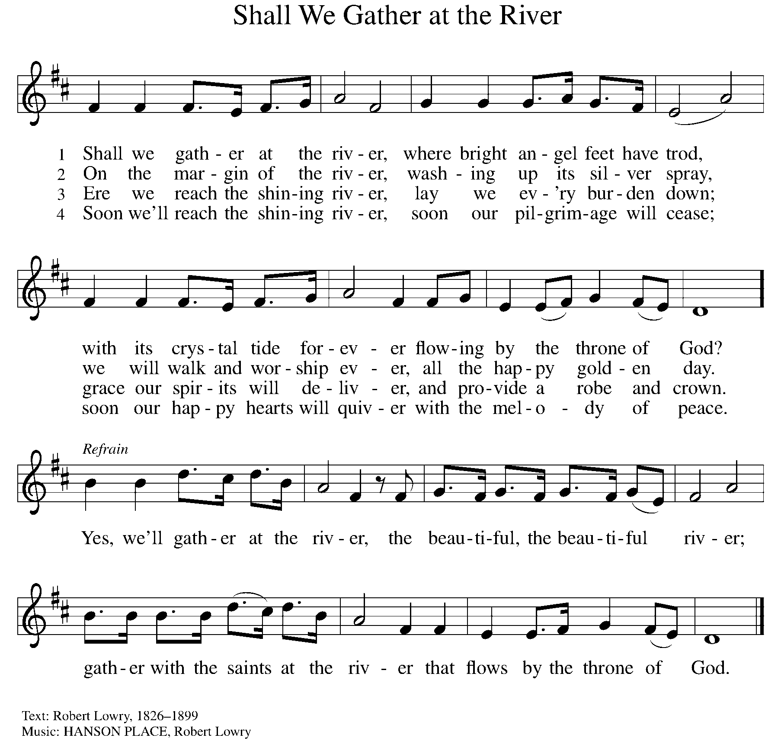

GREETING

P: The grace of our Lord Jesus Christ, the love of God, and the communion of the Holy Spirit be with you all.

C: And also with you.

KYRIE ELW Setting 7, Page 175

Lord, have mercy on us; O Lord, have mercy.
Lord, have mercy on us; O Lord, have mercy.
Christ, have mercy on us; O Christ, have mercy.
Christ, have mercy on us; O Christ, have mercy.
Lord, have mercy on us; O Lord, have mercy.
Lord, have mercy on us; O Lord, have mercy.

CANTICLE OF PRAISE ELW Setting 4, Page 148-149

Glory to God in the highest, and peace to God’s people on earth.

Lord God, heavenly King, almighty God and Father,
we worship you, we give you thanks, we praise you for your glory.
Lord Jesus Christ, only Son of the Father, Lord God, Lamb of God,
you take away the sin of the world: have mercy on us;
you are seated at the right hand of the Father: receive our prayer.
For you alone are the Holy One, you alone are the Lord,
you alone are the Most High, Jesus Christ, with the Holy Spirit,
in the glory of God the Father. Amen.

PRAYER OF THE DAY

P: Let us pray. Almighty God, you anointed Jesus at his baptism with the Holy Spirit and revealed him as your beloved Son. Keep all who are born of water and the Spirit faithful in your service, that we may rejoice to be called children of God, through Jesus Christ, our Savior and Lord, who lives and reigns with you and the Holy Spirit, one God, now and forever.

C: Amen.

(Please be seated.)

CHILDREN’S MESSAGE

(Children are invited to Sunday School.)

TRANSITION SONG ELW 801
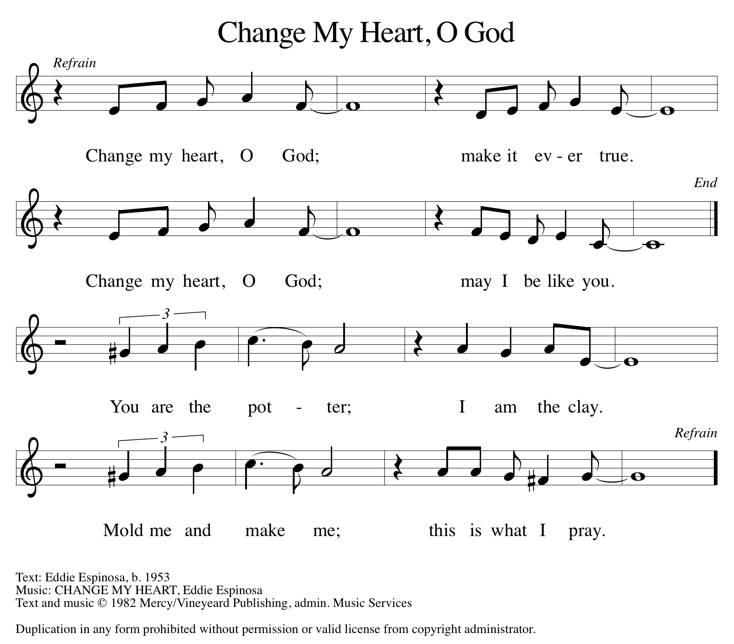

THE WORD

P: God speaks to us in scripture, preaching, and song.

FIRST READING ISAIAH 43:1-7

Near the end of Israel’s exile in Babylon, God promises to bring the people home. They need no longer be afraid, because the one who formed, created, and called them by name now redeems them from all their enemies. God declares them precious and honored, and God loves them.

¹ But now thus says the Lord, he who created you, O Jacob, he who formed you, O Israel: Do not fear, for I have redeemed you; I have called you by name; you are mine. ² When you pass through the waters, I will be with you, and through the rivers, they shall not overwhelm you; when you walk through fire you shall not be burned, and the flame shall not consume you. ³ For I am the Lord your God, the Holy One of Israel, your Savior. I give Egypt as your ransom, Cush and Seba in exchange for you. ⁴ Because you are precious in my sight and honored and I love you, I give people in return for you, nations in exchange for your life.

⁵ Do not fear, for I am with you; I will bring your offspring from the east, and from the west I will gather you; ⁶ I will say to the north, “Give them up,” and to the south, “Do not withhold; bring my sons from far away and my daughters from the end of the earth— ⁷ everyone who is called by my name, whom I created for my glory, whom I formed and made.”

Reader: Word of God, word of life. C: Thanks be to God.

PSALM PSALM 29

The voice of the Lord is upon the waters. (Ps. 29:3)

¹ Ascribe to the Lord, you gods, ascribe to the Lord glory and strength.
² Ascribe to the Lord the glory due God’s name; worship the Lord in the beauty of holiness.
³ The voice of the Lord is upon the waters; the God of glory thunders; the Lord is upon the mighty waters.
⁴ The voice of the Lord is a powerful voice; the voice of the Lord is a voice of splendor.
⁵ The voice of the Lord breaks the cedar trees; the Lord breaks the cedars of Lebanon;
⁶ the Lord makes Lebanon skip like a calf, and Mount Hermon like a young wild ox.
⁷ The voice of the Lord bursts forth in lightning flashes.
⁸ The voice of the Lord shakes the wilderness; the Lord shakes the wilderness of Kadesh.
⁹ The voice of the Lord makes the oak trees writhe and strips the forests bare. And in the temple of the Lord all are crying, “Glory!”
¹⁰ The Lord sits enthroned above the flood; the Lord sits enthroned as king forevermore.
¹¹ O Lord, give strength to your people; give them, O Lord, the blessings of peace.

SECOND READING ACTS 8:14-17

Peter and John are sent to support the new Christians in Samaria, a group that was recently baptized after hearing the good news of Christ through the preaching of Philip. Here the Samaritans receive the gift of the Holy Spirit in the laying on of hands.

¹⁴ Now when the apostles at Jerusalem heard that Samaria had accepted the word of God, they sent Peter and John to them. ¹⁵ The two went down and prayed for them that they might receive the Holy Spirit ¹⁶ (for as yet the Spirit had not come upon any of them; they had only been baptized in the name of the Lord Jesus). ¹⁷ Then Peter and John laid their hands on them, and they received the Holy Spirit.

Reader: Word of God, word of life. C: Thanks be to God.

(Please rise as you are able.)

GOSPEL ACCLAMATION ELW Setting 7, Page 179

Alleluia, alleluia, alleluia!
Alleluia, alleluia, alleluia!
Alleluia, alleluia, alleluia! Alleluia!

GOSPEL LUKE 3:15-17, 21-22

P: The Holy Gospel according to Luke, the 3rd chapter.
C: Glory to you, O Lord.

The reading opens with questions about the identity of the Messiah. John the Baptist insists that he is not the Messiah; instead he points ahead to one who is coming. And whether the voice of God was heard by all or only by Jesus, God settles the matter: Jesus is God’s beloved Son.

¹⁵ As the people were filled with expectation and all were questioning in their hearts concerning John, whether he might be the Messiah, ¹⁶ John answered all of them by saying, “I baptize you with water, but one who is more powerful than I is coming; I am not worthy to untie the strap of his sandals. He will baptize you with the Holy Spirit and fire. ¹⁷ His winnowing fork is in his hand to clear his threshing floor and to gather the wheat into his granary, but the chaff he will burn with unquenchable fire.”

²¹ Now when all the people were baptized and when Jesus also had been baptized and was praying, the heaven was opened, ²² and the Holy Spirit descended upon him in bodily form like a dove. And a voice came from heaven, “You are my Son, the Beloved; with you I am well pleased.”

P: The Gospel of the Lord. C: Praise to you, O Christ.

(Please be seated.)

SERMON PASTOR CARL BALLARD

(Please rise as you are able.)

HYMN OF THE DAY ELW 305
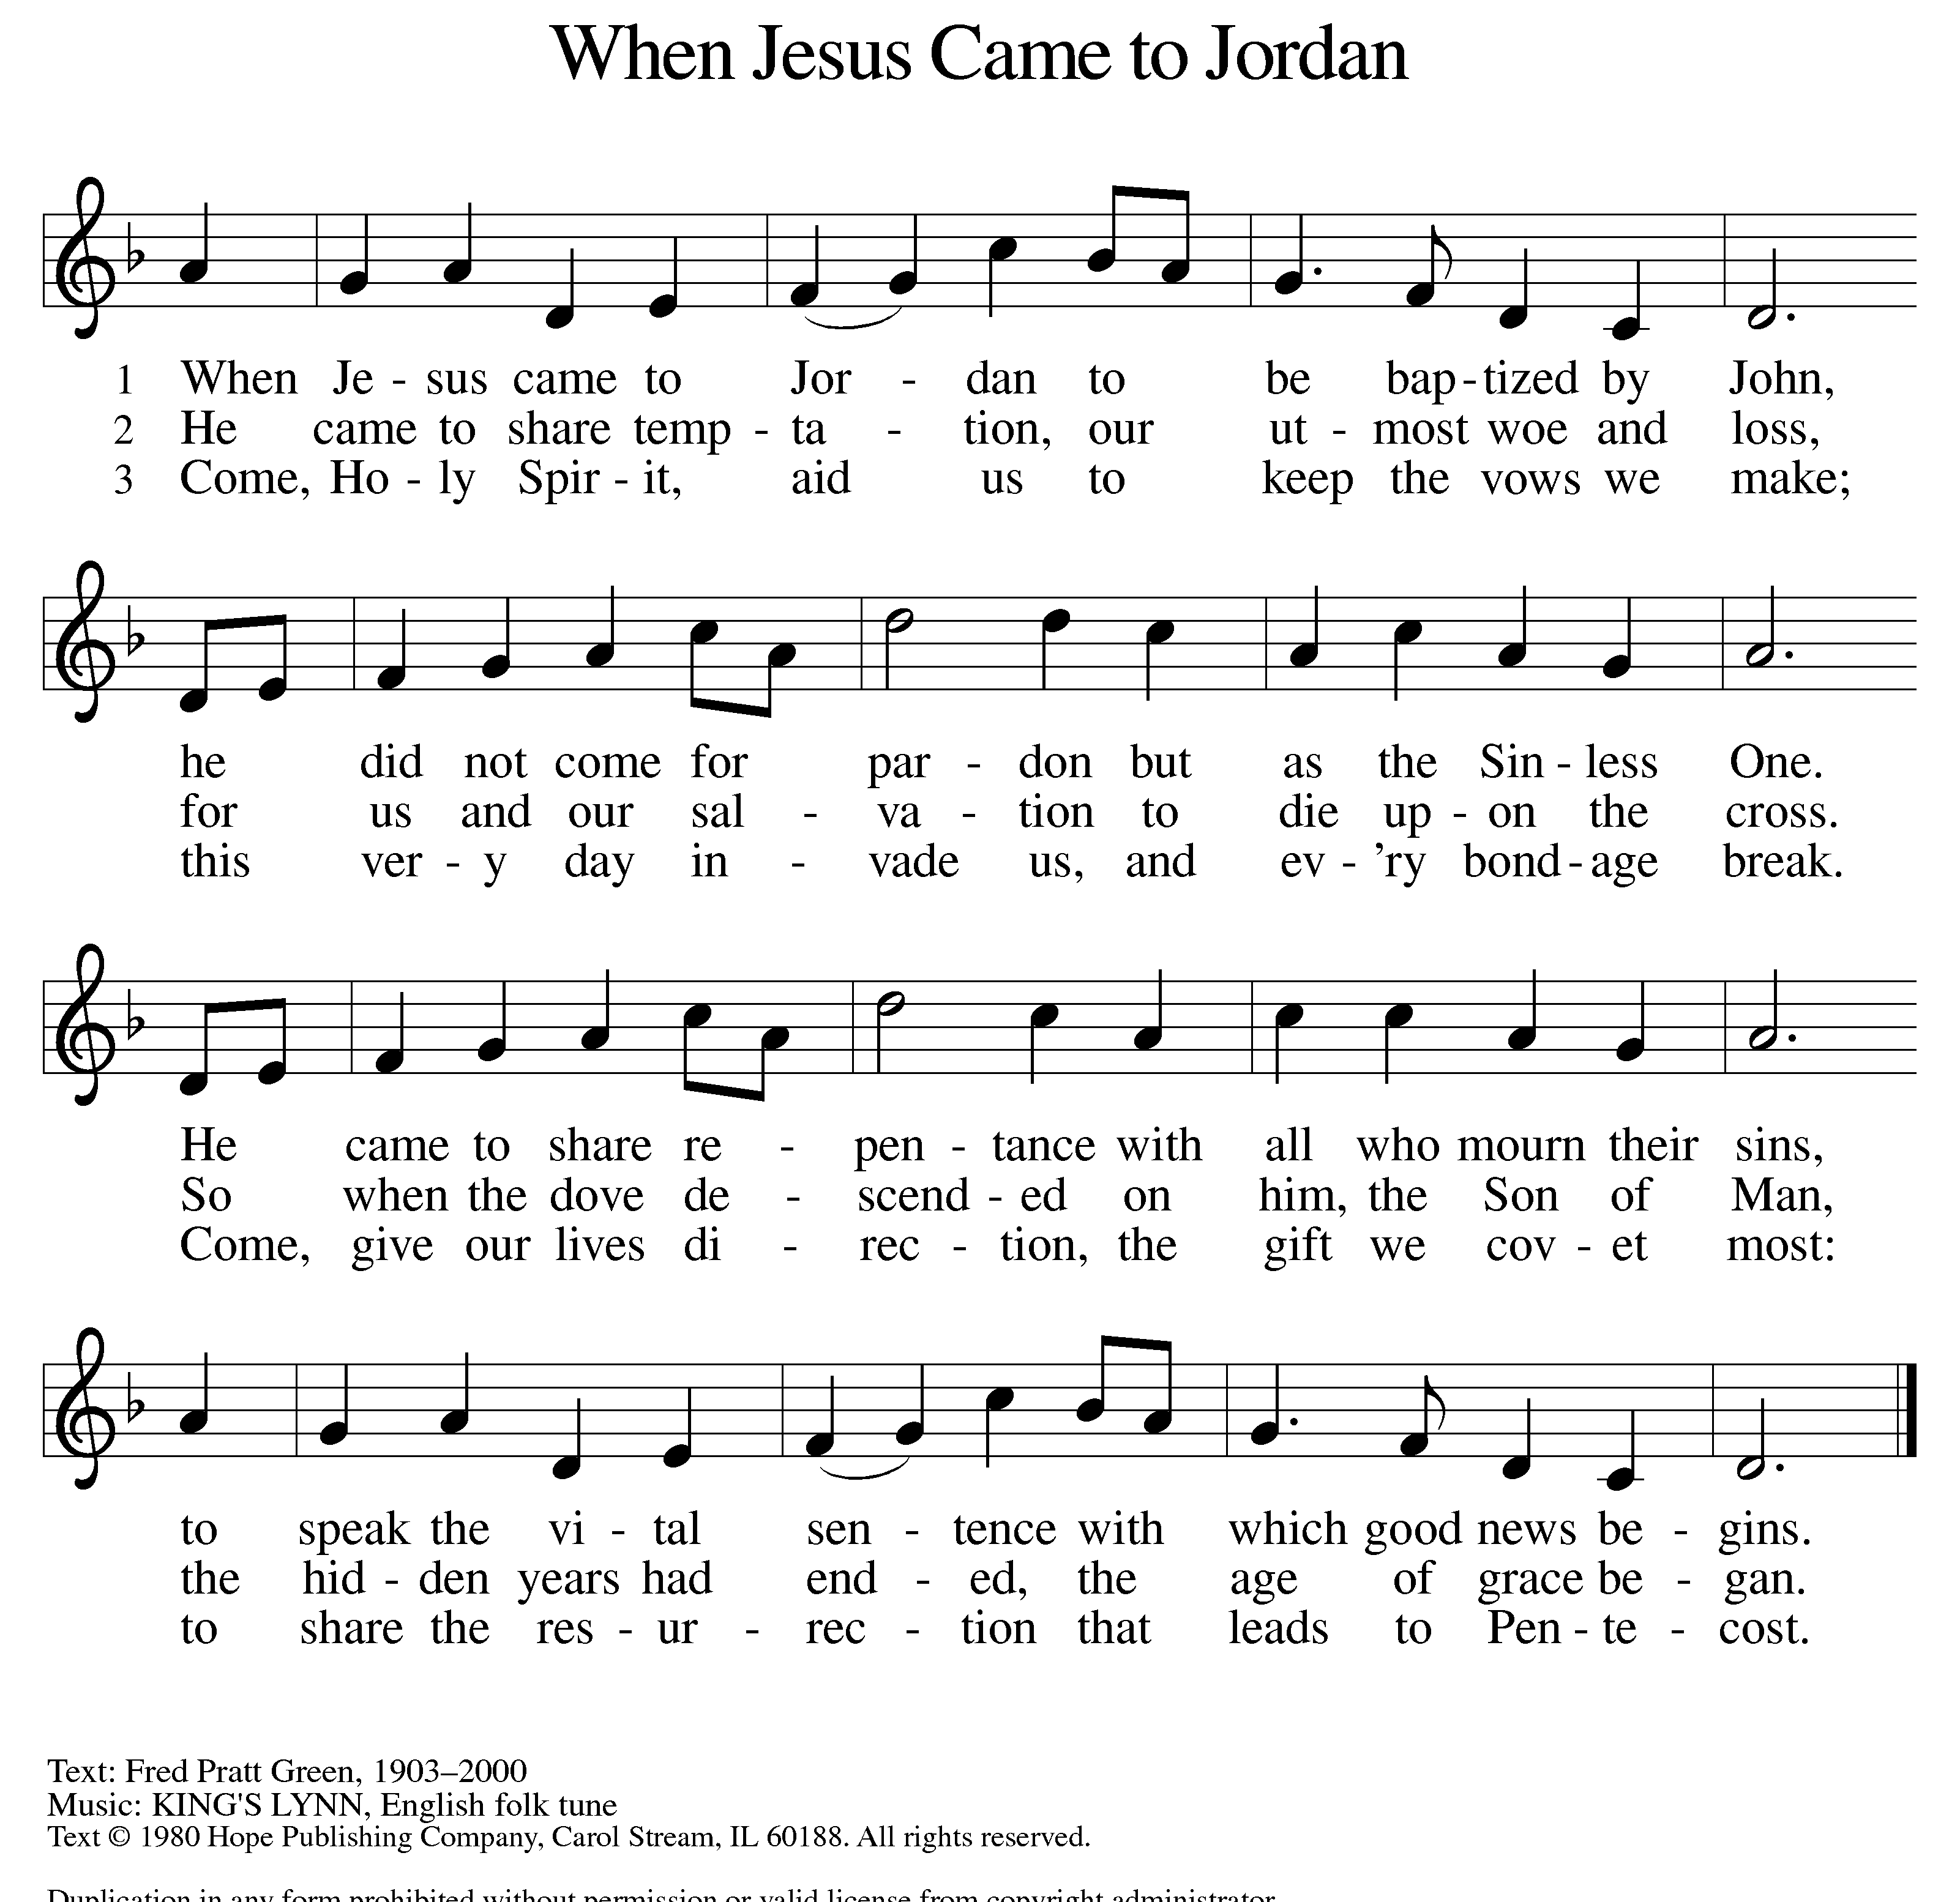

Council installation

APOSTLES’ CREED

I believe in God, the Father almighty,
creator of heaven and earth.

I believe in Jesus Christ, God’s only Son, our Lord,
who was conceived by the Holy Spirit,
born of the Virgin Mary,
suffered under Pontius Pilate,
was crucified, died, and was buried;
he descended to the dead.
On the third day he rose again;
he ascended into heaven,
he is seated at the right hand of the Father,
and he will come to judge the living and the dead.

I believe in the Holy Spirit,
the holy catholic church,
the communion of saints,
the forgiveness of sins,
the resurrection of the body,
and the life everlasting. Amen.

(Please be seated.)
THE PRAYERS

A: With the Spirit of Christ shining upon us, let us boldly pray for the church, the world, and all of creation.

(A brief silence.)

A: You call us by name and form us. We give thanks for the gift of baptism. Nurture the baptized and equip people sent to proclaim the good news, especially Young Adults in Global Mission and international congregations. God of grace,

C: hear our prayer.

A: Your voice sounds over the waters. Speak words of healing over the rivers and lakes, seas and oceans. Heeding your voice, lead us to care for water, and the land and creatures it nourishes. God of grace,

C: hear our prayer.

A: You give strength to your people. Uphold all who serve the common good. Guide federal and state legislators, city and county officials, judges and juries. Strengthen our resolve to serve all in need. God of grace,

C: hear our prayer.

A: You are with us in challenging times. Draw near to all who are ill, undergoing treatment, or recovering from surgery. Accompany individuals and families affected by addiction or mental health challenges. Uphold each person as your beloved. We lift to you all who are undergoing transition in relationships, occupation, living situation, or health condition, especially Ahren, Barb, Beth Ra., Carolyn, Craig, Dan, David, Doretta, Jim & Cheri, John, Johnny, Jon, Jordan, Joseph Ra., Kathy, Kay, Kelly, Lawton, Lera & family, Linda, Lizzy, Marge, Mary, Nathan, Rick & Kathy, Sheri, Sheri, and Wanda. And all that we name now aloud and in our hearts. God of grace,

C: hear our prayer.

A: You draw us into community. Embolden ministries of racial reconciliation, nurture work on behalf of immigrants and refugees, and equip each to use their gifts for the sake of neighbors near and far. God of grace,

C: hear our prayer.

A: You shield us from danger and in perilous times. We pray for those who serve in our armed forces, especially for Beth & Ryan, Jonathan, Jacob, Noah, Irene, and Alex. God of grace,

C: hear our prayer.

A: You call servant-leaders to guide your church here on earth. Give direction to Presiding Bishop Elizabeth, our Synod Bishop Craig, and Pastor Carl. We ask that you be with their respective staffs as they live out their callings to serve. As we are called to be one, even as Jesus and the Father are one, be with the leaders and the congregation of Messiah Lutheran Church in Bay City and all the churches in our community. God of grace,

C: hear our prayer.

A: You grant us peace. Comfort all who grieve. Dwell with us in this life and, at the last, join us with the saints whom you have created, formed, and named. God of grace,

C: hear our prayer.

P: We entrust our prayers to you, O God, in the sure and certain hope that your promise is revealed among the people.

C: Amen.

GREETING OF PEACE

(You are invited to share Christ’s peace with one another.)

P: The peace of Christ be with you always.

C: And also with you.

(Please be seated.)

THE MEAL

OFFERING ELENE
(Please rise as you are able.)

OFFERTORY (VERSE 1 ONLY) ELW 677
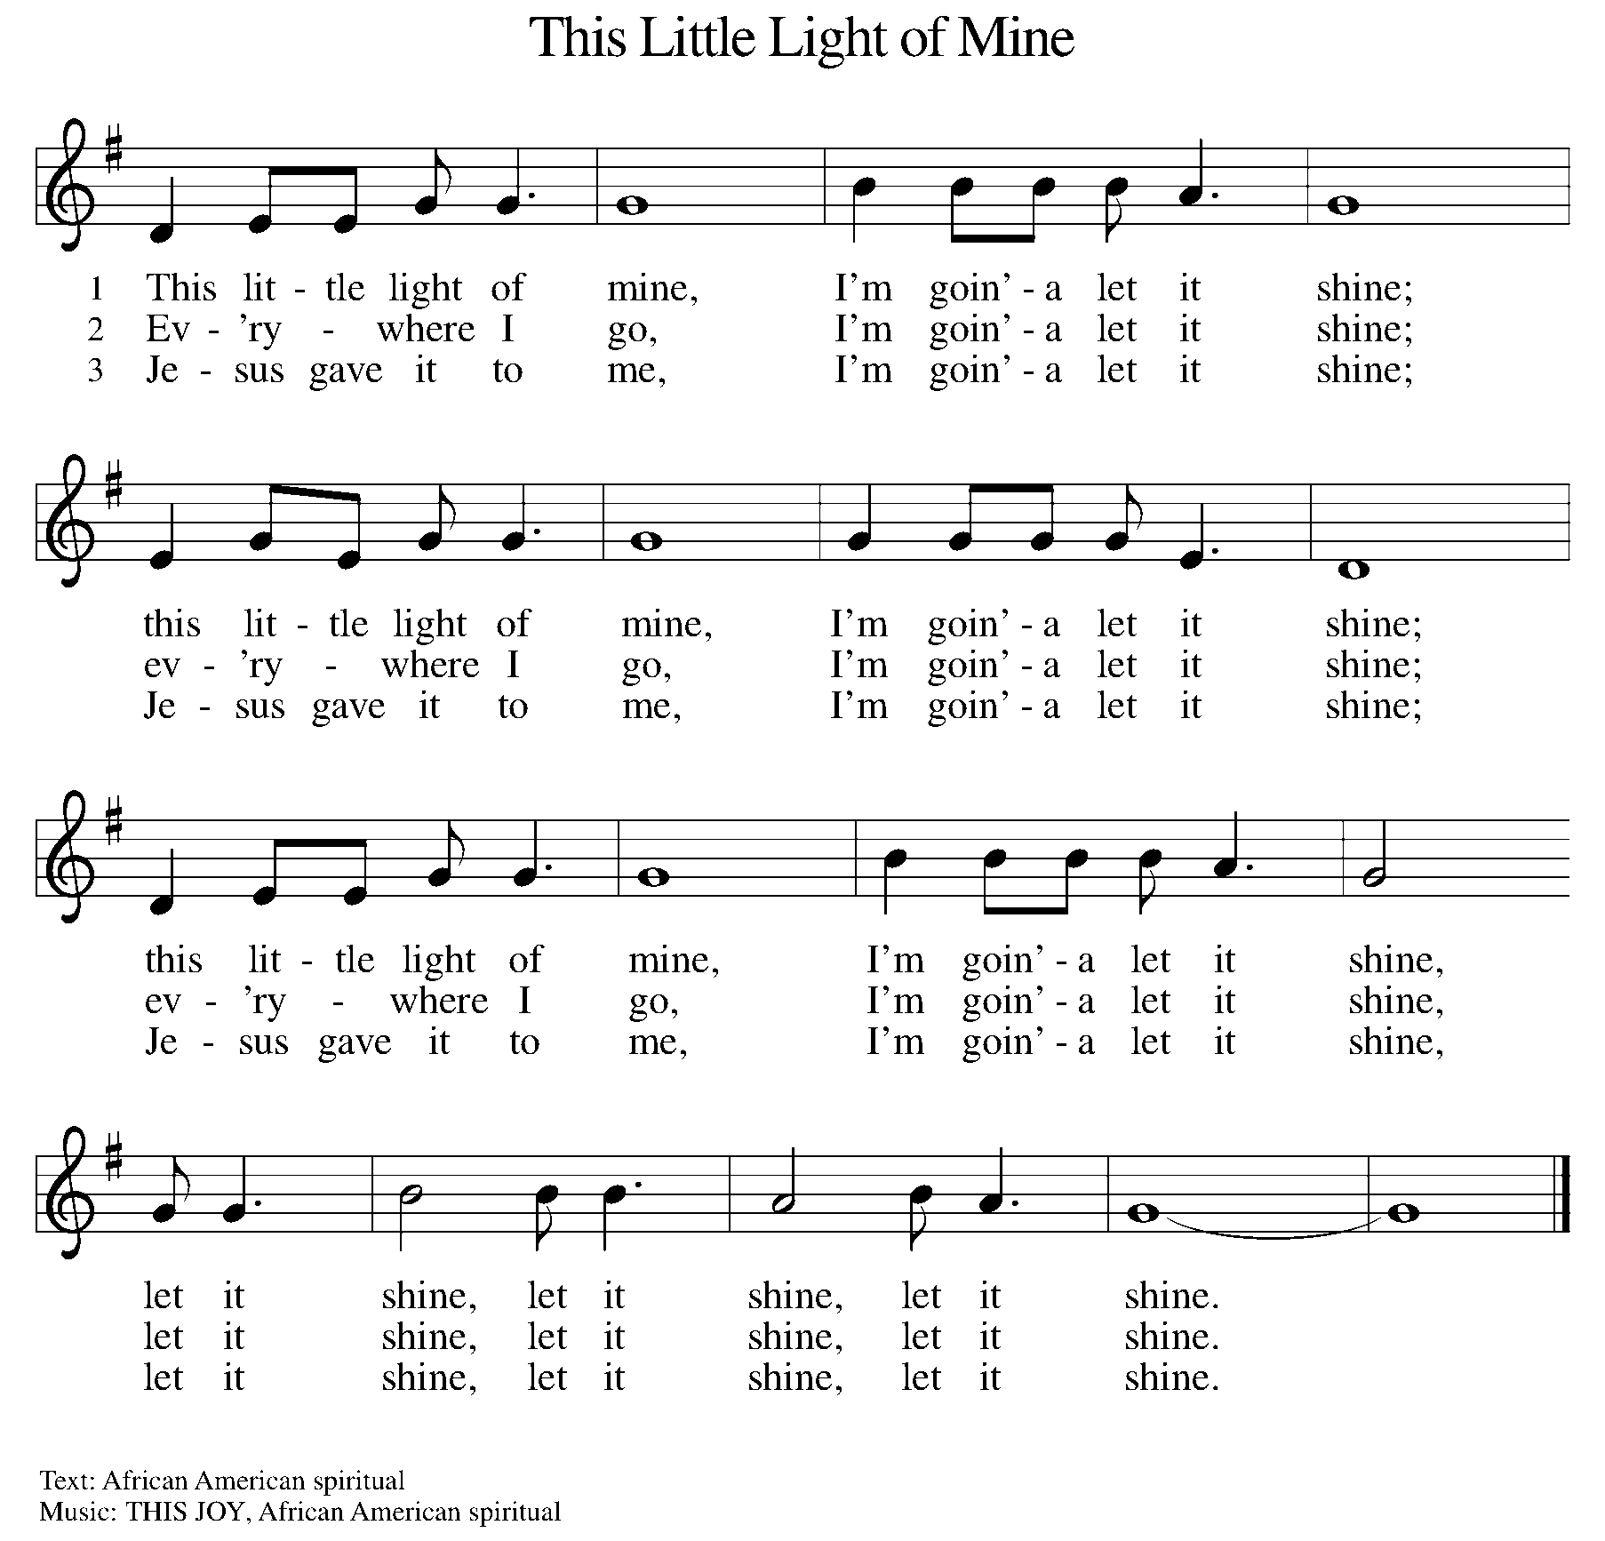

OFFERING PRAYER

A: Let us pray. God of grace, your love reaches to the heavens, and your abundance to the depths of the seas. Bless what we offer to your service: our gifts, our abilities, and our hearts. Let us overflow with gratitude and generosity, now and always.

C: Amen.

THE GREAT THANKSGIVING

P: The Lord be with you.
C: And also with you.
P: Lift up your hearts.
C: We lift them to the Lord.
P: Let us give thanks to the Lord our God.
C: It is right to give our thanks and praise.

PROPER PREFACE

P: It is indeed right, our duty and our joy, that we should at all times and in all places give thanks and praise to you, almighty and merciful God, through our Savior Jesus Christ; who on this day overcame death and the grave, and by his glorious resurrection opened to us the way of everlasting life. And so, with all the choirs of angels, with the church on earth and the hosts of heaven, we praise your name and join their unending hymn:

HOLY, HOLY ELW Setting 7, Page 181

Holy, holy, holy Lord God,
God of might and power; holy is the Lord.
Holy, holy, holy, holy Lord God,
God of might and power; holy is the Lord.
Hosanna in the highest, hosanna here on earth.
Blest is he who comes in the name of the Lord.
Hosanna in the highest, hosanna here on earth.
Blest is he who comes in the name of the Lord.

EUCHARISTIC PRAYER

P: In the night in which he was betrayed, our Lord Jesus took bread, and gave thanks; broke it, and gave it to his disciples, saying:
Take and eat; this is my body, given for you. Do this for the remembrance of me.
Again, after supper, he took the cup, gave thanks, and gave it for all to drink, saying:
This cup is the new covenant in my blood, shed for you and for all people for the forgiveness of sin. Do this for the remembrance of me.

LORD'S PRAYER

P: Lord, remember us in your kingdom, and teach us to pray:

C: Our Father in heaven, hallowed be your name, your kingdom come, your will be done, on earth as in heaven. Give us today our daily bread. Forgive us our sins as we forgive those who sin against us. Save us from the time of trial and deliver us from evil. For the kingdom, the power, and the glory are yours, now and forever. Amen.

(Please be seated.)

COMMUNION DISTRIBUTION

All who believe in the real presence of Christ in the bread and the wine (juice) are welcome to the table. Others may come forward for a blessing. If you prefer grape juice, please indicate this to the assisting minister.

When approaching the communion rail, come forward down the side aisle, kneel, if you are able, starting at the front of the communion rail (spot closest to the font) on your side and filling in toward the back. After receiving both the bread and the wine, you may return to your seat by the center aisle.

INVITATION TO COMMUNION

P: The joy of the Lord is our strength. Come, eat this meal of gladness.

COMMUNION HYMN ELW 496
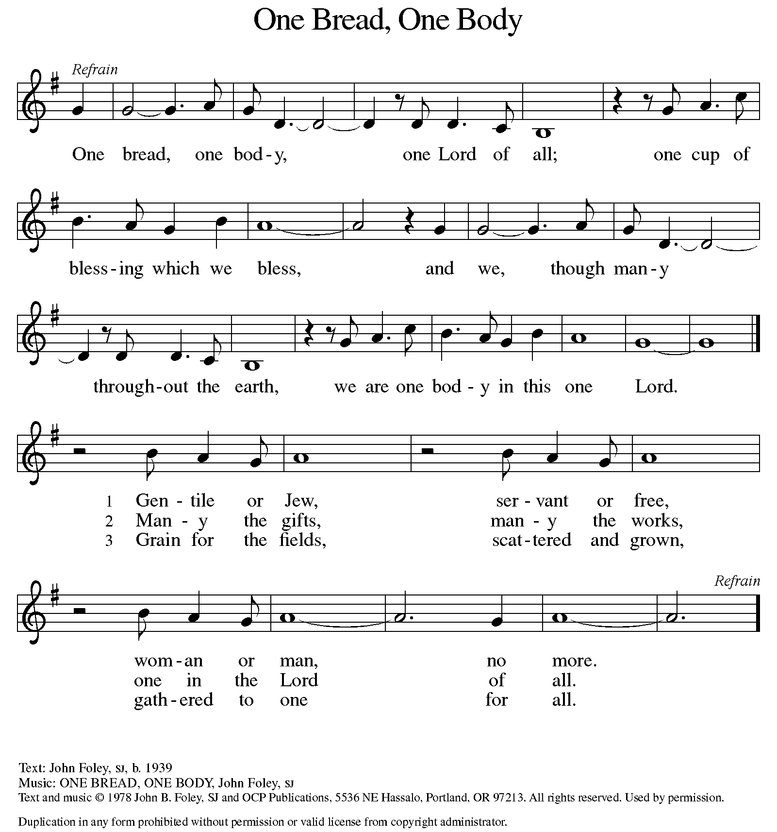

P: The body of Christ, given for you.

C: Amen.

A: The blood of Christ, shed for you.

C: Amen.
(Please rise as you are able.)

P: May the body and blood of our Lord Jesus Christ strengthen and keep you in his grace.

C: Amen.
PRAYER AFTER COMMUNION

P: Let us pray. Nourishing God, at this table you have refreshed us with holy gifts of food and drink. Strengthen us for service, and send us out to embody your good news of liberation and healing for the sake of the world. In the name of Christ we pray,

C: Amen.

SENDING

BLESSING

P: The Spirit of the triune God ☩ bless you with joy, anoint you with compassion, and send you in love.

C: Amen.

SENDING HYMN ELW 453
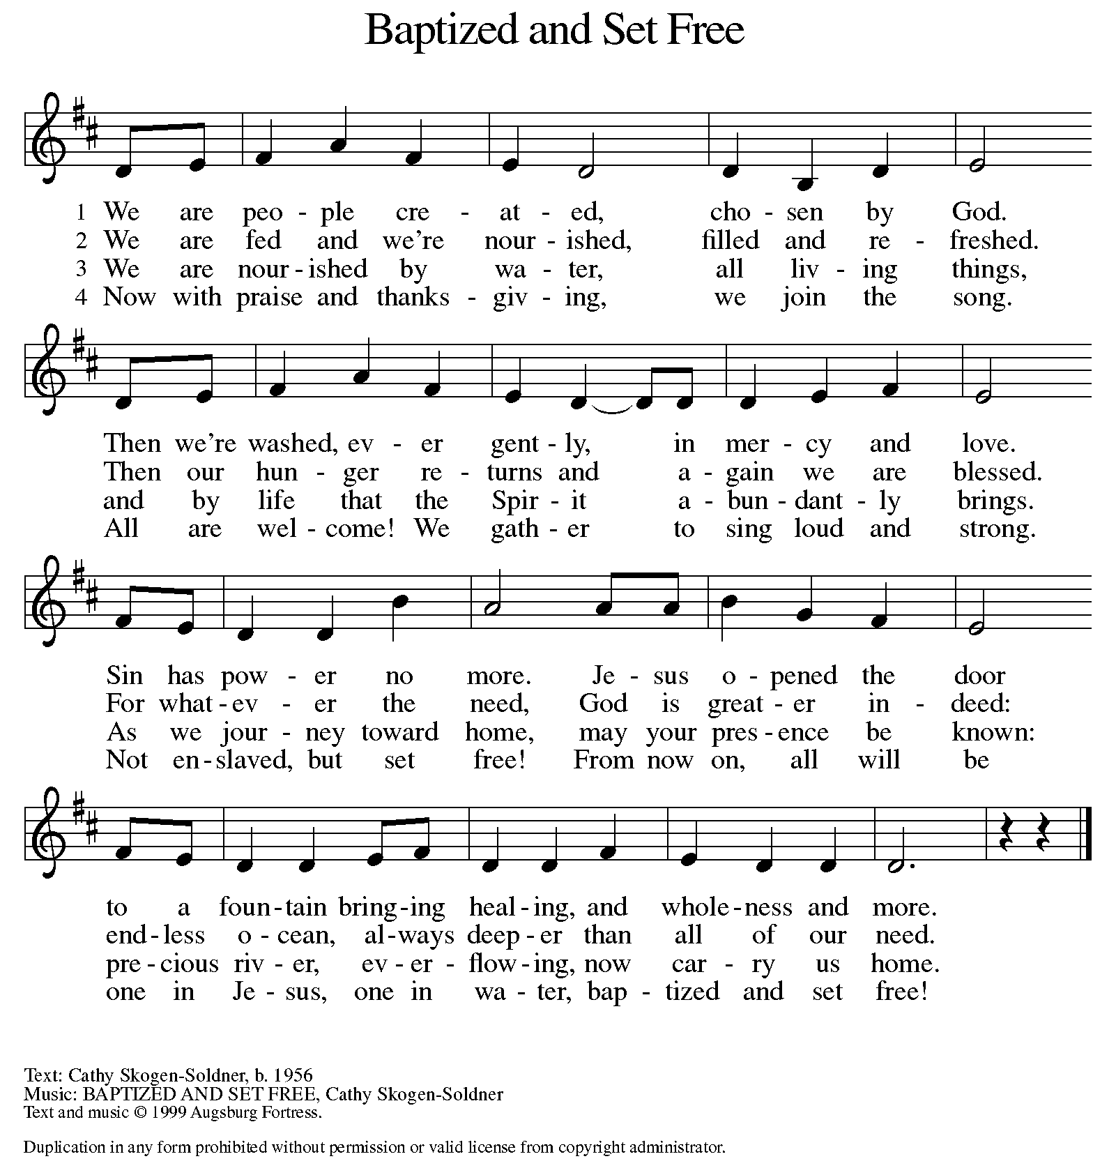

DISMISSAL

A: Go in peace. Live in hope.

C: Thanks be to God.

Announcements:

- Friday, January 17 – Ecumenical Prayer Service @ 6:30pm. Address: University United Methodist 1120 S. Harrison, East Lansing.
- Monday, January 20 – MLK Day
- Sunday, January 26 – New Member Reception. Please let Pastor know if you’d like to become a member.

Recurring Events
- Every Sunday – Adult Bible Study @ 9am
- Monday, February 10 – Worship Committee Meeting @ 6:30pm
- Wednesday, February 12 – Women’s Bible Study @ 11am
- Thursday, January 16 – Council Meeting @ 7pm

Food Pantry Dates

- Wednesday, January 15, 5-6:30pm
- Thursday, January 23, 1-3pm
- Wednesday, February 5, 5-6:30pm
- Thursday, February 13, 1-3pm
- Wednesday, February 19, 5-6:30pm
- Thursday, February 27, 1-3pm

Volunteers for January 12 Volunteers for January 19

Reader Sunday – Volunteer Reader Sunday – Volunteer
Assisting Minister - Kathy Assisting Minister – Volunteer

January Birthday Celebrations

1/19 – Don Ke.
1/20 – Kelly Br.
1/23 – Daniel Op.

Acknowledgments
- OneLicense.net, License #A-703165. CCLI, License #2281869.
- From SundaysandSeasons.com. Copyright 2020 Augsburg Fortress. All rights reserved. Reprinted by permission under Augsburg Fortress Liturgies Annual License #23806.
- New Revised Standard Version Bible, copyright 1989, Division of Christian Education of the National Council of the Churches of Christ in the United States of America. Used by permission. All rights reserved.

