

2ND Sunday of Christmas
January 5, 2025

SAINT PAUL LUTHERAN CHURCH
3383 EAST LAKE LANSING ROAD
EAST LANSING, MI 48823

PHONE (517) 351-8541

Pastor Carl E. Ballard
E-MAIL: pastor@stpaul-el.org
officemanager@stpaul-el.org

Visitors WELCOME! If this is your first time worshipping with us, please sign our guest registry just outside the sanctuary doors. We hope you are blessed through worship today. If you have any questions, please feel free to call the church at 351-8541.
Children are always welcome in worship! The choir room (off the sanctuary) can also be used as a cry room for younger children and includes a sound system so parents may continue to participate in the service. Clipboards with children’s bulletins, activities and crayons are available for use during the service. Please see an usher if you are unable to locate them.
Sunday School is available during the worship service September-May except the last Sunday of the month.
This Bulletin is for your use during the service and to take home for the upcoming week. If you choose not to take it home, please place it in the recycle receptacle in the back.
Newsletters and Calendars of Upcoming Events are available in the lobby/narthex. We welcome anyone who has an interest in our small groups or activities! You can also look us up on the web at www.stpaul-el.org.
Contacting Us: Our office manager is Emily Polhamus. She can be reached by phone at 517-351-8541 or at her email address, officemanager@stpaul-el.org. Our Director of Music is Elene Kobulashvili. You may leave a message at 517-351-8541. Pastor Carl can be reached at 517-515-3129, and his email address is cballard123@msn.com.
Holy Communion is available at most services. All who believe in the real presence of Christ in the bread and the wine are invited to celebrate Communion with us. Those who wish can come forward for a blessing.
You are invited to share in fellowship after worship. We would love this opportunity to introduce you to the St. Paul community.

P-Presiding Minister A-Assisting Minister C-Congregation

PRELUDE ELENE

INTRODUCTION

Within the gospel reading’s profound words lies the simple message that God is revealed in a human person. Though we may try to understand how the Word existed with God from the beginning of time, the wonder we celebrate at Christmas is that the Word continues to dwell among us. Christ comes among us in the gathered assembly, the scriptures, the waters of new birth, and the bread and the wine. Through these ordinary gifts we receive the fullness of God’s grace and truth.

GATHERING

P: The Holy Spirit calls us together as the people of God.

(Please rise as you are able.)

CONFESSION & FORGIVENESS

All may make the sign of the cross, the sign that is marked at baptism, as the presiding minister begins.

P: Blessed be the holy Trinity, ☩ one God, whose steadfast love is everlasting.

C: Amen.

P: Let us confess our sin in the presence of God and of one another.

(Silence is kept for reflection.)
P: God-with-us,

C: we confess that we have turned away those seeking shelter, claiming there is no room when we have plenty. We have made power and wealth our idols, while you show us true glory: a baby in a manger. We have overlooked the shepherds, expecting good news in prettier packaging. Too often, we have valued violence instead of your peace. Turn us from our ways to your ways. Grant us the grace to begin again. Free us from all that keeps us bound, and forgive our sin, through Jesus Christ, who gives himself for us. Amen.

P: Hear the good news and rejoice! You are God’s chosen ones, holy and beloved, ☩ forgiven in Christ, and freed to respond in joy.

C: Amen.

GATHERING SONG ELW 292
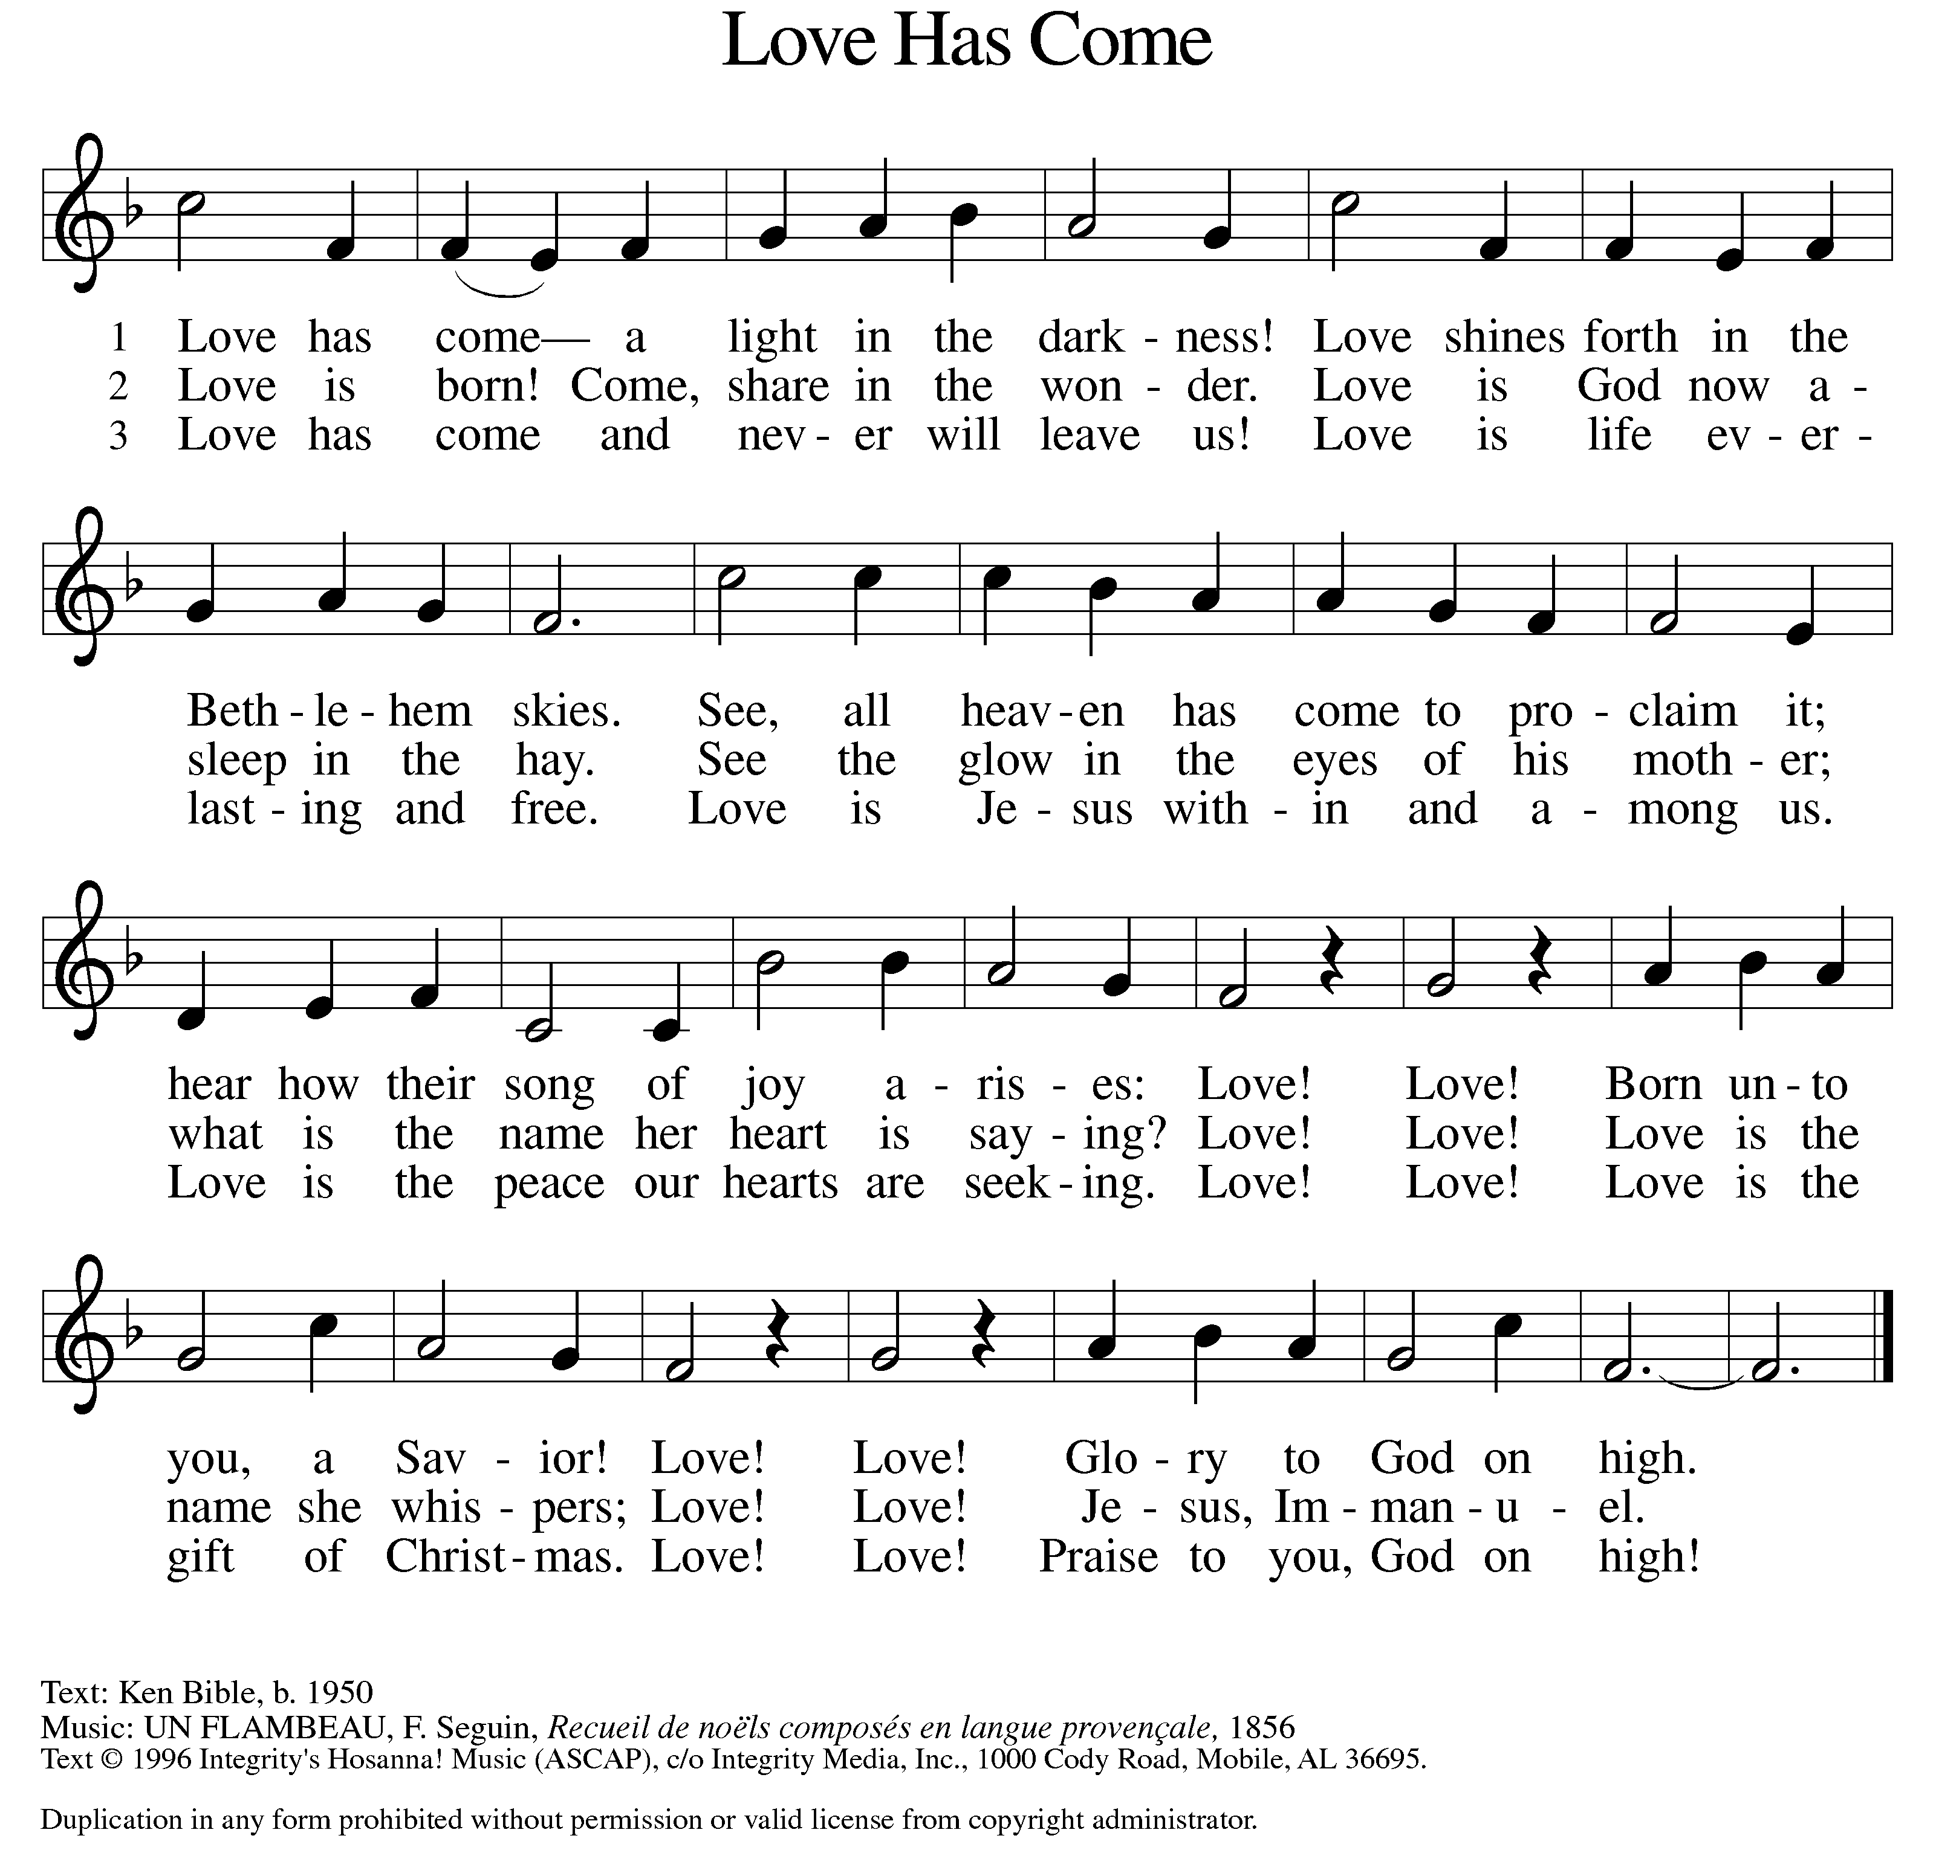

GREETING

P: The grace of our Lord Jesus Christ, the love of God, and the communion of the Holy Spirit be with you all.

C: And also with you.

KYRIE ELW Setting 2, Page 120
In peace, let us pray to the Lord.
Lord, have mercy.
For the peace from above and for our salvation,
let us pray to the Lord.
Lord, have mercy.
For the peace of the whole world, for the well-being of the church of God, and for the unity of all, let us pray to the Lord.
Lord, have mercy.
For this holy house and for all who offer here their worship and praise, let us pray to the Lord.
Lord, have mercy.
Help, save, comfort, and defend us, gracious Lord.
Amen.

CANTICLE OF PRAISE ELW Setting 4, Page 148-149
Glory to God in the highest, and peace to God’s people on earth.
Lord God, heavenly King, almighty God and Father,
we worship you, we give you thanks, we praise you for your glory. Lord Jesus Christ, only Son of the Father, Lord God, Lamb of God, you take away the sin of the world: have mercy on us;
you are seated at the right hand of the Father: receive our prayer. For you alone are the Holy One, you alone are the Lord,
you alone are the Most High, Jesus Christ, with the Holy Spirit,
in the glory of God the Father. Amen.

PRAYER OF THE DAY

P: Let us pray. Almighty God, you have filled all the earth with the light of your incarnate Word. By your grace empower us to reflect your light in all that we do, through Jesus Christ, our Savior and Lord, who lives and reigns with you and the Holy Spirit, one God, now and forever.

C: Amen.

(Please be seated.)

CHILDREN’S MESSAGE

(Children are invited to Sunday School.)

TRANSITION SONG ELW 801
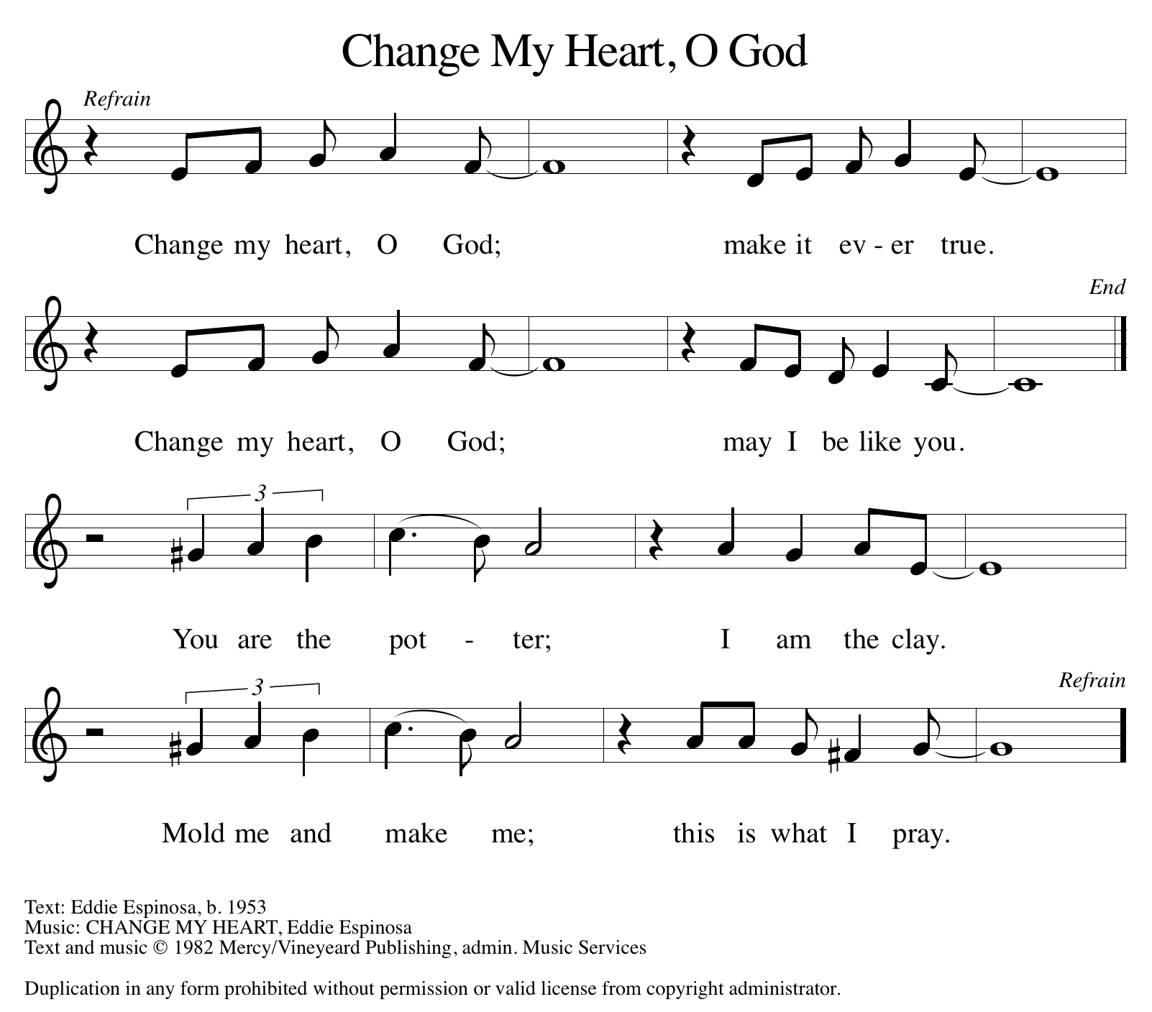

THE WORD

God speaks to us in scripture, preaching, and song.

First Reading JEREMIAH 31:7-14
God promises to bring Israel back to its land from the most remote parts of exile. In Zion Israel will rejoice over God’s gift of food and livestock. Young women will express their joy in dancing; God will give gladness instead of sorrow.

⁷ For thus says the Lord: Sing aloud with gladness for Jacob, and raise shouts for the chief of the nations; proclaim, give praise, and say, “Save, O Lord, your people, the remnant of Israel.” ⁸ See, I am going to bring them from the land of the north and gather them from the farthest parts of the earth, among them the blind and the lame, those with child and those in labor together; a great company, they shall return here. ⁹ With weeping they shall come, and with consolations I will lead them back; I will let them walk by brooks of water, in a straight path where they shall not stumble, for I have become a father to Israel, and Ephraim is my firstborn.

¹⁰ Hear the word of the Lord, O nations, and declare it in the coastlands far away; say, “He who scattered Israel will gather him and will keep him as a shepherd does a flock.” ¹¹ For the Lord has ransomed Jacob and has redeemed him from hands too strong for him. ¹² They shall come and sing aloud on the height of Zion, and they shall be radiant over the goodness of the Lord, over the grain, the wine, and the oil, and over the young of the flock and the herd; their life shall become like a watered garden, and they shall never languish again. ¹³ Then shall the young women rejoice in the dance, and the young men and the old shall be merry. I will turn their mourning into joy; I will comfort them and give them gladness for sorrow. ¹⁴ I will give the priests their fill of fatness, and my people shall be satisfied with my bounty, says the Lord.

Word of God, word of life. C: Thanks be to God.

PSALM PSALM 147:12-20
Worship the Lord, O Jerusalem; praise your God, O Zion. (Ps. 147:12)

¹² Worship the Lord, O Jerusalem; praise your God, O Zion,
¹³ who has strengthened the bars of your gates and has blessed your children within you.
¹⁴ God has established peace on your borders and satisfies you with the finest wheat.
¹⁵ God sends out a command to the earth, a word that runs very swiftly.
¹⁶ God gives snow like wool, scattering frost like ashes.
¹⁷ God scatters hail like bread crumbs. Who can stand against God’s cold?
¹⁸ The Lord sends forth the word and melts them; the wind blows, and the waters flow.
¹⁹ God declares the word to Jacob, statutes and judgments to Israel.
²⁰ The Lord has not done so to any other nation; they do not know God’s judgments. Hallelujah!

SECOND READING EPHESIANS 1:3-14
In Jesus, all of God’s plans and purposes have been made known as heaven and earth are united in Christ. Through Jesus, we have been chosen as God’s children and have been promised eternal salvation.

³ Blessed be the God and Father of our Lord Jesus Christ, who has blessed us in Christ with every spiritual blessing in the heavenly places, ⁴ just as he chose us in Christ before the foundation of the world to be holy and blameless before him in love. ⁵ He destined us for adoption as his children through Jesus Christ, according to the good pleasure of his will, ⁶ to the praise of his glorious grace that he freely bestowed on us in the Beloved. ⁷ In him we have redemption through his blood, the forgiveness of our trespasses, according to the riches of his grace ⁸ that he lavished on us. With all wisdom and insight ⁹ he has made known to us the mystery of his will, according to his good pleasure that he set forth in Christ, ¹⁰ as a plan for the fullness of time, to gather up all things in him, things in heaven and things on earth. ¹¹ In Christ we have also obtained an inheritance, having been destined according to the purpose of him who accomplishes all things according to his counsel and will, ¹² so that we, who were the first to set our hope on Christ, might live for the praise of his glory. ¹³ In him you also, when you had heard the word of truth, the gospel of your salvation, and had believed in him, were marked with the seal of the promised Holy Spirit; ¹⁴ this is the pledge of our inheritance toward redemption as God’s own people, to the praise of his glory.

Word of God, word of life. C: Thanks be to God.

(Please rise as you are able.)
GOSPEL ACCLAMATION ELW Setting 2, Page 124
Alleluia, alleluia, alleluia, alleluia.
Lord, to whom shall we go?
You have the words of eternal life.
Alleluia, alleluia, alleluia, alleluia.

GOSPEL JOHN 1:[1-9] 10-18

P: The Holy Gospel according to John, the 1st chapter.
C: Glory to you, O Lord.
John begins his gospel with this prologue: a hymn to the Word through whom all things were created. This Word became flesh and brought grace and truth to the world.
^{[1}In the beginning was the Word, and the Word was with God, and the Word was God. ²He was in the beginning with God. ³All things came into being through him, and without him not one thing came into being. What has come into being ⁴in him was life, and the life was the light of all people. ⁵The light shines in the darkness, and the darkness did not overtake it. ⁶There was a man sent from God whose name was John. ⁷He came as a witness to testify to the light, so that all might believe through him. ⁸He himself was not the light, but he came to testify to the light. ⁹The true light, which enlightens everyone, was coming into the world.]
¹⁰He was in the world, and the world came into being through him, yet the world did not know him. ¹¹He came to what was his own, and his own people did not accept him. ¹²But to all who received him, who believed in his name, he gave power to become children of God, ¹³who were born, not of blood or of the will of the flesh or of the will of man, but of God. ¹⁴And the Word became flesh and lived among us, and we have seen his glory, the glory as of a father’s only son, full of grace and truth. ¹⁵(John testified to him and cried out, “This was he of whom I said, ‘He who comes after me ranks ahead of me because he was before me.’”) ¹⁶From his fullness we have all received, grace upon grace. ¹⁷The law indeed was given through Moses; grace and truth came through Jesus Christ. ¹⁸No one has ever seen God. It is the only Son, himself God, who is close to the Father’s heart, who has made him known.
P: The Gospel of the Lord. C: Praise to you, O Christ.
(Please be seated.)

SERMON PASTOR CARL BALLARD

(Please rise as you are able.)
HYMN OF THE DAY ELW 270
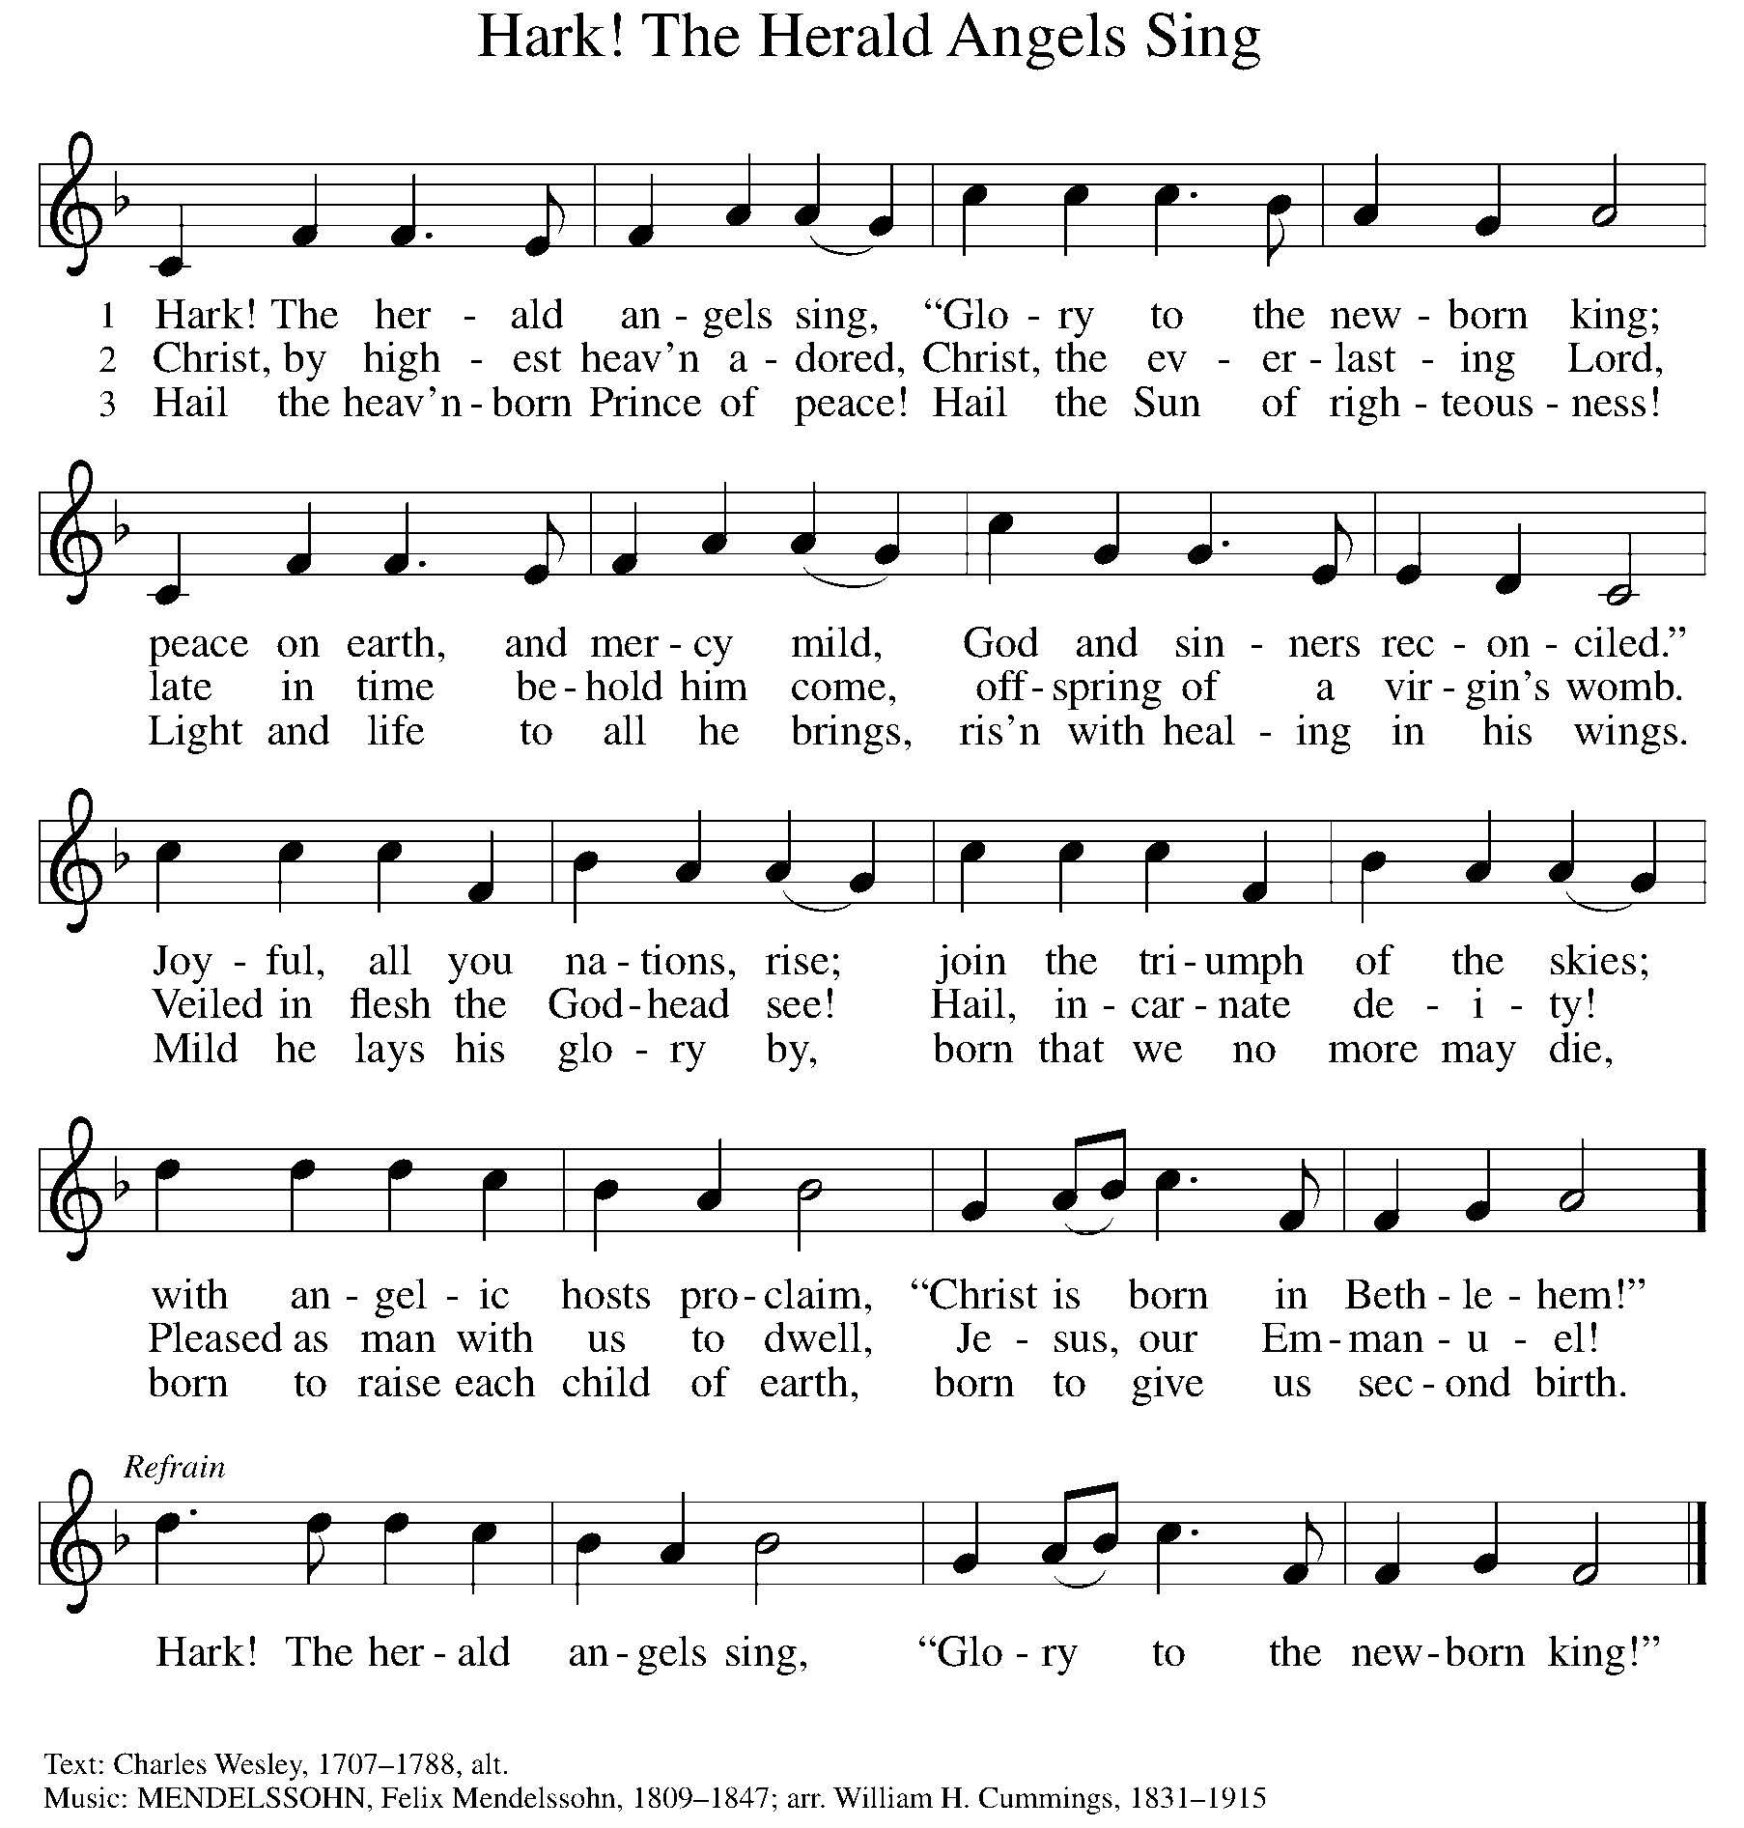

NICENE CREED

We believe in one God,
the Father, the Almighty,
maker of heaven and earth,
of all that is, seen and unseen.

We believe in one Lord, Jesus Christ,
the only Son of God,
eternally begotten of the Father,
God from God, Light from Light,
true God from true God,
begotten, not made,
of one Being with the Father;
through him all things were made.
For us and for our salvation
he came down from heaven,
was incarnate of the Holy Spirit and the virgin Mary
and became truly human.
For our sake he was crucified under Pontius Pilate;
he suffered death and was buried.
On the third day he rose again
in accordance with the scriptures;
he ascended into heaven
and is seated at the right hand of the Father.
He will come again in glory to judge the living and the dead,
and his kingdom will have no end.

We believe in the Holy Spirit, the Lord, the giver of life,
who proceeds from the Father and the Son,
who with the Father and the Son is worshiped and glorified,
who has spoken through the prophets.
We believe in one holy catholic and apostolic church.
We acknowledge one baptism for the forgiveness of sins.
We look for the resurrection of the dead,
and the life of the world to come. Amen.

(Please be seated.)

THE PRAYERS

A: Filled with good news of great joy, let us offer our prayers for the church, the earth, and all people.
(A brief silence)
A: O God, you reveal yourself in this assembly. In water, wine, and bread, show us again and again your grace upon grace, that your church boldly testifies to your love. God of grace,

C: receive our prayer.

A: You reveal yourself in creation. In seedlings and planets, microorganisms and galaxies, awaken us to the cry of the earth. As you nourish your people like a watered garden, empower us to nourish our creaturely companions. God of grace,

C: receive our prayer.

A: You reveal yourself in every land and in the farthest parts of the earth. Deliver peoples who suffer under oppressive regimes. Thwart the foolish plans of unjust leaders. Give wisdom to our elected officials. God of grace,

C: receive our prayer.

A: You reveal yourself in every human being. Help us recognize your image in our siblings in Christ who are in the strong grip of addiction, depression, anxiety, hopelessness, or other illness. Grant us compassion in our care for your people. God of grace,

C: receive our prayer.
A: You reveal yourself anew every day. In this new year, renew this congregation and its ministries in our witness to the good news of the incarnation. Transform the way we have always done things into your new future for us. God of grace,
C: receive our prayer.

A: You reveal yourself by sending angels of protection to provide care and compassion for those who serve in our armed forces, especially Beth & Ryan, Jonathan, Jacob, Noah, Irene, and Alex. God of grace,

C: receive our prayer.

A: You reveal yourself as you walk with us through life’s changes. Be near to all who are changing jobs, moving, welcoming children, or facing the loss of loved ones. Sustain those who are ill or suffering, especially Ahren, Barb, Carolyn, Craig, Dan, David, Doretta, Jim & Cheri, John, Johnny, Jon, Jordan, Kathy, Kay, Kelly, Lawton, Lera & family, Linda, Lizzy, Marge, Mary, Nathan, Rick & Kathy, Sheri, Sheri, and Wanda, and all whom we name now aloud and in our hearts. In times of change, remind us of your steadfast love. God of grace,

C: receive our prayer.

A: You reveal yourself as you guide our church’s leaders, Presiding Bishop Elizabeth, our Synod Bishop Craig, and Pastor Carl and their respective staffs as they live out their callings to serve. As we are called to be one, even as Jesus and the Father are one, be with the leaders and the congregation of Trinity Lutheran Church in Battle Creek and all the churches in our community. God of grace,

C: receive our prayer.

A: You reveal yourself in the lives of your holy ones. We give you thanks for those who set their hope on you, trusting the inheritance we receive in you. God of grace,

C: receive our prayer.

P: We commend these prayers to you, O God, trusting your grace made known to all, through the Word made flesh, Jesus Christ, our Savior and Lord.

C: Amen.

GREETING OF PEACE

(You are invited to share Christ’s peace with one another.)

P: The peace of Christ be with you always.

C: And also with you.
(Please be seated.)
THE MEAL
OFFERING ELENE
(Please rise if you are able.)

OFFERTORY ELW 294
(Only Verse 3)
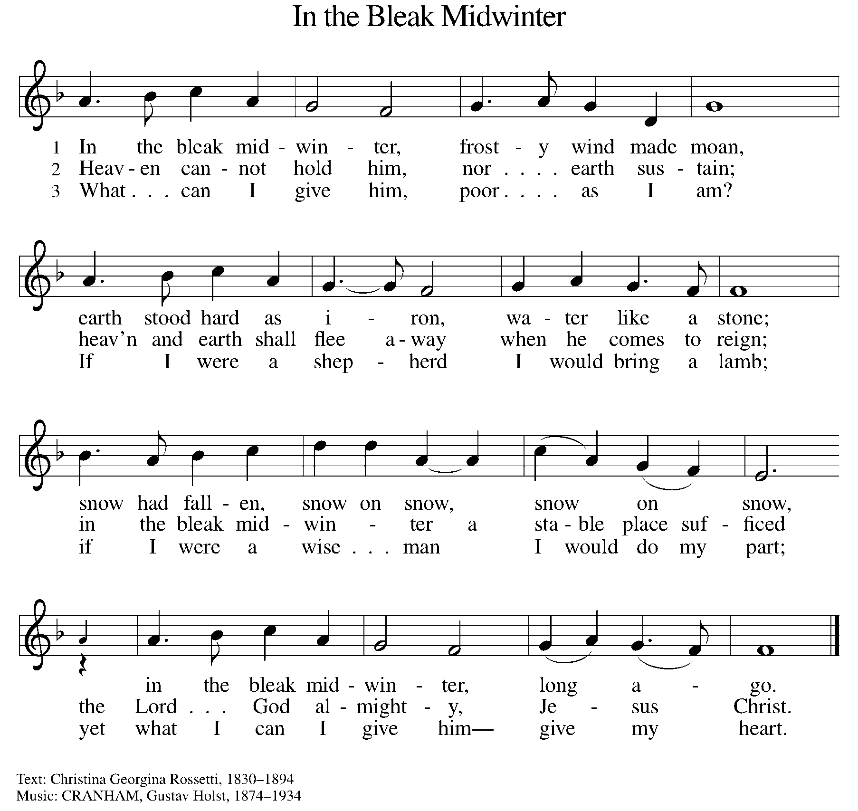

OFFERING PRAYER
A: Let us pray. God of heaven and earth, from the beginning, you have called forth life, in which you take delight. The trees, the fields, and the seas sing for joy. Bless now these gifts, received from your bounty, that we may join the chorus of creation to tell of your salvation from day to day.

C: Amen.

THE GREAT THANKSGIVING

P: The Lord be with you.
C: And also with you.
P: Lift up your hearts.
C: We lift them to the Lord.
P: Let us give thanks to the Lord our God.
C: It is right to give our thanks and praise.

PROPER PREFACE

P: It is indeed right, our duty and our joy, that we should at all times and in all places give thanks and praise to you, almighty and merciful God, through our Savior Jesus Christ. In the wonder and mystery of the Word made flesh you have opened the eyes of faith to a new and radiant vision of your glory, that, beholding the God made visible, we may be drawn to love the God whom we cannot see. And so, with all the choirs of angels, with the church on earth and the hosts of heaven, we praise your name and join their unending hymn:

HOLY, HOLY ELW Setting 2, Page 130

Holy, holy, holy Lord, God of power and might,
heaven and earth are full of your glory.
Hosanna in the highest.
Blessed is he who comes in the name of the Lord.
Hosanna in the highest. Hosanna in the highest.

EUCHARISTIC PRAYER

P: In the night in which he was betrayed, our Lord Jesus took bread, and gave thanks; broke it, and gave it to his disciples, saying:
Take and eat; this is my body, given for you. Do this for the
remembrance of me.
Again, after supper, he took the cup, gave thanks, and gave it for all to drink, saying:
This cup is the new covenant in my blood, shed for you and for all people for the forgiveness of sin. Do this for the remembrance of me.

LORD'S PRAYER

P: Lord, remember us in your kingdom, and teach us to pray:

C: Our Father, who art in heaven, hallowed be thy name, thy kingdom come, thy will be done on earth as it is in heaven. Give us this day our daily bread; and forgive us our trespasses as we forgive those who trespass against us; and lead us not into temptation, but deliver us from evil. For thine is the kingdom, and the power, and the glory, forever and ever. Amen.
(Please be seated.)
COMMUNION DISTRIBUTION

All who believe in the real presence of Christ in the bread and the wine (juice) are welcome to the table. Others may come forward for a blessing. If you prefer grape juice, please indicate this to the assisting minister.

When approaching the communion rail, come forward down the side aisle, kneel, if you are able, starting at the front of the communion rail (spot closest to the font) on your side and filling in toward the back. After receiving both the bread and the wine, you may return to your seat by the center aisle.

INVITATION TO COMMUNION

P: A child has been born for us, a Son given to us. Come, receive the gift of Jesus.

COMMUNION HYMN ELW 528
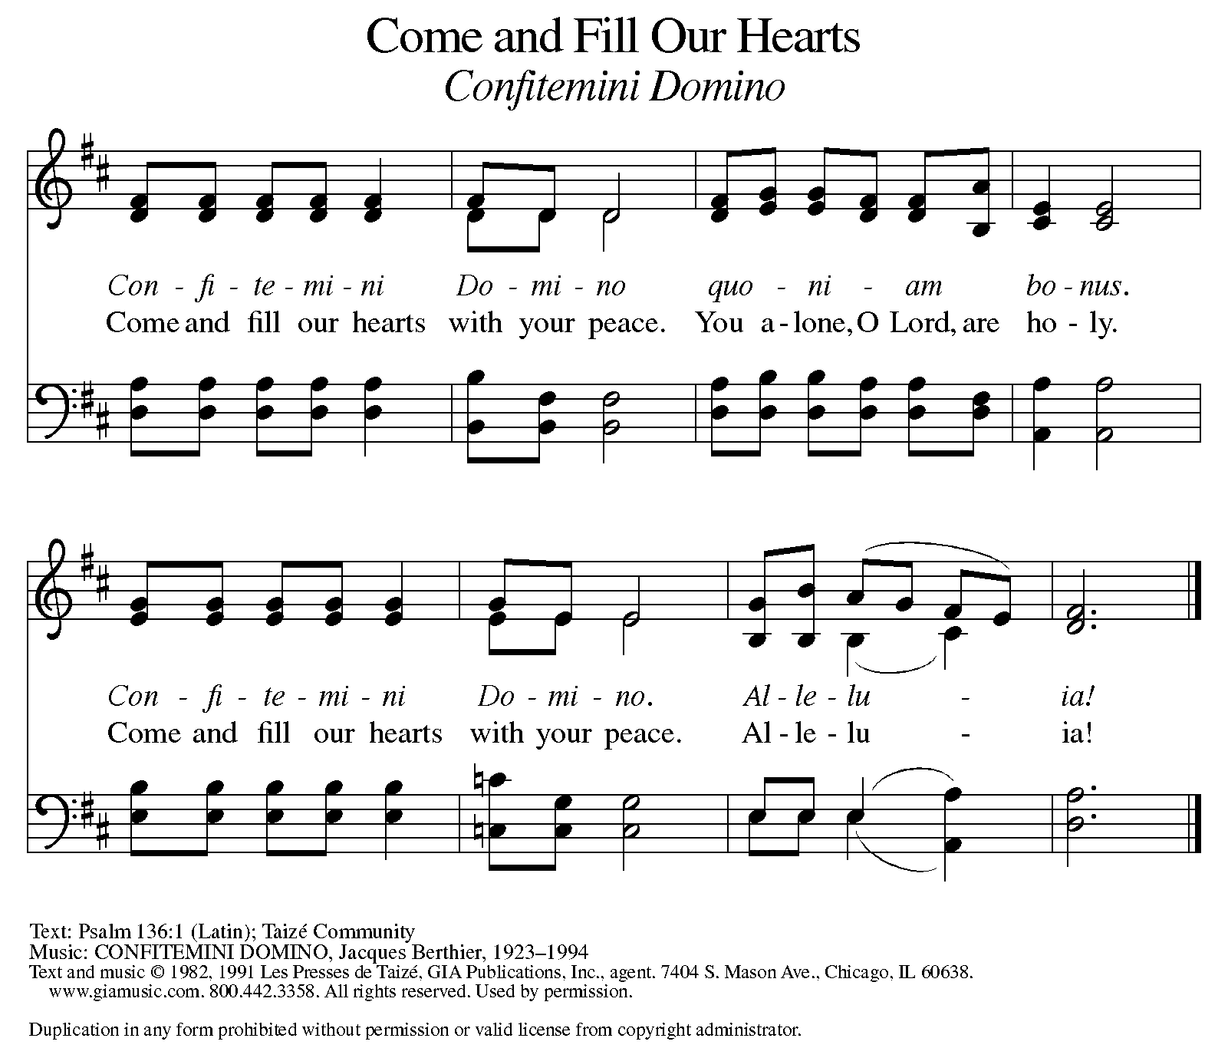

P: The body of Christ, given for you.

C: Amen.

A: The blood of Christ, shed for you.

C: Amen.
(Please rise as you are able.)

P: May the body and blood of our Lord Jesus Christ strengthen and keep you in his grace.

C: Amen.

PRAYER AFTER COMMUNION
P: Let us pray. Merciful God, we thank you for Jesus, who is our heavenly food. Strengthened by this goodness, send us forth to announce your peace, comfort the afflicted, and share the good news of great joy.

C: Amen.

SENDING

BLESSING

P: The God of love, Father, ☩ Son, and Holy Spirit, lavish you with grace,
illumine your path, and increase your joy, today and always.

C: Amen.

SENDING HYMN ELW 876
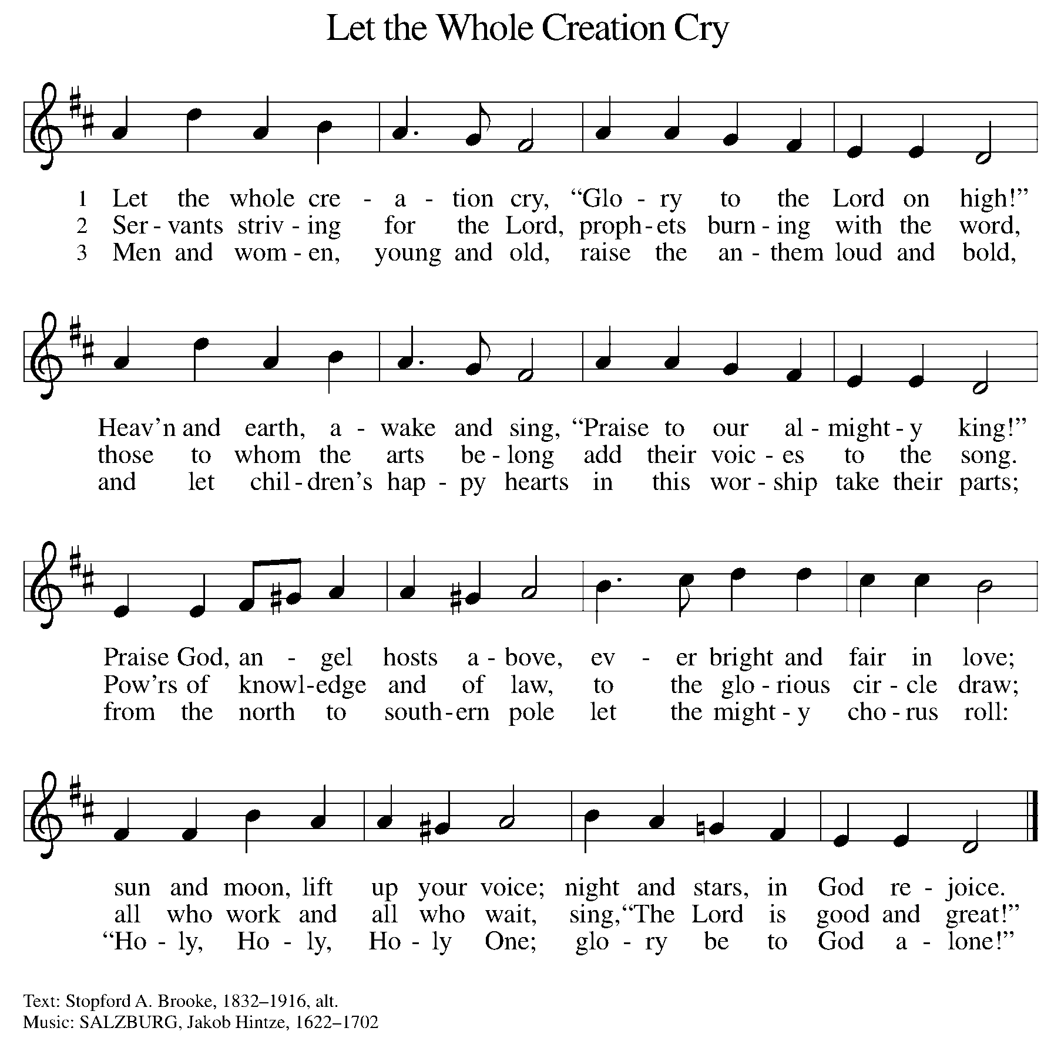

DISMISSAL

A: Go in peace. The Word of God dwells in you richly.

C: Thanks be to God.

Announcements

- Saturday, January 11 – Unhanging of the Greens @ 9:30am
- Monday, January 20 – MLK Day
- Sunday, January 26 – New Member Reception. Please let Pastor know if you’d like to become a member.

Recurring Events

- Every Sunday – Adult Bible Study @ 9am
- Monday, January 6 – Worship Committee Meeting @ 6:30pm
- Wednesday, January 8 – Women’s Bible Study @ 11am
- Thursday, January 16 – Council Meeting @ 7pm

Food Pantry Dates

Thursday, January 9, 1-3pm
Wednesday, January 15, 5-6:30pm
Thursday, January 23, 1-3pm
Wednesday, February 5, 5-6:30pm

Volunteers for January 5 Volunteers for January 12

Reader - Volunteer Reader – Volunteer
Assisting Minister - Kathy Assisting Minister –

January Birthday Celebrations

1/19 – Don Ke.
1/20 – Kelly Br.
1/23 – Daniel Op.
Acknowledgments
- OneLicense.net, License #A-703165.
- CCLI, License #2281869.
- From SundaysandSeasons.com. Copyright 2020 Augsburg Fortress. All rights reserved. Reprinted by permission under Augsburg Fortress Liturgies Annual License #23806.
- New Revised Standard Version Bible, copyright 1989, Division of Christian Education of the National Council of the Churches of Christ in the United States of America. Used by permission. All rights reserved.

