

Second Sunday After Epiphany
January 19, 2025

SAINT PAUL LUTHERAN CHURCH
3383 EAST LAKE LANSING ROAD
EAST LANSING, MI 48823

PHONE (517) 351-8541

Pastor Carl E. Ballard
E-MAIL: pastor@stpaul-el.org
officemanager@stpaul-el.org

Visitors WELCOME! If this is your first time worshipping with us, please sign our guest registry just outside the sanctuary doors. We hope you are blessed through worship today. If you have any questions, please feel free to call the church at 351-8541.
Children are always welcome in worship! The choir room (off the sanctuary) can also be used as a cry room for younger children and includes a sound system so parents may continue to participate in the service. Clipboards with children’s bulletins, activities and crayons are available for use during the service. Please see an usher if you are unable to locate them.
Sunday School is available during the worship service September-May except the last Sunday of the month.
This Bulletin is for your use during the service and to take home for the upcoming week. If you choose not to take it home, please place it in the recycle receptacle in the back.
Newsletters and Calendars of Upcoming Events are available in the lobby/narthex. We welcome anyone who has an interest in our small groups or activities! You can also look us up on the web at www.stpaul-el.org.
Contacting Us: Our office manager is Emily Polhamus. She can be reached by phone at 517-351-8541 or at her email address, officemanager@stpaul-el.org. Our Director of Music is Elene Kobulashvili. You may leave a message at 517-351-8541. Pastor Carl can be reached at 517-515-3129, and his email address is cballard123@msn.com.
Holy Communion is available at most services. All who believe in the real presence of Christ in the bread and the wine are invited to celebrate Communion with us. Those who wish can come forward for a blessing.
You are invited to share in fellowship after worship. We would love this opportunity to introduce you to the St. Paul community.

P-Presiding Minister A-Assisting Minister C-Congregation

PRELUDE ELENE

INTRODUCTION

The Sundays after Epiphany continue to celebrate the revelation of God’s glory to us as it was made known to the magi and to those on Jordan’s banks at Jesus’ baptism—today using wedding imagery. Our God rejoices over God’s people as those being married rejoice over one another. By the power of the Spirit there are gifts galore for everyone. In Christ Jesus the best wine is saved for last. Taste and see.

GATHERING

P: The Holy Spirit calls us together as the people of God.

(Please rise as you are able.)

CONFESSION & FORGIVENESS

All may make the sign of the cross, the sign that is marked at baptism, as the presiding minister begins.

P: Blessed be the holy Trinity, ☩ one God, our creator, our protector, our wellspring of life.

C: Amen.

P: Trusting that God receives our words and the meditations of our hearts, let us confess our sin.

(Silence is kept for reflection.)
P: Merciful God,
C: you speak blessing and compassion into the world. Forgive us for the ways we act with judgment, cruelty, or indifference. We ignore the needs of our neighbors; we resist your call to oppose injustice; we give in to scarcity and fear; we assume the worst about one another. Cleanse us from our faults and release us from their grasp. Show us your loving kindness. Restore our hearts and repair your world, that we may live in Christ’s ways. Amen.

P: God proclaims these words of assurance: “Do not fear, for I have redeemed you. I have called you by name. You are mine.” In ☩ Christ, you are forgiven. In the Spirit, you are made free. Refreshed by the waters of mercy, live anew as beloved children of God.

C: Amen.

GATHERING SONG ELW 462
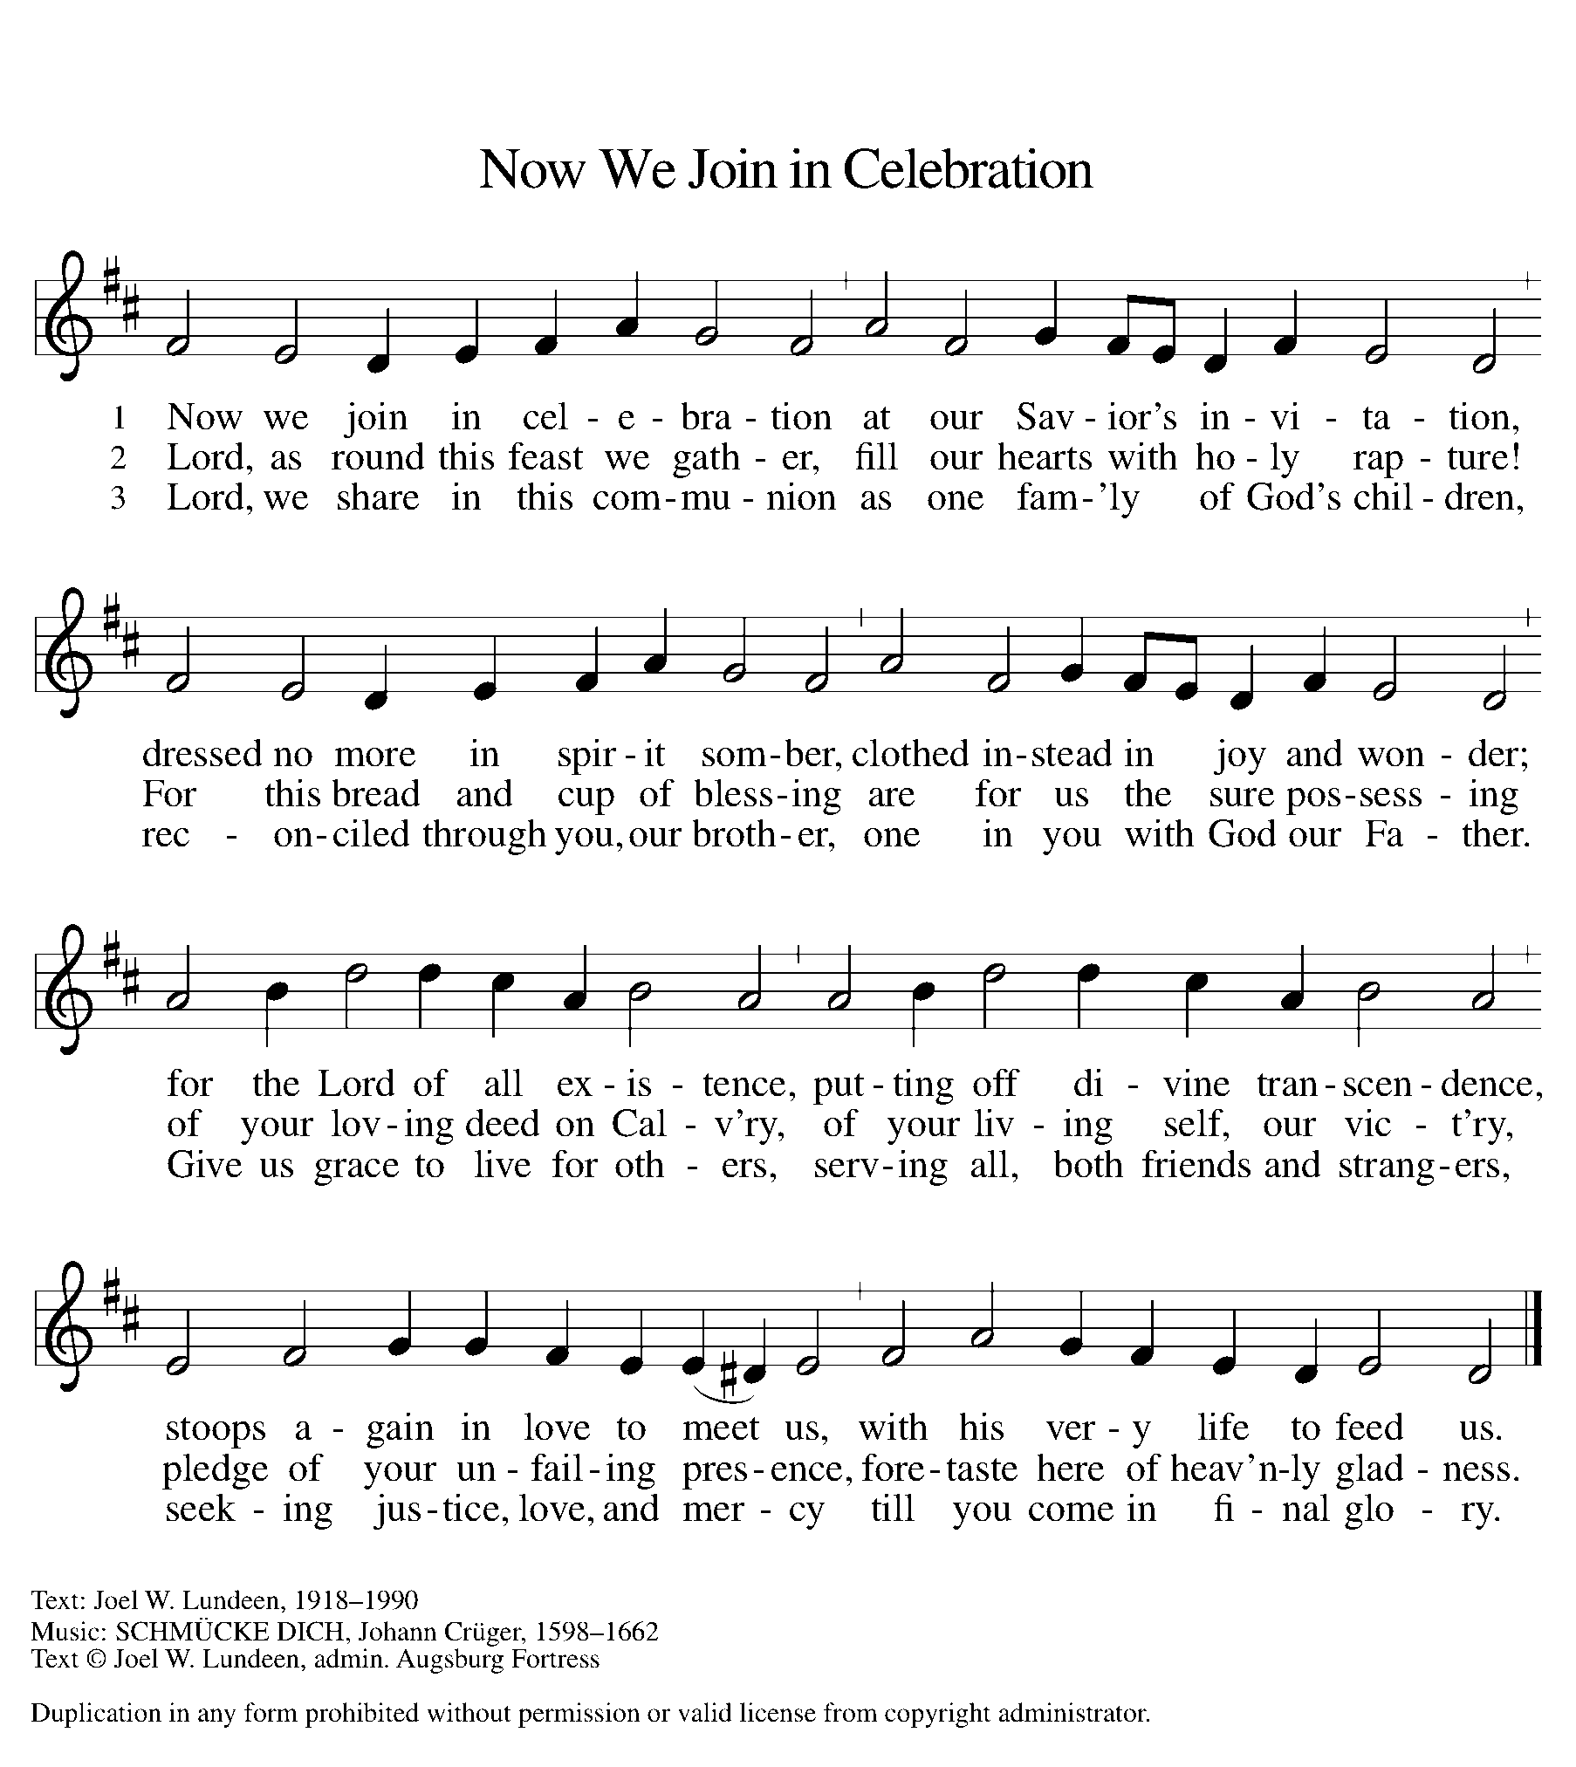

GREETING

P: The grace of our Lord Jesus Christ, the love of God, and the communion of the Holy Spirit be with you all.

C: And also with you.

KYRIE ELW Setting 2, Page 120
In peace, let us pray to the Lord.
Lord, have mercy.
For the peace from above and for our salvation,
let us pray to the Lord.
Lord, have mercy.
For the peace of the whole world, for the well-being of the church of God, and for the unity of all, let us pray to the Lord.
Lord, have mercy.
For this holy house and for all who offer here their worship and praise, let us pray to the Lord.
Lord, have mercy.
Help, save, comfort, and defend us, gracious Lord.
Amen.

CANTICLE OF PRAISE ELW Setting 4, Page 148-149
Glory to God in the highest, and peace to God’s people on earth.
Lord God, heavenly King, almighty God and Father,
we worship you, we give you thanks, we praise you for your glory. Lord Jesus Christ, only Son of the Father, Lord God, Lamb of God, you take away the sin of the world: have mercy on us;
you are seated at the right hand of the Father: receive our prayer. For you alone are the Holy One, you alone are the Lord,
you alone are the Most High, Jesus Christ, with the Holy Spirit,
in the glory of God the Father. Amen.

PRAYER OF THE DAY

P: Let us pray. Lord God, source of every blessing, you showed forth your glory and led many to faith by the works of your Son, who brought gladness and salvation to his people. Transform us by the Spirit of his love, that we may find our life together in him, Jesus Christ, our Savior and Lord.

C: Amen.

(Please be seated.)

CHILDREN’S MESSAGE

(Children are invited to Sunday School.)

TRANSITION SONG ELW 801
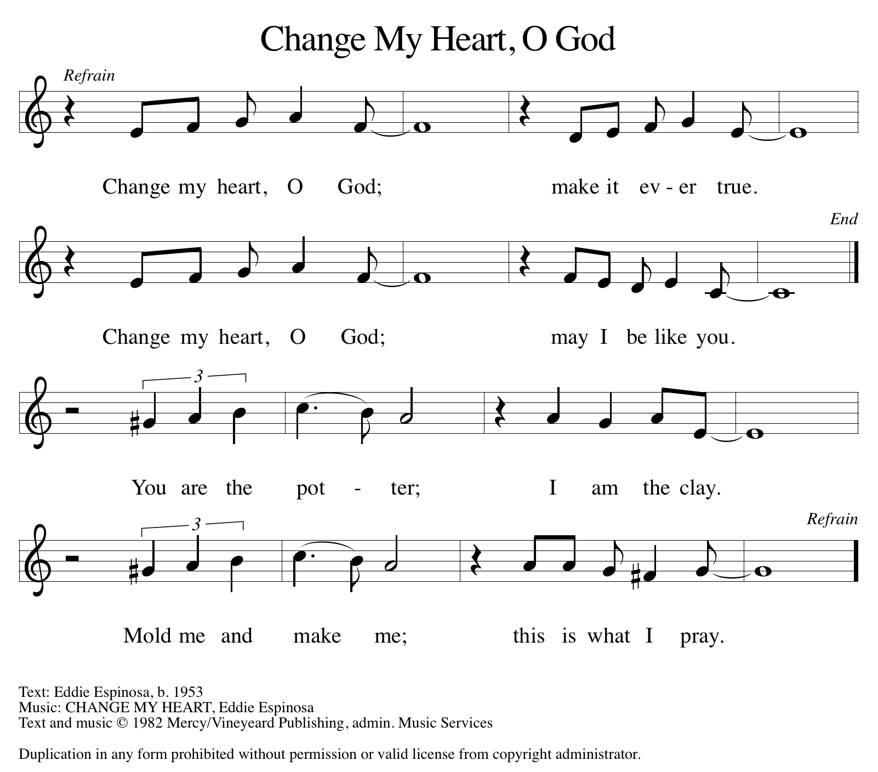

THE WORD

God speaks to us in scripture, preaching, and song.

First Reading isaiah 62:1-5
The people’s return to Judah after the exile was marred by economic and political troubles. Nevertheless, the prophet declares, Jerusalem and Judah will be restored. God will rejoice over Jerusalem as a bridegroom rejoices over the bride, and the people are called to the celebration.

¹ For Zion’s sake I will not keep silent, and for Jerusalem’s sake I will not rest, until her vindication shines out like the dawn and her salvation like a burning torch. ² The nations shall see your vindication and all the kings your glory, and you shall be called by a new name that the mouth of the Lord will give. ³ You shall be a beautiful crown in the hand of the Lord and a royal diadem in the hand of your God. ⁴ You shall no more be termed Forsaken, and your land shall no more be termed Desolate, but you shall be called My Delight Is in Her and your land Married, for the Lord delights in you, and your land shall be married. ⁵ For as a young man marries a young woman, so shall your builder marry you, and as the bridegroom rejoices over the bride, so shall your God rejoice over you.

Word of God, word of life. C: Thanks be to God.

PSALM PSALM 36:5-10
We feast upon the abundance of your house, O Lord. (Ps. 36:8)

⁵Your love, O Lord, reaches to the heavens, and your faithfulness to the
clouds.
⁶Your righteousness is like the strong mountains, your justice like the great deep; you save humankind and animals, O Lord.
⁷How priceless is your love, O God! All people take refuge under the shadow of your wings.
⁸They feast upon the abundance of your house; you give them drink from the river of your delights.
⁹For with you is the well of life, and in your light we see light.
¹⁰Continue your lovingkindness to those who know you, and your favor to those who are true of heart.

SECOND READING 1 CORINTHIANS 12:1-11
The congregation at Corinth experienced division as people were comparing their spiritual gifts, thinking some to be superior to others. Paul invites this fractured community to trust that God’s Holy Spirit has gifted them all perfectly for their mission together.

¹ Now concerning spiritual gifts, brothers and sisters, I do not want you to be ignorant. ² You know that when you were gentiles you were enticed and led astray to idols that could not speak. ³ Therefore I want you to understand that no one speaking by the Spirit of God ever says “Let Jesus be cursed!” and no one can say “Jesus is Lord” except by the Holy Spirit. ⁴ Now there are varieties of gifts but the same Spirit,

⁵ and there are varieties of services but the same Lord, ⁶ and there are varieties of activities, but it is the same God who activates all of them in everyone. ⁷ To each is given the manifestation of the Spirit for the common good. ⁸ To one is given through the Spirit the utterance of wisdom and to another the utterance of knowledge according to the same Spirit, ⁹ to another faith by the same Spirit, to another gifts of healing by the one Spirit, ¹⁰ to another the working of powerful deeds, to another prophecy, to another the discernment of spirits, to another various kinds of tongues, to another the interpretation of tongues. ¹¹ All these are activated by one and the same Spirit, who allots to each one individually just as the Spirit chooses.

Word of God, word of life. C: Thanks be to God.

(Please rise as you are able.)
GOSPEL ACCLAMATION ELW Setting 2, Page 124
Alleluia, alleluia, alleluia, alleluia.
Lord, to whom shall we go?
You have the words of eternal life.
Alleluia, alleluia, alleluia, alleluia.

GOSPEL JOHN 2:1-11

P: The Holy Gospel according to John, the 2nd chapter.
C: Glory to you, O Lord.
Turning water to wine at the wedding at Cana is described as the first of Jesus’ signs. Through many such epiphanies, Jesus reveals that he bears God’s creative power and joyful presence into the world.
¹On the third day there was a wedding in Cana of Galilee, and the mother of Jesus was there. ²Jesus and his disciples had also been invited to the wedding. ³When the wine gave out, the mother of Jesus said to him, “They have no wine.” ⁴And Jesus said to her, “Woman, what concern is that to me and to you? My hour has not yet come.” ⁵His mother said to the servants, “Do whatever he tells you.” ⁶Now standing there were six stone water jars for the Jewish rites of purification, each holding twenty or thirty gallons.
⁷Jesus said to them, “Fill the jars with water.” And they filled them up to the brim. ⁸He said to them, “Now draw some out, and take it to the person in charge of the banquet.” So they took it. ⁹When the person in charge tasted the water that had become wine and did not know where it came from (though the servants who had drawn the water knew), that person called the bridegroom ¹⁰and said to him, “Everyone serves the good wine first and then the inferior wine after the guests have become drunk. But you have kept the good wine until now.” ¹¹Jesus did this, the first of his signs, in Cana of Galilee and revealed his glory, and his disciples believed in him.
P: The Gospel of the Lord. C: Praise to you, O Christ.
(Please be seated.)

SERMON PASTOR CARL BALLARD

(Please rise as you are able.)

HYMN OF THE DAY ELW 310
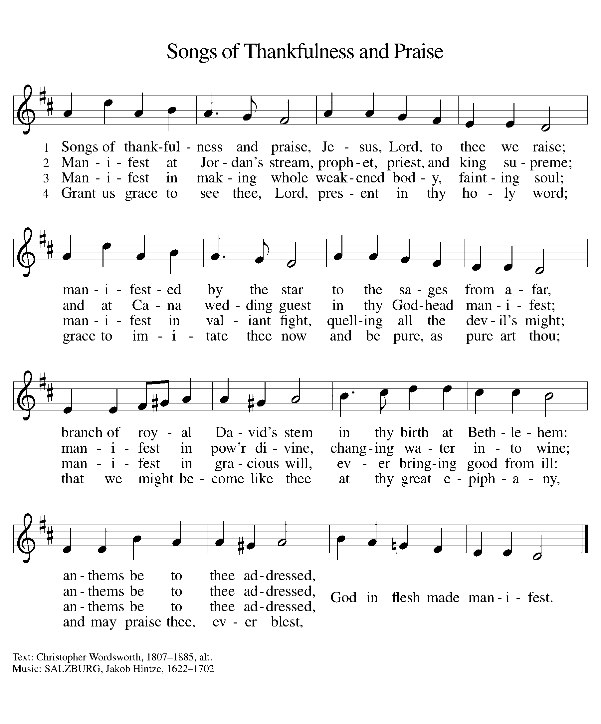

apostles’ CREED

I believe in God, the Father almighty,
creator of heaven and earth.
I believe in Jesus Christ, God’s only Son, our Lord,
who was conceived by the Holy Spirit,
born of the virgin Mary,
suffered under Pontius Pilate,
was crucified, died, and was buried;
he descended to the dead.
On the third day he rose again;
he ascended into heaven,
he is seated at the right hand of the Father,
and he will come to judge the living and the dead.
I believe in the Holy Spirit,
the holy catholic church,
the communion of saints,
the forgiveness of sins,
the resurrection of the body,
and the life everlasting. Amen.

(Please be seated.)

THE PRAYERS

A: With the Spirit of Christ shining upon us, let us boldly pray for the church, the world, and all of creation.
(A brief silence)
A: Giver of gifts, you form each member of the church to serve. Inspire us to boldly use gifts of welcome and healing, service and teaching, leading and preaching, for the sake of your work in the world. God of grace,

C: hear our prayer.
A: Refuge of creatures, you place all the living under the shadow of your wings. Lead us in ways that tend to the needs of wild and domestic animals, creatures threatened by extinction, and the environment we share. God of grace,

C: hear our prayer.
A: Voice of the oppressed, you call prophets throughout time. We remember the Rev. Dr. Martin Luther King Jr., a voice for racial and economic justice and for peace. Guide our nation in continuing to heed your prophetic call. God of grace,

C: hear our prayer.

A: God of steadfast love, as Jesus celebrated at Cana, nurture marriages and relationships in mutual care; in times of separation or divorce hold tenderly broken hearts and broken dreams. Be present to all who are sick, grieving or in any need. God of grace,

C: hear our prayer.

A: Spirit of peace, celebrating this Week of Prayer for Christian Unity, we pray for neighboring congregations and ministry sites. Nurture our shared commitment to embody Jesus’ love, justice, and healing. God of grace,
C: hear our prayer.

A: Shield of safety, protect and care for those who serve in our armed forces, especially Beth & Ryan, Jonathan, Jacob, Noah, Irene, and Alex. God of grace,

C: hear our prayer.

A: God, whose love is constant, you walk with us through life’s changes. Be near to all who are changing jobs, moving, welcoming children, or facing the loss of loved ones. Sustain those who are ill or suffering, especially Ahren, Barb, Beth Ra., Carolyn, Craig, Dan, David, Doretta, Jim & Cheri, John, Johnny, Jon, Jordan, Joseph Ra., Kathy, Kay, Kelly, Lawton, Lera & family, Linda, Lizzy, Marge, Mary, Nathan, Randy, Rick & Kathy, Sheri, Sheri, Steve, and Wanda, and all whom we name now aloud and in our hearts. In times of change, remind us of your steadfast love. God of grace,

C: hear our prayer.

A: Leader of your people, the church, give direction to Presiding Bishop Elizabeth, our Synod Bishop Craig, and Pastor Carl and their respective staffs as they live out their callings to serve. As we are called to be one, even as Jesus and the Father are one, be with the leaders and the congregation of Immanuel Lutheran Church in Big Rapids and all the churches in our community. God of grace,

C: hear our prayer.

A: Wellspring of life, in living and dying we trust in you. We give thanks for the saints. Guide us in our living until, at last, we rest in you. God of grace,

C: hear our prayer.

P: We entrust our prayers to you, O God, in the sure and certain hope that your promise is revealed among the people.

C: Amen.

GREETING OF PEACE

(You are invited to share Christ’s peace with one another.)

P: The peace of Christ be with you always.

C: And also with you.
(Please be seated.)
THE MEAL
OFFERING ELENE
(Please rise if you are able.)
OFFERTORY ELW 677
(Only Verse 1)
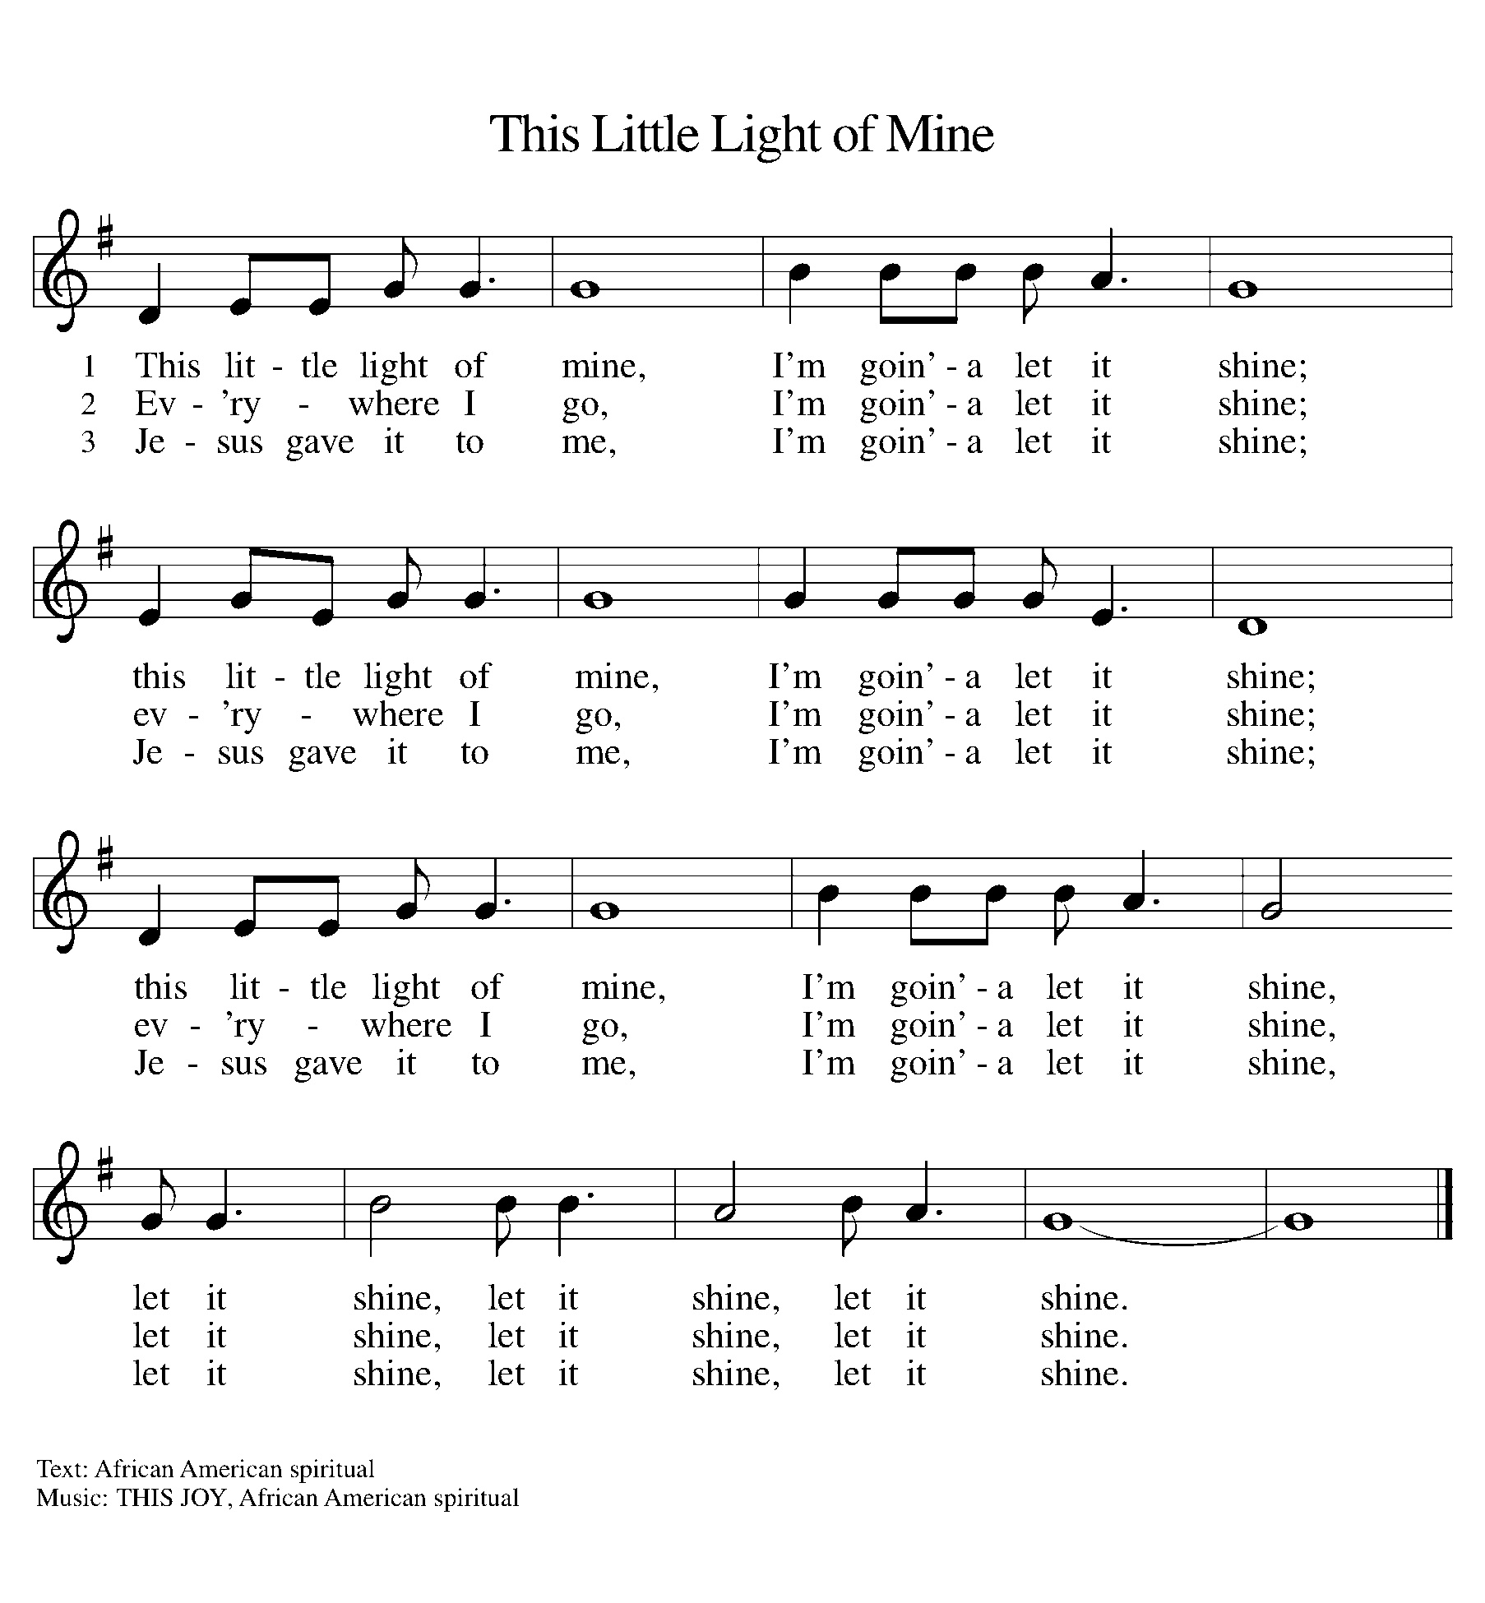

OFFERING PRAYER
A: Let us pray. God of grace, your love reaches to the heavens, and your abundance to the depths of the seas. Bless what we offer to your service: our gifts, our abilities, and our hearts. Let us overflow with gratitude and generosity, now and always.

C: Amen.

THE GREAT THANKSGIVING

P: The Lord be with you.
C: And also with you.
P: Lift up your hearts.
C: We lift them to the Lord.
P: Let us give thanks to the Lord our God.
C: It is right to give our thanks and praise.

PROPER PREFACE

P: It is indeed right, our duty and our joy, that we should at all times and in all places give thanks and praise to you, almighty and merciful God, through our Savior Jesus Christ; who on this day overcame death and the grave, and by his glorious resurrection opened to us the way of everlasting life. And so, with all the choirs of angels, with the church on earth and the hosts of heaven, we praise your name and join their unending hymn:

HOLY, HOLY ELW Setting 2, Page 130

Holy, holy, holy Lord, God of power and might,
heaven and earth are full of your glory.
Hosanna in the highest.
Blessed is he who comes in the name of the Lord.
Hosanna in the highest. Hosanna in the highest.

EUCHARISTIC PRAYER

P: In the night in which he was betrayed, our Lord Jesus took bread, and gave thanks; broke it, and gave it to his disciples, saying:
Take and eat; this is my body, given for you. Do this for the
remembrance of me.
Again, after supper, he took the cup, gave thanks, and gave it for all to drink, saying:
This cup is the new covenant in my blood, shed for you and for all people for the forgiveness of sin. Do this for the remembrance of me.

LORD'S PRAYER

P: Lord, remember us in your kingdom, and teach us to pray:

C: Our Father, who art in heaven, hallowed be thy name, thy kingdom come, thy will be done on earth as it is in heaven. Give us this day our daily bread; and forgive us our trespasses as we forgive those who trespass against us; and lead us not into temptation, but deliver us from evil. For thine is the kingdom, and the power, and the glory, forever and ever. Amen.
(Please be seated.)

COMMUNION DISTRIBUTION

All who believe in the real presence of Christ in the bread and the wine (juice) are welcome to the table. Others may come forward for a blessing. If you prefer grape juice, please indicate this to the assisting minister.

When approaching the communion rail, come forward down the side aisle, kneel, if you are able, starting at the front of the communion rail (spot closest to the font) on your side and filling in toward the back. After receiving both the bread and the wine, you may return to your seat by the center aisle.

INVITATION TO COMMUNION

P: The joy of the Lord is our strength. Come, eat this meal of gladness.

COMMUNION HYMN ELW 496
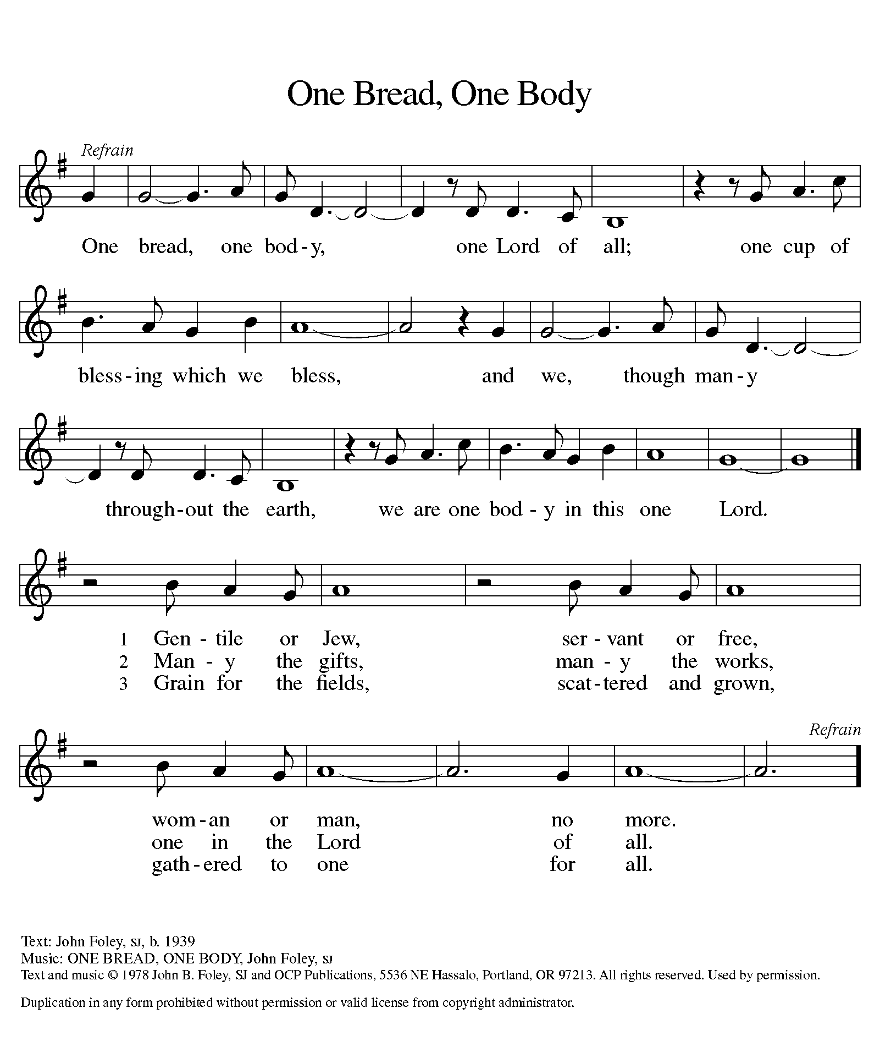

P: The body of Christ, given for you.

C: Amen.

A: The blood of Christ, shed for you.

C: Amen.
(Please rise as you are able.)

P: May the body and blood of our Lord Jesus Christ strengthen and keep you in his grace.

C: Amen.
PRAYER AFTER COMMUNION
P: Let us pray. Nourishing God, at this table you have refreshed us with holy gifts of food and drink. Strengthen us for service, and send us out to embody your good news of liberation and healing for the sake of the world. In the name of Christ we pray,

C: Amen.

SENDING

BLESSING

P: The Spirit of the triune God ☩ bless you with joy, anoint you with compassion, and send you in love.

C: Amen.

SENDING HYMN ELW 576
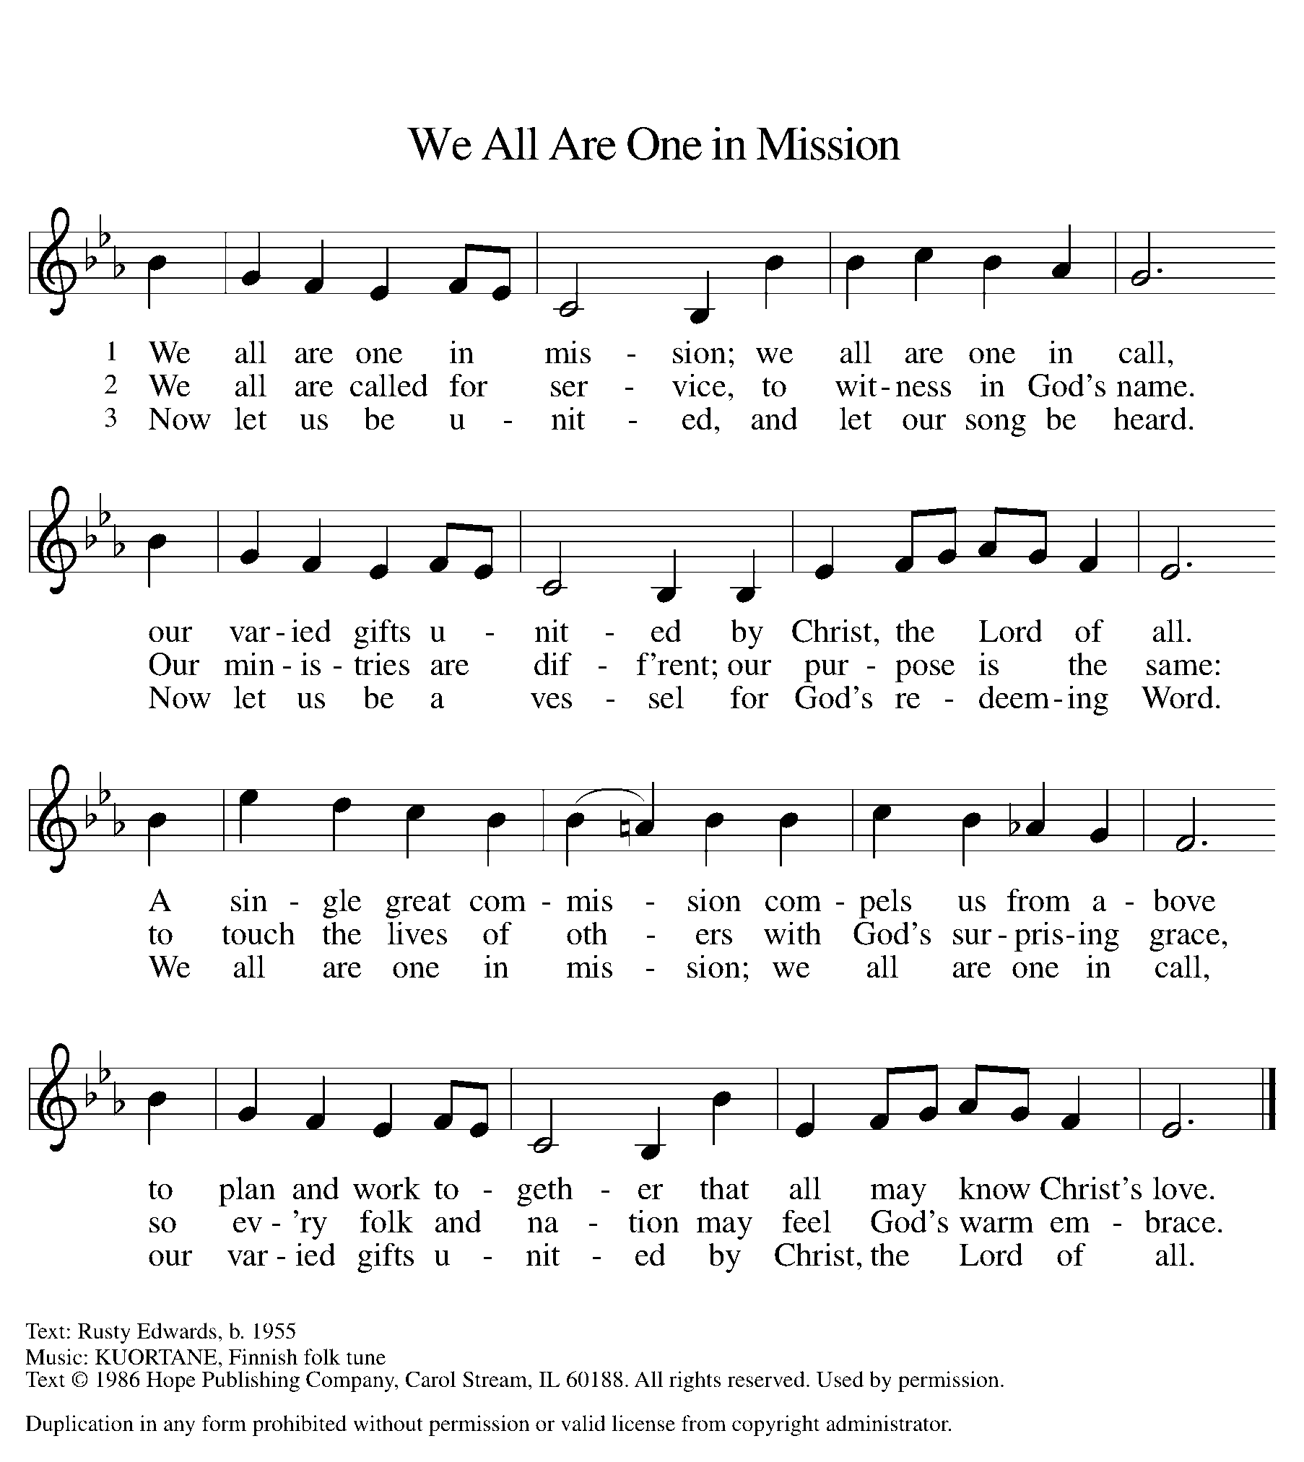

DISMISSAL

A: Go in peace. Live in hope.

C: Thanks be to God.

Announcements
- Monday, January 20 – MLK Day
- Sunday, January 26 – New Member Reception. Please let Pastor know if you’d like to become a member.
- Sunday, February 2 – Fish Fry (following service) @ 11:15am
- Friday, February 14 – Happy Valetine’s Day! 
- Monday, February 17 – Presidents’ Day
- Wednesday, March 5 – Ash Wednesday @ 6pm

Recurring Events
- Every Sunday – Adult Bible Study @ 9am
- Monday, February 10 – Worship Committee Meeting @ 6:30pm
- Wednesday, February 12 – Women’s Bible Study @ 11am
- Thursday, February 20 – Council Meeting @ 7pm

Food Pantry Dates
Thursday, January 23, 1-3pm
Wednesday, February 5, 5-6:30pm
Thursday, February 13, 1-3pm
Wednesday, February 19, 5-6:30pm
Thursday, February 27, 1-3pm

Volunteers for January 19 Volunteers for January 26
Reader - Volunteer Reader – Volunteer
Assisting Minister - Volunteer Assisting Minister – Volunteer

January Birthday Celebrations
1/19 – Don Ke.
1/20 – Kelly Br.
1/23 – Daniel Op.
Acknowledgments
- OneLicense.net, License #A-703165.
- CCLI, License #2281869.
- From SundaysandSeasons.com. Copyright 2020 Augsburg Fortress. All rights reserved. Reprinted by permission under Augsburg Fortress Liturgies Annual License #23806.
- New Revised Standard Version Bible, copyright 1989, Division of Christian Education of the National Council of the Churches of Christ in the United States of America. Used by permission. All rights reserved.

