

3rd Sunday of Advent
December 15, 2024

SAINT PAUL LUTHERAN CHURCH
3383 EAST LAKE LANSING ROAD
EAST LANSING, MI 48823

PHONE (517) 351-8541

Pastor Carl E. Ballard
E-MAIL: pastor@stpaul-el.org
officemanager@stpaul-el.org

Visitors WELCOME! If this is your first time worshipping with us, please sign our guest registry just outside the sanctuary doors. We hope you are blessed through worship today. If you have any questions, please feel free to call the church at 351-8541.
Children are always welcome in worship! The choir room (off the sanctuary) can also be used as a cry room for younger children and includes a sound system so parents may continue to participate in the service. Clipboards with children’s bulletins, activities and crayons are available for use during the service. Please see an usher if you are unable to locate them.
Sunday School is available during the worship service September-May except the last Sunday of the month.
This Bulletin is for your use during the service and to take home for the upcoming week. If you choose not to take it home, please place it in the recycle receptacle in the back.
Newsletters and Calendars of Upcoming Events are available in the lobby/narthex. We welcome anyone who has an interest in our small groups or activities! You can also look us up on the web at www.stpaul-el.org.
Contacting Us: Our office manager is Emily Polhamus. She can be reached by phone at 517-351-8541 or at her email address, officemanager@stpaul-el.org. Our Director of Music is Elene Kobulashvili. You may leave a message at 517-351-8541. Pastor Carl can be reached at 517-515-3129, and his email address is cballard123@msn.com.
Holy Communion is available at most services. All who believe in the real presence of Christ in the bread and the wine are invited to celebrate Communion with us. Those who wish can come forward for a blessing.
You are invited to share in fellowship after worship. We would love this opportunity to introduce you to the St. Paul community.

P-Presiding Minister A-Assisting Minister C-Congregation

PRELUDE

INTRODUCTION

Christ’s presence in our midst in the wonder of the holy supper is cause for singing. The nearness of the God in prayer, in every circumstance, is cause for rejoicing. The coming of one “more powerful” than John, even with a winnowing fork in hand, is good news—and cause for exultation—for us who are being saved. Great joy is the tone for the third Sunday of Advent.

GATHERING

P: The Holy Spirit calls us together as the people of God.

(Please rise as you are able.)

CONFESSION & FORGIVENESS

All may make the sign of the cross, the sign that is marked at baptism, as the presiding minister begins.

P: Blessed be the holy Trinity, ☩ one God, alive in the world, reviving creation,
arriving soon.

C: Amen.

P: Let us confess our sin in the presence of God and of one another.

(Silence is kept for reflection.)
P: God of mercy,

C: we confess that we have sinned. We trust earthly powers and human authority alone. We grow fearful. We cling to false comforts.

P: God of might,

C: we confess that we have sinned. We have turned away from our neighbors. We have trusted false promises.

P: God in our midst,

C: we confess that we have sinned. We plead: come to us. Bring your mercy to birth in us.

P: A righteous branch springs forth: it is Christ the Lord, our Savior, in whom we have forgiveness, life, and mercy. By the power of the Holy Spirit,
receive the grace and forgiveness of God through ☩ Christ Jesus, whose day draws near.

C: Amen.

GATHERING SONG ELW 264
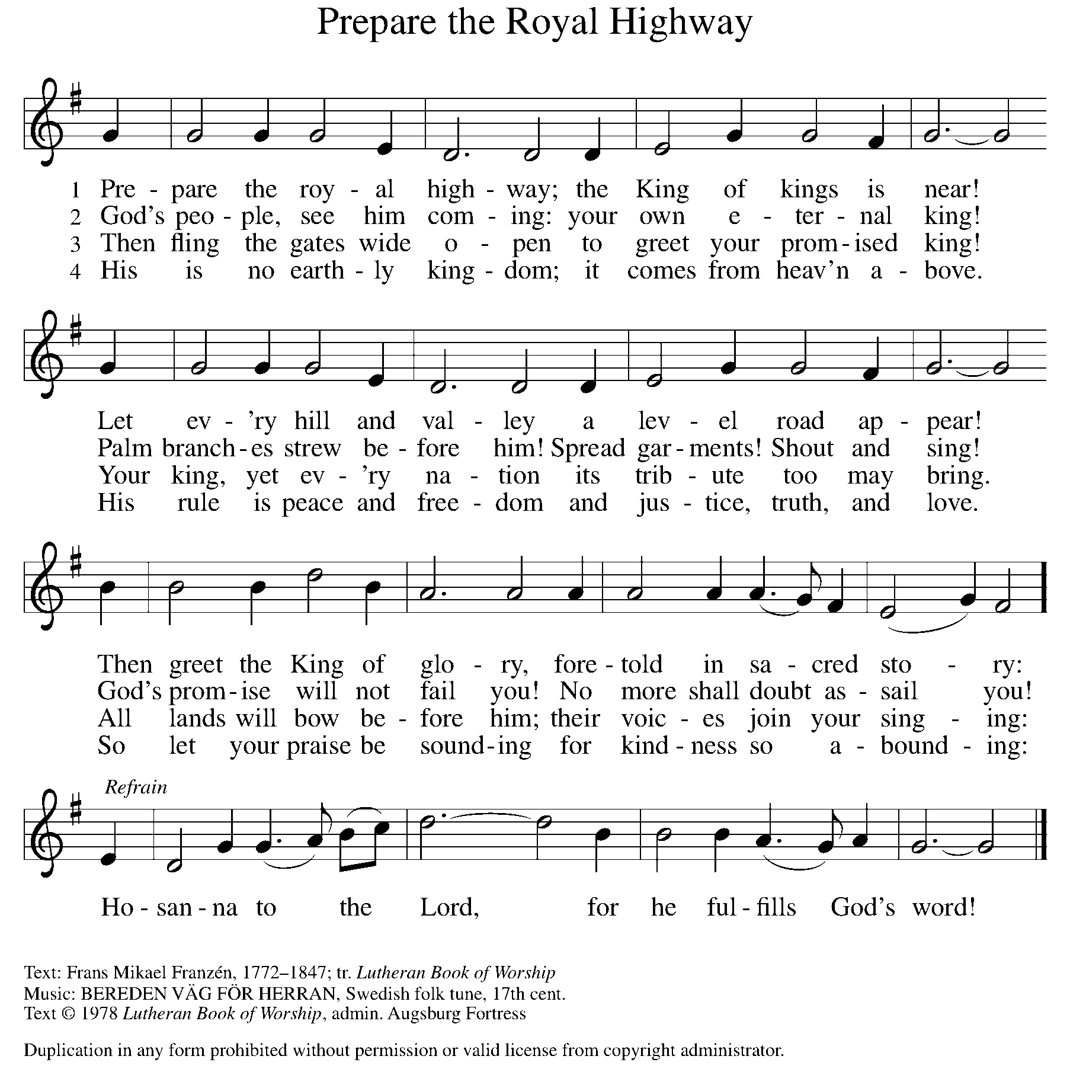

BLESSING OF THE ADVENT WREATH
Candle Lighter: At every beginning there is a yearning for the one who is coming. O Emmanuel,
C: Prepare us for your coming.
CL: We gather together to get ready for what? Only heaven knows. O Emmanuel,
C: Prepare us for your coming.
CL: We wait for the day when God will create a prevailing peace on the earth, and natural-born enemies turn into newborn friends. O Emmanuel,
C: Prepare us for your coming.
CL: We get ready for God to come close by laying our lives open to Jesus, asking him to sort through all our mixed motives. O Emmanuel,
C: Prepare us for your coming.
CL: Jesus, we welcome your presence now with the lighting of these candles, whose flames bring warmth to winter and fill this place with the glow of hope.
C: Amen.

LIGHT ONE CANDLE TO WATCH FOR MESSIAH ELW 240
Light one candle to watch for Messiah:
let the light banish darkness.
He shall bring salvation to Israel,
God fulfills the promise.

Light two candles to watch for Messiah:
let the light banish darkness.
He shall feed the flock like a shepherd,
gently lead them homeward.

Light three candles to watch for Messiah:
let the light banish darkness.
Lift your heads and lift high the gateway
for the King of glory.

GREETING

P: The grace of our Lord Jesus Christ, the love of God, and the communion of the Holy Spirit be with you all.

C: And also with you.

KYRIE ELW Setting 2, Page 120
In peace, let us pray to the Lord.
Lord, have mercy.
For the peace from above and for our salvation,
let us pray to the Lord.
Lord, have mercy.
For the peace of the whole world, for the well-being of the church of God, and for the unity of all, let us pray to the Lord.
Lord, have mercy.
For this holy house and for all who offer here their worship and praise, let us pray to the Lord.
Lord, have mercy.
Help, save, comfort, and defend us, gracious Lord.
Amen.

CANTICLE OF PRAISE ELW Setting 4, Page 148-149

Glory to God in the highest, and peace to God’s people on earth.
Lord God, heavenly King, almighty God and Father,
we worship you, we give you thanks, we praise you for your glory. Lord Jesus Christ, only Son of the Father, Lord God, Lamb of God, you take away the sin of the world: have mercy on us;
you are seated at the right hand of the Father: receive our prayer. For you alone are the Holy One, you alone are the Lord,
you alone are the Most High, Jesus Christ, with the Holy Spirit,
in the glory of God the Father. Amen.

PRAYER OF THE DAY

P: Let us pray. Stir up the wills of your faithful people, Lord God, and open our ears to the preaching of John, that, rejoicing in your salvation, we may bring forth the fruits of repentance; through Jesus Christ, our Savior and Lord, who lives and reigns with you and the Holy Spirit, one God, now and forever.

C: Amen.

(Please be seated.)

CHILDREN’S MESSAGE

(Children are invited to Sunday School.)

TRANSITION SONG ANCIENT WORDS
Ancient words ever true
Changing me, and changing you.
We have come with open hearts
Oh let the ancient words impart.
THE WORD

God speaks to us in scripture, preaching, and song.

First Reading Zephaniah 3:14-20
The prophet Zephaniah’s message is mostly one of judgment for sin. This reading, however, which comes from the conclusion of the book, prophesies joy for Judah and Jerusalem. Judgment has led to repentance, and God’s salvation is at hand.

¹⁴ Sing aloud, O daughter Zion; shout, O Israel! Rejoice and exult with all your heart, O daughter Jerusalem! ¹⁵ The Lord has taken away the judgments against you; he has turned away your enemies. The king of Israel, the Lord, is in your midst; you shall fear disaster no more. ¹⁶ On that day it shall be said to Jerusalem: “Do not fear, O Zion; do not let your hands grow weak. ¹⁷ The Lord, your God, is in your midst, a warrior who gives victory; he will rejoice over you with gladness; he will renew you in his love; he will exult over you with loud singing ¹⁸ as on a day of festival.” I will remove disaster from you, so that you will not bear reproach for it.

¹⁹ I will deal with all your oppressors at that time. And I will save the lame and gather the outcast, and I will change their shame into praise and renown in all the earth. ²⁰ At that time I will bring you home, at the time when I gather you; for I will make you renowned and praised among all the peoples of the earth, when I restore your fortunes before your eyes, says the Lord.

Word of God, word of life. C: Thanks be to God.

PSALM ISAIAH 12:2-6
In your midst is the Holy One of Israel. (Is. 12:6)

²Surely God is my salvation; I will trust and not be afraid. The Lord, the Lord himself, is my strength and my defense; he has become my salvation.
³With joy you will draw water from the wells of salvation.
⁴And you will say in that day: Give thanks to the Lord, call on God’s name; make known the deeds of the Lord among the nations; proclaim that this name is exalted.
⁵Sing praises to the Lord, for he has done gloriously; let this be known in all the earth.
⁶Shout aloud and sing for joy, O royal Zion, for great in your midst is the Holy One of Israel.

SECOND READING PHILIPPIANS 4:4-7
Despite being in prison, Paul is remarkably upbeat as he writes this letter. Here, he urges his friends in Philippi to trust God with all their worries and concerns with the hope that they will experience God’s joy and peace.

⁴Rejoice in the Lord always; again I will say, Rejoice. ⁵Let your gentleness be known to everyone. The Lord is near. ⁶Do not be anxious about anything, but in everything by prayer and supplication with thanksgiving let your requests be made known to God. ⁷And the peace of God, which surpasses all understanding, will guard your hearts and your minds in Christ Jesus.

Word of God, word of life. C: Thanks be to God.

(Please rise as you are able.)
GOSPEL ACCLAMATION ELW Setting 2, Page 124
Alleluia, alleluia, alleluia, alleluia.
Lord, to whom shall we go?
You have the words of eternal life.
Alleluia, alleluia, alleluia, alleluia.

GOSPEL LUKE 3:7-18

P: The Holy Gospel according to Luke, 3rd chapter.
C: Glory to you, O Lord.
John the Baptist heralds the mighty one who is coming. John teaches that preparation for God’s reign is not a matter of identity but of bearing fruits of merciful justice, radical generosity, and vocational integrity.
⁷John said to the crowds coming out to be baptized by him, “You brood of vipers! Who warned you to flee from the coming wrath? ⁸Therefore, bear fruits worthy of repentance, and do not begin to say to yourselves, ‘We have Abraham as our ancestor,’ for I tell you, God is able from these stones to raise up children to Abraham. ⁹Even now the ax is lying at the root of the trees; therefore every tree that does not bear good fruit will be cut down and thrown into the fire.” ¹⁰And the crowds asked him, “What, then, should we do?”
¹¹In reply he said to them, “Whoever has two coats must share with anyone who has none, and whoever has food must do likewise.” ¹²Even tax collectors came to be baptized, and they asked him, “Teacher, what should we do?” ¹³He said to them, “Collect no more than the amount prescribed for you.” ¹⁴Soldiers also asked him, “And we, what should we do?” He said to them, “Do not extort money from anyone by threats or false accusation, and be satisfied with your wages.”
¹⁵As the people were filled with expectation and all were questioning in their hearts concerning John, whether he might be the Messiah, ¹⁶John answered all of them by saying, “I baptize you with water, but one who is more powerful than I is coming; I am not worthy to untie the strap of his sandals. He will baptize you with the Holy Spirit and fire. ¹⁷His winnowing fork is in his hand to clear his threshing floor and to gather the wheat into his granary, but the chaff he will burn with unquenchable fire.” ¹⁸So with many other exhortations he proclaimed the good news to the people.

P: The Gospel of the Lord. C: Praise to you, O Christ.
(Please be seated.)

SERMON PASTOR CARL BALLARD

(Please rise as you are able.)

HYMN OF THE DAY ELW 249
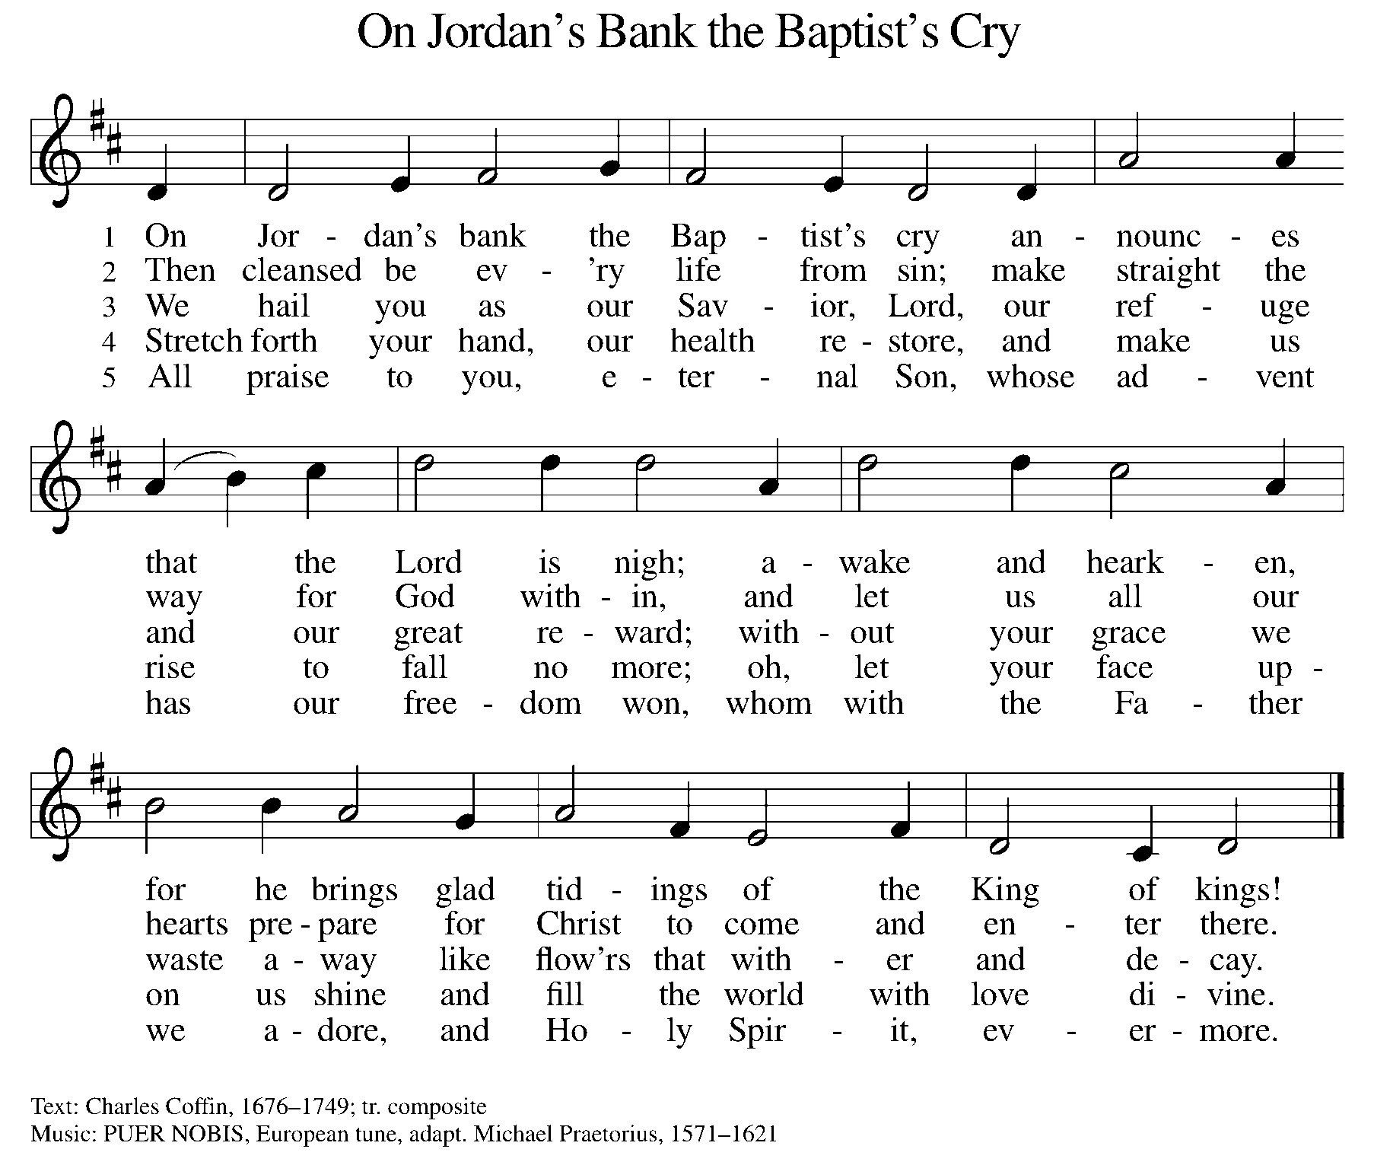

NICENE CREED

We believe in one God,
the Father, the Almighty,
maker of heaven and earth,
of all that is, seen and unseen.

We believe in one Lord, Jesus Christ,
the only Son of God,
eternally begotten of the Father,
God from God, Light from Light,
true God from true God,
begotten, not made,
of one Being with the Father;
For us and for our salvation
he came down from heaven,
was incarnate of the Holy Spirit and the virgin Mary
and became truly human.
For our sake he was crucified under Pontius Pilate;
he suffered death and was buried.
On the third day he rose again
in accordance with the scriptures;
he ascended into heaven
and is seated at the right hand of the Father.
He will come again in glory to judge the living and the dead,
and his kingdom will have no end.

We believe in the Holy Spirit, the Lord, the giver of life,
who proceeds from the Father and the Son,
who with the Father and the Son is worshiped and glorified,
who has spoken through the prophets.
We believe in one holy catholic and apostolic church.
We acknowledge one baptism for the forgiveness of sins.
We look for the resurrection of the dead,
and the life of the world to come. Amen.

(Please be seated.)

THE PRAYERS

A: As we prepare for Emmanuel, God-with-us, let us pray for all people and places that long for God’s presence.
(A brief silence)
A: God who reforms, fill your church with courage to do your will. Empower your people in taking risks that bear fruit. Raise up leaders who will proclaim the good news. Lord, in your mercy,

C: receive our prayer.

A: God who creates, you hold in balance diverse ecosystems. Encourage efforts to protect wild lands from devastation. Care for animals and people in the path of destructive fires, storms, and other disasters. Lord, in your mercy,

C: receive our prayer.

A: God who leads, this world cries out for true justice. Guide legislatures, judges, and lawyers in actions steeped in love and restoration. Increase the desire to advocate for all who are confronted with discrimination and oppression based on race, gender, sexuality, class, or age. Lord, in your mercy,

C: receive our prayer.

A: God who embraces, help us notice the places where your people are hurting or sick. Show your compassion and remember your people in love. Lord, in your mercy,

C: receive our prayer.

A: God who abides, you dwell among the people of this congregation. Deepen our relationships with one another, and make us aware of the diverse talents and gifts present here. Lord, in your mercy,
C: receive our prayer.

A: God who shields,, send angels of protection to provide care and compassion for those who serve in our armed forces, especially Beth & Ryan, Jonathan, Jacob, Noah, Irene, and Alex. Lord, in your mercy,

C: receive our prayer.

A: God who never changes, you accompany us through life’s transitions. Be near to all who are changing jobs, moving, welcoming children, or facing the loss of loved ones. Sustain those who are ill or suffering, especially Ahren, Barb, Carolyn, Craig, Dan, David, Doretta, Jim & Cheri, John, Johnny, Jon, Jordan, Kathy, Kay, Kelly, Lawton, Lera & family, Linda, Lizzy, Marge, Mary, Nathan, Pastor Sarah, Rick & Kathy, Sheri, Sheri, and Wanda, and all whom we name now aloud and in our hearts. In times of change, remind us of your steadfast love. Lord, in your mercy,

C: receive our prayer.

A: God who points the way, guide our church’s leaders, Presiding Bishop Elizabeth, our Synod Bishop Craig, and Pastor Carl and their respective staffs as they live out their callings to serve. As we are called to be one, even as Jesus and the Father are one, be with the leaders and the congregation of St. Paul Lutheran Church in Au Gres and all the churches in our community. Lord, in your mercy,

C: receive our prayer.

A: God who consoles, we thank you for the time we have had with loved ones who have died. Comfort us with the promise of everlasting life in you. Lord, in your mercy,

C: receive our prayer.

P: Savior of the nations, come, and receive these prayers and the pleas of our hearts, in the name of Jesus Christ.

C: Amen.
GREETING OF PEACE

(You are invited to share Christ’s peace with one another.)

P: The peace of Christ be with you always.

C: And also with you.
(Please be seated.)
THE MEAL
OFFERING
(Please rise if you are able.)
OFFERTORY ELW 294
(Only Verse 3)
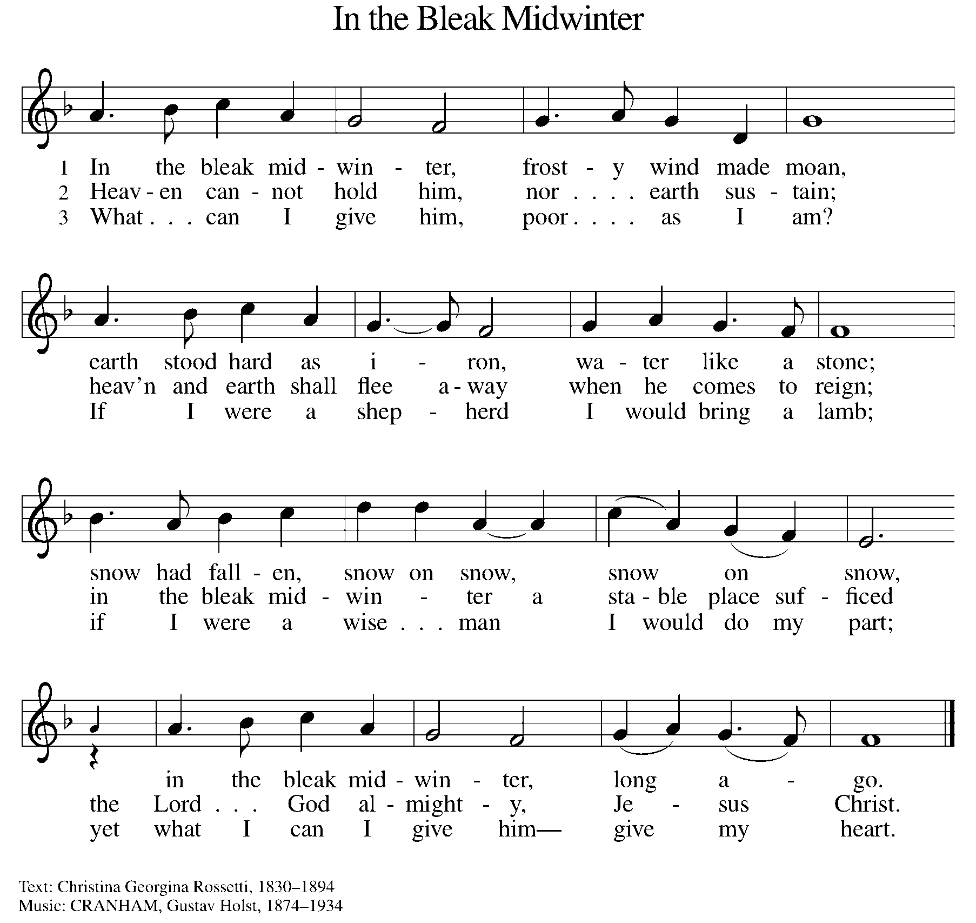
OFFERING PRAYER
A: Let us pray. Creator God, you made the whole world, even the farthest stars, and you draw near to feed us. We praise you for these gifts of bread and wine. Strengthen us with this food that we may live in expectation for the advent of your Son, Jesus Christ our Lord.

C: Amen.

THE GREAT THANKSGIVING

P: The Lord be with you.
C: And also with you.
P: Lift up your hearts.
C: We lift them to the Lord.
P: Let us give thanks to the Lord our God.
C: It is right to give our thanks and praise.

PROPER PREFACE

P: It is indeed right, our duty and our joy, that we should at all times and in all places give thanks and praise to you, almighty and merciful God, through our Savior Jesus Christ. You comforted your people with the promise of the Redeemer, through whom you will also make all things new in the day when he comes to judge the world in righteousness. And so, with all the choirs of angels, with the church on earth and the hosts of heaven, we praise your name and join their unending hymn:

HOLY, HOLY ELW Setting 2, Page 130

Holy, holy, holy Lord, God of power and might,
heaven and earth are full of your glory.
Hosanna in the highest.
Blessed is he who comes in the name of the Lord.
Hosanna in the highest. Hosanna in the highest.

EUCHARISTIC PRAYER

P: In the night in which he was betrayed, our Lord Jesus took bread, and gave thanks; broke it, and gave it to his disciples, saying:
Take and eat; this is my body, given for you. Do this for the
remembrance of me.
Again, after supper, he took the cup, gave thanks, and gave it for all to drink, saying:
This cup is the new covenant in my blood, shed for you and for all people for the forgiveness of sin. Do this for the remembrance of me.

LORD'S PRAYER

P: Lord, remember us in your kingdom, and teach us to pray:

C: Our Father, who art in heaven, hallowed be thy name, thy kingdom come, thy will be done on earth as it is in heaven. Give us this day our daily bread; and forgive us our trespasses as we forgive those who trespass against us; and lead us not into temptation, but deliver us from evil. For thine is the kingdom, and the power, and the glory, forever and ever. Amen.
(Please be seated.)
COMMUNION DISTRIBUTION

All who believe in the real presence of Christ in the bread and the wine (juice) are welcome to the table. Others may come forward for a blessing. If you prefer grape juice, please indicate this to the assisting minister.

When approaching the communion rail, come forward down the side aisle, kneel, if you are able, starting at the front of the communion rail (spot closest to the font) on your side and filling in toward the back. After receiving both the bread and the wine, you may return to your seat by the center aisle.

INVITATION TO COMMUNION

P: God feeds us with tender mercy. Come to the table.

COMMUNION HYMN ELW 528
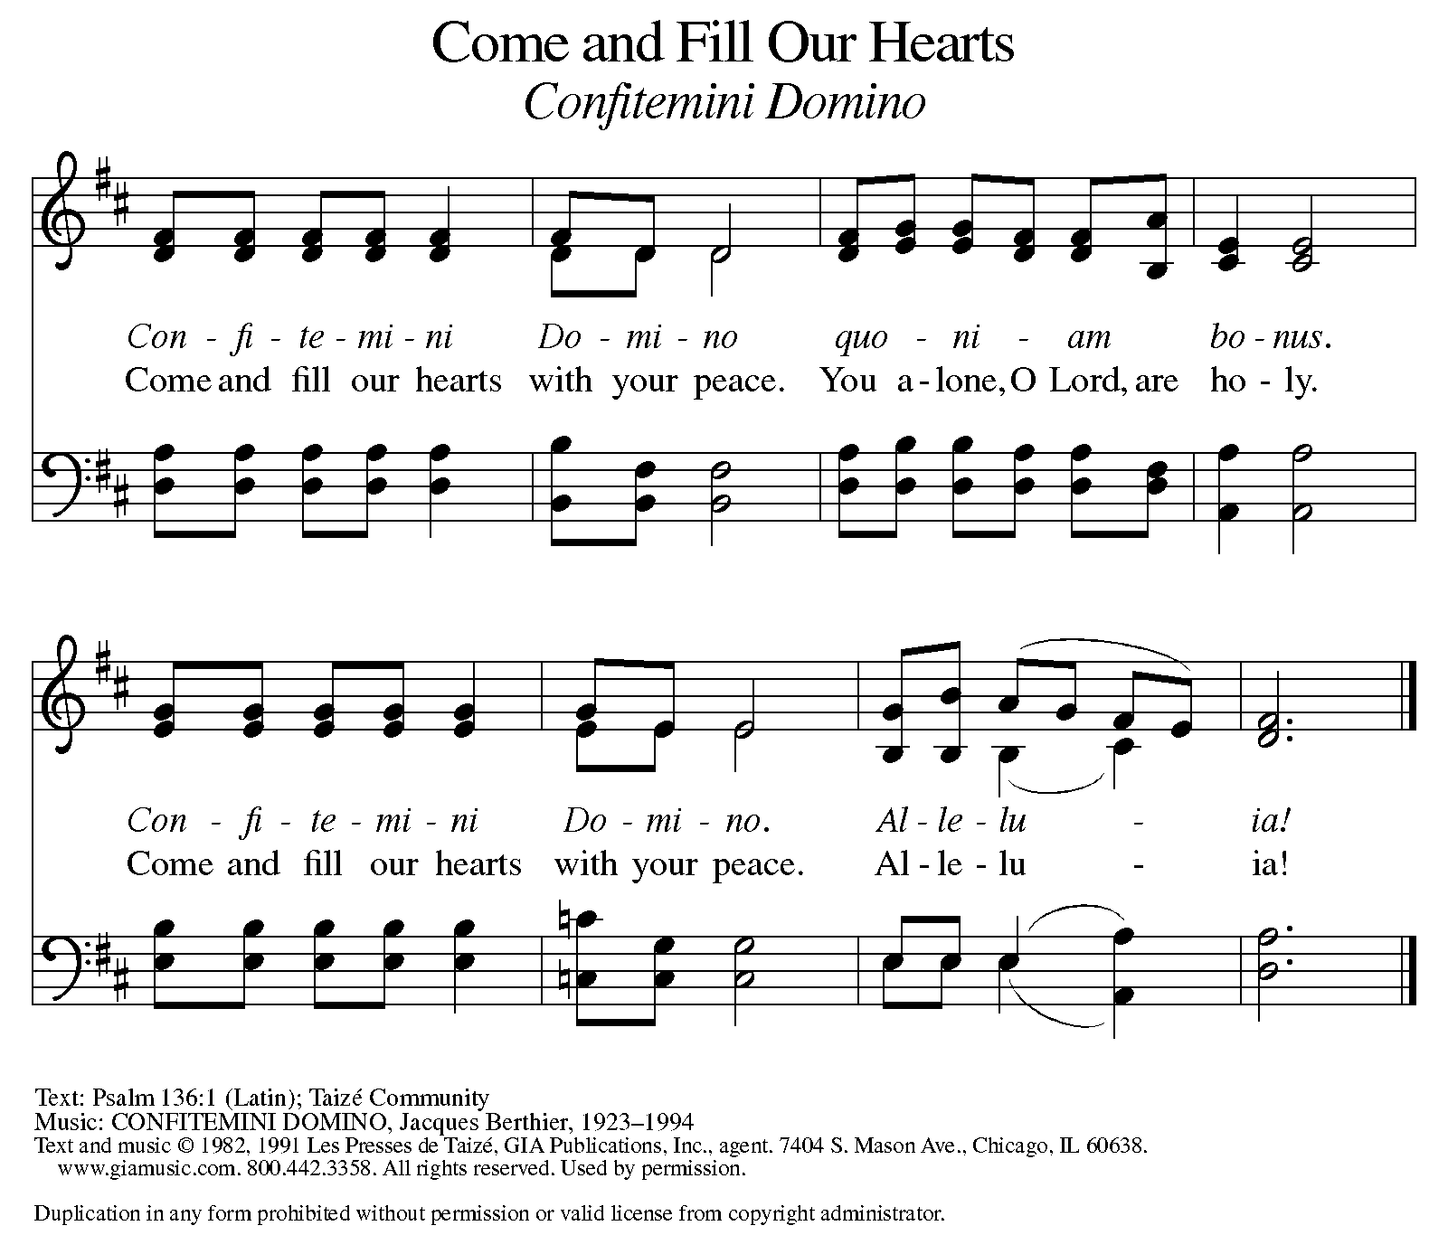

P: The body of Christ, given for you.

C: Amen.

A: The blood of Christ, shed for you.

C: Amen.
(Please rise as you are able.)

P: May the body and blood of our Lord Jesus Christ strengthen and keep you in his grace.

C: Amen.

PRAYER AFTER COMMUNION

P: Let us pray. Generous God, we thank you for the gift of life, for the bread of salvation. We thank you for coming among us, for leading us into peace. We thank you for showering us with mercy, for sending us into the world. Come, Lord Jesus, and go with us as we feed the hungry in your name.

C: Amen.

SENDING

BLESSING

P: God of endings and beginnings, God in the darkness and the light, God, our hope for the journey, ☩ bless and keep you now and forever.

C: Amen.

SENDING HYMN ELW 244
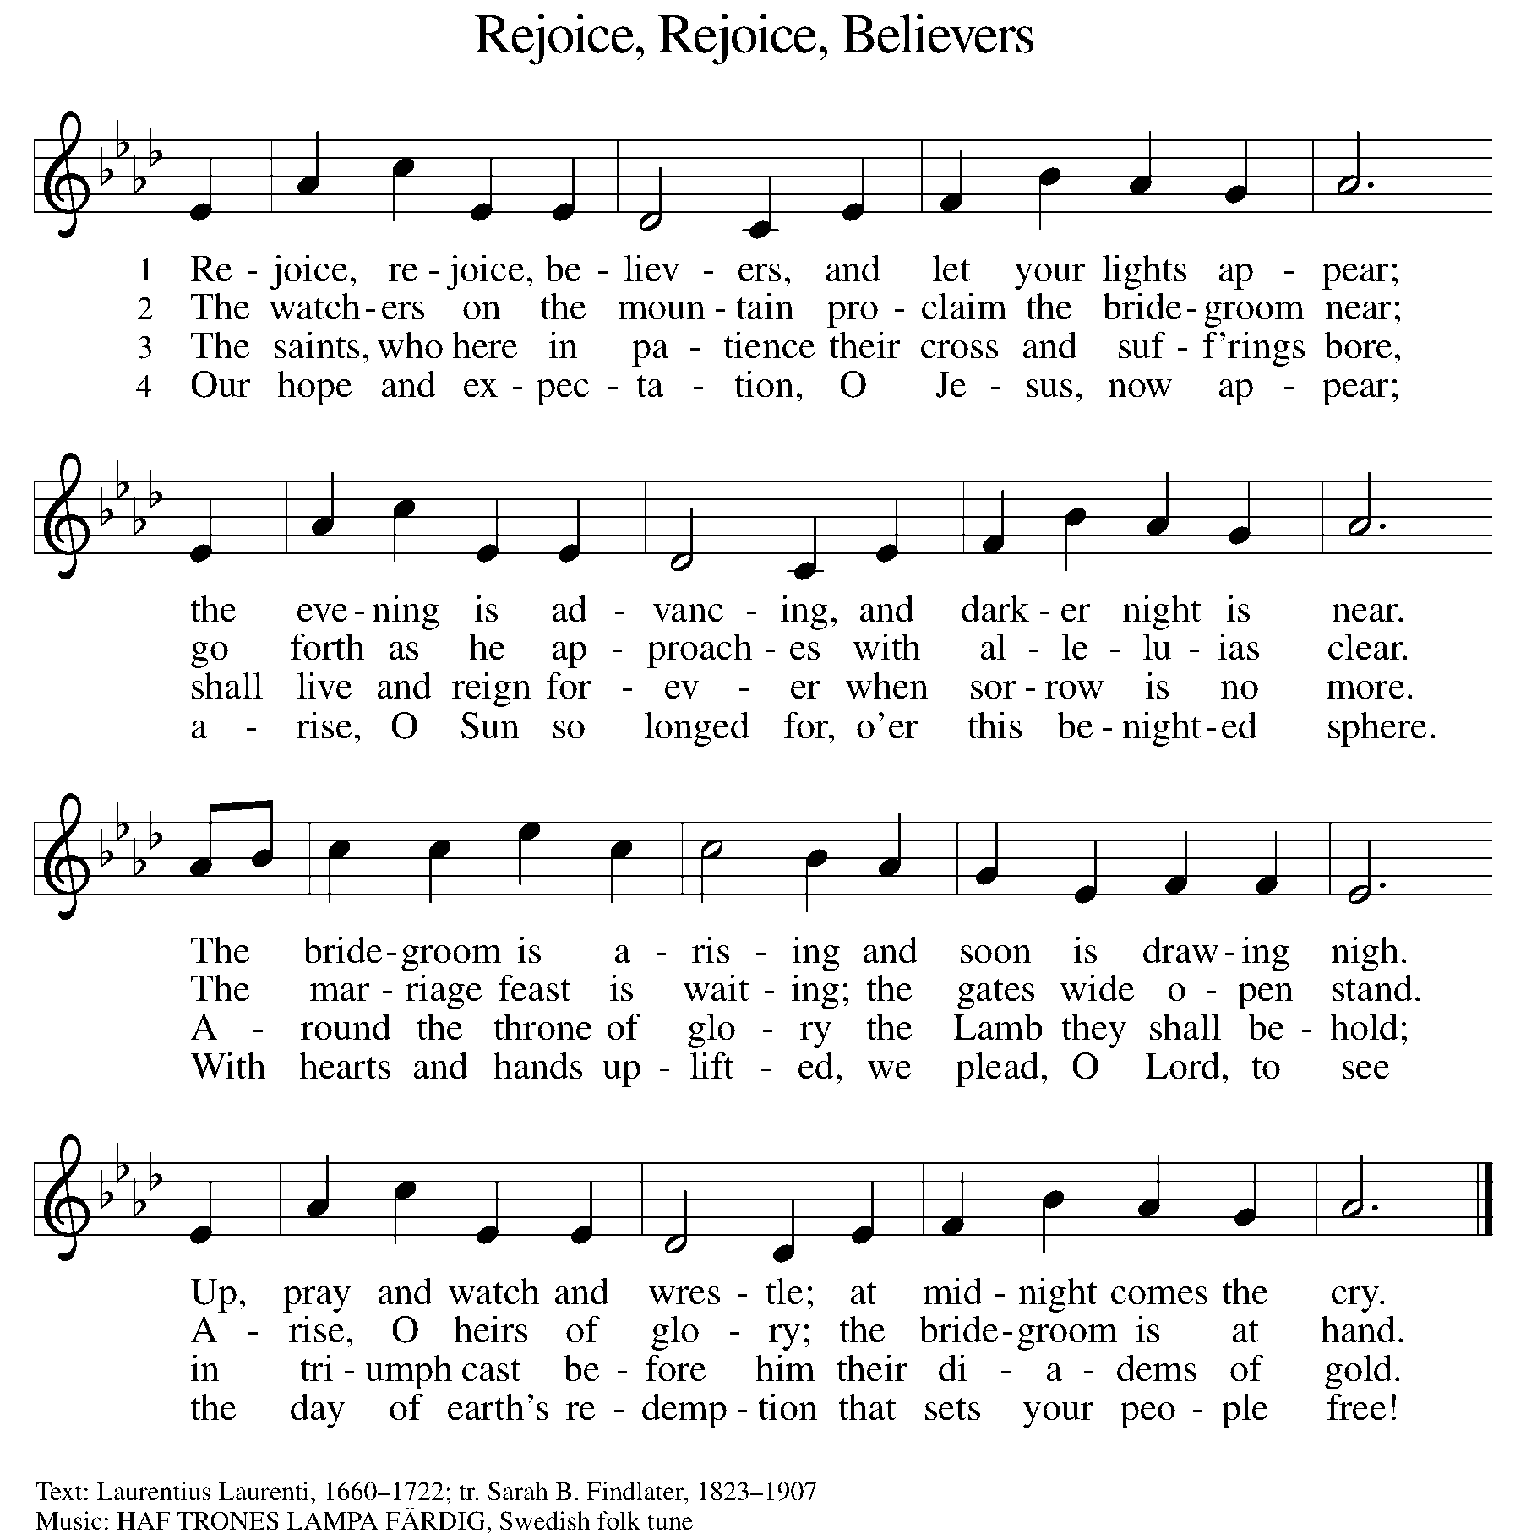

DISMISSAL

A: Go in peace. Prepare the way for Emmanuel.

C: Thanks be to God.

Announcements

- Mid-Week Gathering on Wednesdays 12/18 – Music by James Tavadze & Devotional Lessons.
- Saturday, December 21 – Practice for SS Christmas Program @ 10am
- Sunday, December 22 – SS Christmas Program (during service)
- Tuesday, December 24 – Christmas Eve Service @ 6pm
- Wednesday, December 25 – Merry Christmas!
- Wednesday, January 1st – Happy New Year!

Recurring Events

- Every Sunday – Adult Bible Study @ 9am
- Monday, January 6 – Worship Committee Meeting @ 6:30pm
- Wednesday, January 8 – Women’s Bible Study @ 11am
- Thursday, December 19 – Council Meeting @ 7pm

Food Pantry Dates

Wednesday, December 18, 5-6:30pm
Monday, December 23, 1-3pm
Monday, December 30, 5-6:30pm
Thursday, January 9, 1-3pm
Wednesday, January 15, 5-6:30pm

Volunteers for December 15 Volunteers for December 22

Reader - Volunteer Reader – Volunteer
Assisting Minister - Kathy Assisting Minister –
Candle Reader & Lighter – Paul & Tracy Candle Reader & Lighter – Jim & Pat

Poinsettia In Memory Of

Rodger Johnson
Poinsettia In Honor Of

St. Paul Family

December Birthday Celebrations

12/1 – Office Manager Emily Po.
12/3 – Tara Mc.
12/7 – Sharon Br.
12/15 – Daphne Mc.
12/24 – Calvin Bo.
12/26 – Judy St.
12/29 – Jon Ke.

December Anniversary Celebrations

12/20 – Jim & Traci Mo.

Acknowledgments
- OneLicense.net, License #A-703165.
- CCLI, License #2281869.
- From SundaysandSeasons.com. Copyright 2020 Augsburg Fortress. All rights reserved. Reprinted by permission under Augsburg Fortress Liturgies Annual License #23806.
- New Revised Standard Version Bible, copyright 1989, Division of Christian Education of the National Council of the Churches of Christ in the United States of America. Used by permission. All rights reserved.

