

2nd Sunday of Advent
December 8, 2024


SAINT PAUL LUTHERAN CHURCH
3383 EAST LAKE LANSING ROAD
EAST LANSING, MI 48823

PHONE (517) 351-8541

Pastor Carl E. Ballard

E-MAIL: pastor@stpaul-el.org
officemanager@stpaul-el.org

Visitors WELCOME! If this is your first time worshipping with us, please sign our guest registry just outside the sanctuary doors. We hope you are blessed through worship today. If you have any questions, please feel free to call the church at 351-8541.
Children are always welcome in worship! The choir room (off the sanctuary) can also be used as a cry room for younger children and includes a sound system so parents may continue to participate in the service. Clipboards with children's bulletins, activities and crayons are available for use during the service.
Sunday School is available during the worship service September-May except the last Sunday of the month.
This Bulletin is for your use during the service and to take home for the upcoming week. If you choose not to take it home, please place it in the recycle receptacle in the back.
Newsletters and Calendars of Upcoming Events are available in the lobby/narthex. We welcome anyone who has an interest in our small groups or activities! You can also look us up on the web at www.stpaul-el.org.
Contacting Us: Our Office Manager is Emily Polhamus. She can be reached by phone at 517-351-8541 or at her email address, officemanager@stpaul-el.org. Our Director of Music is Elene Kobulashvili. You may leave a message at 517-351-8541. Pastor Carl can be reached at 517-515-3129, and his email address is cballard123@msn.com.
Holy Communion is available at most services. All who believe in the real presence of Christ in the bread and the wine are invited to celebrate Communion with us. Those who wish can come forward for a blessing.
You’re invited to share in fellowship after worship. We would love this opportunity to introduce you to the St. Paul community.

P-Presiding Minister A-Assisting Minister C-Congregation

PRELUDE SUB NAME

INTRODUCTION

Forerunners and messengers advance the advent of our God. While John the baptizer’s voice in the wilderness may be the principal focus of the day, Malachi’s prophecy could as easily herald the coming Christ as forerunner of the Lord of hosts. Finally all the baptized are called to participate in the sharing of the gospel. In so doing we prepare the way for the coming of Jesus and assist all people in capturing a vision of the “salvation of God.”

GATHERING

P: The Holy Spirit calls us together as the people of God.

(Please rise as you are able.)

CONFESSION & FORGIVENESS

All may make the sign of the cross, the sign that is marked at baptism, as the presiding minister begins.

P: Blessed be the holy Trinity, ☩ one God, alive in the world, reviving creation, arriving soon.

C: Amen.

P: Let us confess our sin in the presence of God and of one another.

C: Amen.
(Silence for reflection.)

P: God of mercy,

C: we confess that we have sinned. We trust earthly powers and human authority alone. We grow fearful. We cling to false comforts.

P: God of might,
C: we confess that we have sinned. We have turned away from our neighbors. We have trusted false promises.

P: God in our midst,

C: we confess that we have sinned. We plead: come to us. Bring your mercy to birth in us.

P: A righteous branch springs forth: it is Christ the Lord, our Savior, in whom we have forgiveness, life, and mercy. By the power of the Holy Spirit, receive the grace and forgiveness of God through ☩ Christ Jesus, whose day draws near.

C: Amen.

GATHERING SONG ELW 254
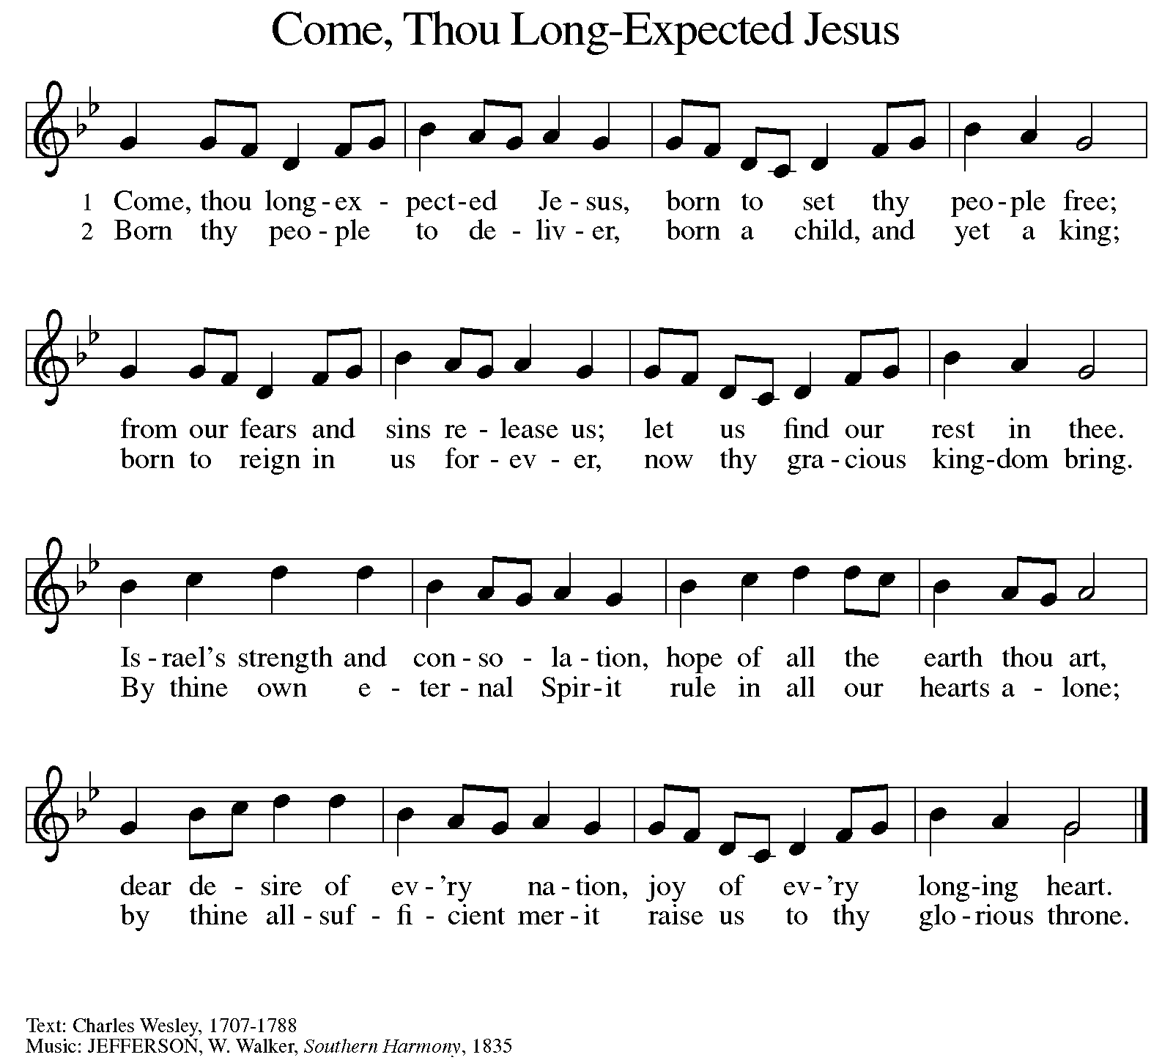
BLESSING OF THE ADVENT WREATH

Candle Lighter: At every beginning there is a yearning for the one who is coming. O Emmanuel,

C: Prepare us for your coming.

CL: We gather together to get ready for what? Only heaven knows. O Emmanuel,

C: Prepare us for your coming.

CL: We wait for the day when God will create a prevailing peace on the earth, and natural-born enemies turn into newborn friends. O Emmanuel,

C: Prepare us for your coming.

CL: We get ready for God to come close by laying our lives open to Jesus, asking him to sort through all our mixed motives. O Emmanuel,

C: Prepare us for your coming.

CL: Jesus, we welcome your presence now with the lighting of these candles, whose flames bring warmth to winter and fill this place with the glow of hope.

C: Amen.

LIGHT ONE CANDLE TO WATCH FOR MESSIAH ELW 240

Light one candle to watch for Messiah:
let the light banish darkness.
He shall bring salvation to Israel,
God fulfills the promise.

Light two candles to watch for Messiah:
let the light banish darkness.
He shall feed the flock like a shepherd,
gently lead them homeward.

GREETING

P: The grace of our Lord Jesus Christ, the love of God, and the communion of the Holy Spirit be with you all.

C: And also with you.

KYRIE ELW Setting 7, Page 175

Lord, have mercy on us; O Lord, have mercy.
Lord, have mercy on us; O Lord, have mercy.
Christ, have mercy on us; O Christ, have mercy.
Christ, have mercy on us; O Christ, have mercy.
Lord, have mercy on us; O Lord, have mercy.
Lord, have mercy on us; O Lord, have mercy.

CANTICLE OF PRAISE ELW Setting 4, Page 148-149

Glory to God in the highest, and peace to God’s people on earth.
Lord God, heavenly King, almighty God and Father,
we worship you, we give you thanks, we praise you for your glory.
Lord Jesus Christ, only Son of the Father, Lord God, Lamb of God,
you take away the sin of the world: have mercy on us;
you are seated at the right hand of the Father: receive our prayer.
For you alone are the Holy One, you alone are the Lord,
you alone are the Most High, Jesus Christ, with the Holy Spirit,
in the glory of God the Father. Amen.

PRAYER OF THE DAY

P: Let us pray. Stir up our hearts, Lord God, to prepare the way of your only Son. By his coming give to all the people of the world knowledge of your salvation; through Jesus Christ, our Savior and Lord, who lives and reigns with you and the Holy Spirit, one God, now and forever.

C: Amen.

(Please be seated.)

CHILDREN’S MESSAGE

(Children are invited to Sunday School.)

TRANSITION SONG ANCIENT WORDS

Ancient words ever true
Changing me, and changing you.
We have come with open hearts
Oh let the ancient words impart.

THE WORD

P: God speaks to us in scripture, preaching, and song.

FIRST READING MALACHI 3:1-4

God announces a covenant with Israel. A messenger like Malachi (his name means “my messenger”) will prepare the way for the coming of the Lord by purifying and refining God’s people, as silver and gold are refined.

¹ See, I am sending my messenger to prepare the way before me, and the Lord whom you seek will suddenly come to his temple. The messenger of the covenant in whom you delight—indeed, he is coming, says the Lord of hosts. ² But who can endure the day of his coming, and who can stand when he appears? For he is like a refiner’s fire and like washers’ soap; ³ he will sit as a refiner and purifier of silver, and he will purify the descendants of Levi and refine them like gold and silver, until they present offerings to the Lord in righteousness. ⁴ Then the offering of Judah and Jerusalem will be pleasing to the Lord, as in the days of old and as in former years.

Reader: Word of God, word of life. C: Thanks be to God.

PSALM PSALM: LUKE 1:68-79

In the tender compassion of our God the dawn from on high shall break upon us. (Lk. 1:78)

⁶⁸ Blessed are you, Lord, the God of Israel, you have come to your people and set them free.
⁶⁹ You have raised up for us a mighty Savior, born of the house of your servant David.
⁷⁰ Through your holy prophets, you promised of old to save us from our enemies,
⁷¹ from the hands of all who hate us,
⁷² to show mercy to our forebears, and to remember your holy covenant.
⁷³ This was the oath you swore to our father Abraham:
⁷⁴ to set us free from the hands of our enemies, free to worship you without fear,
⁷⁵ holy and righteous before you, all the days of our life.
⁷⁶ And you, child, shall be called the prophet of the Most High, for you will go before the Lord to prepare the way,
⁷⁷ to give God’s people knowledge of salvation by the forgiveness of their sins.
⁷⁸ In the tender compassion of our God the dawn from on high shall break upon us,
⁷⁹ to shine on those who dwell in darkness and in the shadow of death, and to guide our feet into the way of peace.

SECOND READING PHILIPPIANS 1:3-11

The apostle Paul was the pastor of many new churches. He writes in this letter about his joy to be in partnership with the Christians of Philippi. Listen to how tender-hearted Paul, sometimes a stern preacher, is with his friends as he encourages them to grow in love and knowledge.

³ I thank my God for every remembrance of you, ⁴ always in every one of my prayers for all of you, praying with joy ⁵ for your partnership in the gospel from the first day until now. ⁶ I am confident of this, that the one who began a good work in you will continue to complete it until the day of Jesus Christ. ⁷ It is right for me to think this way about all of you, because I hold you in my heart, for all of you are my partners in God’s grace, both in my imprisonment and in the defense and confirmation of the gospel. ⁸ For God is my witness, how I long for all of you with the tender affection of Christ Jesus. ⁹ And this is my prayer, that your love may overflow more and more with knowledge and full insight ¹⁰ to help you to determine what really matters, so that in the day of Christ you may be pure and blameless, ¹¹ having produced the harvest of righteousness that comes through Jesus Christ for the glory and praise of God.

Reader: Word of God, word of life. C: Thanks be to God.

(Please rise as you are able.)

GOSPEL ACCLAMATION ELW Setting 7, Page 179

Alleluia, alleluia, alleluia!
Alleluia, alleluia, alleluia!
Alleluia, alleluia, alleluia! Alleluia!

GOSPEL LUKE 3:1-6

P: The Holy Gospel according to Luke, the 3rd chapter.
C: Glory to you, O Lord.

John the Baptist is a herald of Jesus, whose way is prepared by “repentance for the forgiveness of sins.” As we hear the careful record of human leaders, we sense the spectrum of political and religious authority that will be challenged by this coming Lord.

¹ In the fifteenth year of the reign of Tiberius Caesar, when Pontius Pilate was governor of Judea, and Herod was ruler of Galilee, and his brother Philip ruler of the region of Ituraea and Trachonitis, and Lysanias ruler of Abilene, ² during the high priesthood of Annas and Caiaphas, the word of God came to John son of Zechariah in the wilderness. ³ He went into all the region around the Jordan, proclaiming a baptism of repentance for the forgiveness of sins, ⁴ as it is written in the book of the words of the prophet Isaiah, “The voice of one crying out in the wilderness: ‘Prepare the way of the Lord; make his paths straight. ⁵ Every valley shall be filled, and every mountain and hill shall be made low, and the crooked shall be made straight, and the rough ways made smooth, ⁶ and all flesh shall see the salvation of God.’ ”

P: The Gospel of the Lord. C: Praise to you, O Christ.

(Please be seated.)

SERMON PASTOR CARL BALLARD

(Please rise as you are able.)

HYMN OF THE DAY ELW 255
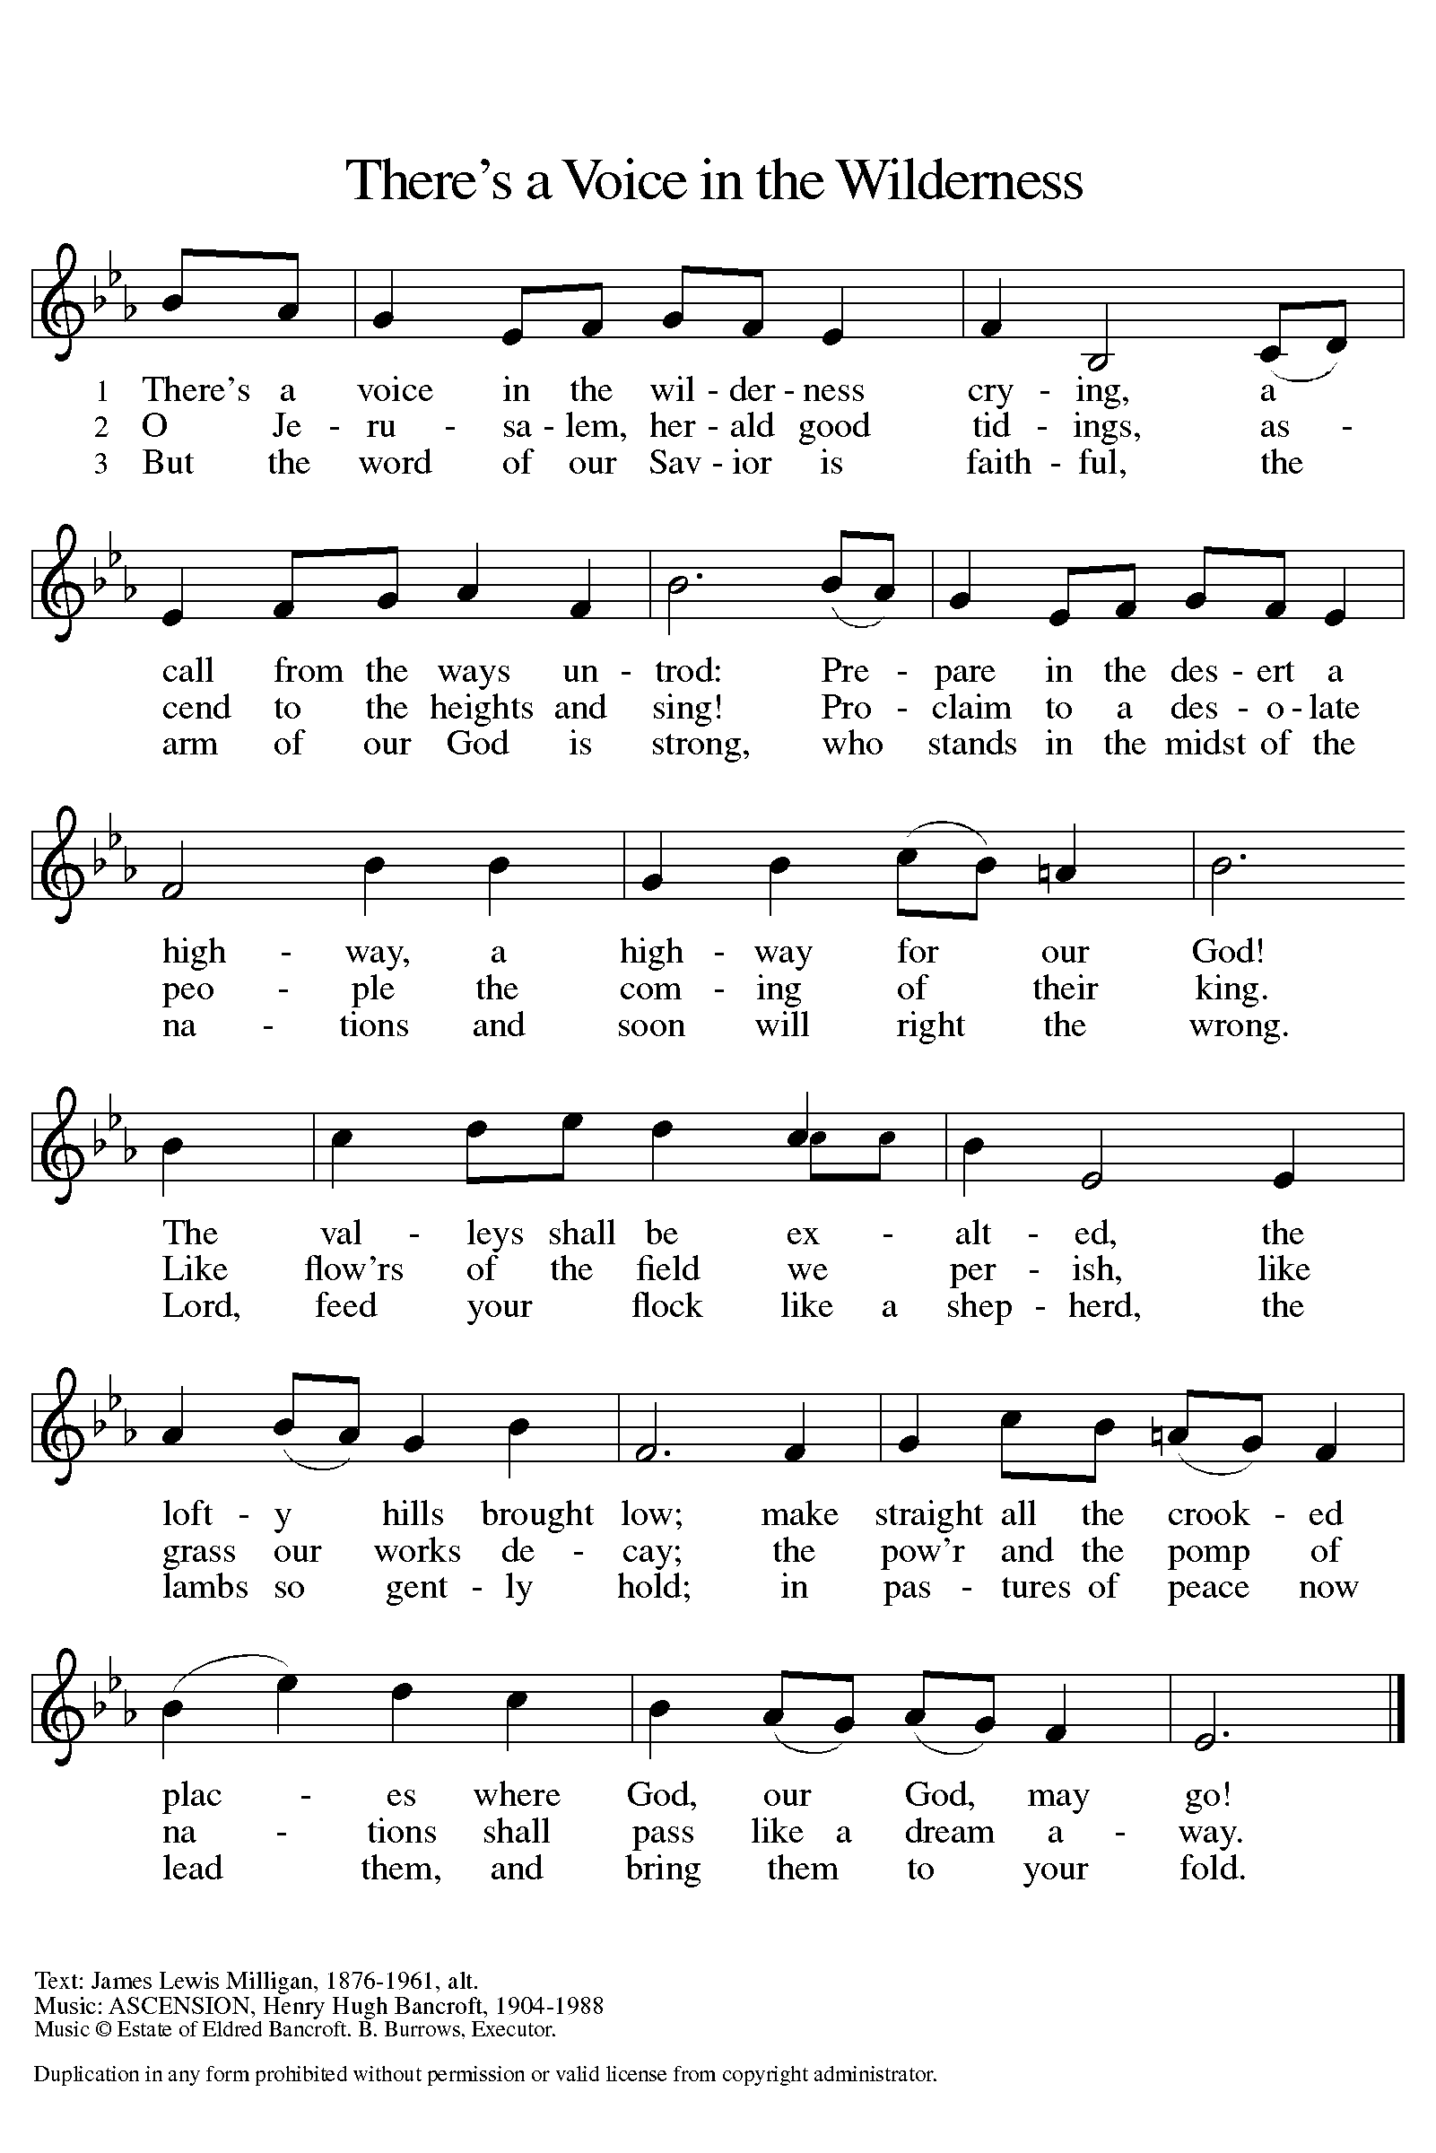

NICENE CREED

We believe in one God,
the Father, the Almighty,
maker of heaven and earth,
of all that is, seen and unseen.

We believe in one Lord, Jesus Christ,
the only Son of God,
eternally begotten of the Father,
God from God, Light from Light,
true God from true God,
begotten, not made,
of one Being with the Father;
through him all things were made.
For us and for our salvation
he came down from heaven, was incarnate of the Holy Spirit and the virgin Mary
and became truly human.
For our sake he was crucified under Pontius Pilate;
he suffered death and was buried.
On the third day he rose again
in accordance with the scriptures;
he ascended into heaven
and is seated at the right hand of the Father.
He will come again in glory to judge the living and the dead,
and his kingdom will have no end.

We believe in the Holy Spirit, the Lord, the giver of life,
who proceeds from the Father and the Son,
who with the Father and the Son is worshiped and glorified,
who has spoken through the prophets.
We believe in one holy catholic and apostolic church.
We acknowledge one baptism for the forgiveness of sins.
We look for the resurrection of the dead,
and the life of the world to come. Amen.

(Please be seated.)
THE PRAYERS

A: As we prepare for Emmanuel, God-with-us, let us pray for all people and places that long for God’s presence.

(A brief silence.)
A: Refining God, move through your church. Root out practices that harm your people, and kindle a fire for sharing the gospel among bishops, pastors, deacons, and all the baptized. Lord, in your mercy,

C: receive our prayer.

A: Renewing God, transform your creation. Steer us from habits that harm what you have made, and guide us in practices that preserve and restore creatures and habitats. Lord, in your mercy,

C: receive our prayer.

A: Ruling God, teach the nations your ways. Strengthen organizations and communities that broker peace and care for refugees, immigrants, and all caught in the center of conflict. Lord, in your mercy,

C: receive our prayer.

A: Rescuing God, restore your people who are in any need. Heal all who are suffering. Provide comfort and strength, and nurture sustained wholeness for the future. Lord, in your mercy,

C: receive our prayer.

A: Reforming God, fill this congregation with your presence. Enrich our seasonal preparations, and bless the efforts by worship committees, music ensembles, staff, clergy, and lay leaders as they work in the weeks ahead. Lord, in your mercy,

C: receive our prayer.

A: Shielding God, send angels of protection to provide care and compassion to those who serve in our armed forces and protect and sacrifice for us so we can be free. We pray especially for Beth & Ryan, Jonathan, Jacob, Noah, Irene, and Alex. Lord, in your mercy,

C: receive our prayer.

A: Reviving God, raise up any who are bowed down with illness or sorrow. Deepen our care and concern for one another. We lift to you all who are undergoing transition in relationships, occupation, living situation, or health condition, especially Ahren, Barb, Carolyn, Craig, Dan, David, Doretta, Jim & Cheri, John, Johnny, Jon, Jordan, Kathy, Kay, Kelly, Lawton, Lera & family, Linda, Lizzy, Marge, Mary, Nathan, Pastor Sarah, Rick & Kathy, Sheri, Sheri, and Wanda. And all that we name now aloud and in our hearts. Lord, in your mercy,

C: receive our prayer.

A: Directing God, we lift up to you Presiding Bishop Elizabeth, our Synod Bishop Craig, and Pastor Carl. We ask that you be with their respective staffs as they live out their callings to serve. As we are called to be one, even as Jesus and the Father are one, be with the leaders and the congregation of St. Paul Lutheran Church in Alpena and all the churches in our community. Lord, in your mercy,

C: receive our prayer.

A: Reassuring God, we remember those who have died and rest in you. Guide us in deep gratitude for their life, and allow us to learn from their faithful witness. Lord, in your mercy,

C: receive our prayer.

P: Savior of the nations, come, and receive these prayers and the pleas of our hearts, in the name of Jesus Christ.

C: Amen.

GREETING OF PEACE

(You are invited to share Christ’s peace with one another.)

P: The peace of Christ be with you always.

C: And also with you.

(Please be seated.)

THE MEAL
OFFERING SUB NAME

OFFERTORY (VERSE 3 ONLY) ELW 294
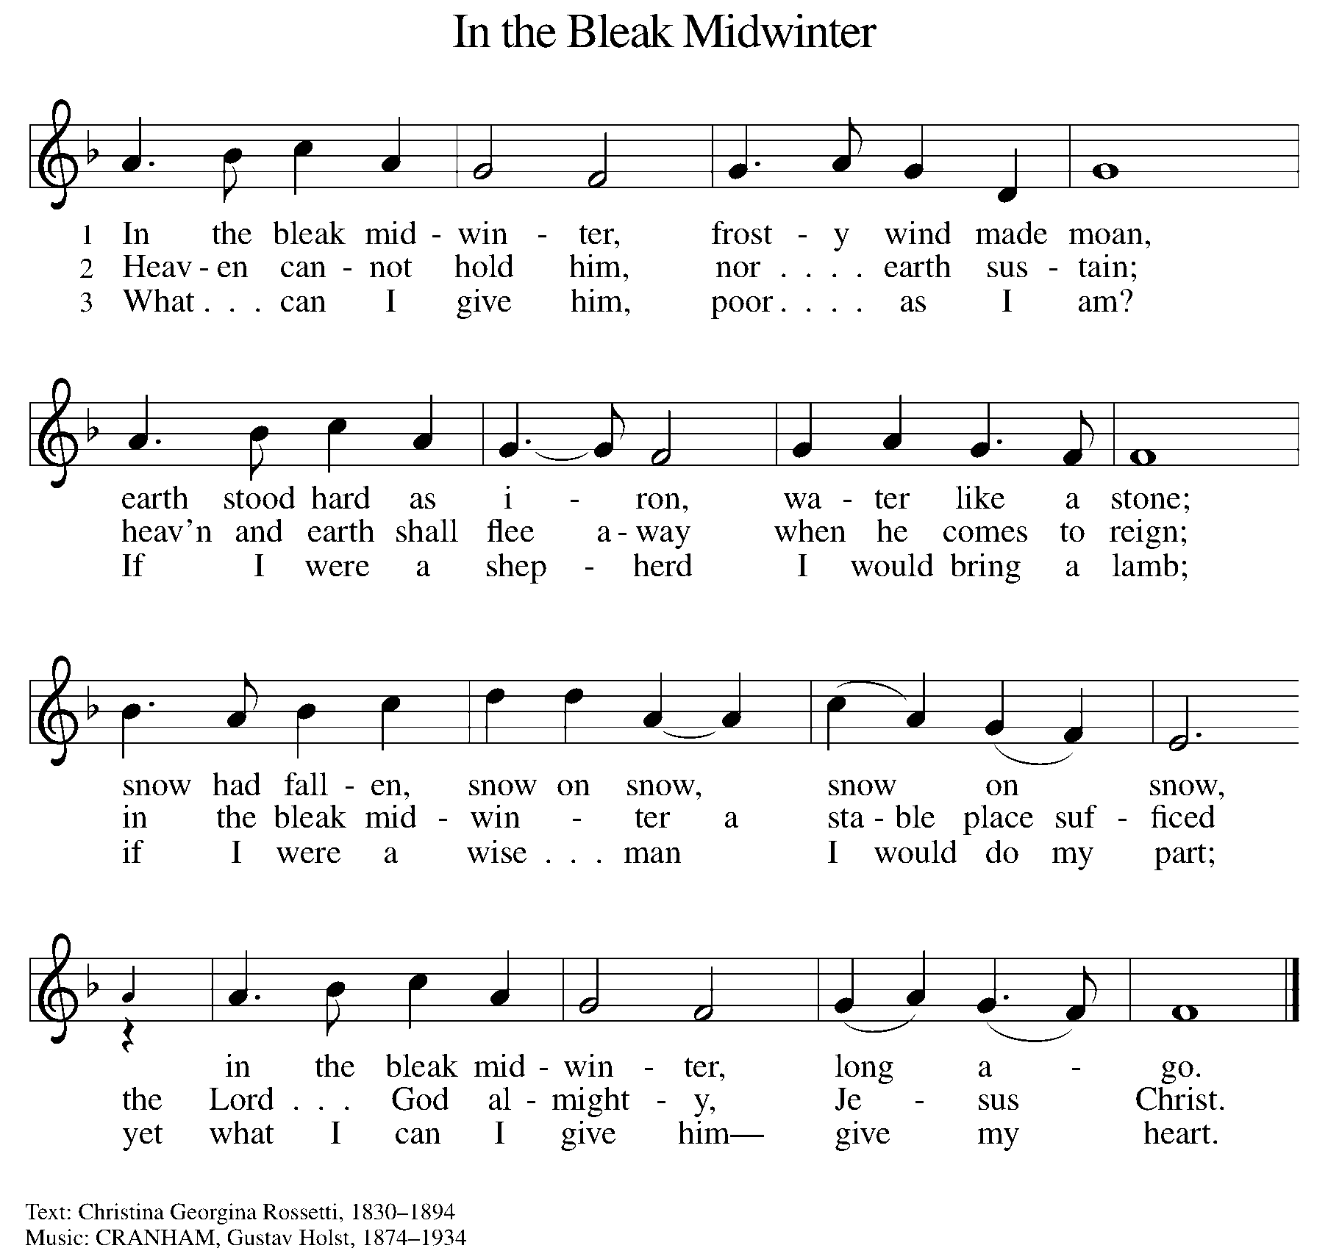

OFFERING PRAYER

A: Let us pray. Creator God, you made the whole world, even the farthest stars, and you draw near to feed us. We praise you for these gifts of bread and wine. Strengthen us with this food that we may live in expectation for the advent of your Son, Jesus Christ our Lord.

C: Amen.

THE GREAT THANKSGIVING

P: The Lord be with you.
C: And also with you.
P: Lift up your hearts.
C: We lift them to the Lord.
P: Let us give thanks to the Lord our God.
C: It is right to give our thanks and praise.

PROPER PREFACE

P: It is indeed right and salutary that we should at all times and in all places offer thanks and praise to you, O Lord, holy Father, almighty and ever living God. You comforted your people with the promise of the Redeemer, through whom you will also make all things new in the day when he comes again to judge the world in righteousness. And so, with the Church on earth and the hosts of heaven, we praise your name and join their unending hymn:

HOLY, HOLY ELW Setting 7, Page 181

Holy, holy, holy Lord God,
God of might and power; holy is the Lord.
Holy, holy, holy, holy Lord God,
God of might and power; holy is the Lord.
Hosanna in the highest, hosanna here on earth.
Blest is he who comes in the name of the Lord.
Hosanna in the highest, hosanna here on earth.
Blest is he who comes in the name of the Lord.

EUCHARISTIC PRAYER

P: In the night in which he was betrayed, our Lord Jesus took bread, and gave thanks; broke it, and gave it to his disciples, saying:
Take and eat; this is my body, given for you. Do this for the remembrance of me.
Again, after supper, he took the cup, gave thanks, and gave it for all to drink, saying:
This cup is the new covenant in my blood, shed for you and for all people for the forgiveness of sin. Do this for the remembrance of me.

LORD'S PRAYER

P: Lord, remember us in your kingdom, and teach us to pray:
C: Our Father in heaven, hallowed be your name, your kingdom come, your will be done, on earth as in heaven. Give us today our daily bread. Forgive us our sins as we forgive those who sin against us. Save us from the time of trial and deliver us from evil. For the kingdom, the power, and the glory are yours, now and forever. Amen.

COMMUNION DISTRIBUTION

All who believe in the real presence of Christ in the bread and the wine (juice) are welcome to the table. Others may come forward for a blessing. If you prefer grape juice, please indicate this to the assisting minister.

When approaching the communion rail, come forward down the side aisle, kneel, if you are able, starting at the front of the communion rail (spot closest to the font) on your side and filling in toward the back. After receiving both the bread and the wine, you may return to your seat by the center aisle.

INVITATION TO COMMUNION

P: God feeds us with tender mercy. Come to the table.

COMMUNION HYMN ELW 528
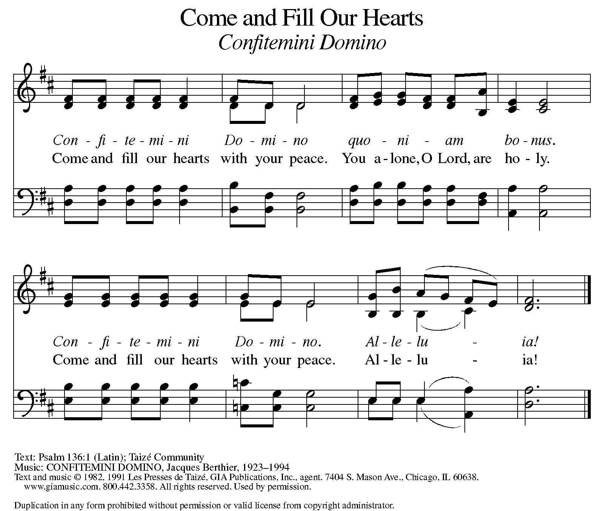

P: The body of Christ, given for you.

C: Amen.

A: The blood of Christ, shed for you.

C: Amen.
(Please rise as you are able.)

P: May the body and blood of our Lord Jesus Christ strengthen and keep you in his grace.

C: Amen.

PRAYER AFTER COMMUNION

P: Let us pray. Generous God, we thank you for the gift of life, for the bread of salvation. We thank you for coming among us, for leading us into peace. We thank you for showering us with mercy, for sending us into the world. Come, Lord Jesus, and go with us as we feed the hungry in your name.

C: Amen.

SENDING

BLESSING

P: God of endings and beginnings, God in the darkness and the light, God, our hope for the journey, ☩ bless and keep you now and forever.

C: Amen.

SENDING HYMN ELW 631
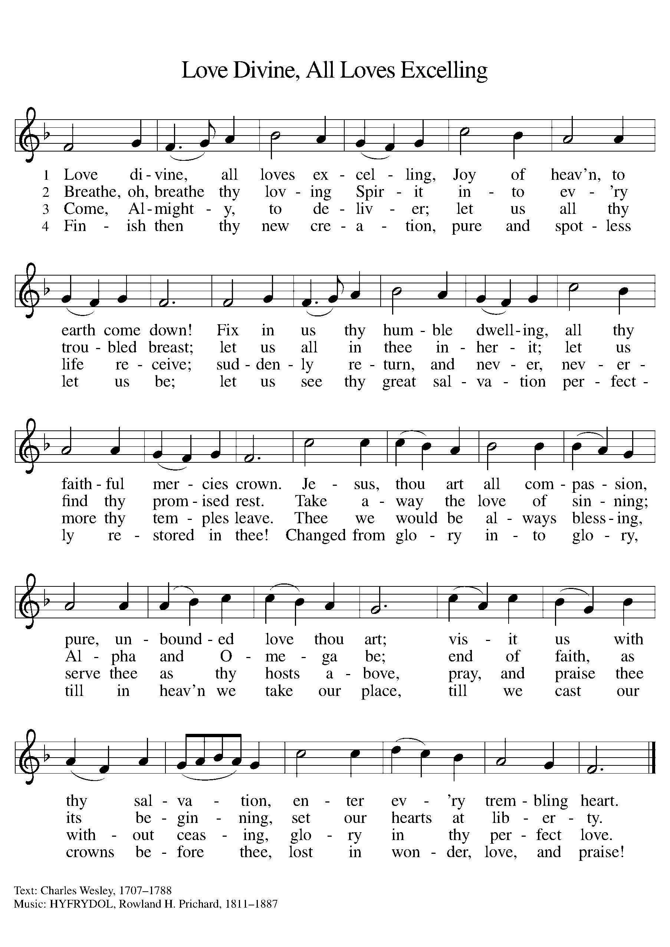

DISMISSAL

A: Go in peace. Prepare the way for Emmanuel.

C: Thanks be to God.
Announcements:

- Mid-Week Gathering on Wednesdays 12/11, 12/18 – Music by James Tavadze & Devotional Lessons.
- Sunday, December 22 – SS Christmas Program (during service)
- Tuesday, December 24 – Christmas Eve Service @ 4pm
- Wednesday, December 25 – Merry Christmas!
- Wednesday, January 1st – Happy New Year!

Recurring Events

- Every Sunday – Adult Bible Study @ 9am
- Monday, January 6 – Worship Committee Meeting @ 6:30pm
- Wednesday, January 8 – Women’s Bible Study @ 11am
- Thursday, December 19 – Council Meeting @ 7pm

Food Pantry Dates

- Thursday, December 12, 1-3pm
- Wednesday, December 18, 5-6:30pm
- Monday, December 23, 1-3pm
- Monday, December 30, 5-6:30pm

Volunteers for December 8 Volunteers for December 15

Reader Sunday – Volunteer Reader Sunday – Volunteer
Assisting Minister - Kathy Assisting Minister – Kathy
Candle Reader & Lighter – Bob & Kay Candle Reader & Lighter – Paul & Tracy

December Birthday Celebrations

12/1 – Office Manager Emily Po.
12/3 – Tara Mc.
12/7 – Sharon Br.
12/15 – Daphne Mc.
12/24 – Calvin Bo.
12/26 – Judy St.
12/29 – Jon Ke.

December Anniversary Celebrations

12/20 – Jim & Traci Mo.

Acknowledgments
- OneLicense.net, License #A-703165. CCLI, License #2281869.
- From SundaysandSeasons.com. Copyright 2020 Augsburg Fortress. All rights reserved. Reprinted by permission under Augsburg Fortress Liturgies Annual License #23806.
- New Revised Standard Version Bible, copyright 1989, Division of Christian Education of the National Council of the Churches of Christ in the United States of America. Used by permission. All rights reserved.

