

1st Sunday of Advent
December 1, 2024

SAINT PAUL LUTHERAN CHURCH
3383 EAST LAKE LANSING ROAD
EAST LANSING, MI 48823

PHONE (517) 351-8541

Pastor Carl E. Ballard
E-MAIL: pastor@stpaul-el.org
officemanager@stpaul-el.org

Visitors WELCOME! If this is your first time worshipping with us, please sign our guest registry just outside the sanctuary doors. We hope you are blessed through worship today. If you have any questions, please feel free to call the church at 351-8541.
Children are always welcome in worship! The choir room (off the sanctuary) can also be used as a cry room for younger children and includes a sound system so parents may continue to participate in the service. Clipboards with children’s bulletins, activities and crayons are available for use during the service. Please see an usher if you are unable to locate them.
Sunday School is available during the worship service September-May except the last Sunday of the month.
This Bulletin is for your use during the service and to take home for the upcoming week. If you choose not to take it home, please place it in the recycle receptacle in the back.
Newsletters and Calendars of Upcoming Events are available in the lobby/narthex. We welcome anyone who has an interest in our small groups or activities! You can also look us up on the web at www.stpaul-el.org.
Contacting Us: Our office manager is Emily Polhamus. She can be reached by phone at 517-351-8541 or at her email address, officemanager@stpaul-el.org. Our Director of Music is Elene Kobulashvili. You may leave a message at 517-351-8541. Pastor Carl can be reached at 517-515-3129, and his email address is cballard123@msn.com.
Holy Communion is available at most services. All who believe in the real presence of Christ in the bread and the wine are invited to celebrate Communion with us. Those who wish can come forward for a blessing.
You are invited to share in fellowship after worship. We would love this opportunity to introduce you to the St. Paul community.

P-Presiding Minister A-Assisting Minister C-Congregation

PRELUDE ELENE

INTRODUCTION

Advent is about the “coming days.” God’s people have always lived in great expectation, but that expectation finds specific, repeated enunciation in the texts appointed for these four weeks. The ancients anticipated a “righteous Branch to spring up for David.” The Thessalonians awaited “the coming of our Lord Jesus with all the saints.” Jesus’ contemporaries hoped for the time “to stand before the Son of Man.” With them we eagerly await the coming days: another Christmas celebration, a second coming, and the advent of Christ in word and supper.

GATHERING

P: The Holy Spirit calls us together as the people of God.

(Please rise as you are able.)

CONFESSION & FORGIVENESS

All may make the sign of the cross, the sign that is marked at baptism, as the presiding minister begins.

P: Blessed be the holy Trinity, ☩ one God, alive in the world, reviving creation,
arriving soon.

C: Amen.

P: Let us confess our sin in the presence of God and of one another.

(Silence is kept for reflection.)
P: God of mercy,

C: we confess that we have sinned. We trust earthly powers and human authority alone. We grow fearful. We cling to false comforts.

P: God of might,

C: we confess that we have sinned. We have turned away from our neighbors. We have trusted false promises.

P: God in our midst,

C: we confess that we have sinned. We plead: come to us. Bring your mercy to birth in us.

P: A righteous branch springs forth: it is Christ the Lord, our Savior, in whom we have forgiveness, life, and mercy. By the power of the Holy Spirit,
receive the grace and forgiveness of God through ☩ Christ Jesus, whose day draws near.

C: Amen.

GATHERING SONG ELW 257
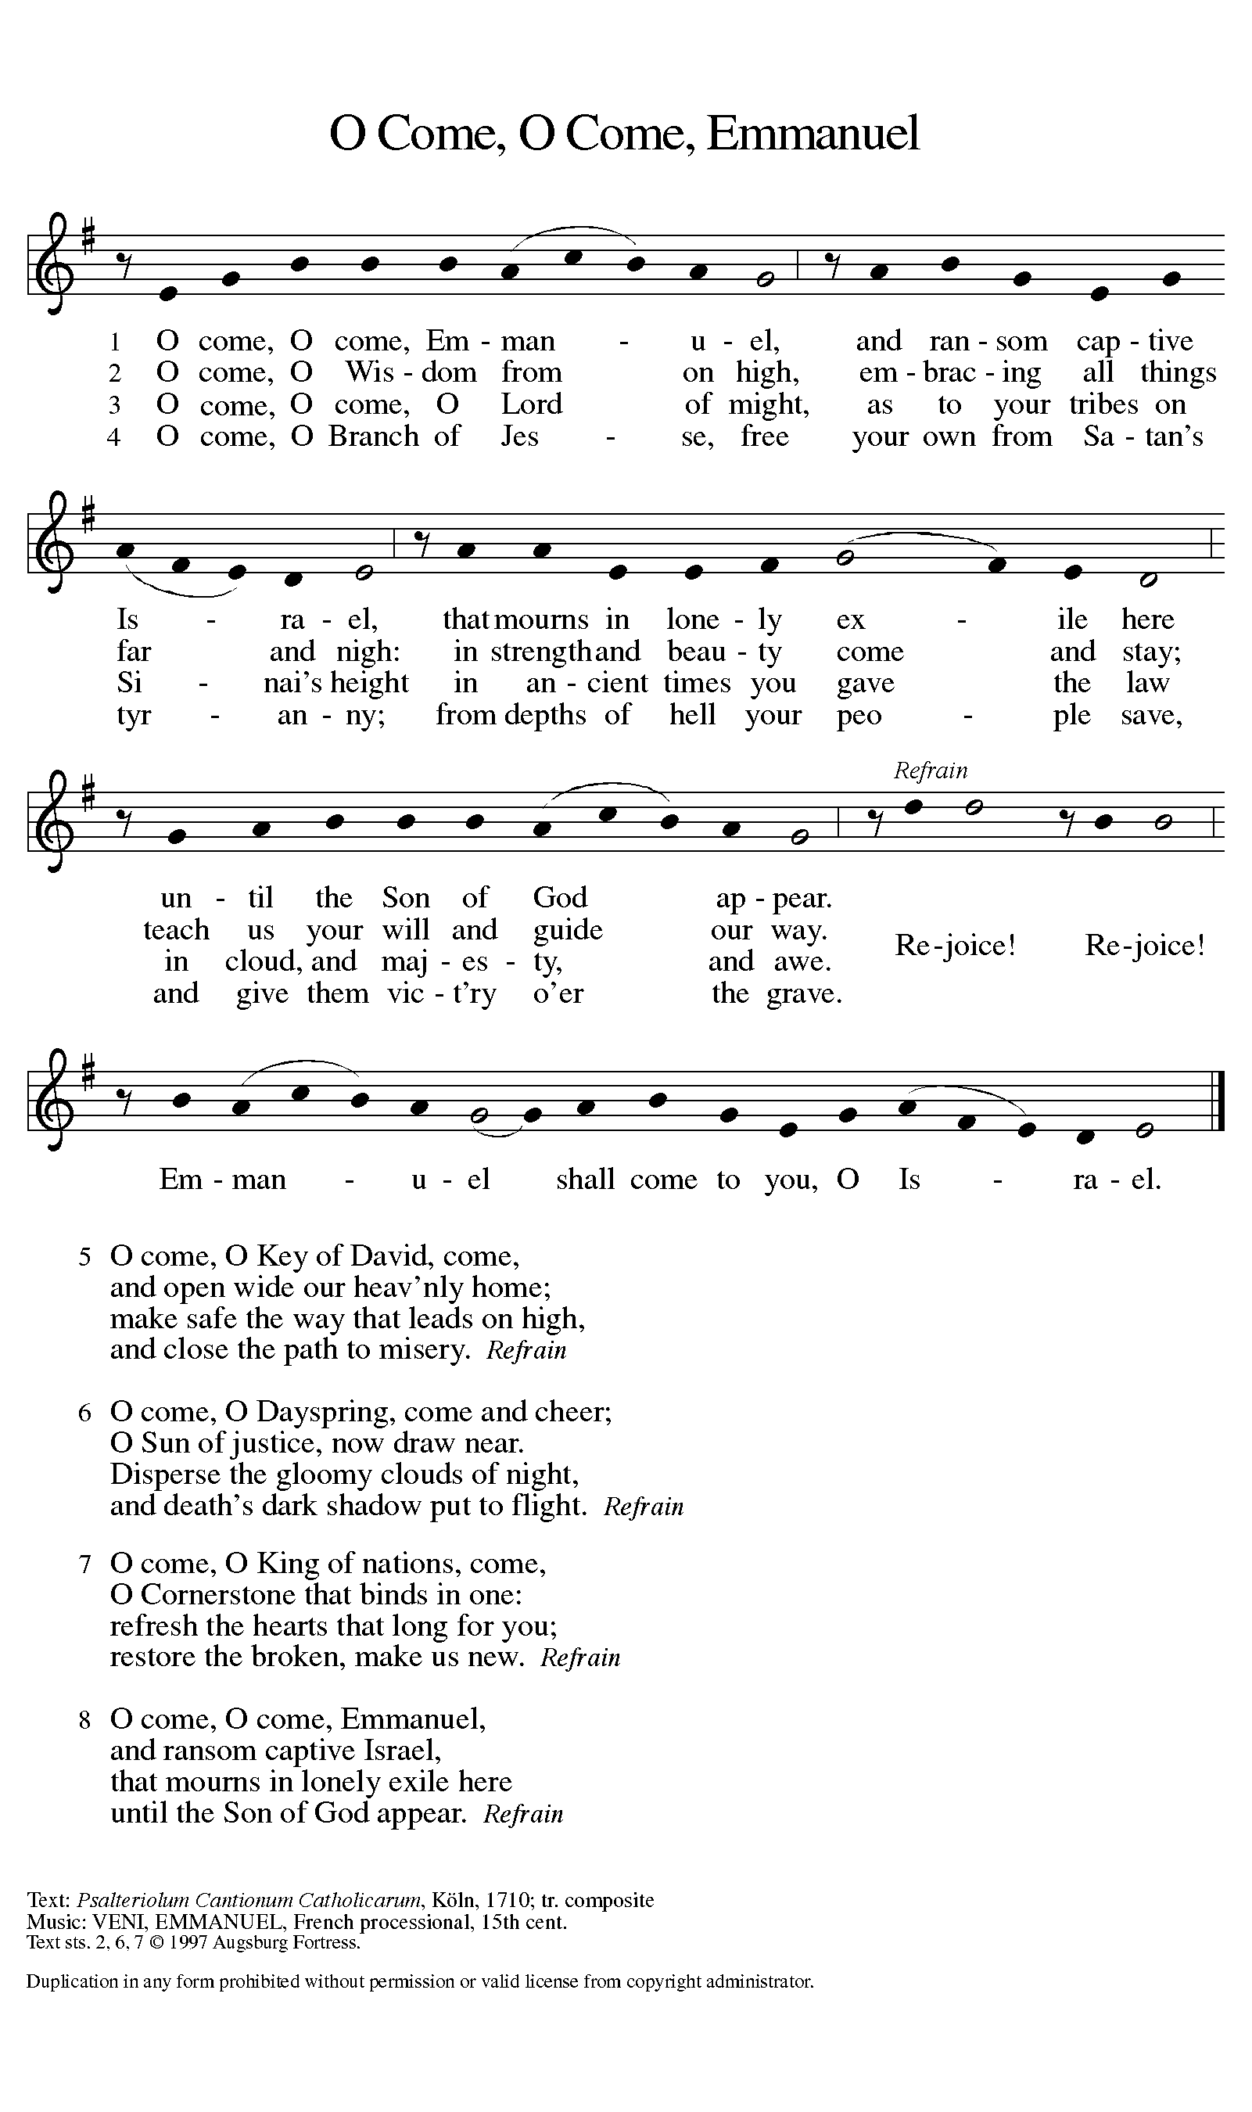

BLESSING OF THE ADVENT WREATH
Candle Lighter: At every beginning there is a yearning for the one who is coming. O Emmanuel,
C: Prepare us for your coming.
CL: We gather together to get ready for what? Only heaven knows. O Emmanuel,
C: Prepare us for your coming.
CL: We wait for the day when God will create a prevailing peace on the earth, and natural-born enemies turn into newborn friends. O Emmanuel,
C: Prepare us for your coming.
CL: We get ready for God to come close by laying our lives open to Jesus, asking him to sort through all our mixed motives. O Emmanuel,
C: Prepare us for your coming.
CL: Jesus, we welcome your presence now with the lighting of these candles, whose flames bring warmth to winter and fill this place with the glow of hope.
C: Amen.

LIGHT ONE CANDLE TO WATCH FOR MESSIAH ELW 240
(VERSE 1)
Light one candle to watch for Messiah:
let the light banish darkness.
He shall bring salvation to Israel,
God fulfills the promise.

GREETING

P: The grace of our Lord Jesus Christ, the love of God, and the communion of the Holy Spirit be with you all.

C: And also with you.

KYRIE ELW Setting 2, Page 120
In peace, let us pray to the Lord.
Lord, have mercy.
For the peace from above and for our salvation,
let us pray to the Lord.
Lord, have mercy.
For the peace of the whole world, for the well-being of the church of God, and for the unity of all, let us pray to the Lord.
Lord, have mercy.
For this holy house and for all who offer here their worship and praise, let us pray to the Lord.
Lord, have mercy.
Help, save, comfort, and defend us, gracious Lord.
Amen.

CANTICLE OF PRAISE ELW Setting 4, Page 148-149

Glory to God in the highest, and peace to God’s people on earth.
Lord God, heavenly King, almighty God and Father,
we worship you, we give you thanks, we praise you for your glory. Lord Jesus Christ, only Son of the Father, Lord God, Lamb of God, you take away the sin of the world: have mercy on us;
you are seated at the right hand of the Father: receive our prayer. For you alone are the Holy One, you alone are the Lord,
you alone are the Most High, Jesus Christ, with the Holy Spirit,
in the glory of God the Father. Amen.

PRAYER OF THE DAY

P: Let us pray. Stir up your power, Lord Christ, and come. By your merciful protection alert us to the threatening dangers of our sins, and redeem us for your life of justice, for you live and reign with the Father and the Holy Spirit, one God, now and forever.

C: Amen.

(Please be seated.)

CHILDREN’S MESSAGE

(Children are invited to Sunday School.)
TRANSITION SONG ANCIENT WORDS
Ancient words ever true
Changing me, and changing you.
We have come with open hearts
Oh let the ancient words impart.
THE WORD

God speaks to us in scripture, preaching, and song.

First Reading JEREMIAH 33:14-16
In the Old Testament, “righteousness” often has to do with being faithful in relationship. God acts righteously both in punishing Israel for its sin and in having mercy. In today’s reading, Jerusalem’s future name—“The Lord is our righteousness”—proclaims that God is even now working salvation for Israel.

¹⁴ The days are surely coming, says the Lord, when I will fulfill the promise I made to the house of Israel and the house of Judah. ¹⁵ In those days and at that time I will cause a righteous Branch to spring up for David, and he shall execute justice and righteousness in the land. ¹⁶ In those days Judah will be saved, and Jerusalem will live in safety. And this is the name by which it will be called: “The Lord is our righteousness.”

Word of God, word of life. C: Thanks be to God.

PSALM PSALM 25:1-10

To you, O Lord, I lift up my soul. (Ps. 25:1)

¹To you, O Lord, I lift up my soul.
²My God, I put my trust in you; let me not be put to shame, nor let my enemies triumph over me.
³Let none who look to you be put to shame; rather let those be put to shame who are treacherous.
⁴Show me your ways, O Lord, and teach me your paths.
⁵Lead me in your truth and teach me, for you are the God of my salvation; in you have I trusted all the day long.
⁶Remember, O Lord, your compassion and love, for they are from everlasting.
⁷Remember not the sins of my youth and my transgressions; remember me according to your steadfast love and for the sake of your goodness, O Lord.
⁸You are gracious and upright, O Lord; therefore you teach sinners in your way.
⁹You lead the lowly in justice and teach the lowly your way.
¹⁰All your paths, O Lord, are steadfast love and faithfulness to those who keep your covenant and your testimonies.

SECOND READING 1 THESSALONIANS 3:9-13
Upon Timothy’s report from the congregation at Thessalonica, Paul is exuberant with gratitude for them. In this passage from his letter, Paul voices overflowing thanks, joy, and blessing for the people of this growing church.

⁹How can we thank God enough for you in return for all the joy that we feel before our God because of you? ¹⁰Night and day we pray most earnestly that we may see you face to face and restore whatever is lacking in your faith. ¹¹Now may our God and Father himself and our Lord Jesus direct our way to you. ¹²And may the Lord make you increase and abound in love for one another and for all, just as we abound in love for you. ¹³And may he so strengthen your hearts in holiness that you may be blameless before our God and Father at the coming of our Lord Jesus with all his saints.

Word of God, word of life. C: Thanks be to God.

(Please rise as you are able.)
GOSPEL ACCLAMATION ELW Setting 2, Page 124
Alleluia, alleluia, alleluia, alleluia.
Lord, to whom shall we go?
You have the words of eternal life.
Alleluia, alleluia, alleluia, alleluia.

GOSPEL LUKE 21:25-36
P: The Holy Gospel according to Luke, 21st chapter.
C: Glory to you, O Lord.
God will fulfill God’s purposes, and already, hidden signs of that fulfillment abound. On that great day there will be dismay, perplexity, confusion, and terror, but God’s people shall be given strength to stand boldly and receive God’s promised redemption.
[Jesus said:] ²⁵ “There will be signs in the sun, the moon, and the stars and on the earth distress among nations confused by the roaring of the sea and the waves. ²⁶People will faint from fear and foreboding of what is coming upon the world, for the powers of the heavens will be shaken. ²⁷Then they will see ‘the Son of Man coming in a cloud’ with power and great glory. ²⁸Now when these things begin to take place, stand up and raise your heads, because your redemption is drawing near.”
²⁹Then he told them a parable: “Look at the fig tree and all the trees; ³⁰as soon as they sprout leaves you can see for yourselves and know that summer is already near. ³¹So also, when you see these things taking place, you know that the kingdom of God is near. ³²Truly I tell you, this generation will not pass away until all things have taken place. ³³Heaven and earth will pass away, but my words will not pass away.
³⁴ “Be on guard so that your hearts are not weighed down with dissipation and drunkenness and the worries of this life and that day does not catch you unexpectedly, ³⁵like a trap. For it will come upon all who live on the face of the whole earth. ³⁶Be alert at all times, praying that you may have the strength to escape all these things that will take place and to stand before the Son of Man.”
The Gospel of the Lord. C: Praise to you, O Christ.
(Please be seated.)

SERMON PASTOR CARL BALLARD

(Please rise as you are able.)
HYMN OF THE DAY ELW 266
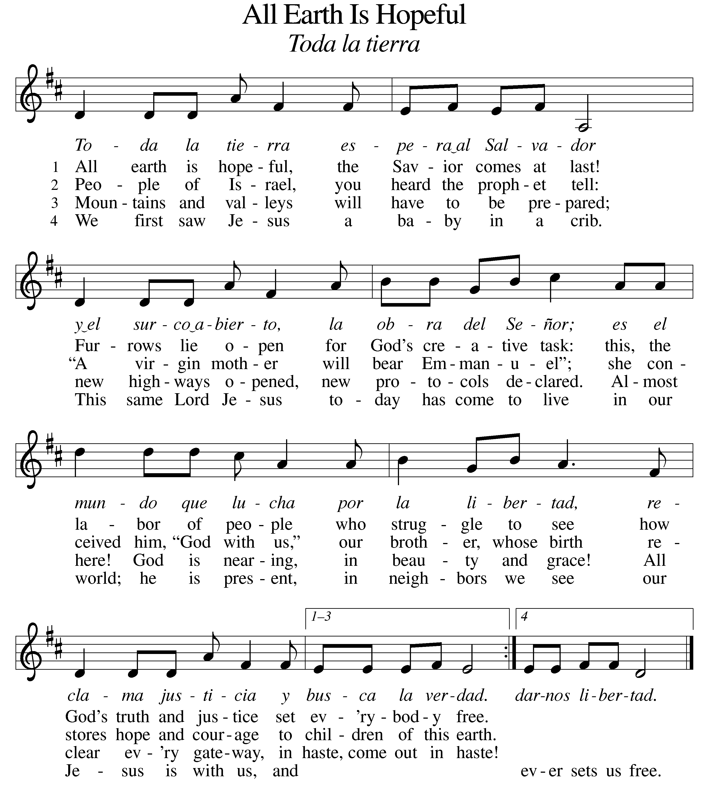

NICENE CREED

We believe in one God,
the Father, the Almighty,
maker of heaven and earth,
of all that is, seen and unseen.

We believe in one Lord, Jesus Christ,
the only Son of God,
eternally begotten of the Father,
God from God, Light from Light,
true God from true God,
begotten, not made,
of one Being with the Father;
For us and for our salvation
he came down from heaven,
was incarnate of the Holy Spirit and the virgin Mary
and became truly human.
For our sake he was crucified under Pontius Pilate;
he suffered death and was buried.
On the third day he rose again
in accordance with the scriptures;
he ascended into heaven
and is seated at the right hand of the Father.
He will come again in glory to judge the living and the dead,
and his kingdom will have no end.

We believe in the Holy Spirit, the Lord, the giver of life,
who proceeds from the Father and the Son,
who with the Father and the Son is worshiped and glorified,
who has spoken through the prophets.
We believe in one holy catholic and apostolic church.
We acknowledge one baptism for the forgiveness of sins.
We look for the resurrection of the dead,
and the life of the world to come. Amen.

(Please be seated.)

THE PRAYERS

A: As we prepare for Emmanuel, God-with-us, let us pray for all people and places that long for God’s presence.
(A brief silence)
A: God of righteousness, your people live in hopeful expectation of your coming. Fill your church with renewed passion for our shared mission, and deepen our relationships with other Christians and other faith traditions in our local community and across the world. Lord, in your mercy,

C: receive our prayer.

A: God of the cosmos, all creation shows that your presence is near. Help us sense your goodness and love in the sun and moon, in sprouting leaves and bare branches, in the roaring sea and quiet breeze. Lord, in your mercy,

C: receive our prayer.

A: God of the nations, your reign extends over all principalities and powers. Give leaders and all in authority hearts for justice and peace. Encourage efforts to enact policies that benefit the common good. Lord, in your mercy,

C: receive our prayer.

A: God of community, your Spirit holds us together. Sustain our care for one another. Inspire us to seek new ways to live together and to embrace the diversity of thought and identity in our communities. Lord, in your mercy,

C: receive our prayer.

A: God of watchfulness, send angels of protection to provide care and compassion for those who serve in our armed forces, especially Beth & Ryan, Jonathan, Jacob, Noah, Irene, and Alex. Lord, in your mercy,

C: receive our prayer.

A: God of change, you accompany us through life’s transitions. Be near to all who are changing jobs, moving, welcoming children, or facing the loss of loved ones. Sustain those who are ill or suffering, especially Ahren, Barb, Carolyn, Craig & family, Dan, David, Doretta, Jim & Cheri, John, John, Johnny, Jon, Jordan, Kathy, Kay, Lawton, Lera & family, Liam, Linda, Lizzy, Marge, Mary, Pastor Sarah, Randy, Rick & Kathy, Sheri, Sheri, and Wanda, and all whom we name now aloud and in our hearts. In times of change, remind us of your steadfast love. Lord, in your mercy,

C: receive our prayer.

A: God of direction, guide our church’s leaders, Presiding Bishop Elizabeth, our Synod Bishop Craig, and Pastor Carl and their respective staffs as they live out their callings to serve. As we are called to be one, even as Jesus and the Father are one, be with the leaders and the congregation of Grace Evangelical Lutheran Church in Alpena and all the churches in our community. Lord, in your mercy,

C: receive our prayer.

A: God of memory, we give you thanks for faithful ones who have died and tend to our grief and sorrow with renewed trust in your promise of abundant and eternal life. Lord, in your mercy,

C: receive our prayer.

P: Savior of the nations, come, and receive these prayers and the pleas of our hearts, in the name of Jesus Christ.

C: Amen.

GREETING OF PEACE

(You are invited to share Christ’s peace with one another.)

P: The peace of Christ be with you always.

C: And also with you.
(Please be seated.)
THE MEAL

OFFERING ELENE

OFFERTORY ELW 294
(Only Verse 3)
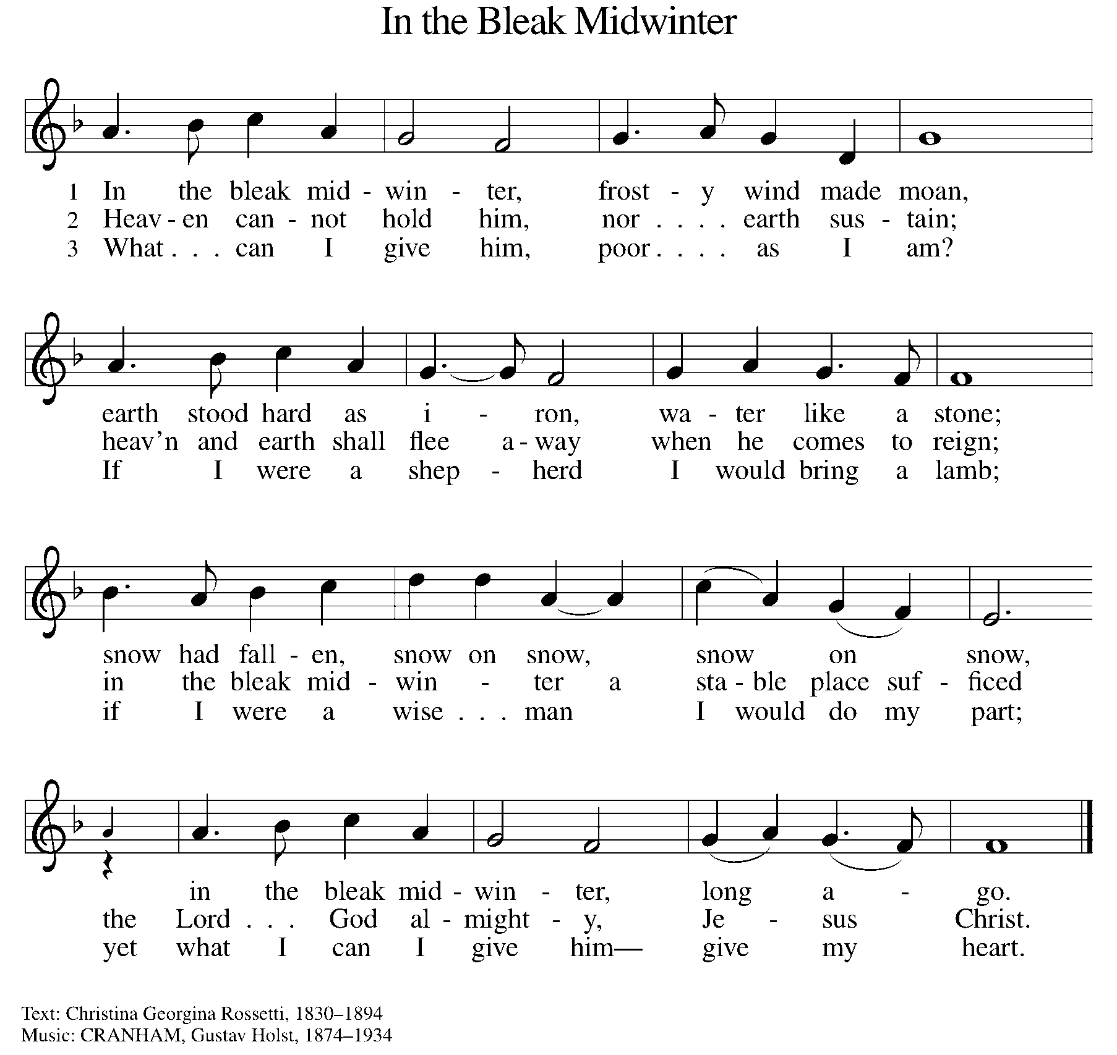

OFFERING PRAYER
A: Let us pray. Creator God, you made the whole world, even the farthest stars, and you draw near to feed us. We praise you for these gifts of bread and wine. Strengthen us with this food that we may live in expectation for the advent of your Son, Jesus Christ our Lord.

C: Amen.

THE GREAT THANKSGIVING

P: The Lord be with you.
C: And also with you.
P: Lift up your hearts.
C: We lift them to the Lord.
P: Let us give thanks to the Lord our God.
C: It is right to give our thanks and praise.

PROPER PREFACE

P: It is indeed right and salutary that we should at all times and in all places offer thanks and praise to you, O Lord, holy Father, almighty and ever living God. You comforted your people with the promise of the Redeemer, through whom you will also make all things new in the day when he comes again to judge the world in righteousness. And so, with the Church on earth and the hosts of heaven, we praise your name and join their unending hymn:

HOLY, HOLY ELW Setting 2, Page 130

Holy, holy, holy Lord, God of power and might,
heaven and earth are full of your glory.
Hosanna in the highest.
Blessed is he who comes in the name of the Lord.
Hosanna in the highest. Hosanna in the highest.

EUCHARISTIC PRAYER

P: In the night in which he was betrayed, our Lord Jesus took bread, and gave thanks; broke it, and gave it to his disciples, saying:
Take and eat; this is my body, given for you. Do this for the
remembrance of me.
Again, after supper, he took the cup, gave thanks, and gave it for all to drink, saying:
This cup is the new covenant in my blood, shed for you and for all people for the forgiveness of sin. Do this for the remembrance of me.

LORD'S PRAYER

P: Lord, remember us in your kingdom, and teach us to pray:

C: Our Father, who art in heaven, hallowed be thy name, thy kingdom come, thy will be done on earth as it is in heaven. Give us this day our daily bread; and forgive us our trespasses as we forgive those who trespass against us; and lead us not into temptation, but deliver us from evil. For thine is the kingdom, and the power, and the glory, forever and ever. Amen.

COMMUNION DISTRIBUTION

All who believe in the real presence of Christ in the bread and the wine (juice) are welcome to the table. Others may come forward for a blessing. If you prefer grape juice, please indicate this to the assisting minister.

When approaching the communion rail, come forward down the side aisle, kneel, if you are able, starting at the front of the communion rail (spot closest to the font) on your side and filling in toward the back. After receiving both the bread and the wine, you may return to your seat by the center aisle.

INVITATION TO COMMUNION

P: God feeds us with tender mercy. Come to the table.

COMMUNION HYMN ELW 528
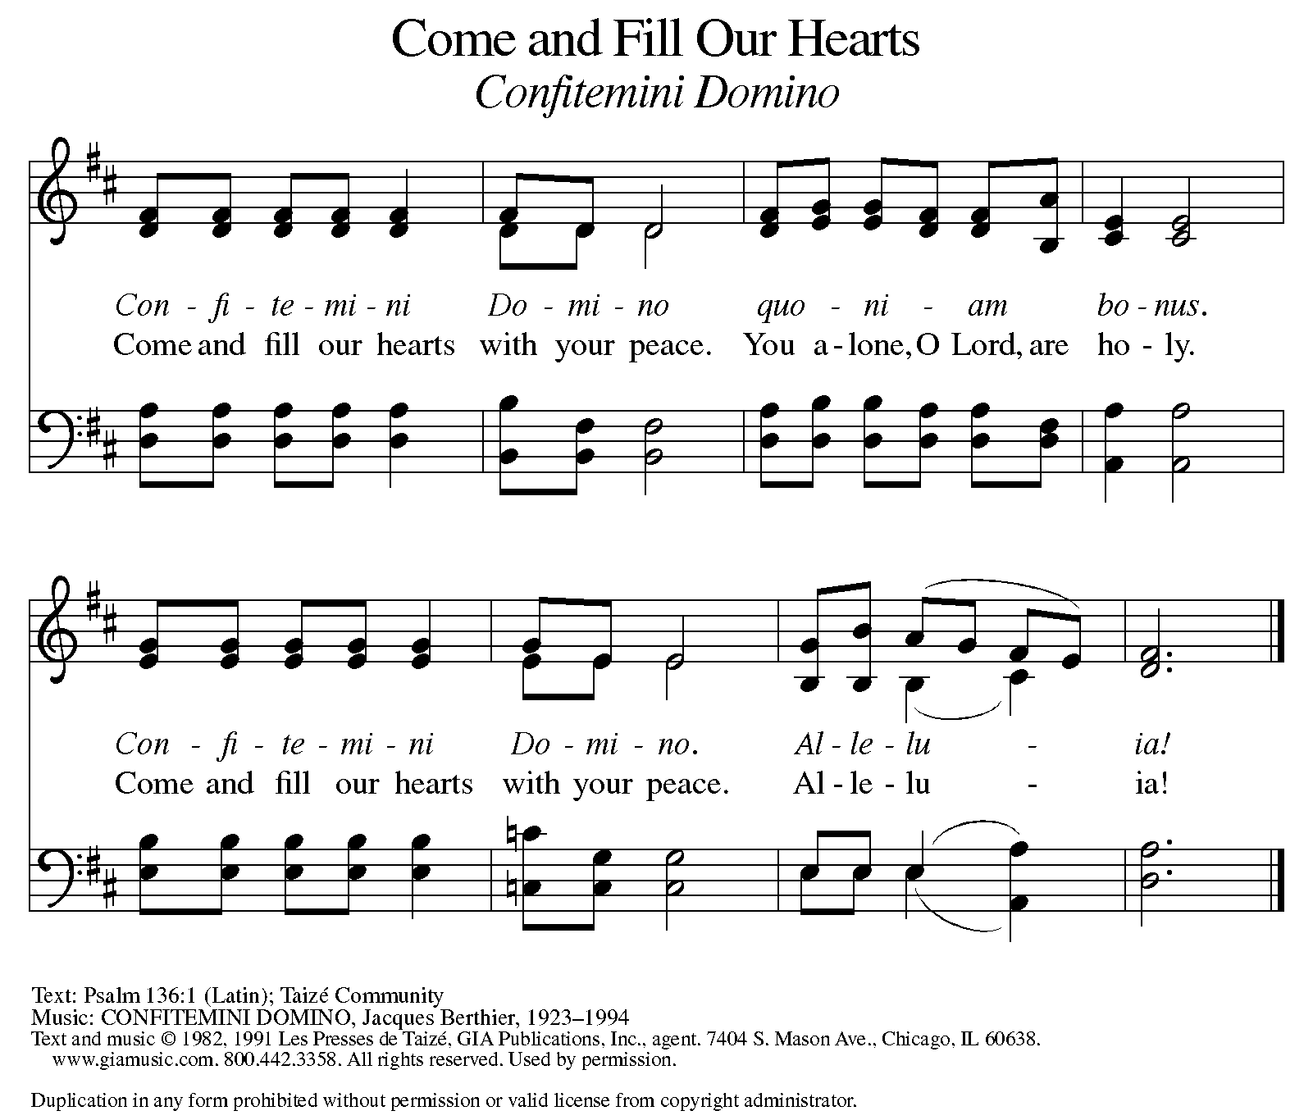

P: The body of Christ, given for you.

C: Amen.

A: The blood of Christ, shed for you.

C: Amen.
(Please rise as you are able.)

P: May the body and blood of our Lord Jesus Christ strengthen and keep you in his grace.

C: Amen.

PRAYER AFTER COMMUNION

P: Let us pray. Generous God, we thank you for the gift of life, for the bread of salvation. We thank you for coming among us, for leading us into peace. We thank you for showering us with mercy, for sending us into the world. Come, Lord Jesus, and go with us as we feed the hungry in your name.

C: Amen.

SENDING

BLESSING

P: God of endings and beginnings, God in the darkness and the light, God, our hope for the journey, ☩ bless and keep you now and forever.

C: Amen.

SENDING HYMN ELW 257

DISMISSAL

A: Go in peace. Prepare the way for Emmanuel.

C: Thanks be to God.

Announcements

- Sunday, December 1 – Poinsettia forms are due.
- Mid-Week Gathering on Wednesdays 12/4, 12/11, 12/18 – Music by James Tavadze & Devotional Lessons.
- Sunday, December 22 – School Christmas Program (during service)
- Tuesday, December 24 – Christmas Eve Service @ 4pm
- Wednesday, December 25 – Merry Christmas!

Recurring Events

- Every Sunday – Adult Bible Study @ 9am
- Monday, December 2 – Worship Committee Meeting @ 6:30pm
- Wednesday, January 8 – Women’s Bible Study @ 11am
- Thursday, December 19 – Council Meeting @ 7pm

Food Pantry Dates

Wednesday, December 4, 5-6:30pm
Thursday, December 12, 1-3pm
Wednesday, December 18, 5-6:30pm
Monday, December 23, 1-3pm
Monday, December 30, 5-6:30pm

Volunteers for December 1 Volunteers for December 8

Reader - Volunteer Reader – Volunteer
Assisting Minister - Mary Assisting Minister – Mary
December Birthday Celebrations

12/1 – Office Manager Emily Po.
12/3 – Tara Mc.
12/7 – Sharon Br.
12/15 – Daphne Mc.
12/24 – Calvin Bo.
12/26 – Judy St.
12/29 – Jon Ke.

December Anniversary Celebrations

12/20 – Jim & Traci Mo.

Acknowledgments
- OneLicense.net, License #A-703165.
- CCLI, License #2281869.
- From SundaysandSeasons.com. Copyright 2020 Augsburg Fortress. All rights reserved. Reprinted by permission under Augsburg Fortress Liturgies Annual License #23806.
- New Revised Standard Version Bible, copyright 1989, Division of Christian Education of the National Council of the Churches of Christ in the United States of America. Used by permission. All rights reserved.

