

16th Sunday after Pentecost
September 8, 2024


SAINT PAUL LUTHERAN CHURCH
3383 EAST LAKE LANSING ROAD
EAST LANSING, MI 48823

PHONE (517) 351-8541

Pastor Carl E. Ballard
E-MAIL: pastor@stpaul-el.org
officemanager@stpaul-el.org
Visitors WELCOME! If this is your first time worshipping with us, please sign our guest registry just outside the sanctuary doors. We hope you are blessed through worship today. If you have any questions, please feel free to call the church at 351-8541.
Children are always welcome in worship! The choir room (off the sanctuary) can also be used as a cry room for younger children and includes a sound system so parents may continue to participate in the service. Clipboards with children's bulletins, activities and crayons are available for use during the service.
Sunday School is available during the worship service September-May except the last Sunday of the month.
Virtual Services We can provide a virtual live Zoom session during worship upon request.
This Bulletin is for your use during the service and to take home for the upcoming week. If you choose not to take it home, please place it in the recycle receptacle in the back.
Newsletters and Calendars of Upcoming Events are available in the lobby/narthex. We welcome anyone who has an interest in our small groups or activities! You can also look us up on the web at www.stpaul-el.org.
Contacting Us: Our Office Manager is Emily Polhamus. She can be reached by phone at 517-351-8541 or at her email address, officemanager@stpaul-el.org. Our Director of Music is Elene Kobulashvili. You may leave a message at 517-351-8541. Pastor Carl can be reached at 517-515-3129, and his email address is cballard123@msn.com.
Holy Communion is available at most services. All who believe in the real presence of Christ in the bread and the wine are invited to celebrate Communion with us. Those who wish may come forward for a blessing.
You’re invited to share in fellowship after worship. Kay (with the assistance of Bob) makes the most delicious snacks to our delight. We would love this opportunity to introduce you to the St. Paul community.

P-Presiding Minister A-Assisting Minister C-Congregation

PRELUDE ELENE

INTRODUCTION

James tells us to stop showing favoritism in the assembly, treating the rich visitor with more honor than the poor one. Jesus himself seems to show partiality in his first response to the Syrophoenician woman in today’s gospel. Was he testing her faith in saying Gentiles don’t deserve the goods meant for God’s children? Or was he speaking out of his human worldview, but transcended those limits when she took him by surprise with her reply? Either way, the story tells us that God shows no partiality. Everyone who brings a need to Jesus is received with equal honor as a child and heir.

GATHERING

P: The Holy Spirit calls us together as the people of God.

(Please rise as you are able.)

CONFESSION AND FORGIVENESS

All may make the sign of the cross, the sign that is marked at baptism, as the presiding minister begins.

P: Blessed be the holy Trinity, ☩ one God, who forgives all our sin, whose mercy endures forever.

C: Amen.

P: Let us confess our sin and come to God for healing.

(Silence for reflection)
P: Gracious God,

C: have mercy on us. We confess that we have honored you with our lips, but have harmed our neighbors with our tongues. The cravings at war within us cause conflicts and disputes. In our desire to be first
we make distinctions among ourselves. We place the needs of the poor and the suffering last. In your great mercy, forgive us our sins. Draw near to us with grace in time of need, and turn us to follow in the way of Jesus Christ, our Savior and Lord. Amen.

P: God promises to forgive our iniquity and to remember our sin no more. By grace you have been saved. In the name of ☩ Jesus Christ, the source of eternal healing, your sins are forgiven.

C: Amen.

GATHERING SONG ELW 612
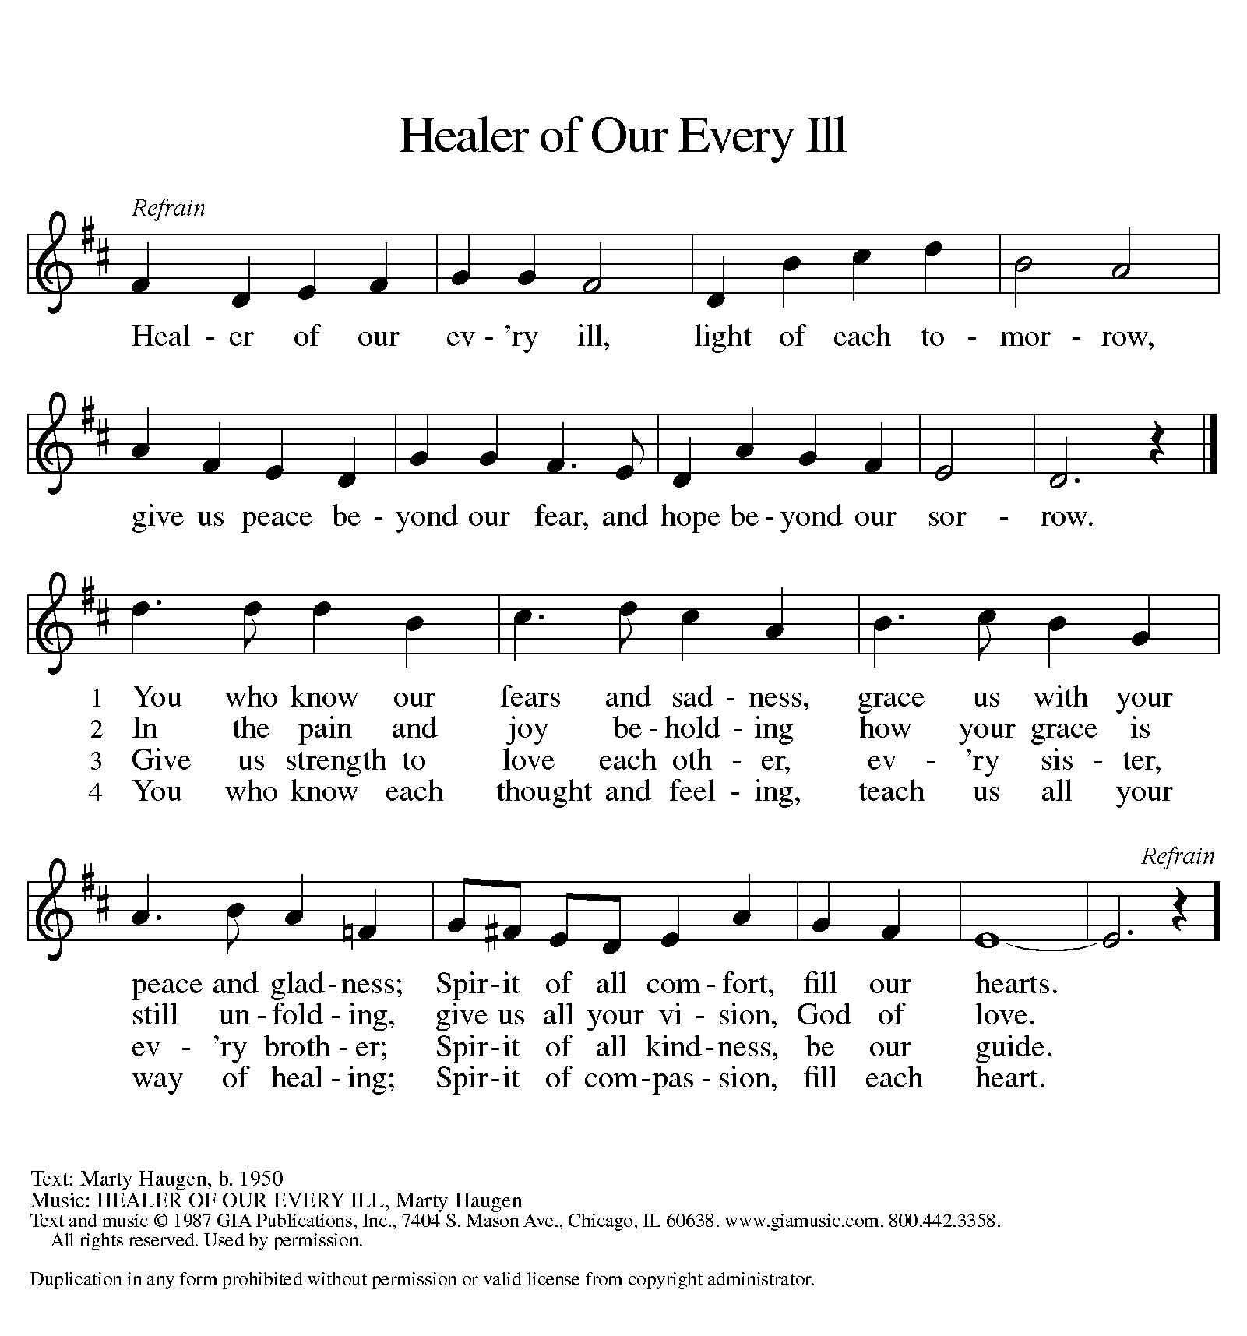

GREETING

P: The grace of our Lord Jesus Christ, the love of God, and the communion of the Holy Spirit be with you all.

C: And also with you.

KYRIE ELW Setting 8, Page 184
Kyrie eleison, on our world and on our way.
Kyrie eleison, ev’ry day.

For peace in the world, for the health of the church, for the unity of all;
for this holy house, for all who worship and praise,
let us pray to the Lord, let us pray to the Lord.

Kyrie eleison, on our world and on our way.
Kyrie eleison, ev’ry day.

That we may live out your impassioned response to the hungry and the poor;
that we may live out truth and justice and grace,
let us pray to the Lord, let us pray to the Lord.

Kyrie eleison, on our world and on our way.
Kyrie eleison, ev’ry day.

For peace in our hearts, for peace in our homes, for friends and family;
for life and for love, for our work and our play,
let us pray to the Lord, let us pray to the Lord.

Kyrie eleison, on our world and on our way.
Kyrie eleison, ev’ry day.

For your Spirit to guide; that you center our lives in the water and the Word;
that you nourish our souls with your body and blood,
let us pray to the Lord, let us pray to the Lord.

Kyrie eleison, on our world and on our way.
Kyrie eleison, ev’ry day.
CANTICLE OF PRAISE ELW Setting 4, Page 149-150

This is the feast of victory for our God.
Alleluia.

Worthy is Christ, the Lamb who was slain,
whose blood set us free to be people of God.
Power and riches and wisdom and strength,
and honor and blessing and glory are his.
This is the feast of victory for our God.
Alleluia.

Sing with all the people of God
and join in the hymn of all creation:
Blessing and honor and glory
and might be to God and the Lamb forever.
Amen.

This is the feast of victory for our God,
for the Lamb who was slain has begun his reign.
Alleluia. Alleluia.

PRAYER OF THE DAY

P: Let us pray. Gracious God, throughout the ages you transform sickness into health and death into life. Open us to the power of your presence, and make us a people ready to proclaim your promises to the whole world, through Jesus Christ, our healer and Lord.

C: Amen.

(Please be seated.)

CHILDREN’S MESSAGE

(Children are invited to Sunday School.)

TRANSITION SONG ELW 715
CHRIST, BE OUR LIGHT (REFRAIN ONLY)
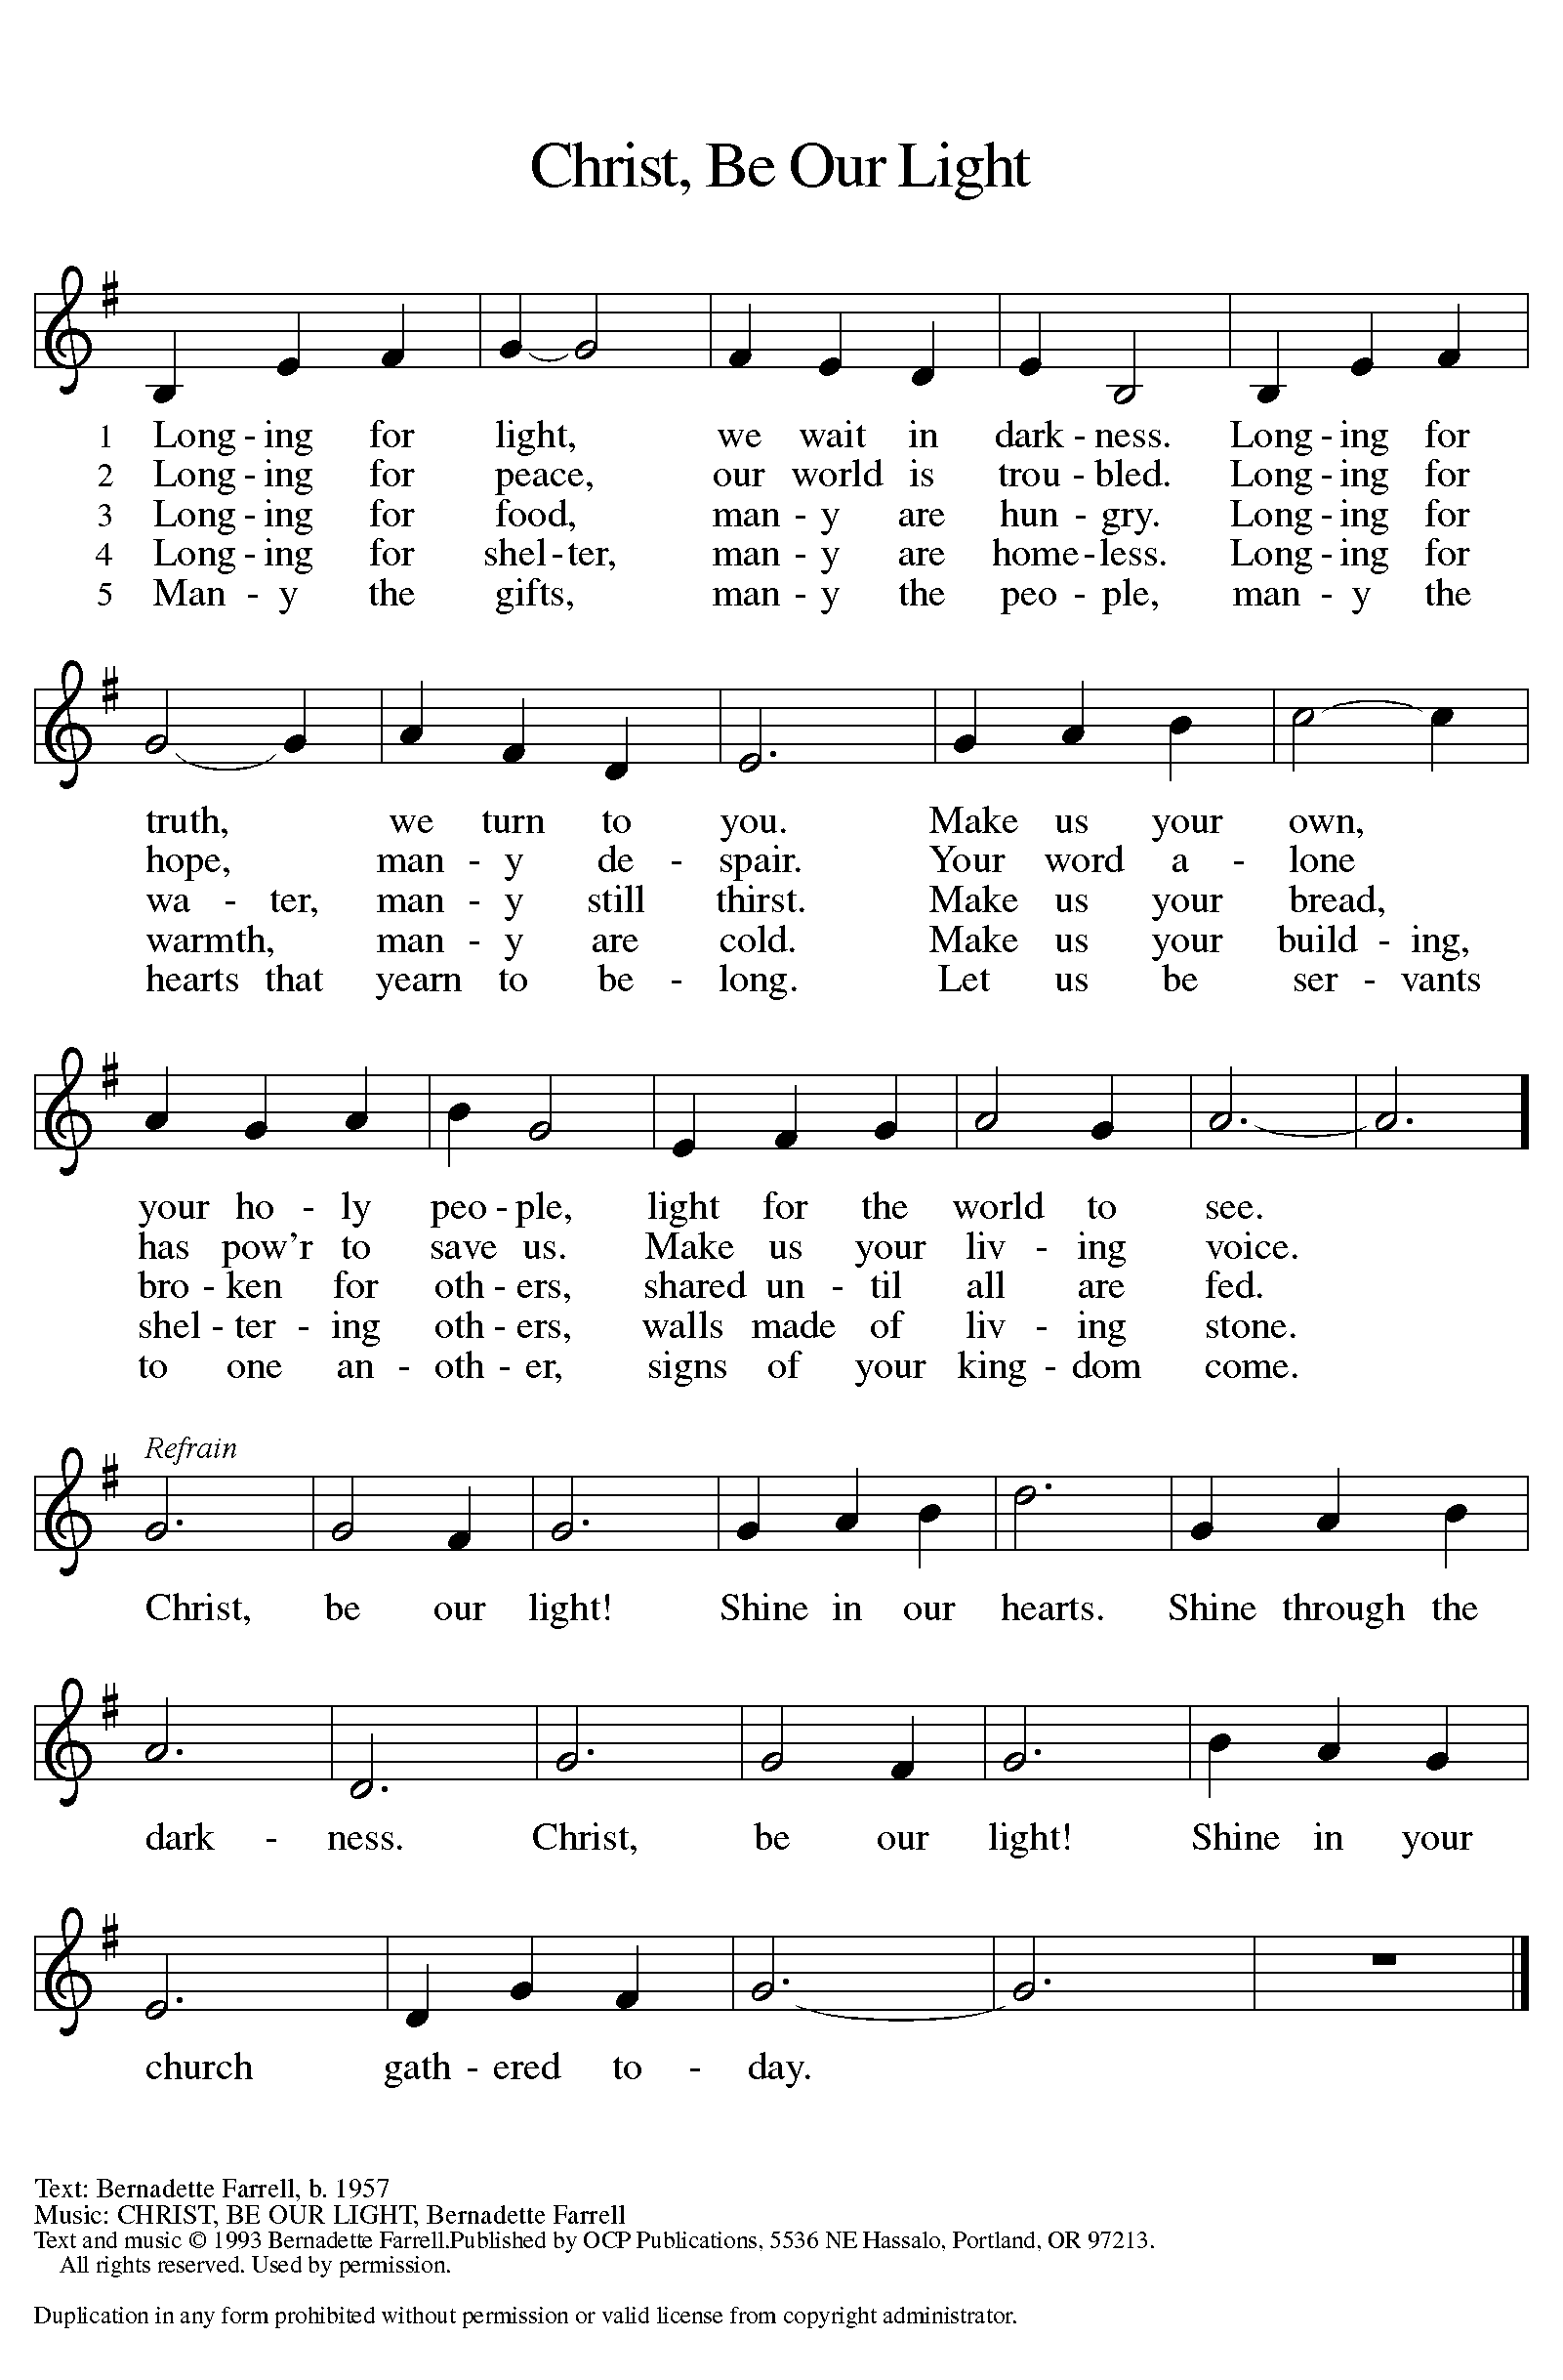

THE WORD

P: God speaks to us in scripture, preaching, and song.

FIRST READING ISAIAH 35:4-7a

These verses are a word of hope to the exiles in Babylon. Isaiah 34 portrays God’s vengeance on Edom, Israel’s age-old enemy, which makes the path from Babylon to Zion safe for the exiles’ return. The desert itself will flow with water to give drink to the returning exiles.

⁴Say to those who are of a fearful heart, “Be strong, do not fear! Here is your God. He will come with vengeance, with terrible recompense. He will come and save you.” ⁵Then the eyes of the blind shall be opened, and the ears of the deaf unstopped; ⁶then the lame shall leap like a deer, and the tongue of the speechless sing for joy. For waters shall break forth in the wilderness, and streams in the desert; ^{7a}the burning sand shall become a pool, and the thirsty ground springs of water.

Reader: Word of God, word of life. C: Thanks be to God.
PSALM PSALM 146

I will praise the Lord as long as I live. (Ps. 146:2)

¹Hallelujah! Praise the Lord, O my soul!
²I will praise the Lord as long as I live; I will sing praises to my God while I have my being.
³Put not your trust in rulers, in mortals in whom there is no help.
⁴When they breathe their last, they return to earth, and in that day their thoughts perish.
⁵Happy are they who have the God of Jacob for their help, whose hope is in the Lord their God;
⁶who made heaven and earth, the seas, and all that is in them;
who keeps promises forever;
⁷who gives justice to those who are oppressed, and food to those who hunger. The Lord sets the captive free.
⁸The Lord opens the eyes of the blind; the Lord lifts up those who are bowed down; the Lord loves the righteous.
⁹The Lord cares for the stranger; the Lord sustains the orphan and widow, but frustrates the way of the wicked.
¹⁰The Lord shall reign forever, your God, O Zion, throughout all generations. Hallelujah!

SECOND READING JAMES 2:1-10 [11-13] 14-17

Faithful Christians do not show partiality to the rich and powerful of the world, especially at the expense of the poor and weak. Likewise, faith does not pay mere lip service to God’s will. Instead, a living Christian faith expresses itself in acts of compassion and mercy for those in need.

¹My brothers and sisters, do you with your acts of favoritism really believe in our glorious Lord Jesus Christ? ²For if a person with gold rings and in fine clothes comes into your assembly, and if a poor person in dirty clothes also comes in, ³and if you take notice of the one wearing the fine clothes and say, “Have a seat here, please,” while to the one who is poor you say, “Stand there,” or, “Sit at my feet,” ⁴have you not made distinctions among yourselves, and become judges with evil thoughts? ⁵Listen, my beloved brothers and sisters. Has not God chosen the poor in the world to be rich in faith and to be heirs of the kingdom that he has promised to those who love him? ⁶But you have dishonored the poor. Is it not the rich who oppress you? Is it not they who drag you into court? ⁷Is it not they who blaspheme the excellent name that was invoked over you? ⁸You do well if you really fulfill the royal law according to the scripture, “You shall love your neighbor as yourself.” ⁹But if you show partiality, you commit sin and are convicted by the law as transgressors. ¹⁰For whoever keeps the whole law but fails in one point has become accountable for all of it.

^{[11}For the one who said, “You shall not commit adultery,” also said, “You shall not murder.” Now if you do not commit adultery but if you murder, you have become a transgressor of the law. ¹²So speak and so act as those who are to be judged by the law of liberty. ¹³For judgment will be without mercy to anyone who has shown no mercy; mercy triumphs over judgment.]

¹⁴What good is it, my brothers and sisters, if you say you have faith but do not have works? Can faith save you? ¹⁵If a brother or sister is naked and lacks daily food, ¹⁶and one of you says to them, “Go in peace; keep warm and eat your fill,” and yet you do not supply their bodily needs, what is the good of that? ¹⁷So faith by itself, if it has no works, is dead.

Reader: Word of God, word of life. C: Thanks be to God.

(Please rise as you are able.)

GOSPEL ACCLAMATION ELW SETTING 8, PAGE 188

Alleluia. Lord, to whom shall we go?
You have the words of eternal life. Alleluia.
Alleluia, alleluia. Alleluia.
Alleluia, alleluia.

GOSPEL MARK 7:24-37

P: The Holy Gospel according to Mark, the 7th chapter.

C: Glory to you, O Lord.

In Mark’s gospel, encounters with women usually signify turning points in Jesus’ ministry. Here, a conversation with a Syrophoenician woman marks the beginning of his mission to the Gentiles.

²⁴[Jesus] set out and went away to the region of Tyre. He entered a house and did not want anyone to know he was there. Yet he could not escape notice,²⁵but a woman whose little daughter had an unclean spirit immediately heard about him, and she came and bowed down at his feet. ²⁶Now the woman was a Gentile, of Syrophoenician origin. She begged him to cast the demon out of her daughter. ²⁷He said to her, “Let the children be fed first, for it is not fair to take the children’s food and throw it to the dogs.” ²⁸But she answered him, “Sir, even the dogs under the table eat the children’s crumbs.” ²⁹Then he said to her, “For saying that, you may go—the demon has left your daughter.” ³⁰So she went home, found the child lying on the bed, and the demon gone.
³¹Then he returned from the region of Tyre, and went by way of Sidon towards the Sea of Galilee, in the region of the Decapolis. ³²They brought to him a deaf man who had an impediment in his speech; and they begged him to lay his hand on him. ³³He took him aside in private, away from the crowd, and put his fingers into his ears, and he spat and touched his tongue. ³⁴Then looking up to heaven, he sighed and said to him, “Ephphatha,” that is, “Be opened.” ³⁵And immediately his ears were opened, his tongue was released, and he spoke plainly. ³⁶Then Jesus ordered them to tell no one; but the more he ordered them, the more zealously they proclaimed it. ³⁷They were astounded beyond measure, saying, “He has done everything well; he even makes the deaf to hear and the mute to speak.”
P: The Gospel of the Lord. C: Praise to you, O Christ.

(Please be seated.)

SERMON Pastor Carl Ballard
(Please rise as you are able.)

HYMN OF THE DAY ACS 1000
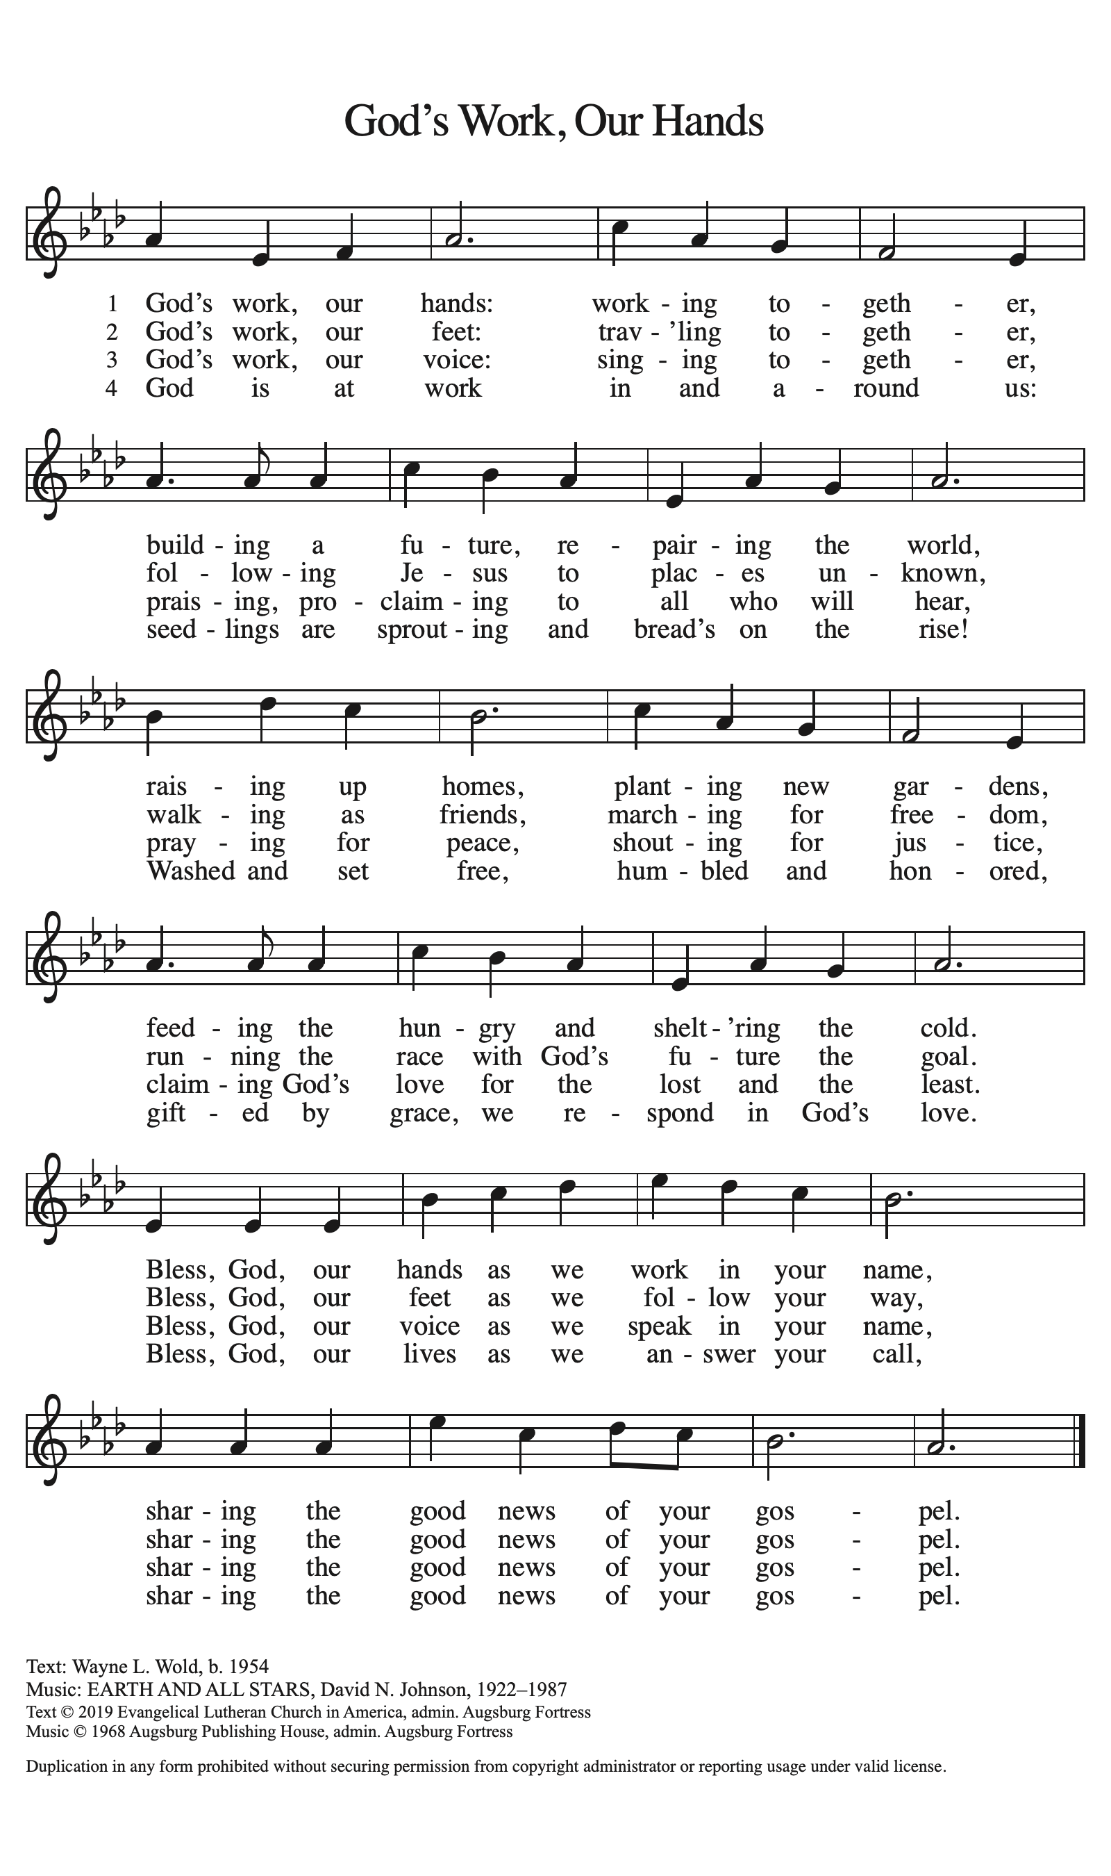
AposTles’ CREED

I believe in God, the Father almighty,
creator of heaven and earth.
I believe in Jesus Christ, God’s only Son, our Lord,
who was conceived by the Holy Spirit,
born of the virgin Mary,
suffered under Pontius Pilate,
was crucified, died, and was buried;
he descended to the dead.
On the third day he rose again;
he ascended into heaven,
he is seated at the right hand of the Father,
and he will come to judge the living and the dead.
I believe in the Holy Spirit,
the holy catholic church,
the communion of saints,
the forgiveness of sins,
the resurrection of the body,
and the life everlasting. Amen.

(Please be seated.)

THE PRAYERS

A: Drawn together in the power of the Holy Spirit, we pray with confidence for the church, God’s good creation, and all who are in need.

(A brief silence.)

A: Awaken in our communities of faith a spirit of radical hospitality. Encourage our churches to celebrate and embrace people of diverse backgrounds, experiences, and abilities. Deepen our commitment to ecumenical and interreligious partnerships. Hear us, O God.

C: Your mercy is great.

A: Bring forth water to nourish plants and animals in places suffering from drought. Renew our commitments to protect rivers, lakes, and streams, and make us good stewards of water in our homes and communities. Preserve wetland habitats and the creatures that make their homes there. Hear us, O God.

C: Your mercy is great.

A: Inspire leaders of cities, nations, and tribes to lead with wisdom and humility. Bring peace among peoples in conflict and strengthen global commitments to nonviolent solutions. Guide all who seek refuge from war to a safe haven. Hear us, O God.

C: Your mercy is great.

A: Comfort all who live with chronic illness. Surround them in your tender embrace and sustain all who provide ongoing care and support. Bring hope and healing to people struggling with addiction and nourish the spirits of all who are in recovery. Hear us, O God.

C: Your mercy is great.

A: Nurture in all people the gift of your creating Spirit. Inspire artists and musicians, woodworkers and quilters, poets and dancers. Revive those whose artistic wells have run dry and enliven all who doubt their creative talents. Hear us, O God.

C: Your mercy is great.

A: Provide care and compassion for those who serve in our armed forces, especially Beth & Ryan, Jonathan, Jacob, Noah, Irene, and Alex. Hear us, O God.

C: Your mercy is great.

A: Deepen our care for those who are bowed down with illness or sorrow and those who are undergoing transition in relationships, occupation, living situation, or health condition, especially Ahren, Carolyn, Craig & family, Dan, David, Jim & Cheri, John, John, Jon, Jordan, Kay, Lawton, Lera & family, Liam, Linda, Lizzy, Marge, Mary, Pastor Sarah, Randy, Rick & Kathy, Sheri, Sheri (co-worker of Mary Mc.), and Wanda. And all that we name now aloud and in our hearts. Hear us, O God.

C: Your mercy is great.

A: Guide our church’s leaders, Presiding Bishop Elizabeth, our Synod Bishop Craig, and Pastor Carl. We ask that you be with their respective staffs as they live out their callings to serve. As we are called to be one, even as Jesus and the Father are one, be with the leaders and the congregation Immanuel Lutheran Church in Suttons Bay and all the churches in our community. Hear us, O God.

C: Your mercy is great.

A: We give you thanks for all who have died and now find their rest in you. May their faithful witness guide us in our daily life with you. Hear us, O God.

C: Your mercy is great.

P: We entrust these and all our prayers to you, holy God, in the name of your beloved child, Jesus Christ, our Savior.

C: Amen.

GREETING OF PEACE

P: The peace of Christ be with you always.

C: And also with you.

(You are invited to share Christ’s peace with one another.)

(Please be seated.)

THE MEAL

OFFERING ELENE

OFFERTORY ELW 692
WE ARE AN OFFERING

We lift our voices,
We lift our hands,
We lift our lives up to you:
We are an offering.

Lord, use our voices,
Lord, use our hands,
Lord, use our lives, they are yours:
We are an offering.

All that we have,
All that we are,
All that we hope to be,
We give to you,
We give to you.

We lift our voices,
We lift our hands,
We lift our lives up to you:
We are an offering,
We are an offering.

OFFERING PRAYER

A: Let us pray. Blessed are you, O God, source of every gift of your creation. By these gifts and with our lives, help us to serve one another and all in need, through Jesus Christ, our Savior and Lord.

C: Amen.

THE GREAT THANKSGIVING

P: The Lord be with you.
C: And also with you.
P: Lift up your hearts.
C: We lift them to the Lord.
P: Let us give thanks to the Lord our God.
C: It is right to give our thanks and praise.

PROPER PREFACE

P: It is indeed right, our duty and our joy, that we should at all times and in all places give thanks and praise to you, almighty and merciful God, through our Savior Jesus Christ; who on this day overcame death and the grave, and by his glorious resurrection opened to us the way of everlasting life. And so, with all the choirs of angels, with the church on earth and the hosts of heaven, we praise your name and join their unending hymn:

HOLY, HOLY ELW SETTING 8, Page 190

Holy, holy, holy Lord,
God of power and might,
heaven and earth are full of your glory, full of your glory.
Hosanna, hosanna, hosanna in the highest.
Blessed is he who comes in the name of the Lord.
Hosanna, hosanna, hosanna in the highest.

EUCHARISTIC PRAYER

P: In the night in which he was betrayed, our Lord Jesus took bread, and gave thanks; broke it, and gave it to his disciples, saying:
Take and eat; this is my body, given for you. Do this for the remembrance of me.
Again, after supper, he took the cup, gave thanks, and gave it for all to drink, saying:
This cup is the new covenant in my blood, shed for you and for all people for the forgiveness of sin. Do this for the remembrance of me.

LORD'S PRAYER

P: Lord, remember us in your kingdom, and teach us to pray:

C: Our Father in heaven, hallowed be your name, your kingdom come, your will be done, on earth as in heaven. Give us today our daily bread. Forgive us our sins as we forgive those who sin against us. Save us from the time of trial and deliver us from evil. For the kingdom, the power, and the glory are yours, now and forever. Amen.

COMMUNION DISTRIBUTION

All who believe in the real presence of Christ in the bread and the wine (juice) are welcome to the table. Others may come forward for a blessing. If you prefer grape juice, please indicate this to the assisting minister.

When approaching the communion rail, come forward down the side aisle, kneel, if you are able, starting at the front of the communion rail (spot closest to the font) on your side and filling in toward the back. After receiving both the bread and the wine, you may return to your seat by the center aisle.

INVITATION TO COMMUNION

P: Jesus welcomes you to this table. Come, here is your God.

COMMUNION HYMN ELW 496
(REFRAIN ONLY)
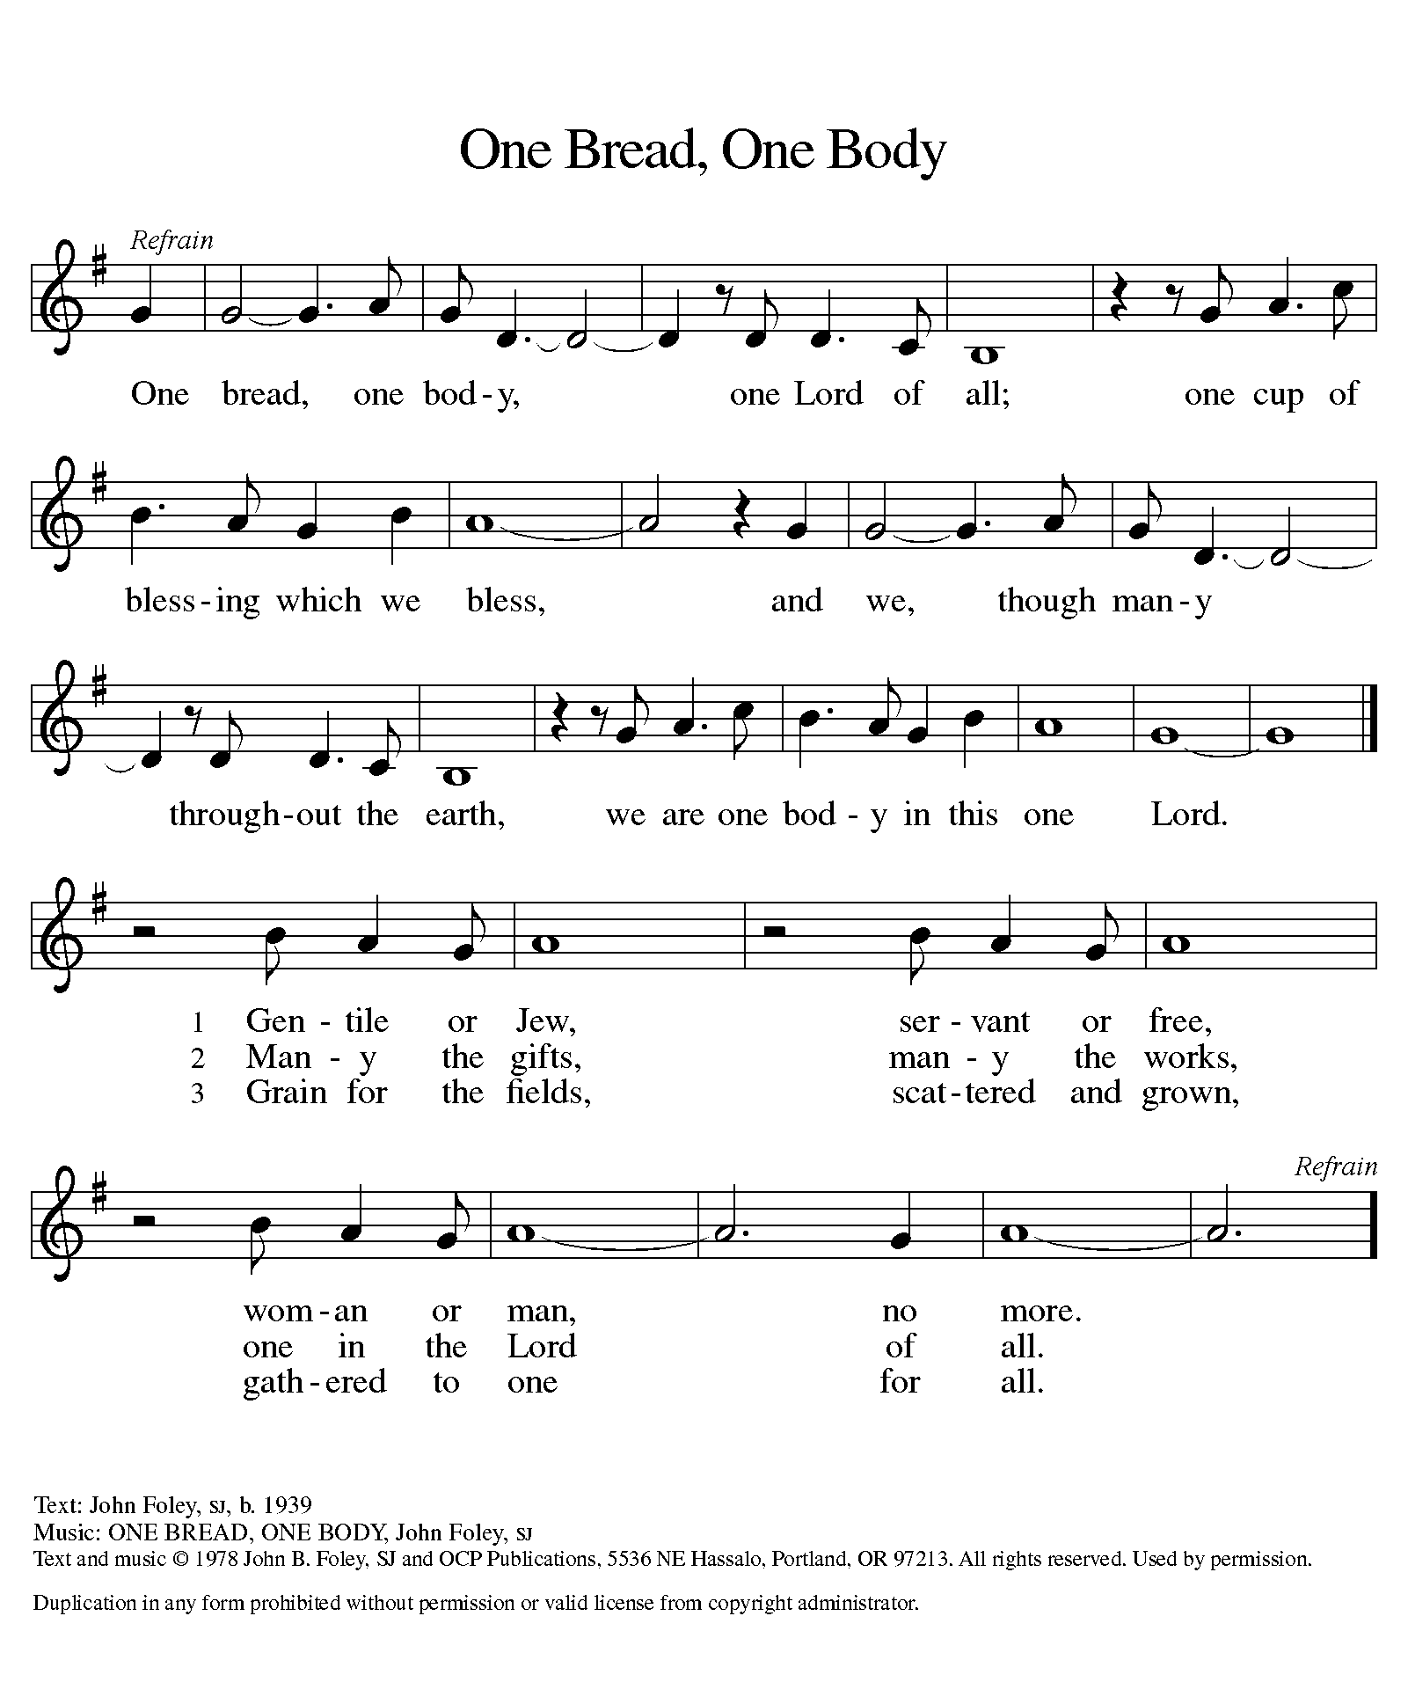

P: The body of Christ, given for you.

C: Amen.

A: The blood of Christ, shed for you.

C: Amen.
(Please rise as you are able.)

P: May the body and blood of our Lord Jesus Christ strengthen and keep you in his grace.

C: Amen.

PRAYER AFTER COMMUNION

P: Let us pray. Holy God, you have welcomed us to this meal and fed us with dignity at your table. Send us now to welcome others and to be at peace with one another, through Jesus Christ our Lord.

C: Amen.

SENDING

BLESSING

P: God all mighty, God most merciful ☩ bless you, keep you, and give you peace.

C: Amen.

SENDING HYMN ELW 886
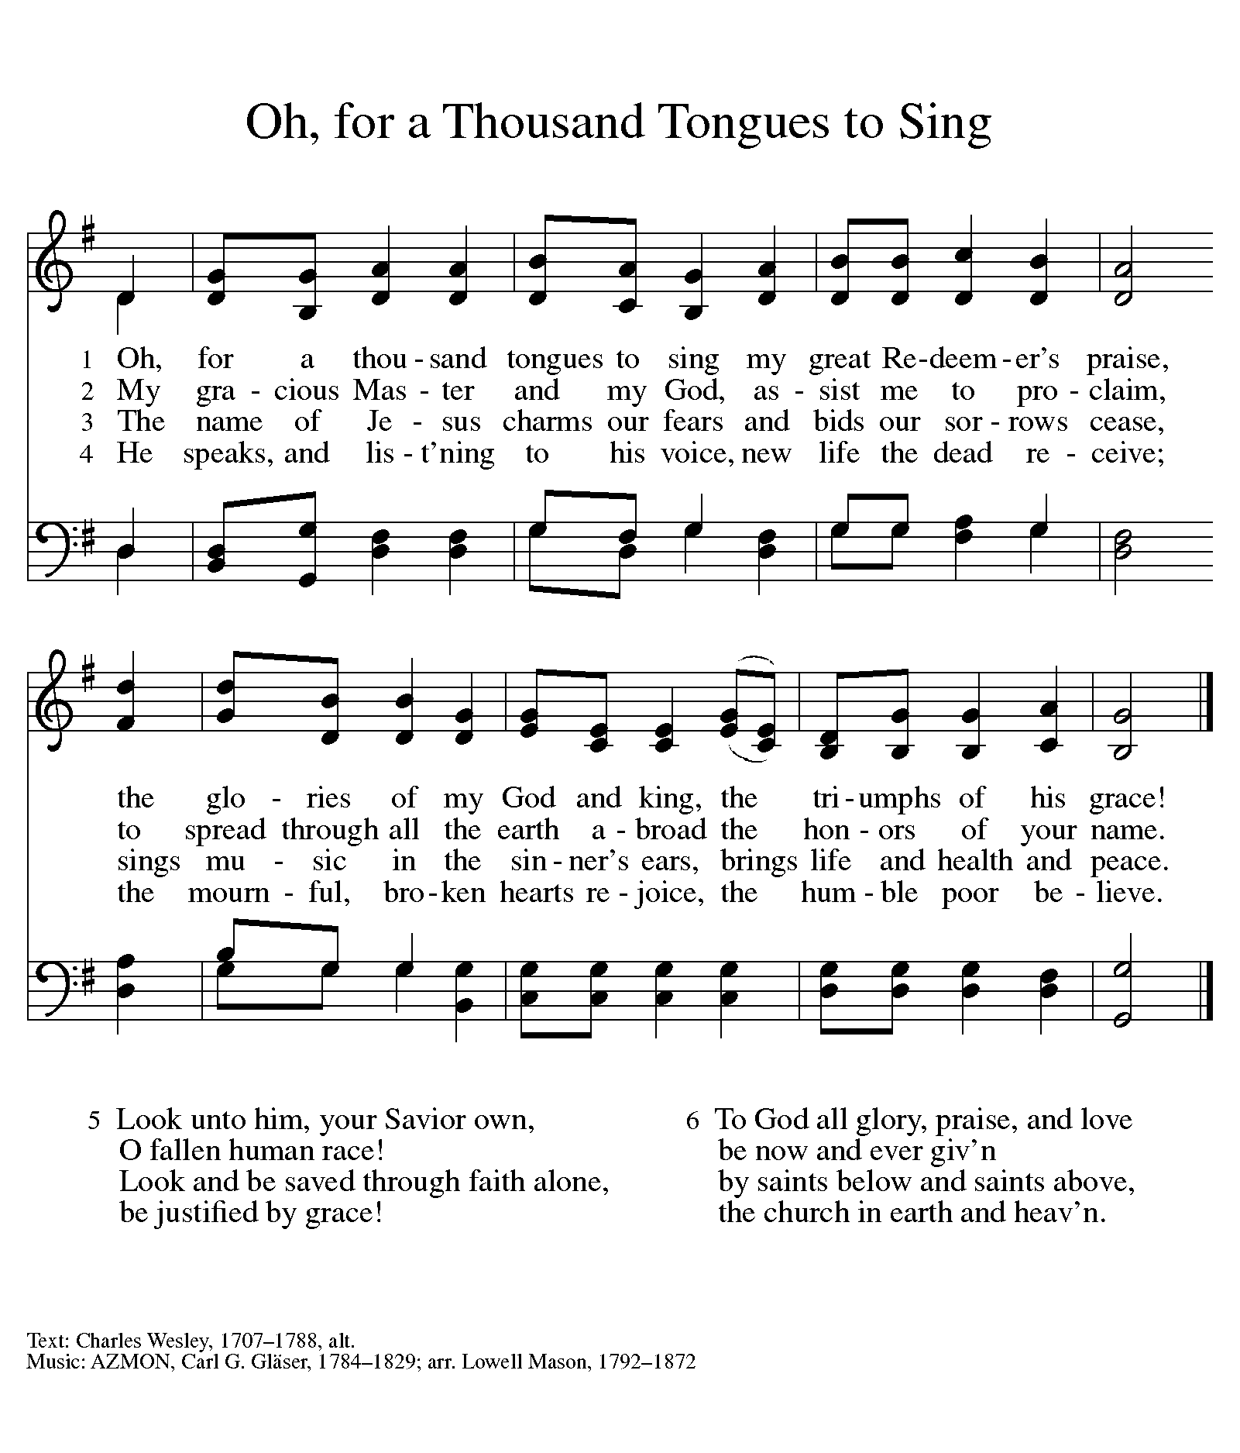

DISMISSAL

A: Go in peace. Follow Jesus.

C: Thanks be to God.

Announcements

- Sunday, September 8 – Rally Day & God’s Work, Our Hands Sunday. (Assemble helpful Homeless Kits for Advent House.)

- Sunday, September 15 – Fish Fry after worship. Teach Installation Day.

Recurring Events
- Every Sunday – Adult Bible Study @ 9am
- Monday, September 9 – Worship Committee Meeting @ 6:30pm
- Wednesday, September 18 – Women’s Bible Study @ 11am
- Thursday, September 19 – Council Meeting @ 7pm

Food Pantry Dates

- Thursday, September 12, 1-3pm
- Wednesday, September 18, 5-7pm
- Thursday, September 26, 1-3pm
- Wednesday, October 2, 5-7pm

Volunteers for September 8 Volunteers for September 15

Reader Sunday – Volunteer Reader Sunday – Volunteer
Assisting Minister – Mary Assisting Minister – Mary

September Birthday Celebrations
9/9 – David Fo.
9/11 – AJ Po.
9/13 – Nathan An.
9/25 – Caroline Co.
9/25 – Jessica Sm.

Anniversary Celebrations
9/2 – James & Ardyth Cl.
9/19 – Dennis & Maryann Lo.
9/30 – Rick & Kathy Kl.

Acknowledgments
- OneLicense.net, License #A-703165. CCLI, License #2281869.
- From SundaysandSeasons.com. Copyright 2020 Augsburg Fortress. All rights reserved. Reprinted by permission under Augsburg Fortress Liturgies Annual License #23806.
- New Revised Standard Version Bible, copyright 1989, Division of Christian Education of the National Council of the Churches of Christ in the United States of America. Used by permission. All rights reserved.

