

Fifteenth Sunday after Pentecost
September 1, 2024


SAINT PAUL LUTHERAN CHURCH
3383 EAST LAKE LANSING ROAD
EAST LANSING, MI 48823

PHONE (517) 351-8541

Pastor Carl E. Ballard
E-MAIL: pastor@stpaul-el.org
officemanager@stpaul-el.org
Visitors WELCOME! If this is your first time worshipping with us, please sign our guest registry just outside the sanctuary doors. We hope you are blessed through worship today. If you have any questions, please feel free to call the church at 351-8541.
Children are always welcome in worship! The choir room (off the sanctuary) can also be used as a cry room for younger children and includes a sound system so parents may continue to participate in the service. Clipboards with children's bulletins, activities and crayons are available for use during the service.
Sunday School is available during the worship service September-May except the last Sunday of the month.
Virtual Services We can provide a virtual live Zoom session during worship upon request.
This Bulletin is for your use during the service and to take home for the upcoming week. If you choose not to take it home, please place it in the recycle receptacle in the back.
Newsletters and Calendars of Upcoming Events are available in the lobby/narthex. We welcome anyone who has an interest in our small groups or activities! You can also look us up on the web at www.stpaul-el.org.
Contacting Us: Our Office Manager is Emily Polhamus. She can be reached by phone at 517-351-8541 or at her email address, officemanager@stpaul-el.org. Our Director of Music is Elene Kobulashvili. You may leave a message at 517-351-8541. Pastor Carl can be reached at 517-515-3129, and his email address is cballard123@msn.com.
Holy Communion is available at most services. All who believe in the real presence of Christ in the bread and the wine are invited to celebrate Communion with us. Those who wish may come forward for a blessing.
You’re invited to share in fellowship after worship. Kay (with the assistance of Bob) makes the most delicious snacks to our delight. We would love this opportunity to introduce you to the St. Paul community.

P-Presiding Minister A-Assisting Minister C-Congregation

PRELUDE ELENE

INTRODUCTION

Jesus protests against human customs being given the weight of divine law, while the essence of God’s law is ignored. True uncleanness comes not from external things, but from the intentions of the human heart. Last week Jesus told us “the words that I have spoken to you are spirit and life” (John 6:63). Now James says God has given us birth by the word of truth. We who were washed in the word when we were born in the font return to it every Sunday to ask God to create in us clean hearts.

GATHERING

P: The Holy Spirit calls us together as the people of God.

(Please rise as you are able.)

CONFESSION AND FORGIVENESS

All may make the sign of the cross, the sign that is marked at baptism, as the presiding minister begins.

P: Blessed be the holy Trinity, ☩ one God, who forgives all our sin, whose mercy endures forever.

C: Amen.

P: Let us confess our sin and come to God for healing.

(Silence for reflection)
P: Gracious God,

C: have mercy on us. We confess that we have honored you with our lips, but have harmed our neighbors with our tongues. The cravings at war within us cause conflicts and disputes. In our desire to be first we make distinctions among ourselves. We place the needs of the poor and the suffering last. In your great mercy, forgive us our sins. Draw near to us with grace in time of need, and turn us to follow in the way of Jesus Christ, our Savior and Lord. Amen.

P: God promises to forgive our iniquity and to remember our sin no more. By grace you have been saved. In the name of ☩ Jesus Christ, the source of eternal healing, your sins are forgiven.

C: Amen.

GATHERING SONG ELW 717
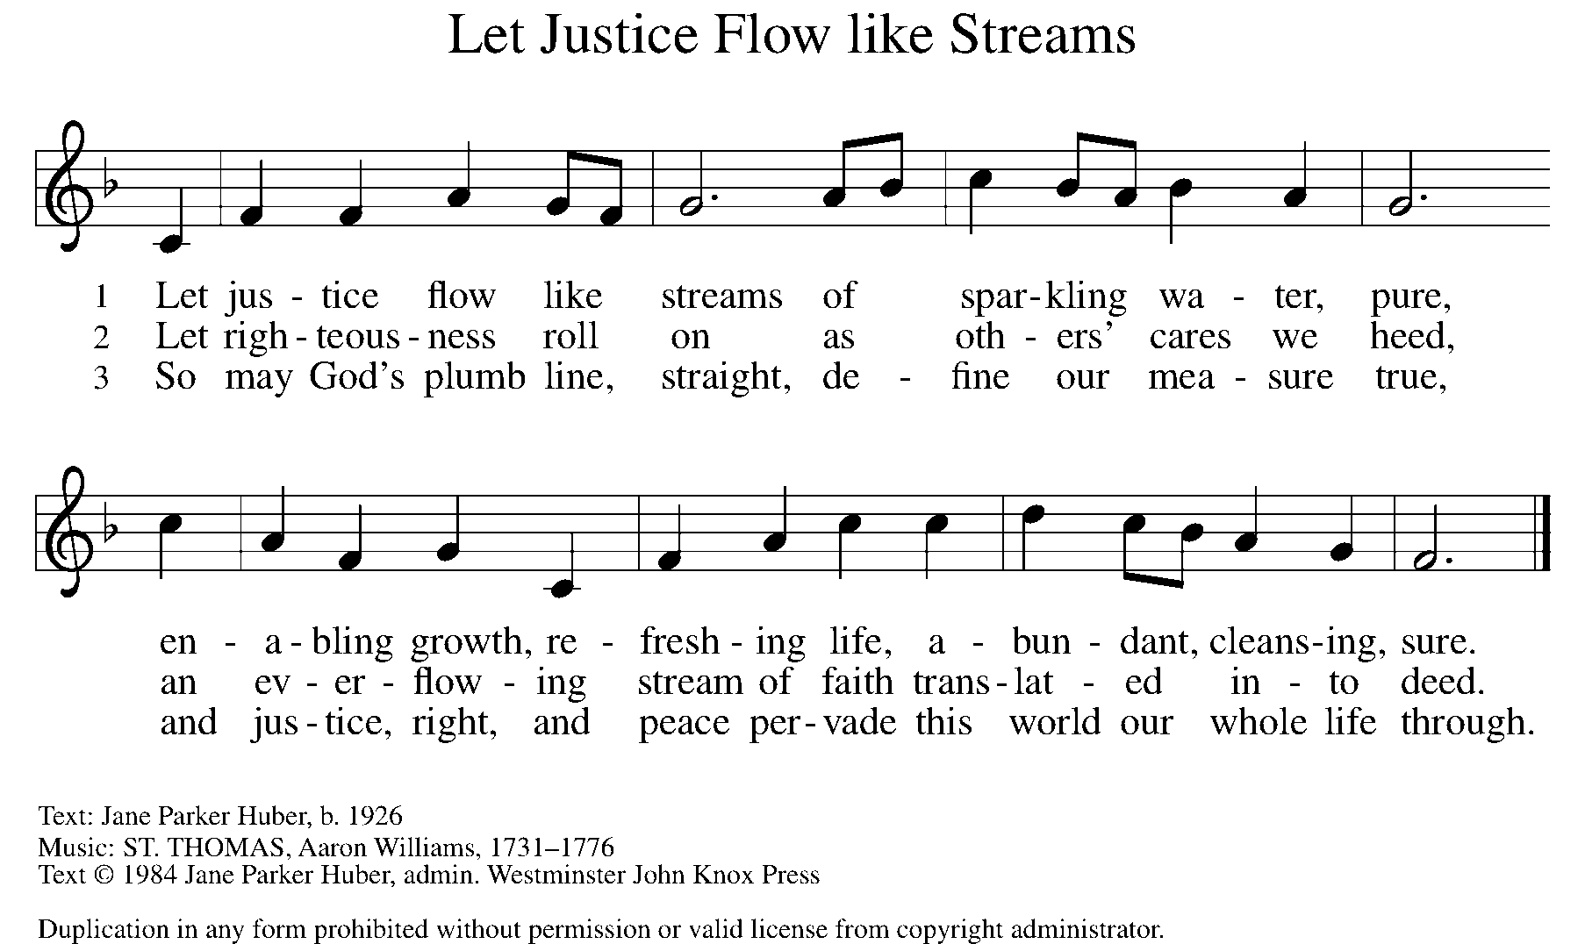

GREETING

P: The grace of our Lord Jesus Christ, the love of God, and the communion of the Holy Spirit be with you all.

C: And also with you.

KYRIE ELW Setting 10, Page 203

Have mercy on us, Lord,
and hear our solemn prayer.
We come to hear your living word;
it saves us from despair.

Have mercy on us, Christ,
and wash away our sin.
Pour out your grace and make us whole
that new life may begin.

Have mercy on us, Lord;
make sin and shame depart.
Renew us with your saving pow’r;
create in us new hearts!

CANTICLE OF PRAISE ELW Setting 4, Page 149-150

This is the feast of victory for our God.
Alleluia.

Worthy is Christ, the Lamb who was slain,
whose blood set us free to be people of God.
Power and riches and wisdom and strength,
and honor and blessing and glory are his.
This is the feast of victory for our God.
Alleluia.

Sing with all the people of God
and join in the hymn of all creation:
Blessing and honor and glory
and might be to God and the Lamb forever.
Amen.

This is the feast of victory for our God,
for the Lamb who was slain has begun his reign.
Alleluia. Alleluia.

PRAYER OF THE DAY

P: Let us pray. O God our strength, without you we are weak and wayward creatures. Protect us from all dangers that attack us from the outside, and cleanse us from all evil that arises from within ourselves, that we may be preserved through your Son, Jesus Christ, our Savior and Lord.

C: Amen.

(Please be seated.)

CHILDREN’S MESSAGE

(Children return to their seats.)

THE WORD

P: God speaks to us in scripture, preaching, and song.

FIRST READING DEUTERONOMY 4:1-2, 6-9

The Israelites believed the law was a divine gift that provided guidelines for living out the covenant. Moses commands the people to obey the law and to neither add to nor subtract from it. The Israelites are also to teach the law to their children and their children’s children.

¹So now, Israel, give heed to the statutes and ordinances that I am teaching you to observe, so that you may live to enter and occupy the land that the Lord, the God of your ancestors, is giving you. ²You must neither add anything to what I command you nor take away anything from it, but keep the commandments of the Lord your God with which I am charging you.

⁶You must observe them diligently, for this will show your wisdom and discernment to the peoples, who, when they hear all these statutes, will say, “Surely this great nation is a wise and discerning people!” ⁷For what other great nation has a god so near to it as the Lord our God is whenever we call to him? ⁸And what other great nation has statutes and ordinances as just as this entire law that I am setting before you today? ⁹But take care and watch yourselves closely, so as neither to forget the things that your eyes have seen nor to let them slip from your mind all the days of your life; make them known to your children and your children’s children.

Reader: Word of God, word of life. C: Thanks be to God.
PSALM PSALM 15

Lord, who may dwell in your tabernacle? (Ps. 15:1)

¹Lord, who may dwell in your tabernacle? Who may abide upon your holy hill?
²Those who lead a blameless life and do what is right, who speak the truth from their heart;
³they do not slander with the tongue, they do no evil to their friends; they do not cast discredit upon a neighbor.
⁴In their sight the wicked are rejected, but they honor those who fear the Lord. They have sworn upon their health and do not take back their word.
⁵They do not give their money in hope of gain, nor do they take bribes against the innocent. Those who do these things shall never be overthrown.

SECOND READING JAMES 1:17-27

The letter of James was intended to provide first-century Christians with instruction in godly behavior. Here Christians are encouraged to listen carefully and to act on what they hear, especially by caring for those least able to care for themselves.

¹⁷Every generous act of giving, with every perfect gift, is from above, coming down from the Father of lights, with whom there is no variation or shadow due to change. ¹⁸In fulfillment of his own purpose he gave us birth by the word of truth, so that we would become a kind of first fruits of his creatures.
¹⁹You must understand this, my beloved: let everyone be quick to listen, slow to speak, slow to anger; ²⁰for your anger does not produce God’s righteousness. ²¹Therefore rid yourselves of all sordidness and rank growth of wickedness, and welcome with meekness the implanted word that has the power to save your souls. ²²But be doers of the word, and not merely hearers who deceive themselves. ²³For if any are hearers of the word and not doers, they are like those who look at themselves in a mirror; ²⁴for they look at themselves and, on going away, immediately forget what they were like. ²⁵But those who look into the perfect law, the law of liberty, and persevere, being not hearers who forget but doers who act—they will be blessed in their doing. ²⁶If any think they are religious, and do not bridle their tongues but deceive their hearts, their religion is worthless. ²⁷Religion that is pure and undefiled before God, the Father, is this: to care for orphans and widows in their distress, and to keep oneself unstained by the world.

Reader: Word of God, word of life. C: Thanks be to God.

(Please rise as you are able.)

GOSPEL ACCLAMATION ELW SETTING 10, PAGE 205

Alleluia! Lord and Savior: open now your saving word.
Let it burn like fire within us; speak until our hearts are stirred.
Alleluia! Lord, we sing for the good news that you bring.

GOSPEL MARK 7:1-8, 14-15, 21-23

P: The Holy Gospel according to Mark, the 7th chapter.

C: Glory to you, O Lord.

Mark’s gospel depicts Jesus as challenging traditional ways in which religious people determine what is pure or impure. For Jesus, the observance of religious practices cannot become a substitute for godly words or deeds that spring from a faithful heart.

¹Now when the Pharisees and some of the scribes who had come from Jerusalem gathered around [Jesus], ²they noticed that some of his disciples were eating with defiled hands, that is, without washing them. ³(For the Pharisees, and all the Jews, do not eat unless they thoroughly wash their hands, thus observing the tradition of the elders; ⁴and they do not eat anything from the market unless they wash it; and there are also many other traditions that they observe, the washing of cups, pots, and bronze kettles.) ⁵So the Pharisees and the scribes asked him, “Why do your disciples not live according to the tradition of the elders, but eat with defiled hands?” ⁶He said to them, “Isaiah prophesied rightly about you hypocrites, as it is written,
‘This people honors me with their lips, but their hearts are far from me; ⁷in vain do they worship me, teaching human precepts as doctrines.’ ⁸You abandon the commandment of God and hold to human tradition.”

¹⁴Then he called the crowd again and said to them, “Listen to me, all of you, and understand: ¹⁵there is nothing outside a person that by going in can defile, but the things that come out are what defile.

²¹“For it is from within, from the human heart, that evil intentions come: fornication, theft, murder, ²²adultery, avarice, wickedness, deceit, licentiousness, envy, slander, pride, folly. ²³All these evil things come from within, and they defile a person.”

P: The Gospel of the Lord. C: Praise to you, O Christ.

(Please be seated.)

SERMON PASTOR CARL BALLARD

(Please rise as you are able.)

HYMN OF THE DAY ELW 512
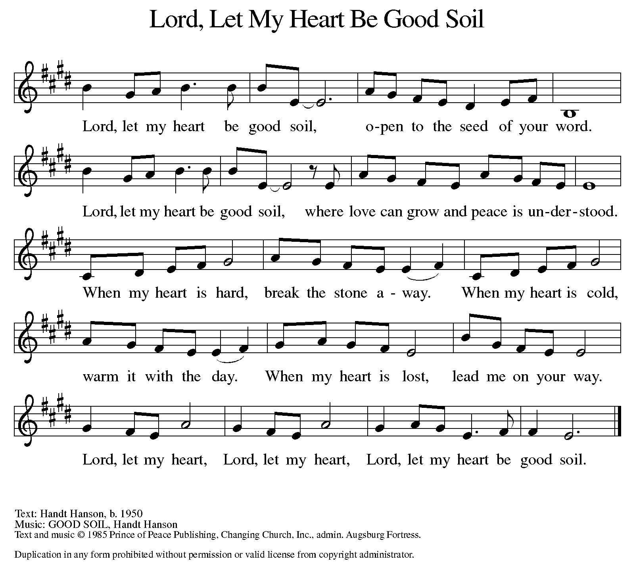

AposTles’ CREED

I believe in God, the Father almighty,
creator of heaven and earth.
I believe in Jesus Christ, God’s only Son, our Lord,
who was conceived by the Holy Spirit,
born of the virgin Mary,
suffered under Pontius Pilate,
was crucified, died, and was buried;
he descended to the dead.
On the third day he rose again;
he ascended into heaven,
he is seated at the right hand of the Father,
and he will come to judge the living and the dead.
I believe in the Holy Spirit,
the holy catholic church,
the communion of saints,
the forgiveness of sins,
the resurrection of the body,
and the life everlasting. Amen.

(Please be seated.)
THE PRAYERS

A: Drawn together in the power of the Holy Spirit, we pray with confidence for the church, God’s good creation, and all who are in need.

(A brief silence.)

A: God of every generation, give the church a sense of purpose and belonging. Sustain and build up leaders and lay people as we accompany one another in our life with Christ. Merciful God,

C: receive our prayer.

A: God of creation, you named humans as co-creators with you. Where the earth cries out in pain, bring wholeness. Guide governments and industry, that environmental laws and practices seek to heal and not harm. Bring relief and justice to people and places suffering from climate catastrophe. Merciful God,

C: receive our prayer.

A: Sovereign God, we pray for local communities of every kind: rural and urban; established and new. Lead those in authority to seek the good of all through their words and actions and to mentor others in honest and generous ways. Merciful God,

C: receive our prayer.

A: Healing God, you draw near to all who are hurting. Be with all who desire relief from chronic and acute illness, cancer, and post-traumatic stress disorder. Strengthen health care workers, therapists, and caregivers. Tend to those who are close to our hearts. Merciful God,

C: receive our prayer.

A: On this Labor Day weekend we remember and give thanks for all who have fought for workers’ rights around the world. Continue to improve working conditions and establish fair wages so that all people may thrive. Merciful God,

C: receive our prayer.

A: Protecting God, provide care and compassion for those who serve in our armed forces, especially Beth & Ryan, Jonathan, Jacob, Noah, Irene, and Alex. Merciful God,

C: receive our prayer.

A: Compassionate God, deepen our care for those who are bowed down with illness or sorrow and those who are undergoing transition in relationships, occupation, living situation, or health condition, especially Ahren, Carolyn, Craig & family, Dan, David, Jim & Cheri, John, John, Jordan, Kay, Lawton, Lera & family, Liam, Linda, Lizzy, Marge, Mary, Pastor Sarah, Randy, Rick & Kathy, Sheri, Sheri (co-worker of Mary Mc.), and Wanda. And all that we name now aloud and in our hearts. Merciful God,

C: receive our prayer.

A: Directing God, guide our church’s leaders Presiding Bishop Elizabeth, our Synod Bishop Craig, and Pastor Carl. We ask that you be with their respective staffs as they live out their callings to serve. As we are called to be one, even as Jesus and the Father are one, be with the leaders and the congregation Saron Lutheran Church in St. Joseph and all the churches in our community. Merciful God,

C: receive our prayer.

A: Comforting God, console us as we mourn our departed. We hold fast to the promise that death has been defeated by our Savior Jesus Christ. Merciful God,

C: receive our prayer.
P: We entrust these and all our prayers to you, holy God, in the name of your beloved child, Jesus Christ, our Savior.

C: Amen.

GREETING OF PEACE

P: The peace of Christ be with you always.

C: And also with you.

(You are invited to share Christ’s peace with one another.)

(Please be seated.)

THE MEAL

OFFERING ELENE

OFFERTORY ELW 692
WE ARE AN OFFERING

We lift our voices,
We lift our hands,
We lift our lives up to you:
We are an offering.

Lord, use our voices,
Lord, use our hands,
Lord, use our lives, they are yours:
We are an offering.

All that we have,
All that we are,
All that we hope to be,
We give to you,
We give to you.

We lift our voices,
We lift our hands,
We lift our lives up to you:
We are an offering,
We are an offering.

OFFERING PRAYER

A: Let us pray. Blessed are you, O God, source of every gift of your creation. By these gifts and with our lives, help us to serve one another and all in need, through Jesus Christ, our Savior and Lord.

C: Amen.

THE GREAT THANKSGIVING

P: The Lord be with you.
C: And also with you.
P: Lift up your hearts.
C: We lift them to the Lord.
P: Let us give thanks to the Lord our God.
C: It is right to give our thanks and praise.

PROPER PREFACE

P: It is indeed right, our duty and our joy, that we should at all times and in all places give thanks and praise to you, almighty and merciful God, through our Savior Jesus Christ; who on this day overcame death and the grave, and by his glorious resurrection opened to us the way of everlasting life. And so, with all the choirs of angels, with the church on earth and the hosts of heaven, we praise your name and join their unending hymn:

HOLY, HOLY ELW SETTING 10, Page 207

Holy, holy, holy Lord,
God of power and might,
heav’n and earth are full of your glory.
Hosanna in the highest.
Blessed is he who comes in the name of the Lord.
Hosanna in the highest,
hosanna in the highest.

EUCHARISTIC PRAYER

P: In the night in which he was betrayed, our Lord Jesus took bread, and gave thanks; broke it, and gave it to his disciples, saying:
Take and eat; this is my body, given for you. Do this for the remembrance of me.
Again, after supper, he took the cup, gave thanks, and gave it for all to drink, saying:
This cup is the new covenant in my blood, shed for you and for all people for the forgiveness of sin. Do this for the remembrance of me.

LORD'S PRAYER

P: Lord, remember us in your kingdom, and teach us to pray:

C: Our Father, who art in heaven, hallowed by thy name, thy kingdom come, thy will be done, on earth as it is in heaven. Give us this day our daily bread; and forgive us our trespasses, as we forgive those who trespass against us; and lead us not into temptation, but deliver us from evil. For thine is the kingdom, and the power, and the glory, forever and ever. Amen.

COMMUNION DISTRIBUTION

All who believe in the real presence of Christ in the bread and the wine (juice) are welcome to the table. Others may come forward for a blessing. If you prefer grape juice, please indicate this to the assisting minister.

When approaching the communion rail, come forward down the side aisle, kneel, if you are able, starting at the front of the communion rail (spot closest to the font) on your side and filling in toward the back. After receiving both the bread and the wine, you may return to your seat by the center aisle.

INVITATION TO COMMUNION

P: Jesus welcomes you to this table. Come, here is your God.

COMMUNION HYMN ELW 496
(REFRAIN ONLY)
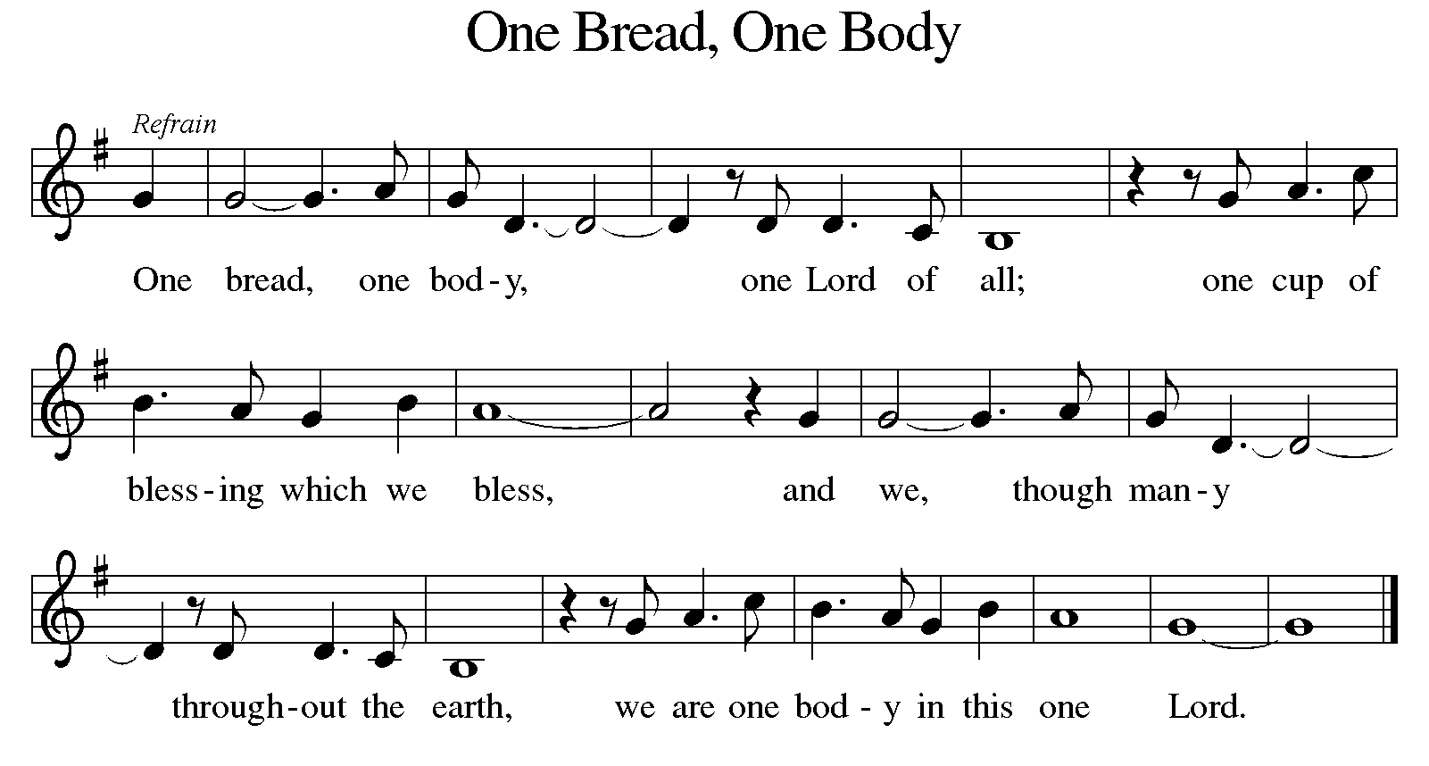

P: The body of Christ, given for you.

C: Amen.

A: The blood of Christ, shed for you.

C: Amen.
(Please rise as you are able.)

P: May the body and blood of our Lord Jesus Christ strengthen and keep you in his grace.

C: Amen.

PRAYER AFTER COMMUNION

P: Let us pray. Holy God, you have welcomed us to this meal and fed us with dignity at your table. Send us now to welcome others and to be at peace with one another, through Jesus Christ our Lord.

C: Amen.

SENDING

BLESSING

P: God all mighty, God most merciful ☩ bless you, keep you, and give you peace.

C: Amen.

SENDING HYMN ELW 583
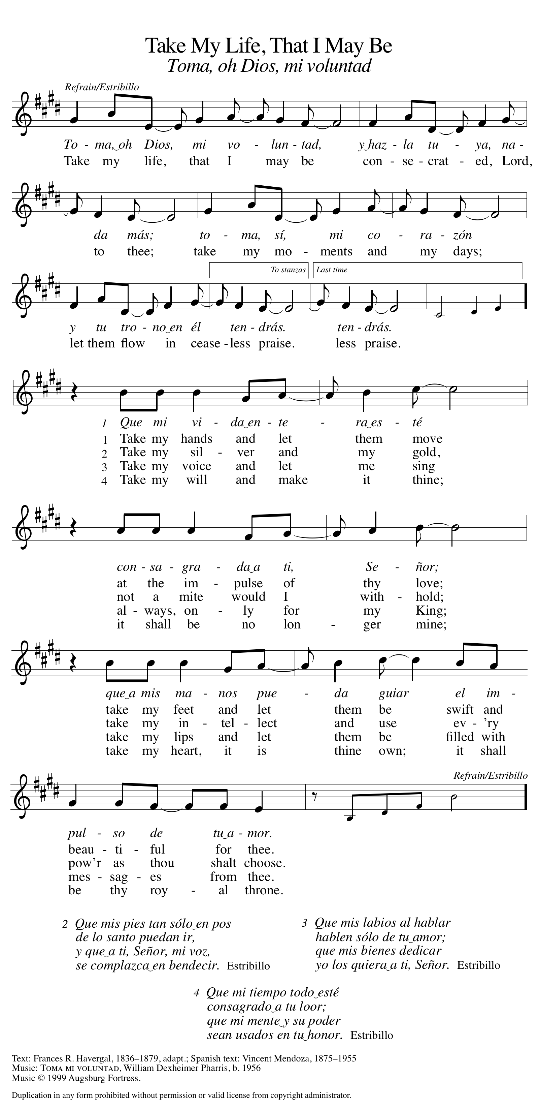
DISMISSAL

A: Go in peace. Follow Jesus.

C: Thanks be to God.

Announcements

- Monday, September 2 – Labor Day!

- Sunday, September 8 – Rally Day & God’s Work, Our Hands Sunday. (Assemble helpful Homeless Kits for Advent House.)

- Sunday, September 15 – Fish Fry after worship.

Recurring Events

- Every Sunday – Adult Bible Study @ 9am
- Monday, September 9 – Worship Committee Meeting @ 6:30pm
- Wednesday, September 18 – Women’s Bible Study @ 11am
- Thursday, September 19 – Council Meeting @ 7pm

Food Pantry Dates

- Wednesday, September 4, 5-7pm
- Thursday, September 12, 1-4pm
- Wednesday, September 18, 5-7pm
- Thursday, September 26, 1-4pm

Volunteers for September 1 Volunteers for September 8

Reader Sunday – Volunteer Reader Sunday – Volunteer
Assisting Minister – Kathy Assisting Minister – Mary

September Birthday Celebrations

9/9 – David Fo.
9/11 – AJ Po.
9/13 – Nathan An.
9/25 – Caroline Co.
9/25 – Jessica Sm.

Anniversary Celebrations

9/2 – James & Ardyth Cl.
9/19 – Dennis & Maryann Lo.
9/30 – Rick & Kathy Kl.

Acknowledgments
- OneLicense.net, License #A-703165. CCLI, License #2281869.
- From SundaysandSeasons.com. Copyright 2020 Augsburg Fortress. All rights reserved. Reprinted by permission under Augsburg Fortress Liturgies Annual License #23806.
- New Revised Standard Version Bible, copyright 1989, Division of Christian Education of the National Council of the Churches of Christ in the United States of America. Used by permission. All rights reserved.

