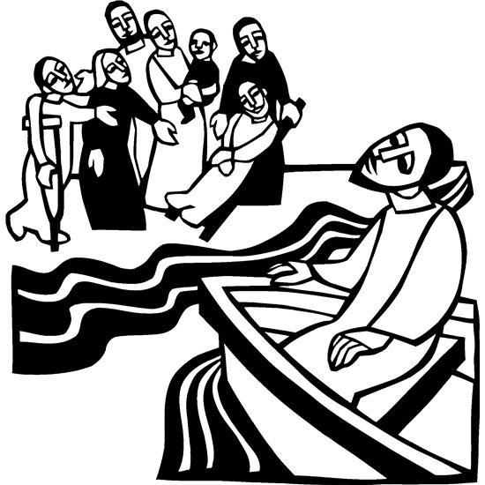

Nineth Sunday after Pentecost
July 21, 2024


SAINT PAUL LUTHERAN CHURCH
3383 EAST LAKE LANSING ROAD
EAST LANSING, MI 48823

PHONE (517) 351-8541

Pastor Carl E. Ballard
E-MAIL: pastor@stpaul-el.org
officemanager@stpaul-el.org
Visitors WELCOME! If this is your first time worshipping with us, please sign our guest registry just outside the sanctuary doors. We hope you are blessed through worship today. If you have any questions, please feel free to call the church at 351-8541.
Children are always welcome in worship! The choir room (off the sanctuary) can also be used as a cry room for younger children and includes a sound system so parents may continue to participate in the service. Clipboards with children's bulletins, activities and crayons are available for use during the service.
Sunday School is available during the worship service September-May except the last Sunday of the month.
Virtual Services We can provide a virtual live Zoom session during worship upon request.
This Bulletin is for your use during the service and to take home for the upcoming week. If you choose not to take it home, please place it in the recycle receptacle in the back.
Newsletters and Calendars of Upcoming Events are available in the lobby/narthex. We welcome anyone who has an interest in our small groups or activities! You can also look us up on the web at www.stpaul-el.org.
Contacting Us: Our Office Manager is Emily Polhamus. She can be reached by phone at 517-351-8541 or at her email address, officemanager@stpaul-el.org. Our Director of Music is Elene Kobulashvili. You may leave a message at 517-351-8541. Pastor Carl can be reached at 517-515-3129, and his email address is cballard123@msn.com.
Holy Communion is available at most services. All who believe in the real presence of Christ in the bread and the wine are invited to celebrate Communion with us. Those who wish can come forward for a blessing.
You’re invited to share in fellowship after worship. Kay (with the assistance of Bob) makes the most delicious snacks to our delight. We would love this opportunity to introduce you to the St. Paul community.

P-Presiding Minister A-Assisting Minister C-Congregation

PRELUDE ELENE

INTRODUCTION

Mark’s gospel makes clear how great is the press of the crowd, with its countless needs to be met, on Jesus and his disciples. Yet in today’s gospel Jesus advises his disciples to get away and rest, to take care of themselves. Sometimes we think that when others are in great need we shouldn’t think of ourselves at all; but Jesus also honors the caregivers’ need. We are sent from Christ’s table to care for others and for ourselves.

GATHERING

P: The Holy Spirit calls us together as the people of God.

(Please rise as you are able.)

CONFESSION AND FORGIVENESS

All may make the sign of the cross, the sign that is marked at baptism, as the presiding minister begins.

P: Blessed be the holy Trinity, ☩ one God, the God of manna, the God of miracles, the God of mercy.

C: Amen.

P: Drawn to Christ and seeking God’s abundance, let us confess our sin.

(Silence for reflection)
P: God, our provider,

C: help us. It is hard to believe there is enough to share. We question your ways when they differ from the ways of the world in which we live. We turn to our own understanding rather than trusting in you. We take offense at your teachings and your ways. Turn us again to you. Where else can we turn? Share with us the words of eternal life and feed us for life in the world. Amen.

P: Beloved people of God: in Jesus, the manna from heaven, you are fed and nourished. By Jesus, the worker of miracles, there is always more than enough. Through Jesus, ☩ the bread of life, you are shown God’s mercy: you are forgiven and loved into abundant life.

C: Amen.

GATHERING SONG ELW 611
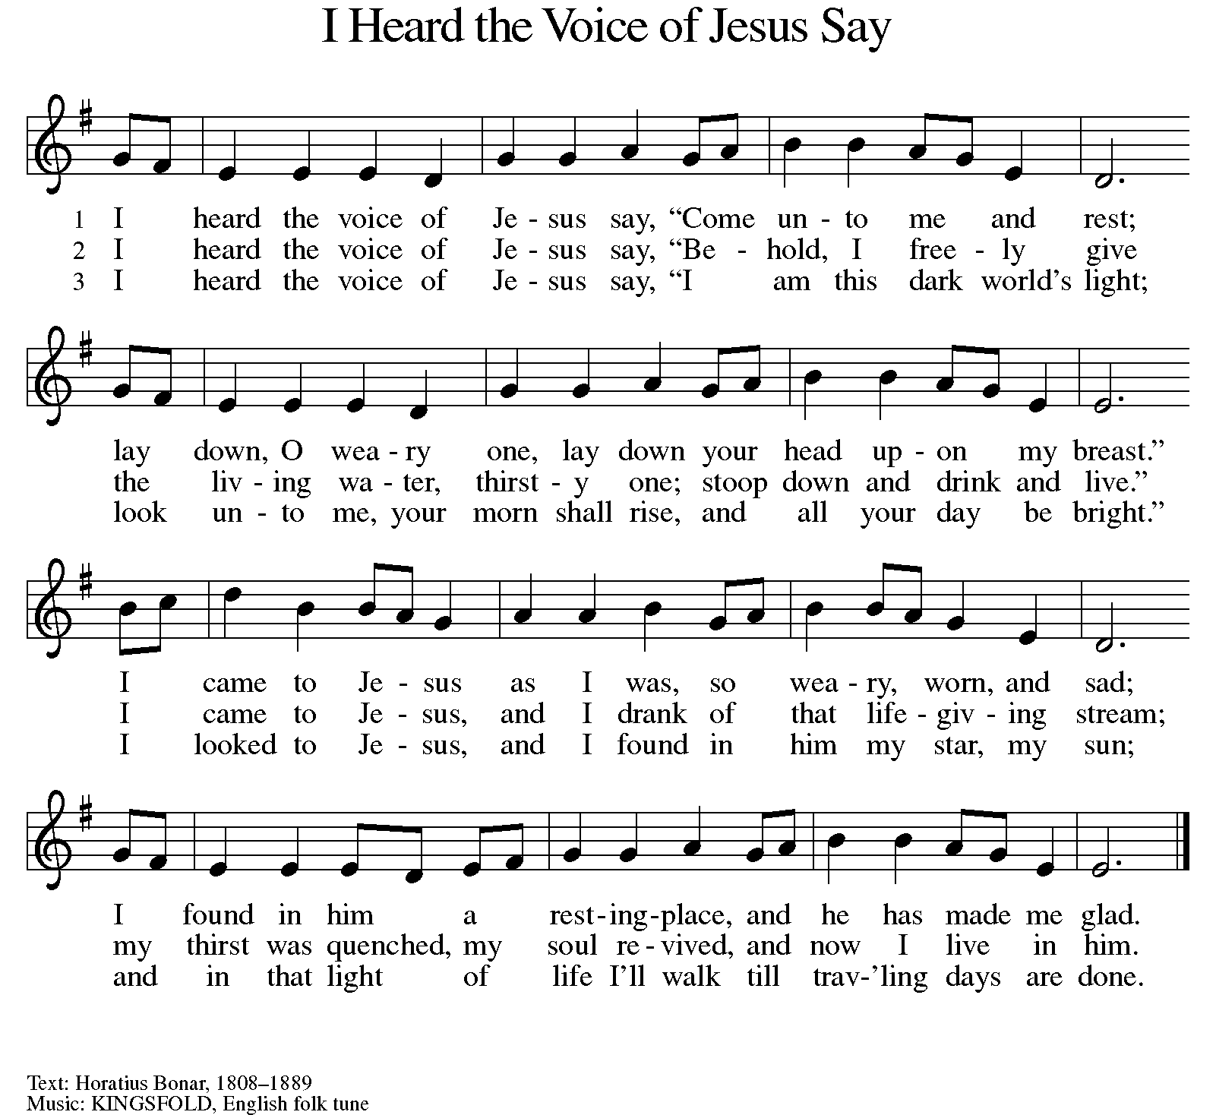

GREETING

P: The grace of our Lord Jesus Christ, the love of God, and the communion of the Holy Spirit be with you all.

C: And also with you.

KYRIE ELW Setting 10, Page 203

Have mercy on us, Lord,
and hear our solemn prayer.
We come to hear your living word;
it saves us from despair.

Have mercy on us, Christ,
and wash away our sin.
Pour out your grace and make us whole
that new life may begin.

Have mercy on us, Lord;
make sin and shame depart.
Renew us with your saving pow’r;
create in us new hearts!

CANTICLE OF PRAISE ELW Setting 4, Page 149-150

This is the feast of victory for our God.
Alleluia.

Worthy is Christ, the Lamb who was slain,
whose blood set us free to be people of God.
Power and riches and wisdom and strength,
and honor and blessing and glory are his.
This is the feast of victory for our God.
Alleluia.

Sing with all the people of God
and join in the hymn of all creation:
Blessing and honor and glory
and might be to God and the Lamb forever.
Amen.

This is the feast of victory for our God,
for the Lamb who was slain has begun his reign.
Alleluia. Alleluia.

PRAYER OF THE DAY

P: Let us pray. O God, powerful and compassionate, you shepherd your people, faithfully feeding and protecting us. Heal each of us, and make us a whole people, that we may embody the justice and peace of your Son, Jesus Christ, our Savior and Lord.

C: Amen.

(Please be seated.)

CHILDREN’S MESSAGE

(Children return to their seats.)

THE WORD

P: God speaks to us in scripture, preaching, and song.

FIRST READING JEREMIAH 23:1-6

Jeremiah prophesied before the exile in 587 BCE. In this passage, he uses the metaphor of a shepherd to describe the bad kings who have scattered the “flock” of Israel. God promises to gather the flock and to raise up a new king from David’s line to save Israel and Judah.

¹ Woe to the shepherds who destroy and scatter the sheep of my pasture! says the Lord. ² Therefore thus says the Lord, the God of Israel, concerning the shepherds who shepherd my people: It is you who have scattered my flock, and have driven them away, and you have not attended to them. So I will attend to you for your evil doings, says the Lord. ³ Then I myself will gather the remnant of my flock out of all the lands where I have driven them, and I will bring them back to their fold, and they shall be fruitful and multiply. ⁴ I will raise up shepherds over them who will shepherd them, and they shall not fear any longer, or be dismayed, nor shall any be missing, says the Lord. ⁵ The days are surely coming, says the Lord, when I will raise up for David a righteous Branch, and he shall reign as king and deal wisely, and shall execute justice and righteousness in the land. ⁶ In his days Judah will be saved and Israel will live in safety. And this is the name by which he will be called: “The Lord is our righteousness.”
Reader: Word of God, word of life. C: Thanks be to God.
PSALM PSALM 23

The Lord is my shepherd; I shall not be in want. (Ps. 23:1)

¹ The Lord is my shepherd;
I shall not be in want.
² The Lord makes me lie down in green pastures
and leads me beside still waters.
³ You restore my soul, O Lord,
and guide me along right pathways for your name’s sake.
⁴ Though I walk through the valley of the shadow of death, I shall fear no evil;
for you are with me; your rod and your staff, they comfort me.
⁵ You prepare a table before me in the presence of my enemies;
you anoint my head with oil, and my cup is running over.
⁶ Surely goodness and mercy shall follow me all the days of my life,
and I will dwell in the house of the Lord forever.

SECOND READING EPHESIANS 2:11-22

The author of this letter reminds his audience that originally they were not part of God’s chosen people. Through Jesus’ death, however, they are included in God’s household of faith, whose cornerstone is Jesus Christ.

¹¹ Remember that at one time you Gentiles by birth, called “the uncircumcision” by those who are called “the circumcision”—a physical circumcision made in the flesh by human hands—¹² remember that you were at that time without Christ, being aliens from the commonwealth of Israel, and strangers to the covenants of promise, having no hope and without God in the world. ¹³ But now in Christ Jesus you who once were far off have been brought near by the blood of Christ. ¹⁴ For he is our peace; in his flesh he has made both groups into one and has broken down the dividing wall, that is, the hostility between us. ¹⁵ He has abolished the law with its commandments and ordinances, that he might create in himself one new humanity in place of the two, thus making peace, ¹⁶ and might reconcile both groups to God in one body through the cross, thus putting to death that hostility through it. ¹⁷ So he came and proclaimed peace to you who were far off and peace to those who were near; ¹⁸ for through him both of us have access in one Spirit to the Father. ¹⁹ So then you are no longer strangers and aliens, but you are citizens with the saints and also members of the household of God, ²⁰ built upon the foundation of the apostles and prophets, with Christ Jesus himself as the cornerstone. ²¹ In him the whole structure is joined together and grows into a holy temple in the Lord; ²² in whom you also are built together spiritually into a dwelling place for God.

Reader: Word of God, word of life. C: Thanks be to God.

(Please rise as you are able.)

GOSPEL ACCLAMATION ELW SETTING 10, PAGE 205

Alleluia! Lord and Savior: open now your saving word.
Let it burn like fire within us; speak until our hearts are stirred.
Alleluia! Lord, we sing for the good news that you bring.

GOSPEL MARK 6:30-34, 53-56

P: The Holy Gospel according to Mark, the 6th chapter.

C: Glory to you, O Lord.

When Jesus sends his disciples out to teach and heal, they minister among large numbers of people. Their work is motivated by Christ’s desire to be among those in need.

³⁰ The apostles gathered around Jesus, and told him all that they had done and taught. ³¹ He said to them, “Come away to a deserted place all by yourselves and rest a while.” For many were coming and going, and they had no leisure even to eat. ³² And they went away in the boat to a deserted place by themselves. ³³ Now many saw them going and recognized them, and they hurried there on foot from all the towns and arrived ahead of them. ³⁴ As he went ashore, he saw a great crowd; and he had compassion for them, because they were like sheep without a shepherd; and he began to teach them many things.

⁵³ When they had crossed over, they came to land at Gennesaret and moored the boat. ⁵⁴ When they got out of the boat, people at once recognized him, ⁵⁵ and rushed about that whole region and began to bring the sick on mats to wherever they heard he was. ⁵⁶ And wherever he went, into villages or cities or farms, they laid the sick in the marketplaces, and begged him that they might touch even the fringe of his cloak; and all who touched it were healed.

P: The Gospel of the Lord. C: Praise to you, O Christ.

(Please be seated.)

SERMON Pastor Carl Ballard

(Please rise as you are able.)

HYMN OF THE DAY ELW 764
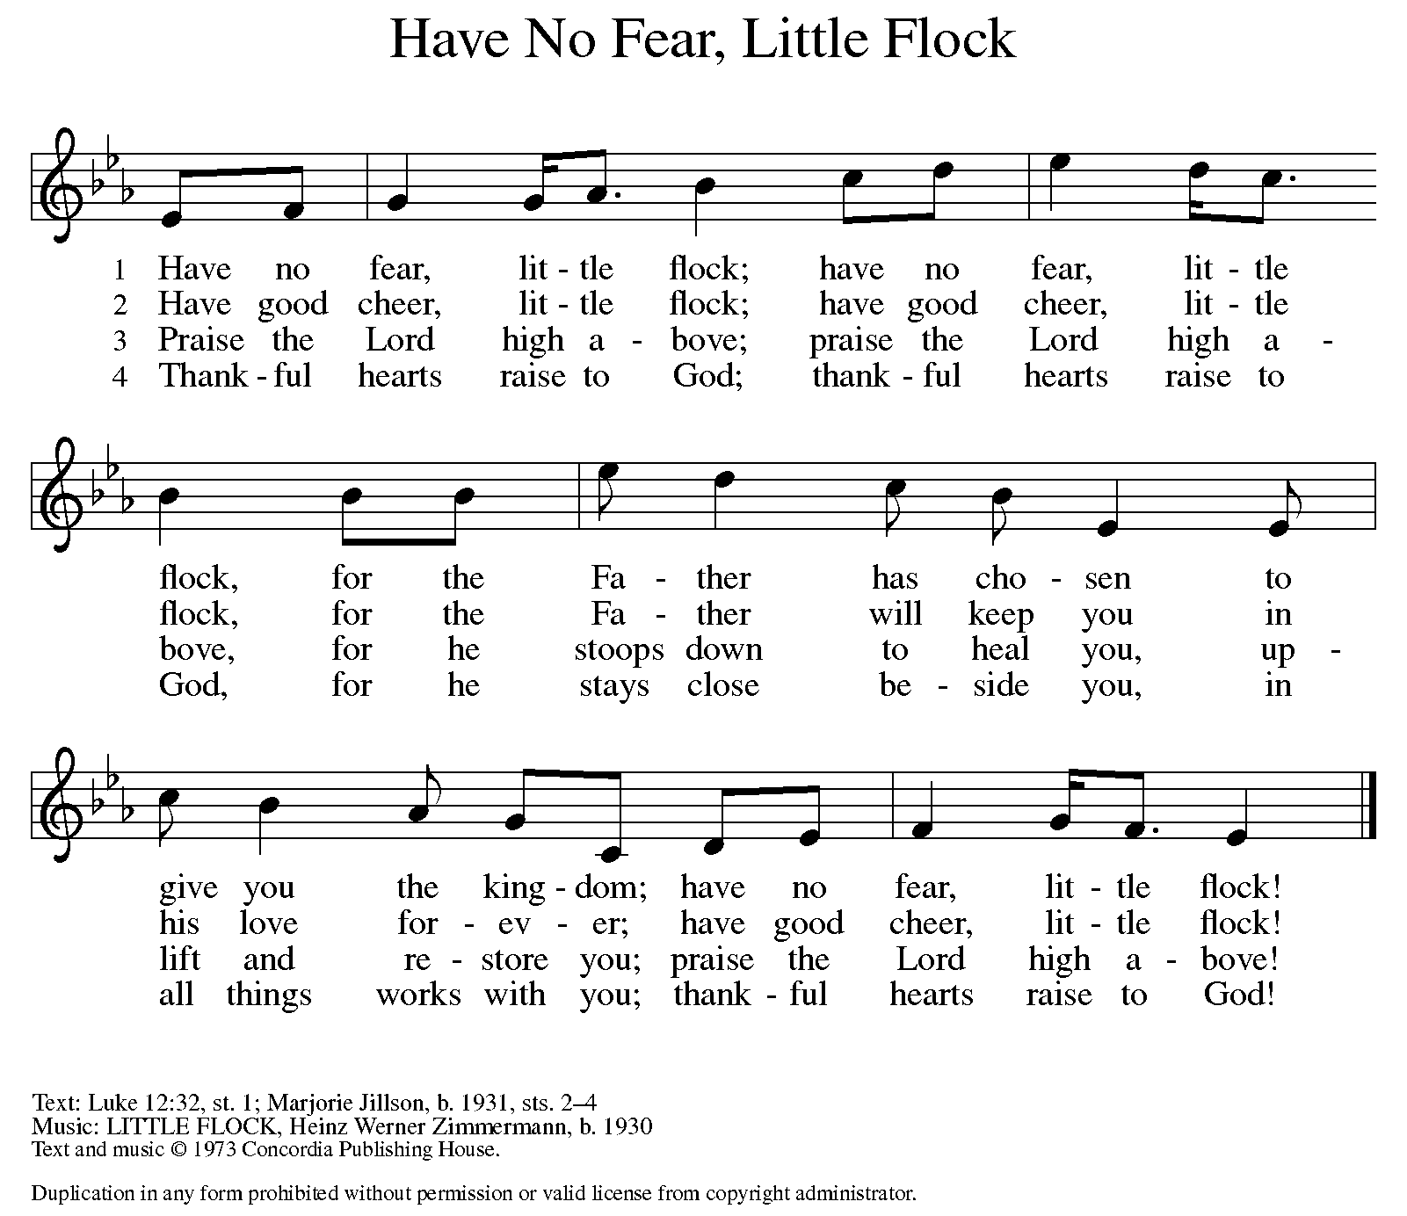

AposTles’ CREED

I believe in God, the Father almighty,
creator of heaven and earth.
I believe in Jesus Christ, God’s only Son, our Lord,
who was conceived by the Holy Spirit,
born of the virgin Mary,
suffered under Pontius Pilate,
was crucified, died, and was buried;
he descended to the dead.
On the third day he rose again;
he ascended into heaven,
he is seated at the right hand of the Father,
and he will come to judge the living and the dead.
I believe in the Holy Spirit,
the holy catholic church,
the communion of saints,
the forgiveness of sins,
the resurrection of the body,
and the life everlasting. Amen.

(Please be seated.)

THE PRAYERS

A: One in the communion of saints and in the power of the Holy Spirit, we join our voices in prayer.
(A brief silence.)

A: For the church of Jesus Christ in this and every land: Through the One who is the cornerstone of a firm foundation, join us together and build us up as a temple of mercy and peace. In your mercy,

C: hear our prayer.

A: For the creation: Cause new trees to be planted. Restrain the melting of polar ice caps. Save land from destruction. Like a shepherd tends her sheep, raise up from among us caretakers of all you have made. In your mercy,

C: hear our prayer.

A: For the leaders of nations and heads of tribes: Where peace seems far off, bring it near. Where justice seems fleeting, bring it to light. Where discord seems relentless, bring harmony. In your mercy,

C: hear our prayer.

A: For the health and well-being of family, friends, and neighbors: Heal those who are sick. Give courage to all who struggle with addiction. Touch with your tender care all who reach out to you in pain. In your mercy,

C: hear our prayer.

A: For this assembly and for the faith communities represented this week at the ELCA Youth Gathering: Nurture the faith of young people as they encounter new experiences and people. Break down dividing walls and inspire collaboration among people of every age. In your mercy,

C: hear our prayer.

A: Protecting God, provide care and compassion for those who serve in our armed forces, especially Beth & Ryan, Jonathan, Jacob, Noah, Irene, and Alex. In your mercy,

C: hear our prayer.

A: Compassionate God, deepen our care for those who are bowed down with illness or sorrow and those who are undergoing transition in relationships, occupation, living situation, or health condition, especially Ahren, Carolyn, Chip, the family of Colleen Shireman, Craig & family, Dan, David, Jim & Cheri, John, John, Jon, Jordan, Kay, Lawton, Lera & family, Liam, Linda, Lizzy, Margaret, Mary, Pastor Sarah, Randy, Rick & Kathy, Sheri, Sheri (co-worker of Mary Mc.), and Wanda. And all that we name now aloud and in our hearts. In your mercy,

C: hear our prayer.

A: Directing God, guide our church’s leaders Presiding Bishop Elizabeth, our Synod Bishop Craig, and Pastor Carl. We ask that you be with their respective staffs as they live out their callings to serve. As we are called to be one, even as Jesus and the Father are one, be with the leaders and the congregation Resurrection Lutheran Church in Saginaw and all the churches in our community. In your mercy,

C: hear our prayer.

A: In thanksgiving for those who have died. Make us certain that in Christ we are no longer strangers and aliens but citizens with the saints in the household of God. In your mercy,

C: hear our prayer.

P: Holy God, holy and merciful: into your outstretched arms we commend ourselves and all for whom we pray, trusting in the one who is the way, the truth, and the life, Jesus Christ our Savior and Lord.

C: Amen.

GREETING OF PEACE

P: The peace of Christ be with you always.

C: And also with you.

(You are invited to share Christ’s peace with one another.)

(Please be seated.)

THE MEAL

OFFERING ELENE

OFFERTORY ELW 692
WE ARE AN OFFERING

We lift our voices,
We lift our hands,
We lift our lives up to you:
We are an offering.

Lord, use our voices,
Lord, use our hands,
Lord, use our lives, they are yours:
We are an offering.

All that we have,
All that we are,
All that we hope to be,
We give to you,
We give to you.

We lift our voices,
We lift our hands,
We lift our lives up to you:
We are an offering,
We are an offering.

OFFERING PRAYER

A: Let us pray. Jesus, Bread of life, you have set this table with your very self, and called us to the feast of plenty. Gather what has been sown among us, and strengthen us in this meal. Make us to be what we receive here, your body for the life of the world.

C: Amen.

THE GREAT THANKSGIVING

P: The Lord be with you.
C: And also with you.
P: Lift up your hearts.
C: We lift them to the Lord.
P: Let us give thanks to the Lord our God.
C: It is right to give our thanks and praise.

PROPER PREFACE

P: It is indeed right, our duty and our joy, that we should at all times and in all places give thanks and praise to you, almighty and merciful God, through our Savior Jesus Christ; who on this day overcame death and the grave, and by his glorious resurrection opened to us the way of everlasting life. And so, with all the choirs of angels, with the church on earth and the hosts of heaven, we praise your name and join their unending hymn:

HOLY, HOLY ELW SETTING 10, Page 207

Holy, holy, holy Lord,
God of power and might,
heav’n and earth are full of your glory.
Hosanna in the highest.
Blessed is he who comes in the name of the Lord.
Hosanna in the highest,
hosanna in the highest.

EUCHARISTIC PRAYER

P: In the night in which he was betrayed, our Lord Jesus took bread, and gave thanks; broke it, and gave it to his disciples, saying:
Take and eat; this is my body, given for you. Do this for the remembrance of me.
Again, after supper, he took the cup, gave thanks, and gave it for all to drink, saying:
This cup is the new covenant in my blood, shed for you and for all people for the forgiveness of sin. Do this for the remembrance of me.

LORD'S PRAYER

P: Lord, remember us in your kingdom, and teach us to pray:

C: Our Father, who art in heaven, hallowed by thy name, thy kingdom come, thy will be done, on earth as it is in heaven. Give us this day our daily bread; and forgive us our trespasses, as we forgive those who trespass against us; and lead us not into temptation, but deliver us from evil. For thine is the kingdom, and the power, and the glory, forever and ever. Amen.
COMMUNION DISTRIBUTION

All who believe in the real presence of Christ in the bread and the wine (juice) are welcome to the table. Others may come forward for a blessing. If you prefer grape juice, please indicate this to the assisting minister.

When approaching the communion rail, come forward down the side aisle, kneel, if you are able, starting at the front of the communion rail (spot closest to the font) on your side and filling in toward the back. After receiving both the bread and the wine, you may return to your seat by the center aisle.

INVITATION TO COMMUNION

P: Christ has set the table with more than enough for all. Come!

COMMUNION HYMN ELW 814
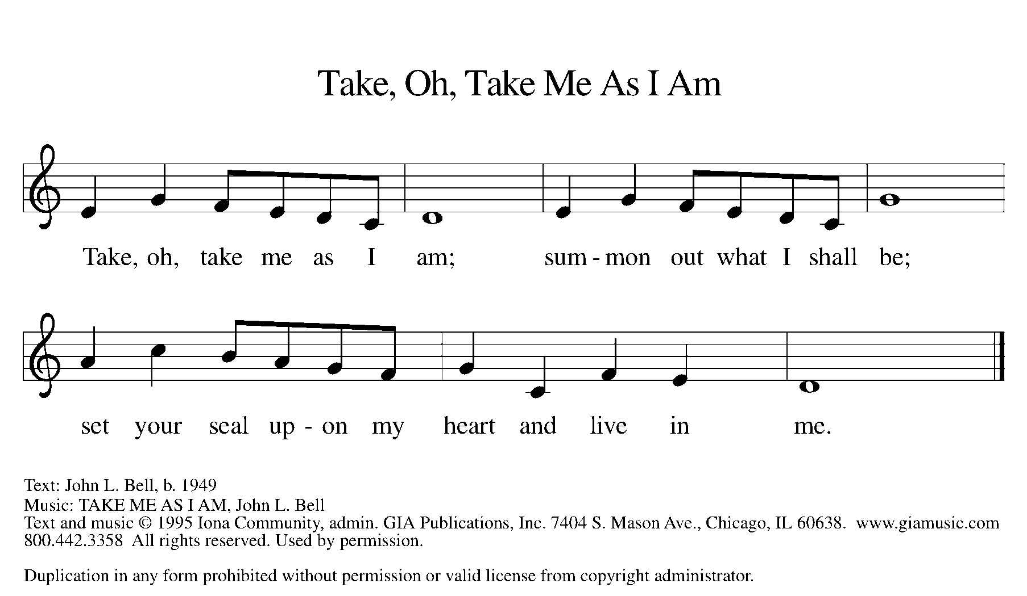

P: The body of Christ, given for you.

C: Amen.

A: The blood of Christ, shed for you.

C: Amen.
(Please rise as you are able.)

P: May the body and blood of our Lord Jesus Christ strengthen and keep you in his grace.

C: Amen.

PRAYER AFTER COMMUNION

P: Let us pray. Jesus, Bread of life, we have received from your table more than we could ever ask. As you have nourished us in this meal, now strengthen us to love the world with your own life. In your name we pray.

C: Amen.

SENDING

BLESSING

P: The blessing of God, who provides for us, feeds us, and journeys with us, ☩ be upon you now and forever.

C: Amen.

SENDING HYMN ELW 654
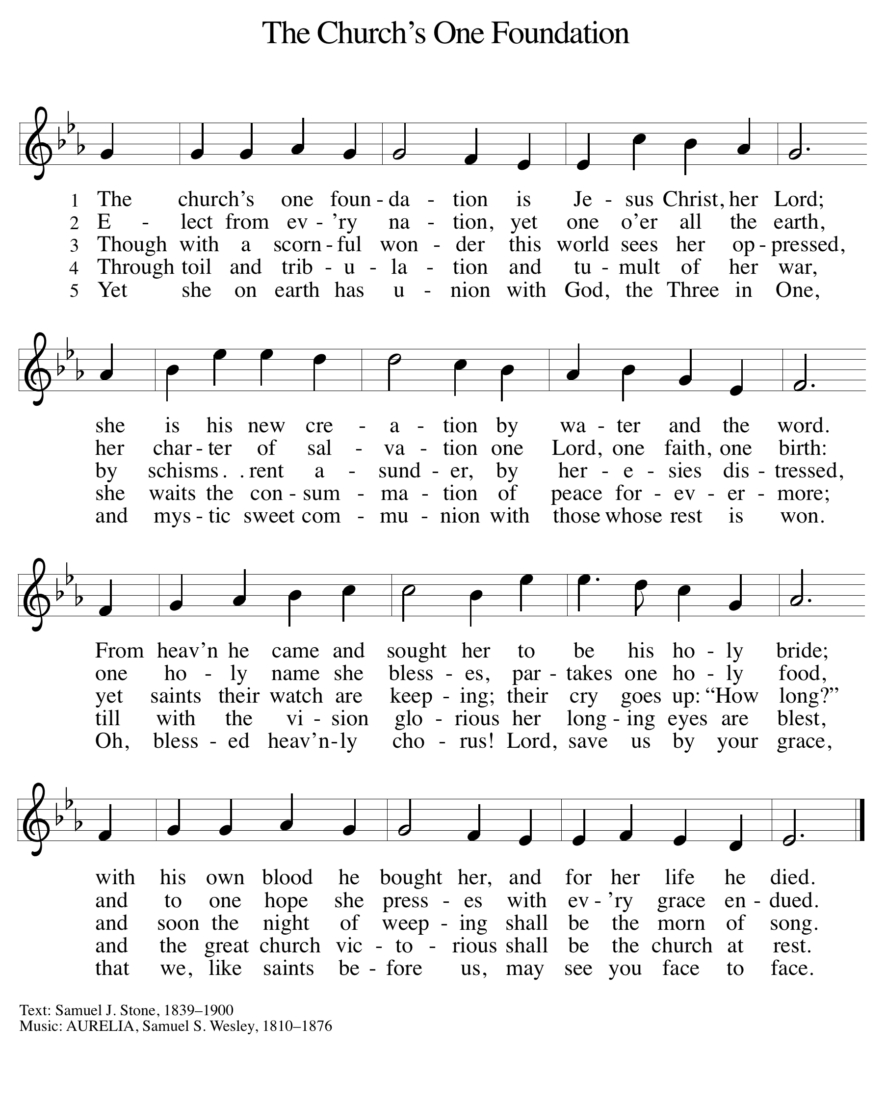

DISMISSAL

A: Go in peace. You are the body of Christ.

C: Thanks be to God.
Announcements

- Monday, July 29th – August 2nd: VBS @ 9am – Noon
- Tuesday, July 30th – Ingham County Registrar of Deeds Property Fraud Protection Presentation @ 6:00pm

Recurring Events

- Every Sunday – Adult Bible Study @ 9am
- Monday, August 12 – Worship Committee Meeting @ 6:30pm
- Wednesday, August 21 – Women’s Bible Study @ 11am
- Thursday, August 15 – Council Meeting @ 7pm

Food Pantry Dates

- Thursday, July 25, 1-4pm
- Wednesday, August 7, 5-7pm
- Thursday, August 15, 1-4pm
- Wednesday, August 21, 5-7pm
- Thursday, August 29, 1-4pm

Volunteers for July 21 Volunteers for July 28

Reader Sunday – Reader Sunday –
Assisting Minister – Kathy Assisting Minister – Mary

July Birthday Celebrations

7/6 – Craig An.
7/8 – Kay Se.
7/12 – Elizabeth Mc.
7/16 – Stan St.
7/25 – Norma Va.

Anniversary Celebrations

7/9 – Paul & Tracy Co.

Acknowledgments
- OneLicense.net, License #A-703165. CCLI, License #2281869.
- From SundaysandSeasons.com. Copyright 2020 Augsburg Fortress. All rights reserved. Reprinted by permission under Augsburg Fortress Liturgies Annual License #23806.
- New Revised Standard Version Bible, copyright 1989, Division of Christian Education of the National Council of the Churches of Christ in the United States of America. Used by permission. All rights reserved.

