

Tenth Sunday after Pentecost
July 28, 2024


SAINT PAUL LUTHERAN CHURCH
3383 EAST LAKE LANSING ROAD
EAST LANSING, MI 48823

PHONE (517) 351-8541

Pastor Carl E. Ballard
E-MAIL: pastor@stpaul-el.org
officemanager@stpaul-el.org
Visitors WELCOME! If this is your first time worshipping with us, please sign our guest registry just outside the sanctuary doors. We hope you are blessed through worship today. If you have any questions, please feel free to call the church at 351-8541.
Children are always welcome in worship! The choir room (off the sanctuary) can also be used as a cry room for younger children and includes a sound system so parents may continue to participate in the service. Clipboards with children's bulletins, activities and crayons are available for use during the service.
Sunday School is available during the worship service September-May except the last Sunday of the month.
Virtual Services We can provide a virtual live Zoom session during worship upon request.
This Bulletin is for your use during the service and to take home for the upcoming week. If you choose not to take it home, please place it in the recycle receptacle in the back.
Newsletters and Calendars of Upcoming Events are available in the lobby/narthex. We welcome anyone who has an interest in our small groups or activities! You can also look us up on the web at www.stpaul-el.org.
Contacting Us: Our Office Manager is Emily Polhamus. She can be reached by phone at 517-351-8541 or at her email address, officemanager@stpaul-el.org. Our Director of Music is Elene Kobulashvili. You may leave a message at 517-351-8541. Pastor Carl can be reached at 517-515-3129, and his email address is cballard123@msn.com.
Holy Communion is available at most services. All who believe in the real presence of Christ in the bread and the wine are invited to celebrate Communion with us. Those who wish can come forward for a blessing.
You’re invited to share in fellowship after worship. Kay (with the assistance of Bob) makes the most delicious snacks to our delight. We would love this opportunity to introduce you to the St. Paul community.

P-Presiding Minister A-Assisting Minister C-Congregation

PRELUDE ELENE

INTRODUCTION

Today is the first of five Sundays with gospel readings from John 6, the first four of which focus on Jesus as bread of life. Today Jesus feeds thousands of people with five loaves and two fish. What we have, what we bring to Jesus’ table, seems like it is not nearly enough to meet all the needs we see around us. But it is not the adequacy of our supplies or our skills that finally makes the difference: it is the power of Jesus working in the littlest and least to transform this world into the world God desires, a world where all the hungry are satisfied.

GATHERING

P: The Holy Spirit calls us together as the people of God.

(Please rise as you are able.)

CONFESSION AND FORGIVENESS

All may make the sign of the cross, the sign that is marked at baptism, as the presiding minister begins.

P: Blessed be the holy Trinity, ☩ one God, the God of manna, the God of miracles, the God of mercy.

C: Amen.

P: Drawn to Christ and seeking God’s abundance, let us confess our sin.

(Silence for reflection)
P: God, our provider,

C: help us. It is hard to believe there is enough to share. We question your ways when they differ from the ways of the world in which we live. We turn to our own understanding rather than trusting in you. We take offense at your teachings and your ways. Turn us again to you. Where else can we turn? Share with us the words of eternal life and feed us for life in the world. Amen.

P: Beloved people of God: in Jesus, the manna from heaven, you are fed and nourished. By Jesus, the worker of miracles, there is always more than enough. Through Jesus, ☩ the bread of life, you are shown God’s mercy: you are forgiven and loved into abundant life.

C: Amen.

GATHERING SONG ELW 482
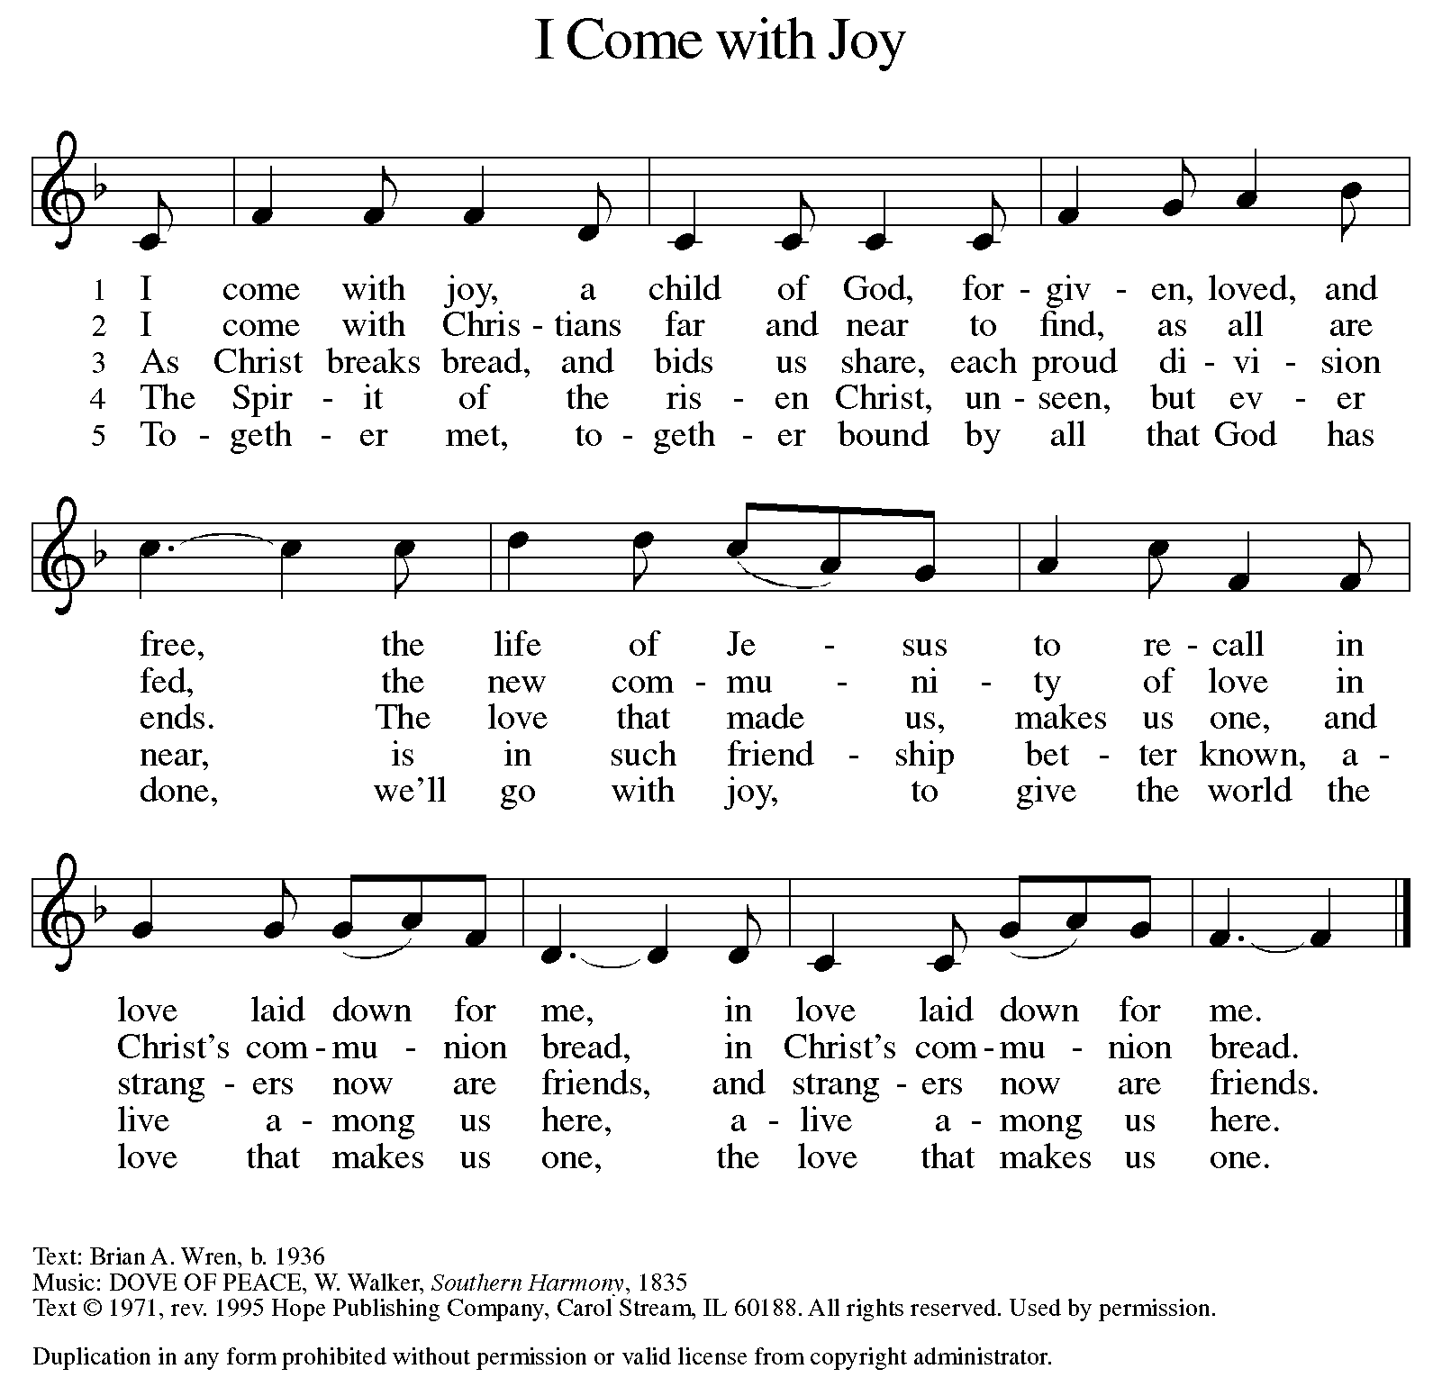
GREETING

P: The grace of our Lord Jesus Christ, the love of God, and the communion of the Holy Spirit be with you all.

C: And also with you.

KYRIE ELW Setting 8, Page 184

Kyrie eleison, on our world and on our way.
Kyrie eleison, ev’ry day.

For peace in the world, for the health of the church, for the unity of all;
for this holy house, for all who worship and praise,
let us pray to the Lord, let us pray to the Lord.

Kyrie eleison, on our world and on our way.
Kyrie eleison, ev’ry day.

That we may live out your impassioned response to the hungry and the poor;
that we may live out truth and justice and grace,
let us pray to the Lord, let us pray to the Lord.

Kyrie eleison, on our world and on our way.
Kyrie eleison, ev’ry day.

For peace in our hearts, for peace in our homes, for friends and family;
for life and for love, for our work and our play,
let us pray to the Lord, let us pray to the Lord.

Kyrie eleison, on our world and on our way.
Kyrie eleison, ev’ry day.

For your Spirit to guide; that you center our lives in the water and the Word;
that you nourish our souls with your body and blood,
let us pray to the Lord, let us pray to the Lord.

Kyrie eleison, on our world and on our way.
Kyrie eleison, ev’ry day.

CANTICLE OF PRAISE ELW Setting 4, Page 149-150

This is the feast of victory for our God.
Alleluia.

Worthy is Christ, the Lamb who was slain,
whose blood set us free to be people of God.
Power and riches and wisdom and strength,
and honor and blessing and glory are his.
This is the feast of victory for our God.
Alleluia.

Sing with all the people of God
and join in the hymn of all creation:
Blessing and honor and glory
and might be to God and the Lamb forever.
Amen.

This is the feast of victory for our God,
for the Lamb who was slain has begun his reign.
Alleluia. Alleluia.

PRAYER OF THE DAY

P: Let us pray. Gracious God, you have placed within the hearts of all your children a longing for your word and a hunger for your truth. Grant that we may know your Son to be the true bread of heaven and share this bread with all the world, through Jesus Christ, our Savior and Lord.

C: Amen.

(Please be seated.)

CHILDREN’S MESSAGE

(Children return to their seats.)

THE WORD

P: God speaks to us in scripture, preaching, and song.

FIRST READING 2 KINGS 4:42-44

Today’s reading is part of a larger section of 2 Kings that describes the miracles of Elisha, the successor to Elijah. Here the prophet gives food to a hungry crowd. Though there is not enough food to go around, Elisha trusts God, who provides enough and even more to satisfy the need.

⁴² A man came from Baal-shalishah, bringing food from the first fruits to [Elisha,] the man of God: twenty loaves of barley and fresh ears of grain in his sack. Elisha said, “Give it to the people and let them eat.” ⁴³ But his servant said, “How can I set this before a hundred people?” So he repeated, “Give it to the people and let them eat, for thus says the Lord, ‘They shall eat and have some left.’ ” ⁴⁴ He set it before them, they ate, and had some left, according to the word of the Lord.

Reader: Word of God, word of life. C: Thanks be to God.
PSALM PSALM 145:10-18

You open wide your hand and satisfy the desire of every living thing. (Ps. 145:16)

¹⁰ All your works shall praise you, O Lord, and your faithful ones shall bless you.
¹¹ They shall tell of the glory of your kingdom and speak of your power,
¹² that all people may know of your power and the glorious splendor of your kingdom.
¹³ Your kingdom is an everlasting kingdom; your dominion endures throughout all ages. You, Lord, are faithful in all your words, and loving in all your works.
¹⁴ The Lord upholds all those who fall and lifts up those who are bowed down.
¹⁵ The eyes of all wait upon you, O Lord, and you give them their food in due season.
¹⁶ You open wide your hand and satisfy the desire of every living thing.
¹⁷ You are righteous in all your ways and loving in all your works.
¹⁸ You are near to all who call upon you, to all who call upon you faithfully.

SECOND READING EPHESIANS 3:14-21
We have been rooted and grounded in the love of Christ, which surpasses all human knowledge. Because Christ dwells in our hearts, our lives are continuously strengthened and empowered by the ongoing presence of the Spirit.

¹⁴ For this reason I bow my knees before the Father, ¹⁵ from whom every family in heaven and on earth takes its name. ¹⁶ I pray that, according to the riches of his glory, he may grant that you may be strengthened in your inner being with power through his Spirit, ¹⁷ and that Christ may dwell in your hearts through faith, as you are being rooted and grounded in love. ¹⁸ I pray that you may have the power to comprehend, with all the saints, what is the breadth and length and height and depth, ¹⁹ and to know the love of Christ that surpasses knowledge, so that you may be filled with all the fullness of God.
²⁰ Now to him who by the power at work within us is able to accomplish abundantly far more than all we can ask or imagine, ²¹ to him be glory in the church and in Christ Jesus to all generations, forever and ever. Amen.

Reader: Word of God, word of life. C: Thanks be to God.

(Please rise as you are able.)

GOSPEL ACCLAMATION ELW SETTING 8, PAGE 188

Alleluia. Lord, to whom shall we go?
You have the words of eternal life. Alleluia.
Alleluia, alleluia. Alleluia.
Alleluia, alleluia.

GOSPEL JOHN 6:1-21

P: The Holy Gospel according to John, the 6th chapter.

C: Glory to you, O Lord.

In John’s gospel, the miracles of Jesus are called “signs,” because they reveal the true character of God. As such, they remain within the mystery of God and cannot be brought under human control.

¹ Jesus went to the other side of the Sea of Galilee, also called the Sea of Tiberias. ² A large crowd kept following him, because they saw the signs that he was doing for the sick. ³ Jesus went up the mountain and sat down there with his disciples. ⁴ Now the Passover, the festival of the Jews, was near. ⁵ When he looked up and saw a large crowd coming toward him, Jesus said to Philip, “Where are we to buy bread for these people to eat?” ⁶ He said this to test him, for he himself knew what he was going to do. ⁷ Philip answered him, “Six months’ wages would not buy enough bread for each of them to get a little.” ⁸ One of his disciples, Andrew, Simon Peter’s brother, said to him, ⁹ “There is a boy here who has five barley loaves and two fish. But what are they among so many people?” ¹⁰ Jesus said, “Make the people sit down.” Now there was a great deal of grass in the place; so they sat down, about five thousand in all. ¹¹ Then Jesus took the loaves, and when he had given thanks, he distributed them to those who were seated; so also the fish, as much as they wanted. ¹² When they were satisfied, he told his disciples, “Gather up the fragments left over, so that nothing may be lost.” ¹³ So they gathered them up, and from the fragments of the five barley loaves, left by those who had eaten, they filled twelve baskets. ¹⁴ When the people saw the sign that he had done, they began to say, “This is indeed the prophet who is to come into the world.”
¹⁵ When Jesus realized that they were about to come and take him by force to make him king, he withdrew again to the mountain by himself.
¹⁶ When evening came, his disciples went down to the sea, ¹⁷ got into a boat, and started across the sea to Capernaum. It was now dark, and Jesus had not yet come to them. ¹⁸ The sea became rough because a strong wind was blowing. ¹⁹ When they had rowed about three or four miles, they saw Jesus walking on the sea and coming near the boat, and they were terrified. ²⁰ But he said to them, “It is I; do not be afraid.” ²¹ Then they wanted to take him into the boat, and immediately the boat reached the land toward which they were going.

P: The Gospel of the Lord. C: Praise to you, O Christ.

(Please be seated.)
SERMON Pastor Carl Ballard
(Please rise as you are able.)

HYMN OF THE DAY ELW 479
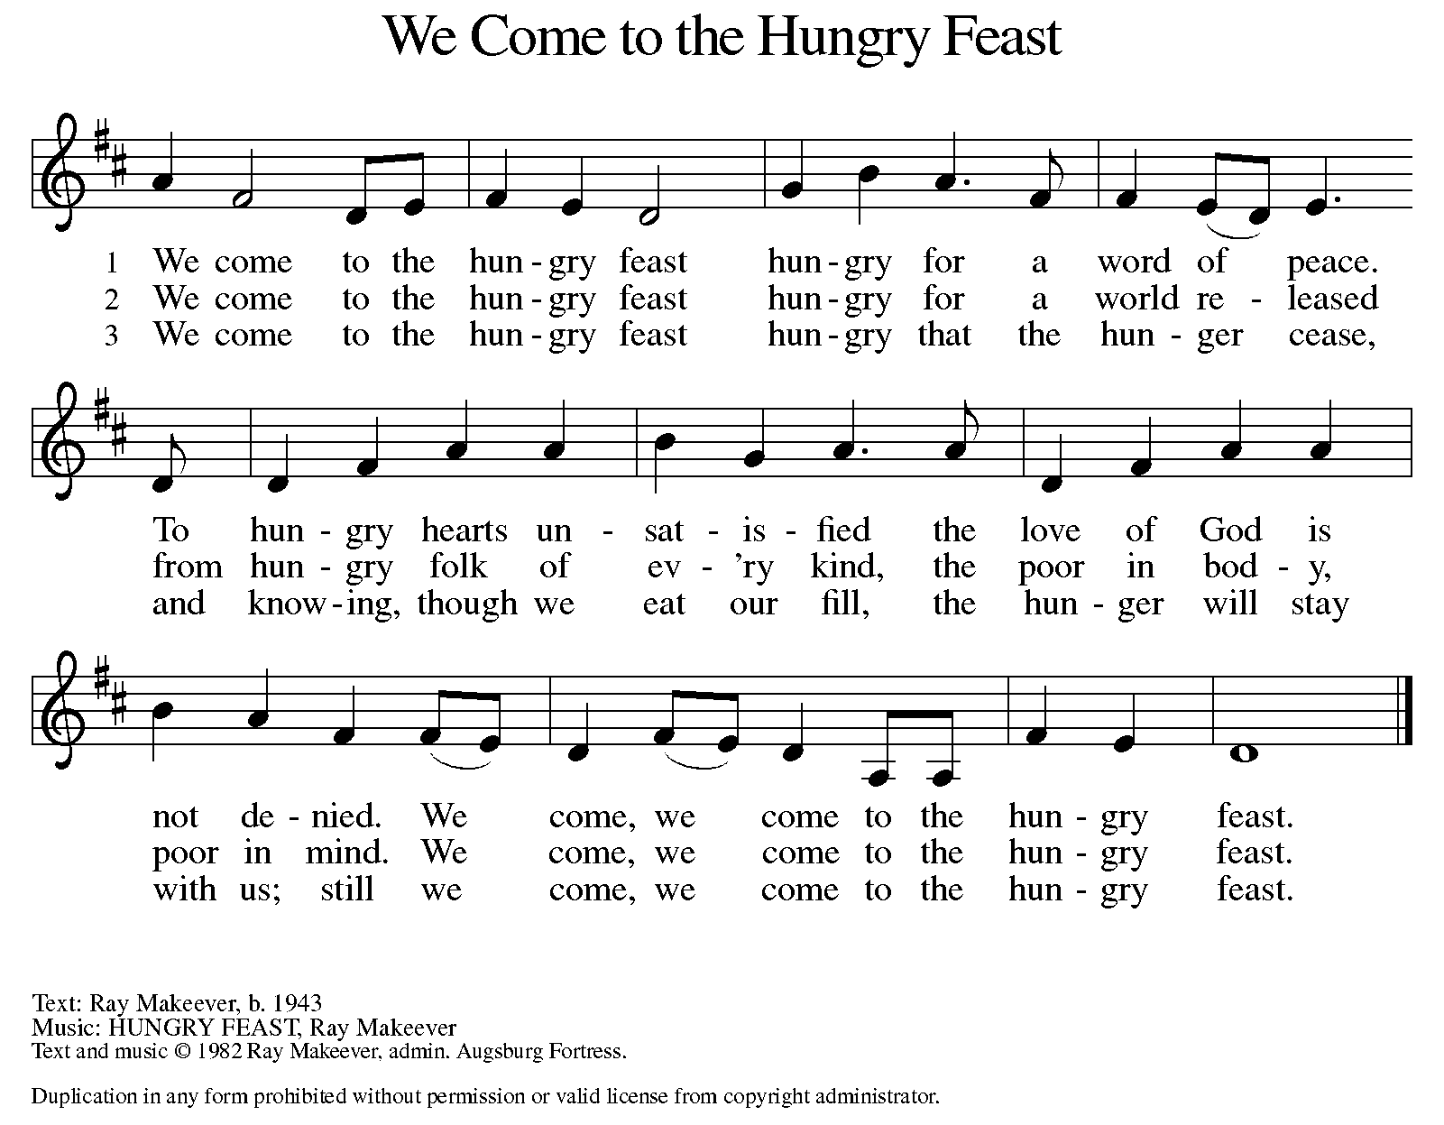

AposTles’ CREED

I believe in God, the Father almighty,
creator of heaven and earth.
I believe in Jesus Christ, God’s only Son, our Lord,
who was conceived by the Holy Spirit,
born of the virgin Mary,
suffered under Pontius Pilate,
was crucified, died, and was buried;
he descended to the dead.
On the third day he rose again;
he ascended into heaven,
he is seated at the right hand of the Father,
and he will come to judge the living and the dead.
I believe in the Holy Spirit,
the holy catholic church,
the communion of saints,
the forgiveness of sins,
the resurrection of the body,
and the life everlasting. Amen.

(Please be seated.)

THE PRAYERS

A: One in the communion of saints and in the power of the Holy Spirit, we join our voices in prayer.
(A brief silence.)

A: God of generations, you work in us far more than we can ask or imagine. Bless the church you have called into being across time and space, and fill it with the power of the Spirit for loving service. In your mercy,

C: hear our prayer.

A: God of field and forest, streams and seas, you are the fullness of all things. As grains of wheat grow upon the earth and fish swim in the waters, sustain your creation. Protect harvests and give every person food in due season. In your mercy,

C: hear our prayer.

A: God beyond borders, you rule all in all. Bless the work of humanitarians and peacekeepers, shield those who live, work, or serve in harm’s way, and bring an end to war and conflict. In your mercy,

C: hear our prayer.

A: God of healing, you open wide your hand and satisfy the desire of every living thing. We remember any who are sick or suffering, families in our community who endure hunger, those who seek asylum or citizenship, and our beloved for whom death is near. In your mercy,
C: hear our prayer.

A: God of grace, you root us and ground us in love. As you inspired our ancestors in this place in their ministry, sustain us also in new endeavors, that your glory may be made known, and your lovingkindness shared anew. In your mercy,

C: hear our prayer.

A: Protecting God, provide care and compassion for those who serve in our armed forces, especially Beth & Ryan, Jonathan, Jacob, Noah, Irene, and Alex. In your mercy,

C: hear our prayer.

A: Compassionate God, deepen our care for those who are bowed down with illness or sorrow and those who are undergoing transition in relationships, occupation, living situation, or health condition, especially Ahren, Carolyn, Craig & family, Dan, David, Family & friends of Chip Smith, Jim & Cheri, John, John, Jon, Jordan, Kay, Lawton, Lera & family, Liam, Linda, Lizzy, Margaret, Mary, Olivia, Pastor Sarah, Randy, Rick & Kathy, Sheri, Sheri (co-worker of Mary Mc.), and Wanda. And all that we name now aloud and in our hearts. In your mercy,

C: hear our prayer.

A: Directing God, guide our church’s leaders, Presiding Bishop Elizabeth, our Synod Bishop Craig, and Pastor Carl. We ask that you be with their respective staffs as they live out their callings to serve. As we are called to be one, even as Jesus and the Father are one, be with the leaders and the congregation Faith Lutheran Church in Sidney and all the churches in our community. In your mercy,

C: hear our prayer.

A: God of all, your love in Christ surpasses all knowledge. We give thanks for the departed who have come to know the fullness of your grace. Join our voices with theirs (and with musicians Johann Sebastian Bach, Heinrich Schütz, and George Frederick Handel) and all the saints in singing your praises. In your mercy,
C: hear our prayer.

P: Holy God, holy and merciful: into your outstretched arms we commend ourselves and all for whom we pray, trusting in the one who is the way, the truth, and the life, Jesus Christ our Savior and Lord.

C: Amen.

GREETING OF PEACE

P: The peace of Christ be with you always.

C: And also with you.

(You are invited to share Christ’s peace with one another.)

(Please be seated.)

THE MEAL

OFFERING ELENE

OFFERTORY ELW 692
WE ARE AN OFFERING

We lift our voices,
We lift our hands,
We lift our lives up to you:
We are an offering.

Lord, use our voices,
Lord, use our hands,
Lord, use our lives, they are yours:
We are an offering.

All that we have,
All that we are,
All that we hope to be,
We give to you,
We give to you.

We lift our voices,
We lift our hands,
We lift our lives up to you:
We are an offering,
We are an offering.

OFFERING PRAYER

A: Let us pray. Jesus, Bread of life, you have set this table with your very self, and called us to the feast of plenty. Gather what has been sown among us, and strengthen us in this meal. Make us to be what we receive here, your body for the life of the world.

C: Amen.

THE GREAT THANKSGIVING

P: The Lord be with you.
C: And also with you.
P: Lift up your hearts.
C: We lift them to the Lord.
P: Let us give thanks to the Lord our God.
C: It is right to give our thanks and praise.

PROPER PREFACE

P: It is indeed right, our duty and our joy, that we should at all times and in all places give thanks and praise to you, almighty and merciful God, through our Savior Jesus Christ; who on this day overcame death and the grave, and by his glorious resurrection opened to us the way of everlasting life. And so, with all the choirs of angels, with the church on earth and the hosts of heaven, we praise your name and join their unending hymn:

HOLY, HOLY ELW SETTING 8, Page 190

Holy, holy, holy Lord,
God of power and might,
heaven and earth are full of your glory, full of your glory.
Hosanna, hosanna, hosanna in the highest.
Blessed is he who comes in the name of the Lord.
Hosanna, hosanna, hosanna in the highest.

EUCHARISTIC PRAYER

P: In the night in which he was betrayed, our Lord Jesus took bread, and gave thanks; broke it, and gave it to his disciples, saying:
Take and eat; this is my body, given for you. Do this for the remembrance of me.
Again, after supper, he took the cup, gave thanks, and gave it for all to drink, saying:
This cup is the new covenant in my blood, shed for you and for all people for the forgiveness of sin. Do this for the remembrance of me.

LORD'S PRAYER

P: Lord, remember us in your kingdom, and teach us to pray:

C: Our Father in heaven, hallowed be your name, your kingdom come, your will be done, on earth as in heaven. Give us today our daily bread. Forgive us our sins as we forgive those who sin against us. Save us from the time of trial and deliver us from evil. For the kingdom, the power, and the glory are yours, now and forever. Amen.

COMMUNION DISTRIBUTION

All who believe in the real presence of Christ in the bread and the wine (juice) are welcome to the table. Others may come forward for a blessing. If you prefer grape juice, please indicate this to the assisting minister.

When approaching the communion rail, come forward down the side aisle, kneel, if you are able, starting at the front of the communion rail (spot closest to the font) on your side and filling in toward the back. After receiving both the bread and the wine, you may return to your seat by the center aisle.

INVITATION TO COMMUNION

P: Christ has set the table with more than enough for all. Come!

COMMUNION HYMN ELW 814
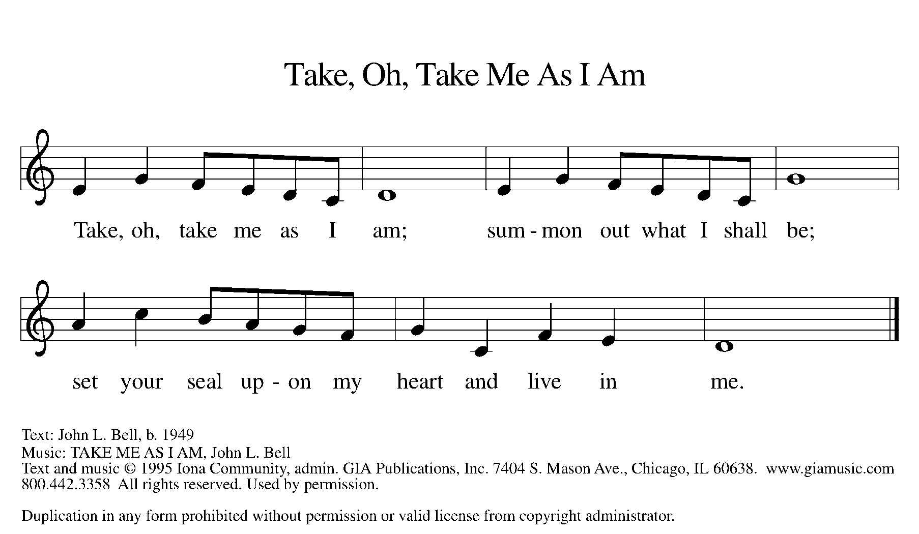

P: The body of Christ, given for you.

C: Amen.

A: The blood of Christ, shed for you.

C: Amen.
(Please rise as you are able.)

P: May the body and blood of our Lord Jesus Christ strengthen and keep you in his grace.

C: Amen.

PRAYER AFTER COMMUNION

P: Let us pray. Jesus, Bread of life, we have received from your table more than we could ever ask. As you have nourished us in this meal, now strengthen us to love the world with your own life. In your name we pray.

C: Amen.
SENDING

BLESSING

P: The blessing of God, who provides for us, feeds us, and journeys with us, ☩ be upon you now and forever.

C: Amen.

SENDING HYMN ELW 547
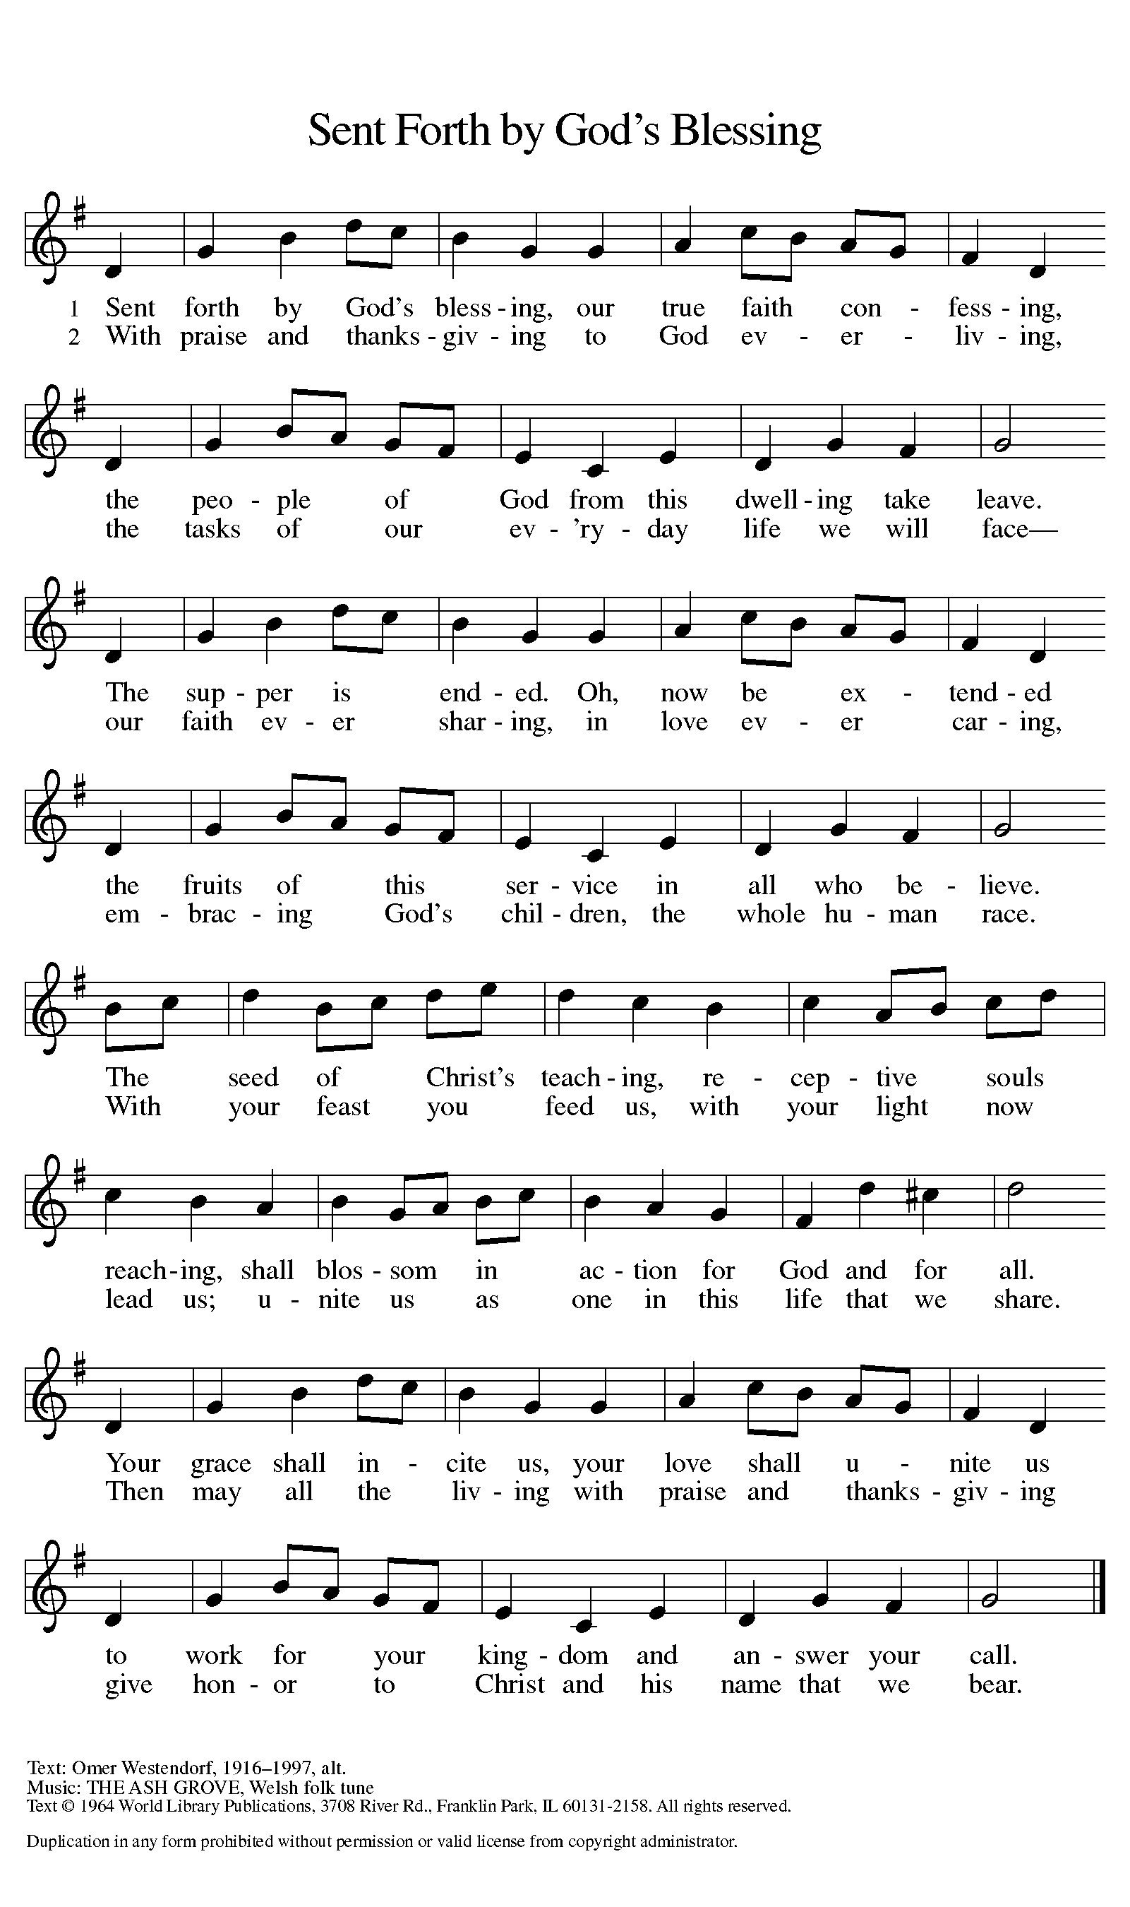
DISMISSAL

A: Go in peace. You are the body of Christ.
C: Thanks be to God.

Announcements

- Today – Pastor’s Appreciation Sundae Sunday – Ice cream & toppings during fellowship time.
- Monday, July 29th – Friday, August 2nd: VBS @ 9am – Noon
- Tuesday, July 30th – Ingham County Registrar of Deeds Property Fraud Protection Presentation @ 6:00pm

Recurring Events
- Every Sunday – Adult Bible Study @ 9am
- Monday, August 12 – Worship Committee Meeting @ 6:30pm
- Thursday, August 15 – Council Meeting @ 7pm
- Wednesday, August 21 – Women’s Bible Study @ 11am

Food Pantry Dates
- Wednesday, August 7, 5-7pm
- Thursday, August 15, 1-4pm
- Wednesday, August 21, 5-7pm
- Thursday, August 29, 1-4pm

Volunteers for July 28 Volunteers for August 4
Reader Sunday – Reader Sunday –
Assisting Minister – Mary Assisting Minister – Mary

July Birthday Celebrations Anniversary Celebrations
7/6 – Craig An. 7/9 – Paul & Tracy Co.
7/8 – Kay Se.
7/12 – Elizabeth Mc.
7/14 – Randy Mc.
7/16 – Stan St.
7/25 – Norma Va.

Acknowledgments
- OneLicense.net, License #A-703165. CCLI, License #2281869.
- From SundaysandSeasons.com. Copyright 2020 Augsburg Fortress. All rights reserved. Reprinted by permission under Augsburg Fortress Liturgies Annual License #23806.
- New Revised Standard Version Bible, copyright 1989, Division of Christian Education of the National Council of the Churches of Christ in the United States of America. Used by permission. All rights reserved.

