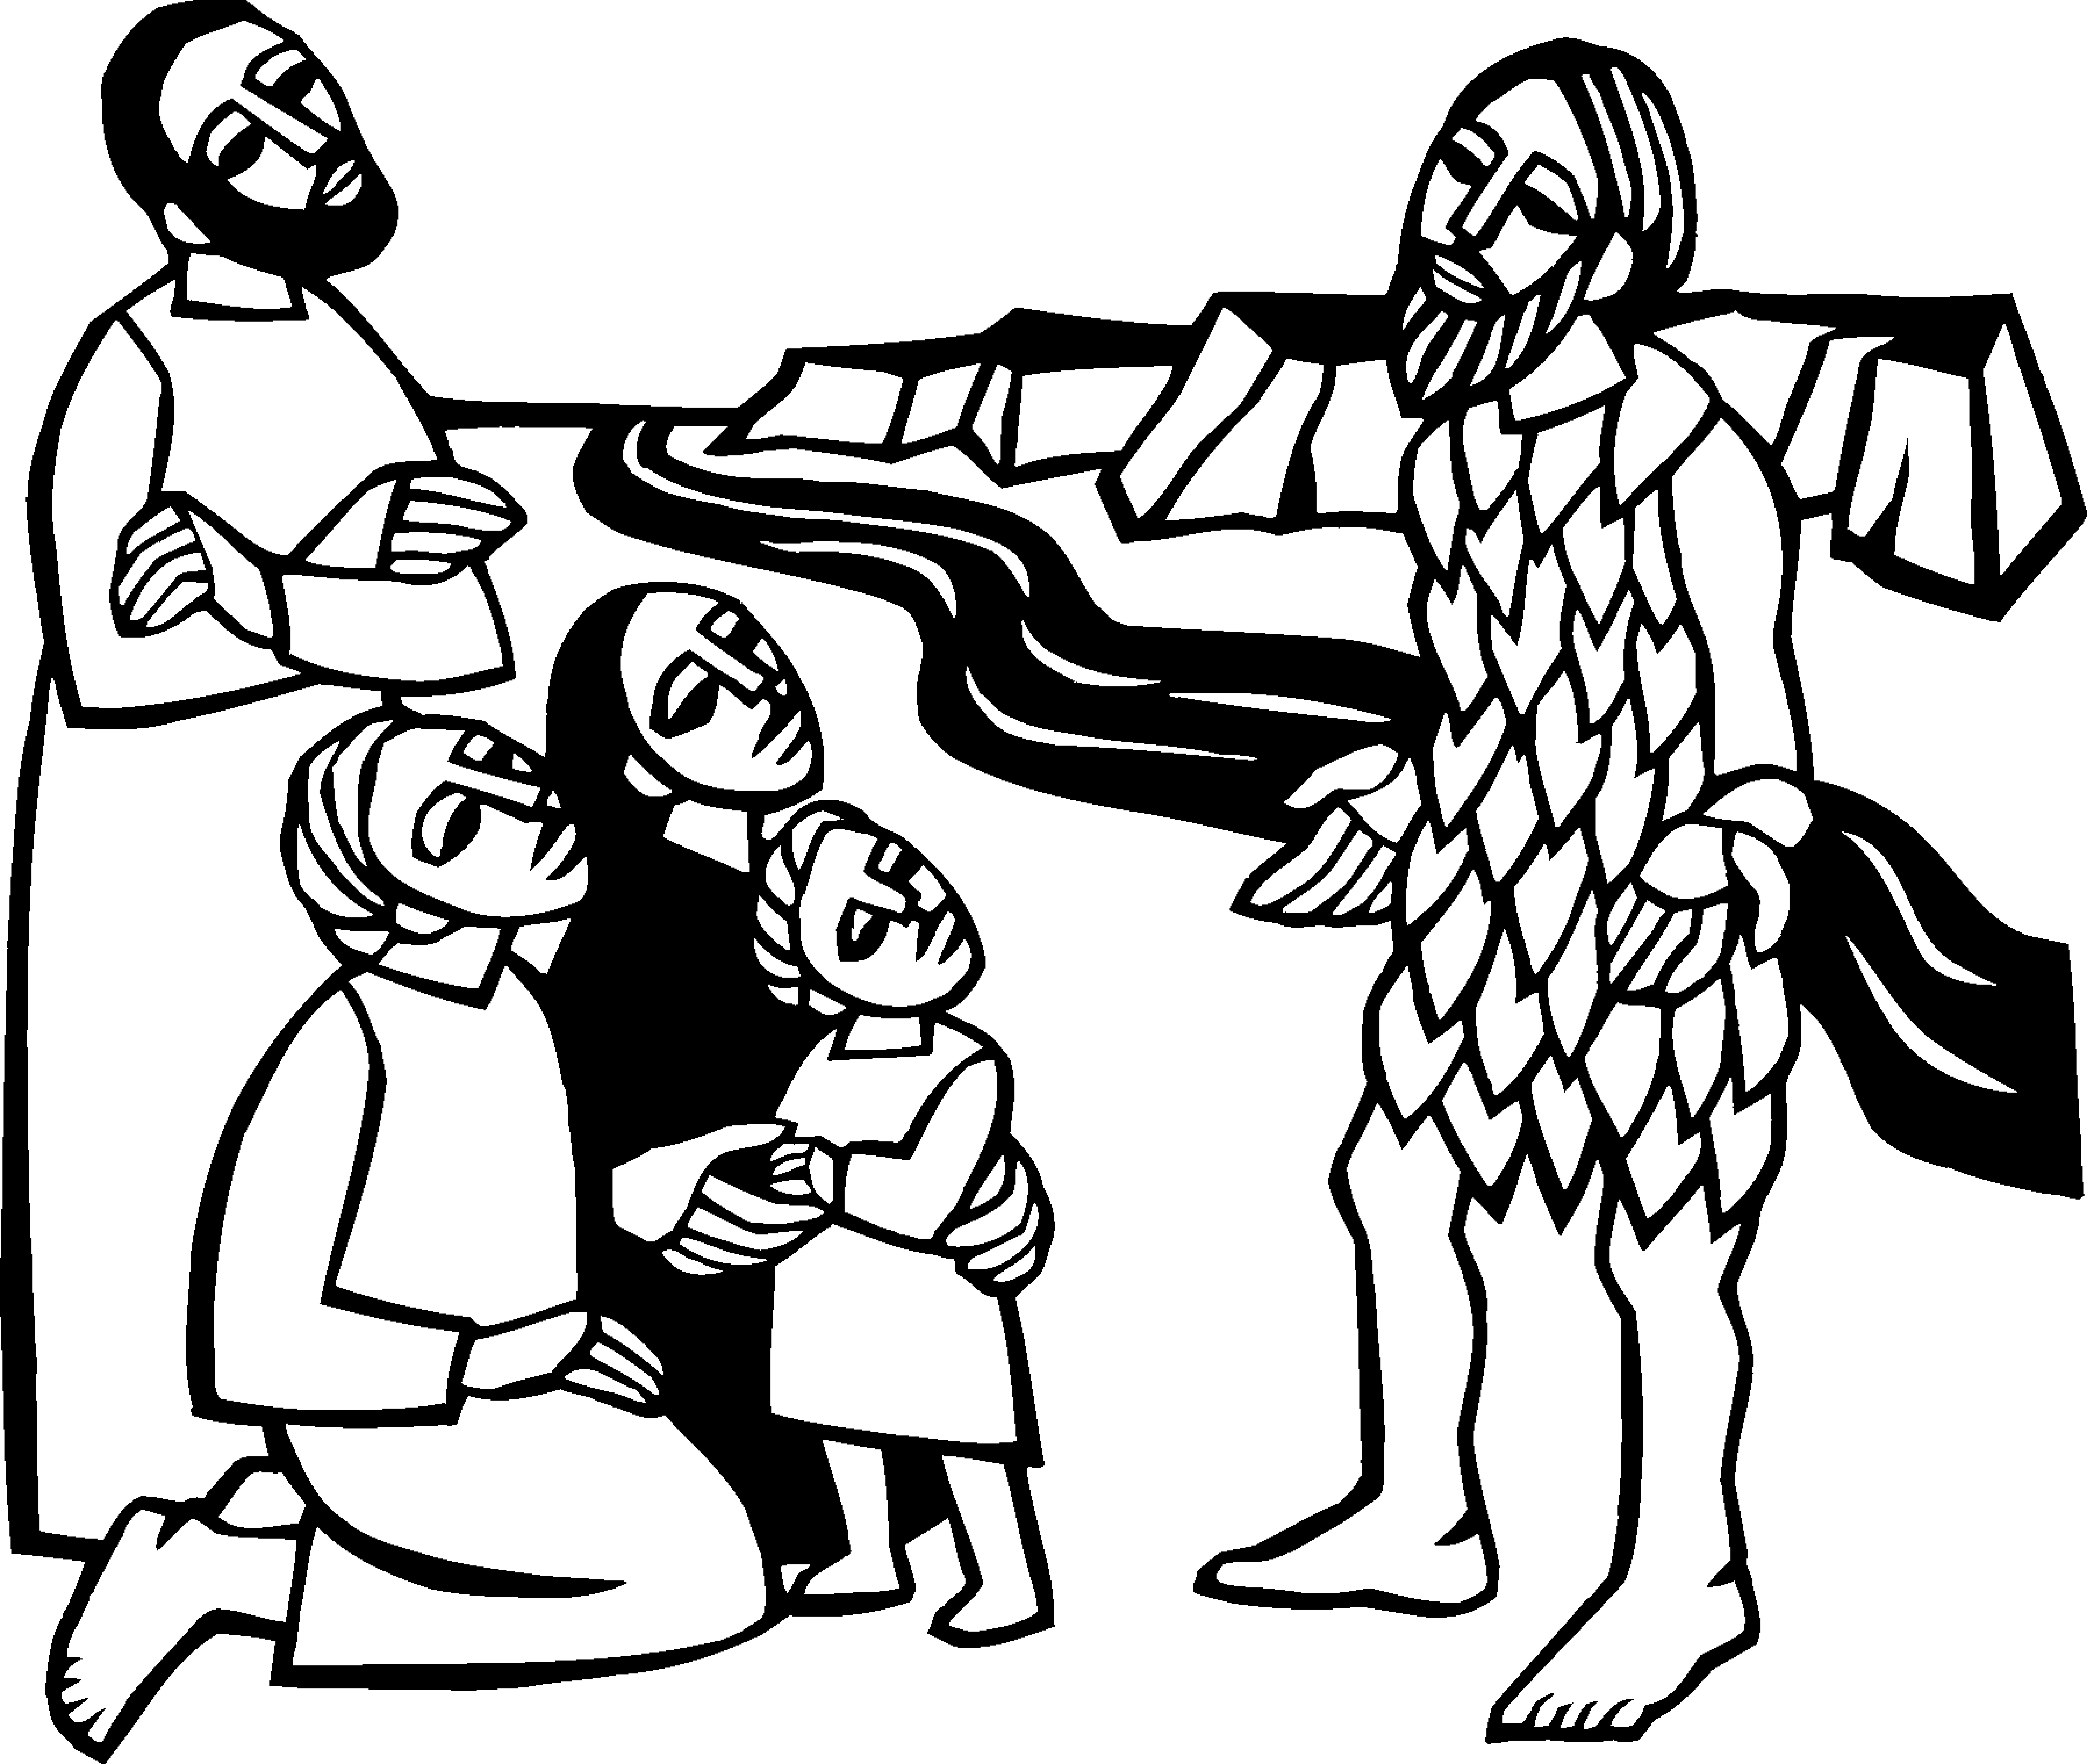

Second Sunday in Advent
December 10, 2023


SAINT PAUL LUTHERAN CHURCH
3383 EAST LAKE LANSING ROAD
EAST LANSING, MI 48823

PHONE (517) 351-8541

Pastor Carl E. Ballard
E-MAIL: pastor@stpaul-el.org
officemanager@stpaul-el.org
Visitors WELCOME! If this is your first time worshipping with us, please sign our guest registry just outside the sanctuary doors. We hope you are blessed through worship today. If you have any questions, please feel free to call the church at 351-8541.
Children are always welcome in worship! The choir room (off the sanctuary) can also be used as a cry room for younger children and includes a sound system so parents may continue to participate in the service. Clipboards with children's bulletins, activities and crayons are available for use during the service.
Sunday School is available during the worship service September-May except the last Sunday of the month.
Virtual Services We can provide a virtual live Zoom session during worship upon request.
This Bulletin is for your use during the service and to take home for the upcoming week. If you choose not to take it home, please place it in the recycle receptacle in the back.
Newsletters and Calendars of Upcoming Events are available in the lobby/narthex. We welcome anyone who has an interest in our small groups or activities! You can also look us up on the web at www.stpaul-el.org.
Contacting Us: Our Office Manager is Kassy Laurence. She can be reached by phone at 517-351-8541 or at her email address, officemanager@stpaul-el.org. Our Director of Music is Elene Kobulashvili. You may leave a message at 517-351-8541. Pastor Carl can be reached at 517-515-3129, and his email address is cballard123@msn.com.
Holy Communion is available at most services. All who believe in the real presence of Christ in the bread and the wine are invited to celebrate Communion with us. Those who wish can come forward for a blessing.
You’re invited to share in fellowship after worship. Kay (with the assistance of Bob) makes the most delicious snacks to our delight. We would love this opportunity to introduce you to the St. Paul community.

P-Presiding Minister A-Assisting Minister C-Congregation

PRELUDE Elene

INTRODUCTION CELEBRATE INSERT

GATHERING

P: The Holy Spirit calls us together as the people of God.

(Please rise as you are able.)

CONFESSION AND FORGIVENESS

All may make the sign of the cross, the sign that is marked at baptism, as the presiding minister begins.

P: Blessed be the holy Trinity, ☩ one God, who opens the heavens and draws near to us with salvation.

C: Amen.

P: God is patient and merciful, desiring all to come to repentance. Trusting this promise of grace, let us confess our sin.

(Silence for reflection)
P: Everlasting God,

C: you love justice and you hate wrongdoing. We confess the fear, greed, and self-centeredness that make us reluctant to work against oppression. We are complicit in systems of exploitation. We choose comfort over courage. We are careless with creation’s bounty. Look upon us with mercy. Turn our hearts again to you. Make us glad to do your will and to walk in your ways for the sake of our waiting world. Amen.

P: Hear these words of assurance: God clothes you with garments of salvation and covers you with robes of righteousness. In the tender compassion of ☩ Jesus Christ,
your sins are forgiven. God’s covenant is eternal, and God’s blessing rests upon us all.

C: Amen.

GATHERING SONG ELW 254
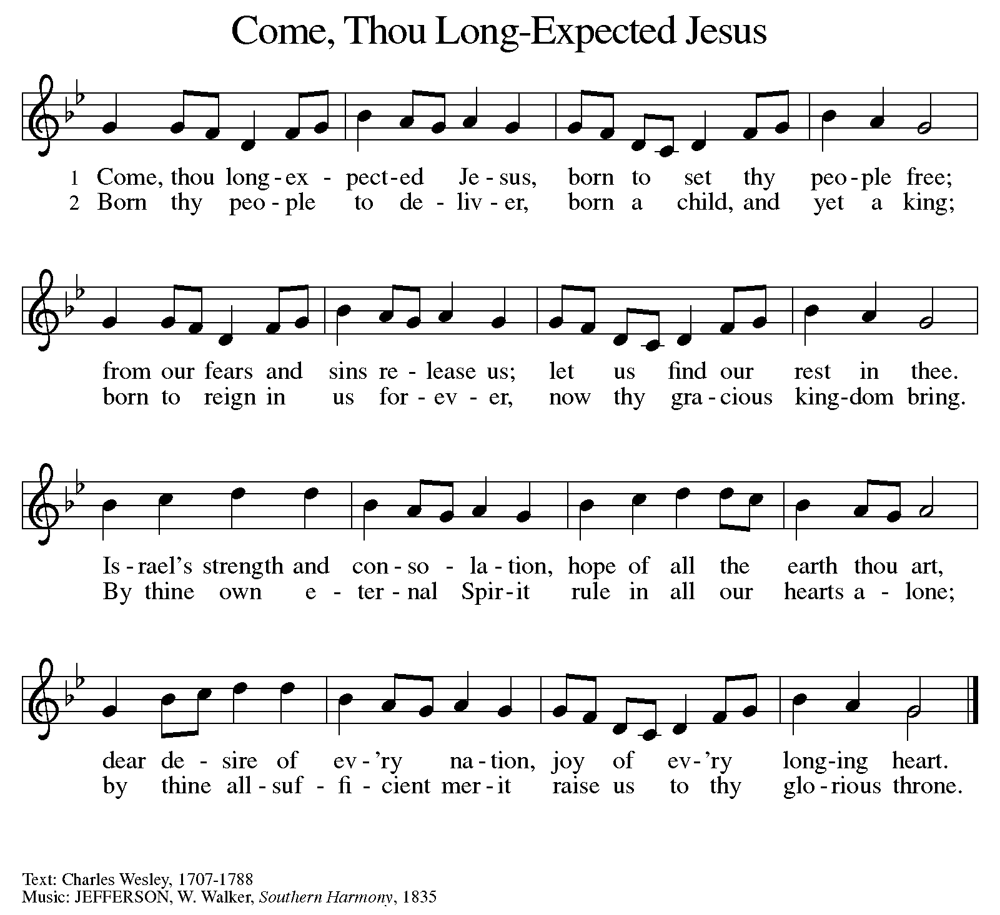
BLESSING OF THE ADVENT WREATH

Candle Lighter: At every beginning there is a yearning for the one who is coming.
O Emmanuel,
C: Prepare us for your coming.
CL: We gather together to get ready for what? Only heaven knows.
O Emmanuel,
C: Prepare us for your coming.
CL: We wait for the day when God will create a prevailing peace on the earth, and natural-born enemies turn into newborn friends.
O Emmanuel,
C: Prepare us for your coming.
CL: We get ready for God to come close by laying our lives open to Jesus, asking him to sort through all our mixed motives.
O Emmanuel,
C: Prepare us for your coming.
CL: Jesus, we welcome your presence now with the lighting of these candles, whose flames bring warmth to winter and fill this place with the glow of hope.
C: Amen.
LIGHT ONE CANDLE TO WATCH FOR MESSIAH ELW 240 (Verses 1 & 2)

Light one candle to watch for Messiah:
let the light banish darkness.
He shall bring salvation to Israel,
God fulfills the promise.

Light two candles to watch for Messiah:
let the light banish darkness.
He shall feed the flock like a shepherd,
gently lead them homeward.

GREETING

P: The grace of our Lord Jesus Christ, the love of God, and the communion of the Holy Spirit be with you all.
C: And also with you.

KYRIE ELW Setting 8, Page 184-185

Refrain: Kyrie eleison, on our world and on our way.
Kyrie eleison, ev’ry day.

For peace in the world, for the health of the church, for the unity of all;
for this holy house, for all who worship and praise,
let us pray to the Lord, let us pray to the Lord. Refrain

That we may live out your impassioned response to the hungry and the poor;
that we may live out truth and justice and grace,
let us pray to the Lord, let us pray to the Lord. Refrain

For peace in our hearts, for peace in our homes, for friends and family;
for life and for love, for our work and our play,
let us pray to the Lord, let us pray to the Lord. Refrain

For your Spirit to guide; that you center our lives in the water and the Word;
that you nourish our souls with your body and blood,
let us pray to the Lord, let us pray to the Lord. Refrain

CANTICLE OF PRAISE ELW Setting 4, Page 148-149

Glory to God in the highest, and peace to God’s people on earth.
Lord God, heavenly King, almighty God and Father,
we worship you, we give you thanks, we praise you for your glory.

Lord Jesus Christ, only Son of the Father, Lord God, Lamb of God,
you take away the sin of the world: have mercy on us;
you are seated at the right hand of the Father: receive our prayer.

For you alone are the Holy One, you alone are the Lord,
you alone are the Most High, Jesus Christ,
with the Holy Spirit, in the glory of God the Father. Amen.

PRAYER OF THE DAY CELEBRATE INSERT

(Please be seated.)

CHILDREN’S MESSAGE

(Children are invited to Sunday school.)

TRANSITION SONG (Only Verse 1) ELW 267
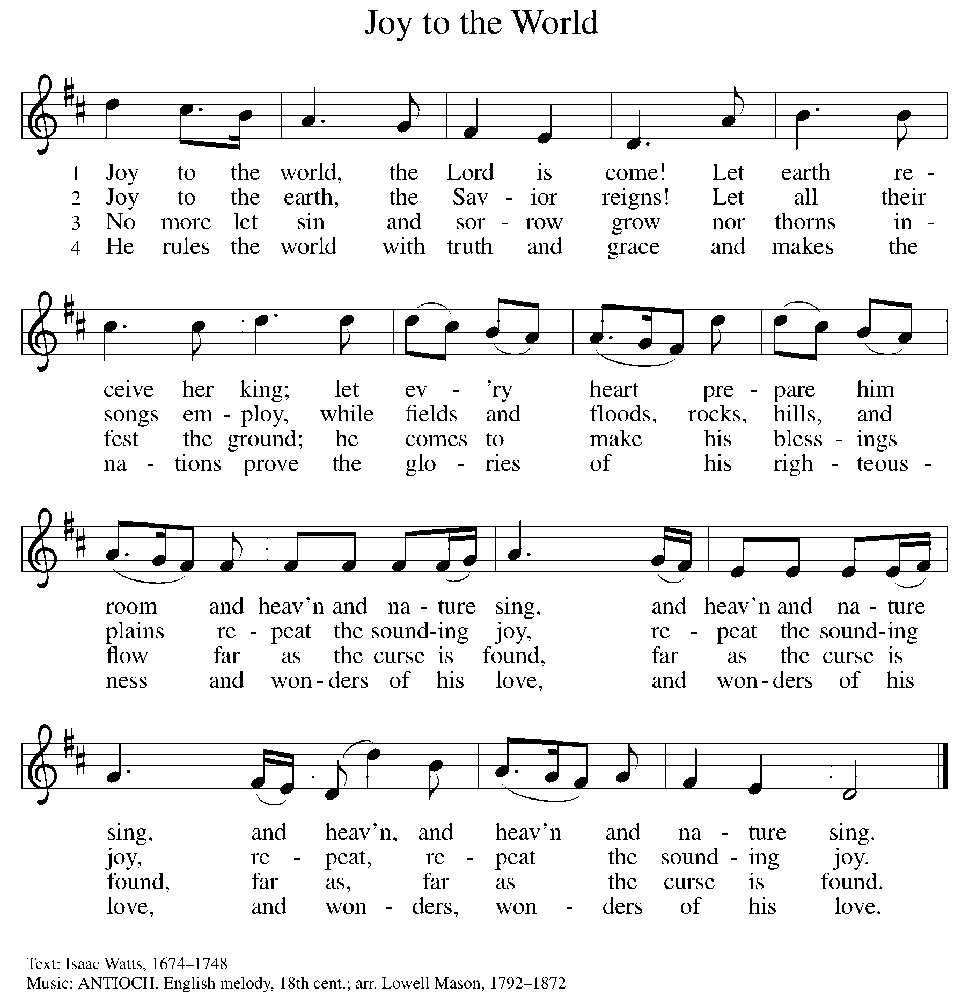
THE WORD

P: God speaks to us in scripture, preaching, and song.

FIRST READING CELEBRATE INSERT

Reader: Word of God, word of life. C: Thanks be to God.

PSALM CELEBRATE INSERT

SECOND READING CELEBRATE INSERT

Reader: Word of God, word of life. C: Thanks be to God.

(Please rise as you are able.)

GOSPEL ACCLAMATION ELW Setting 8, Page 188

Alleluia. Lord, to whom shall we go?
You have the words of eternal life. Alleluia.
Alleluia, alleluia. Alleluia.
Alleluia, alleluia.

GOSPEL

P: The Holy Gospel according to Mark, the 1st chapter.
C: Glory to you, O Lord.
CELEBRATE INSERT
P: The Gospel of the Lord.
C: Praise to you, O Christ.

(Please be seated.)

SERMON Pastor Carl Ballard

(Please rise as you are able.)

Hymn of the Day ELW 255
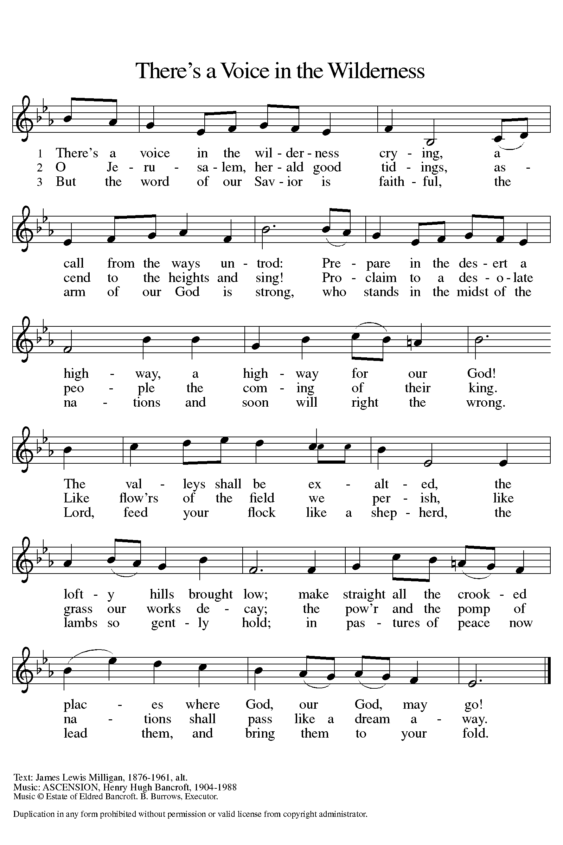

NICENE CREED

We believe in one God,
the Father, the Almighty,
maker of heaven and earth,
of all that is, seen and unseen.

We believe in one Lord, Jesus Christ,
the only Son of God,
eternally begotten of the Father,
God from God, Light from Light,
true God from true God,
begotten, not made,
of one Being with the Father;
through him all things were made.
For us and for our salvation
he came down from heaven,
was incarnate of the Holy Spirit and the virgin Mary
and became truly human.
For our sake he was crucified under Pontius Pilate;
he suffered death and was buried.
On the third day he rose again
in accordance with the scriptures;
he ascended into heaven
and is seated at the right hand of the Father.
He will come again in glory to judge the living and the dead,
and his kingdom will have no end.

We believe in the Holy Spirit, the Lord, the giver of life,
who proceeds from the Father and the Son,
who with the Father and the Son is worshiped and glorified,
who has spoken through the prophets.
We believe in one holy catholic and apostolic church.
We acknowledge one baptism for the forgiveness of sins.
We look for the resurrection of the dead,
and the life of the world to come. Amen.

(Please be seated.)

THE PRAYERS
IN THE CELEBRATE INSERT ALONG WITH

Send angels of protection to provide care and compassion to those who serve in our armed forces. We pray especially for Beth & Ryan, Jonathan, Jacob, Noah, Irene, and Alex. Merciful God,
C: receive our prayer.

Healing God, raise up any who are bowed down with illness or sorrow. Deepen our care and concern for one another. We lift to you all who are undergoing transition in relationships, occupation, living situation, or health condition, especially Ahren, Anne & Bob, Dan, David, John, Jon, Jordan, Julie, Lawton, Lera & family, Kristem, Pastor Joan, Wanda, Mary, Chip, Pastor Dana, Pastor Sarah, the Moran family, and Pastor Roseanne. Merciful God,
C: receive our prayer.

We especially lift up to you Presiding Bishop Elizabeth, our Synod Bishop Craig, and Pastor Carl. We ask that you be with their respective staffs as they live out their callings to serve. As we are called to be one, even as Jesus and the Father are one, be with the leaders and the congregation of Trinity Lutheran Church in Kalamazoo and the churches in our community. Merciful God,
C: receive our prayer.

GREETING OF PEACE

(Shake hands with your neighbor if you are comfortable.)

P: The peace of Christ be with you always.
C: And also with you.

THE MEAL

The gifts of the bread, wine, and contributions are brought forward to the altar.

OFFERING Elene

OFFERTORY (Only sing the 3rd verse.) ELW 294
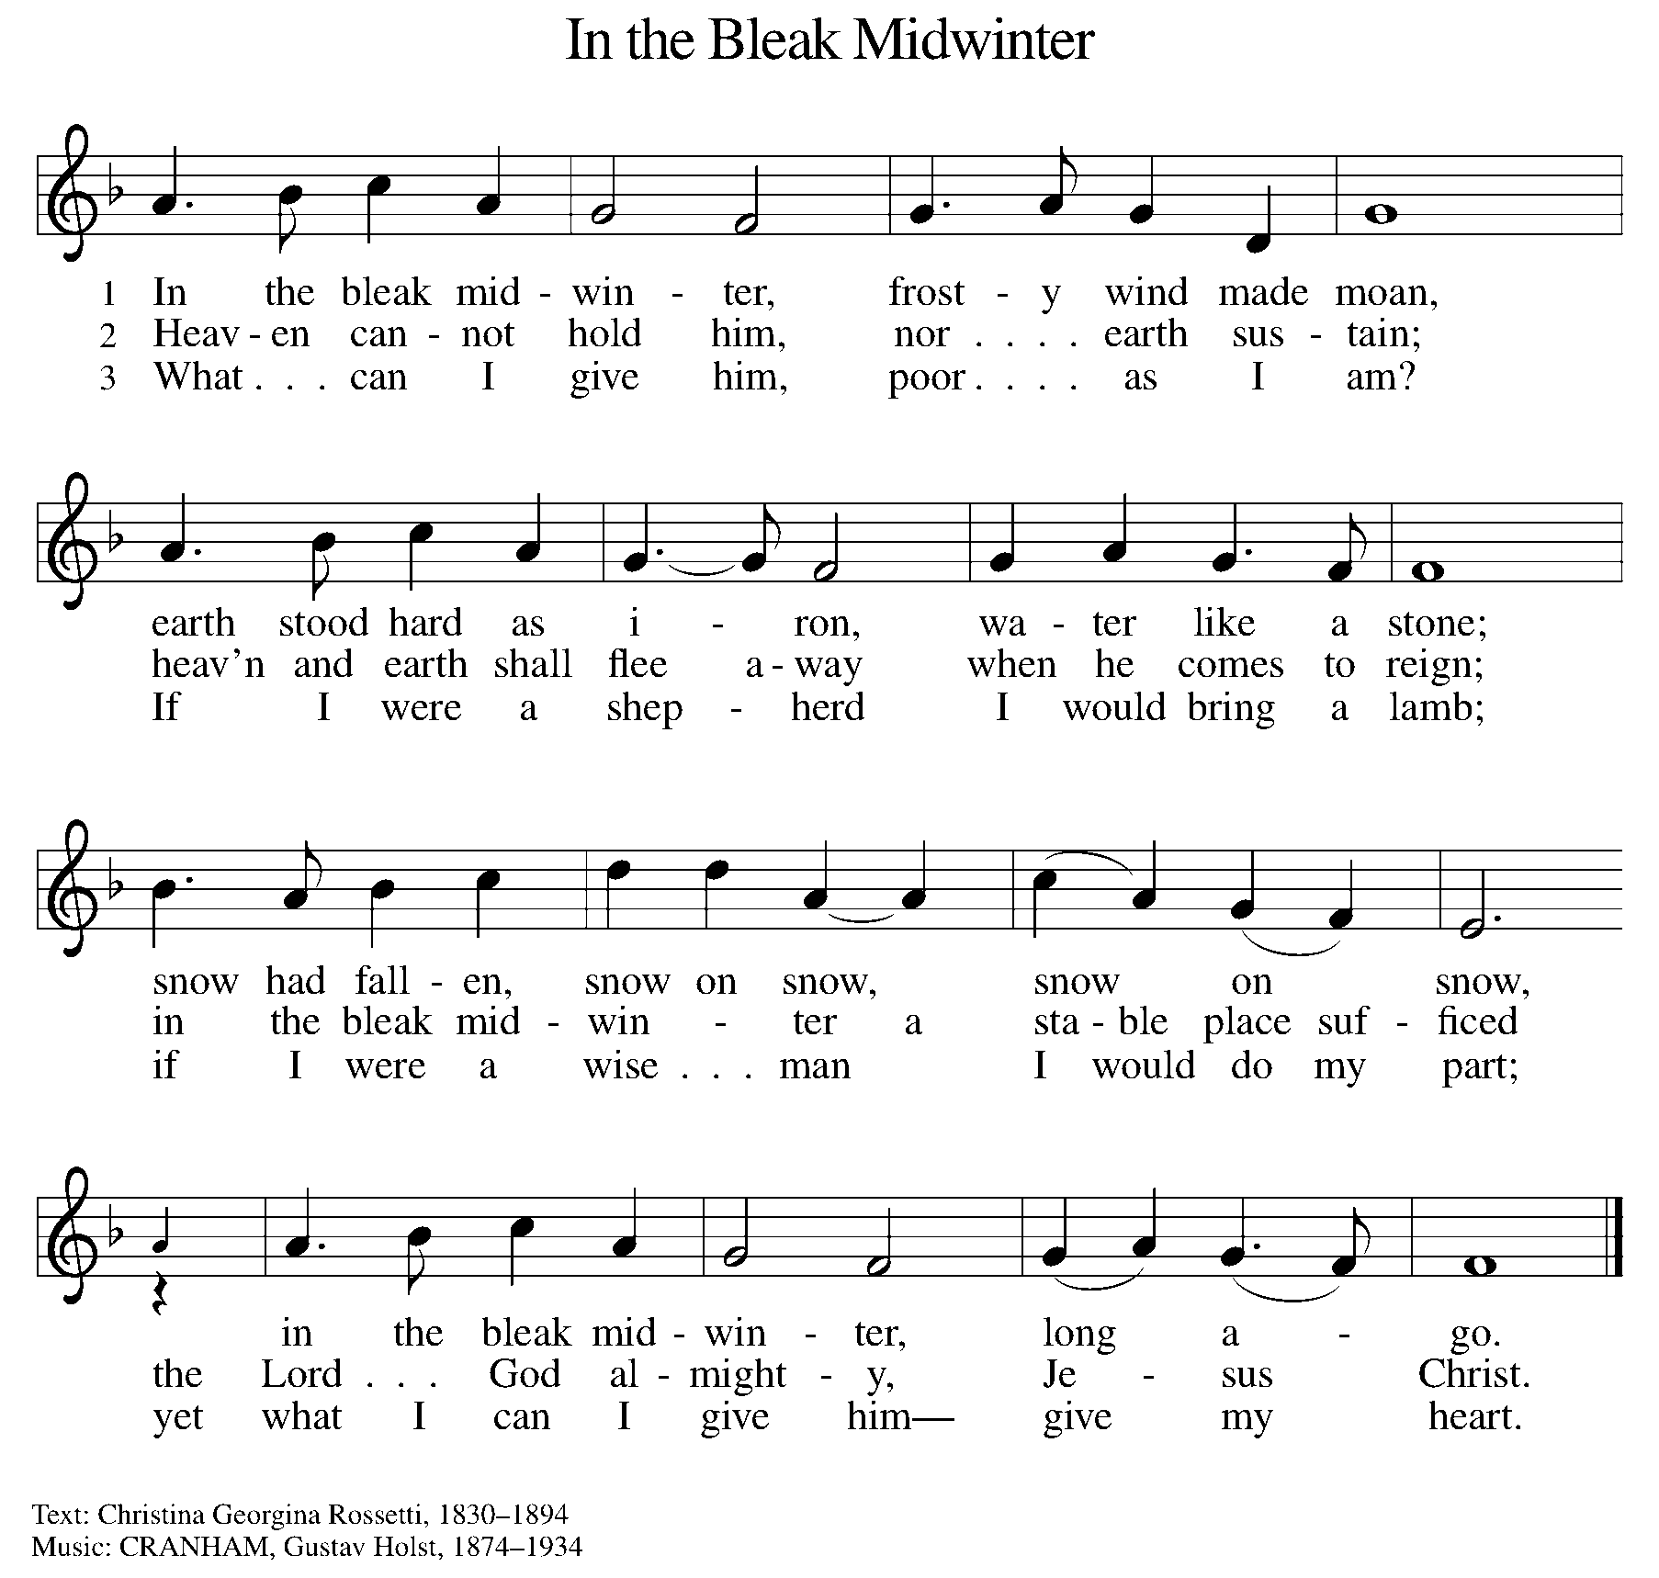

OFFERING PRAYER

A: Let us pray.
God our provider,
by your merciful hand
abundance springs up from the earth.
Receive and bless these gifts of your own bounty.
Let them be a sign of your steadfast love
and faithfulness for all people,
through Jesus Christ our Savior.
C: Amen.

THE GREAT THANKSGIVING

P: The Lord be with you.
C: And also with you.
P: Lift up your hearts.
C: We lift them up to the Lord.
P: Let us give thanks to the Lord our God.
C: It is right to give our thanks and praise.

PROPER PREFACE

P: It is indeed right, our duty and our joy, that we should at all times and in all places give thanks and praise to you, almighty and merciful God, through our Savior Jesus Christ. You comforted your people with the promise of the Redeemer, through whom you will also make all things new in the day when he comes to judge the world in righteousness. And so, with all the choirs of angels, with the church on earth and the hosts of heaven, we praise your name and join their unending hymn:

HOLY, HOLY ELW Setting 8, Page 190

Holy, holy, holy Lord,
God of pow’r and might,
heaven and earth are full of your glory, full of your glory.
Hosanna, hosanna, hosanna in the highest.
Blessed is he who comes in the name of the Lord.
Hosanna, hosanna, hosanna in the highest.

EUCHARISTIC PRAYER

P: In the night in which he was betrayed, our Lord Jesus took bread, and gave thanks; broke it, and gave it to his disciples, saying:
Take and eat; this is my body, given for you. Do this for the remembrance of me.
Again, after supper, he took the cup, gave thanks, and gave it for all to drink, saying:
This cup is the new covenant in my blood, shed for you and for all people for the forgiveness of sin. Do this for the remembrance of me.

LORD'S PRAYER

P: Lord, remember us in your kingdom, and teach us to pray:
C: Our Father in heaven, hallowed be your name, your kingdom come, your will be done, on earth as in heaven. Give us today our daily bread. Forgive us our sins as we forgive those who sin against us. Save us from the time of trial and deliver us from evil. For the kingdom, the power, and the glory are yours, now and forever. Amen.

COMMUNION DISTRIBUTION

All who believe in the real presence of Christ in the bread and the wine (juice) are welcome to the table. Others may come forward for a blessing. If you prefer grape juice, please indicate this to the assisting minister.

When approaching the communion rail, come forward down the side aisle, kneel if you are able, starting at the front of the communion rail (spot closest to the font) on your side and filling in toward the back. After receiving both the bread and the wine, you may return to your seat by the center aisle.

INVITATION TO COMMUNION

P: In this meal, righteousness and peace meet together. Come, take your place at the table.

COMMUNION HYMN ELW 528
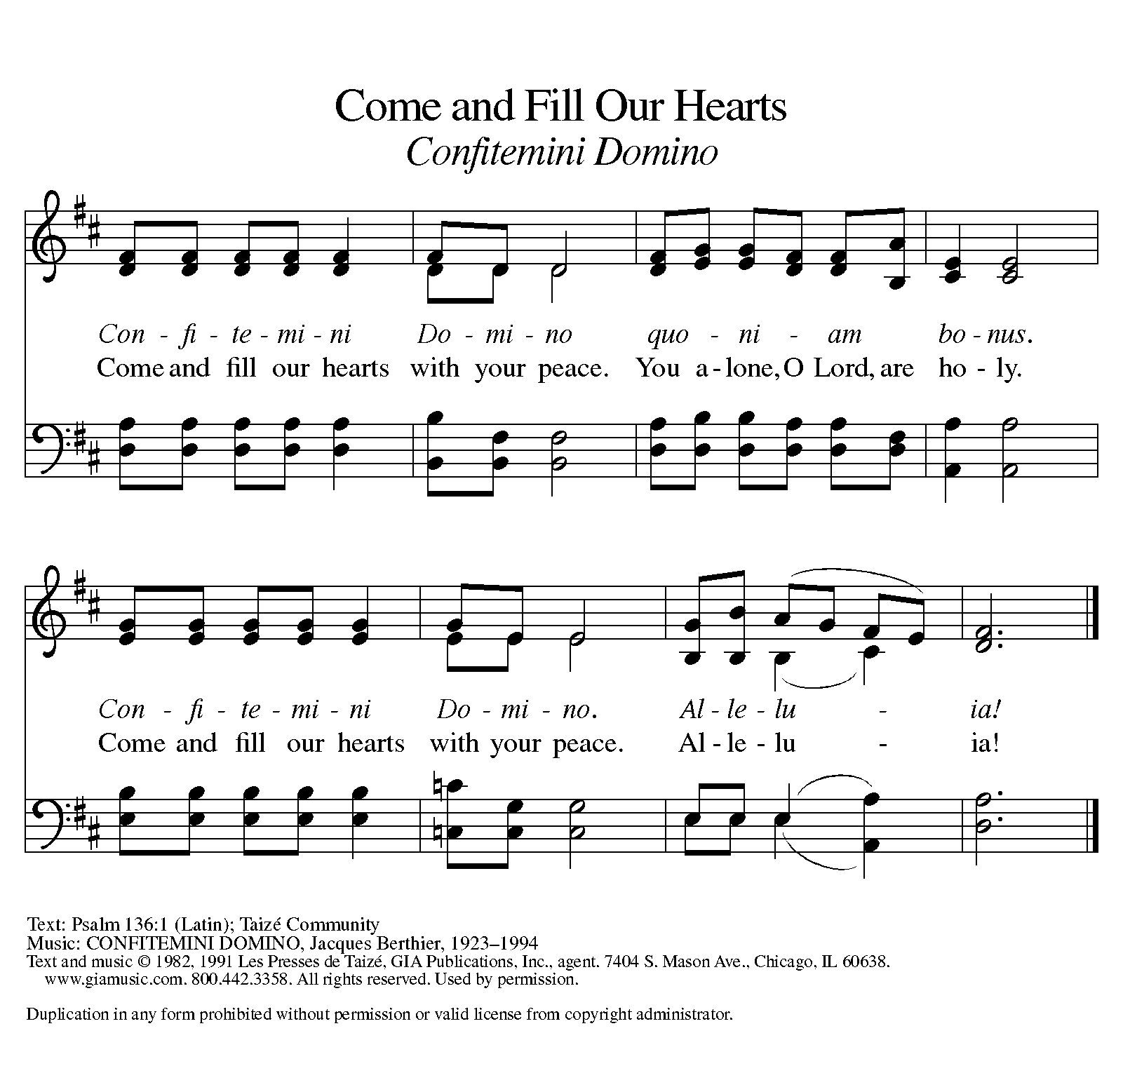

P: The body of Christ, given for you.
C: Amen.
A: The blood of Christ, shed for you.
C: Amen.

(Please rise as you are able.)

P: May the body and blood of our Lord Jesus Christ strengthen and keep you in his grace.
C: Amen.

PRAYER AFTER COMMUNION

P: Let us pray.
C: Generous God, in bread and cup you have revealed your glory for all people to see together. Nourished by this meal, send us out to proclaim your good news of liberation and release, brought to birth in Jesus Christ our Savior. Amen.

BLESSING

P: The God of peace bless you, the love of Christ sustain you in hope, and the anointing of the Spirit ☩ remain upon you now and forever.
C: Amen.

SENDING HYMN ELW 631
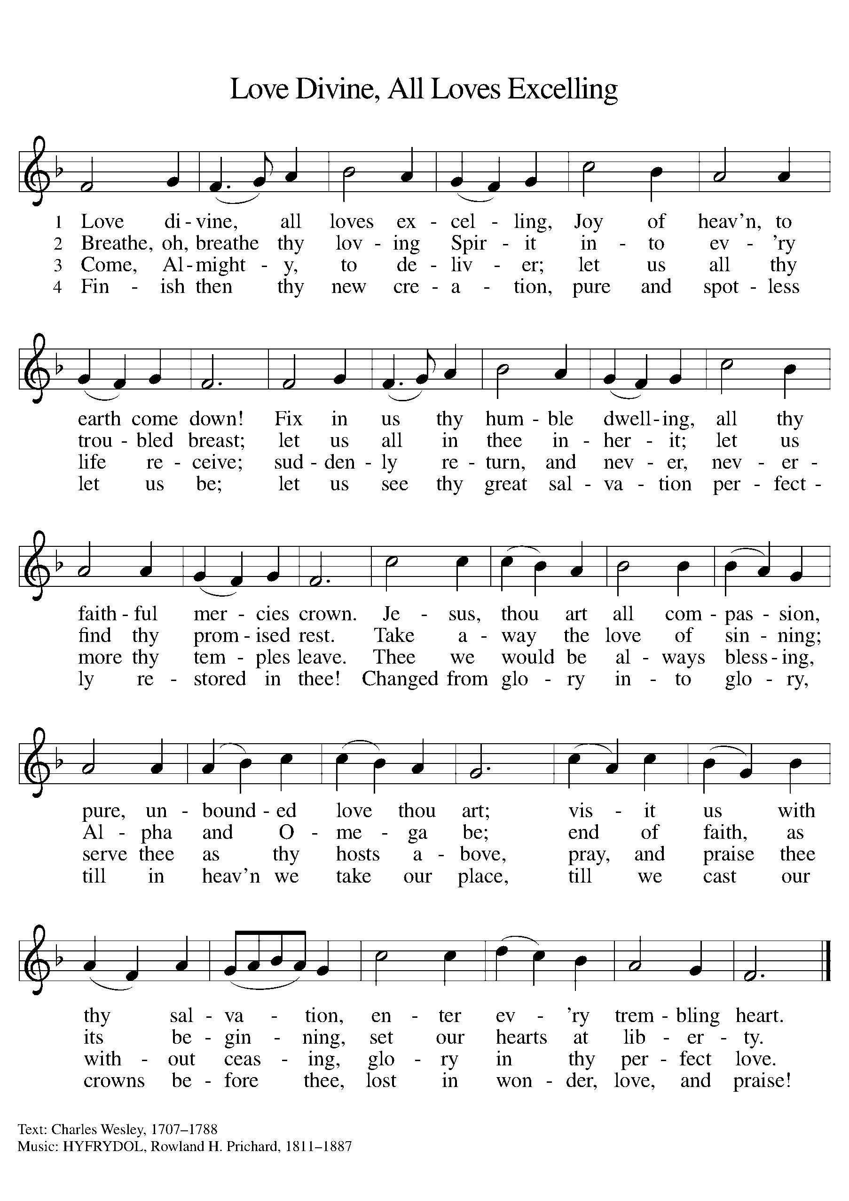

DISMISSAL

A: Go in peace. Keep awake.
C: Thanks be to God.
Announcements

- Wednesday, December 13 – Soup Supper @ 6pm
- Friday, December 15 – Blood Drive 11am-4:45pm
- Sunday, December 17 – Children’s program during worship
- Wednesday, December 20 – Soup Supper @ 6pm

Recurring Events

- Every Sunday – Adult Bible Study @ 9am
- 1st Monday – Worship Committee Meeting @ 6:30pm
- 2nd Wednesday – Women’s Bible Study @ 11am
- 3rd Thursday – Council Meeting @ 7pm

Food Pantry Dates

- Thursday, December 14, 1-4pm
- Wednesday, December 20, 5-7pm
- Thursday, December 28, 1-4pm

Volunteers for December 10 Volunteers for December 17

Candle Lighters – Candle Lighters –
Reader – Reader –

December Birthday Celebrations

12/07 – Sharon Br.
12/26 – Judy St.
12/29 – Jon Ke.

Acknowledgments
- OneLicense.net, License #A-703165. CCLI, License #2281869.
- From SundaysandSeasons.com. Copyright 2020 Augsburg Fortress. All rights reserved. Reprinted by permission under Augsburg Fortress Liturgies Annual License #23806.
- New Revised Standard Version Bible, copyright 1989, Division of Christian Education of the National Council of the Churches of Christ in the United States of America. Used by permission. All rights reserved.

