Christ the King
November 26, 2023


SAINT PAUL LUTHERAN CHURCH
3383 EAST LAKE LANSING ROAD
EAST LANSING, MI 48823

PHONE (517) 351-8541

Pastor Carl E. Ballard
E-MAIL: pastor@stpaul-el.org
officemanager@stpaul-el.org
Visitors WELCOME! If this is your first time worshipping with us, please sign our guest registry just outside the sanctuary doors. We hope you are blessed through worship today. If you have any questions, please feel free to call the church at 351-8541.
Children are always welcome in worship! The choir room (off the sanctuary) can also be used as a cry room for younger children and includes a sound system so parents may continue to participate in the service. Clipboards with children's bulletins, activities and crayons are available for use during the service.
Sunday School is available during the worship service September-May except the last Sunday of the month.
This Bulletin is for your use during the service and to take home for the upcoming week. If you choose not to take it home, please place it in the recycle receptacle in the back.
Newsletters and Calendars of Upcoming Events are available in the lobby/narthex. We welcome anyone who has an interest in our small groups or activities! You can also look us up on the web at www.stpaul-el.org.
Contacting Us: Our Office Manager is Kassy Laurence. She can be reached by phone at 517-351-8541 or at her email address, officemanager@stpaul-el.org. Our Director of Music is Elene Kobulashvili. You may leave a message at 517-351-8541. Pastor Carl can be reached at 517-515-3129, and his email address is cballard123@msn.com.
Holy Communion is available at most services. All who believe in the real presence of Christ in the bread and the wine are invited to celebrate Communion with us. Those who wish can come forward for a blessing.
You’re invited to share in fellowship after worship. Kay (with the assistance of Bob) makes the most delicious snacks to our delight. We would love this opportunity to introduce you to the St. Paul community.

P-Presiding Minister A-Assisting Minister C-Congregation

PRELUDE Elene

INTRODUCTION CELEBRATE INSERT

GATHERING

P: The Holy Spirit calls us together as the people of God.

(Please rise as you are able.)

CONFESSION AND FORGIVENESS

All may make the sign of the cross, the sign that is marked at baptism, as the presiding minister begins.

P: Blessed be the holy Trinity, ☩ one God, in whose image we are made, who claims us and calls us beloved.
C: Amen.

(Silence for reflection)

P: Holy One,
C: we confess that we are not awake for you. We are not faithful in using your gifts. We forget the least of our siblings. We do not see your beautiful image in one another. We are infected by sin that divides your beloved community. Open our hearts to your coming, open our eyes to see you in our neighbor, open our hands to serve your creation.
Amen.

P: Beloved, we are God’s children, and Jesus, our Beloved, opens the door to us. Through ☩ Jesus you are forgiven, by Jesus you are welcome, in Jesus you are called to rejoice! Let us live in the promises prepared for us from the foundation of the world.
C: Amen.

GATHERING SONG ELW 855
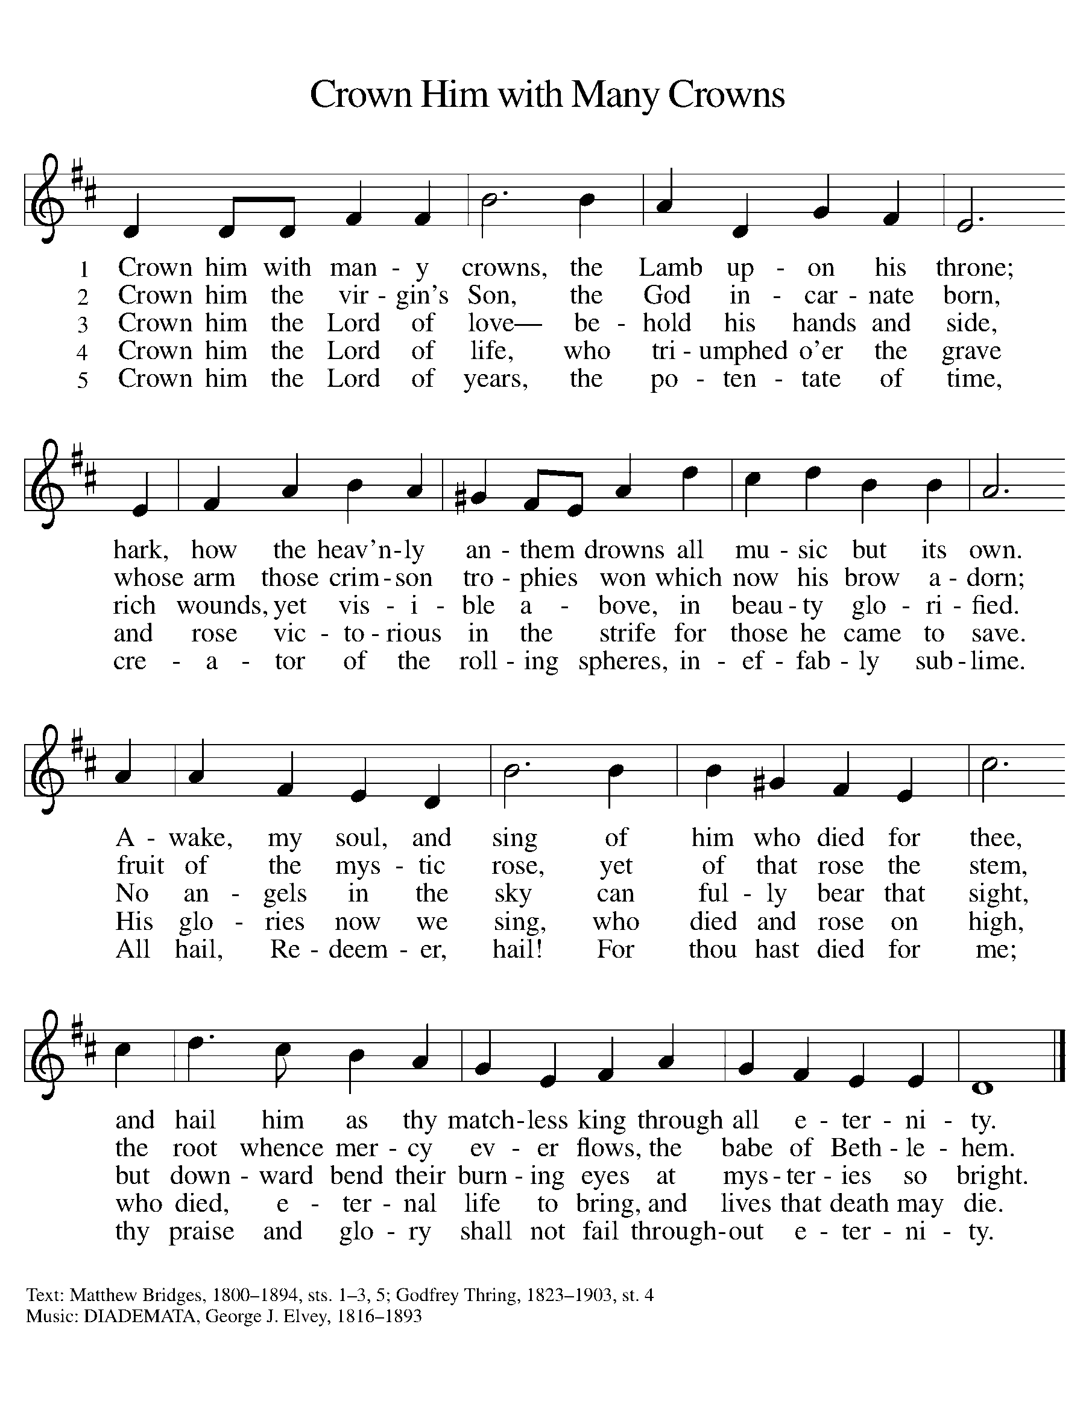

GREETING

P: The grace of our Lord Jesus Christ, the love of God, and the communion of the Holy Spirit be with you all.
C: And also with you.

KYRIE ELW Setting 7, Page 175

Lord, have mercy on us; O Lord, have mercy.
Lord, have mercy on us; O Lord, have mercy.
Christ, have mercy on us; O Christ, have mercy.
Christ, have mercy on us; O Christ, have mercy.
Lord, have mercy on us; O Lord, have mercy.
Lord, have mercy on us; O Lord, have mercy.

CANTICLE OF PRAISE ELW Setting 4, Page 149-150

This is the feast of victory for our God.
Alleluia.
Worthy is Christ, the Lamb who was slain,
whose blood set us free to be people of God.
Power and riches and wisdom and strength,
and honor and blessing and glory are his.
This is the feast of victory for our God.
Alleluia.
Sing with all the people of God
and join in the hymn of all creation:
Blessing and honor and glory
and might be to God and the Lamb forever.
Amen.
This is the feast of victory for our God,
for the Lamb who was slain has begun his reign.
Alleluia. Alleluia.

PRAYER OF THE DAY CELEBRATE INSERT

(Please be seated.)

CHILDREN’S MESSAGE

(Children are invited to Sunday school.)

TRANSITION SONG (Only Verse 1 and Chorus) ELW 595
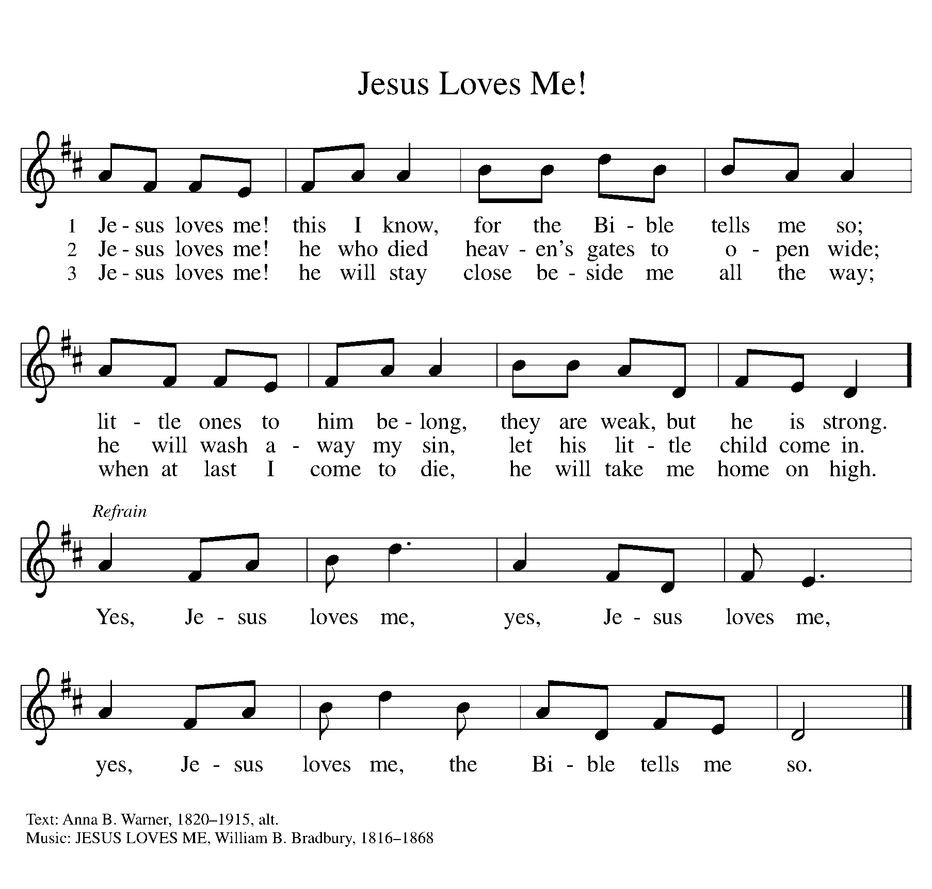

THE WORD

P: God speaks to us in scripture, preaching, and song.

FIRST READING CELEBRATE INSERT

Reader: Word of God, word of life. C: Thanks be to God.

PSALM CELEBRATE INSERT

SECOND READING CELEBRATE INSERT

Reader: Word of God, word of life. C: Thanks be to God.

(Please rise as you are able.)
GOSPEL ACCLAMATION ELW Setting 7, Page 179

Alleluia, alleluia, alleluia!
Alleluia, alleluia, alleluia!
Alleluia, alleluia, alleluia! Alleluia!

GOSPEL

P: The Holy Gospel according to Matthew, the 25th chapter.
C: Glory to you, O Lord.
CELEBRATE INSERT
P: The Gospel of the Lord.
C: Praise to you, O Christ.

(Please be seated.)

SERMON Pastor Carl Ballard

(Please rise as you are able.)

Hymn of the Day ELW 715
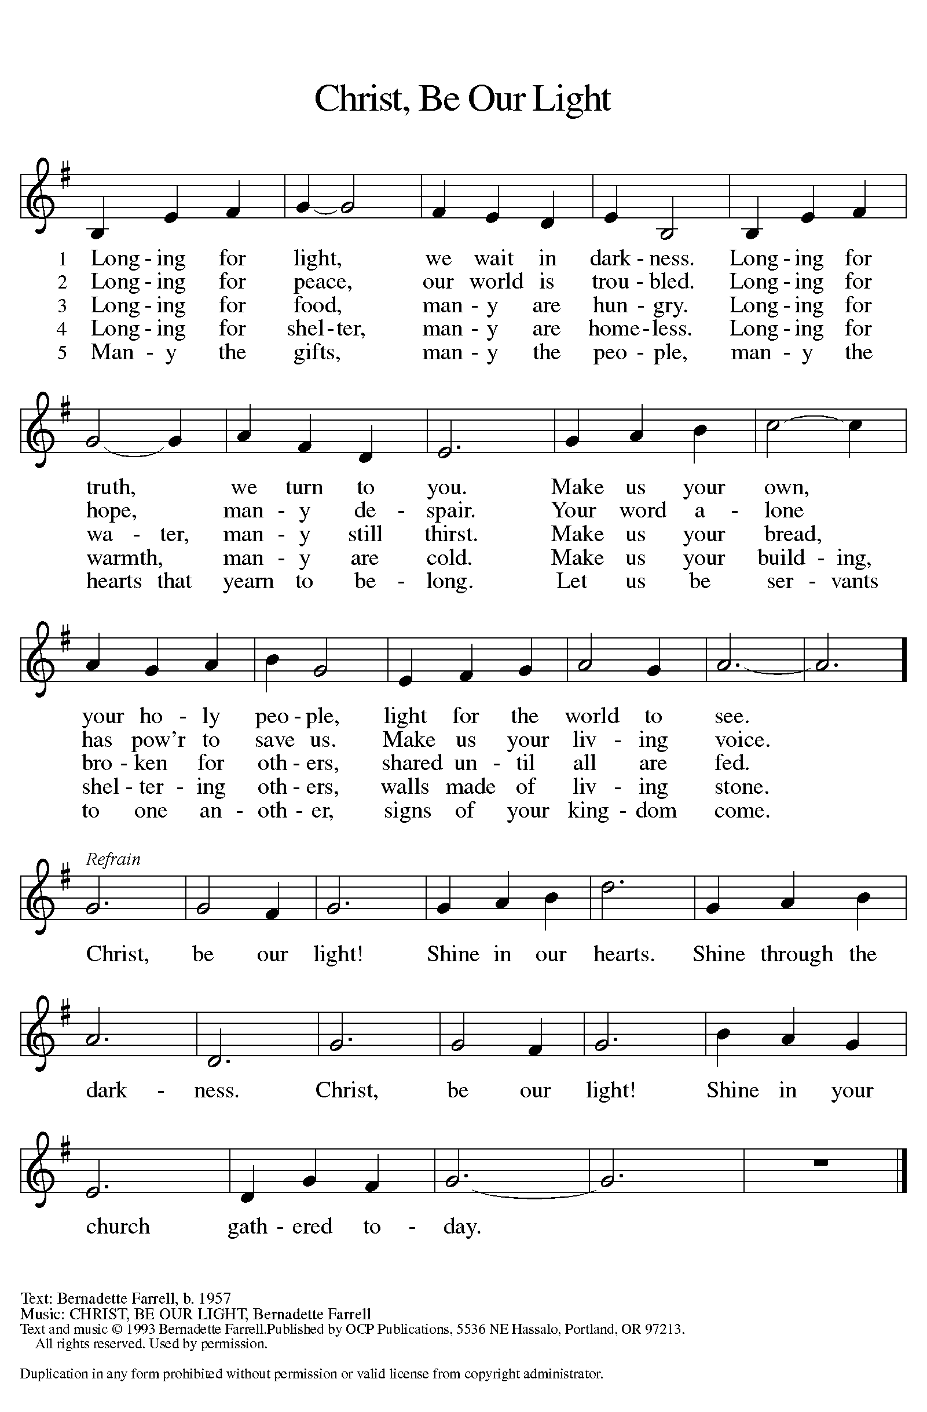

NICENE CREED

We believe in one God,
the Father, the Almighty,
maker of heaven and earth,
of all that is, seen and unseen.

We believe in one Lord, Jesus Christ,
the only Son of God,
eternally begotten of the Father,
God from God, Light from Light,
true God from true God,
begotten, not made,
of one Being with the Father;
through him all things were made.
For us and for our salvation
he came down from heaven,
was incarnate of the Holy Spirit and the virgin Mary
and became truly human.
For our sake he was crucified under Pontius Pilate;
he suffered death and was buried.
On the third day he rose again
in accordance with the scriptures;
he ascended into heaven
and is seated at the right hand of the Father.
He will come again in glory to judge the living and the dead,
and his kingdom will have no end.

We believe in the Holy Spirit, the Lord, the giver of life,
who proceeds from the Father and the Son,
who with the Father and the Son is worshiped and glorified,
who has spoken through the prophets.
We believe in one holy catholic and apostolic church.
We acknowledge one baptism for the forgiveness of sins.
We look for the resurrection of the dead,
and the life of the world to come. Amen.

(Please be seated.)
THE PRAYERS
IN THE CELEBRATE INSERT ALONG WITH

Send angels of protection to provide care and compassion to those who serve in our armed forces and protect and sacrifice for us so we can be free. We pray especially for Beth & Ryan, Jonathan, Jacob, Noah, Irene, and Alex. Hear us, O God.
C: Your mercy is great.
Healing God, raise up any who are bowed down with illness or sorrow. Deepen our care and concern for one another. We lift to you all who are undergoing transition in relationships, occupation, living situation, or health condition, especially Ahren, Anne & Bob, Dan, David, John, Jon, Jordan, Julie, Lawton, Lera & family, Kristem, Pastor Joan, Wanda, Mary, Chip, Matt, Pastor Dana, Pastor Sarah, the Moran family, and Pastor Roseanne. Hear us, O God.
C: Your mercy is great.

We especially lift up to you Presiding Bishop Elizabeth, our Synod Bishop Craig, and Pastor Carl. We ask that you be with their respective staffs as they live out their callings to serve. As we are called to be one, even as Jesus and the Father are one, be with the leaders and the congregation of Immanuel Lutheran Church in Jackson and the churches in our community. Hear us, O God.
C: Your mercy is great.

GREETING OF PEACE

P: The peace of Christ be with you always.
C: And also with you.

THE MEAL
The gifts of the bread, wine, and contributions are brought forward to the altar.

OFFERING Elene

OFFERTORY ELW 184
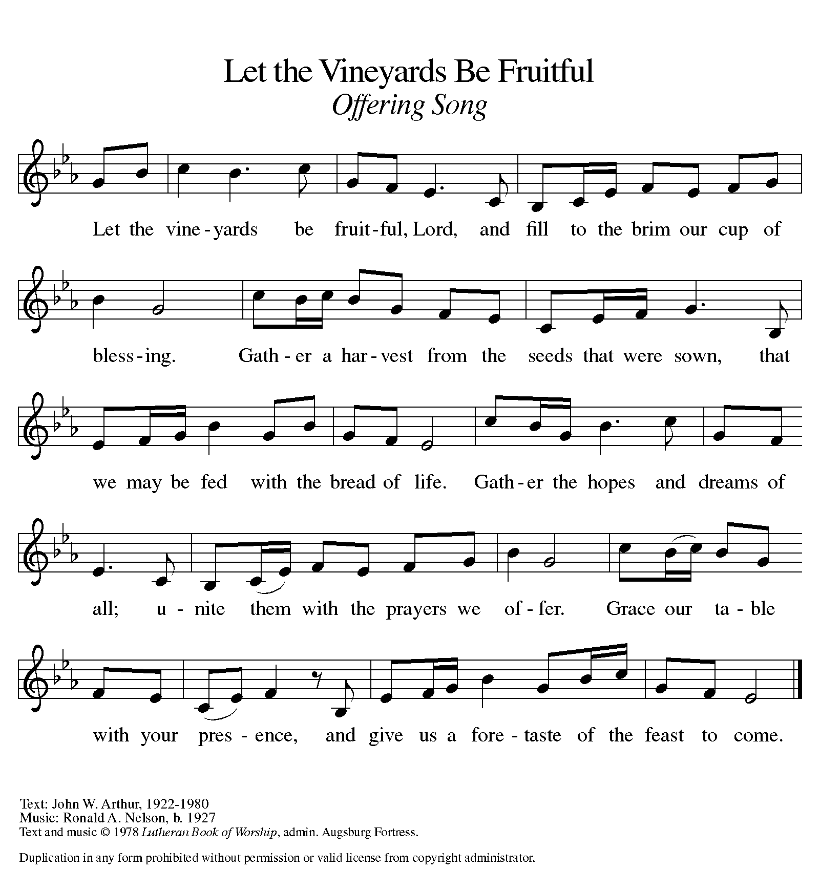

OFFERING PRAYER

A: Let us pray.
God of all goodness,
generations have turned to you,
gathered around your table,
and shared your abundant blessings.
Number us among them
that, as we gather these gifts from your abundance,
and give thanks for your rich blessings,
we may feast upon your very self
and care for all that you have made,
through Jesus Christ, our Sovereign and Servant.
C: Amen.

THE GREAT THANKSGIVING

P: The Lord be with you.
C: And also with you.
P: Lift up your hearts.
C: We lift them to the Lord.
P: Let us give thanks to the Lord our God.
C: It is right to give our thanks and praise.

PROPER PREFACE

P: It is indeed right, our duty and our joy, that we should at all times and in all places give thanks and praise to you, almighty and merciful God, through our Savior Jesus Christ. You comforted your people with the promise of the Redeemer, through whom you will also make all things new in the day when he comes to judge the world in righteousness. And so, with all the choirs of angels, with the church on earth and the hosts of heaven, we praise your name and join their unending hymn:

HOLY, HOLY ELW Setting 7, Page 181

Holy, holy, holy Lord God,
God of might and power; holy is the Lord.
Holy, holy, holy, holy Lord God,
God of might and power; holy is the Lord.
Hosanna in the highest, hosanna here on earth.
Blest is he who comes in the name of the Lord.
Hosanna in the highest, hosanna here on earth.
Blest is he who comes in the name of the Lord.

EUCHARISTIC PRAYER

P: In the night in which he was betrayed, our Lord Jesus took bread, and gave thanks; broke it, and gave it to his disciples, saying:
Take and eat; this is my body, given for you. Do this for the remembrance of me.
Again, after supper, he took the cup, gave thanks, and gave it for all to drink, saying:
This cup is the new covenant in my blood, shed for you and for all people for the forgiveness of sin. Do this for the remembrance of me.

LORD'S PRAYER

P: Lord, remember us in your kingdom, and teach us to pray:
C: Our Father in heaven, hallowed be your name, your kingdom come, your will be done, on earth as in heaven. Give us today our daily bread. Forgive us our sins as we forgive those who sin against us. Save us from the time of trial and deliver us from evil. For the kingdom, the power, and the glory are yours, now and forever. Amen.
COMMUNION DISTRIBUTION

All who believe in the real presence of Christ in the bread and the wine (juice) are welcome to the table. Others may come forward for a blessing. If you prefer grape juice, please indicate this to the assisting minister.

When approaching the communion rail, come forward down the side aisle, kneel, if you are able, starting at the front of the communion rail (spot closest to the font) on your side and filling in toward the back. After receiving both the bread and the wine, you may return to your seat by the center aisle.

INVITATION TO COMMUNION

P: There is a place for you at the banquet. Come and feast at Jesus’ table.

COMMUNION HYMN ELW 481
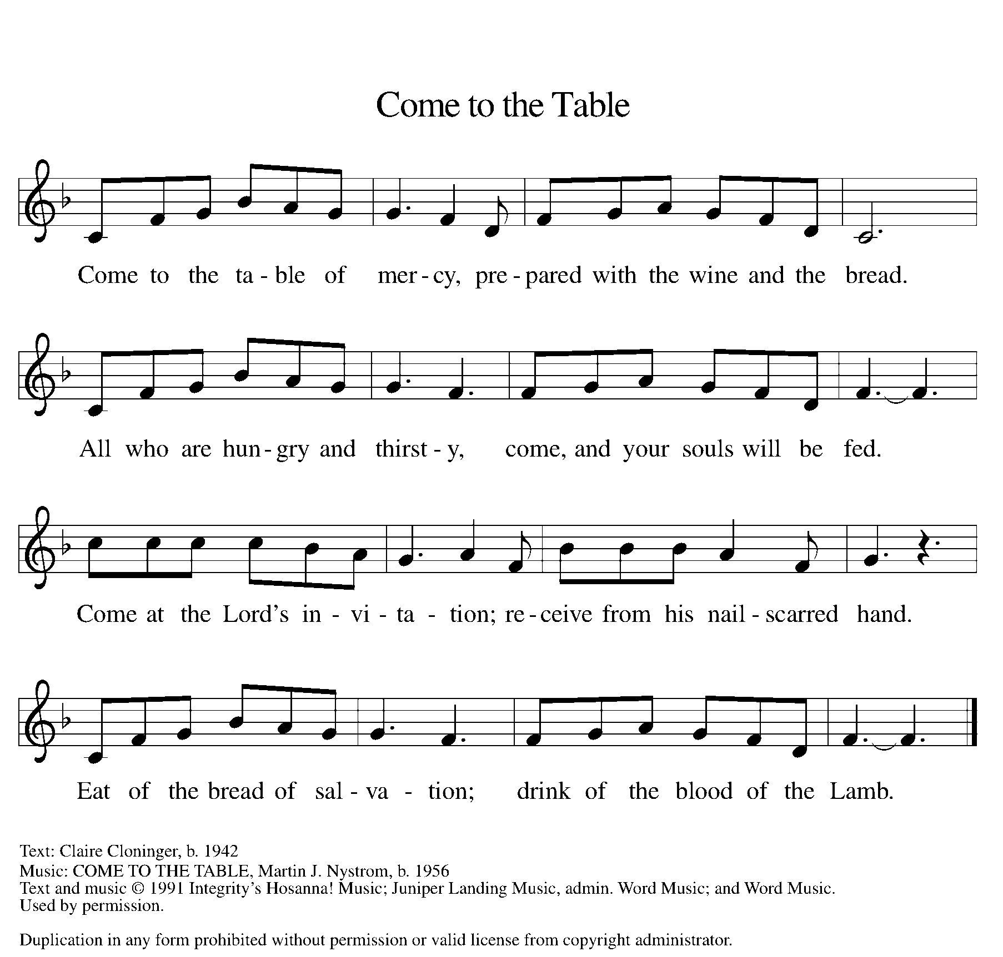
P: The body of Christ, given for you.
C: Amen.
A: The blood of Christ, shed for you.
C: Amen.

(Please rise as you are able.)

P: May the body and blood of our Lord Jesus Christ strengthen and keep you in his grace.
C: Amen.

PRAYER AFTER COMMUNION

P: Let us pray.
C: Lord Jesus, in this simple meal you have set a banquet. Sustain us on the journey, strengthen us to care for the least of your beloved children, and give us glad and generous hearts as we meet you on the way.
Amen.

BLESSING

P: May the God of all creation, in whose image we are made, who claims us and calls us beloved, who strengthens us for service, give you reason to rejoice and be glad!
The blessing of God, Sovereign, ☩ Savior, and Spirit, be with you today and always.
C: Amen.

SENDING HYMN ELW 826
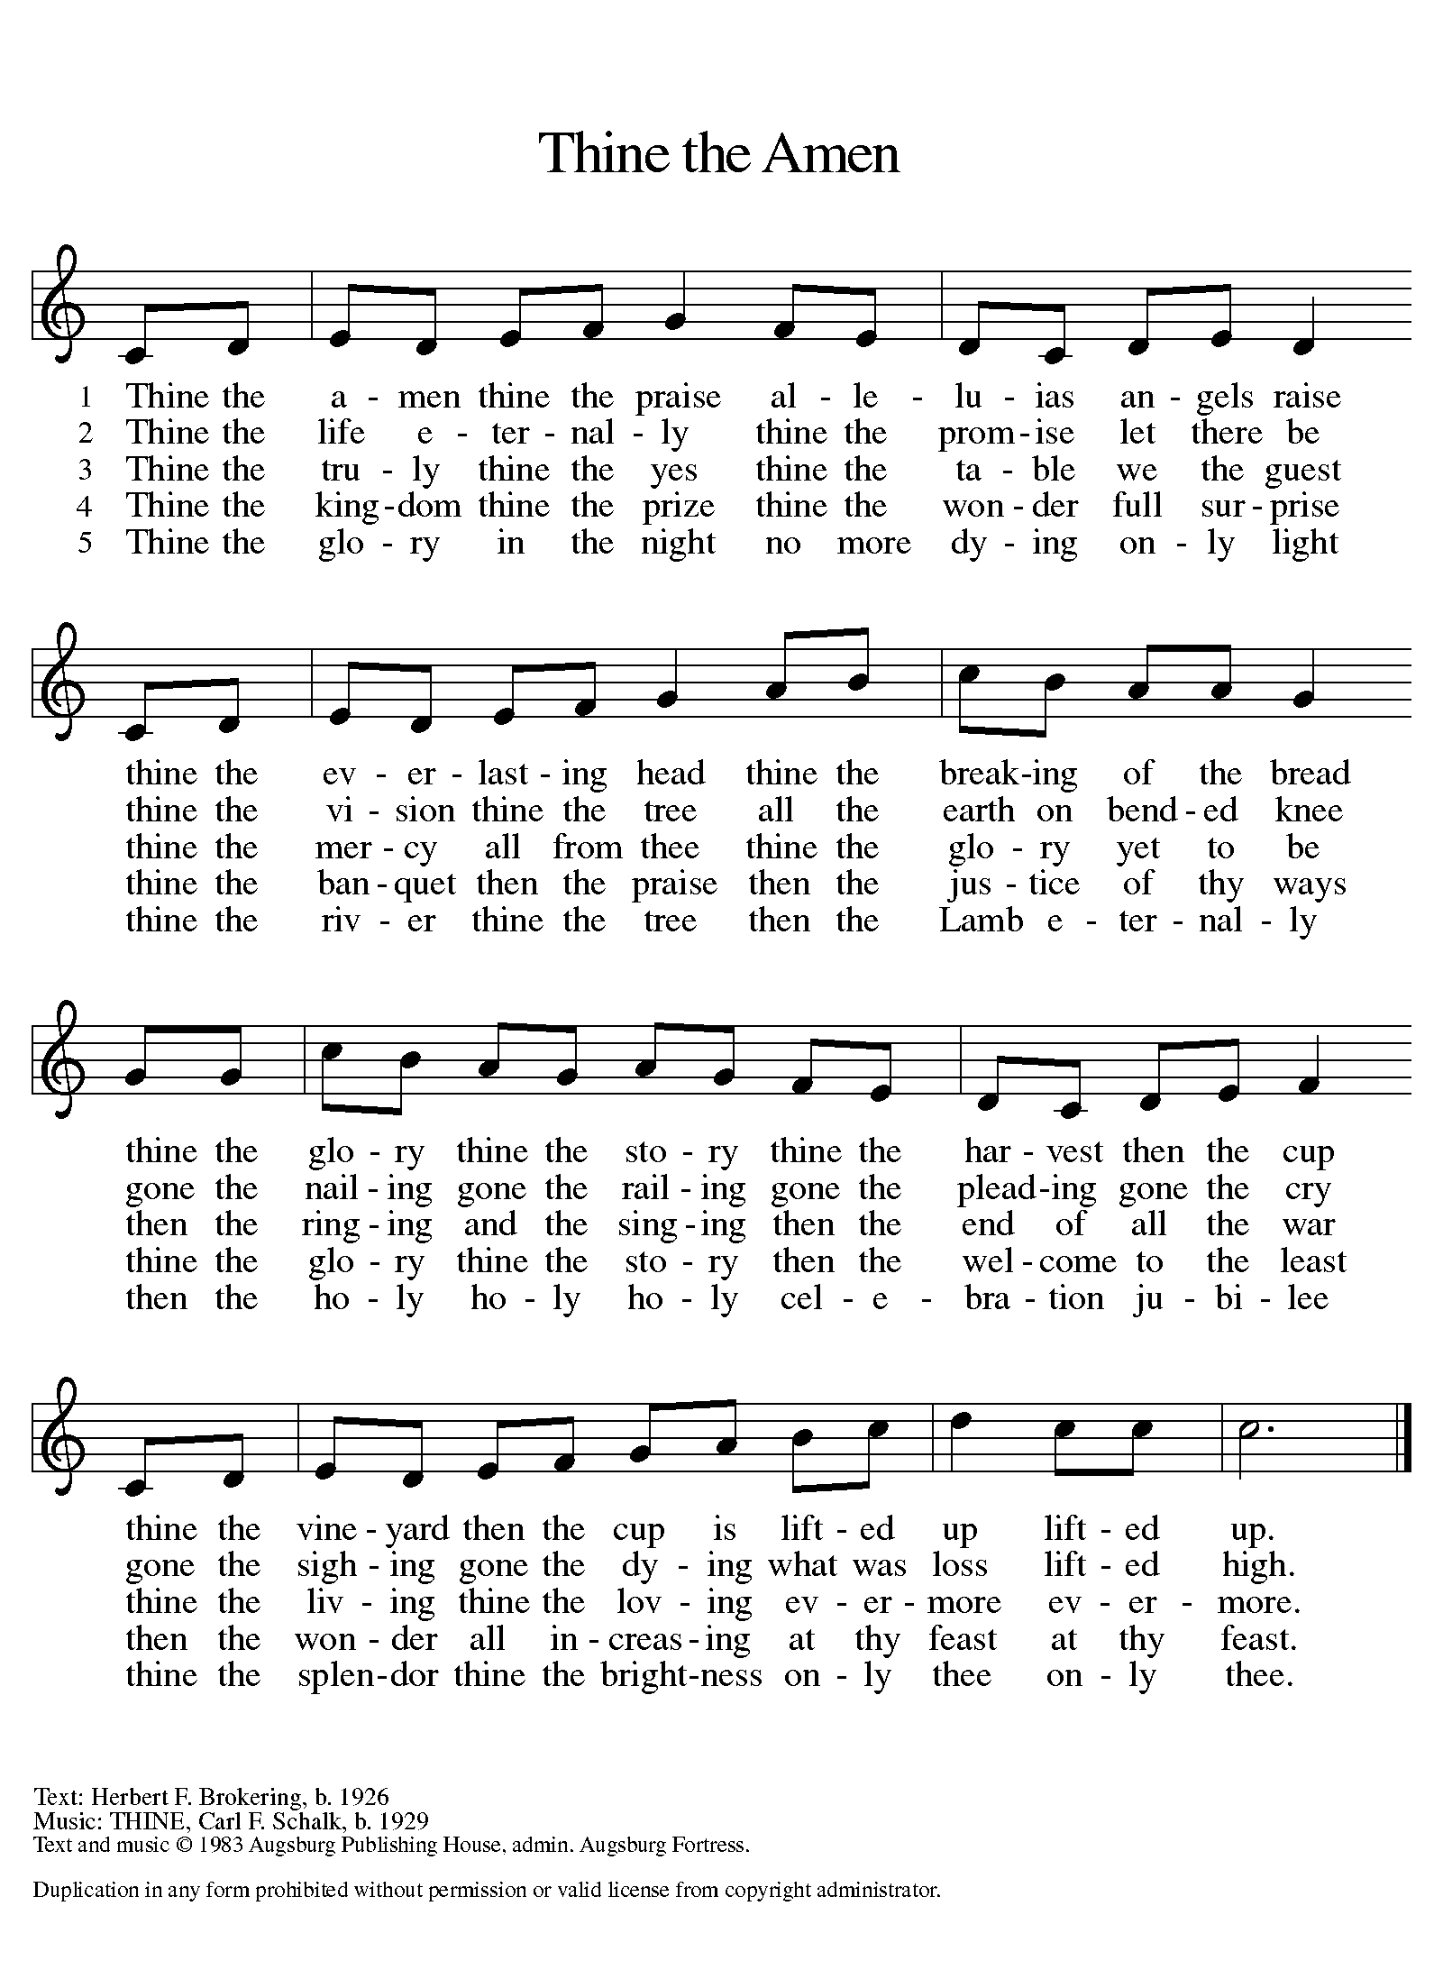

DISMISSAL

A: Beloved of God, go in peace to love and serve the Lord.
C: Thanks be to God.

Announcements:

- Sunday, November 26 - Adult Bible Study @ 9am, Worship @ 10am
- Wednesday, December 6 – Soup Supper @ 6pm
- Wednesday, December 13 – Soup Supper @ 6pm
- Friday, December 15 – Blood Drive 11am-4:45pm
- Sunday, December 17 – Children’s program
- Wednesday, December 20 – Soup Supper @ 6pm

Volunteers for November 26 Volunteers for December 3

Reader Sunday – Pat Reader Sunday – Barb
Assisting Minister Wednesday – Assisting Minister Wednesday –
Assisting Minister Sunday – Assisting Minister Sunday –
Communion Set Up – Communion Set Up –
Communion Clean Up – Communion Clean Up –
Power Point Master – Power Point Master –
Acolyte – Acolyte –
Greeter – Greeter –
Counter – Counter –

November Birthday Celebrations

11/12 - Rick K
11/16 - Maggie L
11/20 - Marty L
11/21 - Char S
11/27 - Garrett K
11/29 - Paul C

Acknowledgments
- OneLicense.net, License #A-703165. CCLI, License #2281869.
- From SundaysandSeasons.com. Copyright 2020 Augsburg Fortress. All rights reserved. Reprinted by permission under Augsburg Fortress Liturgies Annual License #23806.
- New Revised Standard Version Bible, copyright 1989, Division of Christian Education of the National Council of the Churches of Christ in the United States of America. Used by permission. All rights reserved.

