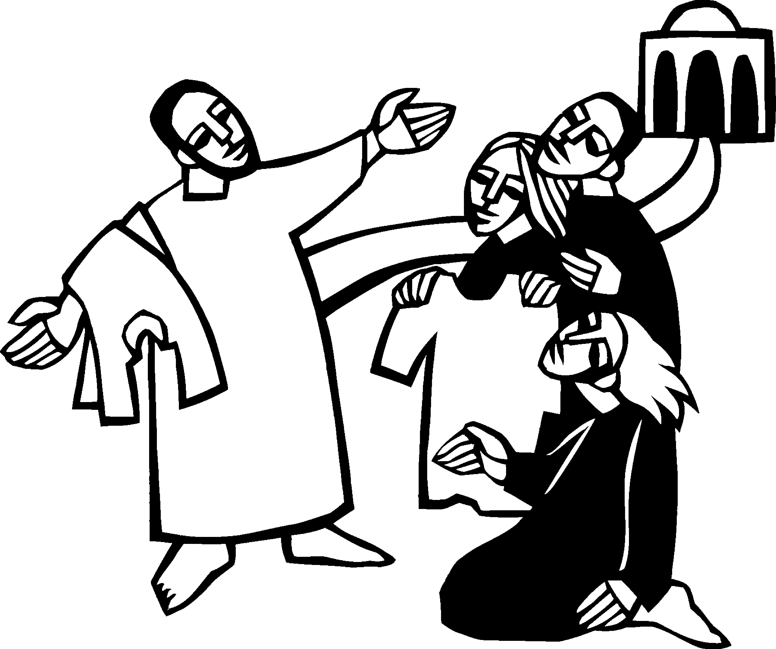

Twentieth Sunday in Pentecost
October 15, 2023


SAINT PAUL LUTHERAN CHURCH
3383 EAST LAKE LANSING ROAD
EAST LANSING, MI 48823

PHONE (517) 351-8541

Pastor Carl E. Ballard
E-MAIL: pastor@stpaul-el.org
officemanager@stpaul-el.org
Visitors WELCOME! If this is your first time worshipping with us, please sign our guest registry just outside the sanctuary doors. We hope you are blessed through worship today. If you have any questions, please feel free to call the church at 351-8541.
Children are always welcome in worship! The choir room (off the sanctuary) can also be used as a cry room for younger children and includes a sound system so parents may continue to participate in the service. Clipboards with children's bulletins, activities and crayons are available for use during the service.
Sunday School is available during the worship service September-May except the last Sunday of the month.
This Bulletin is for your use during the service and to take home for the upcoming week. If you choose not to take it home, please place it in the recycle receptacle in the back.
Newsletters and Calendars of Upcoming Events are available in the lobby/narthex. We welcome anyone who has an interest in our small groups or activities! You can also look us up on the web at www.stpaul-el.org.
Contacting Us: Our Office Manager is Kassy Laurence. She can be reached by phone at 517-351-8541 or at her email address, officemanager@stpaul-el.org. Our Director of Music is Elene Kobulashvili. You may leave a message at 517-351-8541. Pastor Carl can be reached at 517-515-3129, and his email address is cballard123@msn.com.
Holy Communion is available at most services. All who believe in the real presence of Christ in the bread and the wine are invited to celebrate Communion with us. Those who wish can come forward for a blessing.
You’re invited to share in fellowship after worship. Kay (with the assistance of Bob) makes the most delicious snacks to our delight. We would love this opportunity to introduce you to the St. Paul community.

P-Presiding Minister A-Assisting Minister C-Congregation

PRELUDE Elene

INTRODUCTION CELEBRATE INSERT

GATHERING

P: The Holy Spirit calls us together as the people of God.

(Please rise as you are able.)

CONFESSION AND FORGIVENESS

All may make the sign of the cross, the sign that is marked at baptism, as the presiding minister begins.

P: Blessed be God, the one who forms us, ☩ Jesus who bears the cross, the Spirit who makes our joy complete.
C: Amen.

P: Let us bow before God in humility, confessing our sin.

(Silence for reflection)

P: Steadfast and faithful God,
C: you have revealed the ways of justice, yet we fail to follow you. We are overwhelmed by the world’s violence and suffering. We are afraid to risk what we have for the sake of others. For the harm we have caused, known and unknown, forgive us. For the unjust demands we place on others and your creation, forgive us. For the ways we turn away from you and our neighbor, forgive us. Lead us back to you and set us on the right path; in the name of Jesus Christ, our Savior.
Amen.

P: Beloved in Christ, God’s justice stretches beyond all understanding. God’s compassion is beyond compare. In Jesus, God is always making a new way for us.
In ☩ Christ, you are already and always forgiven.
C: Amen.

GATHERING SONG ELW 513
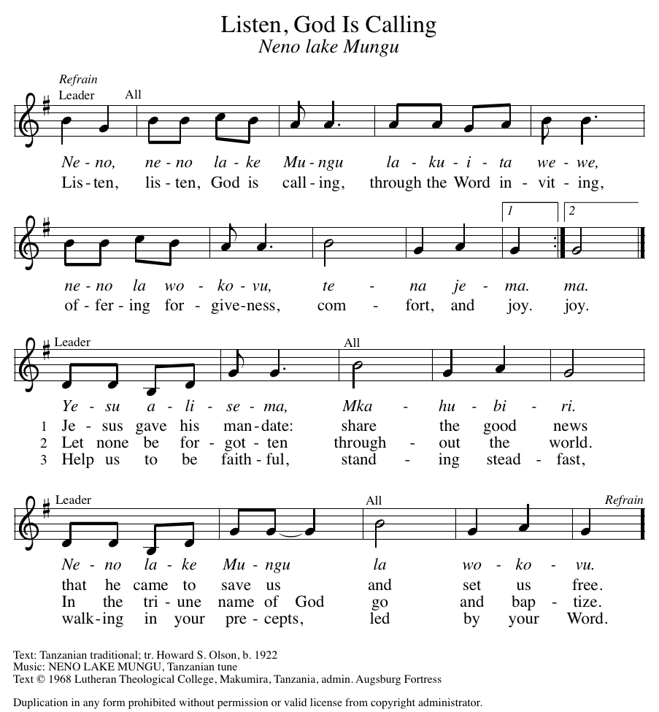

GREETING

P: The grace of our Lord Jesus Christ, the love of God, and the communion of the Holy Spirit be with you all.
C: And also with you.

KYRIE ELW Setting 2, Page 120

In peace, let us pray to the Lord. Lord, have mercy.

For the peace from above, and for our salvation, let us pray to the Lord.
Lord, have mercy.

For the peace of the whole world, for the well-being of the church of God, and for the unity of all, let us pray to the Lord.
Lord, have mercy.

For this holy house, and for all who offer here their worship and praise, let us pray to the Lord.
Lord, have mercy.

Help, save, comfort, and defend us, gracious Lord.
Amen.

CANTICLE OF PRAISE ELW Setting 4, Page 149-150

This is the feast of victory for our God.
Alleluia.
Worthy is Christ, the Lamb who was slain,
whose blood set us free to be people of God.
Power and riches and wisdom and strength,
and honor and blessing and glory are his.
This is the feast of victory for our God.
Alleluia.
Sing with all the people of God
and join in the hymn of all creation:
Blessing and honor and glory
and might be to God and the Lamb forever.
Amen.
This is the feast of victory for our God,
for the Lamb who was slain has begun his reign.
Alleluia. Alleluia.

PRAYER OF THE DAY CELEBRATE INSERT

(Please be seated.)

CHILDREN’S MESSAGE

(Children are invited to Sunday school.)

TRANSITION SONG (Only Verse 1 and Chorus) ELW 595
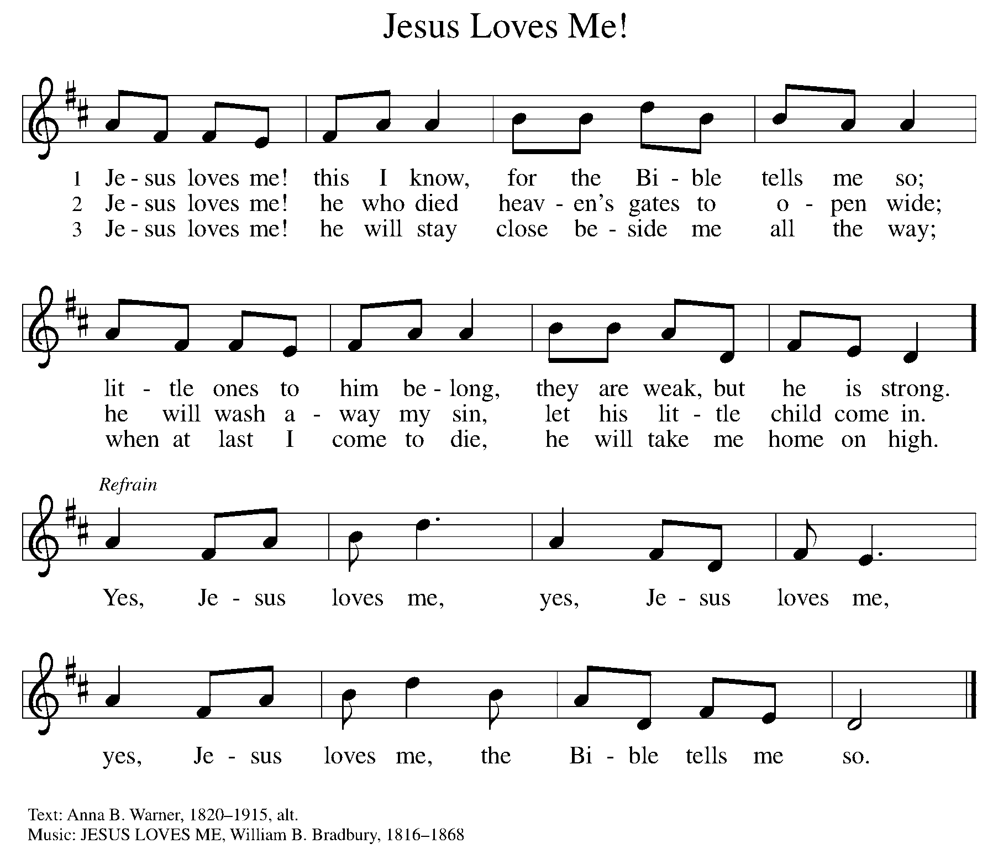

THE WORD

P: God speaks to us in scripture, preaching, and song.

FIRST READING CELEBRATE INSERT

Reader: Word of God, word of life. C: Thanks be to God.

PSALM CELEBRATE INSERT

SECOND READING CELEBRATE INSERT

Reader: Word of God, word of life. C: Thanks be to God.

(Please rise as you are able.)
GOSPEL ACCLAMATION ELW Setting 2, Page 124

Alleluia, alleluia, alleluia, alleluia.
Lord, to whom shall we go? You have the words of eternal life.
Alleluia, alleluia, alleluia, alleluia.

GOSPEL

P: The Holy Gospel according to Matthew, the 22nd chapter.
C: Glory to you, O Lord.
CELEBRATE INSERT
P: The Gospel of the Lord.
C: Praise to you, O Christ.

(Please be seated.)

SERMON Pastor Carl Ballard

(Please rise as you are able.)

Hymn of the Day ELW 462
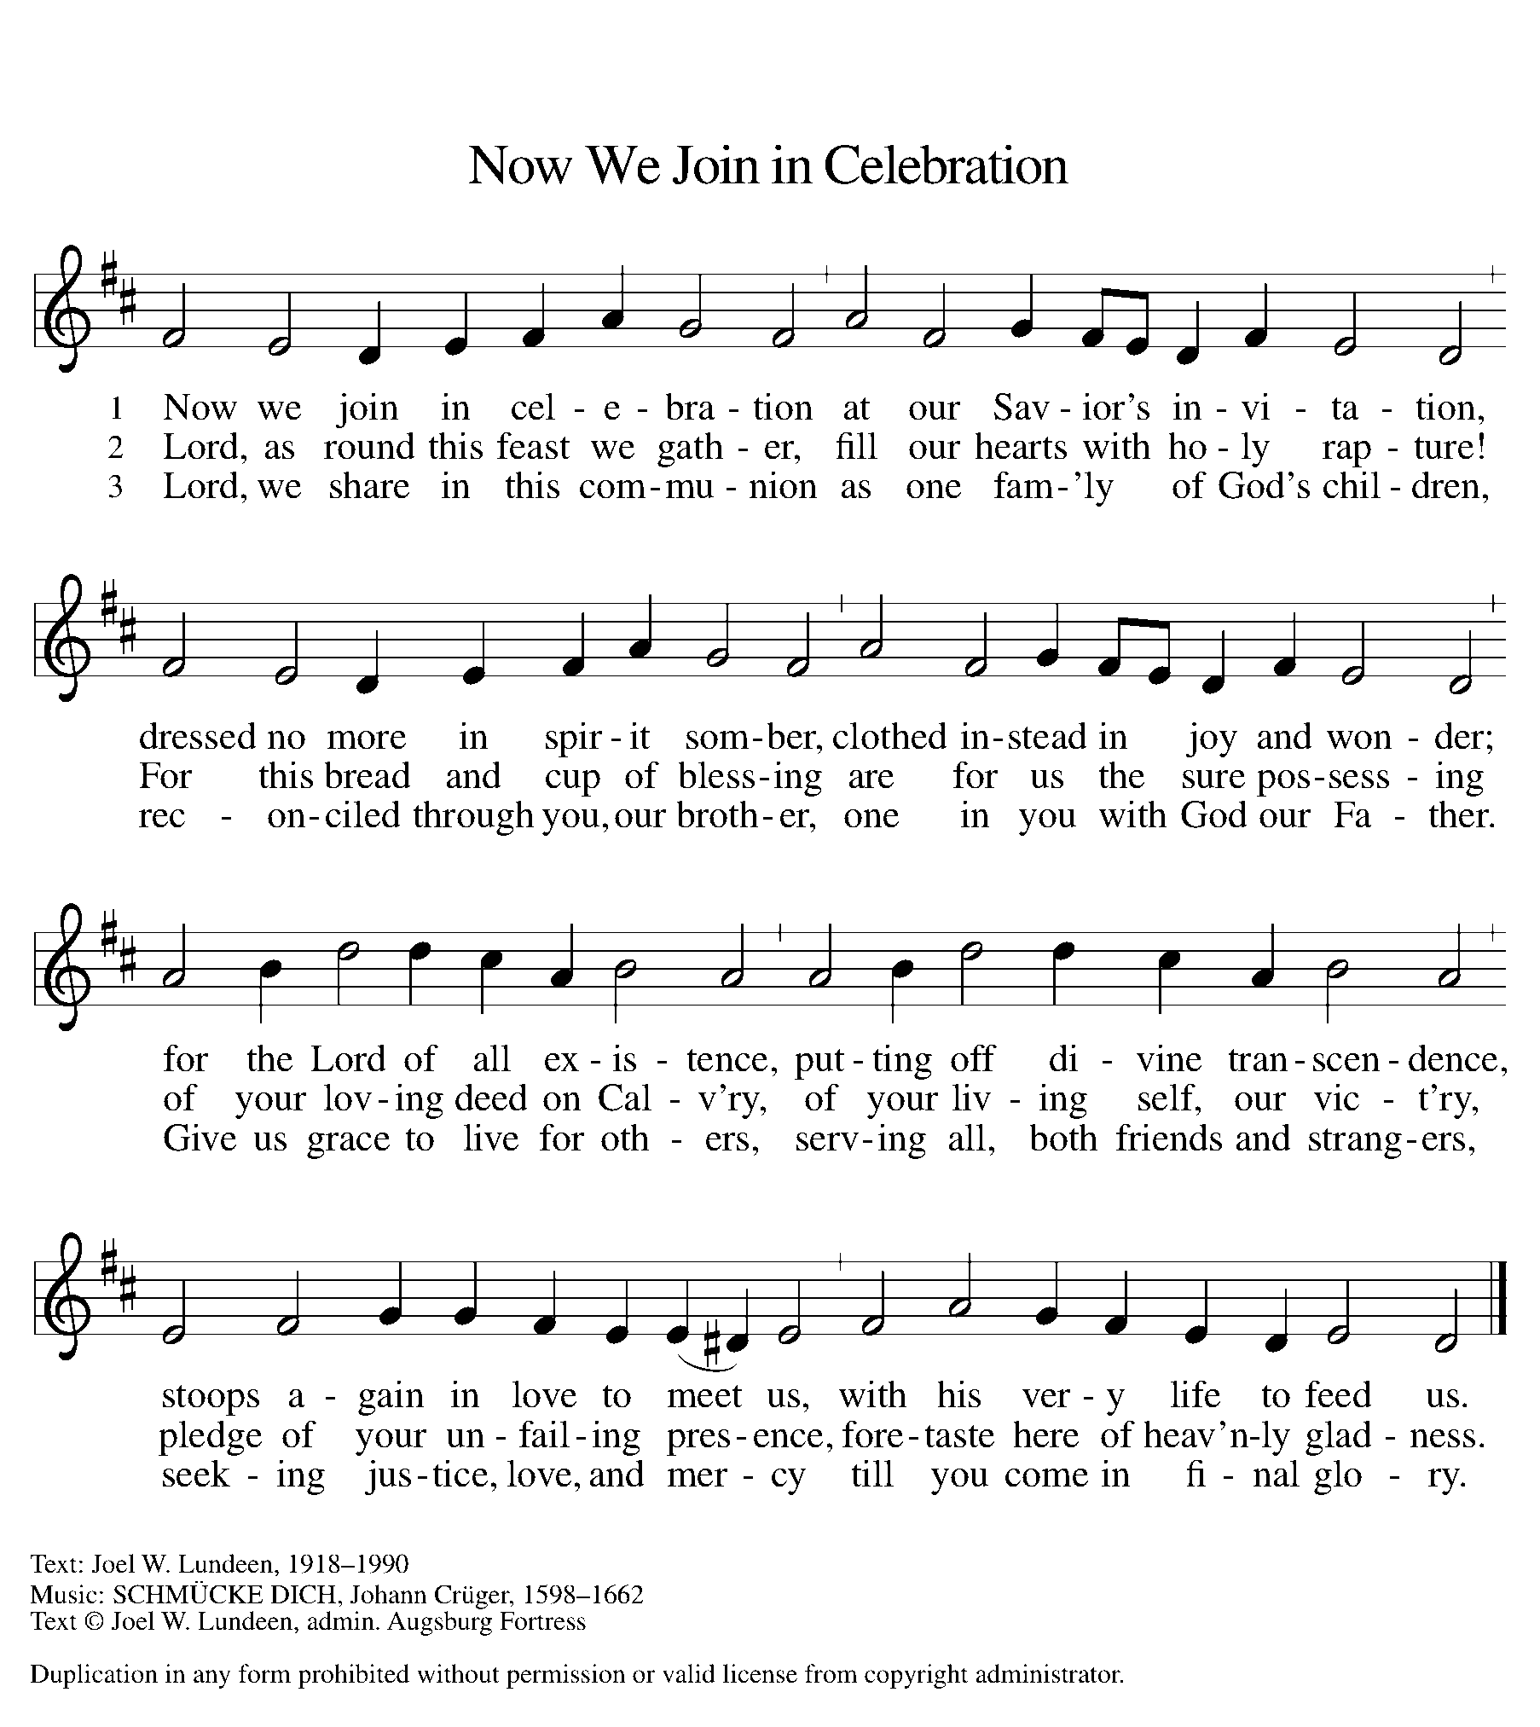

AposTles’ CREED

I believe in God, the Father almighty,
creator of heaven and earth.
I believe in Jesus Christ, God’s only Son, our Lord,
who was conceived by the Holy Spirit,
born of the virgin Mary,
suffered under Pontius Pilate,
was crucified, died, and was buried;
he descended to the dead.
On the third day he rose again;
he ascended into heaven,
he is seated at the right hand of the Father,
and he will come to judge the living and the dead.
I believe in the Holy Spirit,
the holy catholic church,
the communion of saints,
the forgiveness of sins,
the resurrection of the body,
and the life everlasting. Amen.

(Please be seated.)

THE PRAYERS
IN THE CELEBRATE INSERT ALONG WITH

Send angels of protection to provide care and compassion to those who serve in our armed forces and protect and sacrifice for us so we can be free. We pray especially for Beth & Ryan, Jonathan, Jacob, Noah, Irene, and Alex. God of grace,
C: hear our prayer.

Healing God, raise up any who are bowed down with illness or sorrow. Deepen our care and concern for one another. We lift to you all who are undergoing transition in relationships, occupation, living situation, or health condition, especially Ahren, Anne & Bob, Dan, David, John, Jon, Jordan, Lawton, Lera & family, family of Tim, Kristem, Pastor Joan, Maelyn, Wanda, Mary, Char, Chip, Matt, Craig & Julie and family, Pastor Dana, Pastor Sarah, and Pastor Roseanne. God of grace,
C: hear our prayer.

We especially lift up to you Presiding Bishop Elizabeth, our Synod Bishop Craig, and Pastor Carl. We ask that you be with their respective staffs as they live out their callings to serve. As we are called to be one, even as Jesus and the Father are one, be with the leaders and the congregation of Trinity Lutheran Church in Hillsdale and the churches in our community. God of grace,
C: hear our prayer.

GREETING OF PEACE

P: The peace of Christ be with you always.
C: And also with you.

THE MEAL
The gifts of the bread, wine, and contributions are brought forward to the altar.

OFFERING Elene

OFFERTORY ELW 184
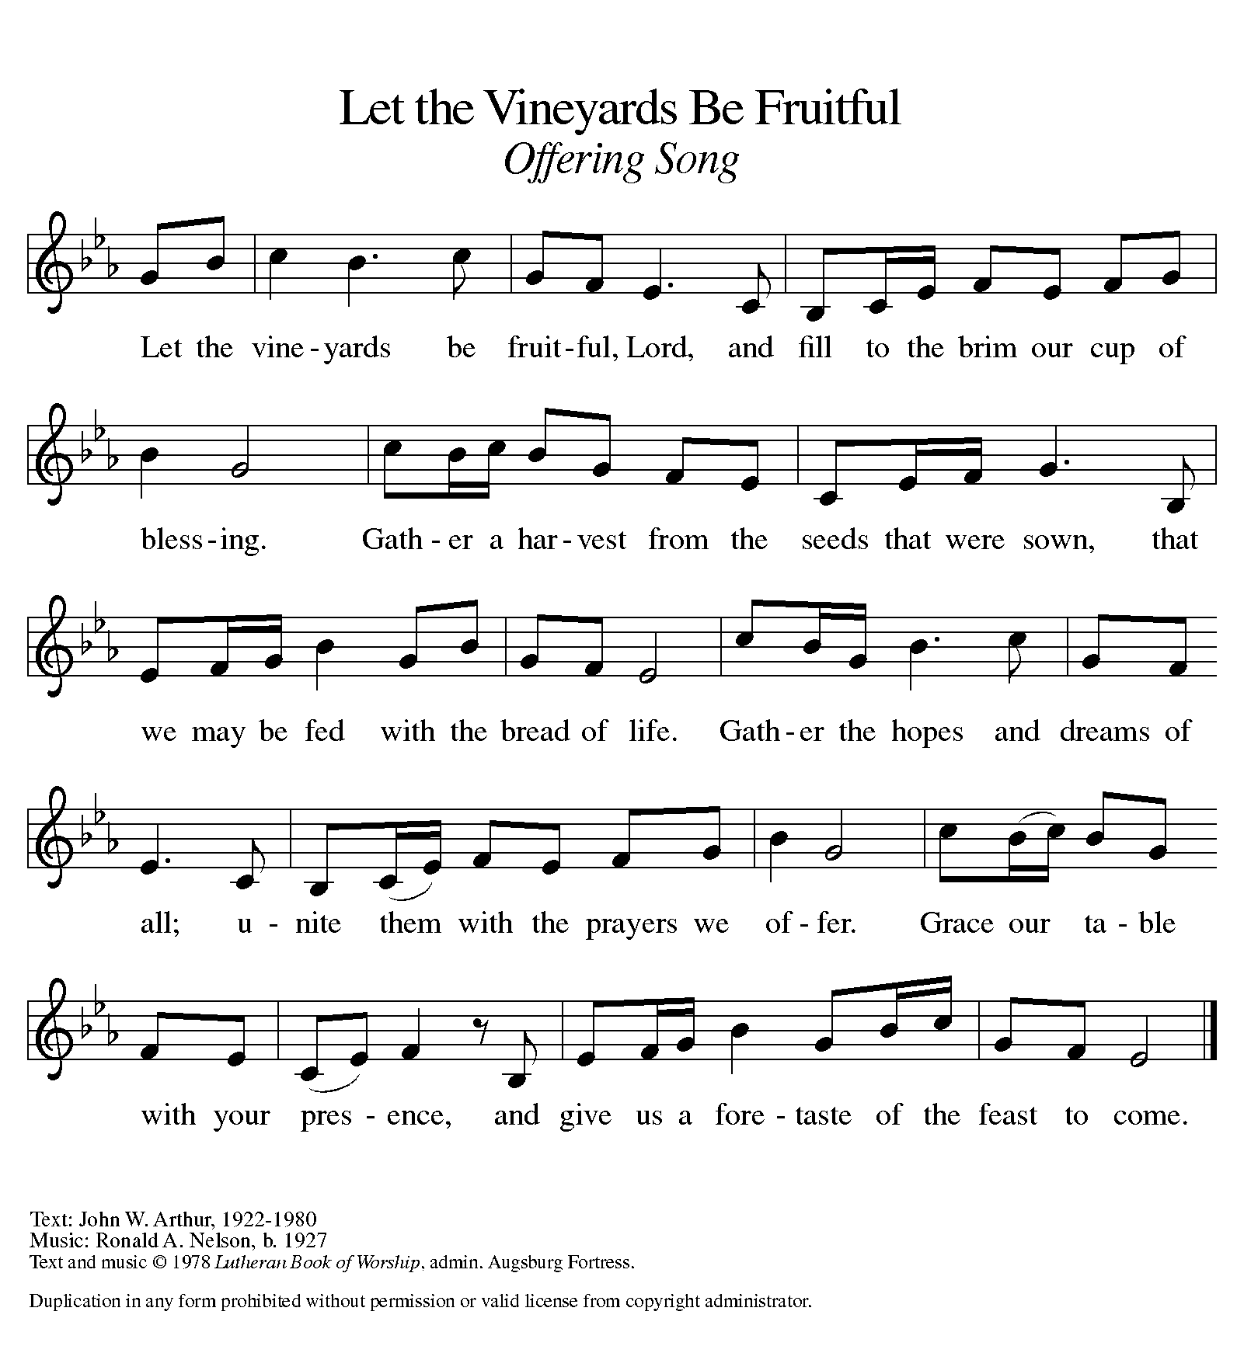
OFFERING PRAYER

A: Let us pray.
God of power, God of plenty,
all things belong to you.
We bring your gifts to the table,
that all might be fed.
Form us into the body of your Beloved,
Jesus Christ, our Savior.
C: Amen.

THE GREAT THANKSGIVING

P: The Lord be with you.
C: And also with you.
P: Lift up your hearts.
C: We lift them to the Lord.
P: Let us give thanks to the Lord our God.
C: It is right to give our thanks and praise.

PROPER PREFACE

P: It is indeed right, our duty and our joy, that we should at all times and in all places give thanks and praise to you, almighty and merciful God, through our Savior Jesus Christ. You comforted your people with the promise of the Redeemer, through whom you will also make all things new in the day when he comes to judge the world in righteousness. And so, with all the choirs of angels, with the church on earth and the hosts of heaven, we praise your name and join their unending hymn:

HOLY, HOLY ELW Setting 2, Page 130

Holy, holy, holy Lord,
God of power and might,
heaven and earth are full of your glory.
Hosanna in the highest.
Blessed is he who comes in the name of the Lord.
Hosanna in the highest.
Hosanna in the highest.

EUCHARISTIC PRAYER

P: In the night in which he was betrayed, our Lord Jesus took bread, and gave thanks; broke it, and gave it to his disciples, saying:
Take and eat; this is my body, given for you. Do this for the remembrance of me.
Again, after supper, he took the cup, gave thanks, and gave it for all to drink, saying:
This cup is the new covenant in my blood, shed for you and for all people for the forgiveness of sin. Do this for the remembrance of me.

LORD'S PRAYER

P: Lord, remember us in your kingdom, and teach us to pray:
C: Our Father, who art in heaven, hallowed be thy name, thy kingdom come, thy will be done, on earth as it is in heaven. Give us this day our daily bread; and forgive us our trespasses, as we forgive those who trespass against us; and lead us not into temptation, but deliver us from evil. For thine is the kingdom, and the power, and the glory, forever and ever. Amen.

COMMUNION DISTRIBUTION

All who believe in the real presence of Christ in the bread and the wine (juice) are welcome to the table. Others may come forward for a blessing. If you prefer grape juice, please indicate this to the assisting minister.

When approaching the communion rail, come forward down the side aisle, kneel, if you are able, starting at the front of the communion rail (spot closest to the font) on your side and filling in toward the back. After receiving both the bread and the wine, you may return to your seat by the center aisle.

INVITATION TO COMMUNION

P: Jesus invites you to this table. Come, eat and live.

COMMUNION HYMN ELW 481
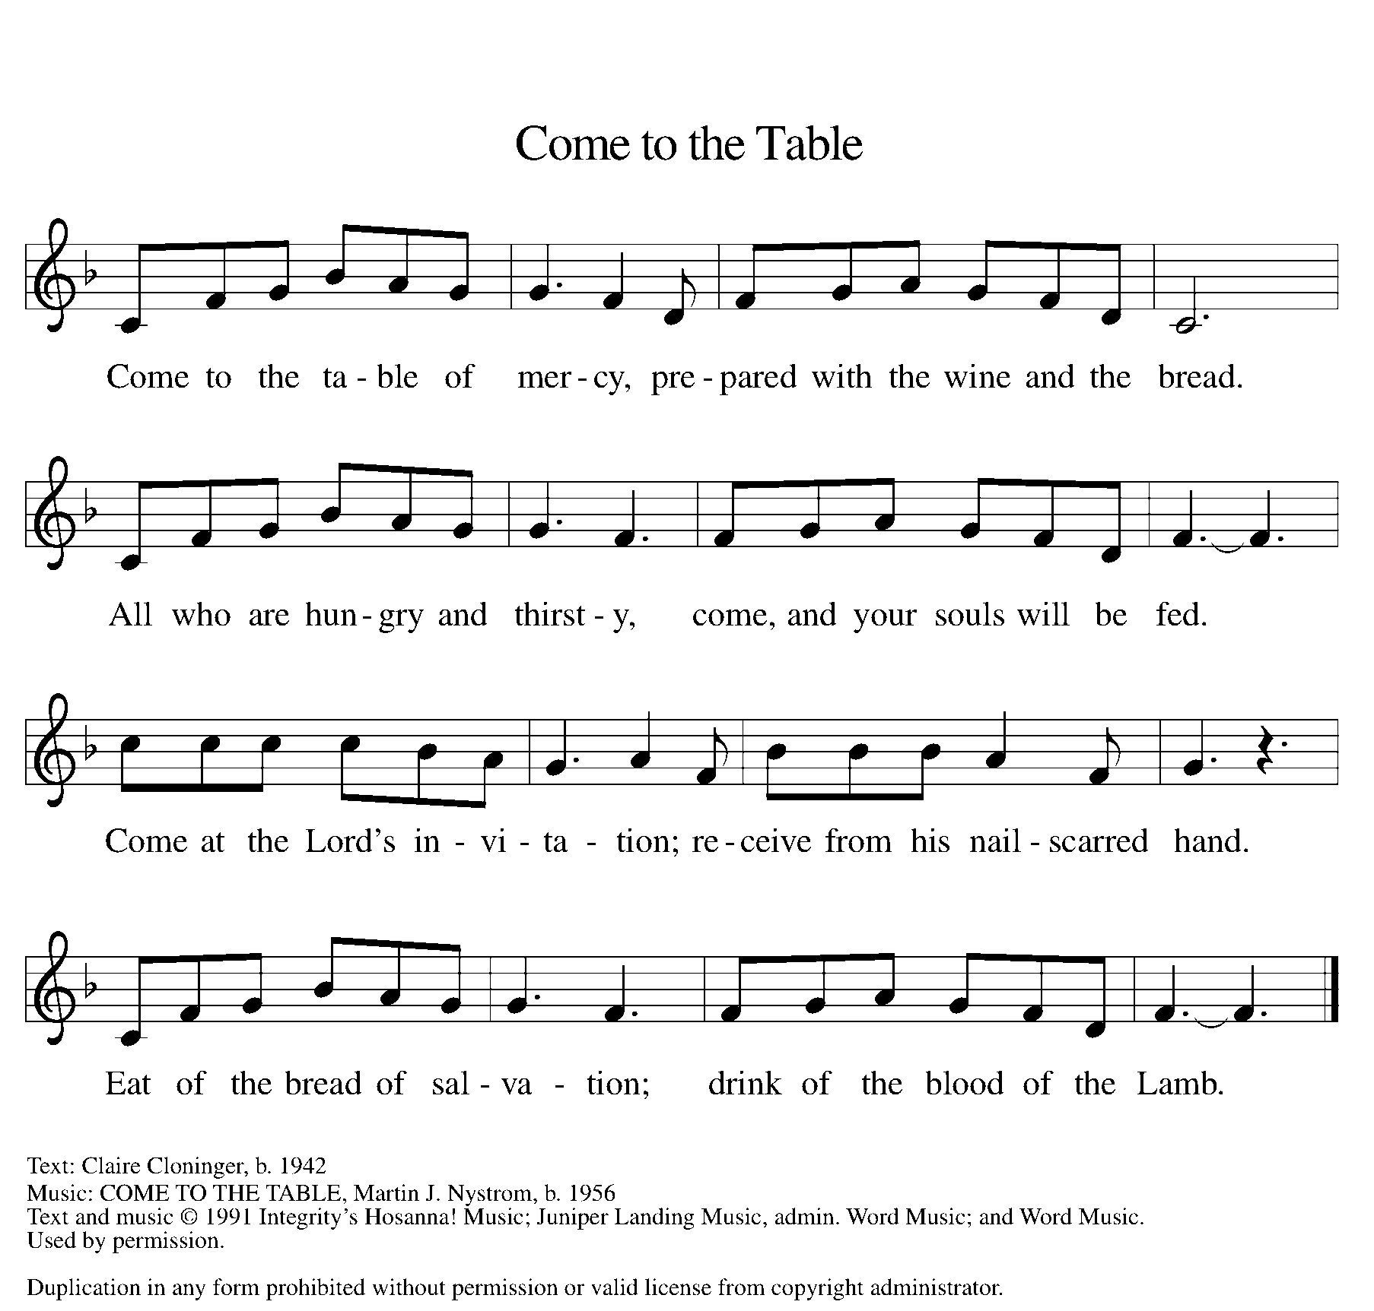

P: The body of Christ, given for you.
C: Amen.
A: The blood of Christ, shed for you.
C: Amen.

(Please rise as you are able.)

P: May the body and blood of our Lord Jesus Christ strengthen and keep you in his grace.
C: Amen.

PRAYER AFTER COMMUNION

P: Let us pray.
C: Blessed be your name, O God,
for we have feasted on your Word,
Christ Jesus, the joy and delight of our hearts.
Strengthened by this food,
send us to gather the world to your banquet,
where none are left out and all are satisfied.
In Jesus’ name we pray.
Amen.

BLESSING

P: The God of glory,
☩ Jesus Christ, name above all names,
and the Spirit who lives in you,
bless you now and forever.
C: Amen.

SENDING HYMN ELW 547
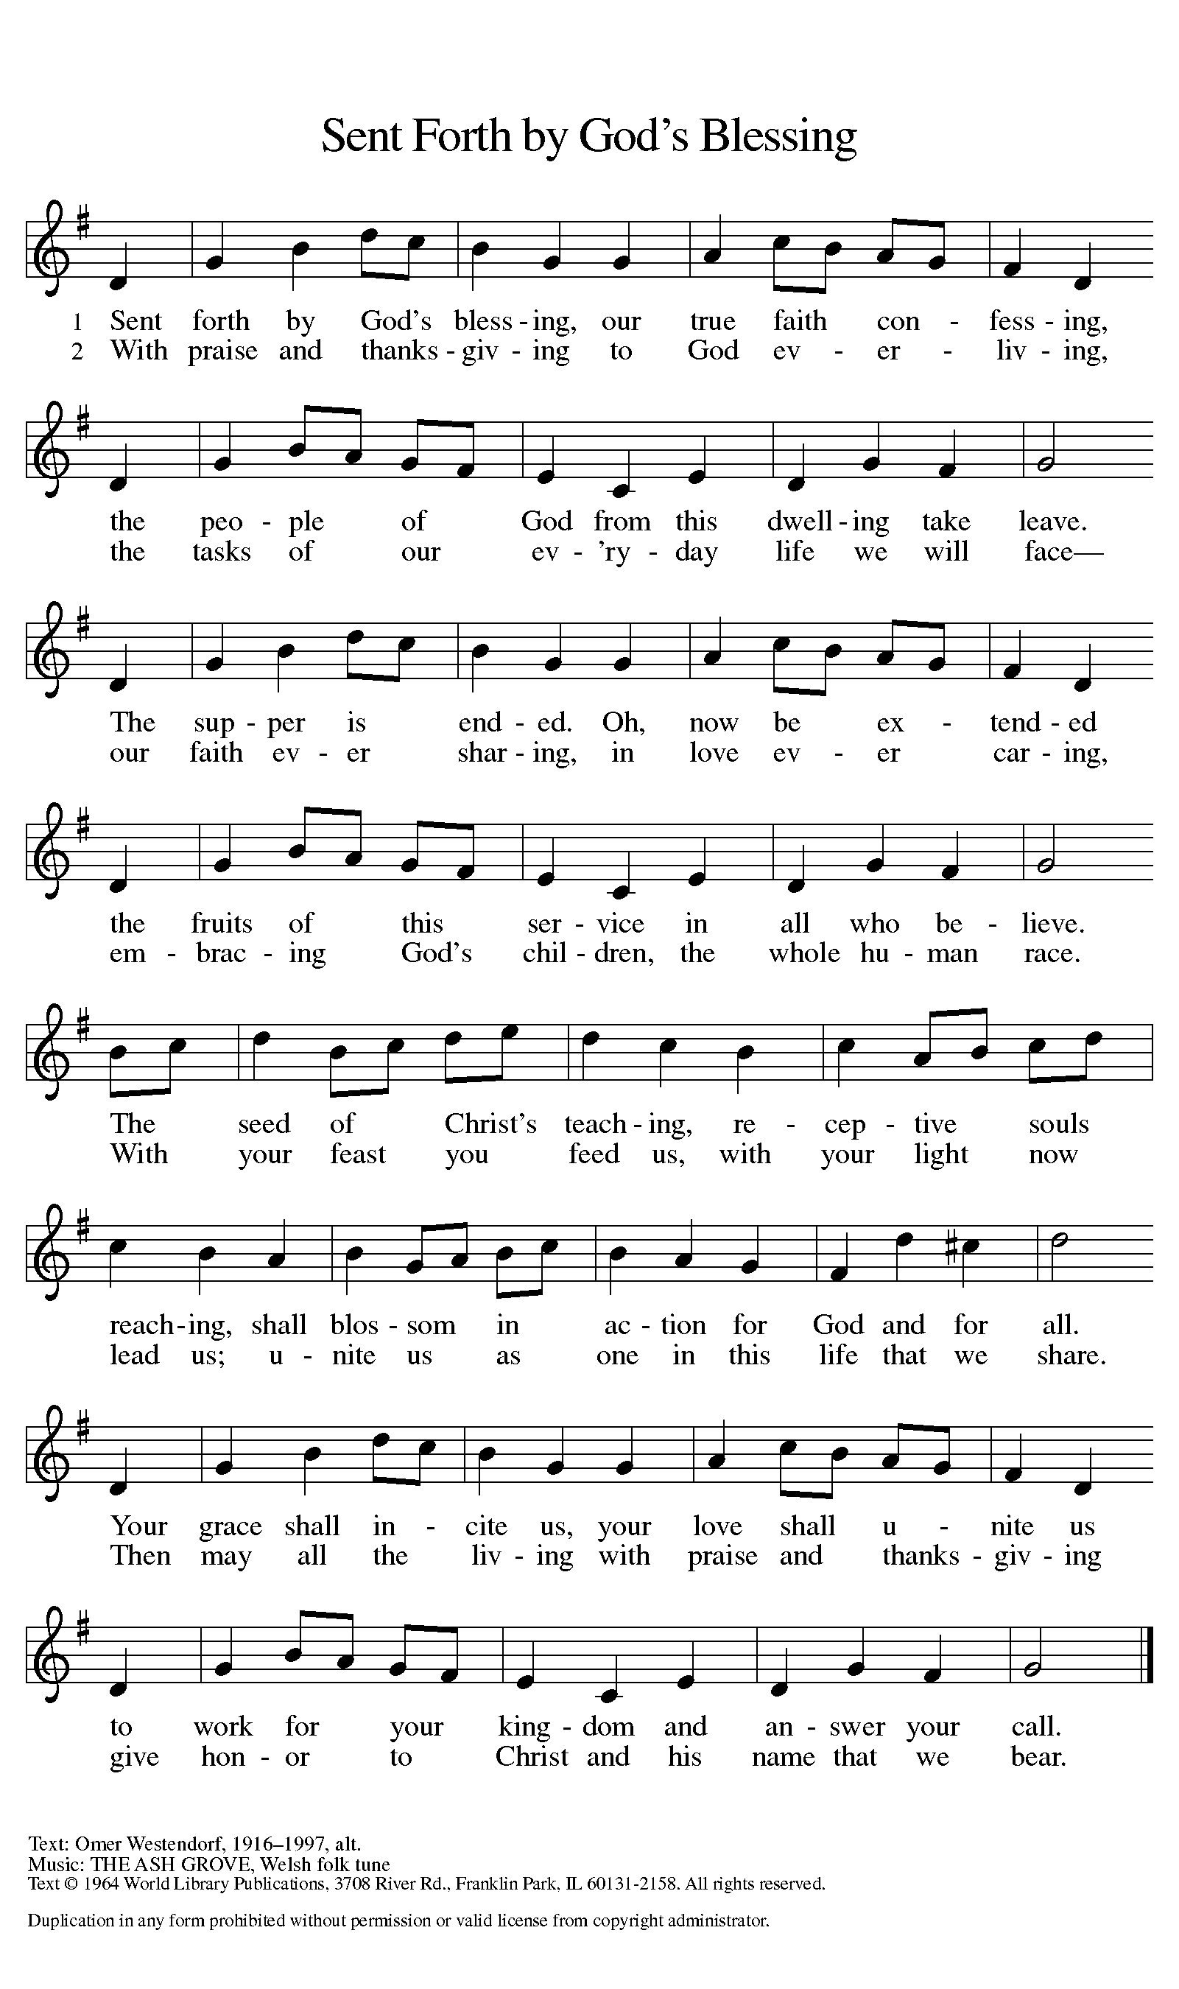

DISMISSAL

A: Go in peace. God is at work in you.
C: Thanks be to God.
Announcements:

- Sunday, October 15 - Adult Bible Study @ 9am, Worship @ 10am (In person and on Zoom)
- Wednesday, October 18 - Food Pantry Distribution @ 5:30pm
- Thursday, October 19 - Council meeting @ 7pm
- Friday, October 20 – Blood Drive, 11-5pm
- Sunday, October 22 - Adult Bible Study @ 9am, Worship @ 10am (In person and on Zoom)
- Thursday, October 26 - Food Pantry Distribution @ 1pm
- Sunday, October 29 - Adult Bible Study @ 9am, Worship @ 10am (In person and on Zoom)

Volunteers for October 15 Volunteers for October 22

Reader Sunday – Reader Sunday –
Assisting Minister Wednesday – Assisting Minister Wednesday –
Assisting Minister Sunday – Assisting Minister Sunday –
Communion Set Up – Mary Communion Set Up –
Communion Clean Up – Communion Clean Up –
Power Point Master – Power Point Master –
Acolyte – Acolyte –
Greeter – Greeter –
Counter – Counter –

October Birthday Celebrations

10/02 – Kassy L 10/07 – Pat S
10/10 – Grant B 10/13 – Maryann L
10/14 – Stacy T 10/19 – Ethan C
10/19 – Rachel J 10/21 – Chuck N
10/25 – Kristin H 10/25 – Daniel N
10/27 – Mary B 10/30 – James Cl

Acknowledgments
- OneLicense.net, License #A-703165. CCLI, License #2281869.
- From SundaysandSeasons.com. Copyright 2020 Augsburg Fortress. All rights reserved. Reprinted by permission under Augsburg Fortress Liturgies Annual License #23806.
- New Revised Standard Version Bible, copyright 1989, Division of Christian Education of the National Council of the Churches of Christ in the United States of America. Used by permission. All rights reserved.

